Cardiovascular Disease Prediction AI model

__________________________________________________________________________________

This project analyzes heart disease prediction by performing data preprocessing, exploratory data analysis with visualizations, and correlation analysis. It evaluates machine learning models like SVM, KNN, Decision Trees, Logistic Regression, and Random Forest to determine the most accurate model for prediction.

__________________________________________________________________________________

Data Preprocessing

Before Preprocessing : After Preprocessing :

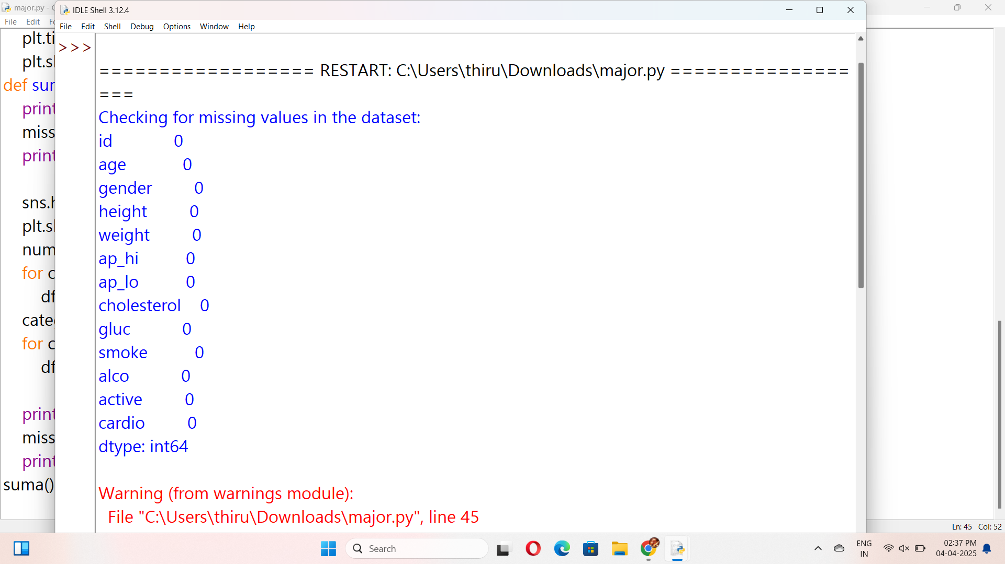

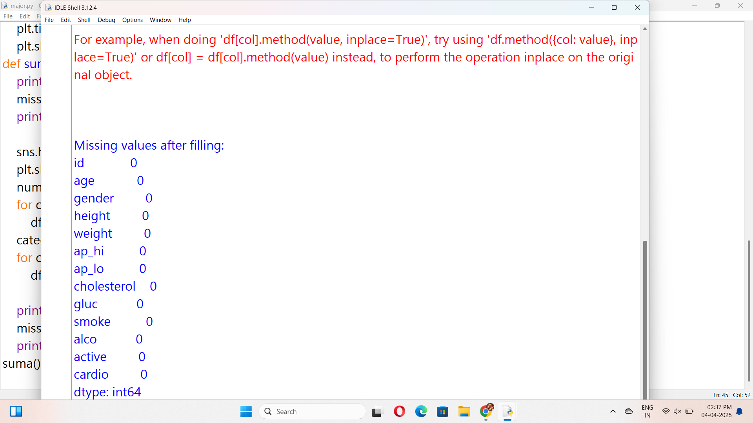

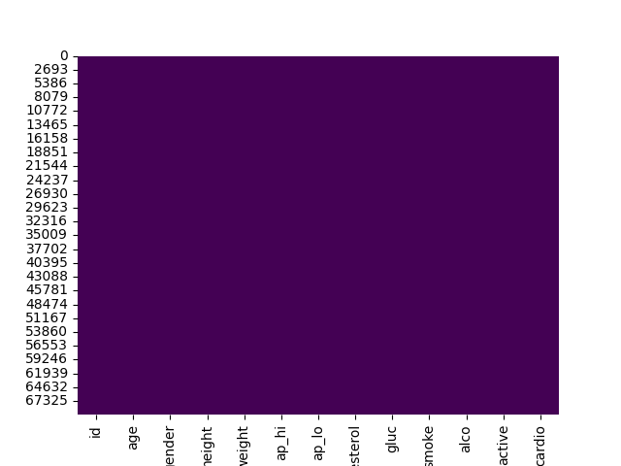

Pairplots and Data Visualizing to find meaningful insights

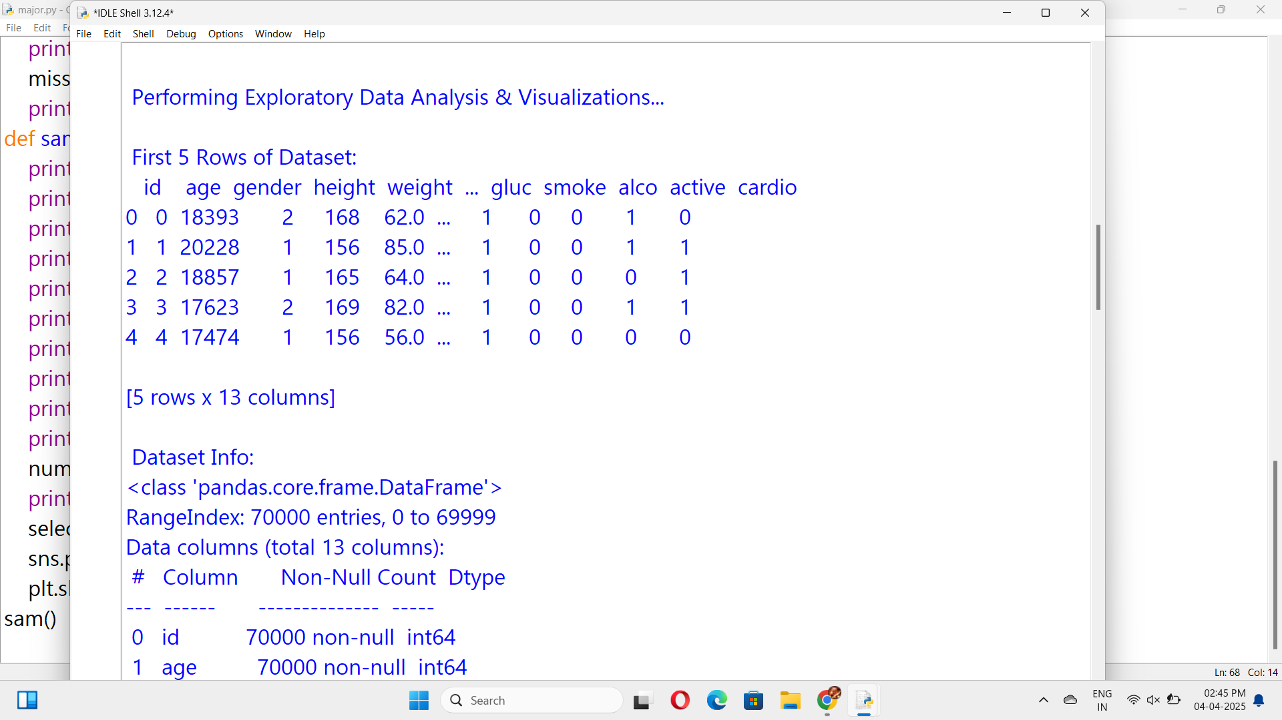

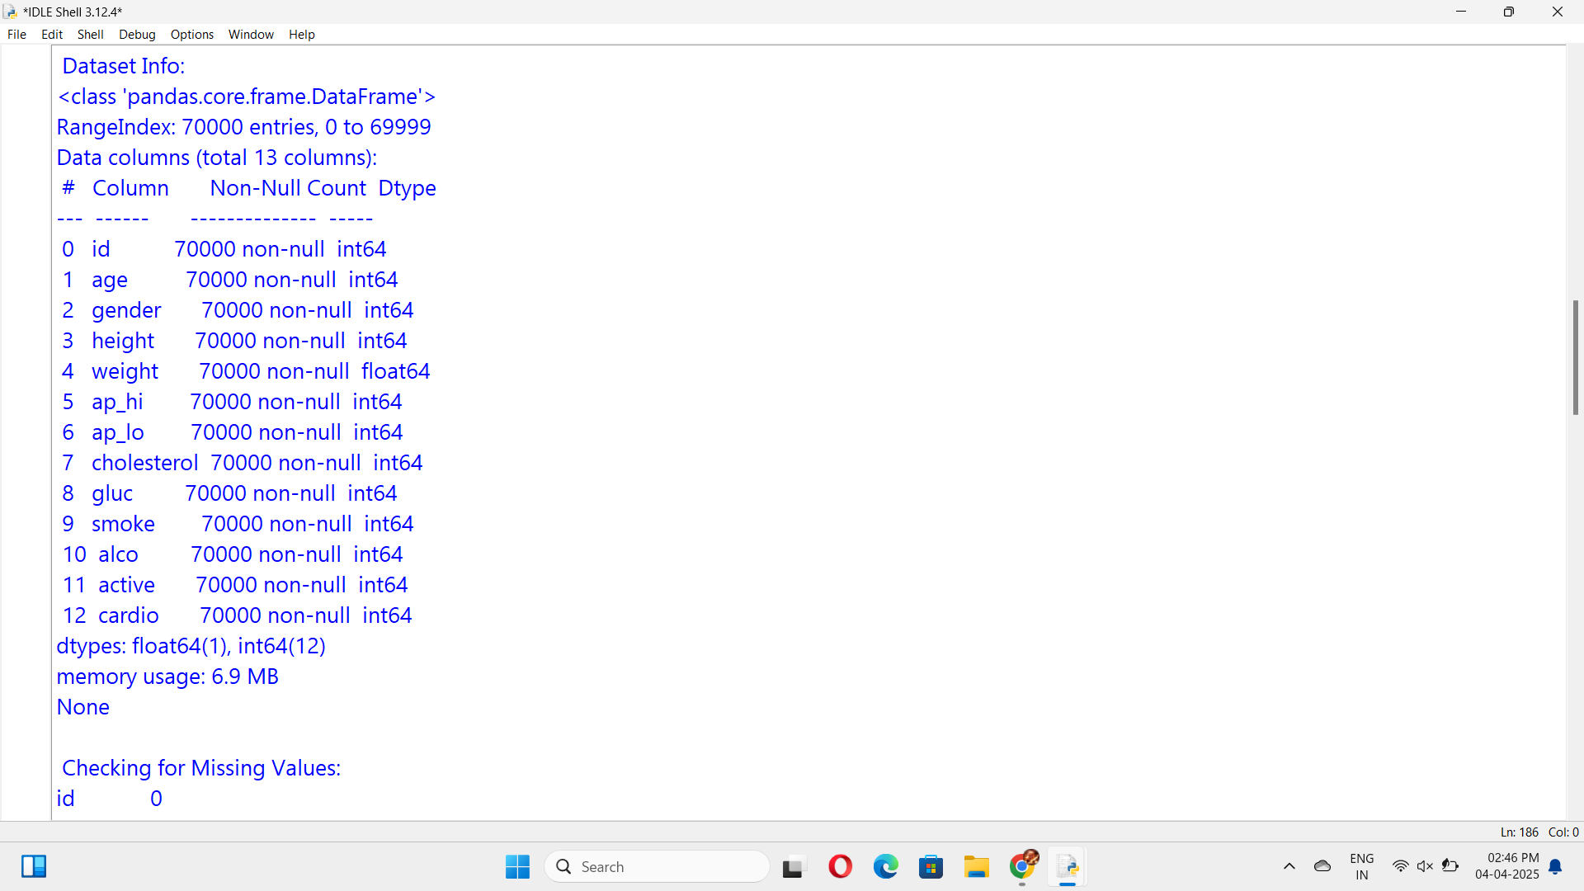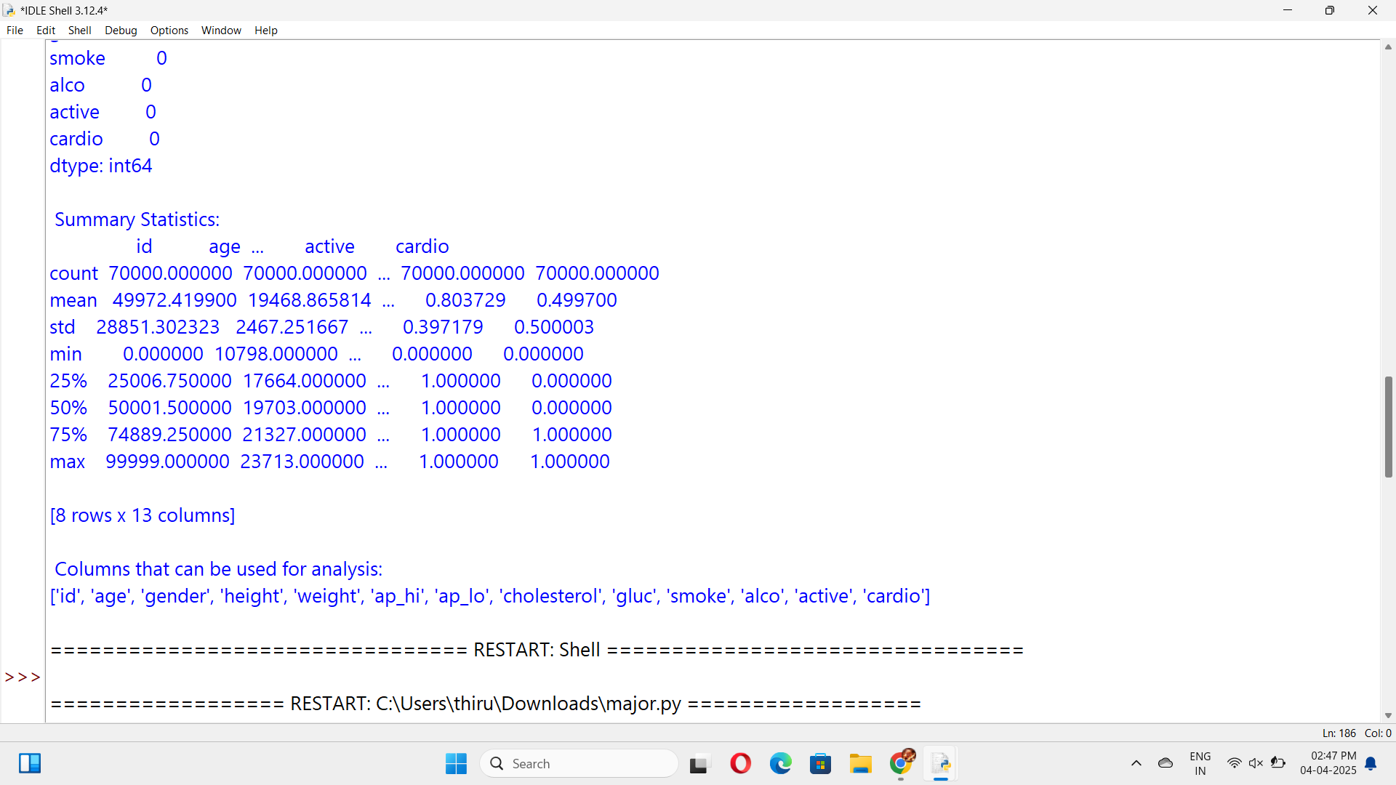

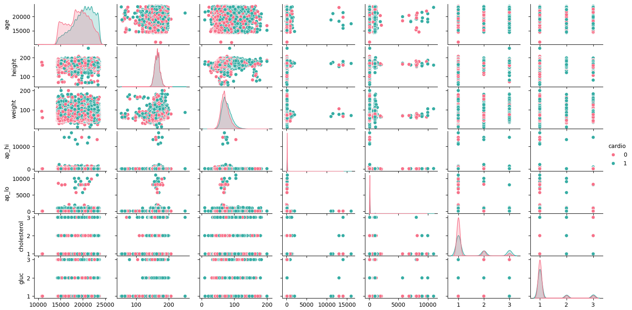

Confusion Matrix

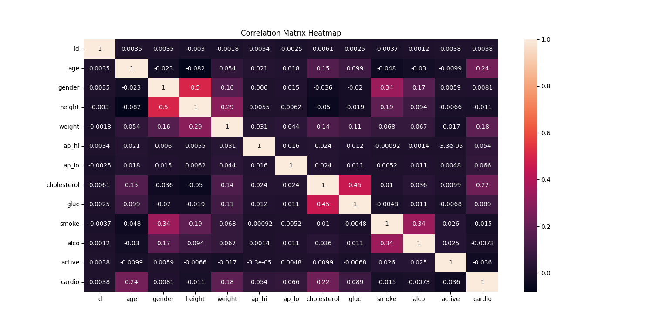

Checking the accuracy of all the models and selecting the best model

