PROJECT REPORT
ML Network Intrusion Detector
Detecting and classifying network attacks with machine learning on the NSL-KDD dataset

Item | Details
Submitted by | Arjun Pundir
Programme | IBM SkillsBuild Cyber Security 2026
Conducted by | BharatCares
Domain | Cyber security · Machine learning · Intrusion detection
Technologies | Python, Scikit-learn, Pandas, NumPy, Matplotlib, Seaborn, Jupyter
Dataset | NSL-KDD (Canadian Institute for Cybersecurity)
Submission date | October 2026

Executive Summary
Network intrusion detection systems (IDS) are a core defensive control, but signature-based tools struggle to recognise new attack variants. This project builds a machine-learning detector that learns patterns of malicious behaviour from labelled network traffic, and evaluates it honestly on attacks it has never seen.
Using the public NSL-KDD dataset, three classifiers (Logistic Regression, Decision Tree and Random Forest) were trained inside a leakage-free Scikit-learn pipeline. The models first separate normal traffic from attacks, and a Random Forest then predicts the attack family (DoS, Probe, R2L or U2R).
Key findings
• Best model: Decision Tree, with 78.3% accuracy, 95.8% attack precision, 64.7% attack recall and 0.773 F1 on the unseen test set.
• Alerts are trustworthy (false-positive rate 3.7%), but about 35% of attacks are missed (false-negative rate 35.3%).
• Scores fall from over 0.97 F1 in cross-validation to 0.74-0.77 on the test set, showing that unseen attack variants are the central challenge.
• DoS attacks are detected well; R2L and U2R attacks are rarely caught because of very limited training data.

1. Introduction

1.1 Background
Organisations face a constant stream of network attacks such as denial-of-service floods, port scans, password guessing and privilege escalation. Signature-based tools detect known attacks reliably but cannot recognise new variants. Machine-learning models learn statistical patterns from labelled traffic and can flag behaviour that deviates from normal, making them a useful complement within a security monitoring stack such as a SIEM.

1.2 Problem Statement
Given a record describing a single network connection (protocol, service, byte counts, error rates and similar statistics), decide whether the connection is normal or malicious and, where possible, identify which family of attack it belongs to.

1.3 Objectives
- Explore and understand the NSL-KDD dataset.
- Build a reproducible pre-processing and training pipeline in Scikit-learn.
- Compare classifiers using metrics suited to security work: precision, recall, F1 and false-negative rate.
- Evaluate on a test set that contains attack types absent from training.
- Identify limitations and recommend improvements.

1.4 Scope
The project covers offline analysis of pre-extracted connection features. It does not capture live packets or deploy the model in production; these are discussed as future work.

2. Dataset

2.1 Overview
NSL-KDD is a refined version of the KDD Cup 1999 dataset, created by the Canadian Institute for Cybersecurity to remove duplicate records that biased earlier results. Each record holds 41 features and an attack label. The data were obtained from a public GitHub mirror (github.com/defcom17/NSL_KDD); the official page is www.unb.ca/cic/datasets/nsl.html.
Table 1: Dataset composition
Property | Training (KDDTrain+) | Test (KDDTest+)
Records | 125,973 | 22,544
Features | 41 | 41
Missing values | 0 | 0
Normal | 67,343 | 9,711
DoS | 45,927 | 7,460
Probe | 11,656 | 2,421
R2L | 995 | 2,885
U2R | 52 | 67

2.2 Feature Groups
- Basic features: duration, protocol type, service, connection flag, bytes sent and received.
- Content features: failed logins, root-shell attempts, file creations and similar host-level indicators.
- Traffic features: error rates and connection counts over a time window or per destination host.

2.3 Attack Families
Table 2: Attack families and examples
Family | Description | Examples
DoS | Denial of service: overwhelm a target with traffic | neptune, smurf, back, teardrop
Probe | Surveillance and scanning to find weaknesses | satan, ipsweep, portsweep, nmap
R2L | Unauthorised access from a remote machine | guess_passwd, warezclient, ftp_write
U2R | Local user gains root privileges | buffer_overflow, rootkit, loadmodule

2.4 Data Characteristics
The test set deliberately includes attack types that do not appear in training, so test scores are more realistic than those from a random split. The training set is also strongly imbalanced: U2R has only 52 examples against 67,343 normal records.
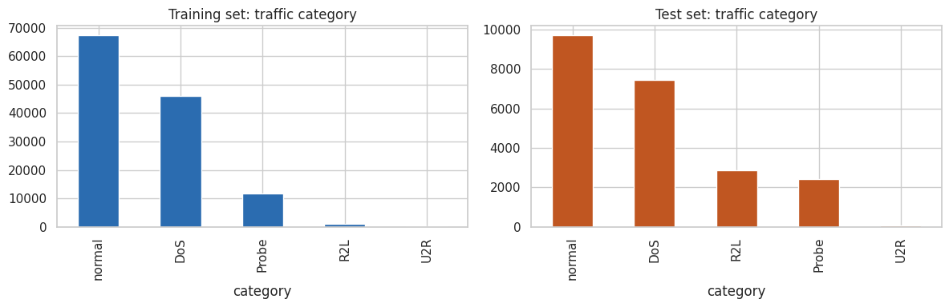
Figure 1: Traffic category distribution in the training and test sets
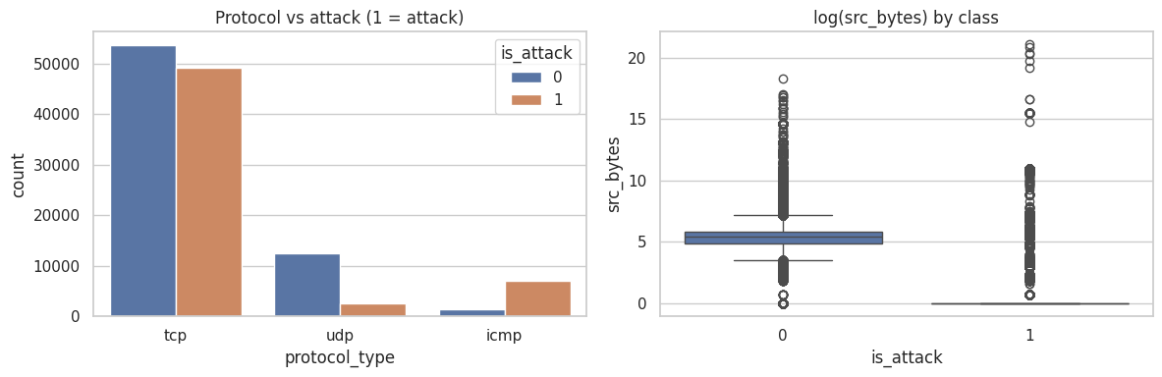
Figure 2: Protocol versus attack label (left) and source bytes by class (right)

3. Methodology

3.1 System Workflow
The project follows a standard machine-learning workflow, summarised below.
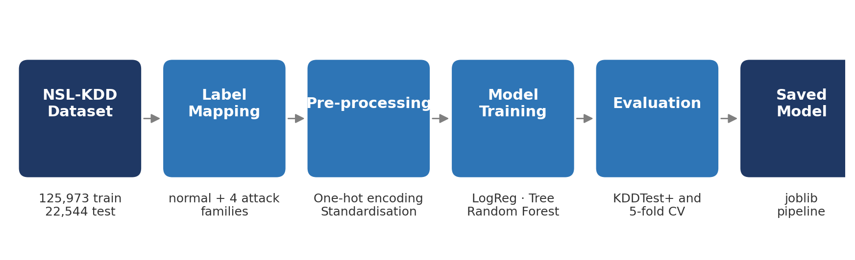
Figure 3: End-to-end project workflow

3.2 Tools and Environment
Python 3 with Jupyter Notebook; Pandas and NumPy for data handling; Scikit-learn for modelling; Matplotlib and Seaborn for visualisation; Joblib to save the trained model.

3.3 Pre-processing
- The three categorical features (protocol_type, service, flag) were one-hot encoded; categories unseen at training time are safely ignored.
- The 38 numeric features were standardised to zero mean and unit variance.
- Labels were mapped to a binary target (normal or attack) and a five-class target (normal, DoS, Probe, R2L, U2R).
- All steps sit inside a Scikit-learn Pipeline, so the scaler and encoder learn only from training data. This prevents data leakage into the test set.

3.4 Models
Table 3: Models and configuration
Model | Configuration and rationale
Logistic Regression | Linear baseline; max_iter = 1000.
Decision Tree | max_depth = 15; fast and interpretable, captures non-linear rules.
Random Forest | 200 trees; an ensemble that reduces the variance of a single tree.

3.5 Evaluation Metrics
Attack is treated as the positive class. Because a missed attack is usually costlier than a false alarm, recall and the false-negative rate receive particular attention.
Table 4: Metric definitions
Metric | Meaning | Why it matters here
Accuracy | Share of all records classified correctly | Overall picture, but hides class imbalance
Precision | Of the alerts raised, how many were real attacks | Low precision causes alert fatigue
Recall | Of all real attacks, how many were caught | Low recall means undetected intrusions
F1 score | Harmonic mean of precision and recall | Single balanced comparison figure

Models were trained on KDDTrain+ and scored on KDDTest+. Five-fold cross-validation on the training file was also run to measure how much performance drops on unseen attacks.

4. Results

4.1 Binary Detection: Normal versus Attack
Table 5: Binary detection performance on KDDTest+
Model | Accuracy | Precision | Recall | F1
Logistic Regression | 0.7537 | 0.9174 | 0.6234 | 0.7424
Decision Tree | 0.7831 | 0.9583 | 0.6471 | 0.7725
Random Forest | 0.7677 | 0.9676 | 0.6123 | 0.7500

The Decision Tree achieved the highest F1 (highlighted). Its false-positive rate is 3.72% (normal traffic wrongly flagged) and its false-negative rate is 35.29% (attacks missed). The three models perform similarly; Random Forest has the highest precision but the lowest recall.
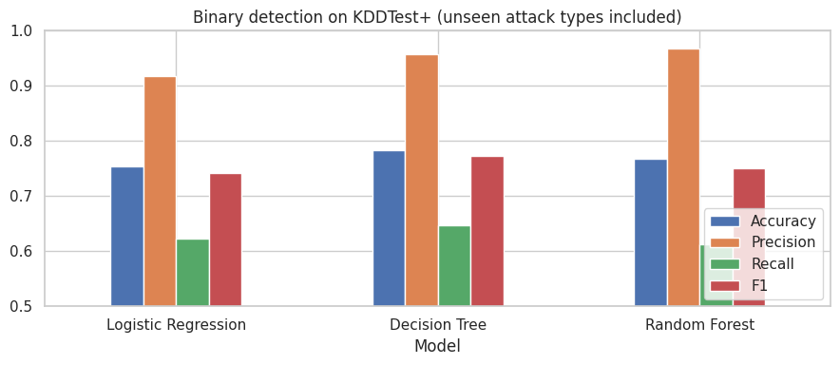
Figure 4: Model comparison on KDDTest+
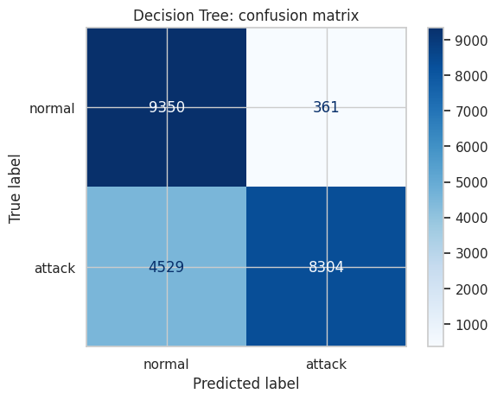
Figure 5: Confusion matrix of the Decision Tree (binary)

4.2 Generalisation to Unseen Attacks
Table 6: Cross-validation versus test performance (F1)
Model | CV F1 (training file) | Test F1 (KDDTest+)
Logistic Regression | 0.9707 | 0.7424
Decision Tree | 0.9980 | 0.7725
Random Forest | 0.9989 | 0.7500

Interpretation
Every model scores above 0.97 in cross-validation but only 0.74-0.77 on the test file. This gap is far larger than the difference between models, so the main difficulty is recognising attack variants not seen in training, not choosing a more complex algorithm.

4.3 Attack Family Classification
A Random Forest trained on the five-class problem reached 75.3% overall accuracy.
Table 7: Per-class performance on KDDTest+
Class | Precision | Recall | F1 | Test records
normal | 0.6533 | 0.9738 | 0.7820 | 9,711
DoS | 0.9628 | 0.7971 | 0.8721 | 7,460
Probe | 0.8242 | 0.6043 | 0.6973 | 2,421
R2L | 0.9737 | 0.0385 | 0.0740 | 2,885
U2R | 0.3333 | 0.0149 | 0.0286 | 67

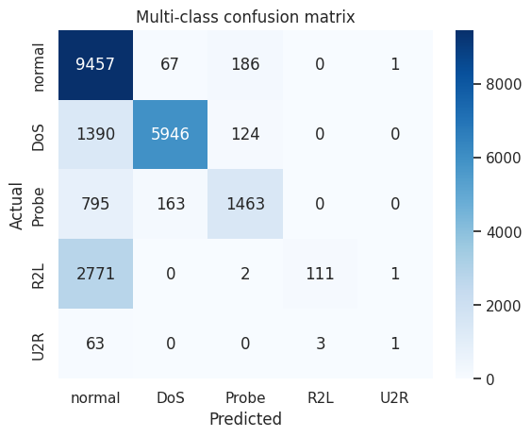
Figure 6: Confusion matrix for attack family classification
DoS attacks are detected well and Probe attacks moderately. R2L and U2R attacks are almost never recognised (recall below 4%): they have very few training samples, and the test set contains many R2L variants absent from training. Most of these attacks are misclassified as normal traffic.

4.4 Feature Importance
The Random Forest ranks src_bytes and dst_bytes as the most influential features, followed by the SF connection flag (a normally completed connection), the number of connections to the same destination service and the same-service rate. Error-rate features such as serror_rate also appear, consistent with how SYN-flood and scanning attacks behave.
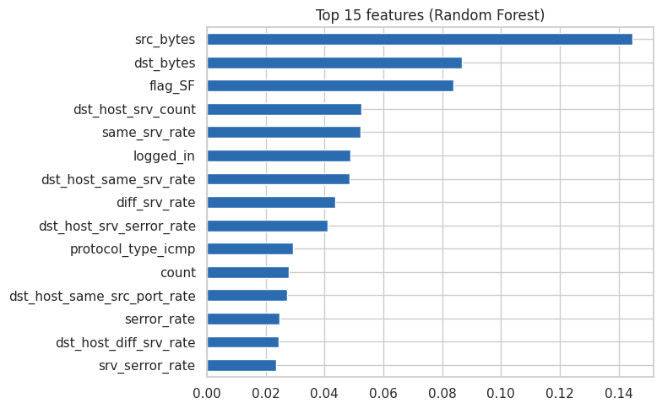
Figure 7: Top 15 features by Random Forest importance

5. Discussion
- Precision versus recall. Alerts are trustworthy (precision 92-97%), but about 35% of attacks are missed. In practice this detector should supplement, not replace, other controls.
- Model choice. The simplest tree-based model scored best and differences between models are small. Gains are more likely to come from better data and rare-class handling than from a more complex algorithm.
- Rare classes. R2L and U2R attacks carry high impact yet are the least detected, a common problem with imbalanced security data.
- Dataset age. NSL-KDD reflects 1990s traffic and attacks, so the scores demonstrate a method rather than production performance.

5.1 Limitations
- Outdated attack types and network behaviour in the dataset.
- Features are pre-computed by the dataset authors; the project does not extract features from live packets.
- No hyper-parameter tuning or class balancing was applied.
- A single train/test split was used for the headline results.

6. Conclusion and Future Work
This project delivered a complete, reproducible machine-learning pipeline for network intrusion detection: data loading, exploration, pre-processing, model comparison, error analysis and a saved model. The best model detects attacks with high precision but incomplete recall, and the analysis clearly identifies unseen and rare attack types as the main weakness.

6.1 Recommended Next Steps
- Apply SMOTE or class weights to improve R2L and U2R recall.
- Lower the decision threshold or use cost-sensitive learning to trade precision for recall.
- Tune hyper-parameters and test gradient-boosting models.
- Retrain on modern datasets such as CIC-IDS2017 or CIC-IDS2018.
- Build a live feature extractor and forward alerts to a SIEM such as Wazuh.

7. References
- Tavallaee, M., Bagheri, E., Lu, W., Ghorbani, A. (2009). A Detailed Analysis of the KDD CUP 99 Data Set. IEEE Symposium on Computational Intelligence for Security and Defense Applications.
- Canadian Institute for Cybersecurity. NSL-KDD dataset: https://www.unb.ca/cic/datasets/nsl.html
- NSL-KDD data mirror: https://github.com/defcom17/NSL_KDD
- Pedregosa et al. (2011). Scikit-learn: Machine Learning in Python. Journal of Machine Learning Research, 12.

Appendix A: How to Run the Project
Table 8: Run instructions
Step | Action
1 | Install dependencies: pip install -r requirements.txt
2 | Open the notebook: jupyter notebook ArjunPundir_NetworkIntrusionDetector.ipynb
3 | Choose Kernel > Restart and Run All. The dataset downloads automatically on first run.
4 | The trained model is saved as intrusion_detector_model.joblib.

Appendix B: Glossary
Term | Definition
IDS | Intrusion detection system: monitors network traffic for malicious activity.
DoS | Denial of service: an attack that exhausts a target's resources.
Probe | Scanning activity used to discover hosts, ports and weaknesses.
R2L | Remote-to-local: gaining access to a machine from a remote location.
U2R | User-to-root: escalating from a normal user to administrator rights.
False positive | Normal traffic wrongly flagged as an attack.
False negative | An attack that goes undetected.
Data leakage | Information from the test set influencing training, inflating results.

