Project Title: Old Book Shop

Project Manager:
Dr. Kazi Masudul Alam Sir
Associate Professor
Computer Science and Engineering Discipline
Khulna University, Khulna

Developed By:
Arjuman Sreashtho (160214)
Antor Ali (160221)

Project Details:

- Old Book Shop is a web-base project that deals with buying and selling old books.
- User sell their books and buy books of others that has been posted by other users.
- Only user can view, sell and buy books.
- From posts, user will see who has been posted that, edition of that book, writer of that book, condition, price and contact number of the seller.
- User who has posted that can edit or delete their post.
- User can also search for their books.

Website Layout:

Log In Page:
- Here user has to log in with his/her email and password to use it.



Home Page:

- After log in, user has to click on “Student Center” option.
- After that he/she will see “Book Shop” option.
- Clicking on “Book Shop” he/she will see that user options for book shop.
- Here user will see “Search Book”, “Sell Book”, “View All Posts”, “Manage Posts”.

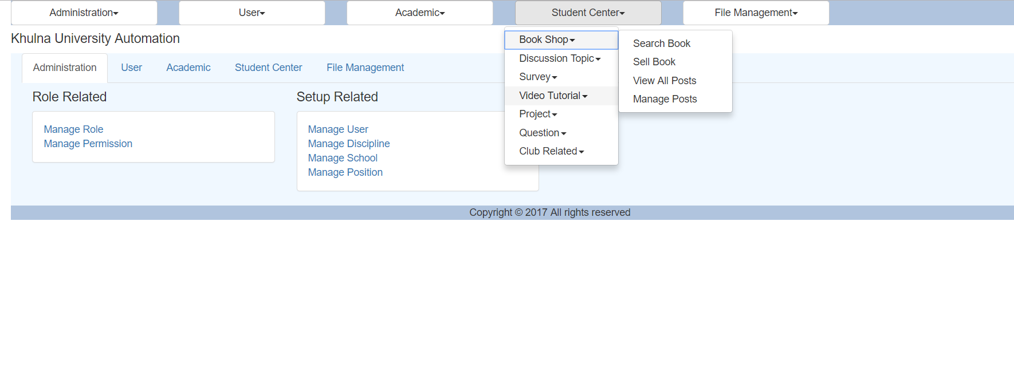

Sell Book:

- If user wants to sell his book, he/she has to click on “Sell Book” option.
- Than he/she has to fulfill the requirements for selling books.
- Then click on “Post This Book” button will create a new post.

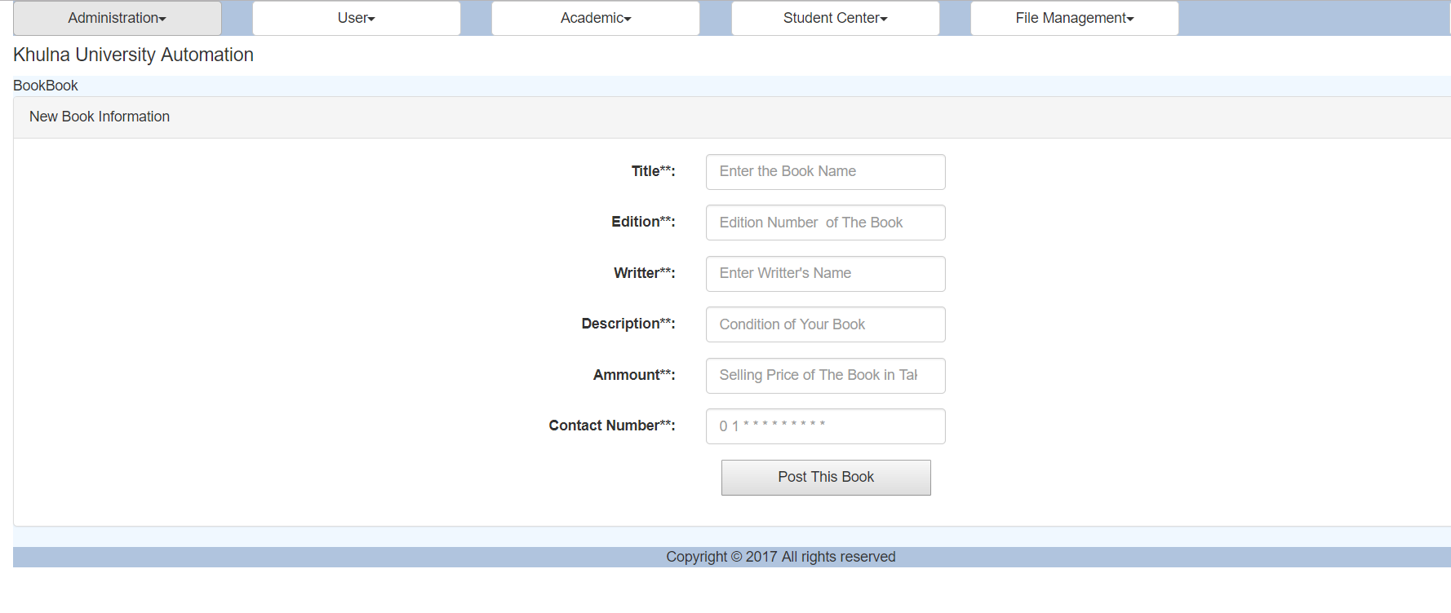

View All Posts:

- If user wants to see all the posts for selling books, he/she has to select “View All Posts” button from “Student Center” > “Book Shop”.
- If user finds any wrong info of his/her post while seeing all other posts, he/she can edit/delete his/her post there.

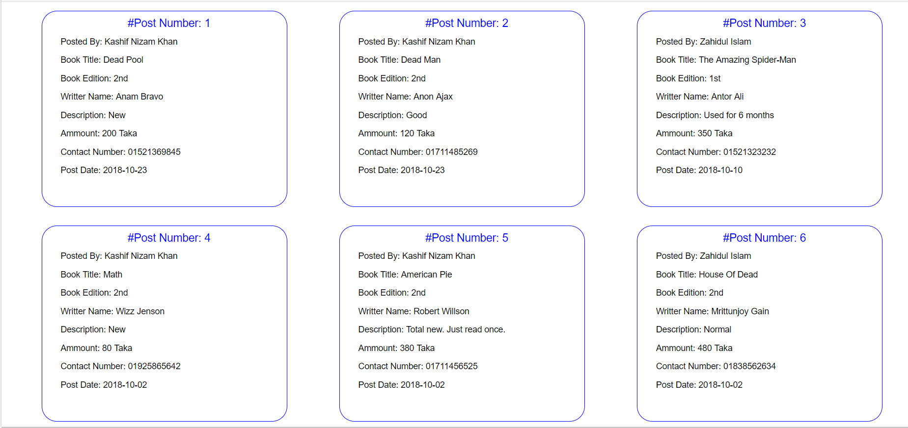

Manage Posts:
- If user wants to update/ delete his/her posts, he/she has to click on “Manage Posts” from “Student Center” > “Book Shop”.
- Here user will see all the posts of his own.

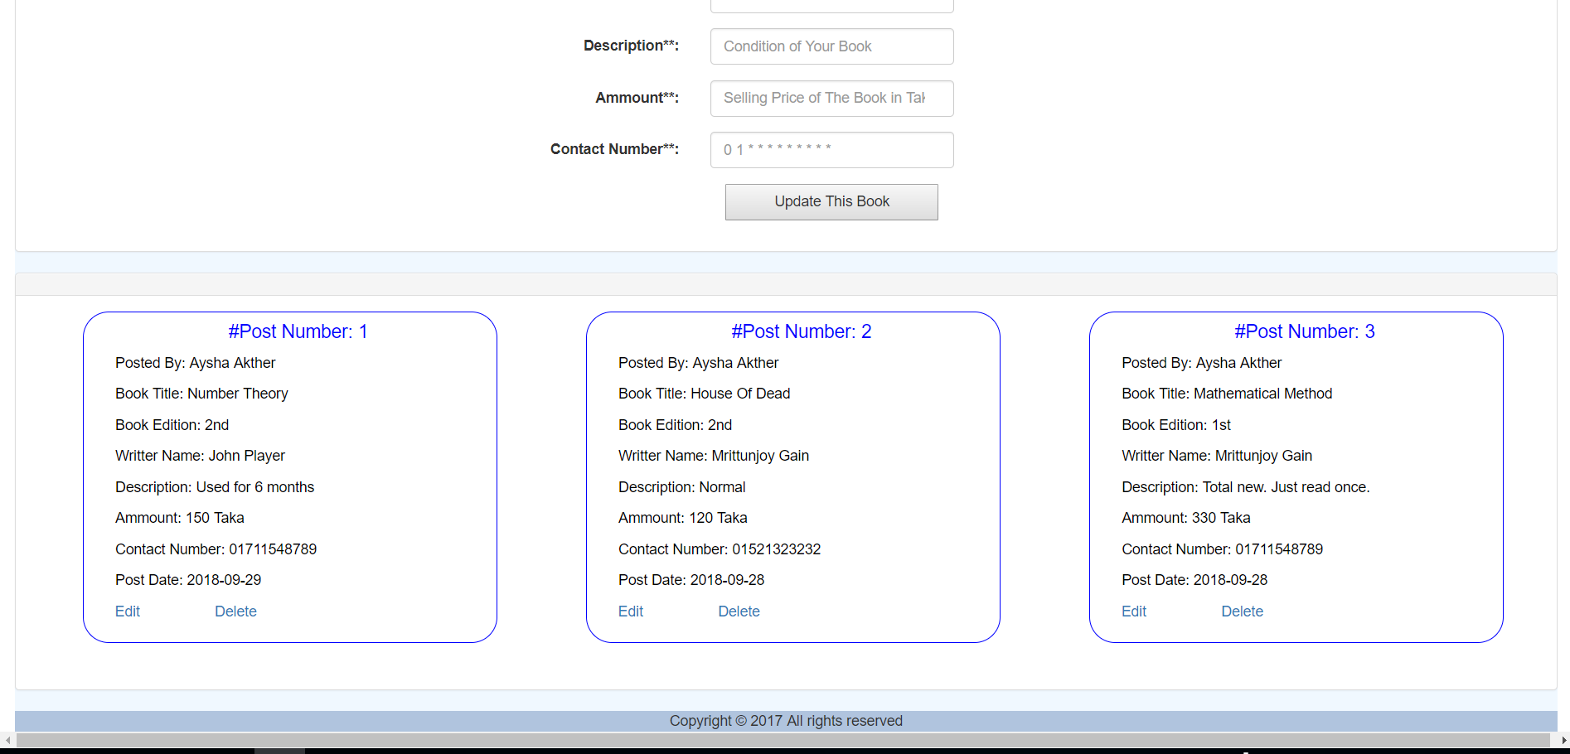
- If user click on edit button, he/she see all the info of post at first block.
- There user can change info and click on “Update This Book” Button will update the book.

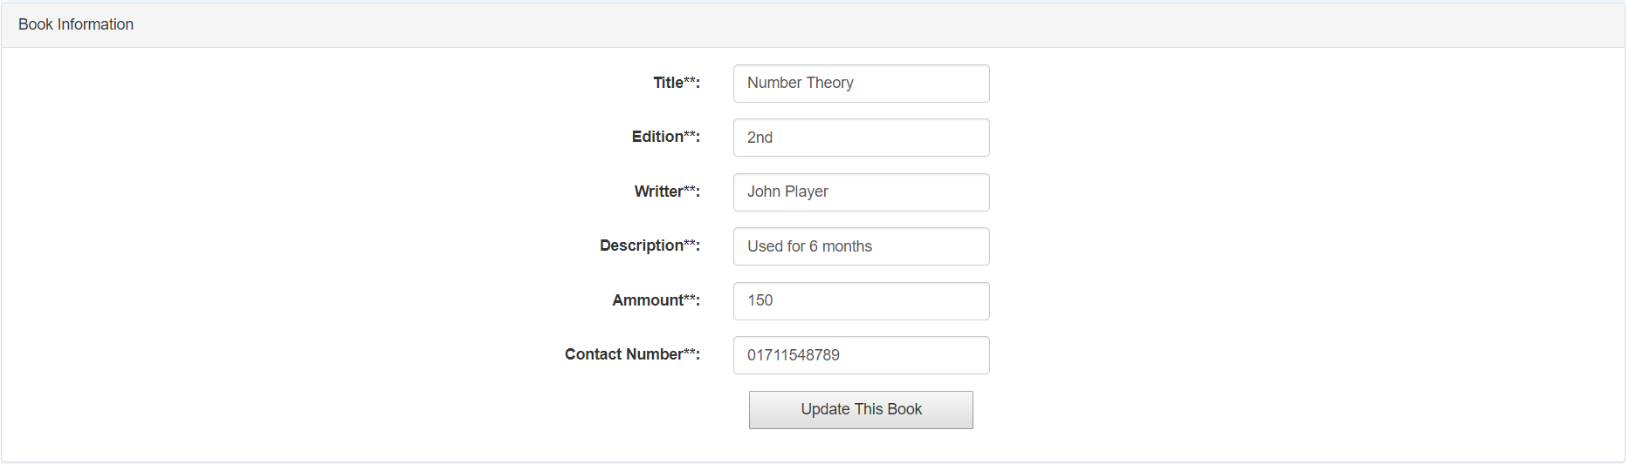

- If user click on “delete” button, that post will be deleted.
- First user will get a conformation message, if user click on “OK”, it will be deleted.

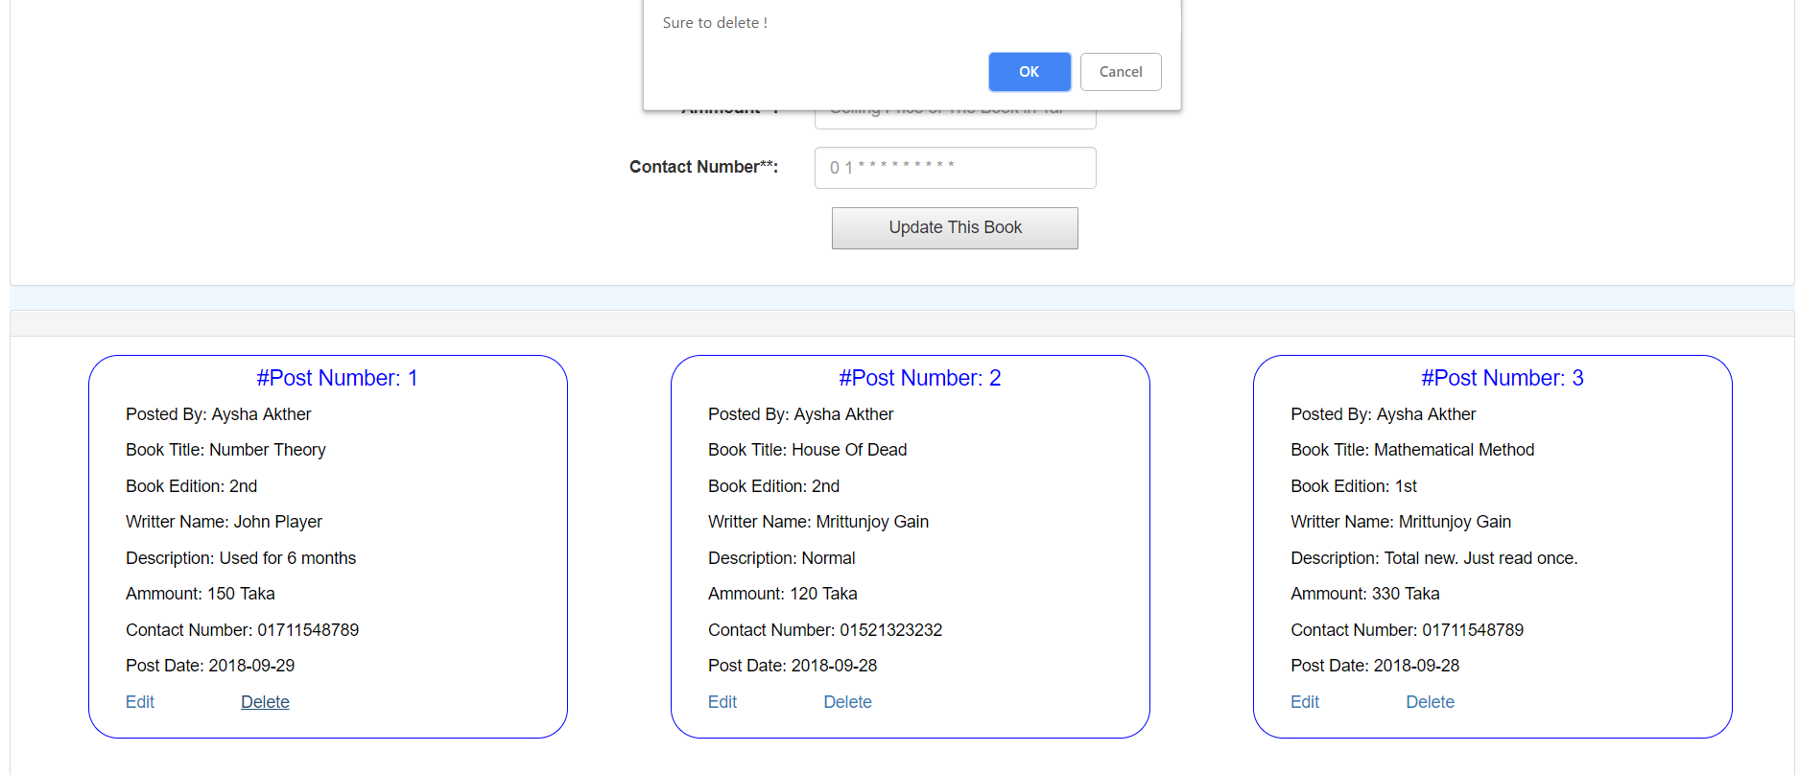

- After clicking on “OK” button.

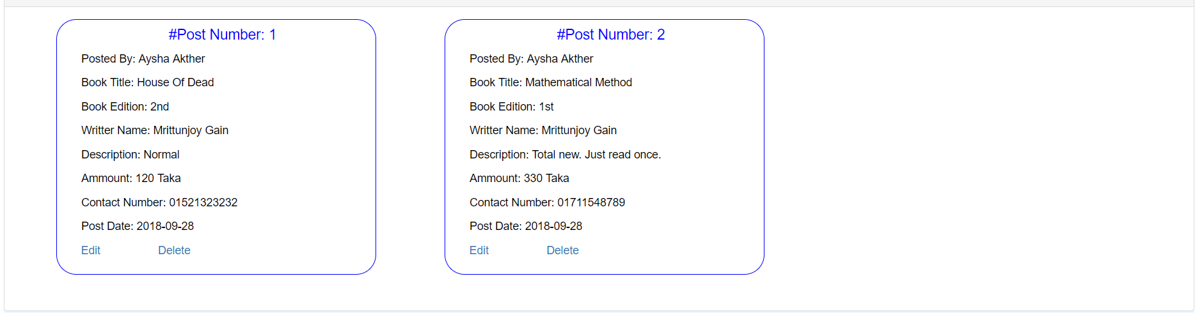

Search Book:
- Here user can search book according to book title, edition, writer name.
- User can see the result sorted by “date”, “price”, “price and date” or “date and price”.
- If user select “price and date” option, the result will be sorted according to lowest to highest price and if price become same that result will sorted according to decreasing order of date.
- If user select “date and price” option, the result will be sorted according to decreasing order of date if date is equal that result will be sorted according to amount in increasing form.
