High-Level Design (HLD)

Cloud Migration and Monitoring Project

________________________________________________________________________________

**Project Overview**

This project involves migrating the open-source Kimai time-tracking application to the AWS cloud infrastructure using Infrastructure as Code (Terraform), Docker-based deployment, Jenkins CI/CD automation, and cloud monitoring with Prometheus and Grafana. Security measures and scalability were also incorporated.

**Objectives**

* Host Kimai app on a secure and scalable AWS infrastructure.
* Automate provisioning using Terraform.
* Deploy using Docker containers.
* Enable CI/CD pipeline using Jenkins.
* Integrate monitoring and alerting using Prometheus and Grafana.

**Architecture Diagram**

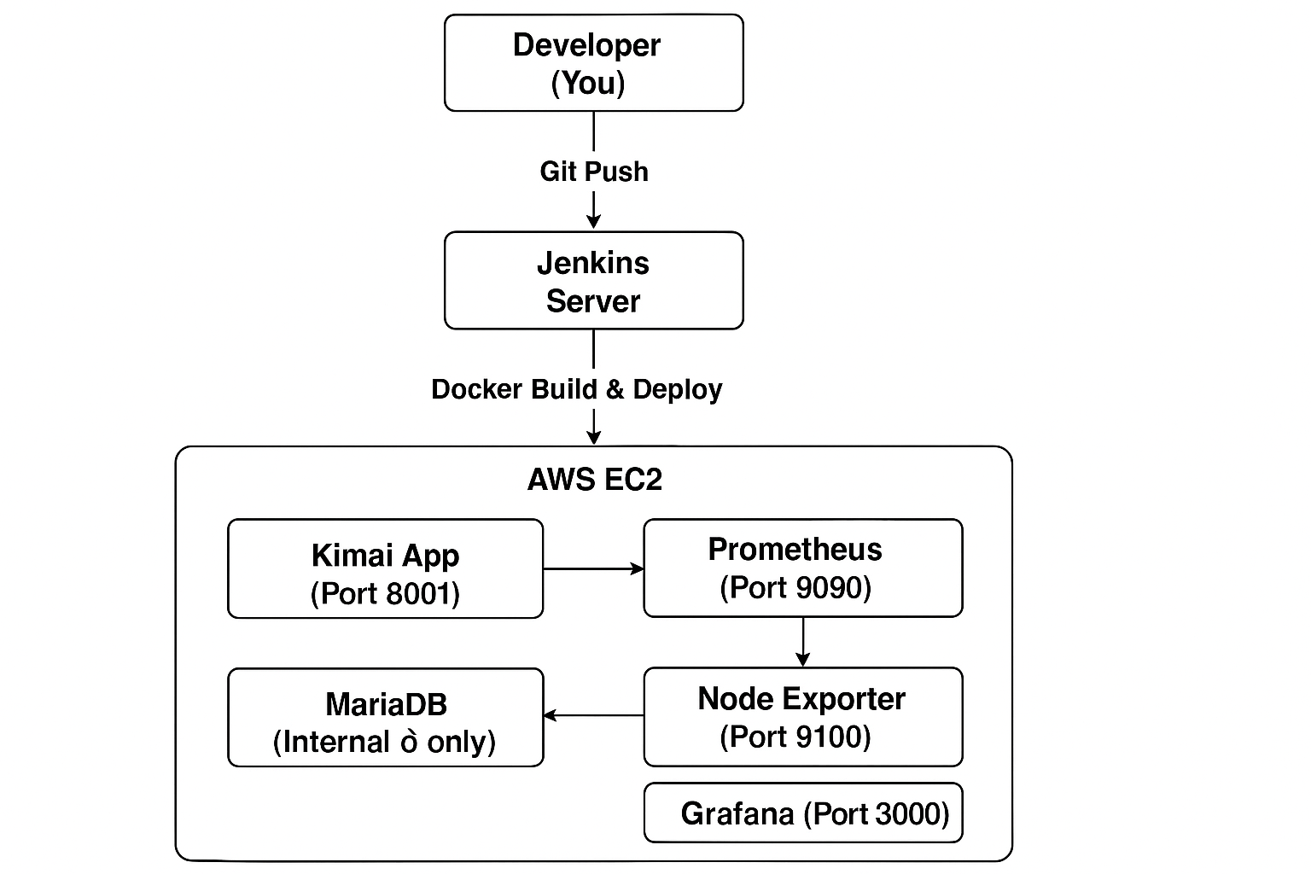

**Components**

**1. AWS Infrastructure**

* EC2 instance with Amazon Linux 2023.
* Security Groups (Inbound: 22, 8001, 9090, 3000, 9100 from Bastion or Developer IP).
* IAM Role for EC2 (CloudWatch access).

**2. Terraform (IAC)**

* Used to create EC2, IAM, Security Groups, Key Pair.
* Used main.tf and variables.tf for modular configuration.

**3. Docker Deployment**

* Docker Compose runs Kimai and MariaDB.
* Monitoring stack runs Prometheus, Grafana, and Node Exporter.

**4. CI/CD with Jenkins**

* Jenkins job pulls GitHub repo.
* Jenkins triggers Docker Compose deployment.
* Optional: Jenkins runs inside Docker.

**5. Monitoring**

* Prometheus scrapes metrics.
* Node Exporter provides system metrics.
* Grafana visualizes metrics.
* Alerts configured for CPU usage.

**Key Ports Used**

| **Component** | **Port** |
| --- | --- |
| Kimai | 8001 |
| Jenkins | 8080 |
| Prometheus | 9090 |
| Grafana | 3000 |
| Node Exporter | 9100 |
| SSH | 22 |

**Visual Representation of Architecture Diagram**

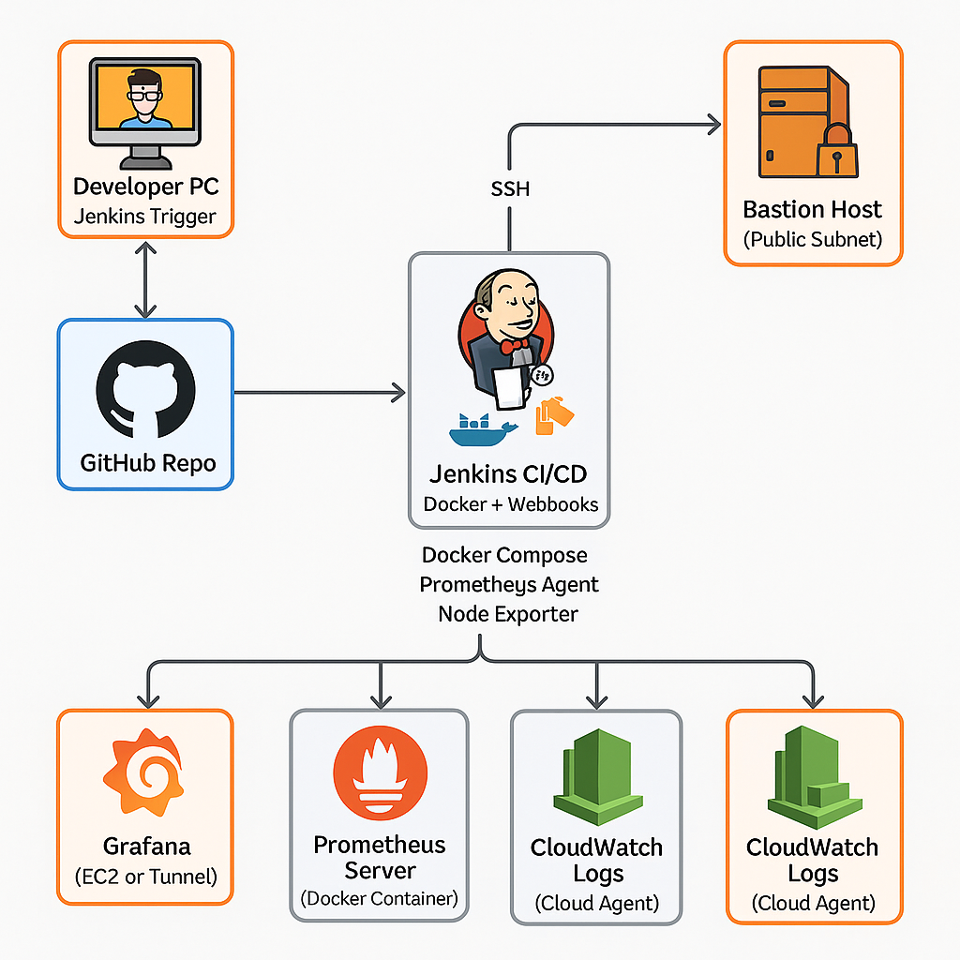

**Deployment Flow**

1. **Terraform** provisions infrastructure.
2. **Jenkins** pulls code and builds Docker containers.
3. **Docker Compose** deploys:
   * Kimai + MariaDB
   * Prometheus + Node Exporter
   * Grafana
4. **Monitoring** via Prometheus scraping + Grafana dashboard.
5. **Alerts** raised for CPU usage or system failures.

**Security Considerations**

* SSH restricted to Bastion or your IP.
* IAM Role with minimum permissions.
* Internal traffic between services (MariaDB).
* Docker networks isolated.

**Scalability and Maintenance**

* Stateless components (Kimai, Prometheus) can be horizontally scaled.
* Docker Compose simplifies service restart/recovery.
* Logs streamed to CloudWatch.

**Tools & Technologies**

* **Cloud**: AWS EC2, IAM, Security Groups
* **IaC**: Terraform
* **Containerization**: Docker, Docker Compose
* **CI/CD**: Jenkins
* **Monitoring**: Prometheus, Grafana, Node Exporter

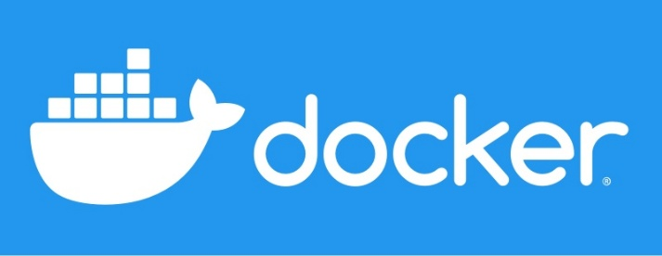

**Outcome**

The architecture ensures:

* Reliable and repeatable deployments.
* Real-time monitoring of application and infrastructure health.
* CI/CD automation.
* Easy-to-maintain MNC-style structure for long-term use.