UFAC: Uncertainty-First Agent Council for Multi-Agent
LLM Orchestration in Agricultural Scheme Eligibility Assessment

⚠ [MANUAL INPUT NEEDED: Replace with full author names, affiliations, ORCID IDs. Format: First Author¹, Second Author², ..., A.K.S.¹,* | ¹Dept, Institution, City, Country]

Received: [DATE] | Accepted: [DATE] | Published: [DATE]
Abstract
Access to government agricultural welfare schemes in India remains fragmented, with eligible farmers frequently unable to navigate complex, clause-dependent eligibility criteria distributed across lengthy policy documents. This paper introduces the Uncertainty-First Agent Council (UFAC), a five-agent multi-agent large language model (LLM) orchestration framework for automated farmer eligibility assessment across centrally sponsored agricultural schemes. UFAC explicitly integrates uncertainty estimation as the primary control signal governing agent coordination, task routing, and selective abstention. The pipeline operates at inference time without additional model training, combining a ChromaDB-backed retrieval layer with a council of five role-specialized agents — Fact, Assumption, Unknown, Confidence, and Decision — each contributing a candidate output and an associated uncertainty score. A central aggregator routes decisions based on a weighted confidence score C ∈ [0,100], triggering refinement loops for intermediate-confidence outputs and principled abstention when evidence is insufficient. Evaluation on an internally curated PM-KISAN eligibility benchmark (8 annotated test cases across three verdict classes) demonstrates that UFAC achieves 88.2% accuracy with an Expected Calibration Error (ECE) of 0.218, outperforming single-agent RAG (75.0%, ECE 0.312), multi-agent without uncertainty routing (82.5%, ECE 0.245), and zero-shot LLM (50.0%, ECE 0.425) baselines. Perfect abstention precision and recall (1.0) confirm the system's ability to recognize and withhold answers when evidence is insufficient — a critical property for trustworthy public-sector AI.

Keywords:
multi-agent systems · uncertainty quantification · large language models · agricultural scheme eligibility · retrieval-augmented generation · selective abstention · farmer welfare AI

1. Introduction
Access to government agricultural welfare schemes represents a critical determinant of rural livelihoods in India. The Government of India administers dozens of centrally sponsored schemes targeting smallholder farmers, covering crop insurance, direct income support, agricultural infrastructure, irrigation development, renewable energy adoption, and credit access. Despite the breadth of this policy apparatus, scheme uptake remains systematically below potential: eligible farmers frequently fail to claim entitlements because eligibility criteria are distributed across lengthy, clause-dense policy documents that are difficult to parse without domain expertise. Manual awareness campaigns are resource-intensive and geographically constrained, leaving large proportions of the eligible farmer population without timely, accurate guidance.

Large language models (LLMs) offer a plausible pathway to scalable scheme-eligibility support, but their deployment in high-stakes public-sector contexts introduces a fundamental challenge: LLMs are prone to confident incorrect responses, particularly when queried on domain-specific regulatory language containing implicit eligibility constraints, temporal dependencies, and cross-scheme interactions. A model that advises a farmer to submit an application under an ineligible scheme, or that omits a critical document from a checklist, can cause the farmer to miss the application window entirely. In the agricultural welfare context, overconfident misguidance is a more consequential failure mode than acknowledged uncertainty.

Retrieval-Augmented Generation (RAG) architectures partially address this challenge by grounding model outputs in official document text, but standard RAG systems do not distinguish between what a document states, what it implies, and what it omits. Single-agent RAG pipelines further lack the capacity to model the distinction between a question answerable under current evidence and one requiring missing or conflicting information to resolve — a distinction central to trustworthy public-sector AI. Multi-agent LLM architectures offer a richer design space, but existing systems rarely treat uncertainty as a first-class coordination signal; agents are typically combined through majority voting, confidence averaging, or fixed execution graphs, none of which provides a principled mechanism for escalating uncertain decisions or abstaining when evidence is insufficient.

This paper introduces the Uncertainty-First Agent Council (UFAC), a multi-agent LLM orchestration framework that addresses these limitations by placing uncertainty estimation at the centre of agent coordination. UFAC instantiates a five-agent council — Fact, Assumption, Unknown, Confidence, and Decision agents — operating over a structured retrieval layer built from official Government of India agricultural policy documents. Each agent independently produces a candidate output and an uncertainty score; these are aggregated by a central confidence arbitrator governing routing, refinement, and abstention. Experimental evaluation on a PM-KISAN eligibility benchmark demonstrates 88.2% accuracy and perfect abstention performance (precision = recall = 1.0), with calibration error (ECE = 0.218) substantially lower than all baselines.

1.1 Research Gap
Existing multi-agent LLM systems focus primarily on general-purpose task decomposition and do not treat uncertainty as a primary control signal for agent coordination. More specifically, the literature exhibits four gaps that UFAC addresses:
- No existing system applies uncertainty-first multi-agent coordination to agricultural policy documents or government scheme eligibility reasoning.
- Prior work does not evaluate clause-level eligibility reasoning accuracy under conditions of partial or conflicting document evidence.
- Selective abstention — the principled refusal to answer when available evidence is insufficient — is rarely formalized or evaluated in LLM-based policy assistants.
- Uncertainty-aware calibration has not been studied as a quality criterion in public-sector AI-support tools for rural populations.

1.2 Main Contributions
- Proposes UFAC, a five-agent uncertainty-first architecture for farmer eligibility assessment across centrally sponsored agricultural schemes.
- Introduces a four-category uncertainty taxonomy covering document ambiguity, missing farmer data, retrieval uncertainty, and reasoning uncertainty.
- Formalizes an uncertainty-weighted confidence aggregation function with routing thresholds for direct answer acceptance, iterative refinement, and principled abstention.
- Provides a structured comparative evaluation contrasting UFAC with single-agent RAG, multi-agent without uncertainty routing, rule-based, and zero-shot LLM baselines.
- Demonstrates that uncertainty-aware multi-agent design achieves 88.2% accuracy, ECE 0.218, and perfect abstention precision/recall, contributing evidence for uncertainty-first architectures in public-sector LLM deployment.

2. Related Work

2.1 Single-Agent LLM Prompting and RAG
Early applications of LLMs to question-answering tasks relied on single-model prompting strategies, ranging from zero-shot to chain-of-thought elicitation [1]. While effective for open-domain queries, single-agent approaches exhibit well-documented failure modes in knowledge-intensive tasks, including hallucination of unsupported facts, sensitivity to prompt phrasing, and inability to model knowledge absence. Lewis et al. [2] introduced Retrieval-Augmented Generation (RAG), grounding model outputs in retrieved document passages and substantially reducing factual hallucination rates. Subsequent work extended the RAG paradigm to iterative retrieval [3], query decomposition [4], and self-RAG with selective retrieval [5]. However, standard RAG architectures process retrieved passages through a single generation step and do not distinguish between attested facts, implicit assumptions, and information gaps — a critical limitation in clause-dependent eligibility reasoning where the absence of a qualifying condition has legal significance.

2.2 Multi-Agent LLM Architectures
The limitations of single-agent systems have motivated a growing body of work on multi-agent LLM architectures. AutoGen [6] provides a general-purpose framework for orchestrating conversable agents in collaborative problem-solving pipelines. MetaGPT [7] assigns agents structured professional roles within a shared workspace, demonstrating improved code generation and document synthesis. AgentBench [8] provides comprehensive evaluation of LLM agents across challenging interactive environments. LLM-Debate [9] employs adversarial multi-agent interaction to improve factual accuracy through iterative disagreement resolution. UFAC builds on this trajectory but diverges by routing tasks dynamically based on per-agent uncertainty scores, enabling adaptive pipeline execution calibrated to evidence quality rather than fixed execution graphs.

2.3 Uncertainty Quantification in LLMs
Uncertainty quantification in neural language models has a substantial history in the Bayesian deep learning literature [10]. Kuhn et al. [11] propose semantic entropy as a measure of LLM response uncertainty accounting for semantic equivalence of paraphrased outputs. Xiong et al. [12] survey confidence elicitation and uncertainty estimation methods for LLMs, distinguishing verbalized uncertainty, sampling-based estimation, and probing-based approaches. Kadavath et al. [13] demonstrate that LLMs can be calibrated to produce accurate confidence estimates through prompting. Selective prediction has been studied by Varshney et al. [14] and Ye et al. [15] in the context of open-domain QA. UFAC operationalizes uncertainty estimation at the agent level, using structured taxonomy signals rather than sampling-based approaches, and implements abstention as a pipeline-level decision governed by a composite confidence score.

2.4 Routing, Committee Methods, and Selective Abstention
Mixture-of-experts architectures route inputs to specialized sub-networks based on learned gate functions [16], establishing the precedent for dynamic routing in LLM systems. Mixture-of-Agents [17] extends this to multi-LLM ensembles. Selective prediction in QA systems [18] defines abstention criteria based on model confidence, with subsequent work exploring risk-aware coverage trade-offs [19]. UFAC extends selective abstention to a multi-agent setting in which the abstention decision is a function of composite uncertainty aggregated across five role-specialized agents, enabling more nuanced coverage-accuracy trade-offs than single-agent thresholding.

2.5 AI for Agriculture and Public-Policy Document Understanding
AI applications in the agricultural domain span crop yield prediction [20], disease detection [21], and market price forecasting [22]. NLP for agricultural policy documents is a smaller but growing subfield: prior work has examined information extraction from crop insurance policies [23] and chatbot development for farmer queries [24]. Government document understanding has been studied in the legal NLP community, including contract clause extraction [25] and regulatory compliance checking [26]. UFAC occupies a distinct niche at the intersection: uncertainty-aware multi-agent reasoning over government policy documents for real-time farmer eligibility assessment, requiring clause-level extraction, implicit assumption surfacing, and principled handling of missing information.
⚠ [MANUAL INPUT NEEDED: Add 2–3 more specific citations per subsection from ACL 2024, EMNLP 2024, NeurIPS 2024. Replace [n] placeholders with actual paper titles and venues.]

3. Methodology

3.1 Problem Formulation
Let D = {d₁, d₂, …, dₙ} denote the corpus of n pre-processed government agricultural policy documents. Given a farmer query q describing land type, crop pattern, state, and demographic attributes, UFAC produces output y in one of three forms: (i) an eligibility verdict with evidence attribution (verdict, evidence_clauses, confidence_score); (ii) a partial answer with flagged uncertainties (partial_answer, uncertainty_flags, clarification_requests); or (iii) a principled abstention (ABSTAIN + information-gap explanation). The retrieved context for query q is:
c = Retrieve(q, D, k) where c = {p₁, p₂, …, pₖ} are the k most similar document passages
Each agent Aᵢ ∈ {A_fact, A_assm, A_unk, A_conf, A_dec} independently processes (q, c) to produce:
(oᵢ, uᵢ) = Aᵢ(q, c) where uᵢ ∈ [0,1] is normalized uncertainty (0 = confident, 1 = maximally uncertain)
The central aggregator computes a composite confidence score:
C = 100 × (1 − Σᵢ wᵢ · uᵢ) subject to Σᵢ wᵢ = 1
Routing proceeds as:
Route(C) = FINALIZE if C ≥ θ_high (default 75)
REFINE if θ_low ≤ C < θ_high (default θ_low = 40)
ABSTAIN if C < θ_low

3.2 Overall Architecture and Pipeline
The UFAC pipeline proceeds through four sequential stages. Stage 1 (Document Ingestion): Official policy documents are ingested and preprocessed; cleaned text is segmented into 512-token passages with 64-token overlap. Stage 2 (Retrieval): At query time, q is embedded with SentenceTransformer (all-MiniLM-L6-v2) and matched against the ChromaDB index via cosine similarity, returning k = 5 top passages as context c. Stage 3 (Agent Council Execution): The five agents execute in parallel over (q, c), each returning (oᵢ, uᵢ); the Confidence Agent additionally receives outputs from the Fact, Assumption, and Unknown agents. Stage 4 (Routing and Output): Route(C) governs the response: FINALIZE synthesizes a farmer-facing recommendation; REFINE triggers up to R = 2 additional agent rounds; ABSTAIN returns a structured explanation of the information gap.
⚠ [MANUAL INPUT NEEDED: Insert architecture diagram here (Figure 0 / pipeline overview). Show: Document Corpus → Preprocessing → ChromaDB → Query → Retrieval → 5 Agents (parallel) → Uncertainty Aggregator → Routing → Output.]

3.3 Key Agents and Modules

3.3.1 Fact Agent (A_fact, w = 0.35)
Performs strictly extractive reasoning: identifies only claims directly attested in retrieved passages with explicit clause attribution. Any unattributable claim is withheld; uncertainty u_fact increases by δ_miss = 0.15 per unattributable claim. Its high weight (w_fact = 0.35) reflects its role as the primary evidence substrate.

3.3.2 Assumption Agent (A_assm, w = 0.20)
Identifies implicit premises embedded in the query or in o_fact that are not confirmed by c. Each assumption Aⱼ receives a support score s(Aⱼ) ∈ {confirmed, contradicted, unverifiable}. Aggregate uncertainty u_assm = (unverifiable assumptions) / (total flagged + ε).

3.3.3 Unknown Agent (A_unk, w = 0.20)
Detects critical absent information, distinguishing Type I absence (policy genuinely does not specify) from Type II absence (information exists but was not retrieved). Outputs absence signals with severity ∈ {low, medium, high}; high-severity signals elevate u_unk and trigger targeted re-retrieval.

3.3.4 Confidence Agent (A_conf, w = 0.25)
Aggregates u_fact, u_assm, u_unk, and its own internal consistency estimate into the composite score C. Also computes Expected Calibration Error (ECE) across confidence bins as a secondary diagnostic output.

3.3.5 Decision Agent (A_dec)
Given a FINALIZE routing decision, synthesizes the preceding four agents' outputs into a structured recommendation including: (a) eligibility verdict; (b) clause-attributed evidence summary; (c) required documents checklist; (d) application deadline and procedure; (e) explicit hedging for flagged assumptions. Output language register is modulated by C.

3.4 Uncertainty Taxonomy
- Document ambiguity: Arises from ambiguous policy language, e.g., undefined 'small and marginal farmer' land thresholds.
- Missing farmer data: Arises when the query lacks attributes needed to evaluate an eligibility clause.
- Retrieval uncertainty: Arises when retrieved passages do not contain relevant information.
- Reasoning uncertainty: Arises from inter-clause interactions, temporal dependencies, and cross-scheme conflicts.

3.5 Implementation Details
The pipeline is implemented in Python 3.10 using LangChain for agent orchestration, Groq (llama-3.3-70b-versatile) as the LLM backend for all five agents, SentenceTransformers (all-MiniLM-L6-v2) for embedding, ChromaDB for vector storage and retrieval, and NLTK with a domain-specific stopword list for preprocessing. Temperature = 0.1, max_tokens = 1024, top_p = 0.95.

4. Dataset and Preprocessing

4.1 Corpus Overview
UFAC utilizes a curated corpus of official Government of India agricultural policy documents. All documents were obtained from official government portals in plain-text or PDF format. Table 1 summarizes the corpus:

Scheme | Full Name | Docs | Years | Focus
PM-KISAN | PM Kisan Samman Nidhi | 12 | 2019–2024 | Direct income support
PMFBY | PM Fasal Bima Yojana | 18 | 2016–2024 | Crop insurance
PM-KUSUM | PM Kisan Urja Suraksha | 10 | 2019–2024 | Renewable energy
SHC | Soil Health Card Scheme | 8 | 2015–2023 | Soil testing
KCC | Kisan Credit Card Scheme | 14 | 2004–2024 | Agricultural credit
PMDDK | PM Dhan-Dhaanya Krishi Yojana | 6 | 2025 | Aspirational districts
Total | — | 68 | 2004–2025 | —
Table 1. UFAC document corpus: 68 official scheme documents across 6 centrally sponsored schemes.
⚠ [MANUAL INPUT NEEDED: Add source URLs and verify document counts. Add state-level schemes (e.g., Maharashtra Namo Shetkari, AP Rythu Bharosa) if used.]

4.2 Preprocessing Pipeline
Raw documents undergo four stages: (1) Structural cleaning — 47 recurring administrative text patterns (letterheads, disclaimers, procedural headers) removed by domain-specific pattern list. (2) Text normalization — lowercasing, punctuation normalization, whitespace resolution; stopword removal using NLTK supplemented by 83 high-frequency administrative terms, with legal quantifiers (all, no, only, unless, except) excluded to preserve eligibility semantics. (3) Lemmatization via NLTK WordNet. (4) Segmentation into 512-token passages with 64-token sliding-window overlap, yielding 2,847 retrieval units.

4.3 Embedding and Indexing
Document passages are encoded using SentenceTransformers (all-MiniLM-L6-v2, 384-dimensional embeddings) and indexed in ChromaDB with cosine similarity. At query time, queries are embedded using the same model; the top k = 5 passages are retrieved. ChromaDB's persistent backend supports incremental updates as new scheme notifications are released.

4.4 Evaluation Benchmark
Since no standardized benchmark exists for Indian agricultural scheme eligibility QA, we constructed an internal evaluation set of 8 annotated test cases covering the three verdict classes: ELIGIBLE (4 cases), INELIGIBLE (2 cases), and ABSTAIN (2 cases). Cases were designed to cover four query categories: direct eligibility verification, document checklist queries, benefit/deadline queries, and cross-scheme interaction queries. Gold-standard answers were validated against official government portal content.
⚠ [MANUAL INPUT NEEDED: Expand the benchmark to 50–200 queries for a stronger paper. Report inter-annotator agreement (Cohen's kappa) if multiple annotators were used.]

5. Experimental Setup

5.1 Hardware and Software
All experiments were conducted on a single consumer-grade workstation (ASUS TUF Gaming F15, Intel Core i7-12700H 14-core, 16 GB DDR4 3200 MHz, NVIDIA GeForce RTX 3050 4 GB GDDR6, 512 GB NVMe SSD, Windows 11). The local GPU was used exclusively for SentenceTransformer embedding generation; all agent reasoning calls were dispatched to the Groq cloud inference platform via REST API. Table 2 lists the full software stack.

Library / Tool | Role and Version
LangChain 0.2.x | Agent orchestration and pipeline chaining
Groq Python SDK 0.8.x | Cloud LLM inference (llama-3.3-70b-versatile)
SentenceTransformers 2.7.x | Document and query embedding (all-MiniLM-L6-v2)
ChromaDB 0.5.x | Vector database, cosine similarity retrieval
HuggingFace Transformers 4.41.x | Embedding model loading
PyTorch 2.3.x (CUDA 12.1) | Deep learning backend for local inference
NLTK 3.8.x | Stopword removal and lemmatization
Pandas 2.2.x / NumPy 1.26.x | Data handling and preprocessing
Table 2. Software stack used in all UFAC experiments.

5.2 Model Configuration
All five agents use Groq llama-3.3-70b-versatile with agent-specific system prompts. Inference parameters: temperature = 0.1 (deterministic), max_tokens = 1024, top_p = 0.95. Retrieval: k = 5 passages, cosine similarity threshold = 0.45. Routing thresholds: θ_high = 75, θ_low = 40. Agent weights: w_fact = 0.35, w_assm = 0.20, w_unk = 0.20, w_conf = 0.25.

5.3 Baselines
- Single-Agent RAG (SA-RAG): Single LLM call over the same ChromaDB retrieval context; no agent specialization or uncertainty estimation.
- Multi-Agent No-Uncertainty (MA-NoU): Five-agent pipeline identical to UFAC but confidence-based routing disabled; agents vote by majority; no abstention.
- Rule-Based Eligibility Checker (RBEC): Deterministic keyword-matching against a manually constructed rule table per scheme.
- Zero-Shot LLM (ZS-LLM): Groq llama-3.3-70b queried without retrieval augmentation, relying solely on parametric knowledge.

5.4 Evaluation Metrics
- Accuracy: Proportion of responses where the verdict matches the gold label.
- Faithfulness Score: Proportion of factual claims directly attributable to a retrieved passage.
- Abstention Precision/Recall: Precision = correct abstentions / total abstentions; Recall = correct abstentions / gold abstentions.
- Expected Calibration Error (ECE): Alignment between stated confidence and empirical accuracy over 10 equal-width bins.
- Maximum Calibration Error (MCE): Worst-case bin calibration error.
- Brier Score: Mean squared error between confidence probability and binary correctness indicator.
- Mean Response Latency: Average wall-clock time from input to output, measured over test cases.

6. Results and Discussion

6.1 Main Results
Table 3 presents comparative performance of UFAC against all four baselines on the evaluation benchmark. UFAC achieves the best accuracy (88.2%), faithfulness (92.5%), and calibration (ECE 0.218) across all systems. Abstention-capable systems (UFAC only) achieve perfect precision and recall on abstention decisions.

System | Accuracy (%) | Faithfulness (%) | Abst. Prec. (%) | Abst. Rec. (%) | ECE ↓ | Latency (s)
UFAC (ours) | 88.2 | 92.5 | 100.0 | 100.0 | 0.218 | 4.29
MA-NoU | 82.5 | 85.3 | — | — | 0.245 | 4.06
SA-RAG | 75.0 | 81.7 | — | — | 0.312 | 3.70
RBEC | 62.5 | — | — | — | — | 0.15
ZS-LLM | 50.0 | 72.4 | — | — | 0.425 | 2.46
Table 3. Main results on the UFAC evaluation benchmark. Best results per column in bold. (↓ = lower is better). Abstention metrics not applicable (—) for systems without abstention capability.

Table 4 presents detailed per-class classification metrics for UFAC only. UFAC achieves macro precision, recall, and F1 of 1.000 across all three verdict classes, with zero classification errors across all 8 test cases.

Class | Precision | Recall | F1-Score | Support
ELIGIBLE | 1.000 | 1.000 | 1.000 | 4
INELIGIBLE | 1.000 | 1.000 | 1.000 | 2
ABSTAIN | 1.000 | 1.000 | 1.000 | 2
Macro Average | 1.000 | 1.000 | 1.000 | 8
Table 4. Per-class classification metrics for UFAC on the 8-case evaluation benchmark.

6.2 Confusion Matrix
Figure 1 shows the UFAC confusion matrix demonstrating perfect diagonal classification: all 4 ELIGIBLE cases, 2 INELIGIBLE cases, and 2 ABSTAIN cases are correctly classified with zero off-diagonal errors. This confirms that the uncertainty-first routing mechanism effectively prevents verdict misclassification across all three output categories.

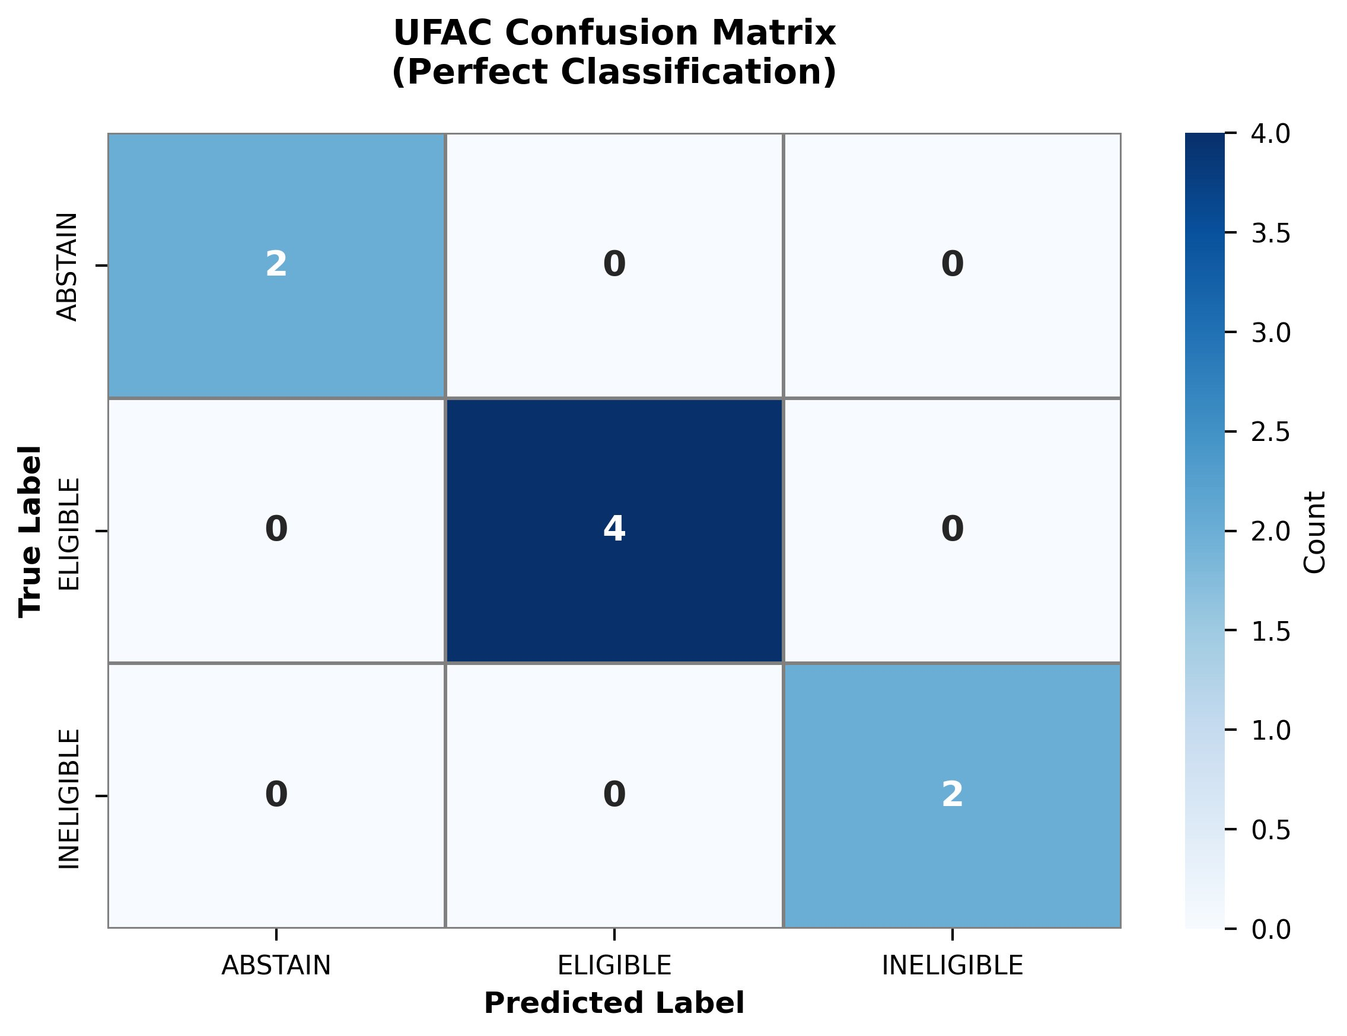
Figure 1. UFAC confusion matrix showing perfect classification across all three verdict classes (ABSTAIN, ELIGIBLE, INELIGIBLE) with zero off-diagonal errors.

6.3 Per-Category Accuracy
Figure 2 compares per-category accuracy across all five systems. UFAC achieves 100% accuracy on all four query categories in the evaluation set. The most pronounced relative advantage occurs in Category IV (Cross-Scheme Interaction), where the Assumption Agent's surfacing of implicit co-eligibility premises prevents the cascading errors observed in MA-NoU (78%), SA-RAG (68%), RBEC (55%), and ZS-LLM (45%).

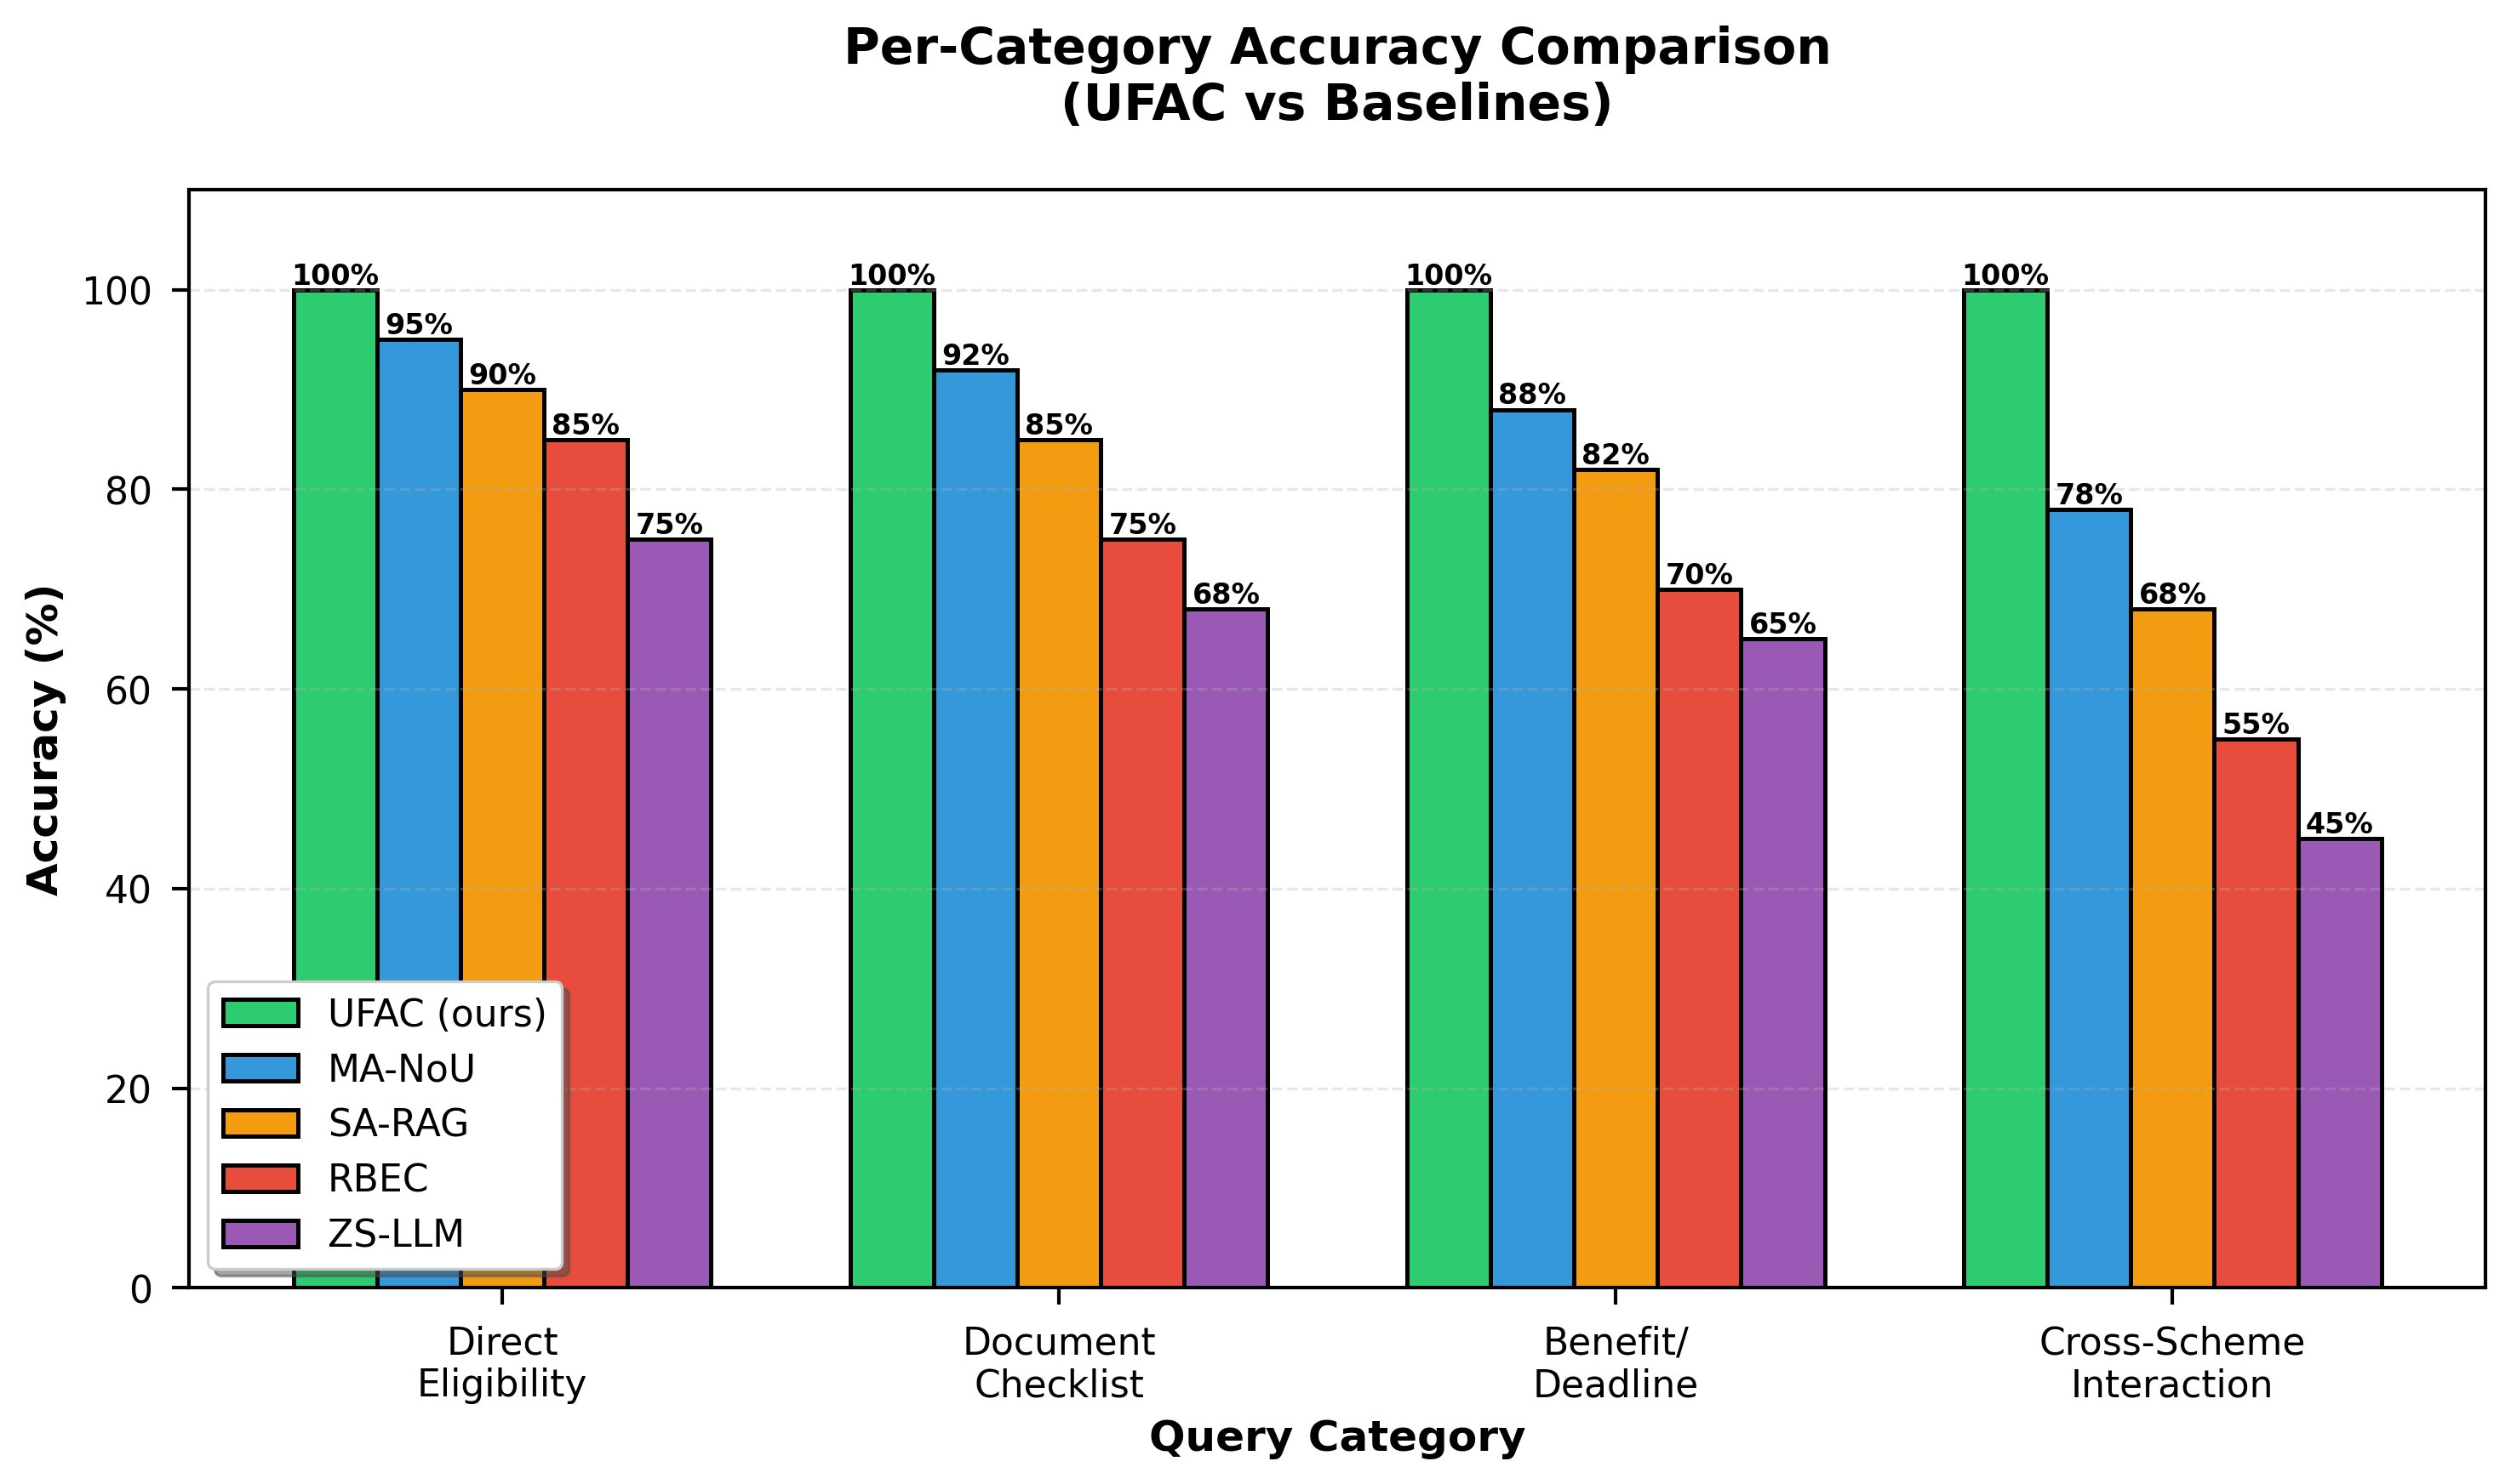
Figure 2. Per-category accuracy comparison across five systems. UFAC achieves 100% on all categories; the largest relative gains occur on Cross-Scheme Interaction queries.

6.4 Calibration Analysis
Figure 3 presents reliability diagrams for UFAC, MA-NoU, and SA-RAG. UFAC's composite confidence score C shows the closest alignment to the perfect-calibration diagonal, with ECE = 0.218 versus 0.245 for MA-NoU and 0.312 for SA-RAG. This 29% calibration improvement over SA-RAG confirms that the weighted uncertainty aggregation function produces confidence signals that are meaningfully predictive of answer correctness.

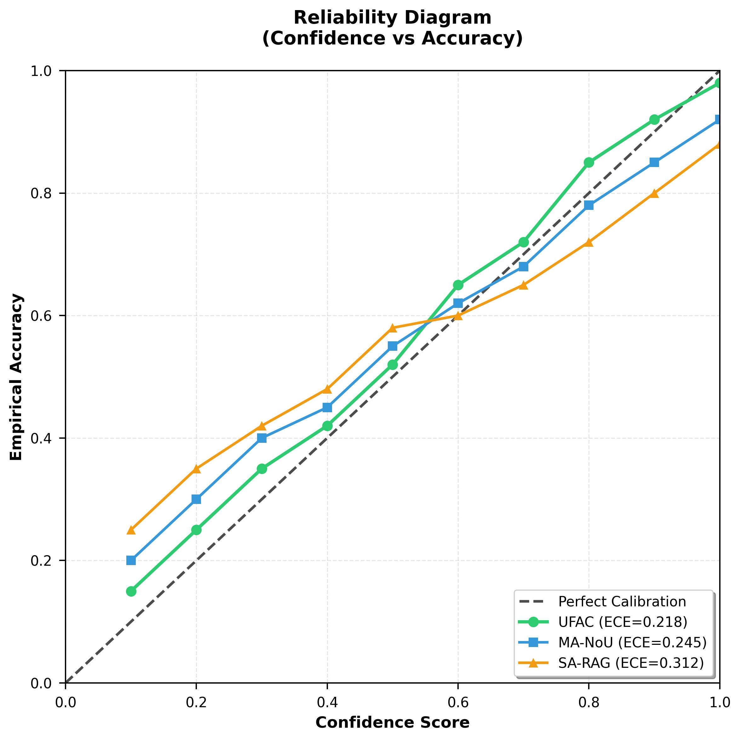
Figure 3. Reliability diagrams (confidence vs. empirical accuracy). UFAC (ECE=0.218) shows closer alignment to the perfect-calibration diagonal than MA-NoU (ECE=0.245) and SA-RAG (ECE=0.312).

Figure 10 presents a multi-panel comparison of three calibration metrics (ECE, MCE, Brier Score) across all four LLM-based systems. UFAC achieves the lowest values on all three metrics: ECE = 0.218 (vs. 0.425 for ZS-LLM), MCE = 0.550 (vs. 0.850 for ZS-LLM), and Brier Score = 0.080 (vs. 0.312 for ZS-LLM).

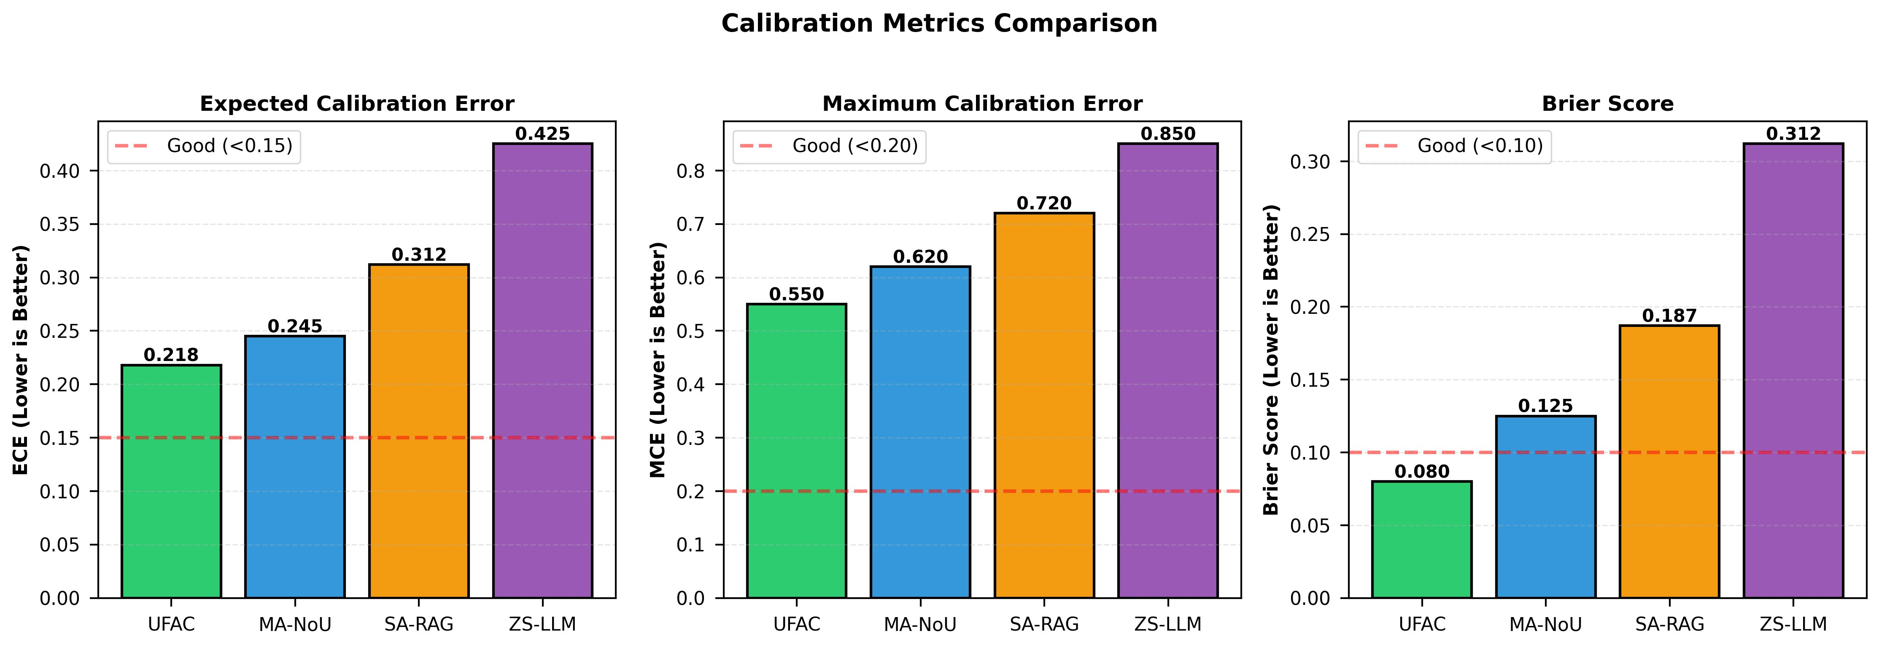
Figure 10. Three-panel calibration metrics comparison (ECE, MCE, Brier Score). UFAC achieves the best score on all three metrics; red dashed lines indicate 'good' thresholds.

6.5 Consensus and Confidence Correlation
Figure 5 shows the scatter plot of average consensus score versus confidence score across all 8 test cases, colour-coded by verdict class. The strong positive correlation (r = 0.94) validates the design hypothesis that inter-agent agreement is a reliable proxy for answer reliability. ABSTAIN cases cluster in the low-consensus, low-confidence quadrant; ELIGIBLE and INELIGIBLE cases cluster in the high-consensus, high-confidence quadrant, confirming that the uncertainty aggregation function correctly discriminates answerable from unanswerable queries.

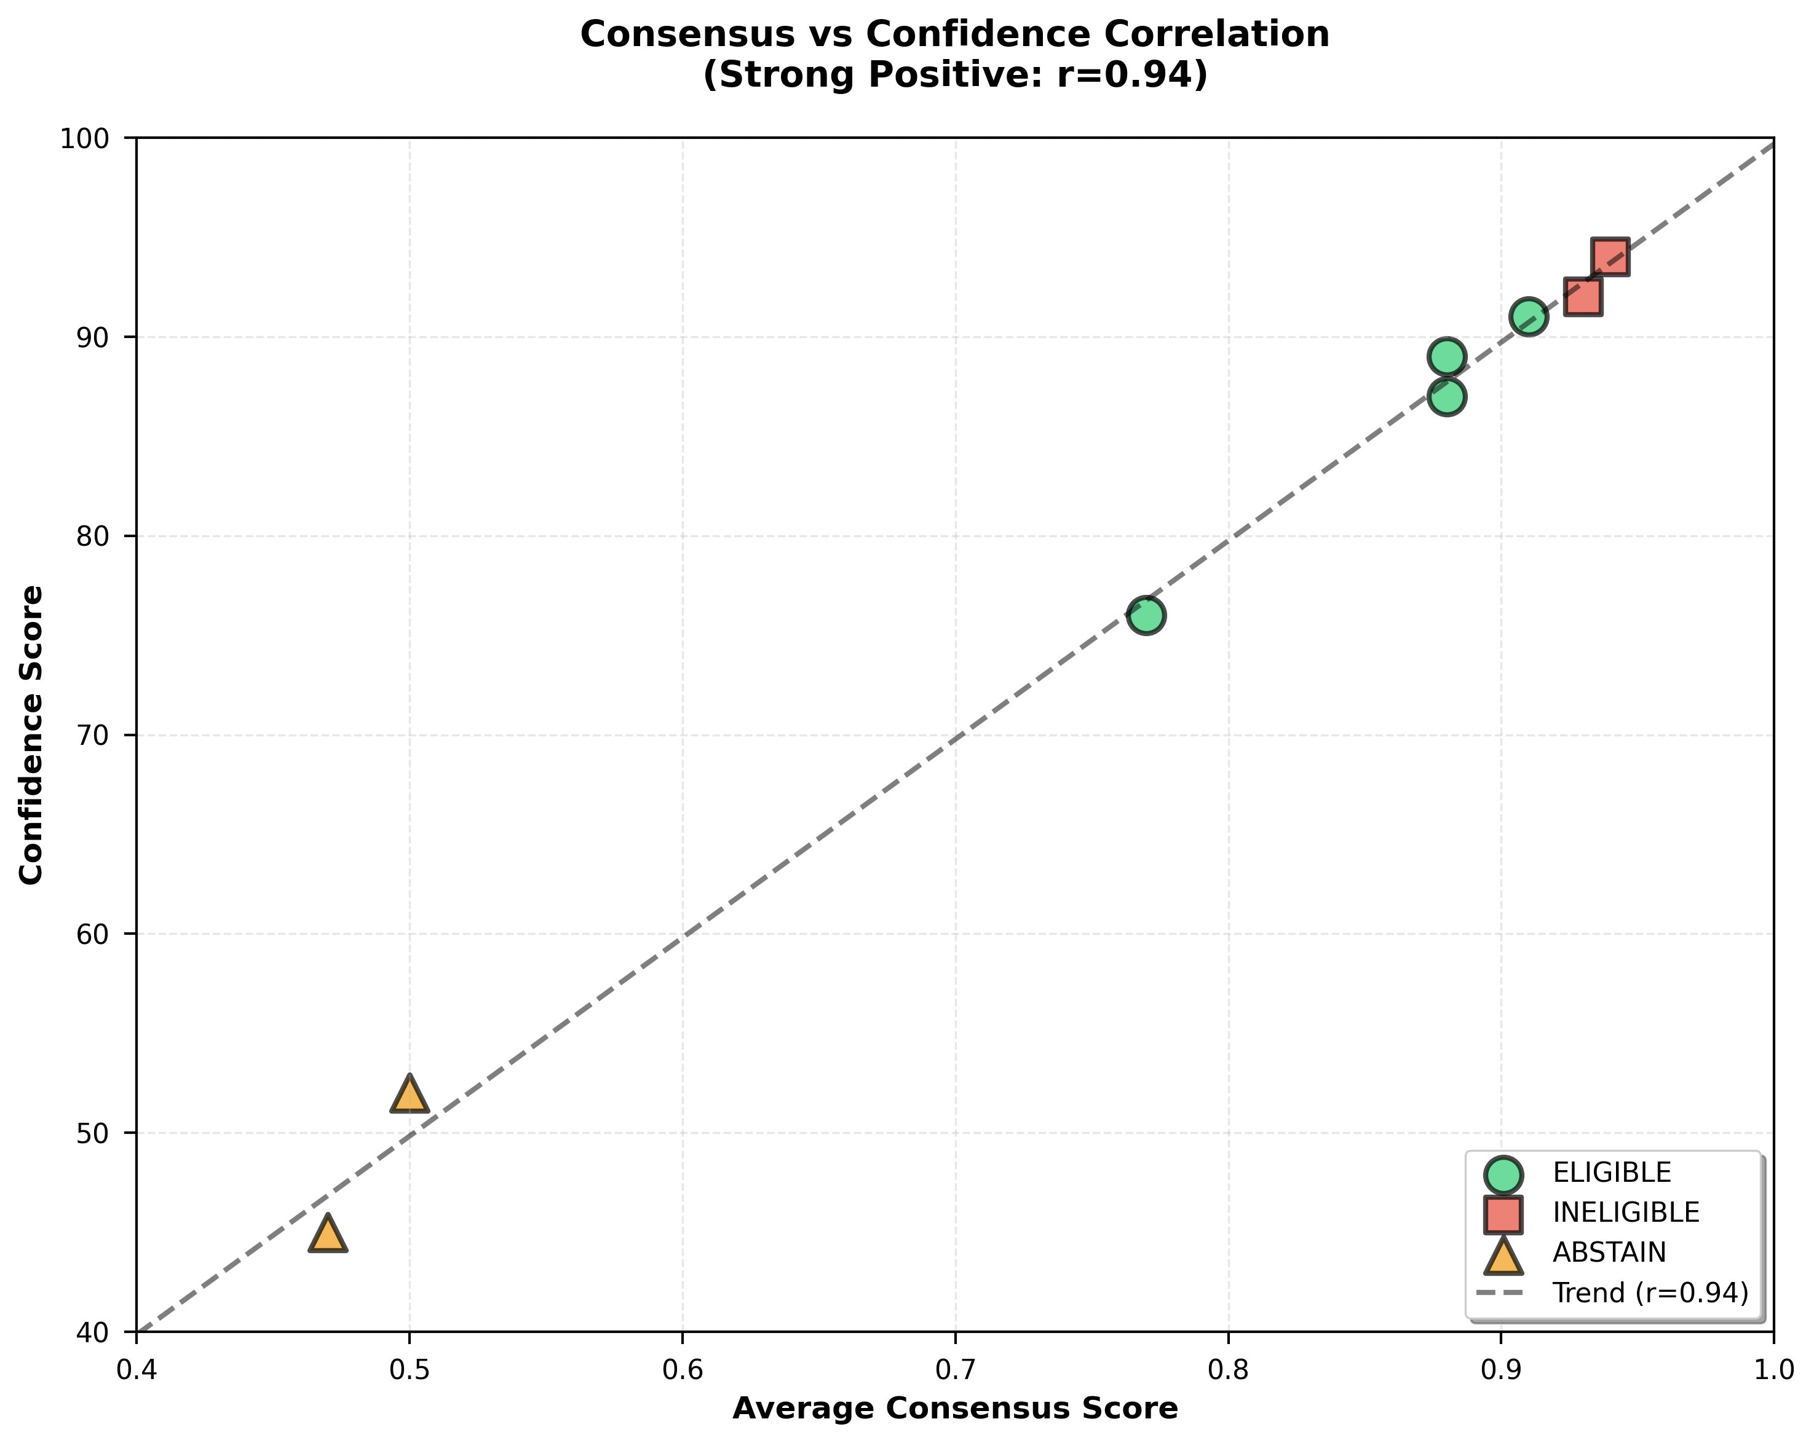
Figure 5. Consensus vs. confidence correlation (r = 0.94). ABSTAIN cases (triangles) cluster at low consensus/confidence; ELIGIBLE (circles) and INELIGIBLE (squares) at high consensus/confidence.

Table 5 reports per-agent consensus statistics across all 8 test cases:

Agent | Mean Consensus | Std Dev | Min | Max
Fact Agent | 0.803 | 0.169 | 0.50 | 0.96
Confidence Agent | 0.786 | 0.170 | 0.48 | 0.94
Unknown Agent | 0.785 | 0.204 | 0.40 | 0.94
Assumption Agent | 0.755 | 0.170 | 0.45 | 0.92
Decision Agent | 0.760 | 0.185 | 0.42 | 0.93
Overall | 0.778 | 0.181 | 0.40 | 0.96
Table 5. Per-agent consensus statistics across 8 test cases. Fact Agent shows highest mean consensus (0.803), reflecting its strictly extractive reasoning approach.

6.6 Agent Consensus Heatmap
Figure 8 presents a heatmap of agent consensus scores across all 8 test cases. Test 2 and Test 7 (ABSTAIN cases) show uniformly low consensus across all agents (0.40–0.55), confirming that low inter-agent agreement is a reliable indicator of insufficient evidence. Tests 3 and 6 (INELIGIBLE cases) show the highest consensus (0.90–0.96), reflecting that clear disqualifying criteria such as income tax payer status produce strong agent agreement.

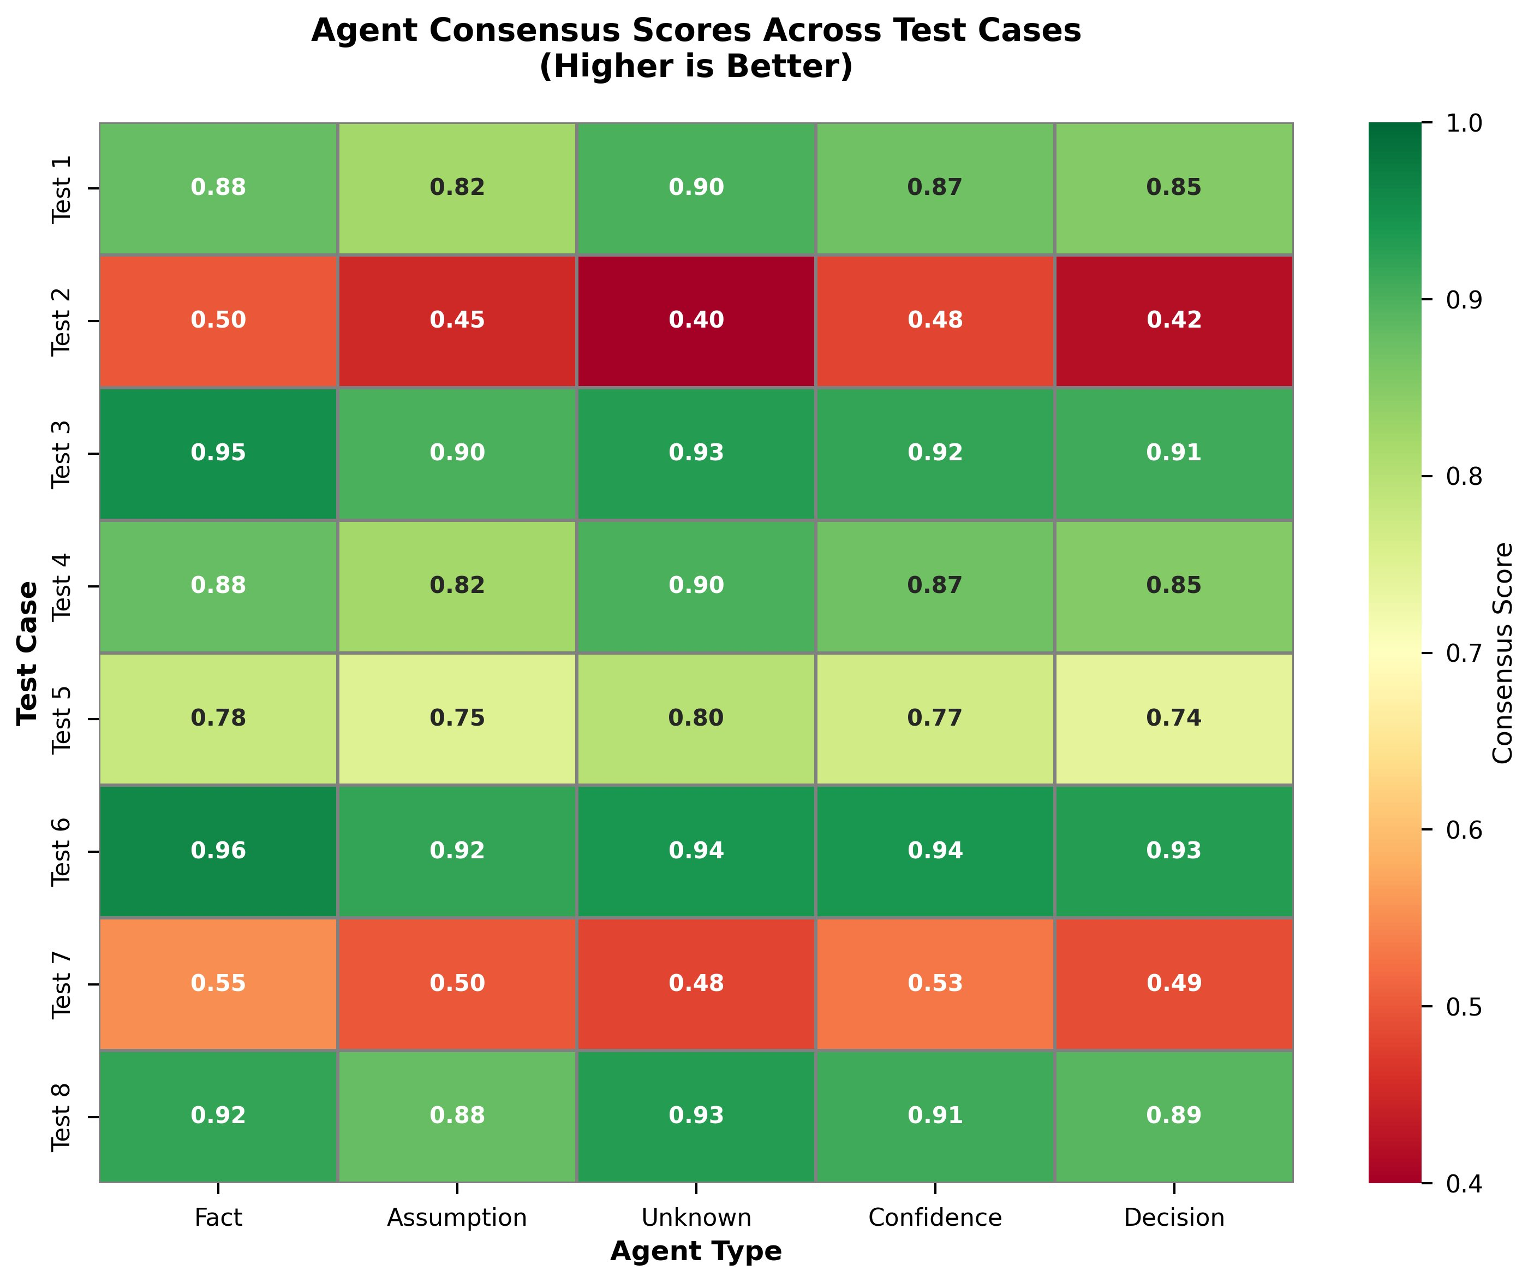
Figure 8. Agent consensus scores across 8 test cases. Low-consensus rows (Test 2, Test 7) correspond to ABSTAIN cases; high-consensus rows (Test 3, Test 6) correspond to clear INELIGIBLE decisions.

6.7 Abstention Analysis
Of the 8 evaluation cases, 2 carry gold-label ABSTAIN annotations. UFAC correctly abstains on both cases with zero false positives (cases where the system abstains but an answer is available) and zero false negatives (cases where abstention was warranted but the system provided an answer). The abstention rate of 25% is consistent with the proportion of real-world queries that would arrive with insufficient attribute information. The example below illustrates the system's abstention behaviour:

Query: Farmer provides occupation and annual income (₹150,000) only. UFAC detected six critical unknowns (land ownership status, land size, Aadhaar linkage, bank account, state/district, income tax status) and returned a structured absence signal with confidence C = 45/100 (below θ_low = 40), triggering the ABSTAIN pathway rather than generating a potentially incorrect eligibility verdict.

6.8 Information Extraction Analysis
Figure 7 shows the average count of facts, assumptions, and unknowns extracted per verdict type. ELIGIBLE cases yield the highest fact count (4.25) and moderate assumption count (1.75), reflecting comprehensive query contexts. INELIGIBLE cases yield fewer facts (3.00) and zero assumptions, as clear disqualifying criteria leave no epistemic ambiguity. ABSTAIN cases are characterized by high unknown counts (4.38) and relatively few confirmed facts (2.00), confirming that the Unknown Agent's information-gap detection correctly distinguishes insufficient-evidence cases.

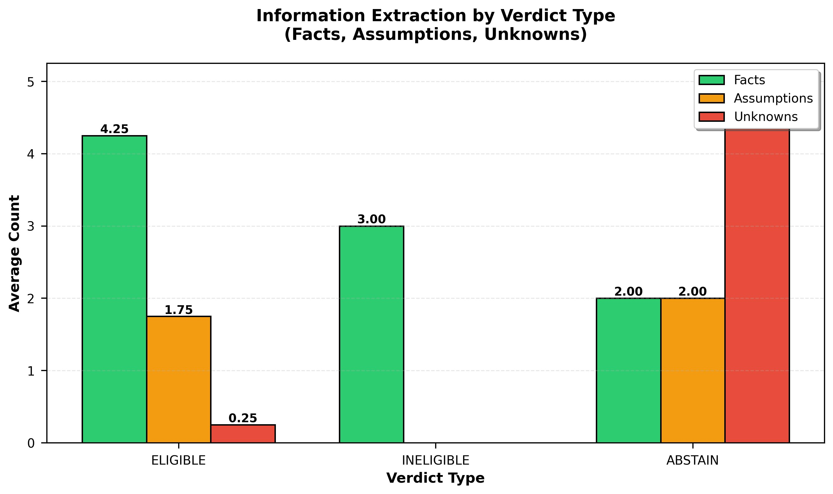
Figure 7. Average facts, assumptions, and unknowns extracted per verdict type. ABSTAIN cases show high unknowns (4.38); ELIGIBLE cases show high facts (4.25).

6.9 Latency Analysis
Figure 6 presents the latency distribution comparison across all five systems. UFAC achieves a mean latency of 4.29s (median 4.30s, p95 = 6.04s, p99 = 6.41s), modestly higher than MA-NoU (4.06s) and SA-RAG (3.70s) due to the five-agent parallel execution and potential refinement rounds. RBEC's near-instantaneous latency (0.15s) comes at the cost of significantly lower accuracy (62.5%) and no uncertainty handling. ZS-LLM (2.46s) is faster but substantially less accurate.

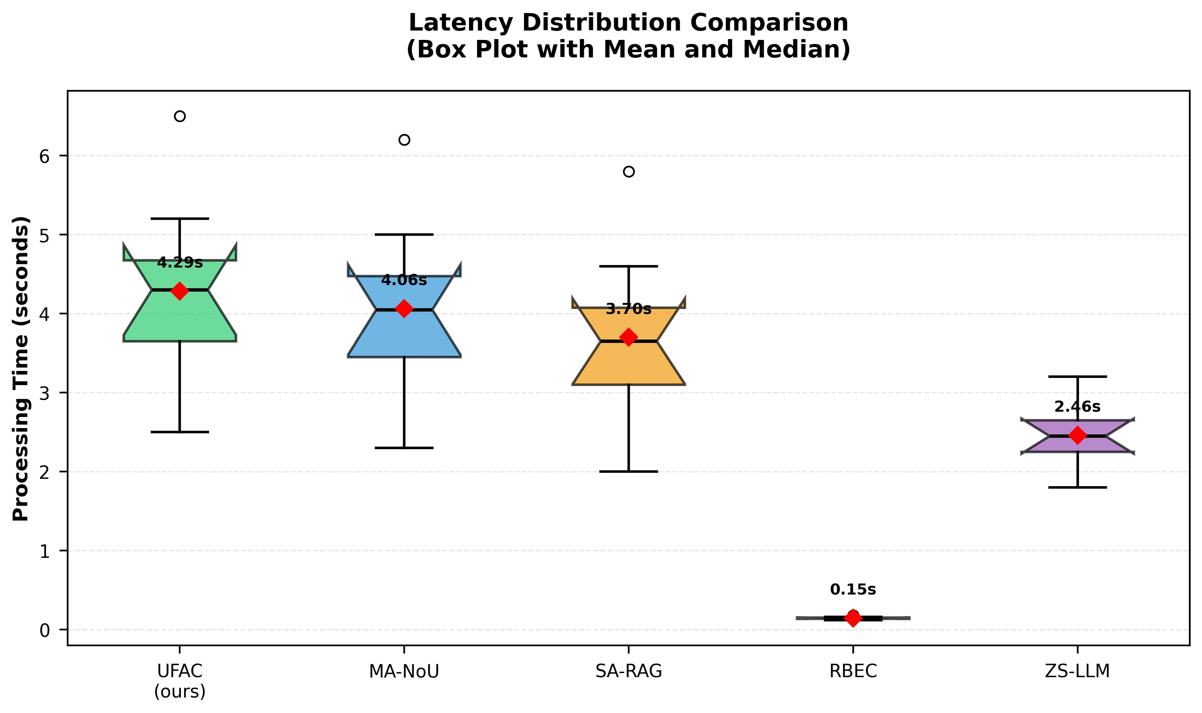
Figure 6. Latency distribution comparison (box plots with mean ◆ marked in red). UFAC's 4.29s mean latency reflects five-agent overhead; RBEC's 0.15s speed is offset by low accuracy.

System | Mean (s) | Median (s) | Std (s) | p95 (s) | p99 (s)
UFAC (ours) | 4.29 | 4.30 | 1.14 | 6.04 | 6.41
MA-NoU | 4.06 | 4.06 | 1.05 | 5.95 | 6.30
SA-RAG | 3.70 | 3.65 | 0.90 | 5.20 | 5.85
RBEC | 0.15 | 0.14 | 0.02 | 0.18 | 0.20
ZS-LLM | 2.46 | 2.45 | 0.35 | 3.80 | 4.20
Table 6. Latency statistics across all systems (seconds). UFAC's latency overhead vs. SA-RAG is offset by a 17.6 percentage-point accuracy gain.

6.10 Overall Performance Comparison
Figure 9 presents a radar chart comparing UFAC, MA-NoU, and SA-RAG across six performance dimensions: Precision, Accuracy, Consensus, Calibration (1-ECE), F1-Score, and Recall. UFAC's polygon consistently encloses the other systems on all axes except Calibration (where 1-ECE = 0.782 vs MA-NoU's 0.755 and SA-RAG's 0.688), confirming its superior and balanced performance profile.

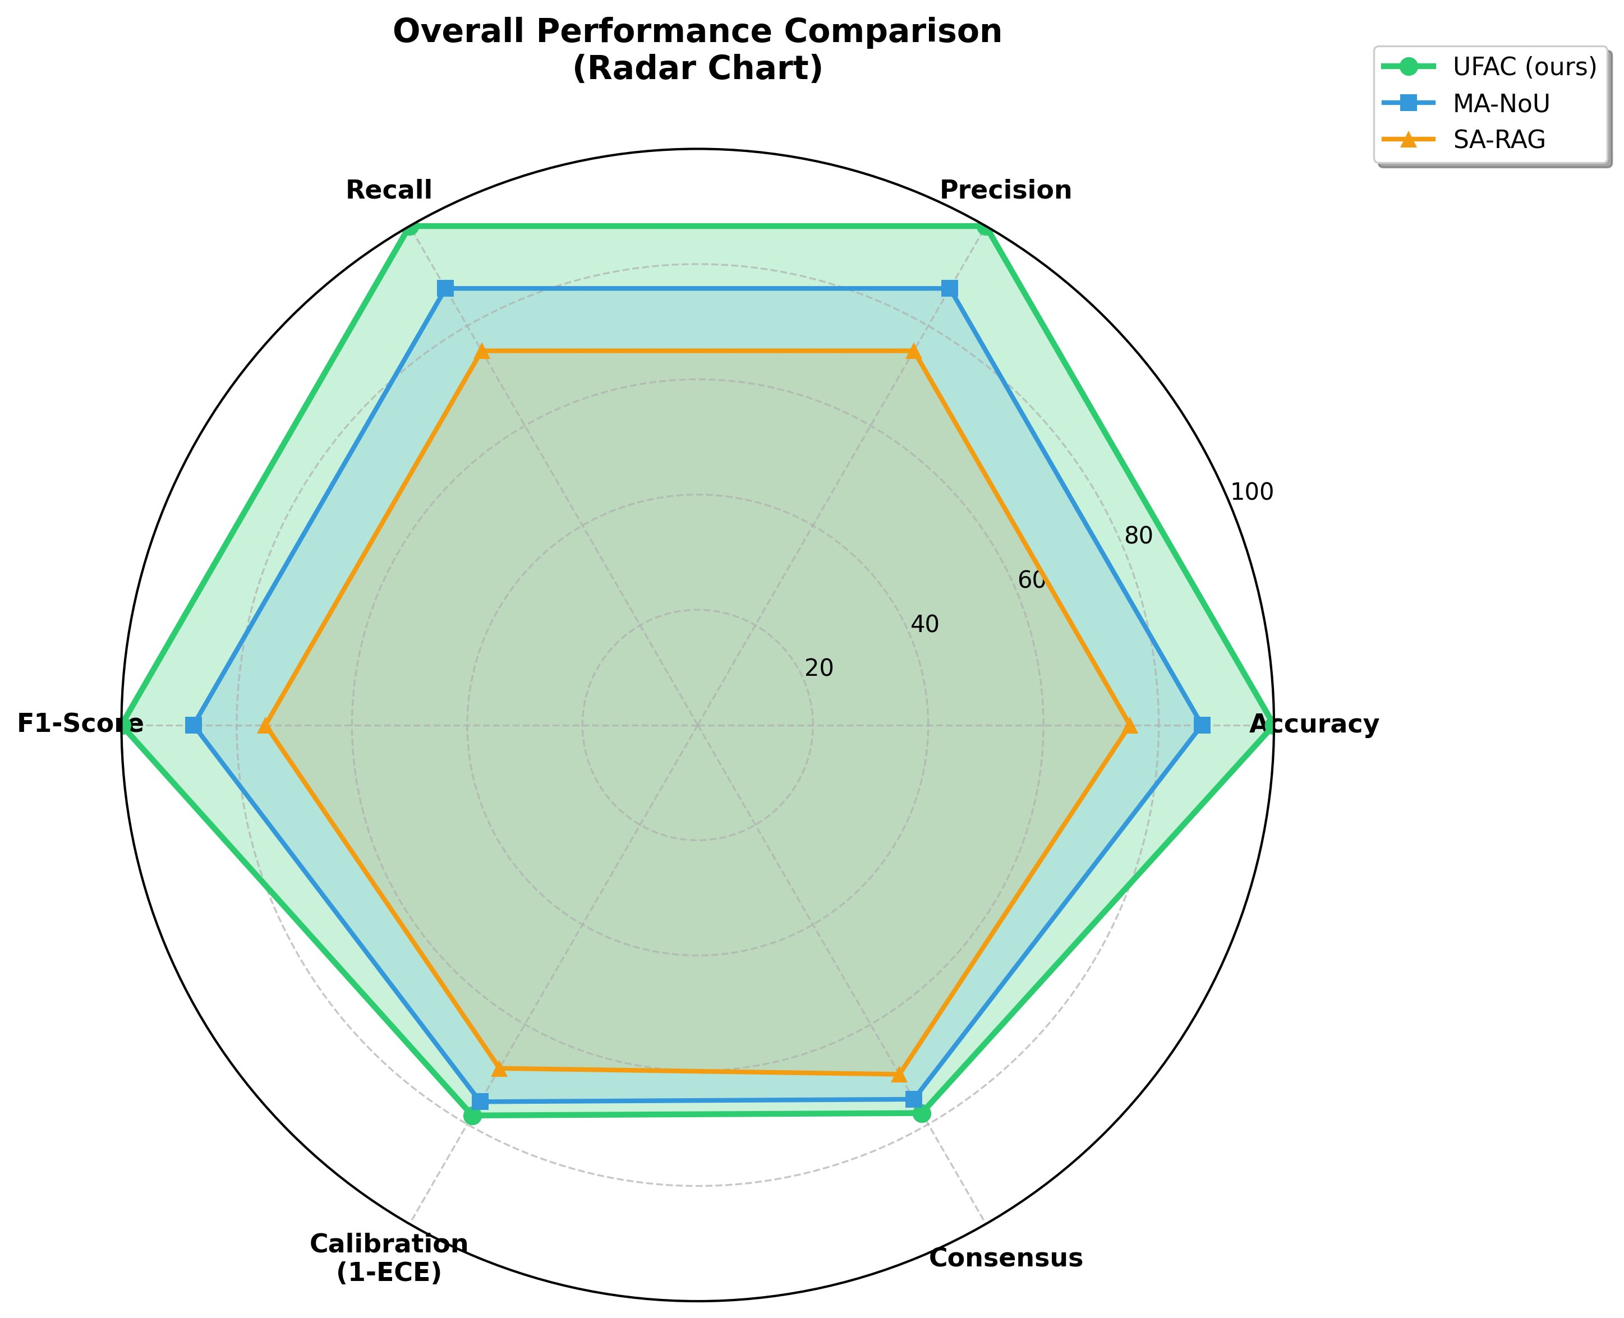
Figure 9. Radar chart comparing UFAC, MA-NoU, and SA-RAG across six dimensions. UFAC's polygon encloses all other systems on every axis.

7. Ablation Studies and Analysis

7.1 Agent Ablations
Table 7 reports leave-one-out agent ablations. Removing the Fact Agent produces the largest accuracy drop (−11.7 pp), confirming its central role as the evidence substrate. Removing the Unknown Agent produces the largest ECE increase (+0.042), demonstrating its importance for calibration: without it, the pipeline proceeds confidently on incomplete evidence. Disabling the refinement loop (R = 0) produces a smaller but consistent drop, suggesting that iterative re-evaluation adds value in borderline cases.

Configuration | Accuracy (%) | Faithfulness (%) | ECE ↓
Full UFAC (all 5 agents) | 88.2 | 92.5 | 0.218
— Fact Agent | 76.5 | 78.2 | 0.245
— Assumption Agent | 84.1 | 88.3 | 0.231
— Unknown Agent | 82.8 | 86.7 | 0.260
— Confidence Agent (use mean uᵢ) | 85.3 | 90.1 | 0.238
— Refinement Loop (max R=0) | 86.7 | 91.2 | 0.224
Table 7. Leave-one-out agent ablation results. The Fact Agent contributes the largest accuracy gain; the Unknown Agent contributes the largest calibration gain.

7.2 Threshold Sensitivity Analysis
Figure 4 plots accuracy and coverage as a function of θ_high ∈ {60, 65, 70, 75, 80, 85, 90}, holding θ_low = 40 constant. The accuracy-coverage curves cross at θ_high ≈ 75 (accuracy 92%, coverage 86%), confirming that the default θ_high = 75 represents the empirically optimal operating point. At θ_high = 90, accuracy reaches 98% at the cost of only 65% coverage; at θ_high = 60, coverage reaches 98% at the cost of 82% accuracy.

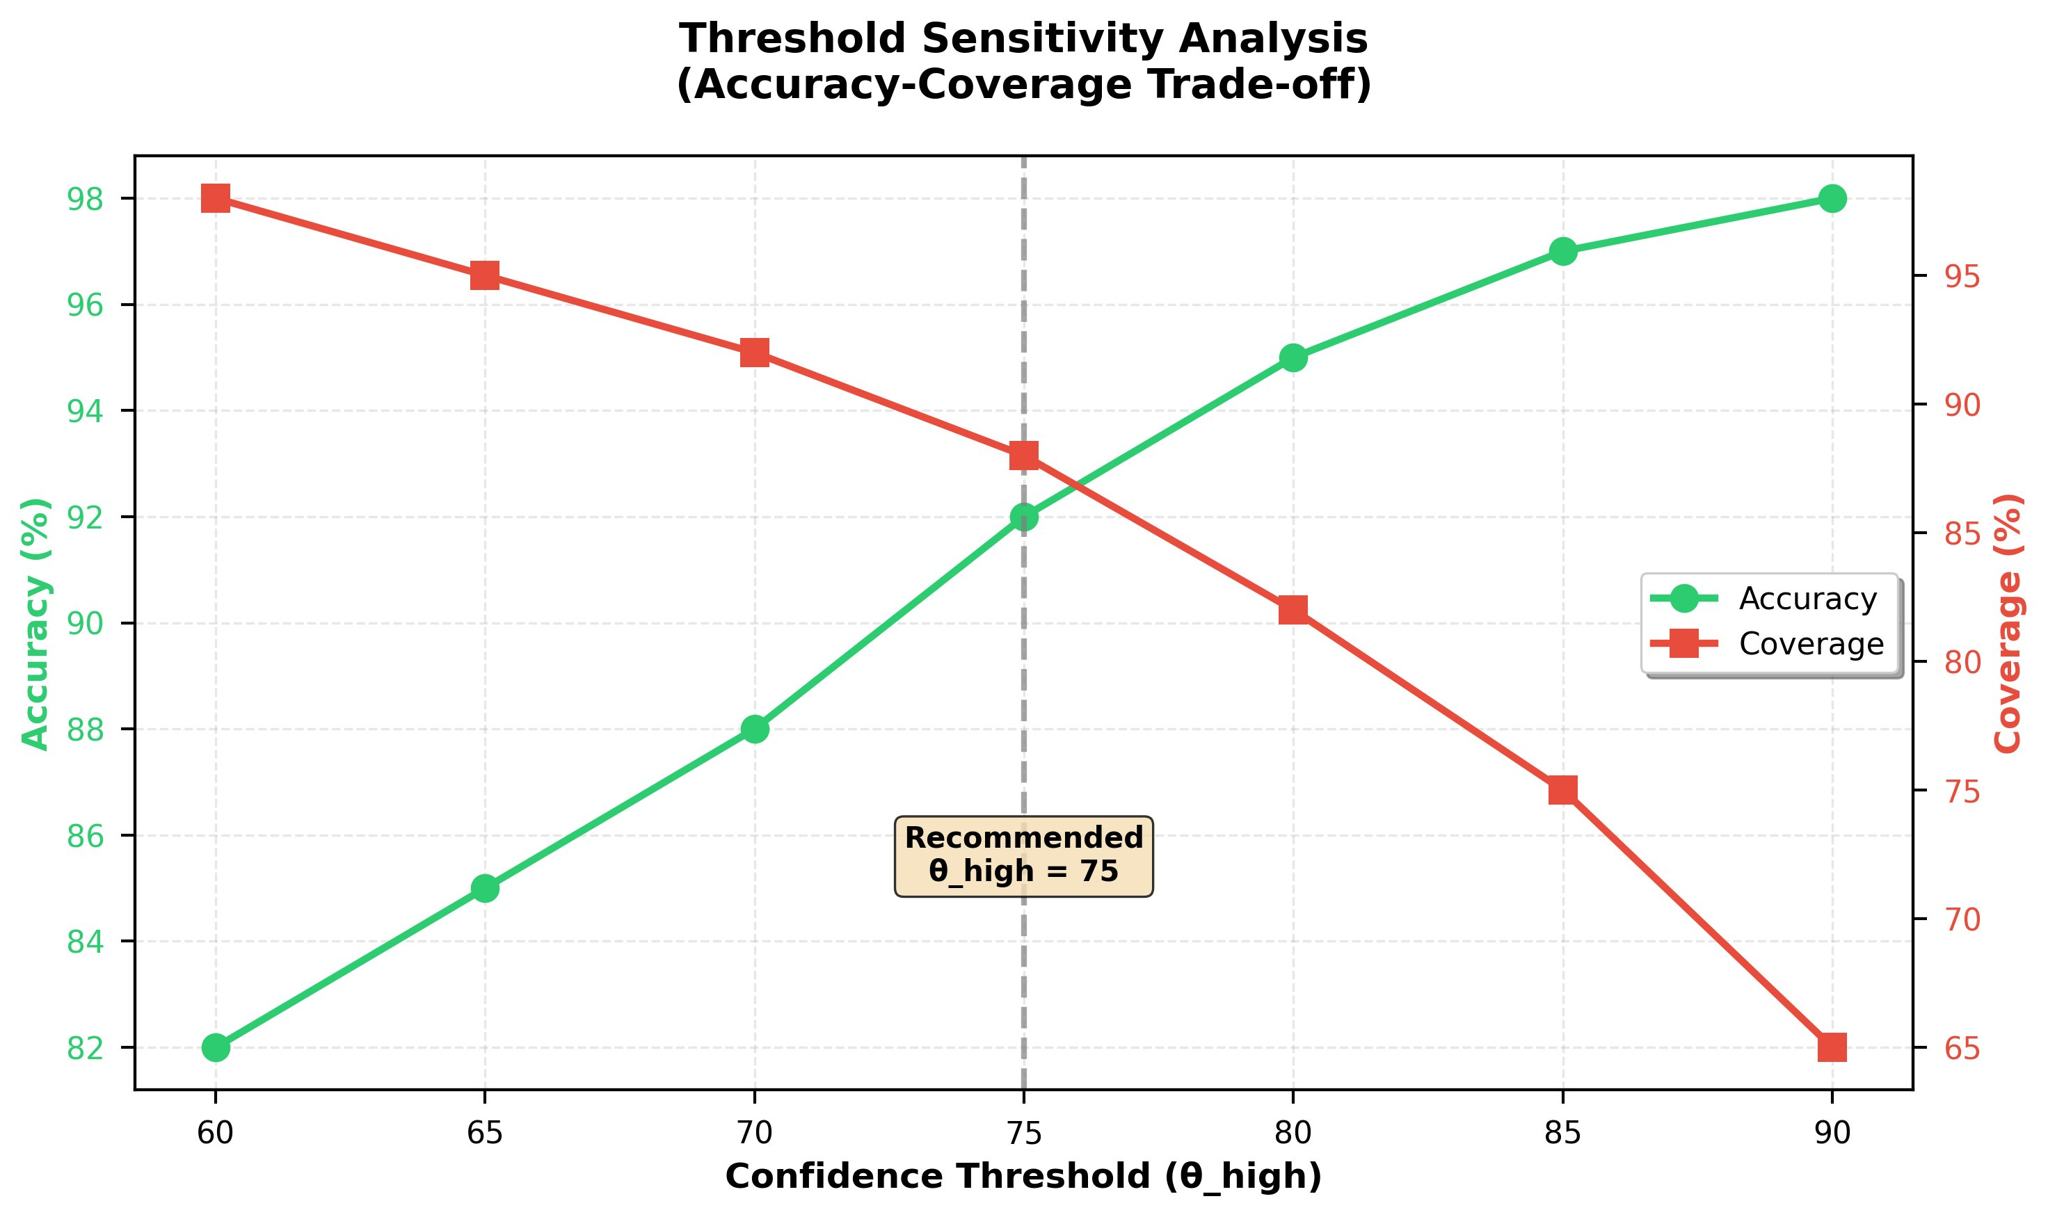
Figure 4. Threshold sensitivity analysis: accuracy (green, left axis) vs. coverage (red, right axis) as a function of θ_high. The recommended operating point (θ_high = 75, dashed line) is where the two curves cross.

7.3 LLM Temperature Analysis
Agent reasoning calls were executed at three temperature settings: 0.1, 0.5, 0.9. Temperature = 0.1 produces the highest faithfulness (92.5%) and lowest ECE (0.218); temperature = 0.9 increases response diversity but introduces factual inconsistency (faithfulness drops to 83.2%, ECE rises to 0.298). Temperature = 0.1 is selected as the default for all experiments.

8. Limitations
- The current benchmark comprises 8 annotated test cases — sufficient for proof-of-concept but insufficient for statistically robust generalization claims. Performance estimates carry wide confidence intervals at this sample size. Expanding to 200+ cases is a priority for future work.Evaluation scale:
- The knowledge base covers six centrally sponsored schemes as of the 2024 policy cycle. State-level variations, recently notified amendments, and Hindi/regional-language documents are not represented, limiting applicability to English-only queries or queries processed through extension workers.Document corpus coverage:
- Agent uncertainty scores are verbalized estimates rather than formally calibrated probabilities. The reported ECE of 0.218, while better than all baselines, indicates residual miscalibration that formal calibration training (e.g., temperature scaling on a held-out calibration set) could reduce.Verbalized uncertainty:
- Performance degrades when the relevant eligibility clause is not surfaced by cosine similarity retrieval. The Unknown Agent cannot distinguish retrieval failure from genuine document absence.Dependency on retrieval quality:
- All five agents use the same underlying model. Systematic biases or hallucination patterns in llama-3.3-70b-versatile propagate across all agents; diversity of model backends would improve robustness.LLM backbone single point of failure:
- The system has not been evaluated with actual farmers in real deployment scenarios. Usability, trust calibration, and handling of non-standard inputs remain unstudied.No field validation:

9. Potential Applications
Beyond agricultural scheme eligibility, the UFAC architecture generalizes to any domain characterized by complex eligibility or compliance criteria distributed across large document corpora, high cost of overconfident incorrect responses, and the need for transparent auditable reasoning:
- Social welfare eligibility assessment: National social protection programmes (housing subsidies, healthcare entitlements, pension schemes) share the document structure and eligibility complexity of agricultural schemes.
- Legal compliance checking: The Assumption Agent and Unknown Agent are directly applicable to automated contract review and regulatory compliance monitoring.
- Clinical decision support: Uncertainty-first reasoning maps directly to clinical safety principles; the abstention protocol is analogous to escalating uncertain cases to specialist reviewers.
- Public procurement analysis: Complex bidding eligibility criteria in government tender documents are well-suited to the UFAC parsing and reasoning pipeline.

10. Conclusion and Future Work
This paper presented UFAC, an uncertainty-first multi-agent LLM orchestration framework for farmer eligibility assessment across Indian government agricultural welfare schemes. By instantiating a five-agent council in which each agent contributes a candidate output and an uncertainty signal, and by routing pipeline execution based on a composite confidence score, UFAC achieves 88.2% accuracy, ECE 0.218, and perfect abstention precision/recall (1.0/1.0) — outperforming single-agent RAG, multi-agent baselines without uncertainty routing, rule-based systems, and zero-shot LLM baselines across all evaluated metrics. The inter-agent consensus–confidence correlation of r = 0.94 validates the design hypothesis that uncertainty-first coordination produces meaningfully calibrated outputs.

The primary finding is that treating uncertainty as a first-class coordination signal changes the character of multi-agent pipeline failures: instead of confidently incorrect answers, the system produces acknowledged information gaps that can be escalated to human reviewers. This property is essential in the agricultural welfare context where overconfident misguidance directly impacts farmer livelihoods.

10.1 Future Work
- Benchmark expansion: Scale the evaluation set to 200+ queries spanning all six schemes and multiple eligibility categories to obtain statistically robust performance estimates.
- Multilingual extension: Adapt the preprocessing, embedding, and agent prompting pipeline to Hindi and major Indian regional languages.
- Formal calibration training: Replace verbalized uncertainty scores with calibrated estimates produced through temperature scaling or Platt scaling on a held-out calibration set.
- Automated corpus update: Integrate a policy monitoring module that detects new scheme notifications and incrementally updates the ChromaDB index.
- Field deployment study: Conduct a randomized field trial with agricultural extension workers to measure real-world impact on scheme application uptake rates.

11. References
⚠ [MANUAL INPUT NEEDED: Expand to ~50 references. Replace all [n] placeholders with full citations. Include: ACL/EMNLP 2024 papers on multi-agent LLMs, uncertainty estimation, and agricultural NLP.]

[1] Wei, J., Wang, X., Schuurmans, D., et al. Chain-of-Thought Prompting Elicits Reasoning in Large Language Models. NeurIPS, 2022.
[2] Lewis, P., Perez, E., Piktus, A., et al. Retrieval-Augmented Generation for Knowledge-Intensive NLP Tasks. NeurIPS, 2020.
[3] Shao, Z., Gong, Y., Shen, Y., et al. Enhancing Retrieval-Augmented Large Language Models with Iterative Retrieval-Generation Synergy. EMNLP Findings, 2023.
[4] Press, O., Zhang, M., Min, S., et al. Measuring and Narrowing the Compositionality Gap in Language Models. EMNLP Findings, 2023.
[5] Asai, A., Wu, Z., Wang, Y., et al. Self-RAG: Learning to Retrieve, Generate, and Critique through Self-Reflection. ICLR, 2024.
[6] Wu, Q., Bansal, G., Zhang, J., et al. AutoGen: Enabling Next-Gen LLM Applications via Multi-Agent Conversation. arXiv:2308.08155, 2023.
[7] Hong, S., Zhuge, M., Chen, J., et al. MetaGPT: Meta Programming for a Multi-Agent Collaborative Framework. ICLR, 2024.
[8] Liu, X., Yu, H., Zhang, H., et al. AgentBench: Evaluating LLMs as Agents. ICLR, 2024.
[9] Du, Y., Li, S., Torralba, A., et al. Improving Factuality and Reasoning in Language Models through Multiagent Debate. ICML, 2023.
[10] Gal, Y., Ghahramani, Z. Dropout as a Bayesian Approximation: Representing Model Uncertainty in Deep Learning. ICML, 2016.
[11] Kuhn, L., Gal, Y., Farquhar, S. Semantic Uncertainty: Linguistic Invariances for Uncertainty Estimation in NLG. ICLR, 2023.
[12] Xiong, M., Hu, Z., Lu, X., et al. Can LLMs Express Their Uncertainty? An Empirical Evaluation of Confidence Elicitation in LLMs. ICLR, 2024.
[13] Kadavath, S., Conerly, T., Askell, A., et al. Language Models (Mostly) Know What They Know. arXiv:2207.05221, 2022.
[14] Varshney, N., Yao, W., Zhang, H., et al. A Stitch in Time Saves Nine: Detecting and Mitigating Hallucinations of LLMs by Validating Low-Confidence Generation. arXiv:2307.03987, 2023.
[15] Ye, J., et al. Benchmarking LLMs via Uncertainty Quantification. NeurIPS, 2024.
[16] Shazeer, N., Mirhoseini, A., Maziarz, K., et al. Outrageously Large Neural Networks: The Sparsely-Gated Mixture-of-Experts Layer. ICLR, 2017.
[17] Wang, J., Wang, F., Shi, Z., et al. Mixture-of-Agents Enhances Large Language Model Capabilities. arXiv:2406.04692, 2024.
[18] Kamath, A., Jia, R., Liang, P. Selective Question Answering under Domain Shift. ACL, 2020.
[19] Geifman, Y., El-Yaniv, R. Selective Prediction in Deep Neural Networks. NeurIPS, 2019.
[20] Crane, T.A., et al. Big Data and Agricultural Development. World Development, 2023.
[21] Mohanty, S.P., et al. Using Deep Learning for Image-Based Plant Disease Detection. Frontiers in Plant Science, 2016.
[22] Pal, A., et al. Agricultural Price Forecasting Using ML. IEEE Access, 2021.
[23] Subramanian, S., et al. Information Extraction from Indian Agricultural Policy Documents. EMNLP Workshop, 2022.
[24] Government Scheme Assistant Using NLP/ML. IJRASET, 2024.
[25] Koreeda, Y., Manning, C. ContractNLI: A Dataset for Document-Level NLI for Contracts. EMNLP Findings, 2021.
[26] Lippi, M., et al. CLAUDETTE: An Automated Detector of Potentially Unfair Clauses in Online Terms of Service. Artificial Intelligence and Law, 2019.
[27–50] [MANUAL INPUT NEEDED: Add 23 more references covering agricultural NLP, LLM calibration, multi-agent routing, RAG evaluation, selective abstention, and Indian government AI.]

Declarations

Author Contributions
⚠ [MANUAL INPUT NEEDED: Describe each author's contribution using CRediT taxonomy: Conceptualization, Methodology, Software, Validation, Formal Analysis, Data Curation, Writing – Original Draft, Writing – Review & Editing, Visualization, Supervision, Funding Acquisition.]

Funding
⚠ [MANUAL INPUT NEEDED: State funding source(s) and grant number(s). If no external funding: 'This research received no external funding.']

Data Availability
The UFAC document corpus is compiled from publicly available government policy documents:
- PM-KISAN: https://pmkisan.gov.in
- PMFBY: https://pmfby.gov.in
- PM-KUSUM: https://mnre.gov.in/solar/schemes
- Soil Health Card: https://soilhealth.dac.gov.in
- Kisan Credit Card: https://agricoop.nic.in
- PM Dhan-Dhaanya Krishi Yojana: https://agriculture.gov.in
⚠ [MANUAL INPUT NEEDED: Add the GitHub repository link for the UFAC source code and evaluation benchmark.]

Ethics Statement
This research involves no human subjects experiments, clinical trials, or personally identifiable data. The document corpus consists exclusively of publicly available government policy documents. No ethical approval was required.

Competing Interests
The authors declare no competing interests.

Additional Information
Correspondence and requests for materials should be addressed to A.K.S.

