# CSS

## Types

* **Inline CSS**: Styling that comes within the tag
* **Internal CSS**: Styling that is done outside the tag but within the same html file using **<style>** tag and **class** or **id** attribute 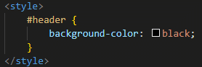
* **External CSS**: Styling done using a separate CSS file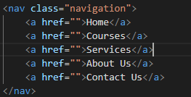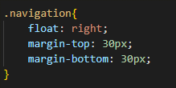

## **<style>** tag attributes

* **z-index**:
  + Attribute which is used to set the layering (overlapping) order in an html webpage
  + Takes the values: 0, 1, 2, 3..etc
  + 0 being the inward layer and as the number increases the layers appears to be on top of the other layers 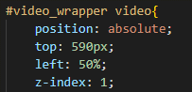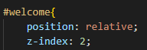

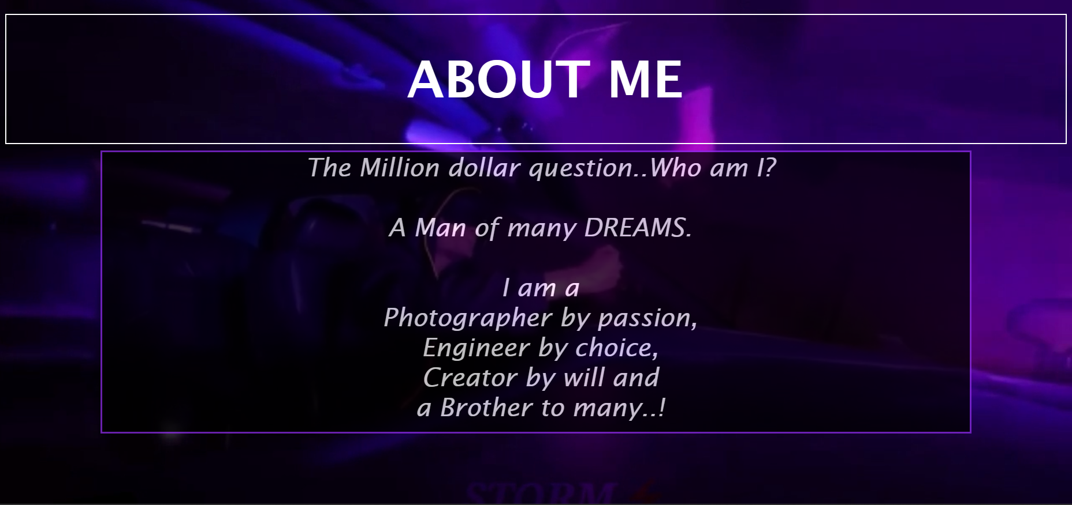

* + NB: If element A has z-index: 0 and element B has z-index: 5, no matter how big is the z-index value is for a child element of A, child of A can never be on top of element B.
* **inline-block**:
  + It is a value that goes into **display** attribute so that the values are presented in a horizontal manner with a specific thickness to the border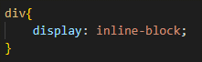
  +  Horizontal display with row thickness
* **!important**:
  + It is a stand alone value that give special priority to the tag in which it is provided
  + div 1 is displayed BLUE
  + 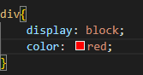Even though CSS is providing RED color
  + 
* Icons:
  + **<i>** tags are used to insert icons to html webpage
  + Along with **<i>** tags, we have to use **<link>** tag to attach special **href** to fetch these things
  + Inorder to use:
    - Font-Awesomeness Icon: 
    - Google Icons: 
    - Bootstrap Icons: 
* text-effects:
  + **text-overflow**:
    - It defines how a text should be displayed while it is overflowing in a text-area
    - Takes the values “clipped” or “ellipsis”
  + **word-wrap**:
    - If defined with the value “break-word”, the long words in the text areas are broken and displayed in the next line
  + **word-break**:
    - It defines how a line should be broken
    - Takes the values “break-all” or “keep-all”
    - “keep-all” keeps the words as it is without breaking the word
    - “break-all” breaks the word to fit it inside the text-area width
  + **writing-mode**:
    - It defines how a content should be displayed in a textarea
    - “horizontal-tb” display’s the content horizontally from top to bottom (like normal text)
    - “vertical-lr” display’s the content 90 degree rotated clockwise from left to right line by line
    - “vertical-rl” display’s the content 90 degree rotated clockwise from right to left line by line

* **text-align**:
  + Takes the values: **left, right, center, justify, justify-all, start, end** etc
* **text-decoration**:
  + Mainly used in **<a>** tags to remove the hyperlink underline with value: none;
* **font-size**:
  + To set the font size in px, em, % etc
* **margin (margin-top, margin-bottom, margin-left, margin-right)**:
  + To set the margin from top-right-bottom-left order (clockwise)
  + 