# HTML

## Tags

* Boiler plate: ! + (tab key)
* Displays general html webpage structure
* **<video> </video>**: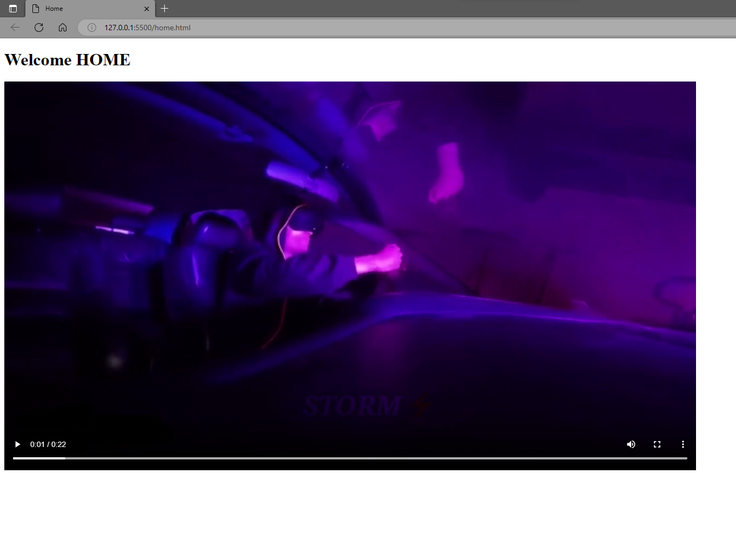
  + Used to display video on a webpage
  + Common attributes are
    1. **control**: It defines the video controls which is displayed with play/pause buttons. 
    2. **src**: It specifies the source URL of the video
    3. **loop**: Plays the video repeatedly
    4. **height** & **width**: Set the height & width of the video player
    5. **autoplay**: Starts playing the video by itself
    6. **poster**: Similar to **alt** in ***img*** tag
* **<iframe></iframe>**: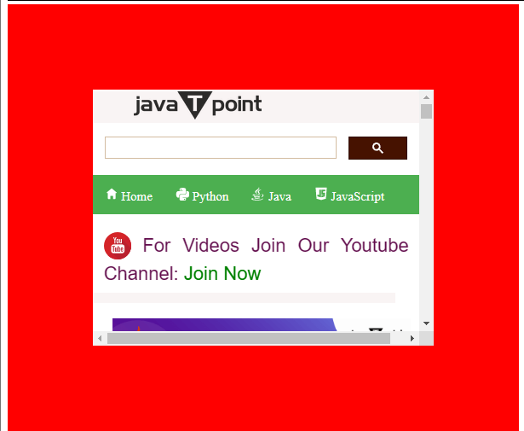
* <iframe src="https://www.javatpoint.com/" height="300" width="400" style="border: 100px solid red;"></iframe>
  + HTML iframe (inline frame) is used to display a nested webpage
  + Common attributes are:
    1. **src:** URL of source webpage
    2. **height** & **width**: Set the height & width of the frame (height="300" width="400")
    3. **style**: Values such as “border:none” removes border of the content. Use keyword **solid** to provide a solid frame border. Also used to change colours and frame type as well
    4. **allowfullscreen**: If possible then that frame can be opened in fullscreen
    5. **sandbox**: Applies extra conditions to a frame content (“allow-forms” ”allow-popups” ”allow-same-origin” ”allow-scripts”)
    6. **scrolling**: You can set “auto” “yes” or “no” for scrollbar
* **<embed>**:
  + Used to embed an external document in html webpage which can be a third party app, plugin, or multimedia
  + Only supports in HTML 5 or newer version
  + Similar to <**iframe**>tag except this tag displays only the content rather than the whole webpage
  + Common attributes are
    1. **src**: Address of the source file
    2. **height** & **width**: Set the height & width of the border
    3. **type**: Specifies the type of file such as gif, adobe plugins etc.
* **<meter> </meter>**:  
  + Used to measure data within a given range.
  + Similar to polling in Whatsapp
  + Also known as gause
  + Common attributes are:
    1. **max** & **min**: To set the maximum and minimum value of the range
    2. **value**: The actual value to which the meter would be pointing
    3. **high, low** & **optimum**: Sets highest, lowest and optimum values considered in the meter and changes the colour of the bar-pointer with respect to the value. (similar to redline being highest in tachometer)
    4. **form**: Specifies the meter element form (Not clear??????)
* **<progress> </progress>**: 



* + Used to display a progress bar for specific processes such as downloading or installing
  + Common attributes are:
    1. **value**: Sets the value of current progress(eg 43%)
    2. **max**: Sets the maximum value of progress (eg 100%)
* **<svg> </svg>**:
  + Used to insert Scalable Vector Graphics
  + Common attributes are:
    1. **height** & **width**: Set the height & width of the SVG
  + <**circle**> tag is used inside to create circle with attributes being
    1. **cx** & **cy**: Value of x & y coordinate where centre is placed
    2. **r**: Value of radius
    3. **stroke**: Colour of perimetric border
    4. **stroke-width:** Width of perimetric border
    5. **fill**: Colour of circle to be filled
  + <**rect**> tag is used inside to create circle with attributes being
    1. **width** & **height**: Length and Breadth of the rectangular edges
    2. **stroke**: Colour of perimetric border
    3. **stroke-width:** Width of perimetric border
    4. **fill**: Colour of circle to be filled
* **<option> </option>**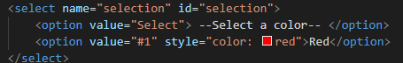
  + Used to include options on a drop-down menu created using <**select>** tag
  + Common attributes are:
    1. **value**: Gives a name
    2. **style**: Specifies font characteristics such as (“color:red;”)
    3. **selected**: If it is specified in one of the options, it will be set by default
    4. **label**: Same as the content which comes in between label tags, it will be displayed as an option in the dropdown list.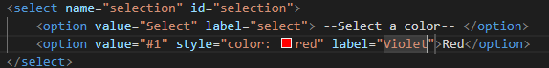 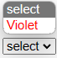
    5. **disabled**: If given to a particular option, then that option will be disabled
* **<select> </select>**:
  + Used to create dropdown list in an html webpage
  + Common attributes are:
    1. **name**: Specifies a name for the drop down list
    2. **autofocus**: Instantly takes the user to dropdown list while getting into the page
    3. **multiple**: User can select multiple choices from the list
    4. **required**: If specified, user must select an option before submitting the form
    5. **size**: Specifies the number of visible options when the list is dropped down
* **<form> </form>**:
  + Used to create a form
  + Commonly used sub-tags are:
    1. **<select> </select>**
    2. **<label> </label>**
    3. **<textarea> </textarea>**
    4. **<button> </button>**
* **<label> </label>**:
  + Used to give a label for the <**input>** tag
  + it can be achieved in two ways
    1. Set an **id** attribute in <**input**>tag and matching it with **for** attribute in <**label**> tag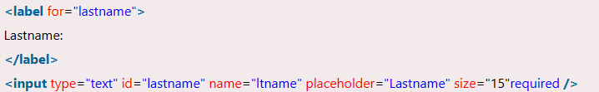
    2. Setting <**input**> tag inside <**label**> tag

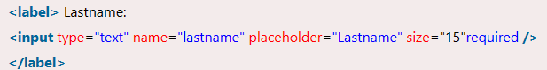

* Common attributes are:
  1. **for**: Defines which label it signifies
* **<input>**:
  + Used to represent a form input control in HTML document
  + **type** attribute defines the type of input such as
    1. **text**: Normal input box to enter text
    2. **email**: Input text will automatically be verified for valid email address while submitting
    3. **password**: Normally the text will be hidden and a show button will be provided at the end of the input box
    4. **date**: Calendar will be provided to choose the date
    5. **file**: A button for browsing a file as well as a display box to show chosen file will be presented
    6. **checkbox** & **button**: Places a checkbox and button in the document
  + Common attributes are:
    1. **name**: Gives a name to each input tag
    2. **placeholder**: A watermark text in the input textbox to denote what the input the particular box is asking
    3. **size**: Number of characters to be displayed in the texbox