**BASICS OF CALCULUS**

**1) Sets**

Sets are an unorganised collection (of often related) data. It is represented in braces ‘{}’.

Eg:

A = {1,2,3}

**2) Relation**

A relation is a set of ordered pairs, indicating the connection (or relation) between two the elements of two or more sets. They are typically represented by R.

Eg:

A = {1,2,3}

B = {10, 20, 30}

Then R = {(1,10), (2,10), (3,10), (3,30)} is a relation between A and B.

A relation is defined to be a subset of **AXB**. Here, A is the domain and B is the co-domain.

**Domain:** Set of x-values

**Co-domain:** Set of y-values

**Range:** Set of y-values that have an image in the domain

**3) Function**

A relation becomes a function if every element in domain has a unique element in the co-domain. i.e,

1. Every x element must have an image

2. The y-value of an x element should be unique

A function **f** from a set A (domain) to a set B (codomain) is denoted as **f: A → B**, where for every element a in A, there exists a unique element b in B such that f(a) = b.

A function can be plotted graphically. All functions pass **vertical line test**.

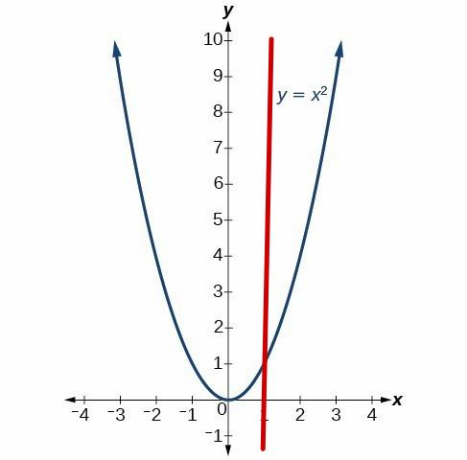

The reason why functions are useful is because they can be thought of as machines, which takes in an element from the domain and converts it in to an element in range. They provide a way to model and analyze relationships, make predictions, solve equations, and understand the behavior and patterns in mathematical systems.It is important to note that not every element in codomain has a pre-image in the domain. It is for this reason that we use ‘range’ instead of ‘co-domain’ for plotting graphs.

Functions can be represented in 4 formats:

* Algebraically
* Graphically
* Verbally
* Mathematically (as dataset)

**Even and odd functions**

A function f(x) is called **odd** if f(-x) = -f(x). Its graph is symmetric about the origin.

A function f(x) is called **even** if f(-x) = f(x). Its graph is symmetric about the y-axis.

**Graph of a function**

The graphical method is a good way to visualize the function.

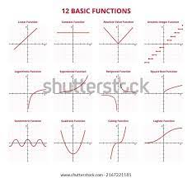

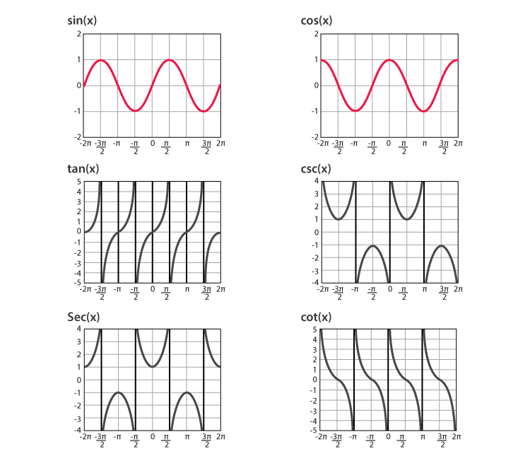

**Transformation of function**

Consider y = f(x) to be a function. Then the three main transformations on functions are:

1. **Translation**

y = f(x) + c :+ve y-axis

y = f(x) – c : -ve y-axis

y = f(x + c) : - ve x-axis

y = f(x – c) : +ve x-axis

1. **Stretching/ Shrinking**

y = c . f(x) : Stretch Vertically

y = 1/c . f(x) : ShrinkVertically When the change is made inside

y = f(c . x) : Shrink Horizontally f(x), the change appears

y = f(1/c . x) : Stretch Horizontally to misbehave

1. **Reflection**

y = - f(x) : Reflect vertically

y = f( - x) : Reflect horizontally

**Mathematical model**

A mathematical model is mathematical description of a real world phenomenon. We take in the data, and create a function that is a good enough idealization of the phenomenon. Its purpose is to help in studying and predicting the phenomenon.

**Composite function**

A function that composes another function. If f(x) and g(x) are two functions, then

**f o g = f(g(x))**

**Inverse of a function**

Inverse of a function can be thought of as a function that reverses what the original function does.i.e, **f-1(f(x)) = x**

* Also,If y = f-(x), then f-1(y) = x
* If a function has to have an inverse, it has to be one-one.
* Graphically, existance of inverse can be checked via horizontal line method
* Domain(f(x) = Range(f-1(x)) , and vice-versa
* Inverse functions have their graphs reflected by the line y = x
* For eg: The inverse of ex is ln x

**4) Limits**

Whenever a variable x approaches a number a, for a function f(x), we represent it in terms

of limits as **Limx->af(x) = L**

**Formally,** L is said to be the limit of a function f(x) as x approaches a, and is represented as above.

For every number **δ** > 0 there exists a number **ε** > 0

such that if **0 < | x – a | < δ** , then **0 < | f(x) – L | < ε**

Limits can be one-sided, if it approaches the graph only through one side.

**Infinite limits**

When limits approaches infinity. They cause vertical asymptotes in graph.

**Squeeze Theorem / Sandwich Theorem**

If **f(x)<= g(x) <= h(x)**  and  **Limx->a f(x) = L** and **Limx->a h(x) = L**

then **Limx->a g(x) = L**

The function in the middle is squeezed between the upper and lower.

**5) Continuity**

A function is said to be continuous on an interval, if there forms a continuous graph when forming the graph of the function. Formally, a function f(x) is said to be continuous at a point c in its domain if ,

The limit of the function as x approaches c is equal to the value of the function at c:

**Lim(x→c) f(x) = f(c).**

**Limits at infinity**

When we tend the limit of a number to ∞, some limit tends to L. They form horizontal asymptotes.

**Intermediate Value Theorem**

The IVT states that for a continuous function f(x) from interval a to b and a number N between f(a) and f(b) [f(a) ≠ f(b)], there exists a value c between a and b such that f(c) = N.

**6) Differentiability**

A function f(x) is said to be differentiable at a point a , if it has a derivative at that point. i.e, **f’(a) = Limh->0 (f(x+h) – f(x))/h**   
 must exist at that point.

* Graphically, the funciton will be smooth, **with no breaks, vertical tangents or sharp corners**, and has a well defined slope at that point. Such a graph will definitely havea **unique tangent at every point in consideration.**
* Differentiablility ensures continuity.
* A function is said to be differentiable on a domain, if it is differentiable at all points in that domain.

**7) Derivative**

The derivative of a function is defined as the change in the function w.r.t the change in the variable of that function at an instant. It is mathematically defined as  
 **f’(a) = Limh->0 (f(x+h) – f(x))/h**

* The derivative of a function at a point is also the slope of the function at that point.
* The process of finding derivative is called differentiation.
* It is helpful in finding the minima and maxima, and in optimising functions.
* To differentiate composite functions, we use the chain rule.
* Applications of differentiation: Linear Approximation, Optimisation, Graph analysis
* Lagrange Notation: f’(x) Leibniz Notation: df/dx

**8) Linear Approximation/ Tangent-line approximation**

It is using differentiation to approximate a function f(x) at a point x, if we know the value of the function at a. The closer x is to a, the better the approximation.

**f(x) = f(a) + f’(a).(x-a)**

**9) Differentials**

We know, dy/dx = f’(x)

Here, dy/dx is the change in the function w.r.to the change in the variable of that function.

Now, if we think of dy as the infinisimal value that represent the change in the function, and dx as the change in the variable, then we can write

dy = f’(x).dx

This can help us approximate the change in the function, if we know the derivative and the change in variable

**Note:** dy/dx is an operation (called differentiation), and hence **dy and dx cannot be separated**. But for the purpose of linear approximation and optimisation, it would be helpful to consider dy and dx as separate entities. This will provide a strong framework for estimating how a small change in variable can lead to a change in the function.

**10) Intermediate VT, MVT, Rolles’ Theorem**

**11) Maxima – minima**

A function will have maximas and minimas throughout it. They are very important, because many problems involves finding and optimising the maximas and minimas.   
Eg: The objective of many buisness models is to maximise the profit function.

Lets consider a function f(x), defined on the doman [a,b]. Let c be a point on the domain, such that f(c) is a maxima or a minima. The main concept here is that,  
 **f’(c) = 0**

The way we generalise this is by defining critical point. The **critical point** c is defined as a point on the domain of a function where f(c) is either not defined or f’(c) = 0 [ horizontal line in graph].  
 Thus we can conclude that the only places where maxima and minima can occur throughout the domain [a,b] are the critical points and the end points a and b. But this only tells us that a point is either minima or maxima or an inflextion point. Inorder to identify them correctly, we use the second derivative test as:

* If f’’(x) > 0, it is a minima
* If f’’(x) < 0, it is a maxima
* If f’’(x) == 0, it is an inflection point

We can also find if a function is increasing or decreasing by the first derivative test:

* If f’(x) > 0 along a domain, then the function f(x) is increasing along the domain
* If f’(x) < 0 along a domain, then the function f(x) is decreasing along the domain

We can also use all these concpts to draw the graph of almost any function.

**12) L’ Hospital’s Rule** **limx>a f(x)/g(x) = limx>a f’(x)/g’(x)**

**13)Integration**

Integration is a process that calculates the anti-derivative of a function. **Anti-derivative** is the opposite of taking the derivative. It may be formally defined as: If F’(x) =f(x), then F(x) is the anti-derivative of f(x).

There are three types of integrals -

* **Indefinite integral** – It is the integral with no limits w.r.t the domain. It calculates the area under the graph of the function as a system of functions. It is literally the anti-derivative of a function. The output is a system of functions.
* **Accumulation function** – It is the integral defined from a point a to x. It calculates the area as x increases from a, and hence the name. It is the “area so far funtion”. The output is a function, just put the value of x, and you’ll get the accumulation area.
* **Definite integral –** It is the integral defined between two points. It calculates the area between those two points in the domain. The output is the area(a number).

**14) Fundemental Theorem of Calculus**

1. FTOC 1: Establishes a relation between integration and differentiation

**d/dx( ∫ax f(t).dt ) = f(x)**

1. FTOC 2: Defines definite integral

**∫abf(x) dx = F(b) - F(a)**