Q. The schematic example given in the Power block doesn’t have reverse current protection. Add a component to solve it. Can be achieved with just one component and try to keep it simple. Explain how your design will protect the whole PCB from reverse current protection.

A. Using a PMOS will protect the PCB from reverse current. If the battery terminals are reversed by mistake, the MOSFET will act as an open switch and prevent current from flowing in reverse direction.

Q. Draw a new improved schematic for power- block and also add a provision for 5V supply for a microcontroller. Potential divider may not be the best solution to produce a constant 5V for the above case, so you would require a different component. Come up with reasons why it is so.

A. Voltage can fluctuate from a source. Hence, on dividing potential, the voltage may not be what we expected. To overcome this, we can use 7805IC which gives constant voltage of 5V.

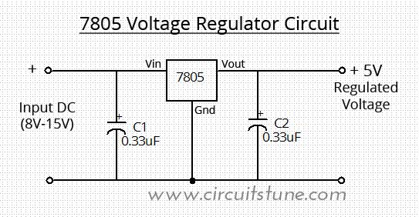

Q. By now, you might have thoroughly understood the working of 555 IC. This IC is the cornerstone of our digital circuits as it offers a simple solution to a latching circuit. You are given a scenario where you are required to design an error latch block that checks for IMD error and BMS error. The input signals are named as IMD_FLT and BMS_FLT for IMD and AMS resp. The nature of the signals is that they go LOW during a case of error/implausibility. These latched signals ultimately control the SDC. The most intuitive way is to use relays for the corresponding error signals that control the SDC, in a similar fashion as shown in the ESI Module-I and also in rulebook’s section EV 6.1 . Our go-to relay is G6DN-5A. While figuring out the design for such logic, your friend warns you that the minimum operating voltage, that any typical relay requires to switch its poles, will not be met by the output of the 555 IC, if used. Will you consider your friend’s advice? Justify your response with figures from the datasheets provided.

Recommended 555 IC: NE556 dual timer IC

(For logic inversion, you are only allowed to use PMOS, and not any digital IC)

A. Must operate voltage of relay = 8.4V. (70% of 12V)