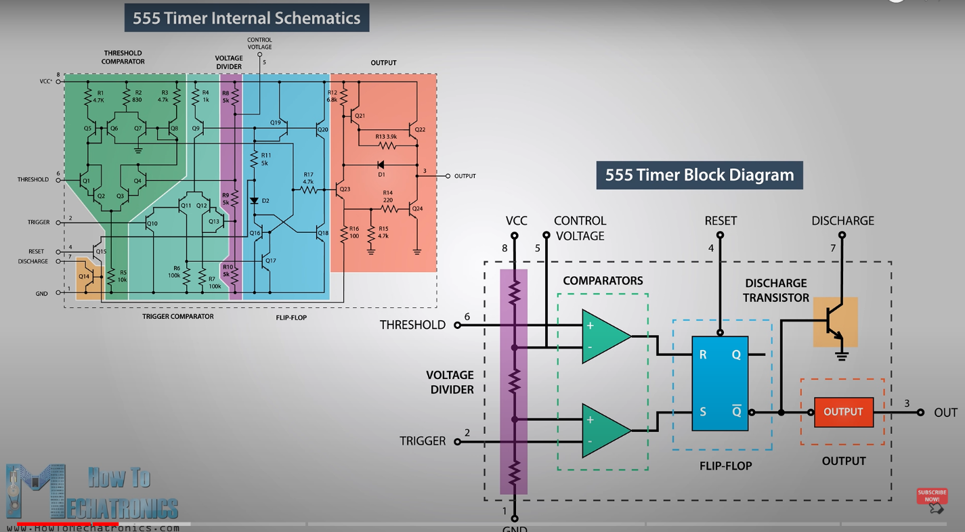

• Pin 1. – Ground: The ground pin connects the 555 timer to the negative (0v) supply rail.

• Pin 2. – Trigger: The negative input to comparator No 1. A negative pulse on this pin “sets” the internal Flip-flop when the voltage drops below 1/3Vcc causing the output to switch from a “LOW” to a “HIGH” state.

• Pin 3. – Output: The output pin can drive any TTL circuit and is capable of sourcing or sinking up to 200mA of current at an output voltage equal to approximately Vcc – 1.5V so small speakers, LEDs or motors can be connected directly to the output.

• Pin 4. – Reset: This pin is used to “reset” the internal Flip-flop controlling the state of the output, pin 3. This is an active-low input and is generally connected to a logic “1” level when not used to prevent any unwanted resetting of the output.

• Pin 5. – Control Voltage: This pin controls the timing of the 555 by overriding the 2/3Vcc level of the voltage divider network. By applying a voltage to this pin, the width of the output signal can be varied independently of the RC timing network. When not used, it is connected to ground via a 10nF capacitor to eliminate any noise.

• Pin 6. – Threshold: The positive input to comparator No 2. This pin is used to reset the Flip-flop when the voltage applied to it exceeds 2/3Vcc causing the output to switch from “HIGH” to “LOW” state. This pin connects directly to the RC timing circuit.

• Pin 7. – Discharge: The discharge pin is connected directly to the Collector of an internal NPN transistor which is used to “discharge” the timing capacitor to ground when the output at pin 3 switches “LOW”.

• Pin 8. – Supply +Vcc: This is the power supply pin and for general purpose TTL 555 timers is between 4.5V and 15V.

**Monostable**

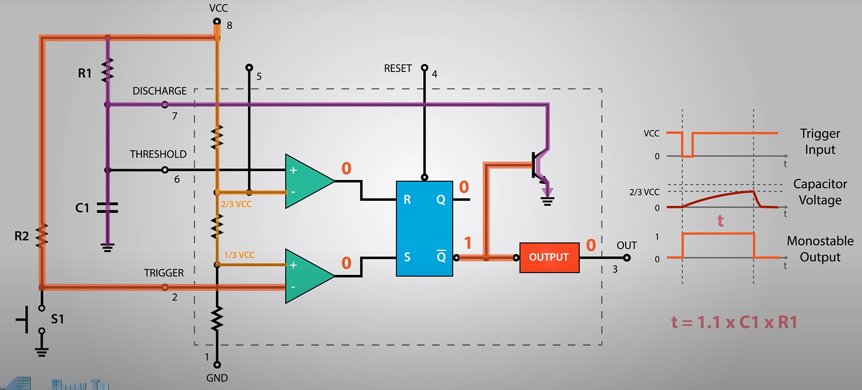

If long time delays are required in the 10’s of seconds, it is not always advisable to use high value timing capacitors as they can be physically large, expensive and have large value tolerances, e.g, ±20%. One alternative solution is to use a small value timing capacitor and a much larger value resistor up to about 20MΩ’s to produce the require time delay.

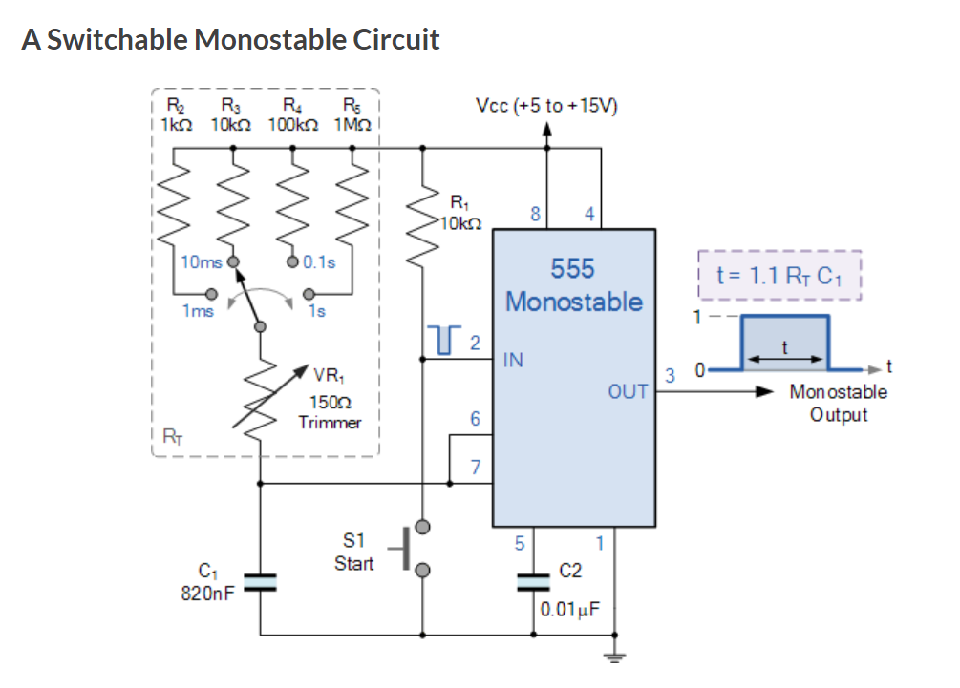

By using one smaller value timing capacitor and different resistor values connected to it through a multi-position rotary switch, we can produce a Monostable 555 timer oscillator circuit that can produce different pulse widths at each switch rotation

**Bistable**

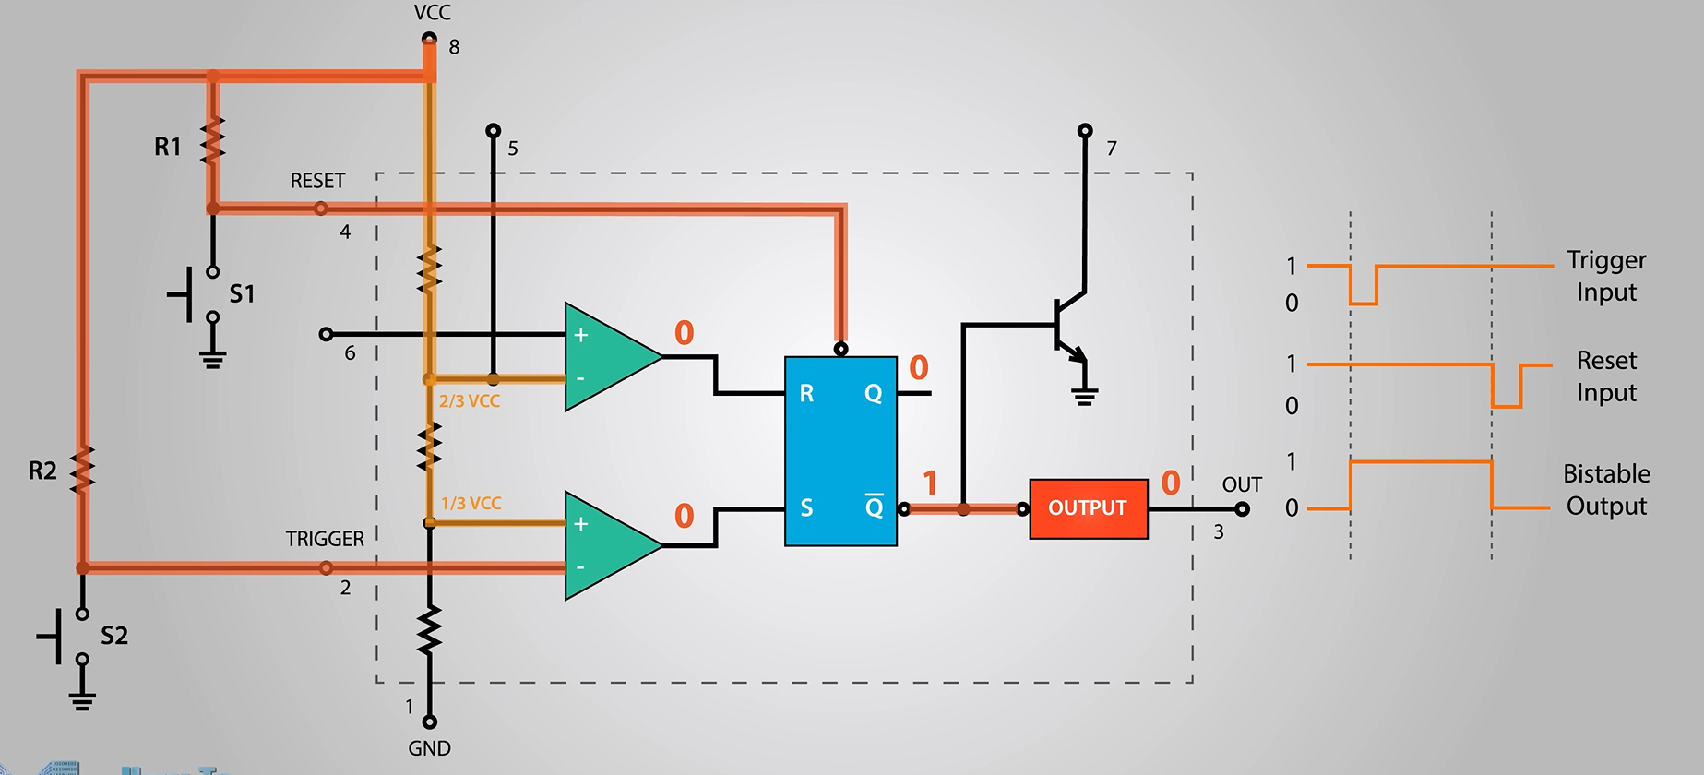

The threshold input (pin 6) is connected to ground to ensure that it cannot reset the bistable circuit as it would in a normal timing application.

**Astable**

