

Assignment Template for Uploading to Blackboard

MECH 4259

Summer 2021

Assignment #1

Last Name: Posarajah

First Name: Arjun

Lab Section: 52

After completing the front page,

1. answer the questions on page 2,
2. Insert a representative CAD screen capture image on top of page 3,
3. Insert a representative Stress screen capture image at bottom of page 3 ,
4. save this template as PDF,
5. upload according to the instruction provided by the instructor.

|  |  |  |  |  |
| --- | --- | --- | --- | --- |
| GA initials | Questions out of 5 | CAD image out of 2 | Stress image out of 3 | Total  out of 10 |
|  |  |  |  |  |

Answer the following five questions (5 points):

1. What type of element was used? Solid / Shell /Beam

Solid

1. What order element was used? Linear/Parabolic

Linear

1. What material was used?

Steel

1. Whare is the most critical position for static failure?

The outer edges of the fillets near the cylindrical part.

1. How many elements do you have in the model?

20343 elements

4867 Nodes

Insert a Representative CAD Screen Capture Image (2 points):

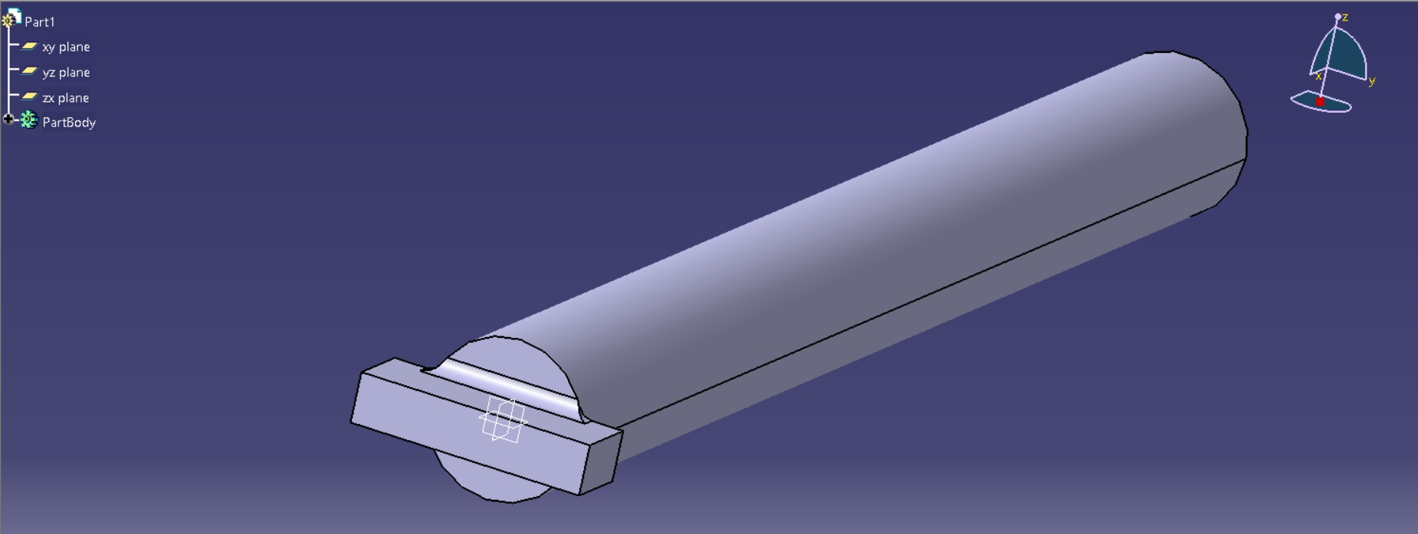

No planes of symmetry

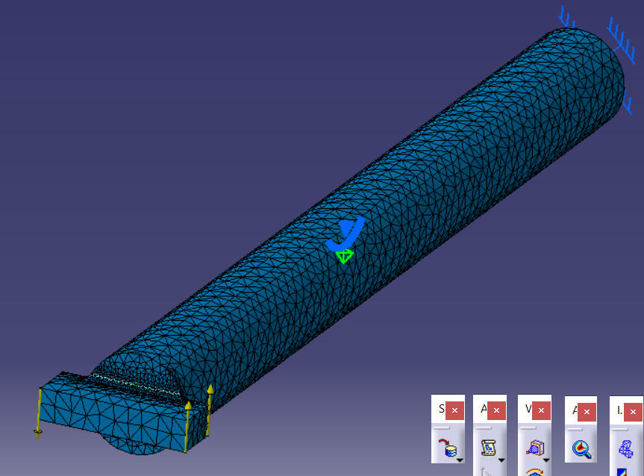

Insert Representative Stress Screen Capture Image (3 points):

