CareerFlowOps: An End-to-End MLOps Pipeline for Explainable Job Ranking, Delivered on AWS
Utkarsh Lakhani (23070126064)
Department of Artificial Intelligence and Machine Learning
Symbiosis Institute of Technology, Pune, India
Guide: Prof. Shruti Sunnad

Abstract—Machine learning services usually fail in production because of the process around the model: data that cannot be reproduced, experiments that cannot be compared and releases that cannot be traced. This paper presents CareerFlowOps, a job-ranking application whose model is produced, delivered and monitored through a complete MLOps pipeline. Data and models are versioned with DVC in a seven-stage pipeline backed by an S3 remote. Twelve experiment runs and a model registry are tracked in MLflow. The selected ranker is exported as a checksummed bundle that the server verifies before it serves a request. GitHub Actions builds immutable container images, authenticates to AWS with OpenID Connect instead of stored keys, and deploys to an EC2 host through AWS Systems Manager. Prometheus and Grafana monitor the service, and Docker restart policies recover crashes. The system was deployed on 27 October 2026 and verified end to end: the live service reports the bundle it loaded, rejects unauthenticated requests, returns explained rankings and recovered from a simulated crash in about four seconds. The ranking benchmark is small (six fictional queries, 29 postings), so its metrics demonstrate the pipeline rather than ranking quality. This limit is stated, and the problems met during deployment are documented.
Index Terms—MLOps, DVC, MLflow, CI/CD, GitHub Actions, AWS, Docker, model deployment, explainable ranking.
I. INTRODUCTION
A trained model is a small part of a machine learning system. Sculley et al. describe how data dependencies, configuration and glue code accumulate hidden technical debt around it [1]. MLOps applies the practices of DevOps to this problem: version control, automated testing, continuous delivery and monitoring, extended from code to data and models [2].
This paper reports a complete, small-scale application of those practices. CareerFlowOps ranks job postings collected from public employer job boards against a candidate's skills and explains each ranking. The product is modest. The contribution is the path its model takes from raw data to a verified, monitored service on AWS, and the evidence that each step works. The contributions are:
1) a seven-stage reproducible pipeline in which settings, data and models are versioned (DVC) and every run is recorded (MLflow);
2) a model bundle with a manifest and checksums, and a server that refuses to serve any other model (fail-closed serving);
3) a keyless CI/CD path from GitHub Actions to AWS using OpenID Connect, immutable image tags and a deploy step that compares the running model with the delivered manifest;
4) an end-to-end verification of the live deployment, with an account of the problems met.
Section II gives background, Section III the system, Section IV the data and model, Section V the MLOps pipeline, Section VI the CI/CD and cloud deployment, Section VII monitoring, Section VIII the evaluation, and Sections IX to XI lessons, limits and conclusions.
II. BACKGROUND AND RELATED WORK
A. MLOps and experiment management
Kreuzberger et al. survey MLOps and propose an architecture with components for data and model management, CI/CD and monitoring [2]. MLflow records the parameters, metrics and artifacts of each run and provides a model registry [3]. DVC extends Git with pipeline definitions and content-addressed storage for large files, and keeps a hash of every stage input and output in a lock file [4]. CI/CD automates build, test and release [5]; here it is applied to a model and its container image.
B. Retrieval models and ranking metrics
TF-IDF weights a term by its frequency in a document and its rarity across a collection [6]. Sentence-BERT produces sentence embeddings that can be compared by cosine similarity [7]. The embedding model used here, all-MiniLM-L6-v2, is built on the compact MiniLM architecture [8]. Ranking quality is measured with metrics such as mean reciprocal rank (MRR) and normalized discounted cumulative gain (nDCG), which reward placing relevant items early [9].
This work proposes no new algorithm. It is a case study of how these established parts fit together in a small production system.
III. SYSTEM OVERVIEW
The application has a React web portal, a FastAPI backend, a PostgreSQL database and a ranking model. A candidate stores a profile of skills. The backend scores active postings against the profile and returns the best matches, each with an explanation and the employer's official apply link. The system never submits an application.
Postings come from the official public endpoints of Greenhouse, Lever and Ashby. Each job keeps its source name, source job ID, source URL and apply URL. Raw payloads are stored apart from normalized records, and duplicate detection never removes provenance.
Fig. 1 shows the lifecycle that carries the model from raw data to a prediction, and Fig. 2 shows how an image and a model reach the server. In production all services run as Docker Compose containers on one EC2 host (Table I). Only ports 80 and 443 are public.
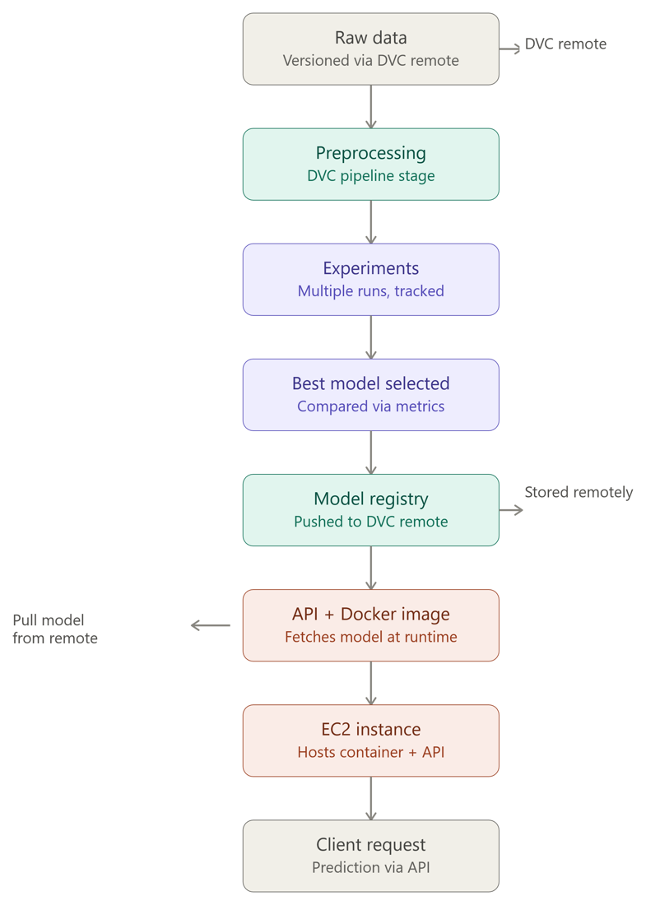
Fig. 1. Lifecycle from versioned raw data to a client prediction.
TABLE I
CONTAINERS ON THE PRODUCTION HOST
Container | Role
api | FastAPI; applies migrations, serves rankings
web | nginx serving the React build
postgres | Jobs, profiles, applications
mlflow | Experiment tracking and registry
edge | Caddy: HTTPS and routing
prometheus, grafana | Metrics and dashboards

IV. DATA AND RANKING MODEL
A. Evaluation data
The evaluation set contains 29 frozen real postings and six fictional candidate queries with relevance labels written during development. Queries are split into validation and test sets: validation selects the model and test is held back. The labels are not human-validated, a limitation discussed in Section VIII.
B. Rankers and scoring
Three rankers are compared: TF-IDF; a sentence-transformer (all-MiniLM-L6-v2, pinned to a fixed revision so that a later upload cannot change results); and a hybrid of the two. The match score combines five component scores with fixed weights read from the pipeline parameters:
S = Σ w_{k} s_{k} (1)
where the components k are semantic, skill, eligibility, location and freshness, with weights 0.40, 0.30, 0.15, 0.08 and 0.07. Each result also carries the matched and missing skills, a text explanation, the model version and a fallback reason that is empty in production. The explanation is part of the output contract because a ranking that influences a job search must be inspectable.
C. Model selection
The pipeline selects the ranker with the highest validation nDCG@5, breaking ties by Precision@5 and then by algorithm name. The rule is deterministic, which keeps reruns reproducible.
V. MLOPS PIPELINE
A. Versioned pipeline
The pipeline is defined in dvc.yaml as seven stages (Table II). Each stage declares its command, inputs and outputs, so DVC reruns only the stages whose inputs changed. Settings (the seed, the score weights, the embedding model and its revision) live in params.yaml and are declared as stage dependencies. After a run, dvc.lock records a content hash for every input and output. Git commits this file, so each commit identifies one exact version of data and model. Large outputs are stored in an S3 bucket (21 objects, 92.6 MB) that is versioned and encrypted.
TABLE II
DVC PIPELINE STAGES
Stage | Main output
ingest | Frozen raw snapshot
preprocess | Normalized jobs
build_training_set | Queries, labels, splits
train | TF-IDF index, embeddings
evaluate | Metrics file
register | MLflow model version
export_model | Verified model bundle

B. Experiment tracking and registry
Each training and evaluation run is logged to an MLflow server: parameters, validation and test metrics, tags for the split policy and the Git commit, and artifacts. The store holds 12 finished runs in the experiment careerflowops-ranking. The registered model careerflowops-ranker has four versions, and the alias production points to version 4. Moving an alias promotes a model without renaming it. The tracking store was created during training and copied once to the server, so the history shown there is the original.
C. Model bundle and fail-closed serving
The last stage exports a self-contained bundle: the model files and a manifest listing the checksum of every file. The bundle ID is the SHA-256 hash of the manifest, so a change to any file produces a new ID. In production the API loads only a verified bundle. If it is missing, corrupt or incompatible, the API returns HTTP 503 instead of answering from another model. The readiness endpoint reports the model version, the algorithm and the bundle ID, so the identity of the live model can be checked from outside.
D. Traceability
A deployed prediction can be traced through five identifiers: the Git commit (code), the dataset hash (data), the MLflow run ID (experiment), the bundle ID (model files) and the image digest (container). The model version string, for example b3e854956e87-574536b6, joins the dataset hash prefix and the training commit prefix.
VI. CI/CD AND CLOUD DEPLOYMENT
A. Workflow
A push to the main branch starts a GitHub Actions workflow with three groups of jobs. The checks run Ruff, pytest and a database migration check for the backend; type checking, ESLint, Prettier, unit tests, a production build and a dependency audit for the frontend; and configuration and alert-rule tests for the monitoring stack. If they pass, the build job creates the API and web images and tags both with the full Git commit SHA. The registry repositories use immutable tags, so a published tag cannot be overwritten and a rollback means deploying an earlier SHA. The final job updates the server.
B. Keyless authentication
The workflow holds no AWS keys. It requests a short-lived OpenID Connect token from GitHub and exchanges it for temporary credentials by assuming an IAM role [10]. Two roles exist, each trusted only for the main branch of this repository: one may push to the two ECR repositories, and the other may only send one shell command to instances tagged for the project through AWS Systems Manager [11]. The EC2 instance has its own role, which can pull the two images and read the model prefix of the bucket and nothing else.
C. Infrastructure
TABLE III
AWS RESOURCES (REGION AP-SOUTH-1)
Resource | Configuration
S3 | Versioned, encrypted, public access blocked
ECR | Two repositories, immutable tags, scan on push
EC2 | m7i-flex.large (8 GiB), Ubuntu 24.04, 40 GiB encrypted disk, IMDSv2 required
Network | Elastic IP; security group opens ports 80 and 443 only
Access | Systems Manager; no SSH key, port 22 closed
IAM | OIDC provider and three least-privilege roles

D. Deployment procedure
On the host the deploy script runs in order and stops at the first failure. It stops the API and web containers, pulls both images, pulls the model bundle from S3 with DVC, validates inference inside the published API image, starts PostgreSQL and MLflow, then the API (which applies migrations first) and the web container. Finally it compares the bundle ID reported by the running API with the SHA-256 of the downloaded manifest. A deploy request is also rejected unless its commit is still the tip of the main branch, so an older run cannot replace a newer release. Fig. 2 summarizes the flow.
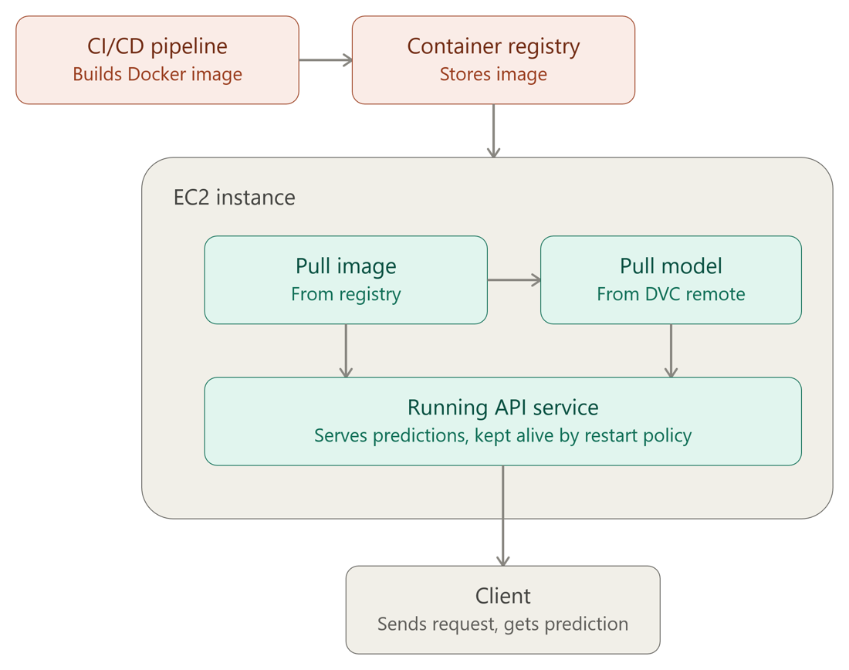
Fig. 2. Image and model delivery to the EC2 host.
E. Security controls
Every service except the HTTPS edge listens on the loopback interface. Administration uses Systems Manager. Production configuration refuses weak or shared tokens, SQLite, a missing model and any cross-origin setting that is not HTTPS or loopback. The instance requires IMDSv2.
VII. MONITORING AND RELIABILITY
The API exports Prometheus metrics for request counts and durations, inference time, ingestion runs and detected duplicates [12]. Prometheus scrapes them and Grafana shows a provisioned dashboard. Four alert rules cover an unreachable API, repeated readiness failures, sustained server errors and failed or partial ingestion; their firing and non-firing behavior is tested in CI. Containers use the restart policy unless-stopped, and Docker starts at boot. Compose health checks call the readiness endpoint, so dependent containers wait for a healthy database and API. Alert delivery, drift detection and host-level metrics are not implemented.
VIII. EVALUATION
A. Ranking metrics
Table IV lists the saved metrics of the three rankers (S-BERT is the sentence-transformer ranker). All three have identical validation scores (nDCG@5 of 1.0 and Precision@5 of 0.6), so the selection rule falls through to the algorithm name and chooses TF-IDF. Test MRR is 1.0 for all three. The hybrid ranker scores lower on the test queries (nDCG@5 0.7426), which shows that the held-out queries can separate rankers even though validation cannot. With six queries these numbers show that the pipeline measures, selects and registers a model. They do not show ranking quality for real users.
TABLE IV
SAVED RANKING METRICS
Ranker | Val. nDCG | Val. P@5 | Test nDCG | Test P@5 | Test R@5 | Test ms
TF-IDF | 1.0 | 0.6 | 1.0 | 1.0 | 0.917 | 26.9
S-BERT | 1.0 | 0.6 | 1.0 | 1.0 | 0.917 | 30.9
Hybrid | 1.0 | 0.6 | 0.743 | 0.7 | 0.667 | 29.0

B. Deployment verification
Table V lists checks run against the live system. Every value is taken from command output.
TABLE V
CHECKS ON THE LIVE DEPLOYMENT
Check | Observed result
Pipeline run on push | Checks, build, publish, deploy: 5 of 5 jobs passed
Readiness | Status ready; bundle ded4d86e…; model b3e854956e87-574536b6
Live ingestion | 1,052 postings (714, 306, 32); 7 duplicates; 1,045 stored
No token | HTTP 401
Candidate token | Ranked jobs with explanation; no fallback
Foreign origin | Cross-origin request refused
Certificate | Let's Encrypt; HTTP redirects to HTTPS
Crash recovery | About 4 s; restart count 1

C. Operational observations
The compressed API image is about 0.62 GB and the web image about 26 MB. Two ranking requests for five results, against a store of 1,045 jobs, took 2.1 s and 2.4 s on the host, including database access and scoring. Recovery from a killed server process took about four seconds. Stopping the container with docker kill is not a valid crash test, because Docker treats it as a manual stop and leaves the container down.
D. Threats to validity
The benchmark is small and its labels were written during development, so ranking metrics carry little statistical weight. Timings come from single observations on one host. The deployment was verified on one cloud account and one region.
IX. CHALLENGES AND LESSONS LEARNED
Five problems arose during deployment and none was solved by weakening a safety check. (1) Production refused a plain HTTP address, because the configuration rejects non-HTTPS origins; the site is served over HTTPS on an IP-derived hostname instead. (2) GitHub could not assume the AWS role, because newer repositories use a subject format that includes owner and repository IDs; the trust policy now accepts both formats. (3) On a forked repository, pushes did not start the workflow until the Actions permission was set explicitly; the cause was not investigated further. (4) The planned crash test did not trigger a restart, for the reason given in Section VIII; the test was corrected. (5) A new MLflow server starts empty, so the original run history was copied across with a checksum check. The common lesson is that a pipeline has to be verified end to end with real pushes and real failures, since each of these problems appeared only in the live system.
X. LIMITATIONS AND FUTURE WORK
One shared candidate token and one admin token protect the site, so there are no per-user accounts. Alert rules exist but nothing receives them. There is no drift detection or host metrics. The system runs on a single host, and database migrations are not rolled back automatically. Recovery after a reboot is expected from the restart policies but was not tested. Future work is a human-labelled benchmark of at least 30 real queries, per-user accounts, alert delivery, drift monitoring of resume and job features, infrastructure as code for the AWS resources, off-host backups and zero-downtime releases.
XI. CONCLUSION
CareerFlowOps carries a ranking model from versioned data to a verified, monitored service on AWS. DVC and MLflow make the model reproducible and its experiments comparable, a checksummed bundle lets the server refuse an unverified model, and a keyless GitHub Actions pipeline delivers immutable images to EC2. The live system was verified end to end, and its limits, mainly the small benchmark and the shared token, are stated. The same structure applies to larger models and teams, with the limits above addressed first.
REFERENCES
[1] D. Sculley et al., “Hidden technical debt in machine learning systems,” in Adv. Neural Inf. Process. Syst. 28, 2015, pp. 2503–2511.
[2] D. Kreuzberger, N. Kühl, and S. Hirschl, “Machine learning operations (MLOps): Overview, definition, and architecture,” IEEE Access, vol. 11, pp. 31866–31879, 2023.
[3] M. Zaharia et al., “Accelerating the machine learning lifecycle with MLflow,” IEEE Data Eng. Bull., vol. 41, no. 4, pp. 39–45, 2018.
[4] DVC Documentation, Iterative, Inc. [Online]. Available: https://dvc.org/doc
[5] J. Humble and D. Farley, Continuous Delivery. Boston, MA, USA: Addison-Wesley, 2010.
[6] G. Salton and C. Buckley, “Term-weighting approaches in automatic text retrieval,” Inf. Process. Manag., vol. 24, no. 5, pp. 513–523, 1988.
[7] N. Reimers and I. Gurevych, “Sentence-BERT: Sentence embeddings using Siamese BERT-networks,” in Proc. EMNLP-IJCNLP, 2019, pp. 3982–3992.
[8] W. Wang et al., “MiniLM: Deep self-attention distillation for task-agnostic compression of pre-trained transformers,” in Adv. Neural Inf. Process. Syst. 33, 2020, pp. 5776–5788.
[9] K. Järvelin and J. Kekäläinen, “Cumulated gain-based evaluation of IR techniques,” ACM Trans. Inf. Syst., vol. 20, no. 4, pp. 422–446, 2002.
[10] GitHub Docs, “Security hardening with OpenID Connect.” [Online]. Available: https://docs.github.com/actions
[11] AWS Documentation, “AWS Systems Manager Run Command.” [Online]. Available: https://docs.aws.amazon.com/systems-manager
[12] Prometheus Documentation. [Online]. Available: https://prometheus.io/docs

