Project ID: INT10



B. Tech. Project

“AI-Powered Meeting Lifecycle Management & Workflow Automation System”
Monthly Progress Report – August 2026

Under the Guidance of

Prof. Shruti Sunnad Dr. Madhvi Saxena

Group Members

Bontha Mallikarjun Reddy | 23070126026

DEPARTMENT OF ARTIFICIAL INTELLIGENCE & MACHINE LEARNING

1. Work Distribution: This is a solo project and all the activities like requirement analysis, literature review, system design, core module development testing and deploying are all being carried out by Bontha Mallikarjun Reddy.
2. Introduction
To begin with Most of the meetings remain central to how organizations plan, collaborate and make decisions yet the way they are typically managed is far from efficient. Notes get taken inconsistently, action items go undocumented and follow really happened in any structured way.
So, this results in most of the useful information getting not noted. Uh in market there is ma uh many number of AI meeting assistants already accessed to help with summarisation and trans transcription, but mostly stop there like they do much to connect the information they extract to the actual workflows of the teams like assigning tasks, tracking decisions, scheduling follow ups and so on this project sets out to build a platform that goes further than a raw meeting discussions and turns them into a structured, actionable workflows by combining meeting intelligence with task management, ongoing context memory, automation.
3. Problem Statement
The problem statement is to build an AI powered meeting life cycle management and workflow automation Platform that can automatically a capture meeting discussion, generate summaries, track decisions across meetings, flag deadlines and surface contextual insights these improve collaboration accountability and productivity.
4. Objectives
The objectives of this project are Convert audio Into accurate test transcript automatically and then generate summaries that are concise and genuinely reflective of the context of discussion then identify the key decisions made during the meetings, extract actionable items and understand whose responsibilities actions are, uh detect the deadlines and automatically create the reminders For the particular user, The meeting context is retained across multiple meetings so users can have a searchable and connected record rather than isolated and finally generating the agendas for upcoming meetings based on what left previously.
Present System Analytics and task status through an interactive dashboard is also an object

5. Literature Review
The following works and existing tools were reviewed to establish the methodological foundation for this project and to identify where current solutions fall short:
Sr. No. | Author(s) | Year | Paper / Study | Methodology / Technology | Key Findings | Research Gap
1 | Vaswani et al. | 2017 | Attention Is All You Need | Transformer Architecture | Introduced the Transformer model, significantly improving NLP tasks such as summarization and text generation. | Does not address meeting-specific understanding or workflow automation.
2 | Radford et al. (OpenAI) | 2022 | Whisper: Robust Speech Recognition via Large-Scale Weak Supervision | Deep Learning-based Automatic Speech Recognition (ASR) | Achieved high speech-to-text accuracy across multiple languages and noisy environments. | Focuses only on transcription without extracting meeting insights or actions.
3 | Jurafsky & Martin | 2023 | Speech and Language Processing | Natural Language Processing (NLP), Named Entity Recognition, Information Extraction | Provides comprehensive techniques for extracting entities, summarization, and semantic understanding from text. | General NLP concepts; does not provide an end-to-end meeting intelligence solution.
4 | Microsoft | 2023 | Microsoft 365 Copilot | Large Language Models (LLMs), Microsoft Graph Integration | Generates meeting summaries, highlights key discussion points, and suggests follow-up actions within Microsoft Teams. | Primarily works within the Microsoft ecosystem and offers limited customizable workflow automation.
5 | Otter.ai Research Team | 2023 | AI-Powered Meeting Assistant | Automatic Speech Recognition, NLP, Cloud-based AI | Provides real-time transcription, searchable meeting notes, and meeting summaries. | Limited long-term context management and project lifecycle tracking across meetings.
6 | Fireflies.ai | 2023 | Meeting Intelligence Platform | Speech Recognition, NLP, AI Automation | Automates note-taking, extracts action items, and integrates with productivity tools. | Focuses mainly on transcription and summaries; lacks advanced contextual memory and intelligent agenda generation.
7 | Zoom Video Communications | 2024 | Zoom AI Companion | Generative AI, NLP, Meeting Intelligence | Automatically summarizes meetings and assists users with post-meeting information. | Primarily designed for meeting summarization with limited workflow tracking beyond meetings.
8 | Lewis et al. | 2020 | Retrieval-Augmented Generation (RAG) for Knowledge-Intensive NLP Tasks | Retrieval-Augmented Generation (RAG), Dense Passage Retrieval | Demonstrated how combining retrieval with LLMs improves factual accuracy and contextual responses. | Not specifically applied to maintaining long-term meeting memory or workflow management.
9 | Brown et al. | 2020 | Language Models are Few-Shot Learners (GPT-3) | Large Language Models (LLMs), Few-shot Learning | Showed that large language models can perform diverse language understanding and generation tasks with minimal task-specific training. | Does not address structured extraction of meeting decisions, deadlines, or enterprise workflows.

6. Research and Technology Gap
So there are many AI meeting assistance which already are available in the market which rewards around basic transcription and summarization What they generally lack is a real memory context which gives it the ability to track the project across multiple meetings and a way to turn extracted information into an active workflow automation So this is a huge gap in the current products. This project tries to close the gap By combining open source models with a workflow automation which aims to create a platform that stays context aware continuously rather than treating a meeting is an isolated event.
7. Proposed Solution (System Workflow)
The platform will turn unstructured meeting discussions into actionable workflows through the following steps:
- Audio Capture & Transcription: Record or accept uploaded meeting audio and convert it to text using the Whisper speech-to-text model.
- Intelligent Summarization: Use a large language model to analyze the transcript and produce a concise, relevant summary.
- Insight Extraction: Automatically identify action items, responsible participants, key decisions, and deadlines.
- Contextual Memory: Store meeting data so it can be searched later and so context carries over across a series of related meetings.
- Workflow Automation: Generate reminders and calendar events automatically based on the deadlines detected.
- Agenda Generation: Build agendas for upcoming meetings by looking at what's still unresolved or pending.
- Centralized Dashboard: Give users one place to track task status, meeting summaries, and overall progress.
8. Requirement Analysis
Functional Requirements:
- User authentication and management
- Meeting audio upload and speech-to-text conversion
- AI-generated summaries and extraction of action items, decisions, and deadlines
- Semantic search across meetings
- Reminder generation and calendar integration
- Analytics dashboard
Non-Functional Requirements:
- High accuracy and reliability in transcription and extraction
- Has a Secure workflow
- UI is user friend friendly And a low latent interface.
9. Technology Stack
These are all the tech technologies we are planning to useless project and chosen technologies are open source so that the project can be furtherly continued
Sr. No. | Component | Technology / Tool | Specific Utilization
1 | Frontend Framework | Next.js | Application routing and frontend rendering.
2 | UI Library | React | Interactive components and application state.
3 | Programming Language | TypeScript | Type safety in frontend logic and API communication.
4 | Styling | Tailwind CSS | Responsive layout and visual styling.
5 | Backend Framework | FastAPI | REST APIs for authentication, meetings, tasks, search, and other functions.
6 | Backend Language | Python | AI integration, processing pipeline, and business logic.
7 | Database ORM | SQLAlchemy 2.0 | Database models, relationships, and asynchronous persistence.
8 | Schema Migrations | Alembic | Versioned database schema management.
9 | Development Database | SQLite | Lightweight local development and automated tests.
10 | Production Database | PostgreSQL | Persistent relational storage for a deployed multi-user environment.
11 | Speech Recognition | faster-whisper / Whisper | Transcription of uploaded meeting audio when the real provider is configured.
12 | Language Model | Ollama with a locally hosted model | Local summarization and structured extraction when model setup is complete.
13 | Optional External LLM | OpenAI API | Alternative analysis provider, if configured. This is not an open-source component.
14 | Embedding Generation | Sentence Transformers | Local embedding generation, subject to successful installation and model availability.
15 | Vector Search | ChromaDB | Semantic retrieval of indexed meeting content.
16 | Background Processing | Python asyncio worker | Executes processing stages, retry handling, and reminder scheduling.
17 | Storage | Local filesystem provider | Stores meeting media using generated storage keys.
18 | Authentication | JWT and Argon2 | Authentication tokens and secure password hashing.
19 | Email | SMTP / Console fallback | Sends configured email notifications or logs demonstration messages.
20 | Calendar | ICS export | Produces calendar-compatible event files.
21 | API Testing | pytest and relevant HTTP test clients | Verifies backend behavior and integration flows.
22 | Code Quality | Ruff and TypeScript checks | Python linting and frontend type validation.
23 | Deployment | Docker and Docker Compose | Containerized development and deployment setup.
24 | Version Control | Git | Source-code history and change tracking.

10. System Design
- 10.1 System Architecture / Block Diagram:
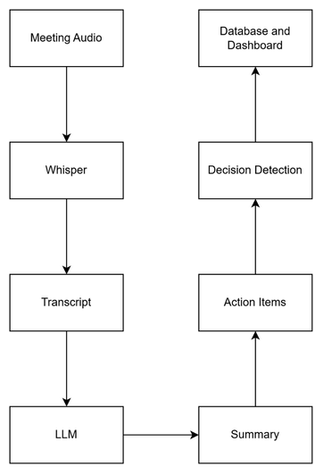

- 10.2 Workflow / Activity Diagram:
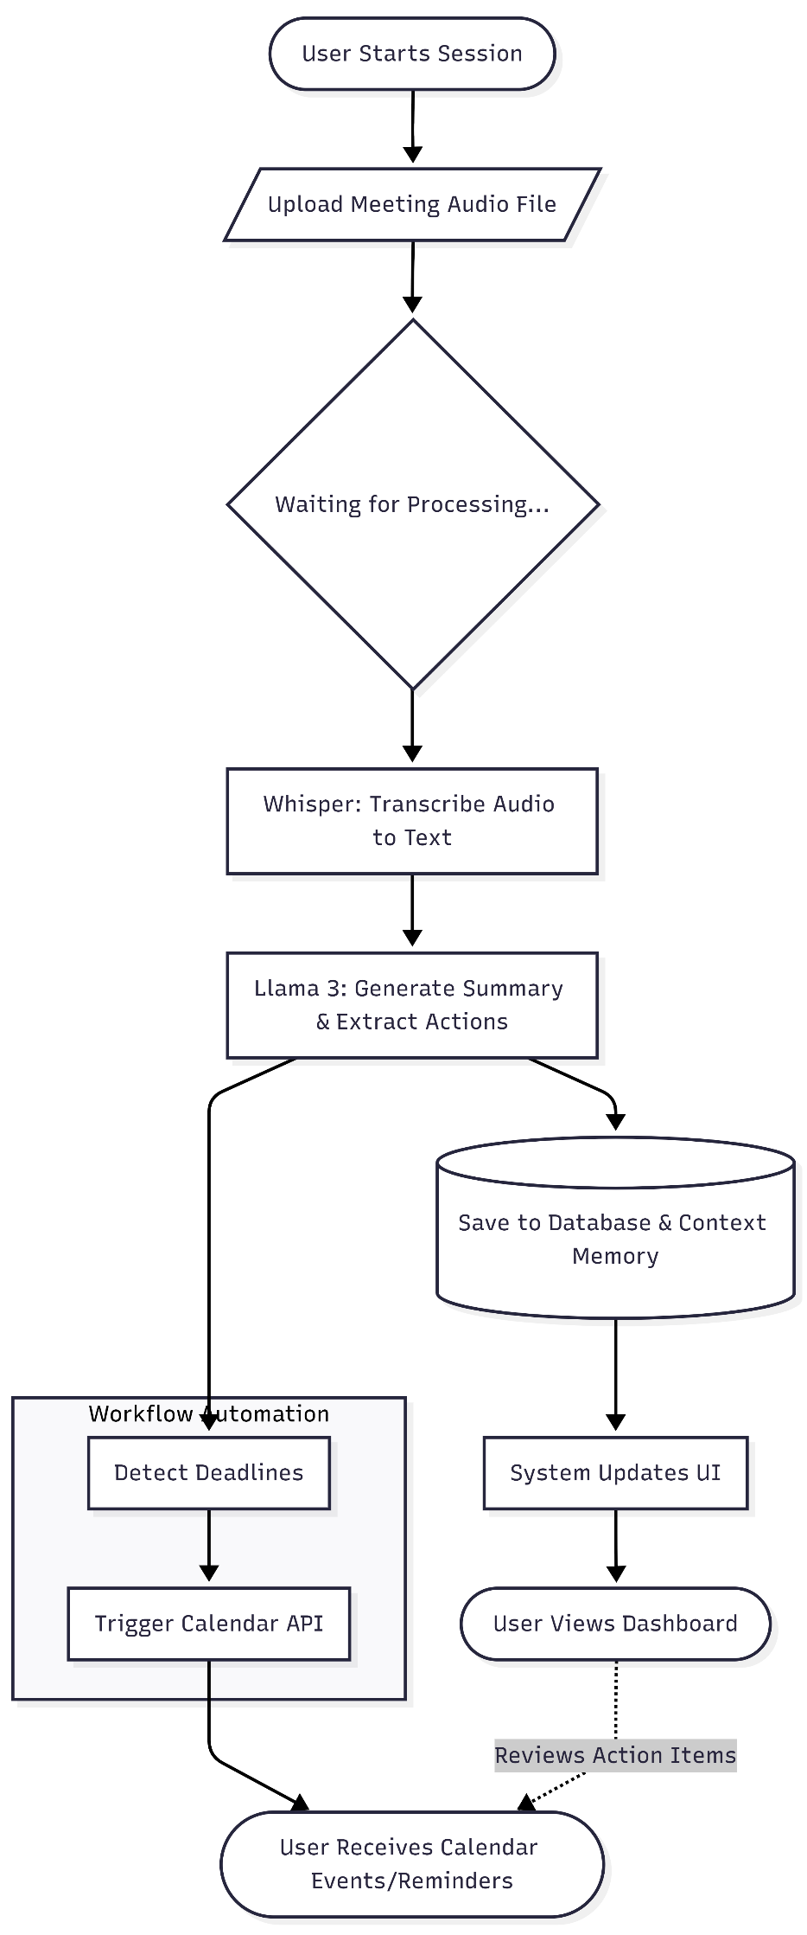

- 10.3 Database Schema / ER Diagram:
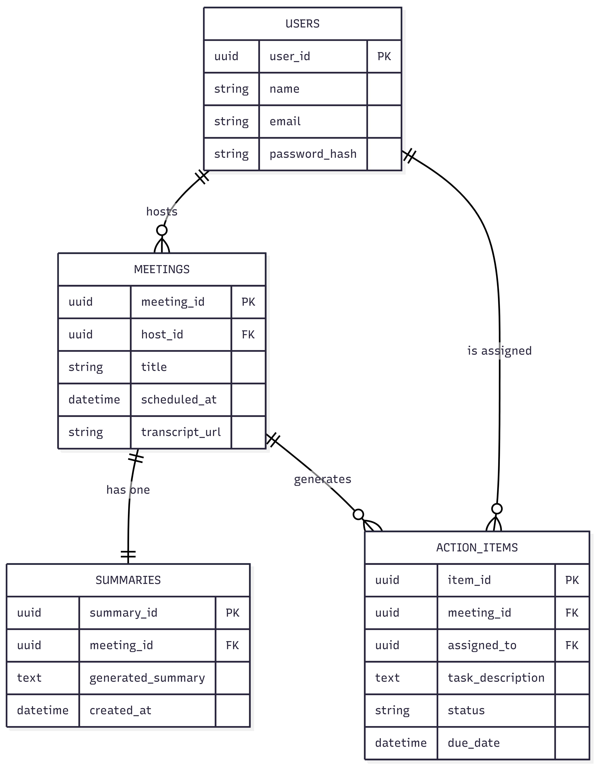

10.4 Main Backend Components
Component | Responsibility
API Routes | Receive requests, validate inputs, authorize access, and return responses.
SQLAlchemy Models | Define persistent entities and their relationships.
Pydantic Schemas | Validate requests and structured outputs.
Provider Interfaces | Abstract transcription, LLM, embedding, storage, and email implementations.
Background Worker | Process uploaded media and advance processing jobs.
State Machine | Validate permitted meeting and action-item status transitions.
Vector Store | Manage ChromaDB collections and indexed content.
Audit Service | Record important user and system actions.
Frontend API Client | Communicate with backend endpoints.
Frontend Views | Present transcripts, summaries, tasks, search results, and other workspace information.
11. Development and Implementation Status
The project has progressed from planning and design to implementation of the core application components.
11.1 Frontend Development
The frontend uses Next.js, React, TypeScript, and Tailwind CSS. It provides a dashboard and workspace interface for interacting with projects, meetings, action items, and related information.
The meeting-detail interface supports viewing meeting information, processing status, transcript segments, summaries, decisions, and action items. The upload interface communicates with backend processing endpoints to display upload progress and job status.
Search and supporting workspace views have also been implemented, with live API data used where configured.
11.2 Backend Development
The backend is implemented using FastAPI and SQLAlchemy. The API layer includes modules for authentication, meetings, projects, action items, decisions, notifications, dashboard aggregates, search, and agenda generation.
The backend includes organization-scoped records, membership roles, authentication utilities, state-transition validation, audit logging, and database migrations.
11.3 Meeting Processing Pipeline
The background processing pipeline contains seven principal stages:
- Validate Media: Confirm that the uploaded media is available and suitable for processing.
- Extract Audio: Prepare or extract an audio stream where necessary.
- Transcribe: Run the configured speech-to-text provider.
- Analyze: Process the transcript using the configured language-model provider.
- Persist: Store transcript segments, summaries, decisions, and action items.
- Vector Embed: Generate embeddings for relevant content and update the vector index.
- Reminders: Create appropriate reminder records and related notifications.
The worker supports status tracking, error handling, retry logic, and idempotent processing. SQLite development behavior and PostgreSQL-oriented job locking are handled separately.
11.4 AI Provider Integration
The project defines provider interfaces for transcription, language-model analysis, and embedding generation. Local implementations are available for faster-whisper and Ollama, with an optional external LLM provider.
Fallback providers support deterministic testing without requiring a model download during every test run. Demonstration output is labelled so that it is not confused with genuine AI-generated output.
Full validation of local model performance requires a correctly configured model runtime and actual meeting recordings.
11.5 Context Memory and Search
The search module combines semantic retrieval with database text matching. A context endpoint provides related meetings, recent decisions, and outstanding tasks.
This functionality supports historical retrieval and provides a foundation for meeting continuity. The quality of retrieval depends on the configured embedding provider, indexed content, and the accuracy of the underlying records.

11.6 Agenda Generation and Workflow Automation
The agenda module generates suggested topics using information such as overdue tasks, open action items, unresolved decisions, previous summaries, and current meeting information.
Reminder scheduling is implemented in the background worker, and ICS export provides a practical way to transfer meeting events into compatible calendar applications.
Direct Google Calendar OAuth remains an outstanding integration.

12. Testing and Debugging
Implementation Status: Planned
For testing and debugging, A full scale testing shoulders planned which is after the development. Evaluation matrix will rely on mostly precise recall, and F1 score score for the A extraction tasks with respect to response time matrix.
The test phases include a unit test integration test and fundamental test which mostly includes whether the transcription is Accurate And checking individual point endpoints are received. Along with validating action items with reminders in the calendar integration, testing whether the AI actually understands the context of the previous meetings and along for the next meeting

UI Screenshots {On Progress}:
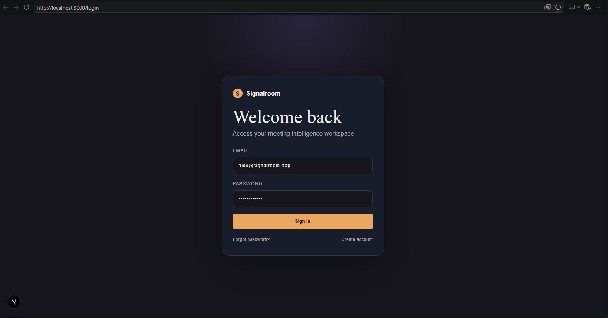
Figure: Login Page
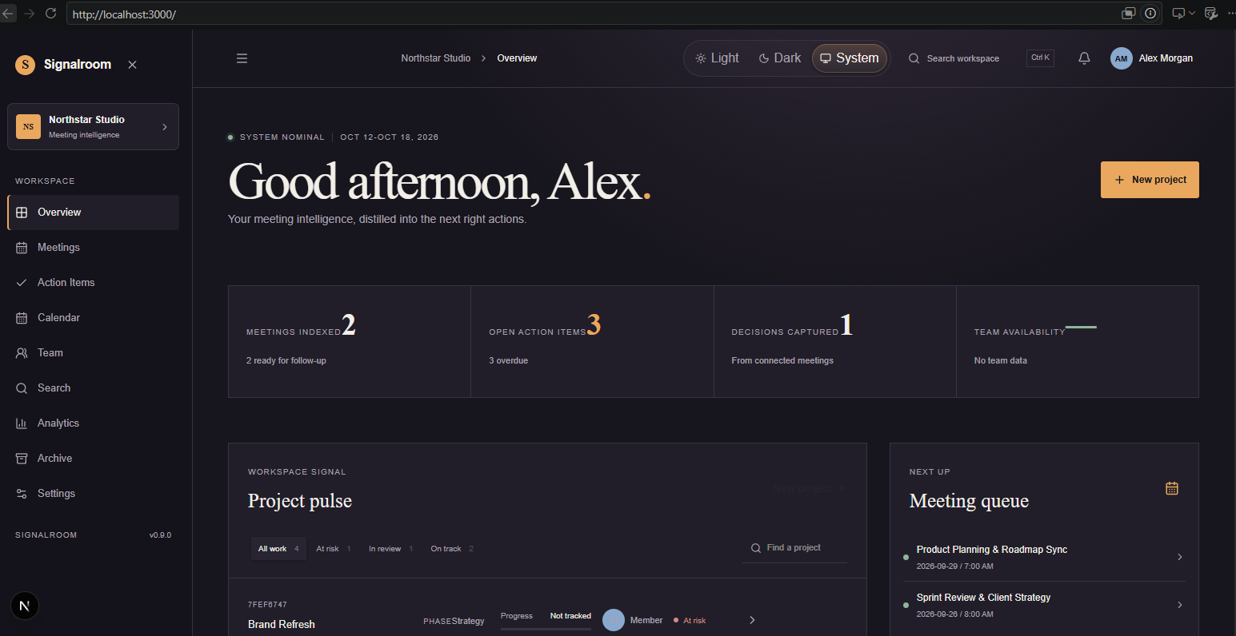
Figure: Home Page
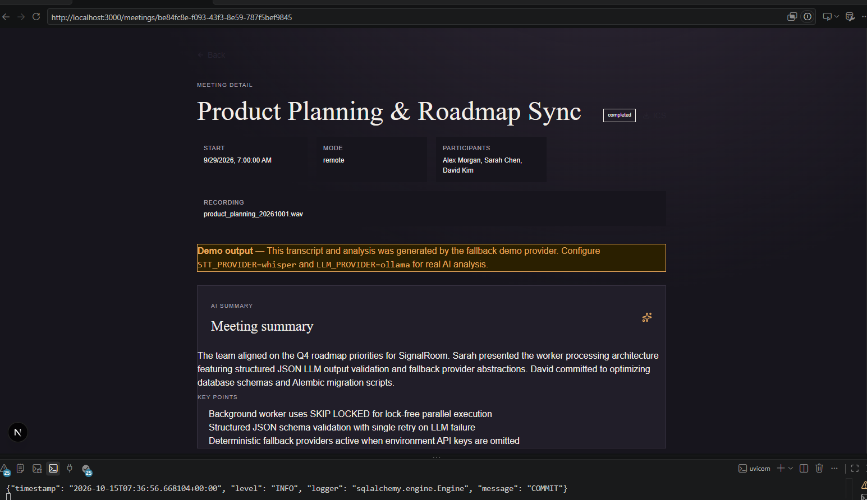
Figure: Meetings Analysis By AI
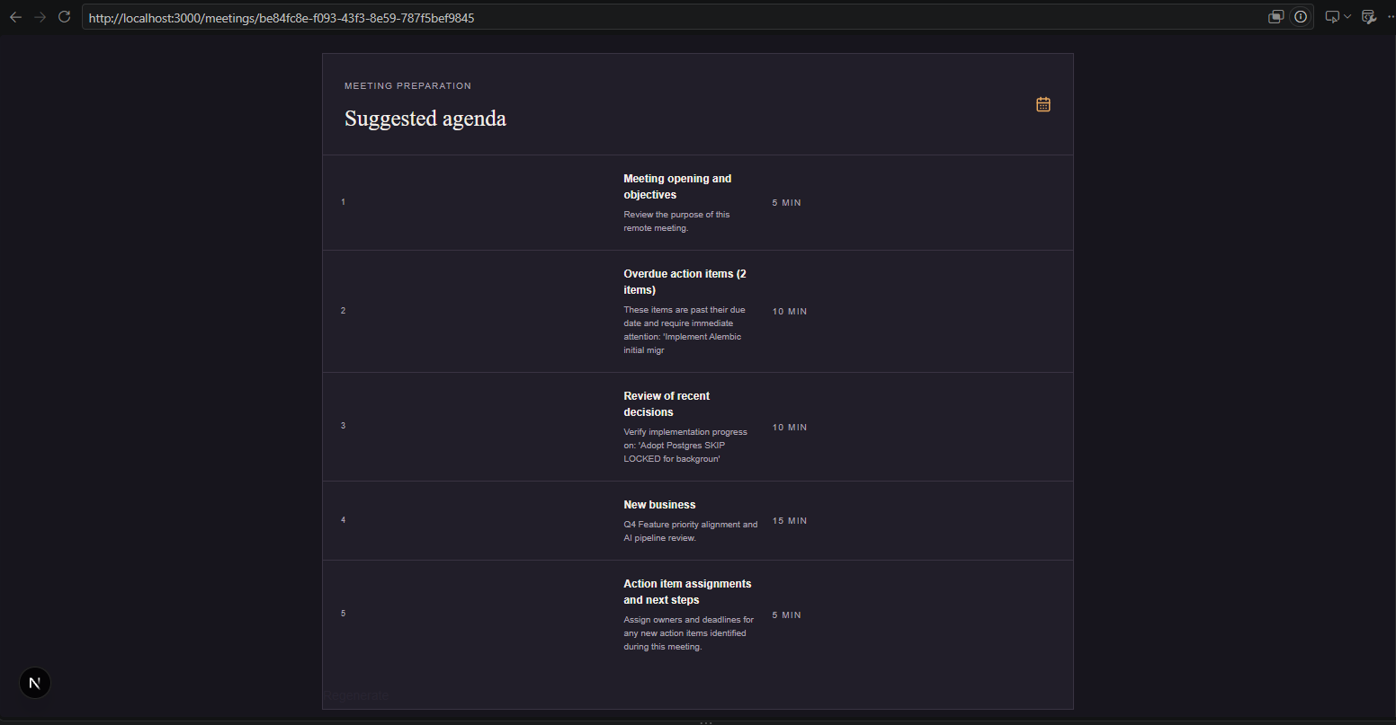
Figure: Agenda Generation
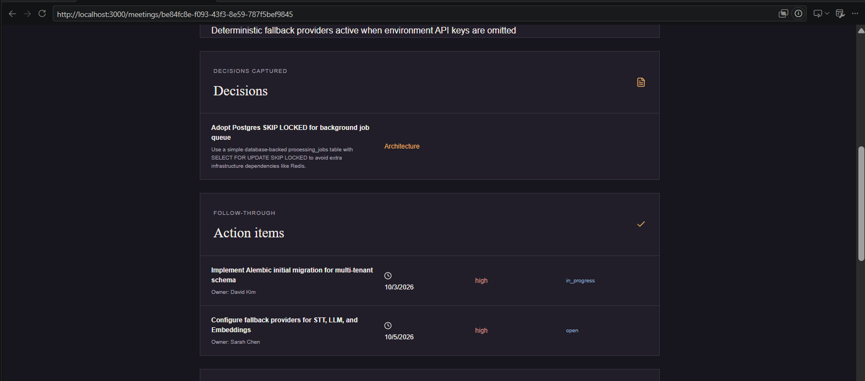
Figure: Decisions and Action Items Captures

13. Project Plan and Progress
The timeline below reflects a slight delay in finalizing the system design and UI, which is currently being actively worked on.
Phase | Planned Duration | Current Status | Remarks
Requirement Analysis & Literature Review | Week 1 | ✅ Complete | Scope, requirements, and literature finalized.
System Design & UI Development | Week 2–4 | 🟡 In Progress | Architecture finalized; UI wireframes and schemas actively being developed.
Core Feature Development | Week 5–7 | ⏳ Planned | Pending backend setup and AI integration.
Dashboard Dev & Refinement | Week 8 | ⏳ Planned | –
Testing & Validation | Week 9–10 | ⏳ Planned | –
Documentation & Deployment | Week 11–12 | ⏳ Planned | –
14. Project Outcome
Currently the expected outcomes are the system should be able to understand the meetings documentation and cut down the manual effort also making the reminders tasks easier to enforce. Tracking decisions along the meetings and updating it to next meet Should also be automated and analytical support must be provided. So far the problem is currently clearly defined and complete literature review has been done and finalization of the technology stack and the open source tools for this project has been decided along with a basic UI for representation has been done which is not yet integrated. Interface design And and of back end are actively underway and preparation for core development phase on going.
15. Conclusion
So the conclusion for this Report Is to show AI can go beyond the basic summarization tasks. By adding some creative understanding along with Real life issues precious the idea of AI for meeting management uh powered by open search alarms for summarization and context memory The platform aims to to make the A manual work effort Simpler. The the next phase is ongoing right and other developments going steadily.
16. References
- Vaswani, A., et al., "Attention Is All You Need," NeurIPS, 2017.
- Radford, A., et al., "Whisper: Robust Speech Recognition via Large-Scale Weak Supervision," OpenAI, 2022.
- Jurafsky, D., & Martin, J. H., Speech and Language Processing, 3rd ed., 2023.
- Brown, T., et al., "Language Models are Few-Shot Learners," NeurIPS, 2020.
- Lewis, P., et al., "Retrieval-Augmented Generation for Knowledge-Intensive NLP," NeurIPS, 2020.
- Microsoft. "Microsoft 365 Copilot Documentation."
- Fireflies.ai Product Documentation.
- Otter.ai Product Documentation.
- Zoom AI Companion Documentation.
17. Similarity Report
PTO
18. AI Plagiarism Report
PTO

