**Python**

Index

Introduction 2

Python 2

Installing Python 3

Python Syntax 4

Python Comment 4

Python Variable 5

Naming Convention of Variable 5

Why Python is case sensitive: 6

# Introduction

## Python

What is Python?

1. Python is an interpreter language that means code will execute as soon as written.
2. Python is dynamic language
3. Python is used for :

* Web development (server-side)
* Software development
* Mathematics
* System scripting.

Note **

*Python was created by Guido van Rossum, and released in 1991.*

*Interpreter language: It means code will be executed line by line by interpreter.*

Why Python is Dynamic Language?

1. No need to define data types while initialize variable.
2. Variable only determine in runtime.
3. Dynamic binding: It means function and operation can be applied to object of different types,

and correct behavior determine dynamically. For example:

Example 1,

a = 10

b = "Hello"

print( a + b ) // it will concatenate integer and string

Example 2,

a = 10

b = 20

print( a + b ) // it will perform Arithmetic operation

## Installing Python

Many PCs and Macs will have python already installed.

To check if you have python installed on a Windows PC, search in the start bar for Python or run the following on the Command Line (cmd.exe):

C:\Users\Your Name>python --version

If not pre-installed follow below instruction:

**Windows:**

1. Visit the official Python website (<https://www.python.org/>).
2. Click on download and select latest version.
3. Run installer

* Ensure the checkbox **"Add Python to PATH"** is selected.
* Click "Install Now" to start the installation.

1. Verify installer by commanding above line in terminal

**Macs:**

1. Homebrew (Recommended):

* Open the Terminal.
* Install Homebrew if not already installed (https://brew.sh/).
* Run brew install python.

1. macOS Package Installer:

* Visit the official Python website.
* Download the macOS package installer (.pkg file).
* Double-click the installer and follow the on-screen instructions.

1. Verify Installation:

* In the Terminal, type python3 --version or python3 -V.

**Linux:**

1. Opend terminal

* sudo apt update
* sudo apt install python3

## Python Syntax

**Python Indentation**

1. It refers spaces at the beginning of the code line (4 spaces)
2. It is used to indicate block of code

Example

Syntax 1:

print(“Hello world”)

Syntax 2:

If 10 > 5:

___print(“10 is greater”) // here ___ indicate space

Do visited this link for more example:

Link:

## Python Comment

1. Comments are used to explain the code.
2. Comment make code more readable.
3. Comment can be used to prevent execution when testing

Types:

* Single Comment (#)

Syntax: #comment

* Multiline Comment(“”””””)

Syntax:

“””

Comment

“””

# Python Variable

* Variables are the container that store values.

Syntax:

num = 10

name = “Python”

## Naming Convention of Variable

1. Variable should not be keyword.

Keywords are reserved word in Python. Keywords are case sensitive. They are used to define the syntax and structured of the Python language.

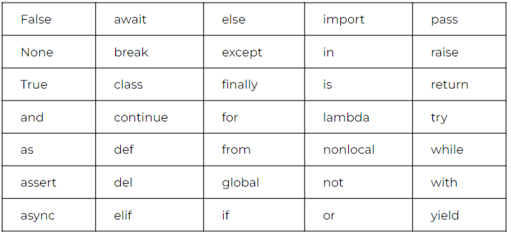

1. Symbol like @!#$ etc. can’t be used in our identifier
2. Variable should be in snake case. (first_name, last_name)
3. Variable should not contain space. (first name)
4. Variable cannot be start with number.

## Why Python is case sensitive:

* ***Variable and variable are not same.***

Example:

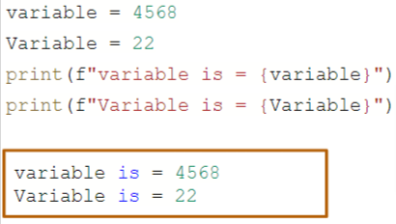

## Possible Interview Question

***Answer in link:***

1. Explain the difference between dynamic typing and static typing in Python.
2. How can you access and modify global variables within a function?
3. How do you check the data type of a variable in Python?
4. What is the difference between mutable and immutable data types in Python?