 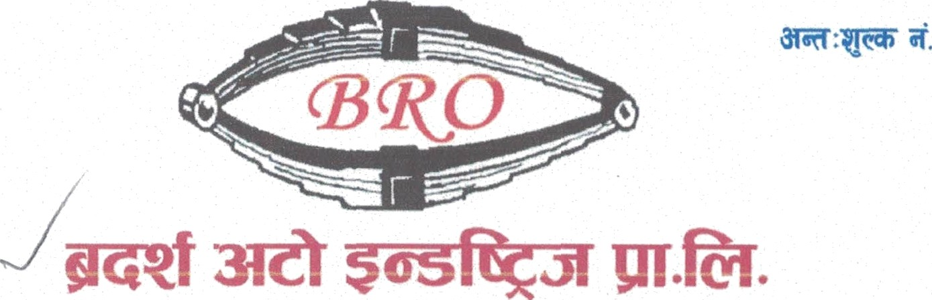 

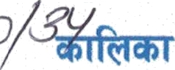

Brothers Auto Industries Pvt. Ltd.

20-04-2023

To whOIR it may concern

This is to certify that Mr. Jeevan Sharma Pandey, son of Mr. Baburam Pandey and Mrs. Tulasi Devi Pandey an inhabitant of Madantole, devdah-

07, Rupandehi (Nepal) has been working as a Technical company since 7t January 2021 to till date 19" April 2023.

Supervisor in this

During that period, his performance was satisfactory and we found that he had exceptional managerial skills. We always found him trustworthy, punctual and dedicated to his duties and responsibilities. He has a good moral character and he behaves well with clients and coworkers.

We w’ish him the best of luck in future endeavors.

Brothers Auto Industries Pvt. Ltd.

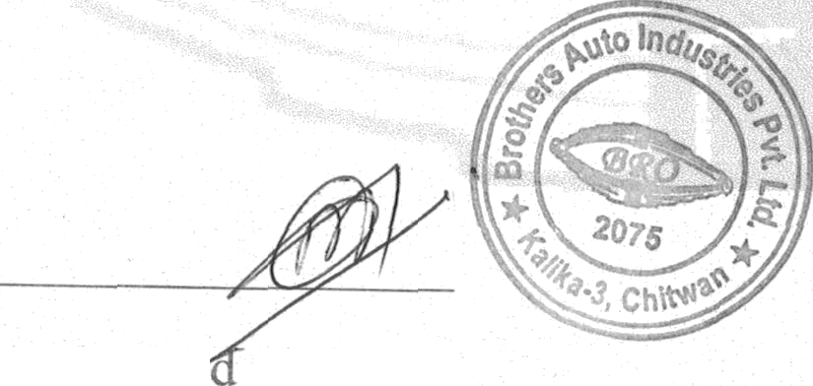

Authorize Signatory