Slither-analyses

Slither is a Solidity static analysis framework written in Python 3

we must need to analyze smart contract to first deploy contract on evm network so we have use slither to find error in the source code.

Installation cmd by using pip3
pip3 install slither-analyzer

Slither-python code:-

from slither.slither import Slither
import os

files_sol = os.listdir("/home/workdir/solidity_files/")
for file in files_sol:
slither = Slither("solidity_files/"+file)
for contract in slither.contracts:
print ('Contract: ', contract.name)
for function in contract.functions:
print('Function: {}'.format(function.name))
print('\tRead: {}'.format([v.name for function.state_variables_read]))
print('\tWritten {}'.format([v.name for v in function.state_variables_written]))

cmd :- slither </filename.sol>

fun_writing.sol
contract Contract{

uint a;

Function arjun() public{
a++;
}

// shadowing of a
function dont_write(uint a) public{
a = a +1;
}

}

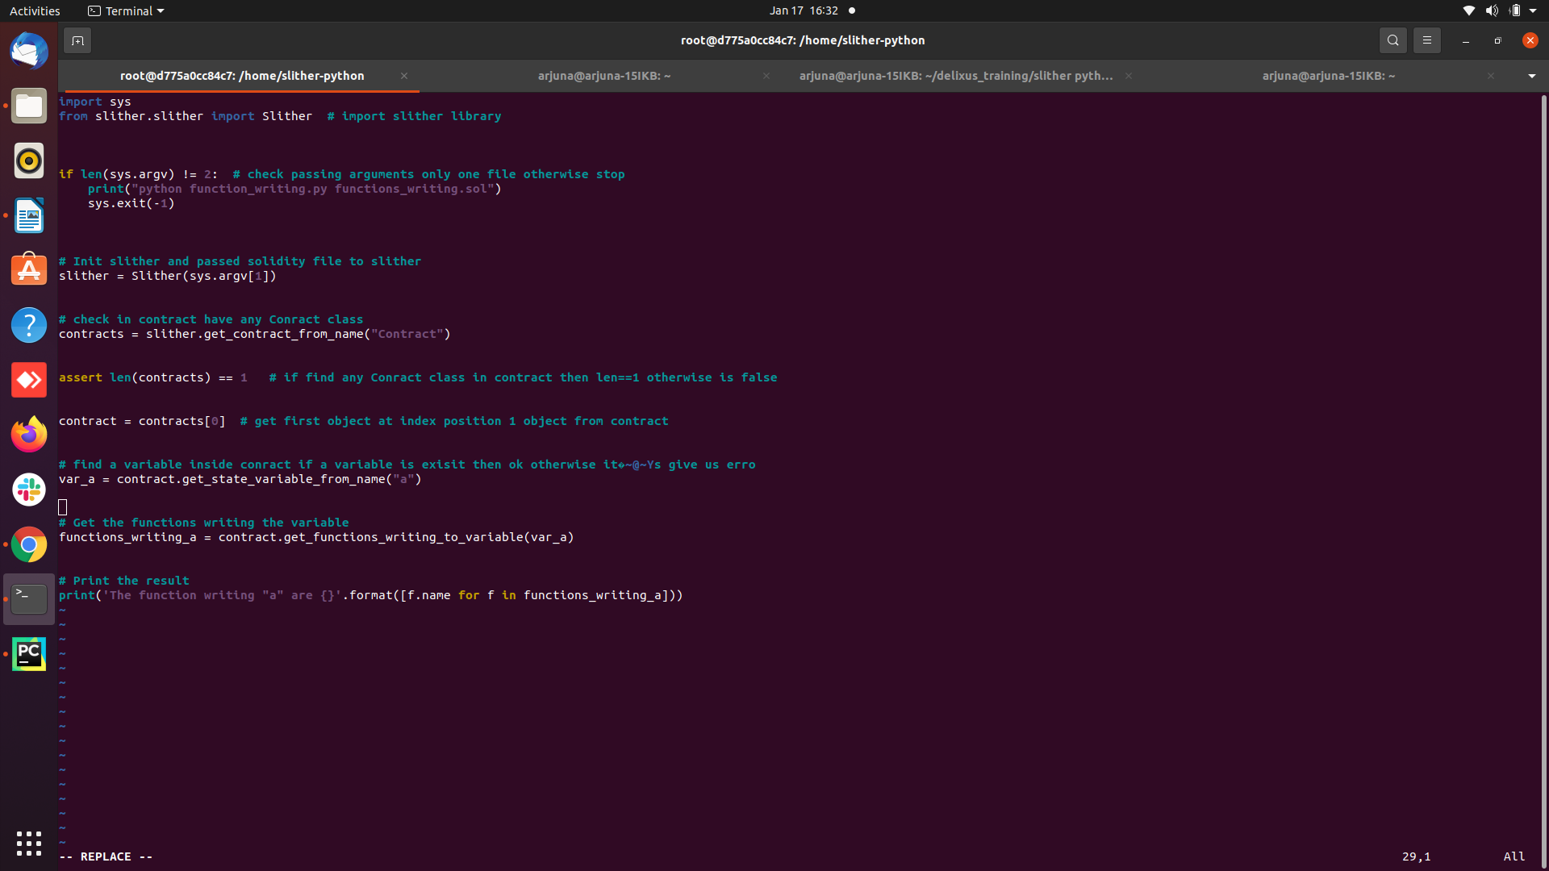

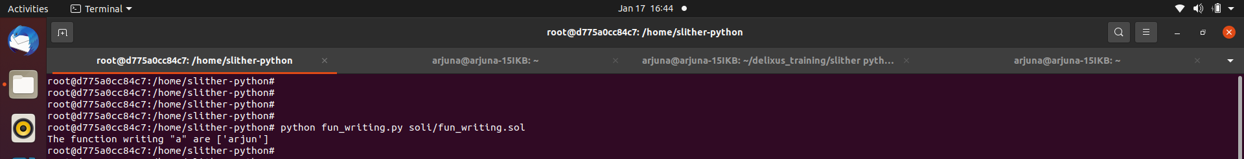
output : The function writing "a" are ['arjun']

