VALORANT GAME

Object Oriented System Design

August 04, 2023

The Kyoto College of Graduate Studies for Informatics

Applied Information Technology

Web Business Technology

Arjun Thapa

M22W0385

（Spring 2023, Web system Development）

Table of Contents

Chapter 1 Introduction 1

Chapter 2 Use case diagrams 2

Chapter 3 Activity diagrams 7

Chapter 4 Class and object diagrams 9

Chapter 5 Sequence diagrams 14

Chapter 6 Communication diagram 18

Chapter 7 State machine diagrams 19

Chapter 8 User interface design 20

Chapter 9 Conclusion 24

# **Chapter 1 Introduction**

The gaming and entertainment environment have been completely transformed by online games, sometimes referred to as multiplayer or internet games. They are video games that connect users from across the world in virtual gaming worlds, enabling online communication and multiplayer gameplay. Role-playing games (RPGs), first-person shooters (FPS), strategy games, massively multiplayer online games (MMOs), and more are among the many types of games that may be played online.

Valorant combines elements of traditional tactical shooters with unique character-based abilities, similar to hero shooters. In the game, players assume the roles of agents, each with their own distinct abilities and playstyles. The objective varies depending on the game mode, but the most common one is a 5v5 format, where one team plays as attackers trying to plant a bomb called the "Spike," while the other team acts as defenders trying to prevent the Spike from being planted or defuse it if it has been planted.

Players can purchase weapons and equipment at the beginning of each round using in-game currency earned through successful plays, kills, and objectives. Valorant emphasizes teamwork, communication, and strategy, as players need to coordinate their abilities and tactics to secure victory.

# **Chapter 2 Use case diagrams**

**Fig: - Use case Diagram**

# 

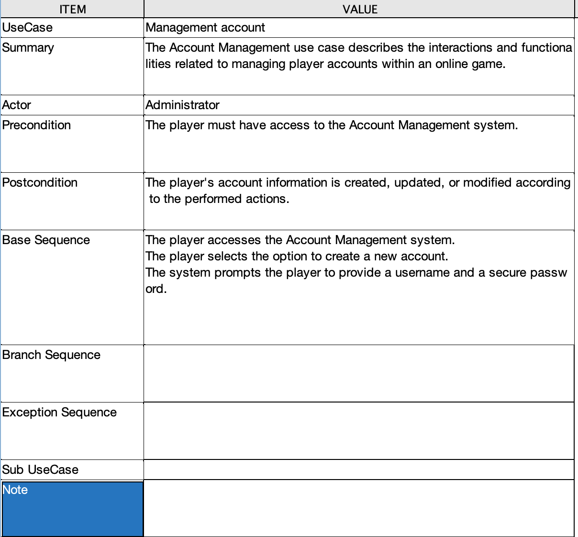

# **Chapter 3 Activity diagrams**

**Fig: - Activity Diagram**

# **Fig: - Activity Diagram**

# **Chapter 4 Class and object diagrams**

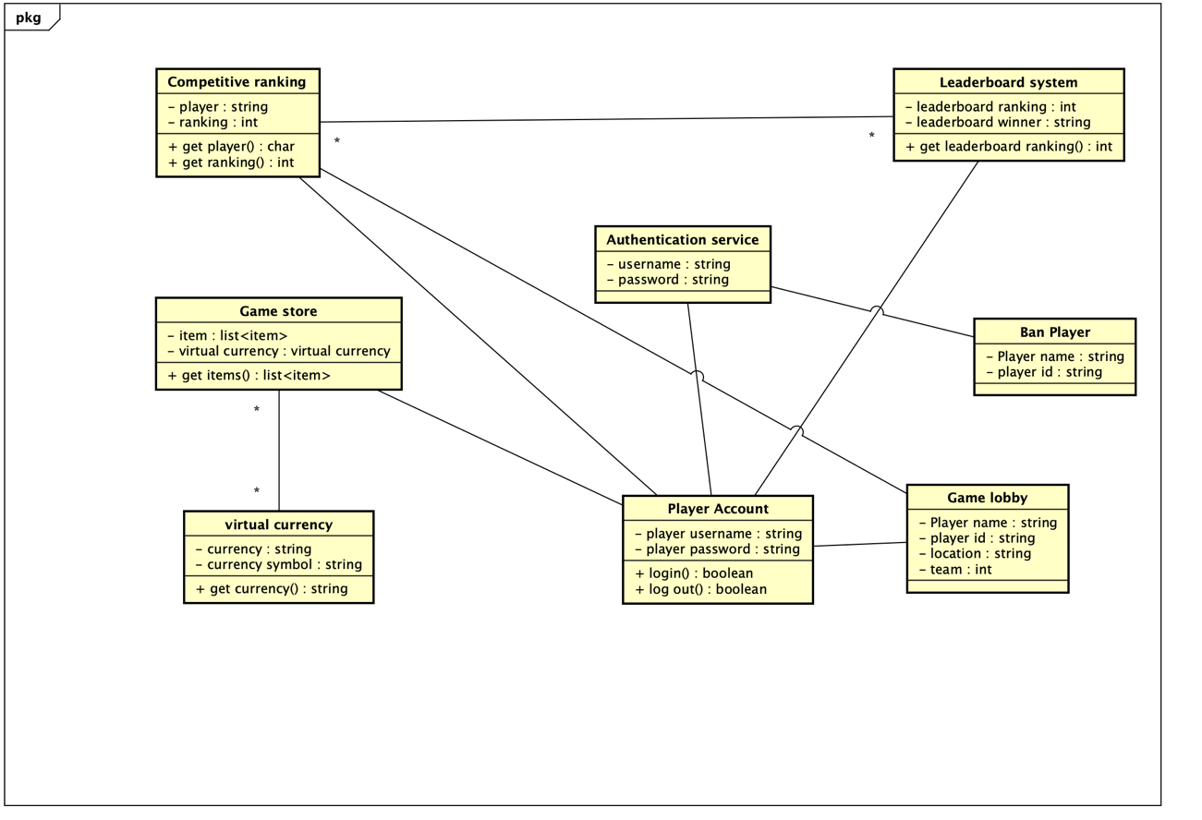

**Fig: - Class Diagram**

**Fig: - Object diagram**

|  |  |  |  |
| --- | --- | --- | --- |
| **Class Name:** Player | **ID:** 1 | | **Type:** |
| **Description:** A player is a person who participates in playing a game. | | | **Associated use cases:** |
| **Responsibilities**  - Act as a game player's representative.  - Save information about a player, such as their username, level, experience points, and accomplishments.  - Engage in gameplay interactions, take actions, and react to game events. | | **Collaborators**  Game store.  Virtual currency.  Competitive ranking.  Leaderboard system | |
| **Attributes:**  Player name  Player ID  Player ranking | | | |

|  |  |  |  |
| --- | --- | --- | --- |
| **Class Name:** Leaderboard System | **ID:** 2 | | **Type:** |
| **Description:** It is showing the player ranking in the game. | | | **Associated use cases:** |
| **Responsibilities**  - Keep track of leaderboard participants.  - Add new entries to the leaderboard.  - Retrieve the current leaderboard. | | **Collaborators**  Player.  Competitive ranking. | |
| **Attributes:**  Player name  Player ID  Leaderboard entry | | | |

|  |  |  |  |
| --- | --- | --- | --- |
| **Class Name:** Competitive Ranking | **ID:** 3 | | **Type:** |
| **Description:** It is showing the ranking of the game which is play by online with other player in the game. | | | **Associated use cases:** |
| **Responsibilities**  - Maintain the ranking of a player in the competitive mode.  - Provide access to the player's ranking. | | **Collaborators**  Player.  Leaderboard system | |
| **Attributes:**  Player name  Player ID  Leaderboard ranking  Competitive ranking | | | |

|  |  |  |  |
| --- | --- | --- | --- |
| **Class Name:** Game store | **ID:** 4 | | **Type:** |
| **Description:** It is the place where player can buy the item by using virtual currency | | | **Associated use cases:** |
| **Responsibilities**  - Maintain a list of available items for purchase.  - Provide access to the list of items.  - Manage virtual currency for transactions. | | **Collaborators**  Player.  Virtual currency. | |
| **Attributes:**  Player name  Player ID  Virtual currency  Item price  Item name | | | |

|  |  |  |  |
| --- | --- | --- | --- |
| **Class Name:** Virtual currency | **ID:** 5 | | **Type:** |
| **Description:** It is the coin or money which is used to buy the item from the game store. | | | **Associated use cases:** |
| **Responsibilities**  - Maintain the name and symbol of the virtual currency. | | **Collaborators**  Game store.  Player. | |
| **Attributes:**  Player name  Player ID  Item name  Item price | | | |

|  |  |  |  |
| --- | --- | --- | --- |
| **Class Name:** Authentication Service | **ID:** 6 | | **Type:** |
| **Description:** It is used to secure the account from the hacker or third party. | | | **Associated use cases:** |
| **Responsibilities**  - Authenticate player accounts based on provided credentials.  - Manage player accounts and access. | | **Collaborators**  player | |
| **Attributes:**  Player name  Player ID  Player password | | | |

|  |  |  |  |
| --- | --- | --- | --- |
| **Class Name:** Player Achievement | **ID:** 1 | | **Type:** |
| **Description:** A player is a person who participates in playing a game. | | | **Associated use cases:** |
| **Responsibilities**  - Track the player's achievements.  - Provide access to the player's achievements. | | **Collaborators**  player | |
| **Attributes:**  Player name  Player ID | | | |

# **Chapter 5 Sequence diagrams**

**Fig: - Sequence diagram of Game Authentication and account management**

**Fig: - Sequence diagram of Game store and virtual currency**

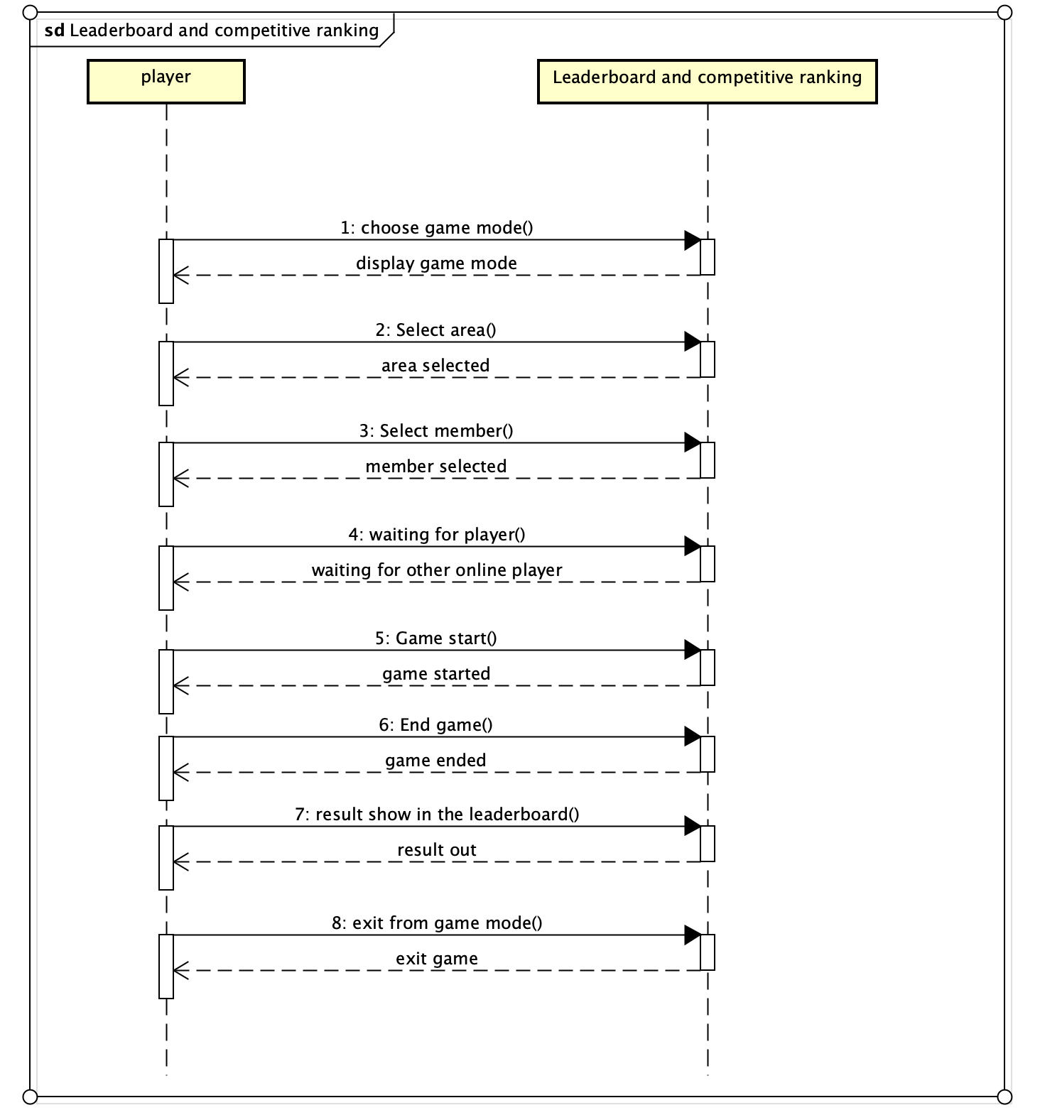

**Fig: - Sequence diagram of Leaderboard and competitive ranking**

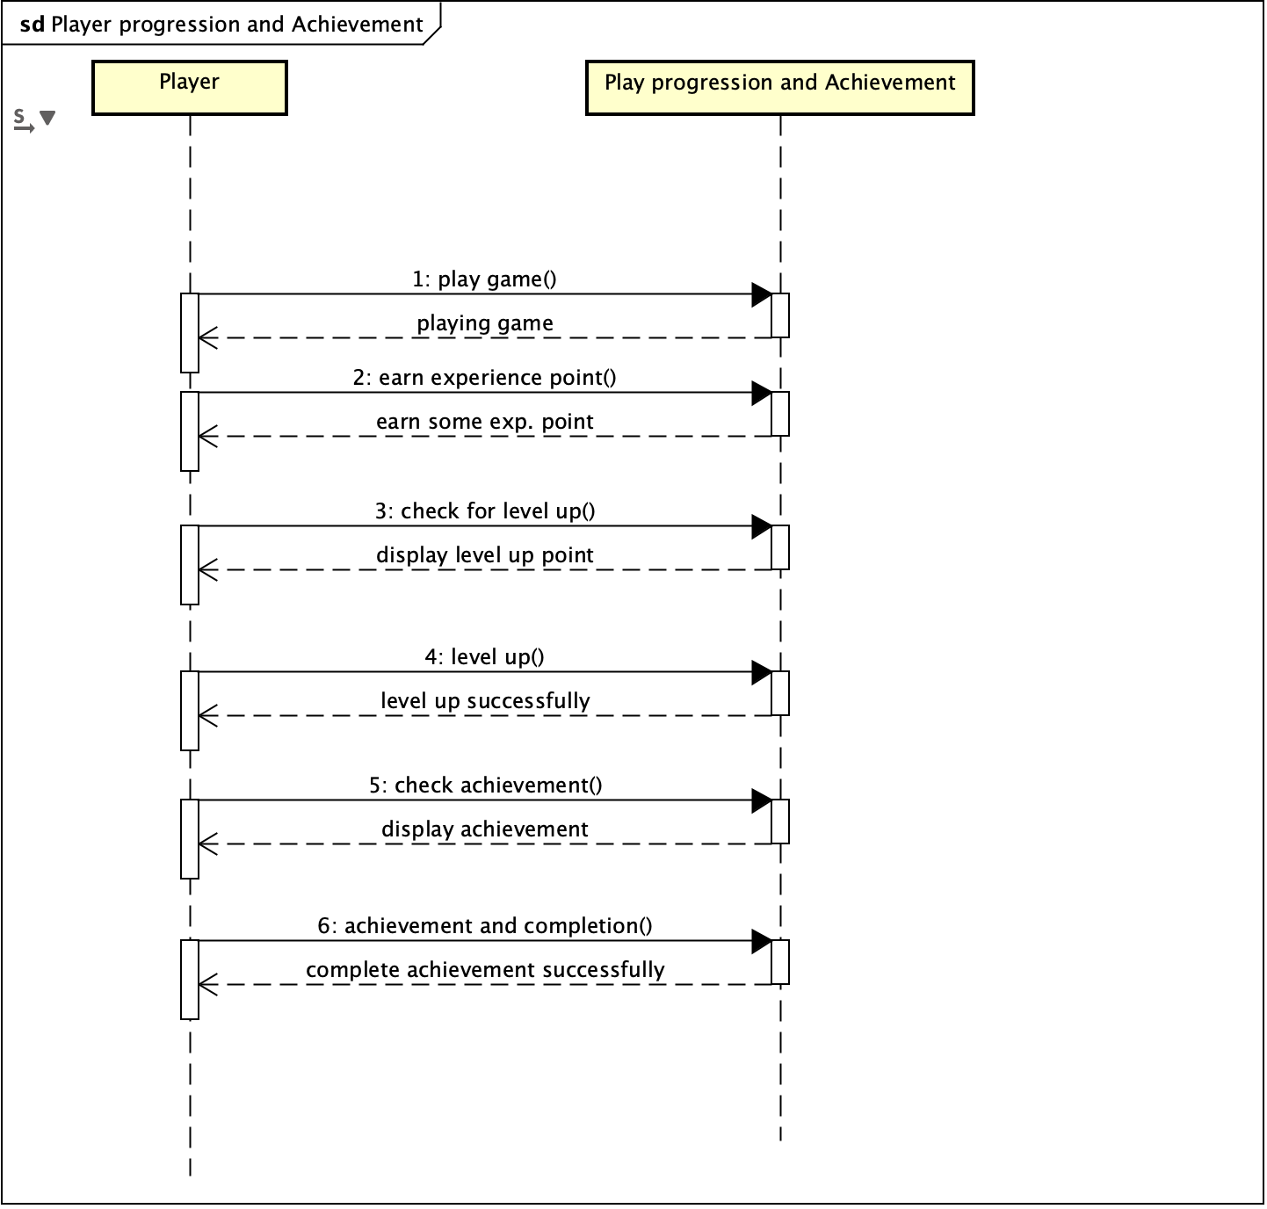

**Fig: - Sequence diagram of Player progression And Achievement**

# **Chapter 6 Communication diagram**

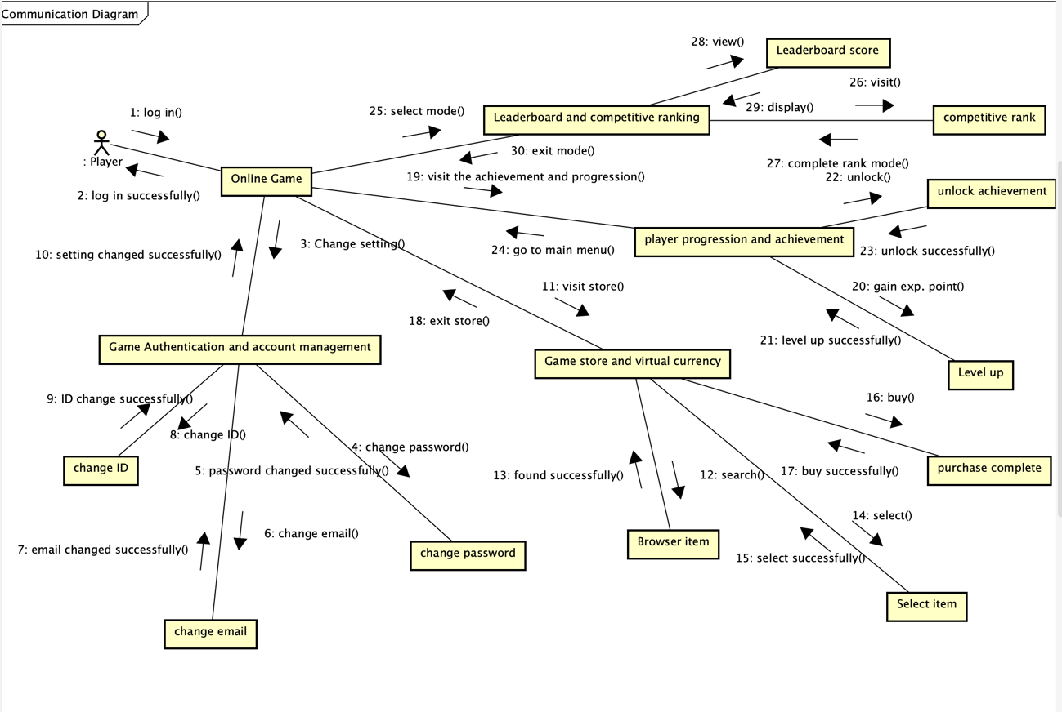

**Fig: - Communication diagram**

# **Chapter 7 State machine diagrams**

**Fig: - State machine diagram**

# **Chapter 8 User interface design**

**Fig: - Sign in**

**Fig: - Home page**

**Fig: - setting**

**Fig: - Mode**

# **Chapter 9 Conclusion**

In conclusion, Valorant is a highly popular first-person tactical shooter game developed and published by Riot Games. It features a unique blend of traditional shooter gameplay and character-based abilities, where players take on the roles of agents with distinct skills and compete in 5v5 matches with objectives like planting or defusing a bomb. The game's focus on teamwork, strategy, and communication, along with its competitive esports scene and regular updates, has contributed to its widespread appeal and lasting success in the gaming community. Valorant offers a mix of gunplay and strategic abilities. Each agent has a set of unique abilities divided into basic and ultimate abilities. Basic abilities are available for purchase each round using in-game currency, while ultimate abilities charge over time and can have game-changing effects. Valorant offers a variety of maps, each with unique layouts and design elements that influence gameplay strategies. The primary game mode involves attacking and defending bomb sites, but the game also introduced new modes and experimental features over time to keep the gameplay experience fresh.