**STUDENT MANAGEMENT SYSTEM**

**Introduction: -**

The student management system is the system which collect the data of the student and record on the database system. It is used database and java application to complete the project. It is used various data structure like list, map, Array list, HashMap, etc. in the program. It is connected to the database where it is stored data, delete the data, and display the data during the program. There are different class in the system like student, courses and teacher which has different function in the system.

Student management system is the main file which is handled the system of the data. There is MySQL connector java which is connected the java application and database together. There are four steps in student, course, and teacher they are add, update, delete and get detail. The four step is important factor for the student management system. School needs this system to maintain their system daily. Every school need student management system to update and detail about the student.

**PURPOSE: -**

Student management system is used to add, update, and get detail about the student. It is used to check their progress and their fee whether they are in good shape or not. Its main purpose is to entry of student into the database to save their file and they also update and delete the file of the student if the file is not needed. It is reduced the time consuming through the physical paperwork. In previous days, school record the data into the paper and store into it where they can be lost or damage the file, but modern-day school and college are kept the data into the database to secure the data from the damage.

**FEATURE: -**

1. Easy to collect the data of students.
2. Add, delete, update, get information of the student, teacher, and courses.
3. Secure the data from others.
4. Easy to run the system without getting error.
5. It is used to save the data for the long term.

**ER-DIAGRAM: -**

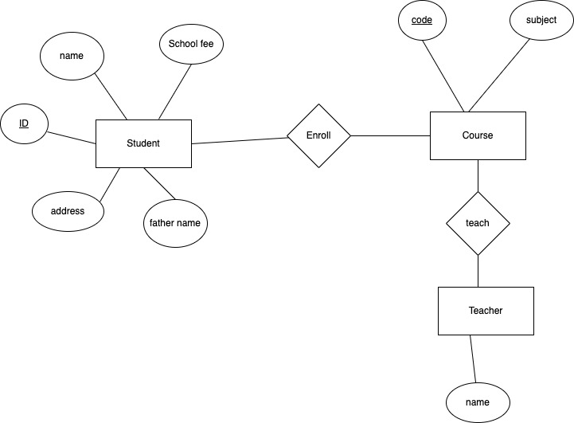

**USE CASE DIAGRAM: -**

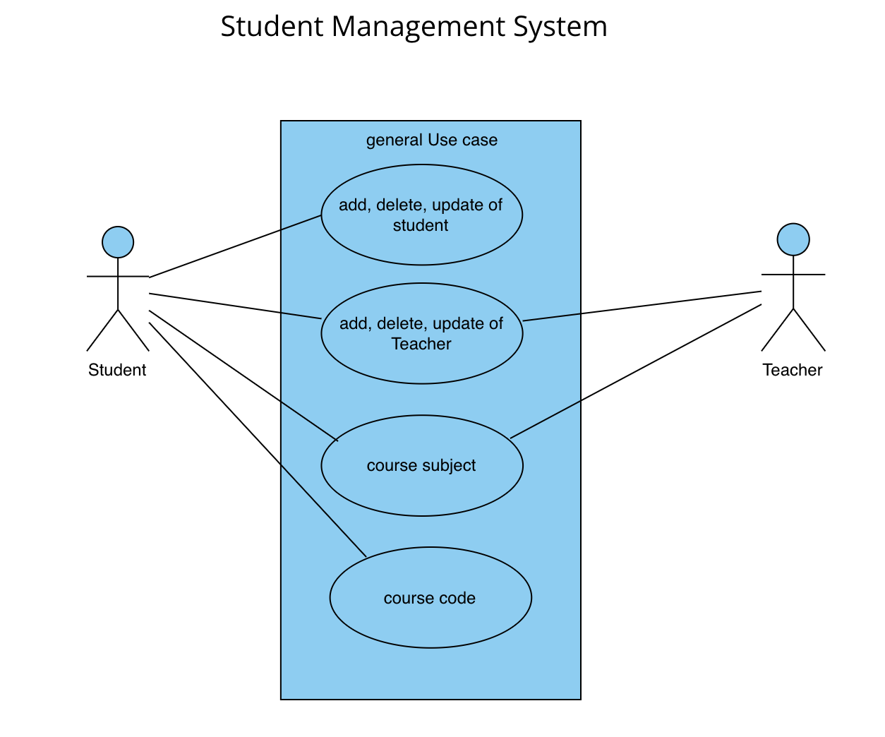

**ADVANTAGE: -**

1. It stores the data of the student for the long period of time.
2. It is secure the data without getting a problem.
3. They can add many student data at store at the database.
4. They can add course and teacher also into the database.
5. It is easy to use and understand.
6. It has better efficiency.

**DISADVANTAGE: -**

1. If the database is lost, then system will be not giving the output.
2. Office staff will take a lot of time to add student because it can add one by one.
3. GUI interface is not used.

**CONCLUSION: -**

This project is fully based on the students.This project is collect the data of students and store into the database.This is reduced the time consuming for the school because it give all the data to the school about the students.

It has some drawbacks of the system because it is connected to the databas. so, if the database is delete then the whole system will not run into the system. This system used in the school, college, and university for record the student data because school or college always check their student performance and fee from the system.