High Level Design (HLD)

Intelligent IoT Data Management Platform
Version: 2.1 (Repository Sync Update)
Date: 2026-05-14

Table of Contents
- Document Overview
- System Vision and Business Context
- Scope Definition
- Stakeholders and User Personas
- Architecture Drivers
- Current Landscape and Repository Reality
- Target High-Level Architecture
- Component View (Layer by Layer)
- Data Architecture and Canonical Contracts
- API Architecture and Interface Contracts
- End-to-End Functional Flows
- Analytics and Intelligence Design
- Non-Functional Requirements (NFRs)
- Security, Privacy, and Governance
- Deployment and Environment Architecture
- Observability, Monitoring, and Operations
- Testing and Quality Strategy
- Risk Register and Mitigation Plan
- Migration and Convergence Plan
- Open Decisions and Assumptions
- Appendix: Mapped Repository Artifacts

1. Document Overview

1.1 Purpose
This High-Level Design (HLD) defines a complete architectural blueprint for the Intelligent IoT Data Management Platform. It is written to serve both academic and engineering objectives: it explains system intent, architecture boundaries, runtime interactions, data contracts, quality attributes, and delivery roadmap in enough detail to support implementation, demonstration, and assessment.

1.2 Intended Audience
- Technical assessors evaluating architecture quality and rationale.
- Developers implementing frontend, backend, and analytics modules.
- Data science contributors operationalizing algorithmic prototypes.
- Project leads coordinating milestones, risks, and integration.

1.3 How to Read This HLD
- Sections 2-7 describe why the system exists and the chosen architectural direction.
- Sections 8-12 describe what the system is and how core flows execute.
- Sections 13-18 describe quality, security, operational readiness, and risk posture.
- Sections 19-21 provide practical transition and traceability to repository assets.
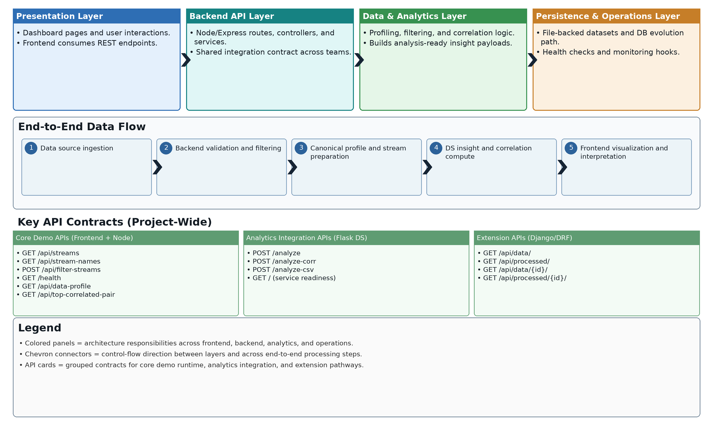
Figure 1.1: Architecture-at-a-Glance (Layers, key APIs, end-to-end data flow, and legend)

2. System Vision and Business Context
The platform addresses a common IoT problem: large volumes of time-series sensor data are collected, but practical decision support is weak without integrated analytics and interpretable visualization.
The system therefore provides a modular pipeline for:
- ingesting and serving sensor streams,
- filtering and contextualizing data by selected streams/time windows,
- computing statistical relationships (for example, correlations and outlier signals), and
- presenting interpretable results via an interactive dashboard.

2.1 Strategic Objective
Deliver a coherent, demonstration-ready intelligent IoT analytics platform that connects software engineering structure (services, APIs, UI, operations) with data science outcomes (correlation insight, anomaly discovery).

2.2 Problem Statement
Without architectural convergence, prototype-heavy repositories often suffer from stack fragmentation, endpoint mismatches, inconsistent data schema assumptions, and unstable demo execution. This project currently exhibits those symptoms and requires a controlled architecture convergence plan.

3. Scope Definition

3.1 In Scope (Target Delivery)
- A unified runtime path centered on:
  - React dashboard (new-frontend/frontend),
  - Node/Express API (backend),
  - curated analytics logic integrated behind API contracts,
  - canonical JSON/CSV sensor payloads.
- Stream discovery, stream filtering, and dashboard visual analytics.
- Correlation-based insight for selected streams and selected windows.
- Baseline operational readiness with health checks and reproducible startup.

3.2 Out of Scope (Current Iteration)
- Full enterprise IAM, RBAC, and SSO lifecycle.
- Multi-region or Kubernetes-grade production deployment.
- Full MLOps model lifecycle orchestration with feature stores and model registries.
- High-frequency streaming guarantees at industrial telemetry scale.

3.3 Success Criteria
- End-to-end UI -> API -> analytics -> visualization flow works reliably.
- One canonical data contract is consistently honored.
- Key user journeys execute without manual patching of code during demo.
- Architecture documentation and implementation are aligned.

4. Stakeholders and User Personas

4.1 Primary Stakeholders
- Platform developers (frontend/backend integration).
- Data science contributors (algorithm adaptation and validation).
- Assessment panel and supervisors.
- Future maintainers onboarding into the project.

4.2 User Personas
- Analyst user
  - Selects streams and time ranges.
  - Interprets correlation and anomaly behavior.
  - Exports insights for reporting.
- Technical operator
  - Starts services and verifies health.
  - Diagnoses API failures and data contract issues.
  - Maintains runbook consistency.
- Data scientist
  - Prototypes algorithms on historical datasets.
  - Promotes reusable functions into runtime services.
  - Compares algorithm output behavior across windows.

5. Architecture Drivers

5.1 Functional Drivers
- Multi-stream sensor data visualization.
- Stream-wise filtering and selected-window analysis.
- Correlation insight and anomaly-oriented interpretation.
- Simple and stable interfaces between UI, API, and analytics.

5.2 Non-Functional Drivers
- Reliability: predictable demo startup and consistent endpoint behavior.
- Maintainability: modular code ownership and explicit layering.
- Reproducibility: clear, low-friction setup for evaluators.
- Performance: responsive dashboard and manageable processing latency.

5.3 Constraint Drivers
- Academic timeline and bounded implementation capacity.
- Existing repository includes multiple parallel technology paths.
- Must preserve existing data science value while reducing integration complexity.

6. Current Landscape and Repository Reality
The repository now reflects merged contributions from multiple teams and contains parallel prototypes and service variants:
- Frontend prototype A: frontend (React/Vite app with auth screens, analyze panel, export flow, and MUI theme toggling).
- Frontend prototype B: new-frontend/frontend (dashboard-focused implementation).
- Backend prototype A: backend/iot_backend (Django + DRF + model-backed API).
- Backend prototype B: backend (Node/Express API with file-backed and DB-oriented evolution path).
- Analytics prototype services:
  - data_science/development/server.py (Flask /analyze),
  - data_science/development/server_corr.py (Flask correlation and CSV outputs),
  - algorithm modules in algorithms/ and exploratory notebooks in correlation_study/.

6.1 Architectural Implication of Current State
This diversity is useful for experimentation but increases integration risk. Specifically:
- endpoint naming diverges across frontend and backend,
- data schemas vary by source,
- operational model is split across Node, Django, and Flask pathways,
- production narrative for assessment remains ambiguous.

6.2 Design Decision
Converge to one primary execution path while treating other stacks as controlled extension paths.
Primary path for delivery:
- new-frontend/frontend
- backend
- Selected analytics logic integrated through API contracts
- Curated dataset source (JSON/CSV)
Secondary/extension path:
- Django/DRF model-backed API remains as future data-layer evolution.

7. Target High-Level Architecture

7.1 Logical Architecture (Primary Runtime)
[User Browser]
|
v
[React Dashboard]
|
v
[Node/Express API Layer]
|
+--> [Data Repository (JSON/CSV)]
|
+--> [Analytics Module (correlation/anomaly functions)]
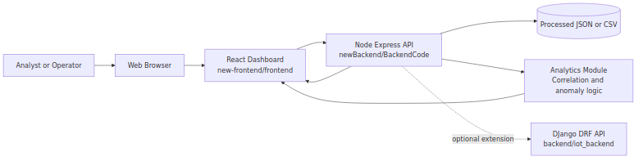
Figure 7.1: System Context Diagram

7.2 Layered Responsibility Model
- Presentation Layer (React)
  - User interaction, selection controls, chart rendering, insight cards.
- Application/API Layer (Node/Express)
  - Contract enforcement, request validation, orchestration, error shaping.
- Analytics Layer (Reusable functions)
  - Deterministic computations for correlation and anomaly indicators.
- Data Layer (File now, DB optional)
  - Current: local processed JSON/CSV.
  - Future: normalized persistence using Django + PostgreSQL.

7.3 Architectural Principles
- Single source of truth for runtime API contracts.
- Thin controller, reusable service, isolated repository pattern.
- Deterministic analytics functions with explicit inputs/outputs.
- Explicit and stable canonical sensor record contract.
- Extension-friendly design without forcing premature infrastructure complexity.

8. Component View (Layer by Layer)
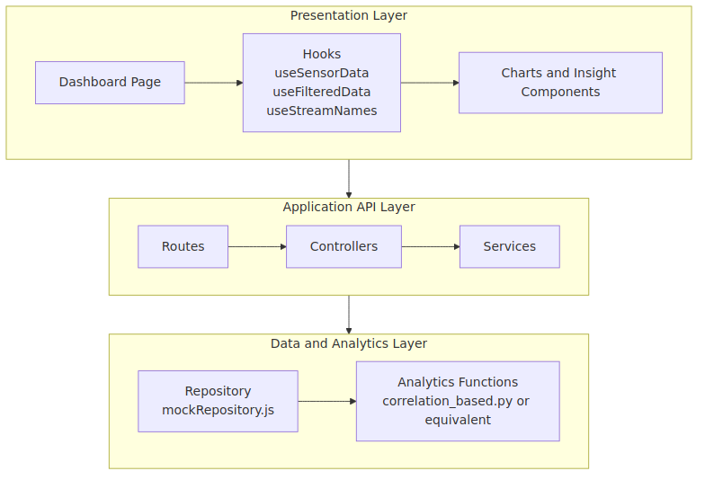
Figure 8.1: Layered Component Diagram (Primary Runtime)

8.1 Presentation Layer: React Dashboard
Primary codebase: new-frontend/frontend
Key component groups (updated with PR #71 frontend integration):
- Pages and routing
  - src/pages/HomePage.jsx
  - src/pages/DashboardPage.jsx
  - src/pages/Login.jsx
  - src/pages/RegistrationPage.jsx
  - src/pages/ForgotPassword.jsx
- Dashboard orchestration
  - src/components/Dashboard.jsx
  - src/components/Layout.jsx (shared shell)
  - src/components/ProtectedRoute.jsx (route guard)
  - src/components/Navbar.jsx, src/components/Footer.jsx
  - src/components/DatasetCard.jsx
- Input controls
  - stream selector, interval selector, time selectors
- Visual output
  - line charts, scatter plot, correlated pair panel, stream stats
- Data hooks
  - useSensorData, useFilteredData, useStreamNames, useTimeRange
Responsibilities:
- Collect user intent (streams, window, interval).
- Render progressively richer visualization as selection depth increases.
- Avoid direct filesystem assumptions in final architecture.
- Support authenticated UX flow before entering protected Home/Dashboard routes.
Current gap observed:
- useSensorData currently defaults to mock mode and requests /api/sensor-data in live mode, while backend exposes /api/streams. This is a contract mismatch risk that must be normalized.

8.2 API Layer: Node/Express Service
Primary codebase: backend
Current implementation structure:
- Server bootstrap: src/server.js
- Routes: src/routes/mock.js
- Controller: src/controllers/mockController.js
- Service: src/services/mockService.js
- Repository: src/repositories/mockRepository.js
Current exposed API (through /api mount):
- GET /api/streams
- GET /api/stream-names
- POST /api/filter-streams
- GET /api/data-profile
- POST /api/top-correlated-pair
Service-level endpoint:
- GET /health
Repository behavior:
- Reads file from PROCESSED_DATA_PATH via .env.
- Parses JSON synchronously and returns all entries.
Benefits of this structure:
- Good separation between transport logic and data access.
- Easy replacement of repository (file -> DB) without rewriting controller contracts.
Backend security integration update (PR #70):
- Upstream merged lightweight authentication support using bcrypt + JWT + middleware.
- Architecture intent is to protect selected routes with bearer-token validation while keeping read-only/open demo routes configurable.
- Supporting backend modules introduced in that stream include middleware/authMiddleware.js and token/hash utility helpers.
Current convergence notes:
- GET /health is implemented in backend/src/server.js and used for operational verification.
- useSensorData live-mode path (/api/sensor-data) is still not aligned with Node route naming (/api/streams), so contract normalization or an alias remains required.

8.3 Optional Data Service Layer: Django + DRF Path
Codebase: backend/iot_backend
Key artifacts:
- Models: timeseries/models.py
- DRF viewsets: timeseries/views.py
- Router endpoints through timeseries/urls.py and iot_backend/urls.py
Current endpoint family:
- GET /api/data/ (time series model records)
- GET /api/processed/ (processed sensor records)
Role in HLD:
- Not primary runtime for current converged demo.
- Strategic evolution path for persistent, model-backed data serving.
DB stream update reference (external fork activity):
- Repository: https://github.com/FarrisBaboo/Intelligent-IoT-Data-Management
- DB-related commit trail indicates ongoing ingestion and endpoint hardening work:
  - 5e04d8e Implement ingestion logic and models
  - 89e7d28 Add controllers/service/repo for DB and ingest fixes
  - bffcaba Fix mock connection to DB
  - c92a28f Fix DB ingestion pipeline and update dataset/series endpoints
Architecture interpretation:
- The project now has a clearer persistence-evolution stream (file-backed -> DB-backed).
- Canonical runtime still documents file-backed Node path as primary, while DB-backed path is treated as integration-ready extension pending full upstream convergence.

8.4 Analytics Service/Module Layer
Available analytics assets:
- Flask APIs in data_science/development/server.py and server_corr.py
- Correlation outlier function in algorithms/correlation_based.py
Role in target architecture:
- Extract deterministic algorithmic functions and integrate in a stable runtime contract.
- Keep notebooks and exploratory scripts as research assets, not runtime dependencies.

8.5 Frontend Integration Update (PR #71)
PR reference: https://github.com/DataBytes-Organisation/Intelligent-IoT-Data-Management/pull/71
Key architecture-facing updates from this frontend stream:
- Route model expanded to include login/registration/forgot-password pages.
- Protected route pattern introduced for /home and /dashboard/:id.
- Shared layout introduced for consistent navbar/footer wrapping.
- Homepage redesign and dataset card presentation added to improve discoverability of dataset entry points.
- New auth service client (src/services/authClient.js) introduced as a seam for backend auth integration.
HLD implication:
- The platform now has an explicit presentation-layer split between public auth routes and authenticated analytical routes.
- This strengthens separation of concerns and improves readiness for future backend-auth convergence.

9. Data Architecture and Canonical Contracts

9.1 Canonical Record Model
{
"created_at": "2025-03-19T15:01:59.000Z",
"entry_id": 3242057,
"Temperature": 22.0,
"RH Humidity": 41.0,
"Voltage Charge": 12.5,
"was_interpolated": false
}

9.2 Contract Rules
- Mandatory fields: created_at, entry_id.
- Dynamic sensor keys are allowed and discovered at runtime.
- Values should be numeric where meaningful; missing values use null.
- Optional lineage field: was_interpolated.

9.3 Data Lifecycle (Current)
- Dataset curated in CSV/JSON.
- Processed file path provided through environment variable.
- Repository reads file and emits records.
- Service layer filters and projects selected streams.
- Frontend receives filtered records and computes visualization-specific transforms.

9.4 Data Quality Considerations
- Timestamp consistency: enforce ISO8601 parseability.
- Numeric coercion strategy: controlled parsing before charting.
- Sparse columns: tolerate absent keys and avoid chart crashes.
- Sampling and interval alignment: configurable for rolling analytics.

10. API Architecture and Interface Contracts

10.1 Existing Contract (Node API)
- GET /api/streams
  - Returns full dataset array.
- GET /api/stream-names
  - Returns array of stream names extracted from first record minus metadata keys.
- POST /api/filter-streams
  - Request:
  - { "streamNames": ["Temperature", "Voltage Charge"] }
  - Response: records containing metadata plus selected stream keys.

10.2 Required Contract Stabilization
- Add GET /health with status and timestamp payload.
- Normalize frontend fetch path either by:
  - changing frontend to /api/streams, or
  - exposing /api/sensor-data alias.
- Define consistent error envelope.
Recommended response envelope for future hardening:
{
"status": "ok",
"data": [],
"message": "optional"
}

10.3 Error Semantics
- 400 for invalid streamNames payload.
- 404 for empty stream-name extraction scenarios.
- 500 for repository read/parse failures.

10.4 API Versioning Guidance
- Keep current unversioned routes during capstone delivery.
- Introduce /api/v1 namespace once contracts are frozen and tested.

11. End-to-End Functional Flows
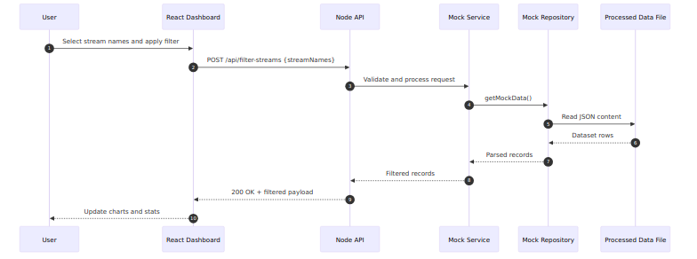
Figure 11.1: End-to-End Sequence Diagram (Stream Filtering)

11.1 Flow A: Dashboard Initialization
- User navigates to dashboard route.
- Frontend requests stream metadata/data from API.
- API reads source file through repository.
- Frontend derives available stream list and initial time range.
- UI renders controls and baseline instructions.

11.2 Flow B: Stream Selection and Filtering
- User selects one or more streams.
- Frontend submits selected stream names for filtered dataset retrieval (or local hook-based filter, depending on current implementation mode).
- API validates payload and returns projection.
- Frontend updates chart and statistics cards.

11.3 Flow C: Correlation Insight Path
- User selects at least two/three streams depending on analysis mode.
- System computes pairwise/rolling correlation output.
- Most correlated pair is identified.
- Scatter and trendline view is rendered.
- User interprets relation strength in context window.

11.4 Flow D: Health and Operational Check
- Operator invokes /health.
- API returns service status and timestamp.
- Startup script or monitoring probe marks service as healthy.

12. Analytics and Intelligence Design
Figure 12.1: Data Processing and Insight Flow

12.1 Analytics Objective
Provide interpretable, deterministic analytics that can be explained to non-ML users while still being technically rigorous for data science evaluation.

12.2 Current Available Methods
- Correlation-based outlier identification (algorithms/correlation_based.py).
- Flask-driven analysis endpoints (/analyze, /analyze-corr, /analyze-csv) for exploratory and export workflows.
- Expanded detector portfolio from DS stream (Yashdeep22 fork), including threshold, LOF, IQR, COPOD, and volatility/level-shift variants under a common benchmarking workflow.
Data science stream reference:
- Repository: https://github.com/Yashdeep22/Intelligent-IoT-Data-Management
- Representative commits:
  - 2ead71a clean ThresholdAD detector integration
  - 2707a31 LOF detector integration
  - a67ac40 LOF single-sample guard
  - f31fad3 NAB label support for benchmark evaluation
  - 7ab182b combined benchmark summary report

12.3 Productionization Strategy
- Keep algorithm inputs explicit: selected streams, time range, threshold/window.
- Return compact summary results for UI consumption.
- Isolate notebook-only logic from runtime modules.
- Preserve detector interface consistency so detector swaps do not require API contract rewrites.
- Maintain benchmark artifact generation as a separate evaluation pipeline, not a runtime dependency.

12.4 Candidate Insight Contract
{
"topPair": ["Temperature", "Humidity"],
"coefficient": 0.89,
"strength": "strong",
"window": "selected-range"
}

12.5 Explainability Expectations
- Every metric exposed in UI should include a plain-language interpretation label.
- Visual artifacts (scatter/trendline/rolling plots) should correspond to computable backend values.
- Threshold-based classification should be documented and reproducible.

13. Non-Functional Requirements (NFRs)

13.1 Reliability
- Startup reliability target: all mandatory services reachable within 2 minutes.
- Health endpoint should support automated readiness checks.
- Failures should degrade gracefully with actionable UI/API messages.

13.2 Performance
- Initial dashboard meaningful render: target under 3 seconds on local developer machine.
- Filter action response: target under 1 second for moderate dataset size.
- Correlation computation: target under 2 seconds for selected stream subset.

13.3 Scalability
- Current design scales vertically for capstone dataset sizes.
- Repository abstraction supports future migration to DB-backed pagination and query pushdown.

13.4 Maintainability
- Clear layering and module ownership.
- Reusable hooks and utility segregation in frontend.
- Service/repository separation in backend.

13.5 Portability and Reproducibility
- Docker-based service packaging available in repository.
- Environment-variable-based file path configuration.
- Consistent setup steps should be captured in runbook.

14. Security, Privacy, and Governance

14.1 Authentication baseline (merged backend stream)
PR reference: https://github.com/DataBytes-Organisation/Intelligent-IoT-Data-Management/pull/70
- Authentication capability has been introduced via lightweight JWT flow and password hashing.
- Middleware-based authorization checks are intended to gate protected API routes.
- This establishes a practical baseline security posture for student-team delivery without full IAM/RBAC rollout.

14.2 Security convergence note
- Frontend auth route flow (PR #71) and backend JWT middleware (PR #70) should be connected through a single token issuance/refresh contract in the next integration increment.

14.1 Current Security Posture
- CORS enabled for development.
- No strong authentication/authorization boundary in converged runtime path yet.

14.2 Baseline Security Controls for Current Phase
- Input validation on all POST payloads.
- Restrict allowed upload/file paths to controlled directories.
- Standardized error handling that avoids leaking sensitive internals.
- Environment secrets in .env, excluded from version control.

14.3 Future Security Enhancements
- Token-based auth for API usage.
- Role-sensitive access for administrative operations.
- Audit logs for analysis requests and exports.
- Data retention and deletion policies.

14.4 Data Governance Notes
- Track source and processing lineage for datasets used in demos.
- Record interpolation/transformation metadata when applicable.
- Ensure reproducibility of reported analytics in submission artifacts.

15. Deployment and Environment Architecture
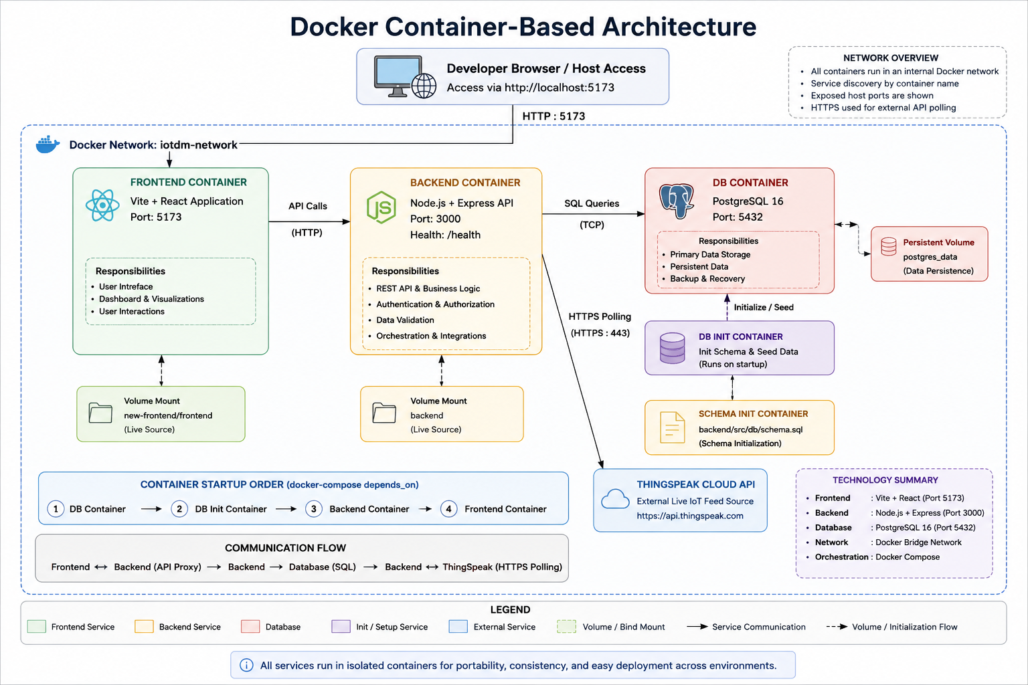
Figure 15.1: Container-Based Architecture (Docker)
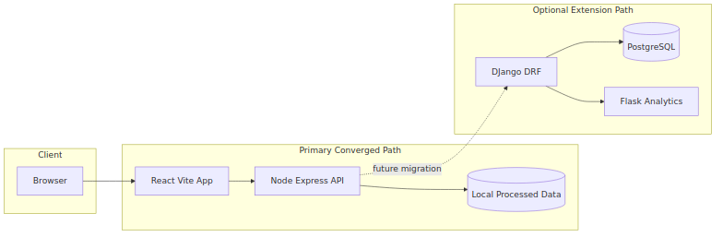
Figure 15.2: Existing Project Mapping (Current Ecosystem)

15.1 Existing Project Mapping Components
- Frontend stream
  - Vite React user interface
  - Authentication pages
  - Dashboard navigation and visualization flow
- Backend stream
  - Node/Express API layer
  - Health endpoint
  - Data, auth, and analytics orchestration
- Analytics extension stream
  - Flask and data-science assets retained as optional extension capability
  - Not treated as the primary demo runtime
- Data and persistence stream
  - Curated local files
  - PostgreSQL schema-backed storage
  - ThingSpeak live feed ingestion

15.2 Container-Based Architecture Components
Figure 15.1 is the primary Docker deployment view. It shows the container boundaries, exposed ports, persistent storage path, bind-mounted development paths, and the communication links between browser, frontend, backend, database, and ThingSpeak ingestion flow.
Figure 15.2 remains the project mapping view. Together, the two diagrams connect the broader project structure to the selected Docker execution path so the architectural narrative remains traceable from repository reality to operational deployment.

15.2.1 Docker Service Topology
- Frontend container
  - Runs the Vite React application
  - Exposes port 5173
  - Proxies /api traffic to the backend container
- Backend container
  - Runs the Node/Express API
  - Exposes port 3000
  - Publishes the /health endpoint for readiness and monitoring
- Database container
  - Runs PostgreSQL 16
  - Exposes port 5432
  - Initializes schema from backend/src/db/schema.sql
- Persistent storage
  - Uses a named volume for PostgreSQL data persistence
  - Preserves data across container restarts
- Development bind mounts
  - Mounts new-frontend/frontend into the frontend container
  - Mounts backend into the backend container
  - Supports live iteration during development

15.2.2 Inter-Container Communication and Data Flow
- Browser requests terminate at the frontend container.
- Frontend API requests are proxied internally to the backend container.
- Backend database operations are executed through the internal PostgreSQL service name.
- Backend ingestion logic also communicates with the external ThingSpeak API.
- Schema initialization and persistent volume usage support stable startup and data retention.

15.2.3 Operational Verification Summary
- Backend health check returns 200 OK.
- Frontend host port is reachable on 5173.
- Proxied API access through /api/streams resolves successfully.
- Database schema initializes with datasets, timeseries, and timeseries_long tables.
- ThingSpeak polling can execute inside the containerized runtime when environment variables are present.

15.3 Container Runtime and Deployment Details
The deployment model separates runtime responsibilities into three operational concerns: container health orchestration, runtime network access, and persistent/configured infrastructure behavior.
- Health and startup control
  - PostgreSQL must become healthy before backend startup.
  - Backend health must succeed before frontend readiness is considered complete.
- Network and ports
  - Frontend host access: 5173
  - Backend host access: 3000
  - PostgreSQL host access: 5432
- Storage and configuration
  - Bind mounts support local development changes.
  - Named volume supports persistence.
  - Environment variables configure DB connectivity and ThingSpeak polling.

15.4 Container Build and Deployment Procedure
The containerized stack is built and executed from the repository root.
docker compose up --build
docker compose up --build -d
docker compose ps
docker compose logs -f
docker compose down
docker compose down -v
- The build step creates frontend and backend images from their Dockerfiles.
- The startup sequence respects service dependency order.
- Verification should confirm browser access, backend health, API proxy success, and database availability.

16. Observability, Monitoring, and Operations
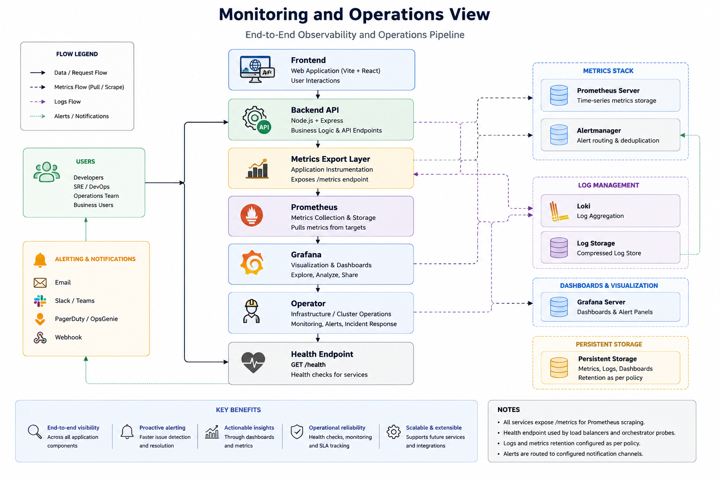
Figure 16.1: Engineering Analytics Metrics View

16.1 Operational Metrics
Figure 16.1 summarizes the engineering metrics view that operations and technical reviewers use to assess runtime stability, endpoint health, performance patterns, and integration quality across the platform.
- API request count and response latency.
- Error-rate by endpoint (4xx and 5xx).
- Dataset read failures and parse exceptions.
- Frontend render/error telemetry (future).

16.2 Health and Readiness
- Mandatory /health endpoint in primary backend path.
- Startup checklist must verify:
  - API reachable,
  - dataset path valid,
  - frontend API calls successful.

16.3 Monitoring Stack Opportunity
Existing Docker assets include Prometheus and Grafana, enabling future instrumentation rollout for demonstrable reliability engineering practices.

16.4 Engineering Analytics Architecture
The engineering analytics architecture is defined as an observability layer over the existing project runtime. Its purpose is to measure service behavior, API reliability, runtime health, and integration quality without duplicating any team-owned application logic.
Figure 16.2 presents the planned analytics stack, showing how runtime sources feed collection targets, how Prometheus stores metrics, and how Grafana and alerting consume those metrics for engineering visibility.
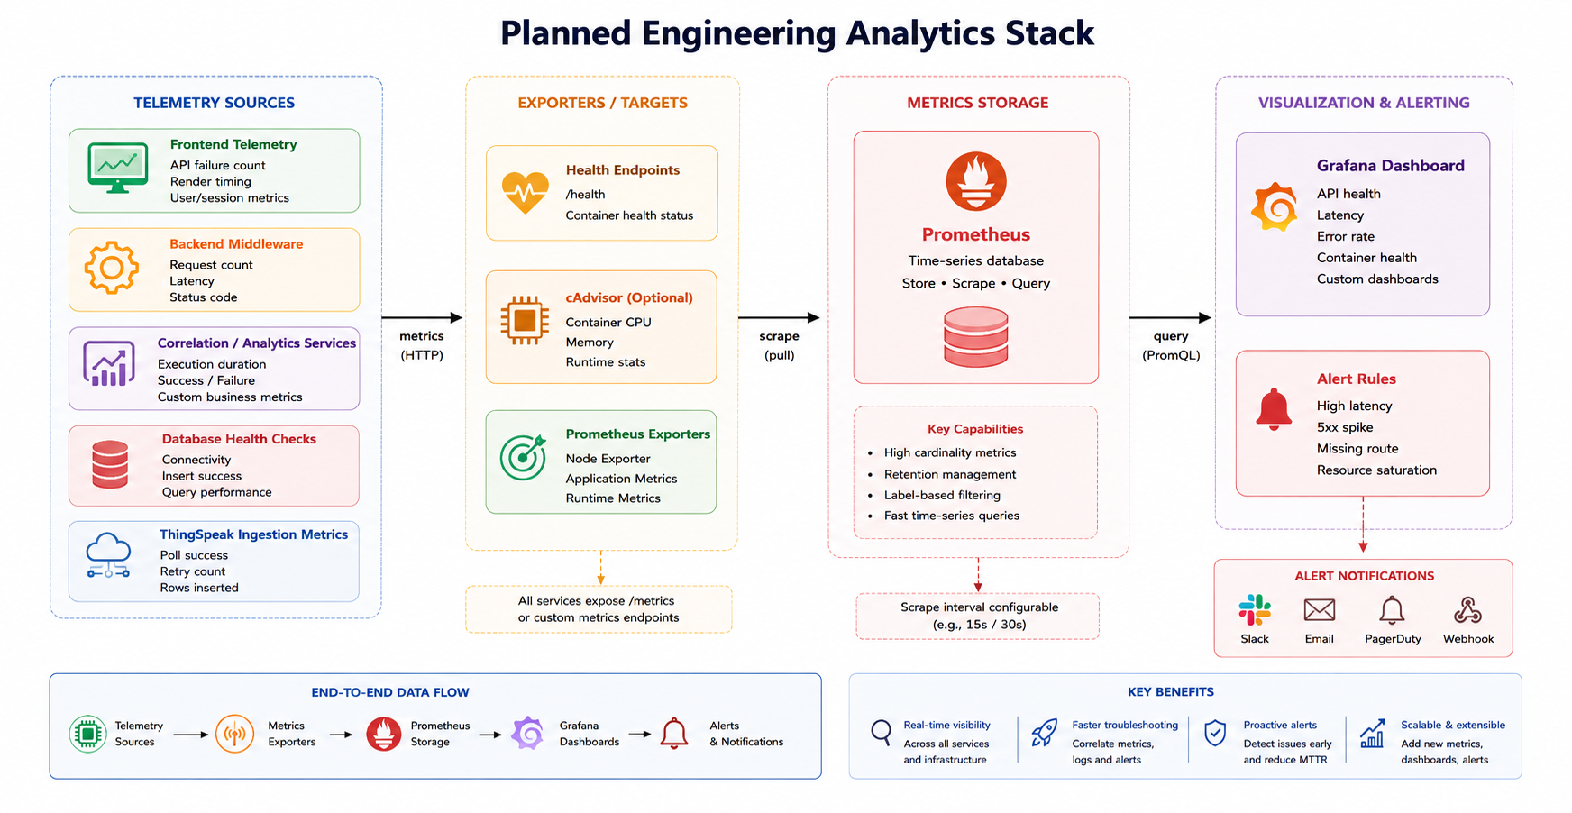
Figure 16.2: Engineering Analytics Stack Architecture

16.4.1 Stack Components
- Frontend telemetry component
  - Captures browser-side API failures, request timing, and user-interface level integration problems that are not visible from the backend alone.
  - Supports detection of route mismatches and failed dashboard/API interactions.
- Backend middleware component
  - Measures request count, endpoint latency, status-code distribution, and route-level execution behavior for the active Node/Express API layer.
  - Provides the primary source of operational metrics for backend endpoints.
- Correlation and analytics service component
  - Records processing duration, success/failure rate, and endpoint responsiveness for correlation and analysis workloads.
  - Ensures engineering monitoring can cover backend-owned and analytics-owned computation paths consistently.
- Database health component
  - Verifies PostgreSQL connectivity, schema readiness, and write-path success.
  - Separates persistence failures from API contract failures.
- ThingSpeak ingestion component
  - Measures polling success, retry frequency, upstream dependency stability, and rows inserted per ingestion cycle.
  - Provides visibility into the external IoT feed dependency.
- Health endpoint component
  - Exposes lightweight readiness and liveness checks through /health and Docker service health checks.
  - Supports startup verification, runtime checks, and automated monitoring.
- Optional cAdvisor component
  - Provides container CPU, memory, and runtime statistics when infrastructure-level visibility is needed.
  - Complements application metrics with container resource metrics.
- Prometheus component
  - Acts as the central time-series metrics store and scrape engine.
  - Collects metrics from application targets, runtime exporters, and health-oriented sources at fixed intervals.
- Grafana component
  - Provides dashboard visualization, service drill-down, and trend-based engineering reporting.
  - Presents API health, latency, error rate, ingestion status, and container state in one monitoring view.
- Alert rules component
  - Evaluates high latency, high error rate, missing route calls, ingestion failure, and service unavailability.
  - Converts passive metrics into operational actions and escalation signals.

16.4.2 Metrics Coverage
- Operational metrics
  - Service availability
  - Container health state
  - Restart count
  - Health-check success
  - Database connectivity
  - Ingestion job state
- Performance metrics
  - Request volume
  - Average latency
  - p95 latency
  - Endpoint execution duration
  - Throughput
  - Ingestion-to-store delay
- Reliability metrics
  - 4xx rate
  - 5xx rate
  - Timeout frequency
  - Retry count
  - Failed inserts
  - Failed frontend API calls
- Integration metrics
  - Frontend/backend route mismatches
  - Backend/database communication issues
  - Backend/ThingSpeak dependency health
  - Cross-team API compatibility gaps
- Benchmarking metrics
  - Stack startup time
  - Service readiness time
  - Analysis endpoint duration
  - Ingestion cycle duration
  - Comparative endpoint performance under defined test conditions

16.4.3 Dashboard Scope
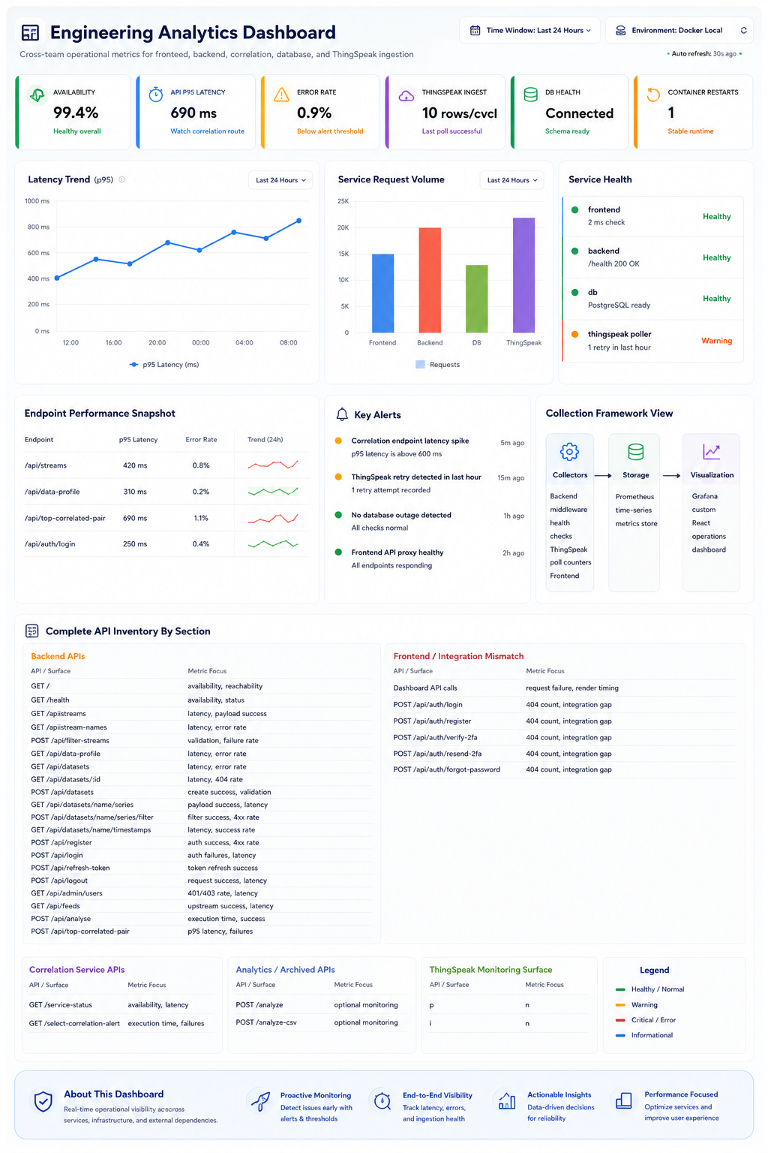
Figure 16.3: Engineering Analytics Dashboard Mockup
Figure 16.3 demonstrates the intended engineering dashboard layout. It emphasizes grouped API monitoring, integration mismatch visibility, ingestion health, runtime status, and a complete API inventory arranged by technical ownership area.
- Backend API section
  - Health, auth, dataset, stream, timestamp, analysis, and ThingSpeak feed endpoints.
- Frontend integration section
  - Browser-side failed calls, missing route visibility, and request timing for dashboard and authentication flows.
- Correlation and analytics section
  - Correlation-alert APIs, analysis endpoints, execution duration, and failure visibility.
- Platform section
  - PostgreSQL health, Docker container runtime metrics, ThingSpeak ingestion health, and alert conditions tied to infrastructure and dependencies.
- Inventory section
  - Complete API catalogue grouped by backend, frontend mismatch, correlation service, analytics service, and ThingSpeak monitoring surfaces.

16.4.4 Architecture Principles
- Non-duplication principle
  - Existing team APIs remain the system of record.
  - Analytics measures them rather than replacing them.
- Cross-team visibility principle
  - Frontend, backend, correlation, analytics, database, and ingestion paths must appear in one engineering monitoring view.
- Low-intrusion instrumentation principle
  - Metrics are captured through middleware, counters, health checks, scrape targets, and exporters rather than through parallel business APIs.
- Deployment alignment principle
  - The analytics stack must operate within the Docker-based runtime already established for the project.
- Extensibility principle
  - Archived or auxiliary services can be monitored later without redesigning the overall stack model.

17. Testing and Quality Strategy

17.1 Backend Test Strategy
Minimum credible suite:
- health endpoint returns success,
- stream names are discoverable,
- invalid filter-streams request returns 400,
- valid filter request returns projected keys.

17.2 Frontend Test Strategy
Minimum smoke checks:
- dashboard load with dataset,
- stream selection updates key components,
- error state appears for failed data fetch,
- correlation panel appears under multi-stream conditions.

17.3 Analytics Validation Strategy
- deterministic test fixtures for known correlation behavior,
- edge cases for low-variance and missing-value windows,
- threshold classification consistency checks.
- detector-specific guards (for example single-sample handling and label-shape handling),
- benchmark reproducibility checks across supported detectors using the same labeled datasets.

17.4 Quality Gate Recommendation
Before demo freeze:
- endpoint contract validation,
- canonical dataset sanity check,
- walkthrough script dry run,
- evidence capture (screenshots/log outputs).

18. Risk Register and Mitigation Plan
Risk | Likelihood | Impact | Mitigation
Multi-stack confusion during demo | Medium | High | Freeze one primary path and label others as extensions
Frontend/backend endpoint mismatch | High | High | Contract alignment and compatibility alias
Inconsistent sensor schema across files | High | Medium | Canonical contract and dataset validation
Missing health/readiness behavior | Medium | Medium | Implement /health and startup checklist
Time overrun from architecture rewrites | Medium | High | Incremental convergence with milestone gates
Algorithm explainability gaps | Medium | Medium | Add interpretation labels and deterministic outputs

19. Migration and Convergence Plan
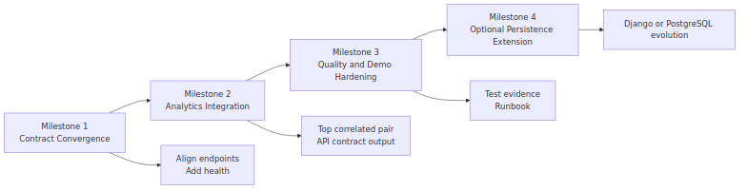
Figure 19.1: Convergence Roadmap Diagram
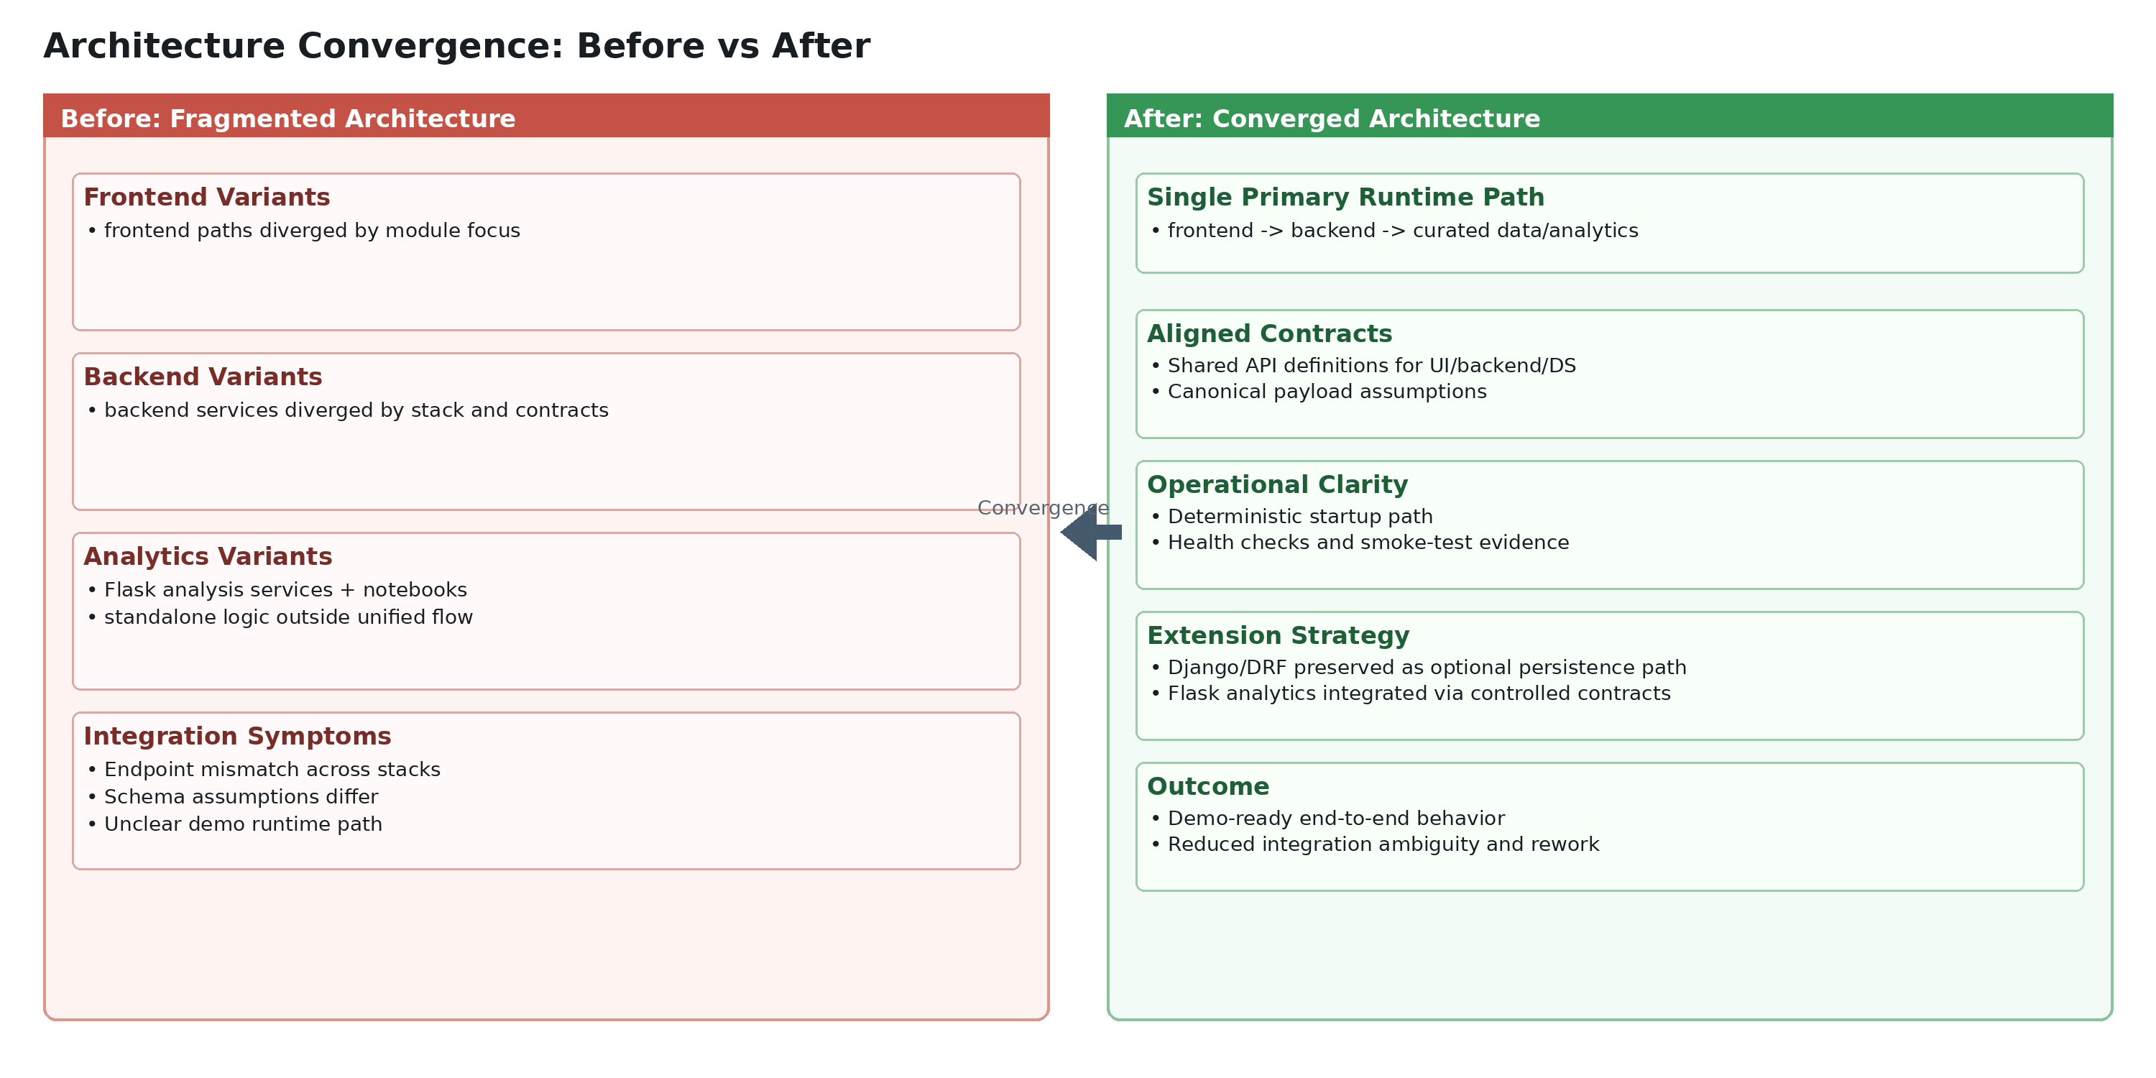
Figure 19.2: Before/After Convergence View (fragmented architecture to aligned delivery path)

Milestone 1: Contract Convergence (1-2 days)
- Align frontend data fetch path with backend routes.
- Add GET /health in Node service.
- Validate .env dataset path behavior.

Milestone 2: Analytics Integration (2-3 days)
- Promote one reusable correlation insight function.
- Serve result through API-ready JSON contract.
- Display insight card in dashboard.

Milestone 3: Quality and Demo Hardening (1-2 days)
- Implement baseline tests and smoke checks.
- Finalize startup runbook.
- Produce architecture evidence and release notes.

Milestone 4: Optional Extension Track
- Begin gradual migration to model-backed persistence (Django/PostgreSQL path) if required by assessment scope.

20. Open Decisions and Assumptions

20.1 Open Decisions
- Whether to preserve /api/sensor-data as compatibility alias or standardize exclusively on /api/streams.
- Whether analytics execution remains embedded in backend process or delegates to standalone Flask microservice.
- Whether final demonstration requires Dockerized all-services path or local dual-service path.

20.2 Working Assumptions
- Curated dataset quality is sufficient for meaningful correlation output.
- Evaluation prioritizes architectural coherence and integration evidence.
- Full enterprise security is not mandatory for this delivery phase.

21. Appendix: Mapped Repository Artifacts

21.1 Primary Runtime Artifacts
- Frontend: new-frontend/frontend/src/components/Dashboard.jsx
- Frontend hook: new-frontend/frontend/src/hooks/useSensorData.js
- Node server: backend/src/server.js
- Node routes: backend/src/routes/mock.js
- Node service: backend/src/services/mockService.js
- Node repository: backend/src/repositories/mockRepository.js

21.2 Secondary/Extension Artifacts
- Django models: backend/iot_backend/timeseries/models.py
- Django viewsets: backend/iot_backend/timeseries/views.py
- Flask analytics server: data_science/development/server.py
- Flask correlation server: data_science/development/server_corr.py
- Correlation algorithm: algorithms/correlation_based.py

21.3 Operations and Platform Artifacts
- Compose topology: docker-compose.yml
- Backend container config: backend/Dockerfile
- Frontend container config: new-frontend/frontend/Dockerfile
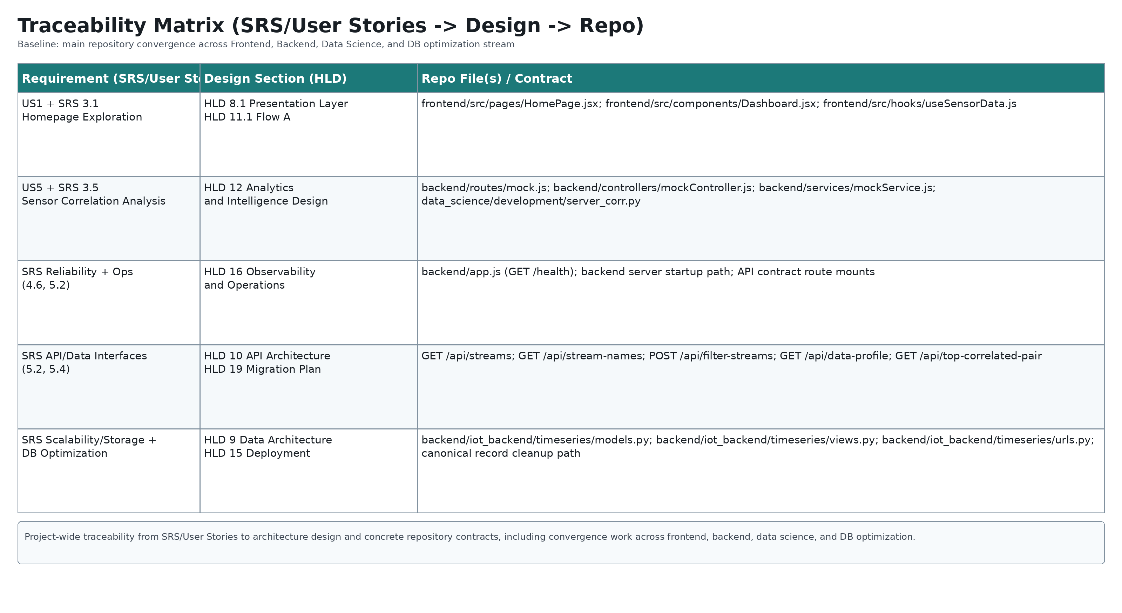
Figure 21.1: Traceability Matrix (Requirement -> Design section -> Repo file)
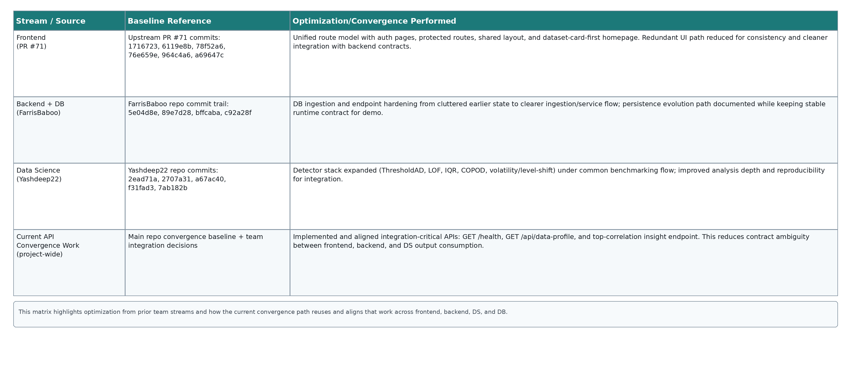
Figure 21.2: Optimization Traceability Matrix (frontend PR #71, backend PR #97, models PR #112, and current API convergence)

Final Architecture Narrative for Presentation
The platform began as a multi-prototype ecosystem (React variants, Node API, Django API, Flask analytics, notebooks). This HLD formalizes convergence into one coherent delivery path that preserves analytics value while reducing integration ambiguity. The resulting architecture is modular, demonstrable, and extensible: a clean dashboard experience over stable API contracts with data-science-informed insights and a clear roadmap toward stronger persistence, monitoring, and production hardening.

