

**Tribhuvan University**

**Bhaktapur Multiple Campus**

**Dudhpati-17, Bhaktapur**

**Lab Report**

**On**

**Simulation And Modeling**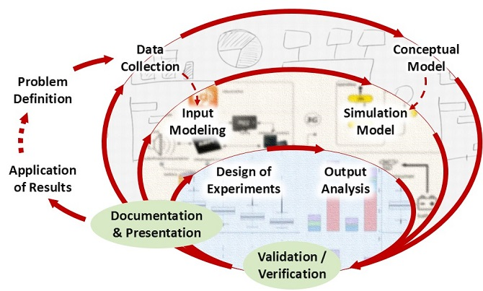

3/12/2021

**Submitted To: Submitted By:**

**Department of B.Sc.CSIT Name: Arjun Shrestha**

**Bhaktapur Multiple Campus Roll No: 15133**