Module Title Artificial Neural Networks

Module Code 7088CEM/M133CEM

Coursework Title: Artificial Neural Networks Applications

Lecturer: Dr. Wenqi Lu

Submitted By: Arjun Jayan (12577022)

Veena Upendran (12732827)

**Table of Contents**

Abstract 2

Introduction 2

Background 2

Components of ANN 3

Discussion 4

Challenges in ANN 7

Data set description 8

Methods 8

Experimental setup 8

Results 12

Social, ethical, legal, and professional considerations 15

Legal and ethical issues 15

Social issues 16

Conclusion 17

Reference List 18

Appendix 20

# Abstract

The problem we choose for this course work should ideally be drawn from the actual world, and we must investigate the most effective way to tackle it using neural network learning methods. This course works major goal is to evaluate our knowledge of the basic ideas behind neural networks and their uses for them. Additionally, to prepare a data set properly and assess how well various neural network algorithms perform on the selected data set. To evaluate that we are capable of analyzing and contrasting the outcomes of various learning algorithms.

# Introduction

An "Artificial neural networks" depends on a bunch of related units or hubs called pseudo neurons. Pseudo neurons by and large model the neurons of the regular brain. Like the normal synapses of the psyche, every affiliation can label various neurons. “Artificial neurons” can get as well as also deal with banners as well as also send messages to related neurons. The related "signal" is genuine and the outcome for every not entirely set in stone by the inconsistent number of criticism bits. Affiliations are called edges. Neurons and edges typically have loads that change as learning advances. The heap increments or diminishes the sign strength of the affiliation. The client can draw a neuron line for guarantee that characters are sent precisely when the quantity of characters surpasses this edge. Neurons are normally gathered in layers. Various layers permit the user to roll out various improvements to the data. The user’s personality might go through layers often previously moving from the principal layer (input layer) to the last layer (yield layer).In this report, there will be a description of the chosen dataset. After that, the experiment will be demonstrated in this report along with numerous snips that were collected during the work in google colab.

# Background

“Artificial neural networks” have at least three interconnected layers. The main layer is comprised of info neurons. These neurons send information to the lower layers, which thusly send the last result information to the last result layer. All inner layers are covered up and shaped by an element that adaptively changes the data got through a progression of changes from one layer to another. Each layer goes about as both an information layer and a result layer, permitting ANN to see more complicated objects. On the whole, these inward layers are known as the nerve layer. Throughout the last 10 years, computerized reasoning (AI) has turned into a famous subject both inside and beyond established researchers; an overflow of articles in innovation as well as non-innovation-based diaries take care of the subjects of AI, Machine learning (ML), as well as AI. Yet there actually remains disarray around AI, ML, and DL. The terms are exceptionally related, however, are not compatible. In 1956, a gathering of PC researchers recommended that PCs could be customized to think and reason, "that each part of the learning or some other component of knowledge on a basic level, be so definitively depicted that a machine be made to recreate it." They portrayed this rule as "counterfeit intelligence." Simply put, AI is a field centered around computerizing scholarly errands typically performed by people, and ML along with DL are explicit strategies for accomplishing this objective. That is, they are inside the domain of AI. Nonetheless, AI incorporates approaches that include no type of "learning." For example, the subfield known as emblematic AI centers around hardcoding rules for each conceivable situation in a specific space of interest. These human-composed rules get from deduced information regarding the matter as well as job needing to be done.

Such as, in the event that somebody programs a calculation that manages the room temperature in an office, that individual most likely definitely knows an agreeable temperature for individuals to work in, and when the temperature surpasses a specific edge rise. Also, when the individual warms, it falls underneath the lower limit. While emblematic AI can take care of distinct consistent issues, it frequently flops on errands that require an elevated degree of example acknowledgment, for example, Discourse acknowledgment or picture characterization. ML along with DL techniques are appropriate for these more intricate undertakings. This audit sums up AI as well as machine learning strategies for a group of people without the broad specialized foundation of PC programming.

# Components of ANN

* Perceptron, which is the premise of “artificial neural networks”. This calculation utilizes a sigmoid capability to scale numerous data sources and convert them to a solitary result in the reach of 0 to 1.
* The “Artificial neural network” interfaces numerous perceptron units with the goal that the result of one unit is utilized as the contribution of another. Additionally, these units are not restricted to the utilization of the sigmoid enactment capability.
* Instances of four distinct initiation capabilities: sigmoid, exaggerated digressions, characters, and amended direct units. The sigmoid scale is an S-molded bend that is placed somewhere in the range of “0 and 1”. Essentially, the exaggerated digression capability utilizes an S-molded bend, yet scales the contribution between “- 1 and 1”. The character capability can increase the contribution by any number to create a straight result. Standardized direct units are like character capabilities, yet all data sources are and it gets the result worth of 0. There are other actuation capabilities, yet these are apparently protective.

# Discussion

When various perceptron are associated, the model is known as the Multilayer Perceptron Algorithm or ANN. ANNs normally contain a layer of info nodes, a layer of result nodes, and some "covered up layers" between the two. In a straightforward ANN, there is an information layer between the 0-3 secret layers and the result layer. Profound neural networks contain handfuls or even many secret layers. For most errands, ANN transfers data. This is known as a feedforward neural organization and implies that data is passed from every one of the nodes in the past layer to every one of the nodes in the following layer, changed as well as also moved to every one of the nodes in the following layer. An intermittent neural network that isn't the subject of this white paper permits data to be passed between nodes inside a layer or to a past layer, where the result is handled as well as also moved once more. “Each layer of the ANN” can contain quite a few nodes. Notwithstanding, the quantity of nodes in the result layer normally relates to the quantity of prescient classes when the objective is a multiclass characterization, a solitary hub with a paired grouping sigmoid enactment, or a straight enactment capability when the objective is relapse. To do. These initiation works just believer the hub's contribution to the ideal result. Every nodes in the ANN contains an actuation capability. These actuation capabilities are not generally straight, however they don't need to be convoluted. For instance, a standardized straight, unit applies a direct change to inputs more prominent than or equivalent to 0 as well as sets the contributions to as well as also let; As the 0-0.25 information goes through the ANN, it changes bit by bit on each layer as well as doesn't look like the first state on the last layer. Be that as it may, this last portrayal of the information is hypothetically more unsurprising for a given outcome. Neural layer units endeavor to find out about the data gathered by weighting the data as indicated by ANN's inside framework. These rules permit the unit to create the changed outcome, which is given as the result to the following layer.

A bunch of extra learning rules utilizes backpropagation. This is the cycle by which ANN can change the result to represent blunders. Backpropagation sends data the other way each time the result is set apart as a blunder during the administered preparing stage. Each weight is refreshed in relation to how much mistake it depicts. Consequently, the mistake is utilized to correct the loads of the ANN unit association, considering the contrast between the ideal and genuine outcomes. After some time, ANN "realizes" how to limit the chance of blunders and undesirable outcomes.

Counterfeit neural network preparing includes looking over a reasonable model with a few pertinent calculations.

“ANN” has a few benefits, yet one of the most unmistakable of these is the way that you can really gain from noticing the dataset. Along these lines, ANN is utilized as an irregular capability estimation device. These sorts of devices assist you with assessing the least expensive and most ideal method for arriving at an answer while characterizing a computational capability or dispersion. ANN utilizes information tests instead of whole datasets to arrive at arrangements, setting aside both time and cash. ANN is viewed as an extremely straightforward numerical model for further developing existing information examination innovation. These can be utilized in numerous reasonable applications, for example prescient investigation for business insight, identification of spam messages, regular language handling of chat bots, and so on.

Gives an illustration of I/O planning to prepare a neural organization. At long last, when the neural networks have finished preparing, it will test the neural networks that are not commented on with these guides. Neural networks foresee the result and utilize different blunder capabilities to assess how right the result is. At last, in light of the outcomes, the model changes the loads of the neural organization to improve the organization after the chain rule steepest drop strategy. With feedforward ANN, the progression of data is one-way in particular. That is, the progression of data streams from the information layer to the secret layer lastly to the result. There is no criticism circle in this neural organization. This sort of neural network is principally utilized in administered learning of occurrences like characterization and picture acknowledgment. Use when the information isn't consecutive. Criticism ANN makes the input circle part of it. This kind of neural network is essentially utilized for memory capacity, just like with intermittent neural organizations. These sorts of organizations are the most appropriate for regions where the information is successive or time subordinate.

**Convolutional neural network**

For picture acknowledgment undertakings, each contribution to the feedforward ANN compares to a pixel in the picture. In any case, this isn't ideal since there are no associations between the hubs in the layer. This implies that the spatial setting of the elements in the picture is lost. As such, pixels that are near one another in a picture might be more unequivocally related than pixels on the opposite side of the picture, however feedforward ANN doesn't consider this. The Convolutional Neural Network (CNN) is an extraordinary instance of ANN that defeats this issue by keeping up with spatial connections between pixels in a picture. Rather than getting individual pixels as info, the CNN takes care of the fix of the picture to a particular hub of the powerful nodes as well as also keeps up with the spatial setting from which the elements were separated. Patches on these nodes figure out how to extricate explicit highlights as well as also are called convolution channels. Convolution is generally utilized in picture handling and is frequently utilized for different undertakings, for example, obscuring and honing pictures and edge location. A noticeable light computerized picture is a straightforward single grid in the event that the picture is a grayscale picture, and three stacked networks assuming that the picture is a variety picture. These lattices contain values (regularly 0-255) that address the pixels in the picture and the power of each variety channel for each pixel. Convolution channels are tiny frameworks with a size of 2x2-9, normally square. This channel is passed to the first picture and a component by-component lattice duplication is performed at each position. The result of this convolution is planned to another grid containing values that relate to whether the convolution channel got the element of interest.

In CNN, channels are prepared to remove explicit highlights from a picture and imprint their situation on the element map. Deep CNNs then, at that point, utilize the element map as contribution to a higher level. At a higher level, the user will utilize the new channel to make another new component map. This can be forged ahead with many layers, as well as after some time the separated elements will become conceptual, yet exceptionally valuable for expectation. The last component guide can then be packed from the square portrayal as well as also shipped off the feedforward ANN to arrange the picture in light of the separated elements along with the surfaces. This interaction is “called DL”.

## Challenges in ANN

Lately, with the computerized accessibility of data, ANN has turned into a hotly debated issue in medication. Nonetheless, many difficulties remain. ANN is restricted by the amount and nature of the information used to prepare the model. It is hard to appraise how much information expected to prepare the ANN framework satisfactorily and dependably, as it relies upon both the nature of the preparation information entered and the intricacy of the undertaking. Huge number of preparing models are ordinarily expected to make an exact and generalizable model. In this manner, creating models to distinguish uncommon illnesses for which enormous datasets may not be promptly accessible is a specific test. Then again, the user might imagine that more information will continuously prompt a superior model, however preparing with exceptionally enormous datasets may bring about mistaken preparing information quality, wrong names, or the situations that can prompt models assuming that they are in some way or another methodically not the same as the genuine working test populace are bad. What's more, there is an understood presumption that the records are precisely named by a human evaluator. Tragically, this is much of the time not the situation, as well as uproarious or missing marks are in many cases a migraine for information researchers.

“The ANN technique” similarly experiences a "black box" issue. In the "black box" issue, the info is given to the calculation and there is yield, yet it isn't clear which elements were distinguished or the way that they advised the model result. Conversely, basic straight calculations are not generally as strong as ANN, however they are not difficult to decipher. The determined loads for every trademark are given after the preparation interaction is finished and might have the option to precisely question the presentation of the model as well as also find significant indicators that might assist with forestalling infection such as “Lungs cancer”. In profound learning, a perplexing arrangement of lattice duplications and unique channels makes interpretability significantly more troublesome. Enactment maps, or heat maps, are a method for attempting to settle the "black box" issue by featuring region of the picture that is "set off with the result grouping mark". Unfortunately, these strategies are in many cases not fundamentally examined regardless require human translation, so this is as yet a functioning field of study. Such as, assuming that the ANN model groups the fundus picture as proliferative diabetic retinopathy, the heat map features the component regions on the fundus picture that added to the choice to be named proliferative diabetic retinopathy. It is the doctor's liability to decipher whether these elements distinguished by the ANN model are the very includes that the doctor uses to analyze the sickness as well as also the ramifications of such discoveries.

# Data set description

Lung cancer data set which has been taken here as well as also worked upon according to the report titled “Artificial neural networks”. The prediction of this data set is done in python google colab. In the chosen dataset some of the names of individuals were provided along with their age, their rate of smoking, the air quality of the area where they lived, as well as also the rate of consumption of Alcohol. In this project, the prediction of lung cancer will be predicted as per their rate of smoking along with their age and rate of smoking. The name along with the surnames of the individuals was also considered to predict the result of the respective individuals.

# Methods

The supervised learning techniques that are used in this case to address the problem are based on "Artificial Neural Networks." A real subcategory of artificial intelligence and machine learning is supervised machine learning, commonly referred to as supervised learning. This is also described as using labeled datasets to train algorithms that are needed for precise and accurate data classification or outcome prediction. These techniques are applied in this analysis of a dataset related to lung cancer.

# Experimental setup

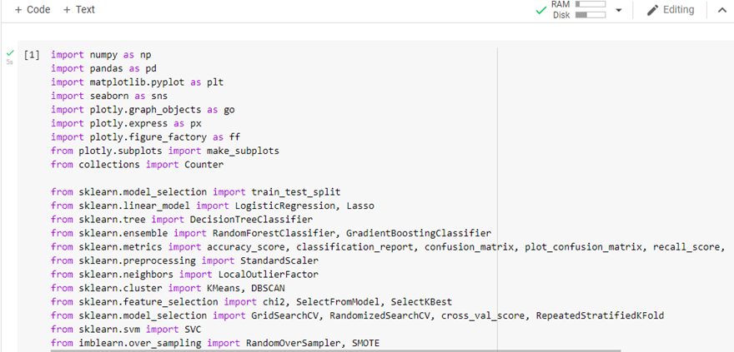

**Figure 1: Importing Packages**

The above figure shows the process of importing all of the required packages or libraries for this project in the google colab .The various library that is been called are the numpy, pandas, malplots, seaborn,plotly.graph_objects, plotly.express etc are been imported so that they will be able to perform the respective function.

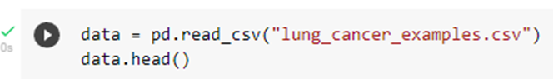

**Figure 2: Importing data set**

The above figure shows the importing process of the dataset that was chosen for this lung cancer prediction project. As the above commands reads the datasets that is been names of the “lung_cancer_examples.csv” as the csv is the format that is been used for the reading in the google colab.

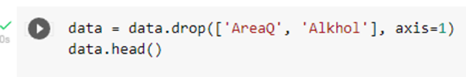

**Figure 3: Dropping the data**

The above figure shows the code for dropping some data from the chosen data set. That means the selected data of this code will be no longer available for the further progression of this project The data that is been selected is the the “AreaQ”, “Alkhol” .

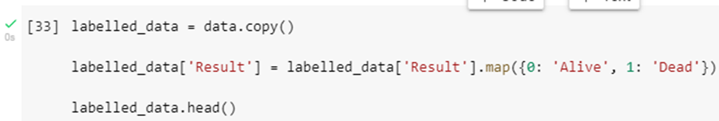

**Figure 4: Code of results**

The above figure shows the code for getting the result of the condition of the individual as per their age along with the rate of smoking. As the above commands signifies the labeling of the datasets that have been chosen for lung cancer analysis .The column that is been labeled is the “Results”

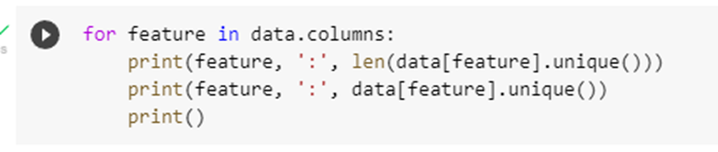

**Figure 5: Code of data columns features**

The above figure signifies the feature that is been used in the data column and along with that there are the commands for the printing the length of the data[feature].unique and in the next line there is been the printing the unique feature of the data of the datasets that is been selected related to the lungs cancer.

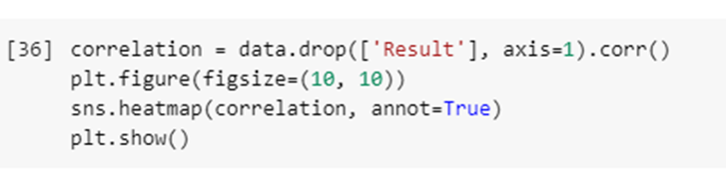

**Figure 6: Codes for the correlation**

The above snips defines the codes that is been used for the correlation of the relation of the column “Results”.As in the next line there is been codes that is been related to the plot of the figure by the specification of the figure size 10, 10 and the next line show the plot in terms of the heatmaps.

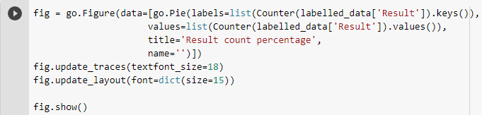

**Figure 7: Code for plotting of the pie chart**

The above snips defines the codes that for the purpose of the plotting of the pie charts of the results of the datasets related to the lung cancer that has been chosen. As the title of the pir chart that has been chosen is the “Result counts percentage” .After that there has been some miscellaneous settings is that is the setting of the font size along with other.



**Figure 8: Printing the feature**

The above figure represents the printing of the features of the results that have been there in the datasets which have been related to lung cancer. As it is been printed with the help of the axis and column.

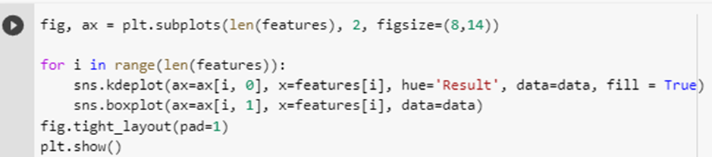

**Figure 9: Plotting the feature using the seaborn**

The above snips represents the loop that has been used with the help of the seaborn commands. As the seabourn commands are being used for the visualization of the data this has been selected for the purpose of the visualization of the data related to lung cancer .The range has been of the feature.

# Results

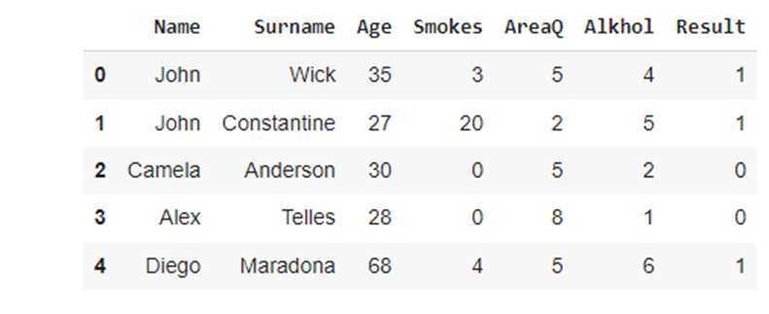

**Figure 10: Printing the list of the first 5 name in the datasets**

As the figure above represents the printing the list of the first five names that have been there in the datasets that has been chosen along with the various fields (column) that have been chosen. The various columns are the Name, surname, age, smokes, AreaQ, Alkohol along with results.

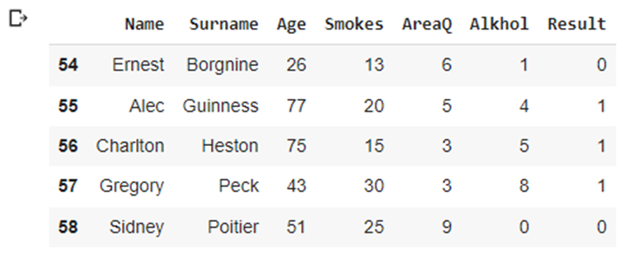

**Figure 11: Printing the list of the last 5 names in the datasets**

As the figure above represents the printing the list of the last five names that have been there in the datasets that have been chosen along with the various fields (column) that have been chosen. The various columns are the name, surname, age, AreaQ, smokes, Alkohol along with results.

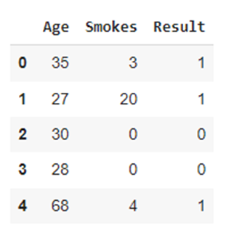

**Figure 12: Elimination of the Column**

As there above snips represent the results of the simplification of the datasets that have been chosen. As in that name, surname, area, alcohol column has been removed .As the simplified form of the datasets is represented in the figure above.

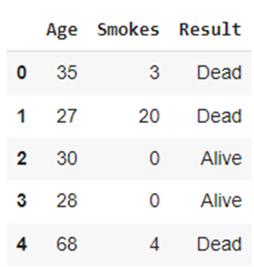

**Figure 13: Changing the data of the results.**

The above snips represent the data of the datasets but there is been some modification is been done related to the last figure as in the previous figure the data is been represented in the form of the 0 and 1 which is been dead and alive as the 1 signifies the dead where as the 0 is signifies the death of the person.

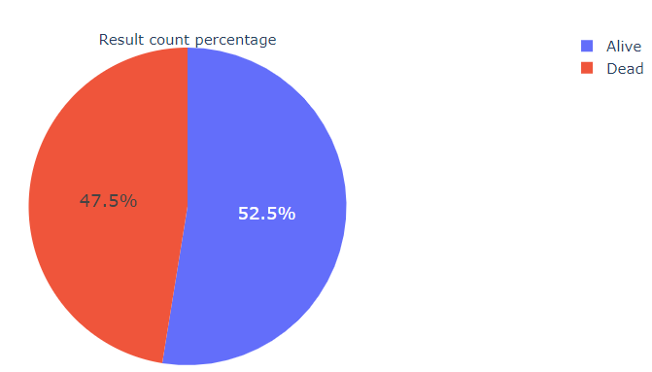

**Figure 14: Plot the pie chart**

As the above figure represents the results of the number of the person that has been dead or alive. As it is the results of the code that has been executed in figure number 7 .The above figure represents that there is more number of living people is been around 52.5 % and the number of dead people is around 47.5 % who has been died from lung cancer.

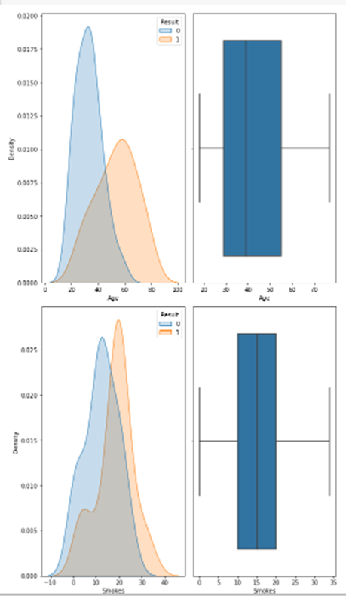

**Figure 15: Graph**

The above figure represents the graph between the two variables that is density and smoke. As the figure represents that the normal distribution graph is obtained between the plot of the variable related to lung cancer. As it has been observed that the mode of both graphs is different in the different graphs. The means of both the graphs are different.

# Social, ethical, legal, and professional considerations

## Legal and ethical issues

The legal along with ethical issues which confront society based on “Artificial Neural Networks” due to “Artificial Intelligence (AI)” includes surveillance as well as privacy, discrimination or bias, as well as potentially the challenge which is philosophical and which is related to the lung cancer disease .The ethical challenges are informed consent of using data, transparency, and safety, the privacy of data, along with biases, and algorithmic fairness as well. The social and professional considerations are also considered here while doing this work on lung cancer using artificial neural networks.

## Social issues

**Legislation**

Human culture is administered by regulation. Computer-based intelligence and ML improvement remained in the scholarly community, however, remained legitimately secure, yet the second these advances by and large started to consume social space, their effect on individuals could arrive at their lawful cutoff points .A typical discussion is the utilization of AI as the reason for self-driving vehicles. The obligation is plainly characterized when an individual is liable for holding the controlling wheel of a vehicle and simply deciding. In any case, the quick modern improvement of semi-independent vehicles towards the objective of completely independent driving is broadening the creases of the current regulation.

**Interpretability along with Explainability**

The organic cerebrum doesn't be guaranteed to foster a method for accounting for itself. This most certainly applies just to specific kinds of social ways of behaving (in spite of the fact that it tends to have contended that social ways of behaving can happen in species where the cerebrum can account for itself through some type of correspondence). In human species, regular language serves this correspondence or clarification capability

# Conclusion

The expression "Artificial neural networks" alludes to an organically propelled subarea of computerized reasoning displayed in the mind. “Artificial neural networks” are typically PC networks in light of natural neural networks that form the design of the human mind. Similarly, as the human mind has neurons that are associated with one another, counterfeit neural networks have neurons that are associated with one another at various layers of the organization. These neurons are called nodes. In the field of man-made consciousness, fake neural networks that attempt to impersonate organizations of neurons structure the human mind, so PCs can comprehend things and go with choices like people. “Artificial neural networks” are created by programming PCs to act like interconnected synapses.

# Reference List

**Journals**

Abu Dalffa, M., Abu-Nasser, B.S. and Abu-Naser, S.S., 2019. Tic-Tac-Toe Learning Using Artificial Neural Networks.

Heriz, H.H., Salah, H.M., Abdu, S.B.A., El Sbihi, M.M. and Abu-Naser, S.S., 2018. English Alphabet Prediction Using Artificial Neural Networks.

Kasai, H., Ziv, N.E., Okazaki, H., Yagishita, S. and Toyoizumi, T., 2021. Spine dynamics in the brain, mental disorders and artificial neural networks. *Nature Reviews Neuroscience*, *22*(7), pp.407-422.

Mangini, S., Tacchino, F., Gerace, D., Bajoni, D. and Macchiavello, C., 2021. Quantum computing models for artificial neural networks. *Europhysics Letters*, *134*(1), p.10002.

Masi, F., Stefanou, I., Vannucci, P. and Maffi-Berthier, V., 2021. Thermodynamics-based Artificial Neural Networks for constitutive modeling. *Journal of the Mechanics and Physics of Solids*, *147*, p.104277.

Rem, B.S., Käming, N., Tarnowski, M., Asteria, L., Fläschner, N., Becker, C., Sengstock, K. and Weitenberg, C., 2019. Identifying quantum phase transitions using artificial neural networks on experimental data. *Nature Physics*, *15*(9), pp.917-920.

Runge, J. and Zmeureanu, R., 2019. Forecasting energy use in buildings using artificial neural networks: A review. *Energies*, *12*(17), p.3254.

Sadeghi, M., Asanjan, A.A., Faridzad, M., Nguyen, P., Hsu, K., Sorooshian, S. and Braithwaite, D., 2019. PERSIANN-CNN: Precipitation estimation from remotely sensed information using artificial neural networks–convolutional neural networks. *Journal of Hydrometeorology*, *20*(12), pp.2273-2289.

Saikia, P., Baruah, R.D., Singh, S.K. and Chaudhuri, P.K., 2020. Artificial Neural Networks in the domain of reservoir characterization: A review from shallow to deep models. *Computers & Geosciences*, *135*, p.104357.

Schmitt, M. and Heyl, M., 2020. Quantum many-body dynamics in two dimensions with artificial neural networks. *Physical Review Letters*, *125*(10), p.100503.

Tang, J., Yuan, F., Shen, X., Wang, Z., Rao, M., He, Y., Sun, Y., Li, X., Zhang, W., Li, Y. and Gao, B., 2019. Bridging biological and artificial neural networks with emerging neuromorphic devices: fundamentals, progress, and challenges. *Advanced Materials*, *31*(49), p.1902761.

# Appendix

1. **import** numpy **as** np
2. **import** pandas **as** pd
3. **import** matplotlib.pyplot **as** plt
4. **import** seaborn **as** sns
5. **import plotly.graph_objects as go**
6. **import** plotly.express **as** px
7. **import** plotly.figure_factory **as** ff
8. **from** plotly.subplots **import** make_subplots
9. **from** collections **import** Counter
11. **from** sklearn.model_selection **import** train_test_split
12. **from** sklearn.linear_model **import** LogisticRegression, Lasso
13. **from** sklearn.tree **import** DecisionTreeClassifier
14. **from** sklearn.ensemble **import** RandomForestClassifier, GradientBoostingClassifier
15. **from sklearn.metrics import accuracy_score, classification_report, confusion_matrix, plot_confusion_matrix, recall_score, precision_score**
16. **from** sklearn.preprocessing **import** StandardScaler
17. **from** sklearn.neighbors **import** LocalOutlierFactor
18. **from** sklearn.cluster **import** KMeans, DBSCAN
19. **from** sklearn.feature_selection **import** chi2, SelectFromModel, SelectKBest
20. **from sklearn.model_selection import GridSearchCV, RandomizedSearchCV, cross_val_score, RepeatedStratifiedKFold**
21. **from** sklearn.svm **import** SVC
22. **from** imblearn.over_sampling **import** RandomOverSampler, SMOTE
24. data = pd.read_csv("lung_cancer_examples.csv")
25. **data.head()**
26. data = pd.read_csv("lung_cancer_examples.csv")
27. data.tail()
28. data = pd.read_csv("lung_cancer_examples.csv")
29. data.all()
30. **data = data.drop(['Name','Surname','AreaQ', 'Alkhol'], axis=1)**
31. data.head()
33. labelled_data = data.copy()
34. labelled_data['Result'] = labelled_data['Result'].map({0: 'Alive', 1: 'Dead'})
35. **labelled_data.head()**
36. data.isnull().sum()
38. **for** a feature **in** data.columns:
39. **print**(feature, ':', len(data[feature].unique()))
40. **print(feature, ':', data[feature].unique())**
41. **print**()
43. correlation = data.drop(['Result'], axis=1).corr()
44. plt.figure(figsize=(10, 10))
45. **sns.heatmap(correlation, annot=True)**
46. plt.show()
48. fig = go.Figure(data=[go.Pie(labels=list(Counter(labelled_data['Result']).keys()),
49. values=list(Counter(labelled_data['Result']).values()),
50. **title='Result Count Distribution',**
51. name='')])
52. fig.update_traces(textfont_size=18)
53. fig.update_layout(font=dict(size=15))
54. fig.show()
56. features = list(data.drop(['Result'], axis=1).columns)
57. features
58. fig, ax = plt.subplots(len(features), 2, figsize=(8,14))
60. **for i in range(len(features)):**
61. sns.kdeplot(ax=ax[i, 0], x=features[i], hue='Result', data=data, fill = True)
62. sns.boxplot(ax=ax[i, 1], x=features[i], data=data)
63. fig.tight_layout(pad=1)
64. plt.show()