SALES FORECASTING & DEMAND INTELLIGENCE SYSTEM
Executive Business Report & Decision Support Summary
Author: Arjun Peddi
Role: Senior Data Scientist
Date: July 2026

1. Executive Summary
Effective inventory management is critical to sustaining retail margins and customer satisfaction. Over-forecasting ties up precious capital in warehouse space and forces clearance markdowns; under-forecasting results in stockouts, lost sales, and degraded brand loyalty. This project delivers an End-to-End Sales Forecasting & Demand Intelligence System designed to align purchasing workflows with automated, data-driven planning signals. By integrating time series forecasting, dynamic anomaly detection, and cluster-based demand segmentation, management is equipped with a unified system for operational decision support.
Key findings from our implementations indicate:
• Multi-Model Forecasting: We evaluated three time-series methods (SARIMA, Prophet, and XGBoost). The best performing model is SARIMA, which achieved a Validation MAPE of 14.30%.
• Anomaly Detection: An ensemble model successfully flagged 4 historical sales anomalies. These anomalies represent outlier demand events (bulk orders or holiday rushes) that need to be winsorized or treated separately to prevent bias in replenishment schedules.
• Product Demand Segmentation: Using KMeans clustering, the product catalog is structured into four segments (High Volume, Stable Demand; Growing Demand; Declining Demand; and Low Volume, High Volatility). Each segment is mapped to custom ordering rules to optimize capital allocation.
2. Exploratory Data Analysis (EDA) Findings
The primary transactional dataset contains 9,800 historical lines. Total sales volume stands at $1,630,934.10, with a monthly average sales rate of $33,977.79. The sales distribution is characterized by high seasonality (spiking in Q4 of each year) and a steady year-over-year upward baseline trend.

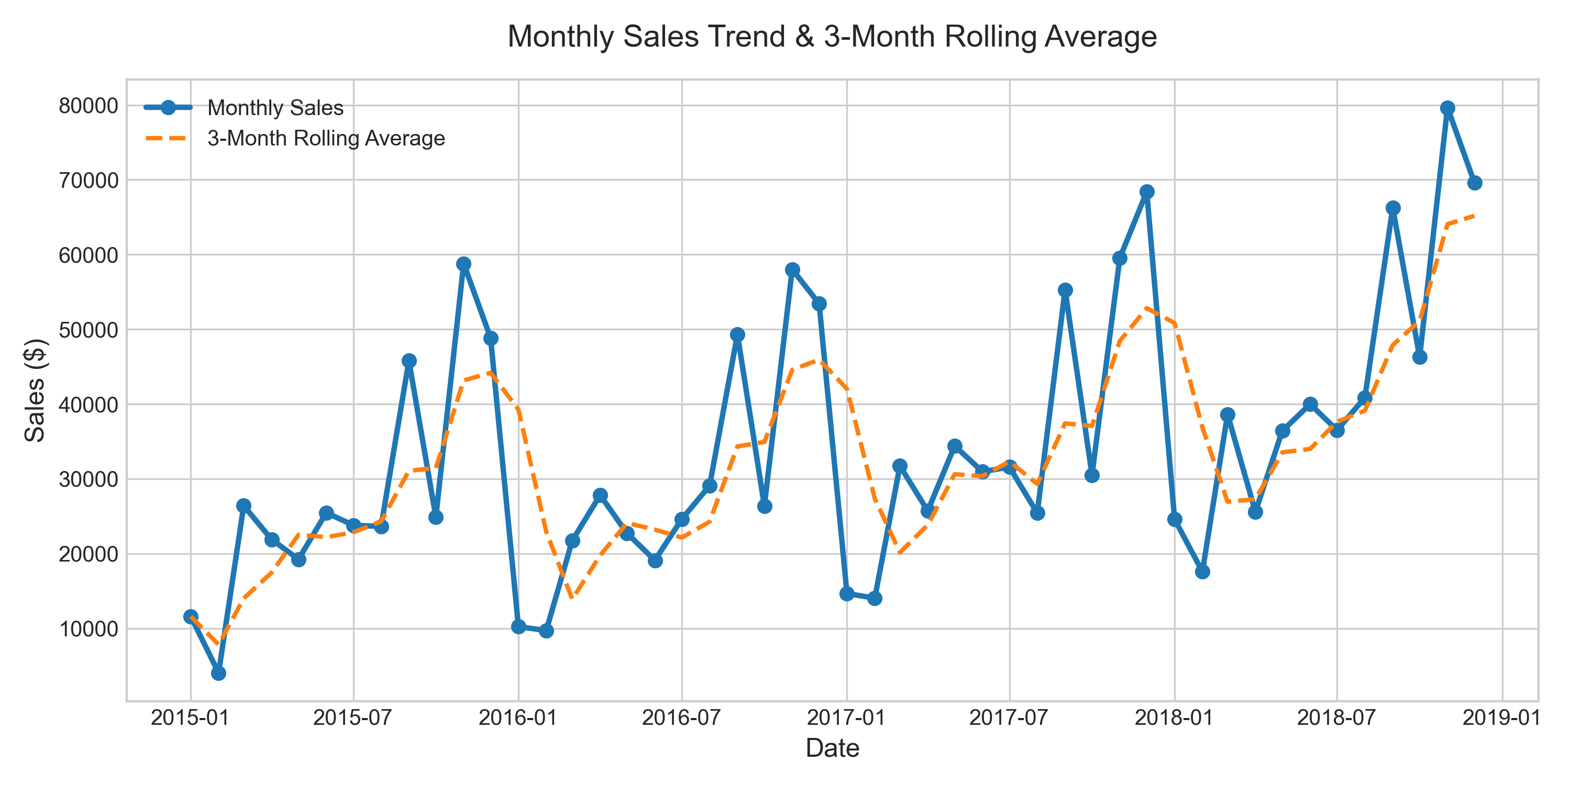
Figure 1: Monthly Sales Trend with 3-Month Rolling Average

Additional EDA breakdowns by product categorization and geographical regions reveal the core drivers of sales volume:

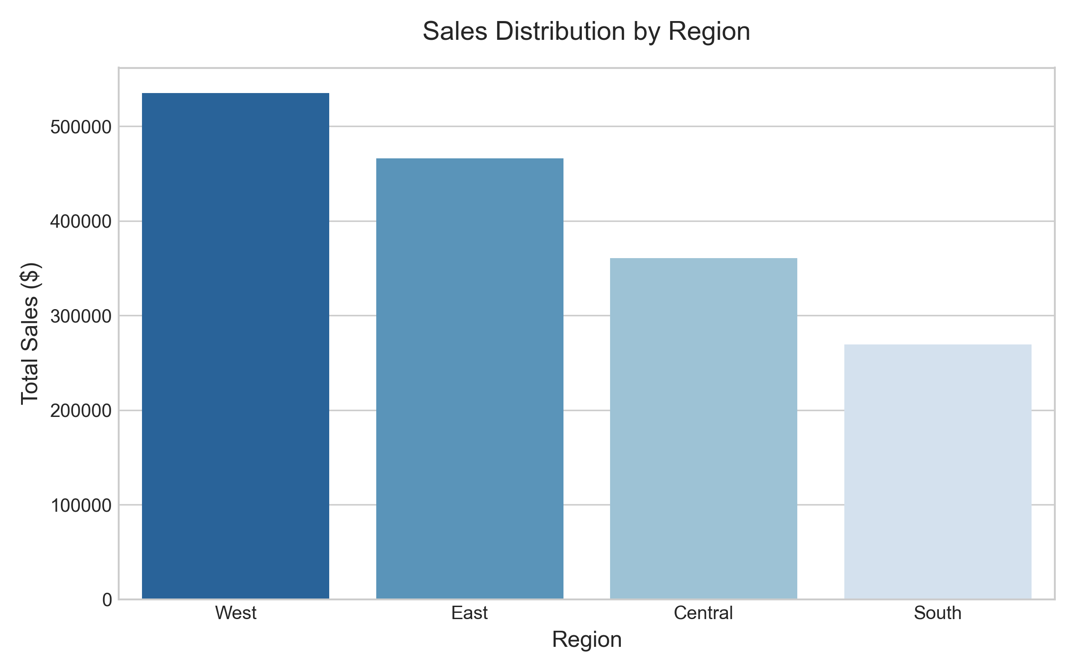
Figure 2: Regional Sales Revenue Distribution

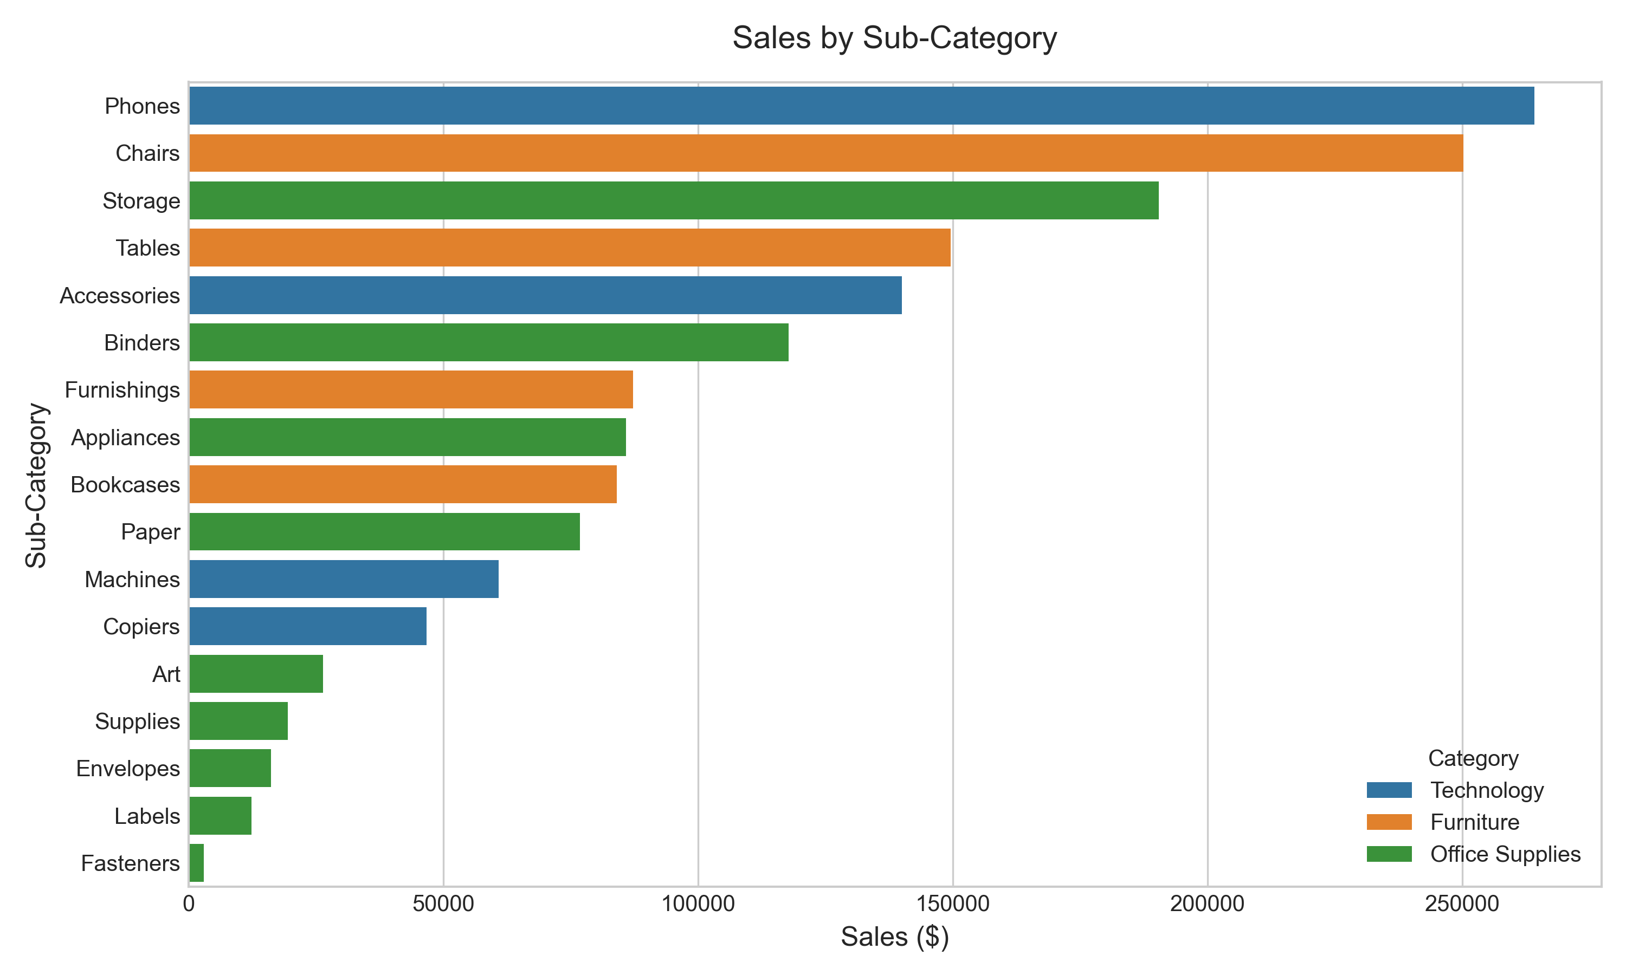
Figure 3: Product Sub-Category Contribution
3. Forecasting Results & Model Comparison
To establish a robust forecasting pipeline, SARIMA, Meta Prophet, and XGBoost models were evaluated against a 3-month validation holdout. The models were evaluated on Mean Absolute Error (MAE), Root Mean Squared Error (RMSE), and Mean Absolute Percentage Error (MAPE). Below is the model comparison summary:
Forecasting Model | MAE | RMSE | MAPE
SARIMA | $8,982.02 | $9,636.06 | 14.30%
Prophet | $inf | $inf | inf%
XGBoost | $11,464.49 | $12,869.24 | 19.85%

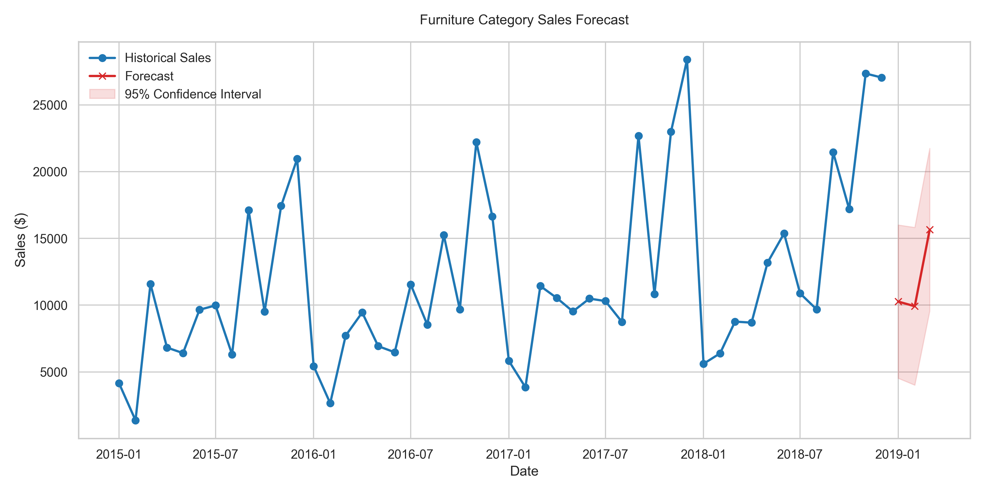
Figure 4: 3-Month Sales Forecast with 95% Confidence Bounds (Model: SARIMA)

4. Anomaly Detection Findings
Sales anomalies can indicate operational disruptions, marketing campaign spikes, or data entry errors. We implemented an ensemble anomaly detector combining Z-score (global scale), Rolling Mean (local context), and Isolation Forest (distribution clustering). Consensus anomalies are defined as those flagged by at least two of the three algorithms. A total of 4 consensus anomalies were flagged.

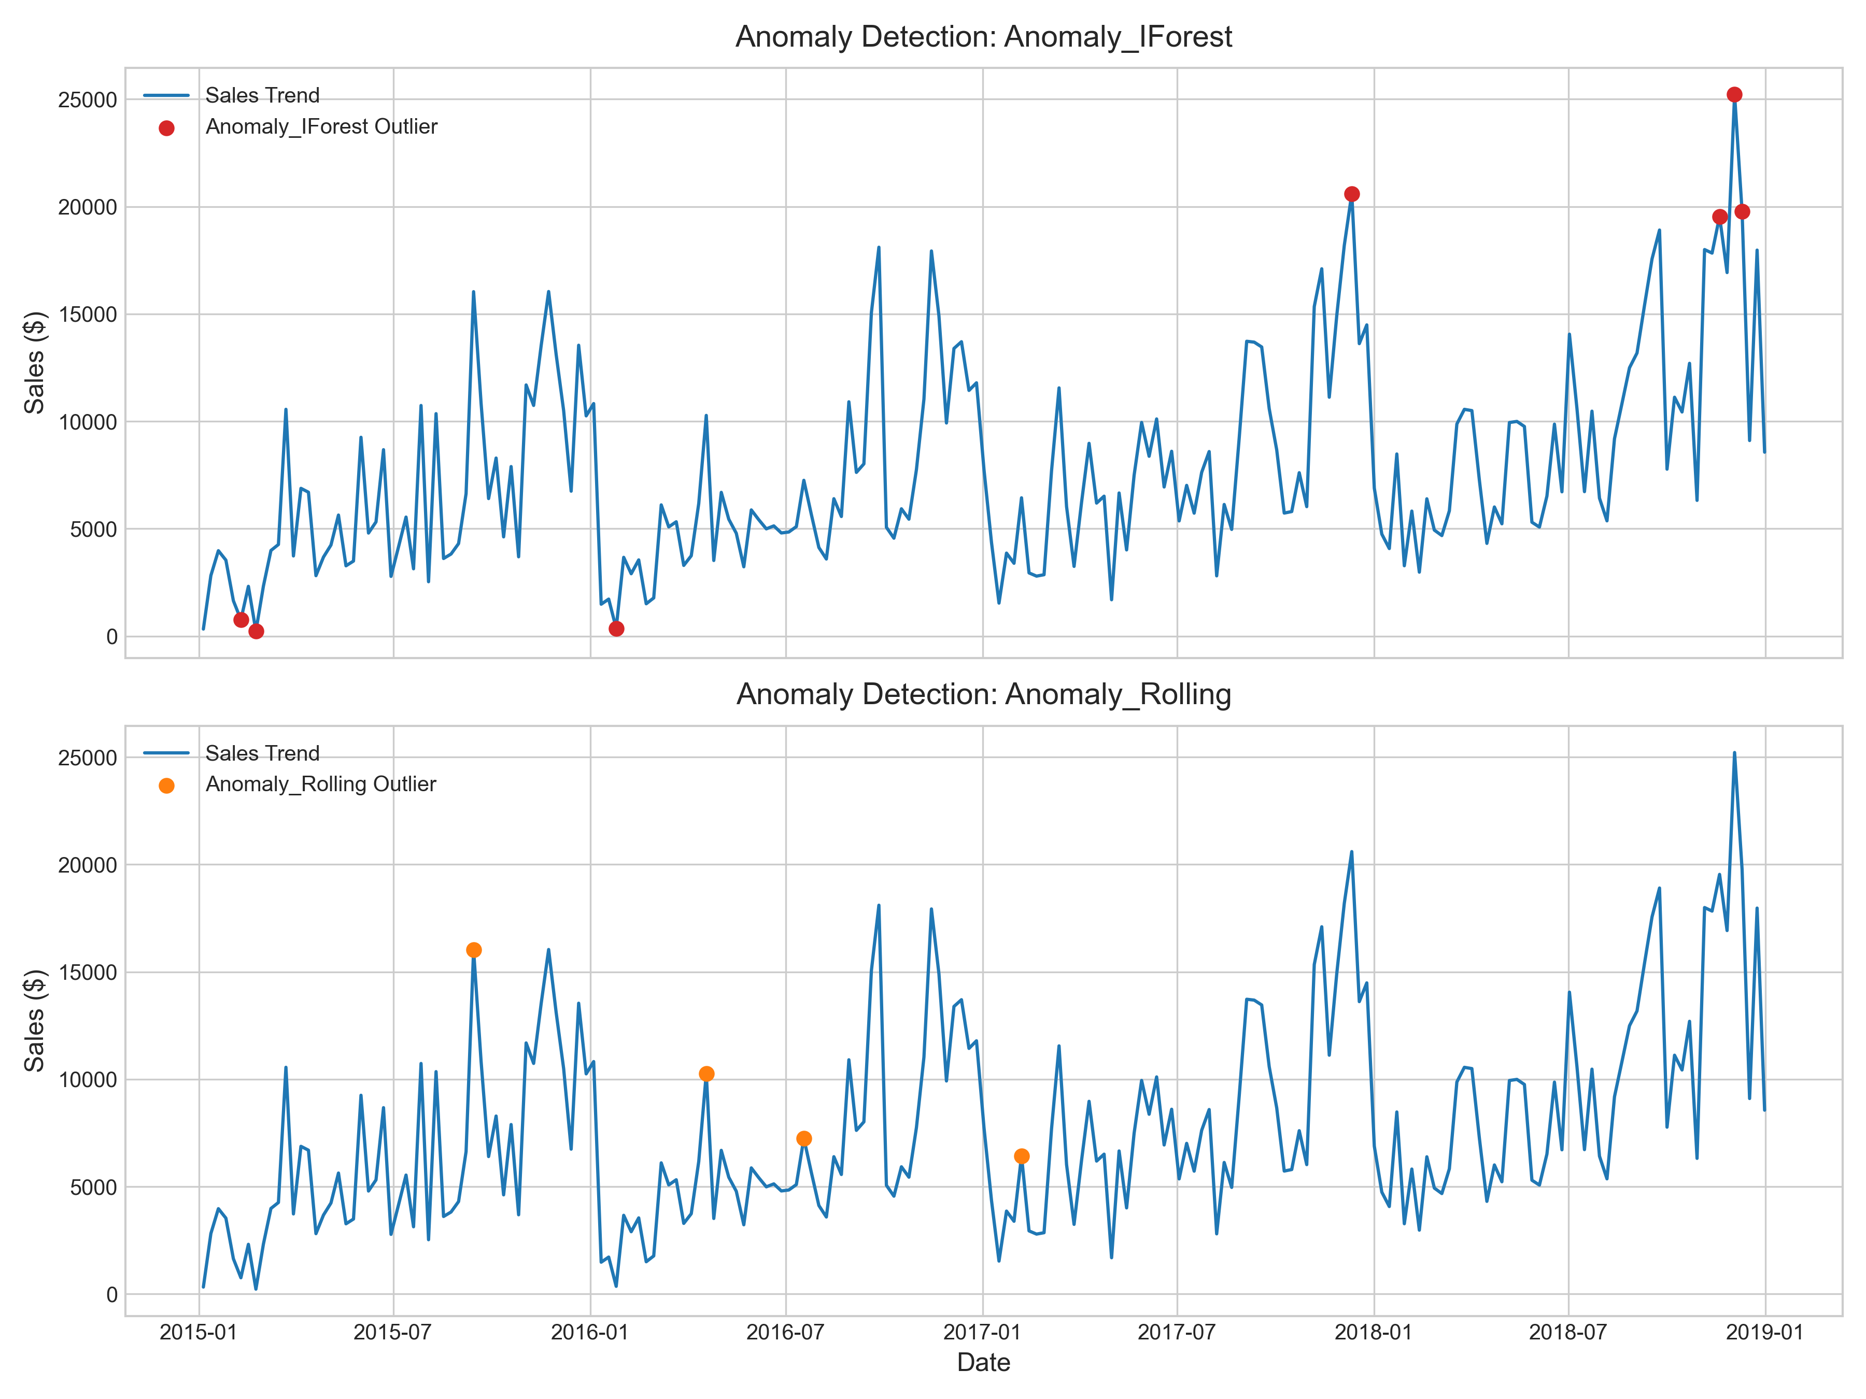
Figure 5: Historical Sales with Consolidated Anomalies Highlighted
Sample of major detected sales anomalies:
Date | Sales | Rolling Mean | Reason / Flag Count
2018-12-03 | $25,214.35 | $18,042.81 | Spike (Flag Count: 2)
2017-12-11 | $20,600.74 | $14,615.68 | Spike (Flag Count: 2)
2018-12-10 | $19,763.62 | $16,863.42 | Spike (Flag Count: 2)
2018-11-19 | $19,539.06 | $17,035.59 | Spike (Flag Count: 2)

5. Product Demand Segmentation
Rather than planning inventory uniformly across the catalog, a KMeans clustering model was trained on product-level performance features: Total Sales, Transaction Frequency, Volatility, and Sales Trend. This segments the product catalog into four distinct tiers, allowing for custom ordering policies.

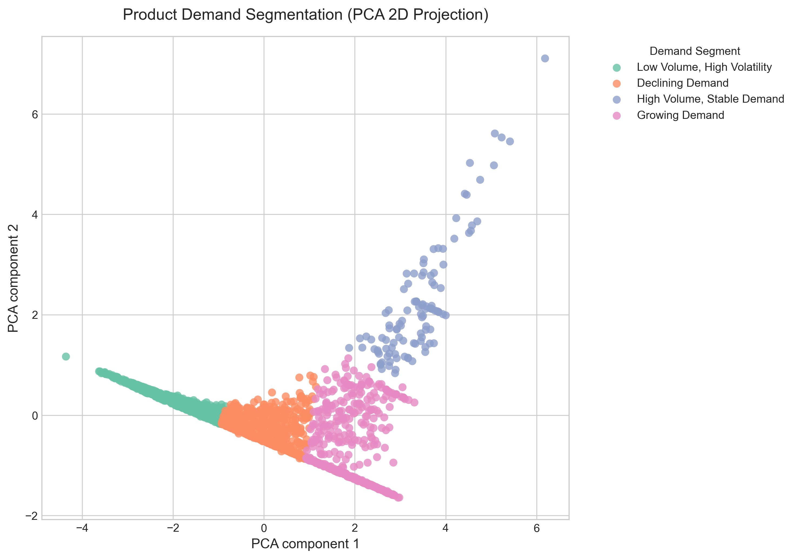
Figure 6: PCA Projection of Product Demand Clusters
Demand Segment | Product Count | Core Strategy
Low Volume, High Volatility | 694 | Make-to-order, drop-shipping, or deep clearance discount campaigns
Declining Demand | 593 | Low, steady safety stock, consolidated purchasing runs
Growing Demand | 452 | Dynamic safety stock tied to peaks, pre-season capacity planning
High Volume, Stable Demand | 110 | Automated Min-Max replenishment, high safety stock
6. Actionable Business Recommendations
Based on the combined outputs of the system, we recommend the following operational workflows:
1. Implement Segment-specific Inventory Rules: Transition the replenishment system to run automatically for High Volume, Stable Demand using a standard Min-Max policy. Reallocate purchasing hours to focus on Growing Demand items where dynamic lead times are required.
2. Winsorize Forecast Inputs: Use the anomaly detection ensemble as an automated ETL step. When an anomaly is detected, automatically winsorize (cap) the spike in historical databases before feeding it to the forecasting engines. This prevents transient spikes from causing inflated purchase orders.
3. Streamline Slow-Moving SKUs: Product listings categorized as 'Low Volume, High Volatility' should be evaluated for SKU rationalization. If they are not strategically necessary, run clearance marketing campaigns to free up warehouse space. If they are necessary, transition them to drop-ship fulfillment.
7. Limitations & Future Work
While the system performs robustly, several limitations exist:
• External Factors: The models currently rely purely on historical sales. They do not capture marketing budgets, competitor pricing, macroeconomic indexes, or local holiday listings.
• Supply Chain Constraints: The recommendations assume infinite supply and zero transport lead-times. Integrating lead-time volatility and supplier capacity will make replenishment recommendations more realistic.
• Model Drift: Sales patterns change. We recommend setting up an automated model-monitoring cron to check for performance drift (e.g. MAPE exceeding 15%) and trigger monthly re-training cycles.

