Placement Management Software System
Introduction
The Placement Management Software System is a software application designed to simplify and organize the placement activities of an educational institution. The system focuses on managing student information, job and internship opportunities, and application processes in a structured and efficient manner. This project is developed following the Software Development Life Cycle (SDLC) approach, emphasizing proper analysis, design, testing, and implementation. The frontend of the system represents the final phase of implementation, demonstrating the working of the designed software.
Problem Statement
In many colleges and universities, placement activities are still managed using manual methods or partially digital tools such as spreadsheets, emails, and notice boards. Student details, company information, and placement records are often stored in separate systems, making it difficult to manage and update data efficiently. This leads to duplication of records, lack of transparency, and delays in communication between students and the placement cell.
Another major issue with the existing system is the absence of a centralized platform where students can easily view placement opportunities and track their application status. Important information such as eligibility criteria, deadlines, and company requirements is often communicated informally, which may result in students missing opportunities. Additionally, placement officers face difficulties in monitoring student applications and generating accurate placement reports.
The proposed Placement Management Software System addresses these issues by providing a centralized and structured software solution. The system allows students to access placement-related information through a single platform, ensuring transparency and consistency. It organizes placement data in a logical manner, making it easier for users to interact with the system and understand the placement process.
Our system is designed to improve efficiency, reduce manual effort, and enhance the overall placement workflow. By following a systematic software engineering approach, the system ensures better usability, reliability, and scalability. The frontend implementation demonstrates how users interact with the system, while the underlying design ensures that the software can be extended in the future with additional features if required.

Objectives of the Project
1. To design a centralized software system for managing placement-related activities.
2. To provide an easy-to-use interface for students to view job and internship opportunities.
3. To help placement administrators efficiently manage student and company information.
4. To reduce manual effort and errors in the placement process.
5. To apply Software Development Life Cycle concepts in the design and development of a real-world software system.
Scope of the Project
The scope of the Placement Management Software System covers the design and development of a software solution that supports placement activities within an educational institution. The system focuses on managing student profiles, job listings, and application workflows in a structured manner. It provides a clear interface for students to access placement information, view available opportunities, and track the status of their applications.
The project emphasizes software engineering principles such as requirement analysis, system design, testing, and maintenance. The system is designed to support multiple user roles, including students and placement administrators, each with specific functionalities. The frontend implementation demonstrates the interaction between users and the system, showcasing dashboards, forms, and status displays using dummy data.
This project does not focus on backend server development or relational database implementation; instead, it highlights the design and lifecycle of a software system using client-side storage (localStorage) to simulate data persistence. The scope also includes testing strategies and future enhancement possibilities such as real database integration, JWT authentication mechanisms, and dynamic report generation. Overall, the project aims to present a scalable, well-structured frontend software solution.

Project Type
It is built using HTML5, modern CSS3 (with CSS variables and responsive flexbox/grid layouts), and vanilla JavaScript. It utilizes the browser's localStorage for data persistence across sessions, making it lightweight, interactive, and completely functional without a backend server.
The project follows a single-tier architecture where all processing occurs on the client side. This approach is suitable for academic demonstration because it allows easy testing without requiring server setup or database connectivity. The project also serves as a strong practical example of applying SDLC principles in software engineering.

Feasibility Study
Feasibility study is an important phase of software development used to determine whether the proposed system is practical, beneficial, and achievable within available resources. For the Placement Management Software System, feasibility analysis confirms that the project can be successfully developed using available technologies and within the defined academic scope.
The study examines different aspects such as cost, technical requirements, operational usability, and long-term sustainability. Since the project uses commonly available tools and basic web technologies, it is considered feasible for implementation and further enhancement.
Economic Feasibility
The project is economically feasible because it requires very low development cost. Free and open-source technologies such as HTML, CSS, and JavaScript are used for development, which eliminates licensing expenses. No dedicated server infrastructure is required during the initial development stage.
The system can be developed using a standard computer and freely available development tools. This makes it affordable for educational institutions and students who wish to demonstrate software concepts without financial burden. So the rough cost of building this software will be somewhat around 20,000 to 25,000 Rupees.
Technical Feasibility
The system is technically feasible because the required technologies are simple, widely available, and easy to implement. HTML provides structure, CSS handles design and responsiveness, and JavaScript enables dynamic behavior in the application.
The project can run smoothly in modern web browsers without requiring specialized hardware or software. Future technical expansion is also possible by integrating backend frameworks such as Flask, Node.js, or databases like MySQL.
Operational Feasibility
Operational feasibility focuses on whether the system can be effectively used by end users in real conditions. The Placement Management Software System is designed with a simple and user-friendly interface so that students and placement administrators can interact with it easily.
The dashboard layout, navigation menus, and placement information display are arranged in a clear and understandable way. Minimal training is required for users, which increases acceptance and usability in educational institutions.
In practical deployment, the system can significantly reduce paperwork, improve communication, and support better decision-making in placement activities. Its operational simplicity makes it suitable for future adoption and expansion.

Functional Requirements
Functional requirements describe the main operations performed by the Placement Management Software System.
- - Student Module: Registration, Login, Profile creation and updates (Department, CGPA, Skills).
- - Student Module: View available jobs, check eligibility criteria, and apply for placement opportunities.
- - Student Module: Check application status (Applied, Shortlisted, Selected, Rejected).
- - Admin Module: Add new job vacancies with detailed requirements and deadlines.
- - Admin Module: View all student applications, shortlist candidates, and declare final results.
- - Admin Module: Manage student records, company details, and system-wide notifications.

Non-Functional Requirements
Non-functional requirements describe the quality and performance of the system.
- The system should be easy to use and understand.
- It should provide fast response during operation.
- The system should be reliable during normal usage.
- It should support future expansion and maintenance.
- The interface should work properly on different browsers.
- The system should maintain data accuracy and consistency.

System Modules & Features
1. Student Portal:
- Dashboard: Overview of available jobs, applications submitted, and current selection status.
- Job Board: Browse listings, filter by criteria, and apply.
- Profile Management: Update contact details, CGPA, and technical skills.
2. Admin Panel:
- Dashboard: Centralized view of total students, active companies, and placement statistics.
- Vacancy Management: Create, update, and remove job postings.
- Applicant Tracking: Review applications, transition status to 'shortlisted' or 'selected'.
- Records Management: Oversee all student and company data.
Decision Tree
  - User’s Point of view
  - Companies Point of view

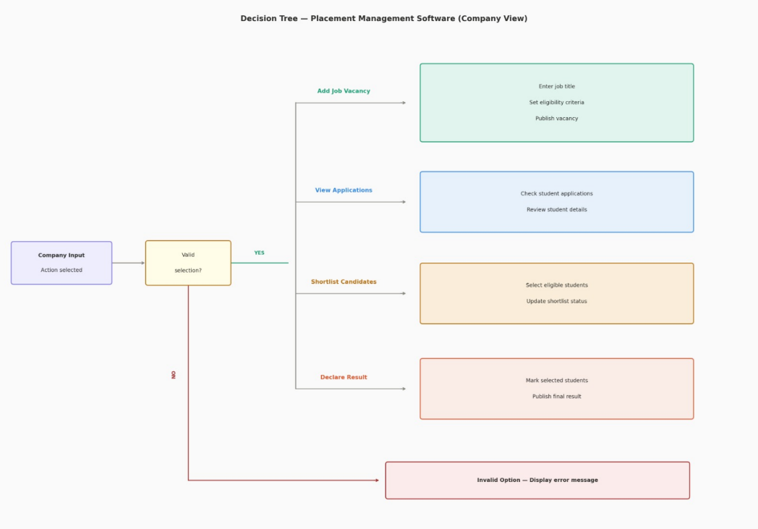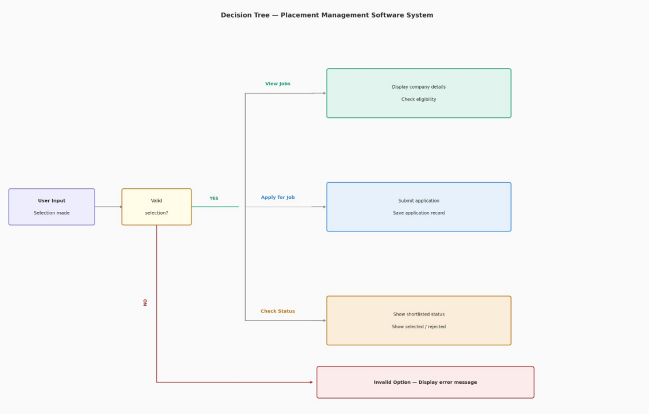
Decision Table
- User’s Decision Table
- Companies Decision Table
