**Assignment: Creating Database for Lift Management System**

**Asgnmt Coordinator: Suresh Burde**

**Submitted By: Arjun Ghule**

**Class Diagram For the Lift Management System**

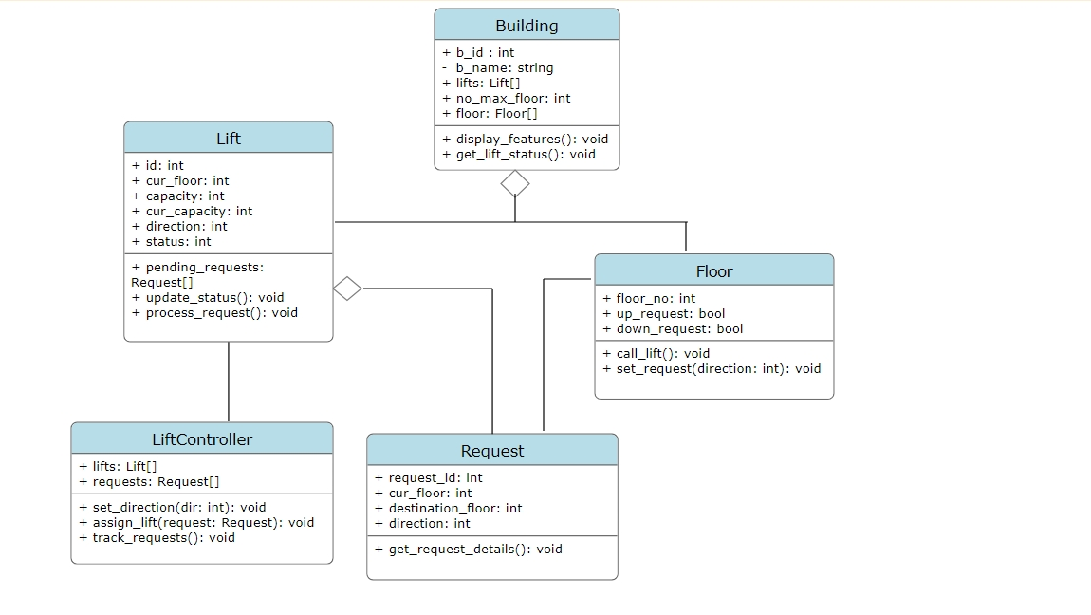

Entity Realtionship Diagram

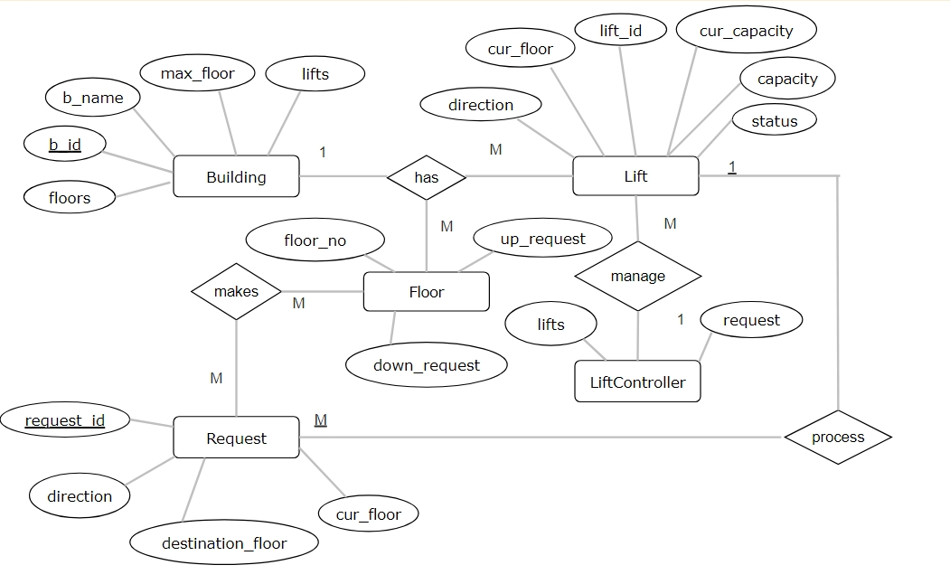

**Database :** Postgres

**Tables count :** 4

**Tables :** floor, building, lift, request

**----------------------------------------------------------------------------------------------**

**#Creating building Table**

CREATE TABLE Building(b_id int primary key, b_name varchar(50) NOT NULL, mar_floor int NOT NULL);

insert into building values(1, 10, 'B1');

insert into building values(2, 20, 'B2');

insert into building values(3, 15, 'B3');

select * from building;

**output:**

b_id | max_floor | b_name

------+-----------+--------

1 | 10 | B1

2 | 20 | B2

3 | 15 | B3

**----------------------------------------------------------------------------------------------**

**#Creating floor Table**

create table floor(b_id int ,CONSTRAINT fk_building FOREIGN KEY (b_id) REFERENCES building(b_id),up_request bool, down_request bool, cur_floor int not null);

insert into floor values(1, False, False, 1);

insert into floor values(1, False, False, 2);

insert into floor values(1, False, False, 3);

select * from floor;

**Output:**

b_id | up_request | down_request | cur_floor

------+------------+--------------+-----------

1 | f | f | 1

1 | f | f | 2

1 | f | f | 3

**----------------------------------------------------------------------------------------------**

**#Creating floor lift**

create table lift(b_id int ,CONSTRAINT fk_building FOREIGN KEY (b_id) REFERENCES building(b_id), lift_no int not null, cur_floor int not null, capacity int not null, cur_capacity int not null, status bool not null, direction varchar(10) not null);

insert into lift values(1, 1, 2, 10, 0, False, 'Default');

insert into lift values(1, 3, 5, 10, 3, True, 'Up');

insert into lift values(1, 2, 6, 10, 1, True, 'Down');

select * from lift;

**output:**

b_id | lift_no | cur_floor | capacity | cur_capacity | status | direction

------+---------+-----------+----------+--------------+--------+-----------

1 | 1 | 2 | 10 | 0 | f | Default

1 | 3 | 5 | 10 | 3 | t | Up

1 | 2 | 6 | 10 | 1 | t | Down

**----------------------------------------------------------------------------------------------**

**#Creating request Table**

create table request(b_id int ,CONSTRAINT fk_building FOREIGN KEY (b_id) REFERENCES building(b_id), request_id int primary key, cur_floor int not null, destination_floor int not null, direction varchar(10) not null);

insert into request values(1, 1, 0, 4, 'Up');

insert into request values(2, 2, 2, 6, 'Up');

insert into request values(1, 3, 6, 0, 'Down');

select * from request;

**output:**

b_id | request_id | cur_floor | destination_floor | direction

------+------------+-----------+-------------------+-----------

1 | 1 | 0 | 4 | Up

2 | 2 | 2 | 6 | Up

1 | 3 | 6 | 0 | Down

**----------------------------------------------------------------------------------------------**

select b_name, lift_no, capacity, status from building left join lift on lift.b_id = lift.b_id where b_name = 'B1';

**output:**

b_name | lift_no | capacity | status

--------+---------+----------+--------

B1 | 1 | 10 | f

B1 | 3 | 10 | t

B1 | 2 | 10 | t

**-------------------------------------------------------------------------------------------**

select lift.lift_no, lift.cur_floor from request left join lift on lift.cur_floor = request.cur_floor where lift.b_id = 1;

**output:**

lift_no | cur_floor

---------+-----------

1 | 2

2 | 6

**----------------------------------------------------------------------------------------------**

select * from request where b_id = (select b_id from building where b_name = 'B1');

**output:**

b_id | request_id | cur_floor | destination_floor | direction

------+------------+-----------+-------------------+-----------

1 | 1 | 0 | 4 | Up

1 | 3 | 6 | 0 | Down

**----------------------------------------------------------------------------------------------**

select building.b_name, lift.lift_no, lift.cur_floor, lift.direction from building left join lift on building.b_id = lift.b_id where lift.direction = 'Default';

**output:**

b_name | lift_no | cur_floor | direction

--------+---------+-----------+-----------

B1 | 1 | 2 | Default