REPORT
Introduction to Amazon Web Services
A Comprehensive Overview of AWS Cloud Platform, Core Services,
Global Infrastructure, and Practical Use Cases

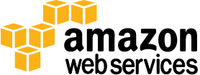

Prepared by: Arjun Shah
Role: IT Intern
Organization: AM/NS India, Hazira
Period: June 2026
Topic: AWS Cloud Services

1. Introduction to Cloud Computing
Before understanding AWS, it is important to understand the concept of cloud computing — the technology that AWS is built on.

1.1 What is Cloud Computing?
Cloud computing is the delivery of computing services — including servers, storage, databases, networking, software, and more — over the internet. Instead of owning and maintaining physical hardware in your office or data center, you access these resources on-demand from a cloud provider and pay only for what you use.

Simple Analogy Cloud computing is like electricity. You don’t build your own power plant — you plug into the national grid and pay for what you consume. AWS is the power grid for computing.

Before cloud computing existed, companies had to:
- Buy expensive physical servers upfront — often costing lakhs or crores of rupees
- Hire dedicated IT staff to manage and maintain the hardware 24/7
- Wait weeks or months to set up new infrastructure
- Guess future capacity needs and often over-provision (wasting money) or under-provision (causing outages)
- Handle failures, backups, and security patches themselves

Cloud computing solves all of these problems. You can spin up a server in minutes, scale it up when traffic increases, scale it down when traffic drops, and shut it completely down when not needed — paying zero when it is off.

1.2 Types of Cloud Services
Model | Description & Examples
IaaS | Infrastructure as a Service — raw compute, storage, networking. You manage the OS and above. (e.g., AWS EC2, Azure VMs)
PaaS | Platform as a Service — managed platform to deploy your app without managing servers. (e.g., AWS Elastic Beanstalk, Heroku)
SaaS | Software as a Service — ready-to-use applications over the internet. (e.g., Gmail, Salesforce, Zoom)
FaaS | Function as a Service / Serverless — run code without managing servers at all. (e.g., AWS Lambda, Azure Functions)

2. What is Amazon Web Services (AWS)?
Amazon Web Services (AWS) is the world’s most comprehensive and broadly adopted cloud platform. It is offered by Amazon and provides over 200 fully-featured services from data centers located globally. AWS was officially launched in 2006 and today serves millions of customers — from small startups to governments to Fortune 500 companies.

2.1 AWS Origin Story
Amazon originally built a massive IT infrastructure to power Amazon.com — one of the world’s busiest e-commerce platforms. By 2004, Amazon’s engineers realized that other companies could benefit from renting access to this infrastructure. Amazon launched AWS in 2006, starting with just three services: EC2 (virtual servers), S3 (storage), and SQS (messaging). Today AWS offers 200+ services across compute, storage, databases, AI, networking, and more.

2.2 AWS Market Position

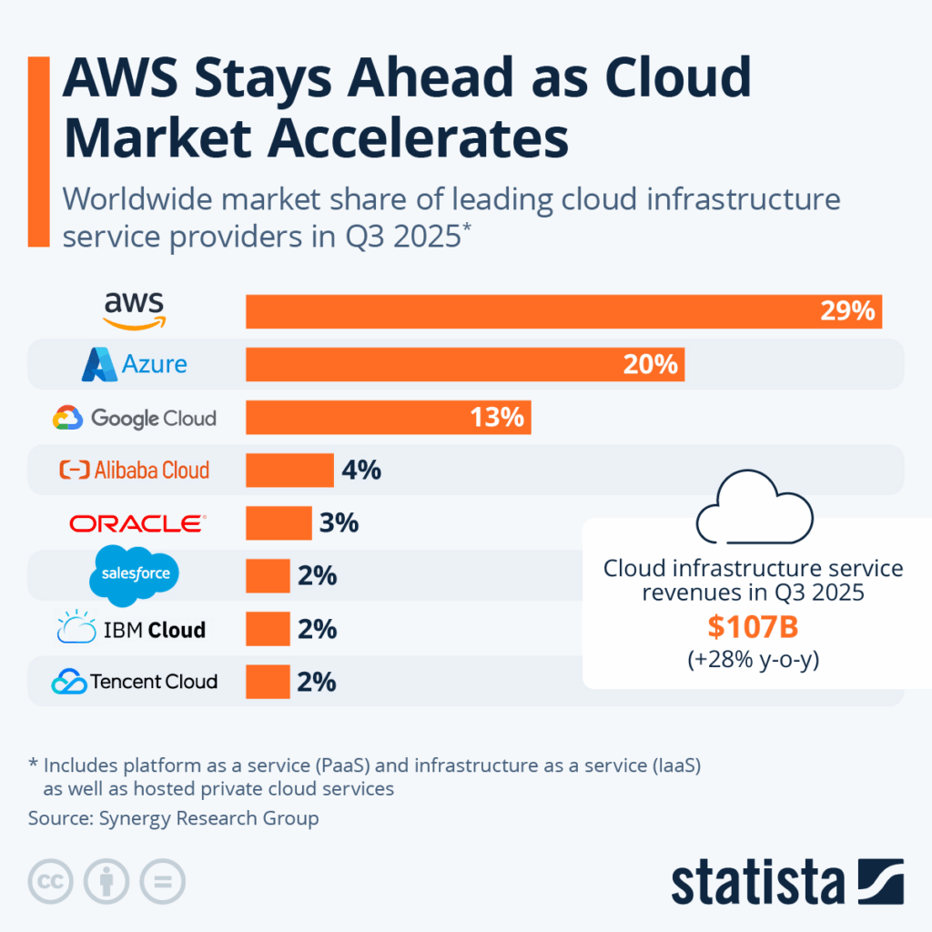
AWS consistently holds the largest share of the global cloud market. According to industry research, AWS commanded approximately 31–33% of the global cloud infrastructure market as of recent years — ahead of Microsoft Azure at approximately 22% and Google Cloud at approximately 10%. The Gartner Magic Quadrant for Cloud Infrastructure & Platform Services has consistently placed AWS as a Leader, with the highest completeness of vision and ability to execute.

Key Fact AWS powers some of the world’s most recognized platforms: Amazon.com, Netflix, Airbnb, NASA, Samsung, LinkedIn, BMW, and millions of other organizations.

2.3 Key Advantages of AWS
What distinguishes AWS from traditional IT infrastructure and competing cloud providers can be summarized in five core pillars:

Cost-Effective
AWS operates on a pay-as-you-go pricing model. There are no upfront costs, no long-term contracts, and no minimum commitments. You pay only for the computing resources you actually consume, by the hour or even by the second.

Scalable and Elastic
AWS can automatically scale resources up when demand increases and down when demand decreases. A startup can launch on a single small server and scale to handle millions of users — without changing any code.

Secure
AWS takes a shared responsibility model to security. Amazon secures the physical infrastructure, hardware, and foundational services. AWS holds certifications including ISO 27001, SOC 1/2/3, PCI-DSS, and FedRAMP, making it trusted by banks, hospitals, and governments worldwide.

Experienced and Reliable
AWS has been building and operating large-scale internet infrastructure since 1994 (for Amazon.com) and as a public cloud since 2006. This experience translates into high uptime, proven reliability, and constant innovation.

Globally Accessible
AWS operates from data centers spread across 30+ geographic regions worldwide, with multiple Availability Zones per region. This global footprint means your application can serve users in India, Europe, and the Americas with consistently low response times.

3. AWS Global Infrastructure
Understanding AWS’s global infrastructure is essential for building reliable, high-performance cloud applications. AWS organizes its physical infrastructure into three levels: Regions, Availability Zones, and Edge Locations.

The AWS Cloud spans 120 Availability Zones within 38 geographic Regions around the world.

3.1 Regions
A Region is a specific geographic area of the world where AWS has built and operates a cluster of data centers. As of 2026, AWS has 38 Regions worldwide, including locations in the United States, Europe, Asia Pacific, South America, Africa, and the Middle East.
Each Region is completely independent from other Regions. Data stored in one Region does not automatically replicate to another.

India Note The closest AWS Region to Surat, Gujarat is ap-south-1 (Mumbai), launched in 2016. Using the Mumbai Region for Indian applications minimizes latency and ensures data remains within India.

When selecting a Region, developers consider four factors:
- Compliance — does local regulation require data to stay in-country?
- Latency — how close is the Region to end users?
- Service availability — not all services are available in all Regions
- Pricing — costs vary slightly between Regions

3.2 Availability Zones (AZs)
Each AWS Region contains multiple Availability Zones (AZs). An Availability Zone is one or more discrete, physical data centers within a Region. Each AZ has independent power, cooling, and physical security. AZs within a Region are connected by high-bandwidth, low-latency private fiber networking.
The purpose of multiple AZs is high availability. AWS recommends deploying production applications across at least two AZs for resilience.

3.3 Edge Locations
Edge Locations are smaller infrastructure points located in 400+ cities worldwide. They are used by Amazon CloudFront (AWS’s Content Delivery Network) to cache and serve content from the location nearest to the end user.

Infrastructure | Count
Regions | 39
Availability Zones | 123
Edge Locations | 750+

AWS Service Categories :

Some of the services offered by AWS :

4. Core AWS Services
AWS offers 200+ services organized into categories including Compute, Storage, Database, Networking, Security, AI/ML, and more. This section covers the 13 key services covered.

4.1 Amazon EC2 — Elastic Compute Cloud
Amazon Elastic Compute Cloud (Amazon EC2) is a web service that provides resizable compute capacity in the cloud. It is designed to make web-scale computing easier for developers and system administrators. EC2 gives complete control over the computing environment — you choose the operating system, CPU, RAM, and storage type.
EC2’s simple web service interface allows you to obtain and configure capacity with minimal friction. It provides you with complete control of your computing resources and lets you run on Amazon’s proven computing environment. Amazon EC2 reduces the time required to obtain and boot new server instances to minutes, allowing you to quickly scale capacity, both up and down, as your computing requirements change.
Real-World Analogy EC2 is like renting a flat in a large apartment building. Amazon owns the building and maintains it. You rent a unit, furnish it how you want, and control what happens inside — but you pay rent only while you occupy it.

4.2 AWS Lambda — Serverless Compute
AWS Lambda is a serverless compute service that lets you run code without provisioning or managing servers. You write a function in Python, Node.js, Java, or another supported language, and Lambda runs it in response to a trigger. You pay only for the time your code executes, measured in milliseconds.
Lambda is ideal for event-driven workloads: processing an uploaded image, responding to a database change, running a scheduled task, or handling API requests. Lambda automatically scales from zero to millions of executions with no configuration required.

Note: AWS Lambda functions have a maximum timeout limit of 15 minutes. If your code runs longer than 15 minutes, AWS terminates the execution.

4.3 Amazon S3 — Simple Storage Service
Amazon S3 is object storage for the internet — effectively an infinite filing cabinet in the cloud. You store files of any type (images, videos, documents, backups, logs, code) in containers called buckets. S3 provides 99.999999999% (eleven nines) durability by automatically replicating objects across multiple Availability Zones.
Amazon S3 provides a simple web services interface that can be used to store and retrieve any amount of data, at any time, from anywhere on the web. S3 is also used to host static websites, create data lakes for analytics, distribute software, and store backups.

4.4 Amazon DynamoDB
Amazon DynamoDB is a fast, fully managed NoSQL database service that makes it simple and cost-effective to store and retrieve any amount of data, and serve any level of request traffic. All data items are stored on Solid State Drives (SSDs), and are replicated across 3 Availability Zones for high availability and durability.
DynamoDB is designed for applications requiring single-digit millisecond performance at any scale. It stores data as key-value pairs or JSON documents, scales automatically to accommodate traffic spikes, and guarantees consistent performance regardless of load. Use cases include gaming leaderboards, shopping carts, IoT device state storage, and real-time recommendation engines.

4.5 Amazon API Gateway
Amazon API Gateway is a fully managed service that makes it easy for developers to create, publish, maintain, monitor, and secure APIs at any scale. API Gateway handles all the tasks involved in accepting and processing up to hundreds of thousands of concurrent API calls, including traffic management, authorization, access control, monitoring, and API version management.
API Gateway acts as the “front door” for applications to access data, business logic, or functionality from your backend services — such as workloads running on Amazon EC2, code running on AWS Lambda, or any web application. It is commonly used to build RESTful APIs and WebSocket APIs for real-time two-way communication.

4.6 AWS IAM — Identity and Access Management
AWS Identity and Access Management (IAM) enables you to securely control access to AWS services and resources for your users. Using IAM, you can create and manage AWS users and groups and use permissions to allow and deny their access to AWS resources.
IAM allows you to manage users and their access, manage roles and their permissions, and manage federated users. You can create users in IAM, assign them individual security credentials (access keys, passwords, and Multi-Factor Authentication devices) or request temporary security credentials to provide users access to AWS services and resources.
Security Principle AWS recommends the Principle of Least Privilege — give each user or service only the minimum permissions needed to perform their specific tasks, and nothing more.

4.7 Amazon CloudWatch
Amazon CloudWatch provides monitoring for AWS cloud resources and the applications customers run on AWS. Developers and system administrators can use it to collect and track metrics, gain insight, and react immediately to keep their applications and businesses running smoothly.
Amazon CloudWatch monitors AWS resources such as Amazon EC2 and Amazon RDS DB Instances, and can also monitor custom metrics generated by a customer’s applications and services. It provides a reliable, scalable, and flexible monitoring solution. You can easily monitor metric data, view graphs, and set alarms to help you troubleshoot, spot trends, and take automated action based on the state of your cloud environment.

4.8 Amazon Bedrock
Amazon Bedrock is a fully managed service that offers a choice of high-performing foundation models (FMs) from leading AI companies — including Amazon’s own Titan models, Anthropic’s Claude, Meta’s Llama, and others — through a single API. With Bedrock, you can build and scale generative AI applications without managing any underlying infrastructure.
Bedrock provides capabilities for text generation, image generation, and retrieval-augmented generation (RAG). It integrates natively with other AWS services such as S3, Lambda, and API Gateway, enabling developers to build AI-powered applications quickly and securely. All data remains private and is not used to train the underlying foundation models.

4.9 AWS Amplify
AWS Amplify is a set of tools and services that enables mobile and front-end web developers to build full-stack applications powered by AWS. Amplify provides a development framework, pre-built UI components, and a hosting platform, making it easy to integrate AWS backend services into web and mobile applications.
With Amplify, developers can quickly add features like authentication (using Amazon Cognito), data storage (using DynamoDB or S3), APIs (using API Gateway or AppSync), and hosting — all from a single CLI or visual interface. Amplify is designed for JavaScript frameworks including React, Next.js, Vue, and Angular, as well as iOS and Android mobile apps.

4.10 Amazon EventBridge
Amazon EventBridge is a serverless event bus service that makes it easy to connect different AWS services, Software-as-a-Service (SaaS) applications, and your own custom applications using event-driven architecture. It enables loosely coupled architectures where services communicate through events rather than direct API calls — improving scalability and maintainability.
EventBridge receives events (state changes) from sources such as AWS services, SaaS partners, or your own applications, and routes them to target services like Lambda, SQS, SNS, or Step Functions based on rules you define. This decoupled approach means each component of your application can evolve independently.

4.11 Amazon Textract
Amazon Textract is a machine learning service that automatically extracts text and data from scanned documents. It goes beyond simple optical character recognition (OCR) to also identify the contents of fields in forms and information stored in tables — without any manual effort or custom code.
Textract can process a wide variety of document types including PDFs, images, invoices, tax forms, medical records, and identification documents. It is commonly used to automate document processing workflows, digitize paper records, and extract structured data from unstructured documents for downstream analysis.

4.12 AWS Secrets Manager
AWS Secrets Manager is a secrets management service that helps you protect access to your applications, services, and IT resources. The service enables you to easily rotate, manage, and retrieve database credentials, API keys, and other secrets throughout their lifecycle.
By using Secrets Manager, you no longer need to hardcode sensitive credentials directly in your application code. Instead, your application makes a programmatic call to Secrets Manager to retrieve the secret when needed. Secrets Manager also supports automatic rotation of secrets for supported AWS services like RDS, reducing the risk of credential compromise.

4.13 Amazon Lex
Amazon Lex is a fully managed service for building conversational interfaces (chatbots and voice bots) using natural language understanding (NLU) and automatic speech recognition (ASR). Amazon Lex uses the same deep learning technologies that power Amazon Alexa — making it available to any developer.
With Amazon Lex, you can build chatbots for customer service, order fulfillment, appointment scheduling, and information lookup. Lex integrates natively with AWS Lambda to fulfill intents, and with Amazon Connect for building contact center bots. Lex supports multiple languages and can be deployed across web, mobile, and messaging platforms.

AWS Operational Responsibility Model :

5. How to Access and Manage AWS
AWS can be accessed and managed through three primary methods, each suited to different use cases:

5.1 AWS Management Console
The Console is a web-based graphical interface accessible at console.aws.amazon.com. It provides a visual, point-and-click way to manage every AWS service. It is the easiest starting point for beginners and useful for exploring services, reviewing dashboards, and performing one-time administrative tasks.

5.2 AWS Command Line Interface (CLI)
The AWS CLI is a tool that allows running AWS commands directly from a terminal or command prompt. Commands follow a structured format. The CLI is preferred by developers and DevOps engineers for scripting, automation, and fast execution of repetitive tasks.

5.3 AWS Software Development Kits (SDKs)
AWS SDKs allow developers to access AWS services directly from code. SDKs are available for Python (boto3), JavaScript/Node.js, Java, .NET, Ruby, PHP, Go, and more. Using SDKs, a Python application can upload a file to S3, trigger a Lambda function, or query DynamoDB — all programmatically within the application code.

6. AWS Certifications
AWS offers a structured certification program that validates cloud knowledge and skills. Certifications are recognized globally and are highly valued in the IT industry for career advancement.

Level | Certification
Foundational | AWS Cloud Practitioner
Associate | Solutions Architect – Associate
Associate | Developer – Associate
Associate | SysOps Administrator – Associate
Professional | Solutions Architect – Professional
Specialty | Machine Learning Specialty

The recommended starting point for someone new to AWS — including college students and IT interns — is the AWS Certified Cloud Practitioner. It covers fundamental cloud concepts, AWS core services, pricing models, and basic security — without requiring hands-on technical experience.

7. Conclusion
Amazon Web Services represents a fundamental shift in how organizations build and operate technology systems. Rather than investing in physical infrastructure that requires upfront capital and ongoing maintenance, AWS enables organizations to consume computing as a utility — paying only for what they use, scaling instantly with demand, and benefiting from Amazon’s global network of data centers.
The 13 core services covered in this report — EC2 (virtual compute), Lambda (serverless), S3 (object storage), DynamoDB (NoSQL database), API Gateway (managed APIs), IAM (identity & access control), Amazon CloudWatch (monitoring), Amazon Bedrock (generative AI), AWS Amplify (full-stack development), EventBridge (event-driven architecture), Amazon Textract (document intelligence), AWS Secrets Manager (credentials management), and Amazon Lex (conversational AI) — form the building blocks of virtually every modern cloud application.
For students and early-career professionals, AWS offers a free tier that provides hands-on experience with core services at no cost. The AWS Certified Cloud Practitioner certification provides a structured path to validating foundational knowledge and building credibility in the job market.

Getting Started Sign up at aws.amazon.com/free for 12 months of free tier access. Start with S3 (store a file), then launch an EC2 instance, then try Lambda — three services that form the backbone of the AWS ecosystem.

Arjun Shah · IT Intern · AM/NS India · June 2026

