Mutual Fund Discovery — Platform Comparison
Zerodha Coin vs Angel One | Shivarjun Reddy Palla | March 2026
Primary research: 21-person investor survey + 14,221 mutual funds analyzed
Why This Analysis
A 21-person primary survey showed 76% of retail investors make fund decisions without tracking any risk metrics. Zerodha and Angel One were the two most-used platforms (6 respondents each). Both display ICICI Prudential Large Cap Fund — yet neither shows Sharpe Ratio, volatility, or max drawdown. This analysis documents that gap.
Platform Screenshots — ICICI Prudential Large Cap Fund (13 Mar 2026)
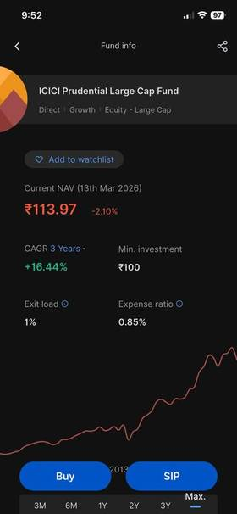 | 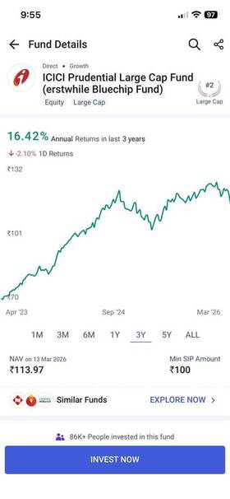
Zerodha Coin — Fund Info | Angel One — Fund Details

Feature Comparison
Feature | Zerodha Coin | Angel One | Gap
3Y CAGR | Shown (16.44%) | Shown (16.42%) | Both lead with returns only
Risk visualization | Absent | Risk meter + Very High | Zerodha shows nothing
Sharpe Ratio | Absent | Absent | Missing on both
Volatility / Drawdown | Absent | Absent | Missing on both
Sector allocation | Absent | Present | Angel One wins
Tax implications | Absent | Present | Angel One wins
Fund manager | Absent | Mr. Vaibhav Dusad | Angel One wins
Investor persona fit | Absent | Absent | Neither platform
AUM | Not shown | Rs 77,451 Cr | Angel One wins
Expense ratio | 0.85% shown | 0.85% shown | Both good
Visual design | Clean dark theme | Data-dense white | Zerodha (clarity)
Additional Screenshots
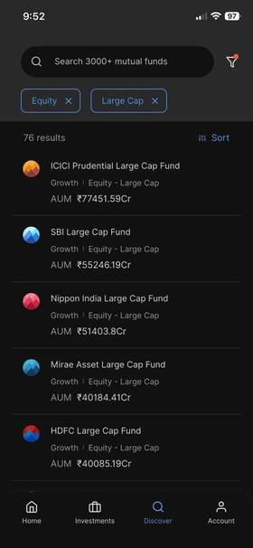 | 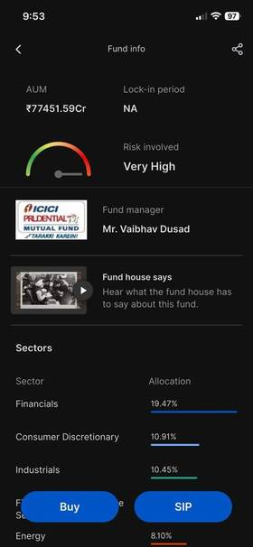 | 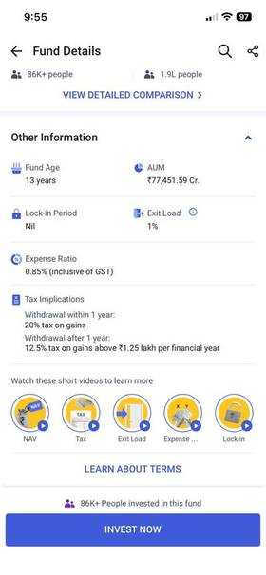
Zerodha — Fund List (Large Cap) | Zerodha — Risk & AUM View | Angel One — Other Info & Tax
Key Findings
What both platforms get right
- Expense ratio and exit load visible — cost transparency good on both
- Multiple chart time ranges — historical context accessible
- Min SIP amount shown (Rs 100) — entry barrier clear
What Angel One does better
- Risk meter present — Zerodha shows no risk indicator at all
- Sector allocation, fund manager, AUM and tax on one screen
- 86K+ investor count — social proof reduces decision anxiety
What Zerodha does better
- Cleaner visual hierarchy — dark theme reduces cognitive load
- Less cluttered — key metrics easier to read at a glance
Critical gap — what neither platform shows
- No Sharpe Ratio, annualized volatility, or max drawdown anywhere
- No investor persona matching — Very High label not actionable
- No benchmark comparison — 16.44% CAGR vs what baseline?
- No risk-return positioning — adequate return for the risk taken?
Research Parallel
The Mutual Fund Risk-Adjusted Analyzer project computed exactly these missing metrics across 342 large-cap funds. ICICI Prudential Large Cap — the fund in both screenshots — passed all 4 downside protection filters. Its Very High label is misleading. Its risk-adjusted performance is better than most funds in its category. This insight is invisible on both platforms. The 76% of investors who track no metrics are not making a mistake — they are not being given the tools to do so.

