ZERODHA KITE + COIN
UX Audit, Competitive Analysis & Redesign Proposal
Why a Stockbroker with 13M+ users forces its customers to juggle two apps
Author | Shivarjun Reddy Palla
Focus | UX Research & Design
Date | April 2026
Contents | Heuristic Audit · Journey Map · Competitive Analysis · Problem Statement · PRD · Case Study

Problem Statement

Problem
Zerodha users who invest in both equities and mutual funds are forced to operate two separate, visually inconsistent apps — Kite (stocks, ETFs, F&O) and Coin (mutual funds) — despite having a single unified demat account. Every competing broker in India (Angel One, Groww, Upstox) has solved this with a unified app experience.

Root Cause
- Coin was launched as a standalone product in 2016, before unified super-apps became the Indian fintech norm.
- Internal product/engineering boundaries: separate teams, codebases, and design systems for Kite vs Coin.
- Limited cross-product navigation, no cross-product search, or limited portfolio aggregation layer was built between the two apps.
- Zerodha prioritised trader-grade tooling depth in Kite over consumer UX Experience.

User Impact
Impact Area | Specific Pain
Fragmented portfolio | User can see total net wealth (equities + MF) in one screen only in Kite but not in Coin. Day's P&L is split across two apps.
Broken invest flow | Investing any amount across a stock and a SIP requires 14 screens and 1 mandatory app switch — vs 7 screens on Angel One.
Duplicate search | Limited cross-product search. Typing "HDFC" in Coin does not surface HDFC Bank Stock or Futures. Two separate search functions.
Mental model mismatch | Users think of "my Zerodha account" as one thing. The system splits it into two disconnected worlds.

Hypothesis
If Zerodha integrates Coin's mutual fund functionality as a native tab within Kite's existing Portfolio screen — users will be able to complete cross-product investment tasks in a single app session, reducing task completion time by ≥40% and increasing MF investment activation from Kite by ≥25%, without degrading Kite's existing trading experience.

Success Metrics (KPIs)
Metric | Baseline | Target (6 months)
Task completion rate (stock + SIP in one session) | ~60% (abandonment at app switch) | ≥ 85%
Cross-product activation (MF invest from Kite) | 0% (no path exists) | +25% MF orders via Kite
Time-on-task (stock + SIP invest) | ~5–6 minutes | ≤ 3 minutes
Portfolio tab Daily Active Users (DAU) | Low (users check in Coin) | +40% DAU on Portfolio tab

Heuristic Evaluation Table

S no. | Heuristic | Kite Score | Coin Score | Observation
1 | Visibility of system status | 3 / 5 | 3 / 5 | Kite shows live price and order status. However, a pending MF order in Coin (e.g. ₹1,000 Parag Parikh processing) is invisible from Kite. "Processing" in Coin gives no ETA.
2 | Match system to real world | 3 / 5 | 2 / 5 | Users conceptualise one "Zerodha account." The system presents two separate apps with different design languages, navigation patterns, and portfolio views — breaking the user's mental model of their wealth.
3 | User control and freedom | 4 / 5 | 3 / 5 | Kite allows order cancellation before market execution. Coin allows SIP cancellation, but the flow is buried 3 levels deep (Portfolio > SIP > Manage). No easy "undo" for a just-placed lumpsum order.
4 | Consistency and standards | 3 / 5 | 2 / 5 | Critical: Kite and Coin use entirely different search systems wherein Kite Search surfaces both stocks and MF but Coin only MF, portfolio structures, and navigation . Kite's watchlist vs Coin's explore screen are visually similar but behaviourally inconsistent. "Portfolio" means different things in each app.
5 | Error prevention | 5 / 5 | 4 / 5 | Kite's "slide to buy" gesture + OTP confirmation is excellent error prevention for high-stakes equity orders. Coin's SIP setup shows a clear confirmation screen with all details before final invest. Minor: Coin does not confirm NAV at which units will be allotted.
6 | Recognition over recall | 3 / 5 | 3 / 5 | Kite's watchlist provides recognition for tracked stocks. However, users must recall that MF investing requires a different app. Typing "Parag Parikh" in Kite finds the fund but then prompts opening Coin — a recognition-to-recall failure at the critical invest moment.
7 | Flexibility and efficiency | 4 / 5 | 3 / 5 | Kite has advanced order types (GTT, bracket, cover) for advanced users. Coin offers no shortcuts; every SIP setup requires the same 5-step flow. No quick-invest from the portfolio screen.
8 | Aesthetic and minimalist design | 4 / 5 | 4 / 5 | Both apps have clean, focused UIs with good information hierarchy within their own contexts. Kite's watchlist (34 items, price + change) and Coin's SIP list are visually well-executed. The aesthetic problem is the disconnection between them, not their individual quality.
9 | Help users recognize, diagnose, recover from errors | 3 / 5 | 3 / 5 | Kite shows clear order rejection messages (e.g., insufficient margin). Coin's payment failures (SIP mandate rejection) redirect to a generic error without actionable guidance on what went wrong or how to fix the mandate.
10 | Help and documentation | 2 / 5 | 2 / 5 | Neither app offers in-context help. Users who want to understand NAV, CAGR, or the difference between Regular and Direct plans must leave the app. No tooltips, no glossary, no onboarding for first-time MF investors. Coin's "Get started" section lacks educational content.
Nielsen's 10 Usability Heuristics applied to Kite + Coin. Score 1–5 (1 = critical fail, 5 = pass).

Current State User Journey Map
"I want to Invest ₹5,000 — ₹3,000 in HDFC Bank stock + ₹2,000 in Parag Parikh Flexi Cap SIP"

Zerodha (Kite + Coin) — Current State
14 screens across 2 apps, 1 mandatory app switch, ~5–6 minutes. Every decision point and context switch is documented below.

# | Step | App | Action / Screen | User Thought | Pain Point
1 | Open app | Kite | App opens to Watchlist | "Let me check HDFC Bank price" | —
2 | Search stock | Kite | Type "HDFCBANK" in watchlist search | "Found it. Current price looks good" | —
3 | Select stock | Kite | Tap HDFCBANK → stock detail screen | "I want to buy ₹3,000 worth" | —
4 | Open buy panel | Kite | Swipe up to open buy/sell panel | "Choose NSE or BSE? Usually NSE" | Exchange selection requires knowledge
5 | Select exchange | Kite | Select NSE, enter amount | "I need to enter the amount to Invest " | —
6 | Confirm buy | Kite | Slide to buy → OTP → Order placed | "Great. Now I need to do the SIP" | —
7 | App switch | SWITCH → Coin | Leave Kite, find and open Coin app | "Where's Coin? Is my SIP still active?" | ⚡ Critical: Context lost. Re-orientation required.
8 | Navigate Coin | Coin | Coin home → Discover tab | "Different layout from Kite. Re-orient." | New UI — must re-learn
9 | Search fund | Coin | "Search 3000+ mutual funds" | "Parag Parikh Flexi Cap" | Separate search from Kite — no shared history
10 | Select fund | Coin | Fund detail page. Select Direct Growth | "Direct or Regular? Direct is better" | No in-app explanation of difference
11 | Choose type | Coin | Select SIP (not lumpsum) | "Monthly SIP, ₹2,000" | —
12 | Set amount | Coin | Enter ₹2,000, set deduction date | "Which date? Before salary credit risk" | Date picker has no guidance on best practices
13 | Review | Coin | Confirmation screen | "Looks right. SIP starts next month." | —
14 | Invest | Coin | Tap Invest → OTP → SIP confirmed | "Done. But what's my total invested today?" | No combined view. Must switch back to Kite.

App Screenshots — Evidence of Disrupted User Experience
The following screenshots were captured from Zerodha (Kite + Coin) and Angel One to document the current-state UX.

Kite — Watchlist (stocks) and Coin — Pending MF Orders
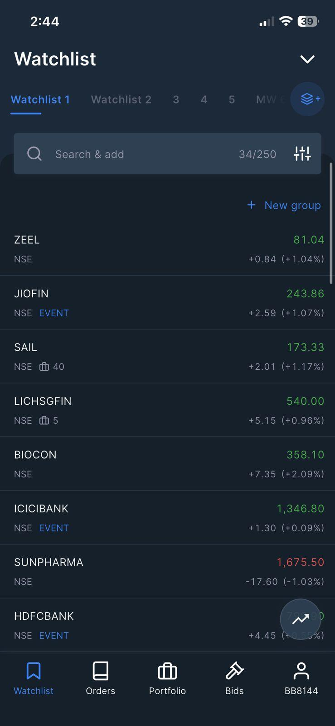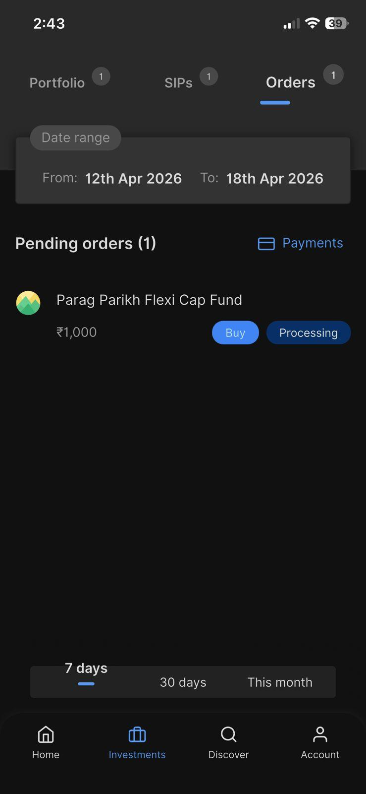
↑ Kite Watchlist (stocks) — 250 stocks tracked ↑ Coin Orders — ₹1,000 Parag Parikh "Processing"
Kite — MF Explore (dead end) and Angel One — Unified Home
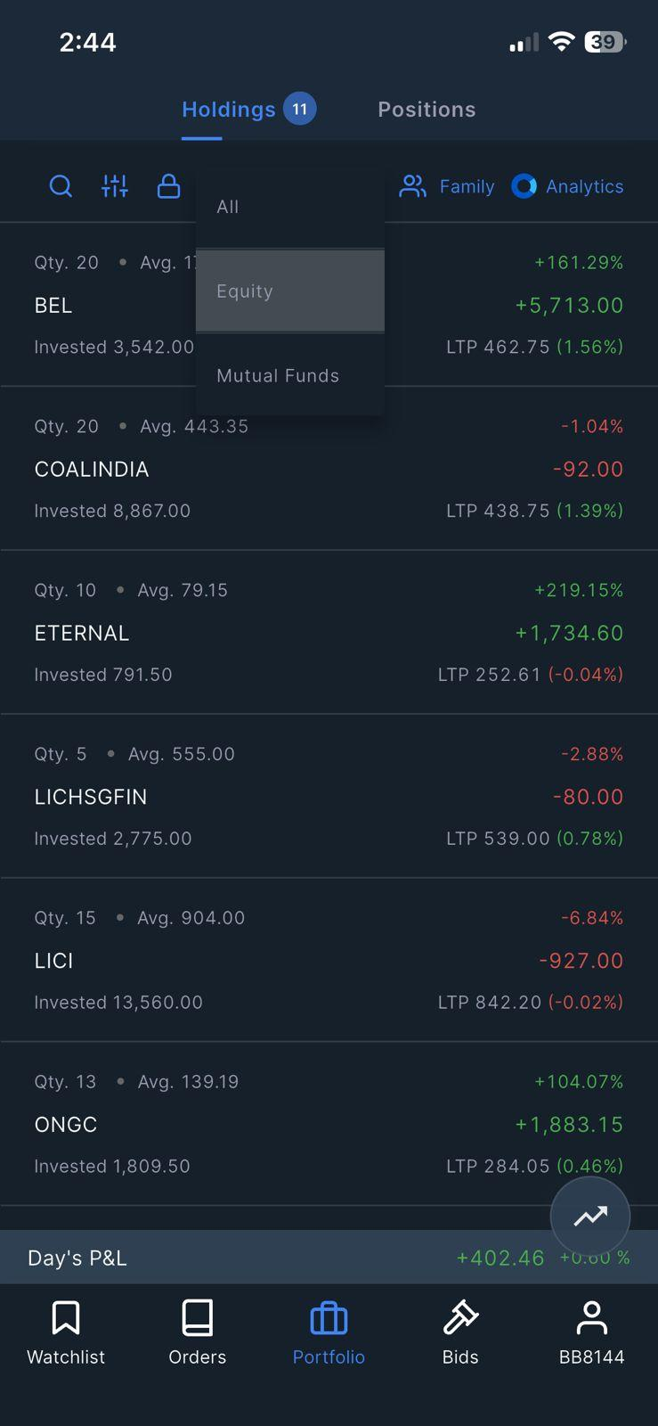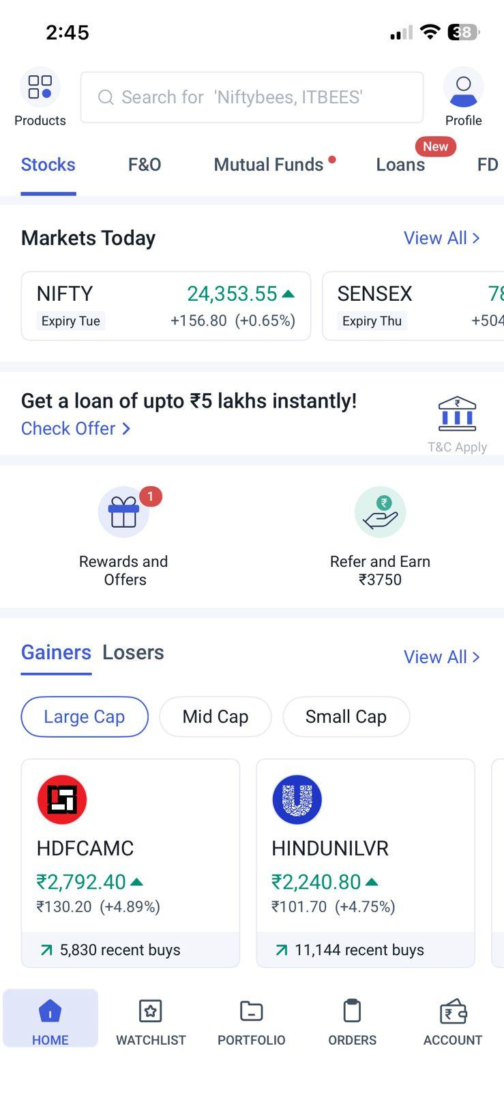
↑ Kite Holdings (equity only, no MF visible but can select to view) ↑ Angel One home — Stocks + MF + F&O in one place in tabs

Coin — MF Discover and Angel One — Mutual Funds Section
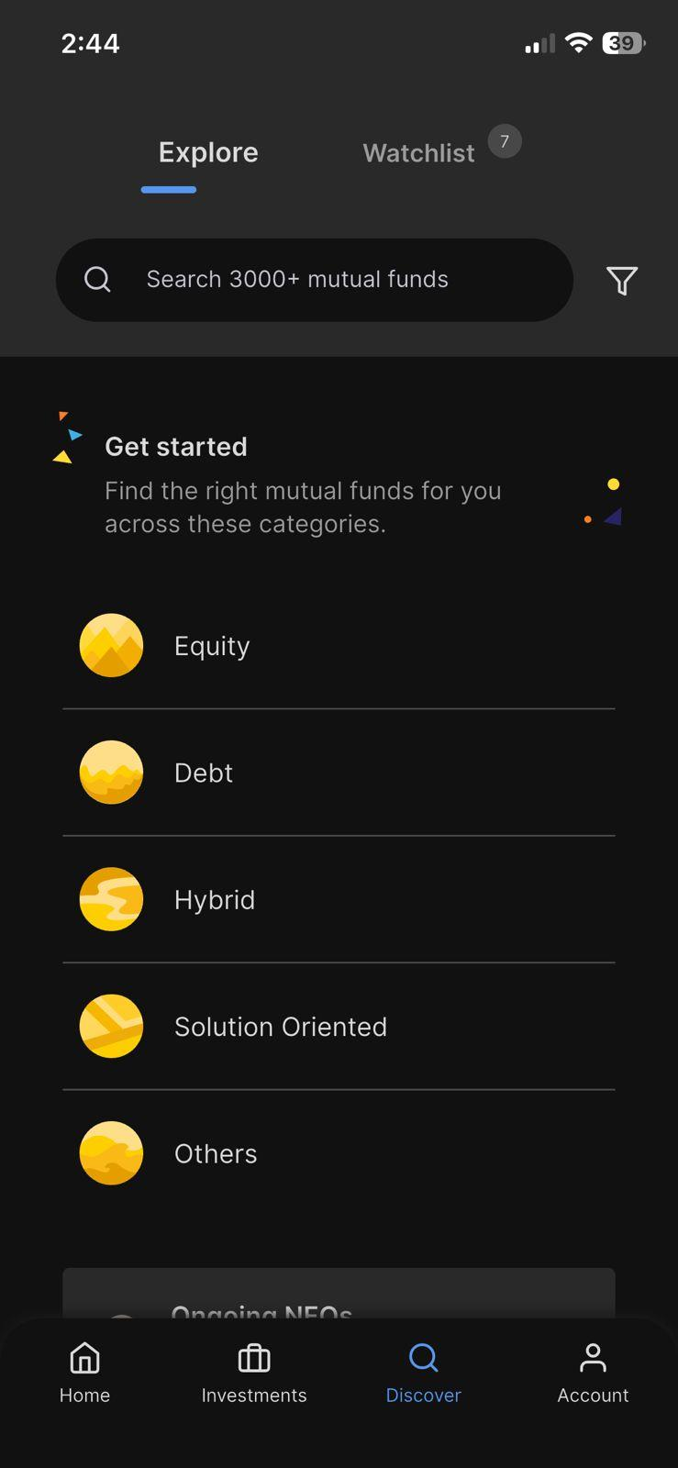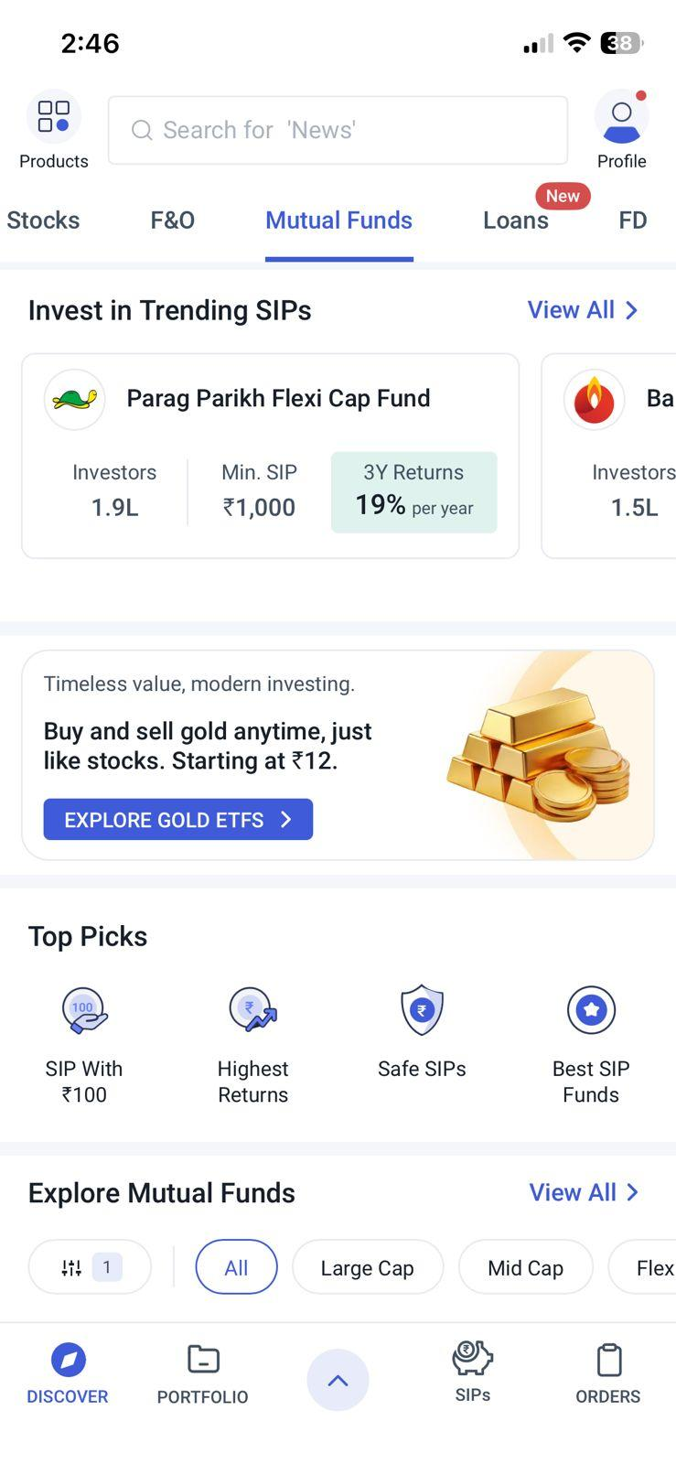
↑ Coin Discover — separate app, different design language ↑ Angel One MF — same app as stocks, trending SIPs

Angel One — Benchmark Flow (same task, 7 steps)
# | Step | App | Screen | Notes
1 | Open app | Angel One | Home: Stocks tab active | NIFTY + SENSEX visible on home. Gainers/Losers shown.
2 | Search stock | Angel One | Global search → HDFCBANK | Single search across all instruments. No app switch needed.
3 | Buy stock | Angel One | Buy → qty → big blue button | Live price visible while entering order. Clean 2-button layout.
4 | Navigate to MF | Angel One | Tap "Mutual Funds" tab in same app | No app switch. Same bottom nav. Same visual language.
5 | Find fund | Angel One | Search or browse trending SIPs | Parag Parikh Flexi Cap appears in Trending SIPs. Tap to proceed.
6 | Set SIP | Angel One | SIP → ₹2,000 → date → invest | 3Y returns (19%/yr) shown on card. Min SIP ₹1,000 shown clearly.
7 | Done | Angel One | SIP confirmed. Portfolio updates. | Portfolio tab shows combined equity + MF. Total wealth visible immediately.

Competitive Analysis
Zerodha (Kite+Coin) vs Angel One vs Groww vs Upstox across 8 key dimensions

Dimension | Zerodha | Angel One | Groww | Upstox
Single app for Stocks + MF | ✗ Two apps (Kite + Coin) | ✓ Unified | ✓ Unified | ✓ Unified
Global search (stocks + MF) | ✗ Separate search systems | ✓ Cross-instrument | ✓ Cross-instrument | ✓ Cross-instrument
Unified portfolio view | ✗ Two separate portfolios | ✓ Combined P&L | ✓ Combined P&L | ~ Partial
Stock charting depth | ★★★★★ Best in class | ★★★★☆ Good | ★★☆☆☆ Basic | ★★★★☆ Good
F&O tooling quality | ★★★★★ Best in class | ★★★☆☆ Good | ★☆☆☆☆ Very basic | ★★★☆☆ Good
MF direct plan investing | ✓ Direct via Coin (₹0) | ~ Regular plan (commission) | ✓ Direct (₹0) | ~ Partial direct
MF discovery UX | ~ Adequate (Coin) | ✓ Trending SIPs, categories | ★★★★★ Best in class | ~ Adequate
UI design consistency | ✗ Kite ≠ Coin (different language) | ✓ Consistent | ✓ Consistent (best consumer UX) | ✓ Consistent

The Key Trade-off
Every broker that unified their app (Groww, Angel One) sacrifices on trading tool depth. Groww's stock charting is inadequate for active traders. Angel One's F&O tools are adequate but not advanced. Zerodha's unique competitive moat is Kite's advanced charting and F&O tools — used by India's most active traders. The redesign must add the MF layer without degrading Kite's tools. The proposed solution: MF integration as a Portfolio tab extension, not a Kite redesign.

Product Requirements Document (PRD)
Unified Investment Experience — Kite + Coin Integration · v1.0

Personas
Rohan, 28 — Active Trader | Priya, 34 — SIP Investor | Kiran, 42 — Wealth Builder
SE in Bengaluru. Trades F&O weekly in Kite, invests in MF monthly via Coin. Power user of Kite's charting. Frustrated by app-switching for routine MF tasks. | HR manager. 3 SIPs running in Coin. Never trades stocks. Wants a simple portfolio overview showing total savings. Often confused by Kite's trading terminology. | Business owner. ₹15L+ across equities, MF, and ETFs. Needs consolidated net worth view for tax planning. Currently exports data manually to Excel.
Goal: Do MF tasks without leaving Kite. Keep F&O tools unchanged. | Goal: See total SIP portfolio and next deduction date in one tap. | Goal: See all investments in one screen with XIRR and tax summary.

User Stories
# | Persona | Story | Acceptance Criteria
01 | All users | As a Zerodha user, I want to view my entire portfolio (equities + MF) in one screen, so I can understand my true net wealth. | Portfolio Overview tab shows combined value, overall P&L, and asset allocation. MF values use latest NAV. Refreshes on load.
02 | Priya (SIP investor) | As a SIP investor, I want to see my SIP status and next deduction date inside Kite, so I don't need Coin just to check my SIPs. | Portfolio → Mutual Funds tab lists all SIPs with status, amount, and next deduction date. User can pause/modify from here.
03 | Rohan (trader) | As a Zerodha user, I want a single search bar that shows both stocks and MF results, so I can compare options without knowing which app hosts what. | Global search returns grouped results: Stocks section and Mutual Funds section. Invest option available on both. No redirect to external app.
04 | Rohan (trader) | As a trader, I want the unified MF features to be additive and not change my Kite trading workflows. | Watchlist, chart, order placement, F&O screens identical to current Kite. MF features accessible only via Portfolio tab or search.
05 | Kiran (wealth builder) | As a tax-aware investor, I want to see equity and MF capital gains in one screen for tax planning. | Portfolio Overview includes Summary card showing estimated total Invested, current value, XIRR. Links to Console for detailed Year Wise Data.

MoSCoW Requirements
Priority | Requirement
Must | Unified Portfolio Overview tab: combined equity + MF current value, overall P&L, asset allocation breakdown
Must | Mutual Funds tab in Kite Portfolio: all MF holdings, active SIPs with status and next deduction date, current value
Must | Invest in MF (lumpsum + SIP) from within Kite — no redirect to external Coin app required
Must | Zero degradation to existing Kite trading flows: watchlist, charts, F&O orders, order book, positions
Should | Global search returning stocks and MF in unified grouped results from the same search bar
Should | SIP management (pause, modify amount, change date) accessible from Kite Portfolio without opening Coin
Should | Asset allocation donut chart on Portfolio Overview (equity vs MF vs other)
Could | Cross-instrument watchlist: stocks and MF in the same watchlist with add/remove functionality
Could | Consolidated account statement export (equity + MF) from Kite
Won't (v1) | Full Coin app deprecation (maintain for deep-link users and Coin-first users during migration)
Won't (v1) | NPS, bonds, FD, insurance integration — separate roadmap item
Won't (v1) | Social trading or copy-trading features

Edge Cases
- User has MF investments via old Coin direct plan: must correctly calculate combined portfolio value without double-counting.
- Market closed (weekend/holiday): equity holdings show last closing value; MF shows last NAV.
- SIP mandate failure: in-Kite notification must surface the error with an actionable fix link.
- Zero MF holdings: Portfolio → Mutual Funds tab shows empty state with "Start your first SIP".
- User has Coin account but never linked to Kite: OAuth-like linking flow required on first access of MF tab in Kite.

KPIs and Success Metrics
Metric | Baseline | Target (6 months) | Measurement Method
Task completion: stock + SIP in one session | ~60% | ≥ 85% | Funnel analytics, session recording
Cross-product activation (MF invest from Kite) | 0% | +25% MF orders via Kite | Order source attribution
Time-on-task (stock + SIP invest flow) | ~5–6 min | ≤ 3 min | Usability testing + analytics
Portfolio tab DAU | Low (Coin primary) | +40% Portfolio tab DAU | Product analytics (screen views)
Coin app opens per month | Baseline TBD | Monitor decline; Kite MF orders rise proportionally | App store analytics + internal tracking
User satisfaction (NPS / CSAT) | Baseline from survey | +10 NPS points post-launch | In-app survey (30-day post-launch)

Case Study
Problem → Research → Insight → Solution → Metrics

# Zerodha Kite + Coin — UX Audit & Unified Investment Flow Redesign
A UX research and design case study examining why India's most trusted broker forces 13M+ users to juggle two separate apps — and how to fix it.
Problem
Zerodha users who invest in both equities and mutual funds must operate two separate apps — Kite for stocks/ETFs/F&O and Coin for mutual funds — despite sharing a single demat account. This creates a broken investment experience: fragmented view, duplicate search systems, and a mandatory app switch mid-invest-flow. Every major competitor (Angel One, Groww, Upstox) has solved this with a unified experience.
Research
- Heuristic evaluation of Kite and Coin against Nielsen's 10 Usability Heuristics. Critical failures on H2 (mental model mismatch) and H4 (consistency and standards).
- User journey mapping: "Invest ₹5,000 — ₹3,000 in a stock + ₹2,000 in a SIP." Current state: 14 screens, 1 mandatory app switch, ~5–6 minutes. Angel One equivalent: 7 screens, 0 switches.
- Competitive analysis across Angel One, Groww, Upstox — comparing 8 dimensions including unified app, global search, portfolio view, charting depth, and MF discovery UX.
Key Insights
- Kite's trading tools (charting, F&O, order types) are genuinely best-in-class and must not be compromised. This rules out a "Groww-style" full consumer redesign.
- The fix is surgical: integrate Coin's MF functionality as a tab within Kite's existing Portfolio screen. The bottom nav stays identical. Trading flows are untouched.
- A unified global search (stocks + MF in one results page) is the single highest-leverage feature — it eliminates the recognition-to-recall failure at the critical invest moment.
Solution
- Portfolio Overview tab: combined equity + MF current value, total P&L, asset allocation breakdown.
- Mutual Funds tab inside Portfolio: all MF holdings, SIP status, next deduction dates, direct invest/SIP from within Kite.
- Unified global search: one search bar returns grouped results — Stocks and Mutual Funds sections — from a single query.
- Zero Kite trading regressions: watchlist, charting, F&O, order types all preserved exactly as-is.
Expected Metrics
- Task completion rate: ~60% → ≥85% (removes app-switch abandonment).
- Cross-product activation: 0% → +25% MF investment orders originating from Kite.
- Time-on-task: ~5–6 minutes → ≤3 minutes for the stock + SIP invest task.
- Portfolio tab DAU: +40% (users now have a reason to visit Portfolio in Kite).
Deliverables in this Repository
- Heuristic Evaluation Table (10 principles × Kite + Coin scores + severity ratings)
- User Journey Map — current state (Zerodha 14-step) vs benchmark (Angel One 7-step)
- Competitive Analysis Table (8 dimensions × 4 brokers)
- Problem Statement Document (problem, root cause, impact, hypothesis, KPIs)
- PRD — Personas, 5 user stories, MoSCoW requirements, edge cases, 6 KPIs
- Wireframe annotations for 3 screens: Unified Home, Portfolio Overview, Invest Flow
Tools Used
- UX Research: Nielsen Heuristic Framework, Journey Mapping, Competitive Analysis
- Design: Figma (wireframes), PptxGenJS (presentation), docx-js (documentation)
- Evidence: Live screenshots from Zerodha Kite, Coin, and Angel One apps

— End of Report —

