PADANJALI DATASET REPORTS, FINDINGS AND ANALYSIS

Part 1: Padanjali Ayurvedic Findings

About
Padanjali Ayurvedics is a skin treatment centre in Kuttippuram, Malappuram district, Kerala. It was set up in December 1995 by Cheeramathil Puthan Veetil Parameswaran Nair.
It offers Ayurvedic treatment for keloids, burns and burn scars, sunburn, chickenpox scars, operation marks, old wounds, diabetic ulcers and itching, based on the patient’s constitution, mental make-up, diet and work schedule. The skin medicine Agnijith is made by a GMP-certified company, Malamel Products.

Findings
# | Finding | Summary
1 | Specialised treatment services | Focuses on specific skin conditions (burns, keloids, scars, eczema, psoriasis) rather than general healthcare.
2 | Individual treatment plans | Programmes are customised to the patient’s health condition, body type and skin problem.
3 | Home-based treatment support | Consultation can begin by phone or email, so guidance is possible without visiting the clinic.
4 | Traditional and modern methods | Uses Ayurvedic practice while publishing information on product testing and research.
5 | External product application | Treatment is mainly external application of medicines. This describes its model, not a recommendation for every skin condition.
6 | Manufacturing through another company | Products are made by Malamel Products, Palakkad, so the centre and the manufacturer are separate operations.
7 | Quality-control emphasis | The manufacturing facility states that it follows Good Manufacturing Practices (GMP).
8 | Different product price points | The store lists items from Agnihari at ₹510 to Agnijith at ₹2,100. Prices may change.
9 | Bundles and bulk purchases | Multipacks and combos may encourage repeat purchases and larger orders.
10 | Multiple contact channels | Telephone, email and WhatsApp are available for enquiries and consultations.
11 | Local business identity | Based in Kuttippuram, Malappuram; its regional identity may attract customers familiar with Kerala Ayurveda.
12 | Limited branch network | No branches or agents. A centralised model that may limit in-person treatment elsewhere.
13 | International customer reach | Services extend beyond Kerala, with arrangements for international patients.
14 | Opportunity for digital marketing | An online store and information pages exist; better educational content and outreach could reach more customers (a recommendation).
15 | Importance of scientific evidence | Research and testing information is published; stronger, accessible evidence could help consumers decide.

Seasonal Overview
Season in Kerala | Seasonal condition | Potential relevance
Monsoon | Humidity, sweating and possible dandruff flare-ups | Hair conditioning and dandruff-care marketing
Summer | Heat and increased sweating | Pre-shampoo hair conditioning
Winter | Dryness or rough hair in some people | Hair conditioning and manageability

Key Business Suggestion
Padanjali Ayurvedic could introduce a “Kerala Monsoon Hair Care” campaign to promote Kadambini during the rainy season, using educational content, product demonstrations and suitable hair-care advice.

References
Padanjali Ayurvedic (P) Ltd. (n.d.). About. Retrieved 15 October 2026, from https://www.padanjaly.com/about-us/
Padanjali Ayurvedic (P) Ltd. (n.d.). Treatment for Keloids, Burns, Burn Scars, Diabetic Wounds and other Skin Problems [Home page]. Retrieved 15 October 2026, from https://www.padanjaly.com/
ChatGPT – used for finding relevant findings about Padanjali Ayurvedic (P) Ltd. (https://chatgpt.com)

Part 2: Findings
- Dataset scope : The dataset holds 690 orders across 72 columns, covering completed and processing orders, with separate columns for amounts, payment, billing and shipping location, and up to four products per order.
- Products : Customers buy Agnijith, Agnahari and Kasmeerini are the most sold.
- International customers : Orders come from several countries, each with its own address details and postal codes.
- Payments in many currencies : Customers pay through Razorpay, and international customers pay in their own currency, so conversion to INR is needed before any revenue total can be trusted.
- Well structured for analysis : Each order has its own date, status, amounts, location and product columns, so sales can be grouped by product, country, month or status.

Part 3: Data Cleaning

Cleaning steps
- Checked the data type of all 80 columns: dates, times, amounts and quantities set to date or numeric types, while IDs, postcodes and phone numbers stay as text.
- Split order_date and paid_date into date and time columns, for analysis by day, month and hour.
- Converted amount columns from US dollars to Indian rupees, so all figures sit in one currency.
- Split line_item_1 to line_item_4 into product name, ID, SKU, quantity, total and subtotal columns.
- Verified billing and shipping city, state and country against postcodes, and saved corrections in new columns so the originals stay available.

Cleaning actions
- Kept the raw file untouched as orders_raw and did all cleaning in a reference query, orders_clean, so every step is recorded in Applied Steps.
- Left null values as they are: a blank paid_date means an unpaid order, and empty Product Item columns mean no extra product.
- Left tax_total and the discount and coupon columns unchanged, as they are 0 or empty in every order and the website confirms no tax or discounts apply.
- Treated customer_id = 0 as guest customers, so guest and registered buyers can be compared.
- Ran a duplicate check on order_id and compared row counts and total order value before and after cleaning to confirm nothing was lost.

Part 4: Sales Analysis Report

Objective and approach
The task was to analyse the sales data, identify patterns, trends, top products and revenue drivers, calculate basic KPIs, and flag anything unusual. I built the dashboard in Power BI on the cleaned dataset (690 orders, all amounts in INR), with KPI cards for the headline numbers and one chart for each question: when sales happen (month), how order size changes (year), how customers pay (payment method), what sells (product) and where it sells (country).
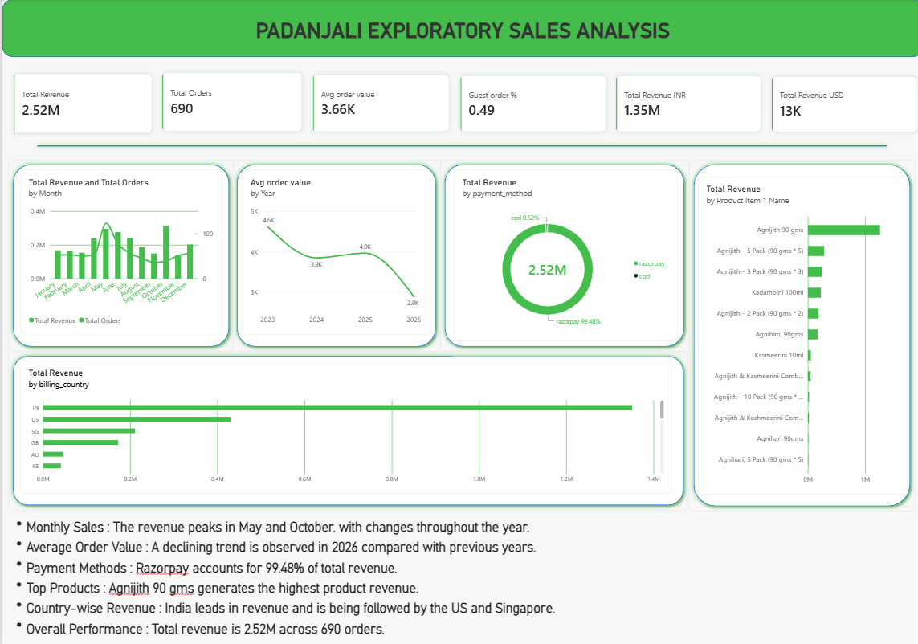

KPI cards
KPI | Value | What it tells me
Total Revenue | 2.52M | All sales converted to INR
Total Orders | 690 | Size of the dataset and volume of business
Average Order Value | 3.66K | Total revenue divided by total orders
Guest Order % | 49% | Orders placed without a registered account (shown as 0.49 on the card)
Total Revenue INR | 1.35M | Revenue from orders paid in rupees
Total Revenue USD | 13K | Revenue from orders paid in dollars, before conversion

Chart analysis
- By month. Revenue peaks at about 0.3M in May and October; other months sit mostly between 0.15M and 0.2M. October has high revenue with fewer orders than May, which points to larger orders.
- By year. AOV was about 4.6K in 2023, 3.9K in 2024, 4.0K in 2025 and 2.9K in 2026, a fall of about 37% from 2023.
- By payment method. Razorpay accounts for 99.48% of revenue and cash on delivery for 0.52%.
- By product. Agnijith 90 gms earns about 1.25M, far ahead of the multipacks and Kadambini 100ml (around 0.2M to 0.3M each). Agnihari, Kasmeerini and the combos add little.
- By country. India brings in about 1.35M (roughly 54%), then the US (~17%), Singapore, the UK, Australia and Kenya. Nearly half of revenue comes from outside India.

Key insights
- India and Agnijith 90 gms drive most revenue, with the US as the strongest overseas market.
- Customers spend less per order in 2026 than in earlier years, and single units sell far better than multipacks.
- Half of the customers check out as guests, and almost everyone pays online.

Anomalies and points for further analysis
- The fall in AOV in 2026 needs a breakdown by country, product and pack size, and 2026 is a partial year.
- The monthly chart combines all years; a year-by-month view would confirm the May and October peaks.
- The product chart uses only Product Item 1, so items in slots 2 to 4 are not counted. Unpivoting the four product columns would give the true ranking.
- Product names are inconsistent (for example “Kasmeerini” and “Kashmeerini”), which splits one product across several bars.
- The Guest Order % card should read 49%, and the Total Revenue card should be labelled as INR.

Conclusion
Total revenue is 2.52M across 690 orders, with an average order value of 3.66K. The business depends on India, on Agnijith 90 gms and on online payment through Razorpay. Revenue peaks in May and October, while average order value has been falling, especially in 2026. The next step is to break that decline down by country and product and to confirm the seasonal peaks year by year.

