**Arjun Singh**

**11413058**

[**akasana8@gmail.com**](mailto:akasana8@gmail.com)

[**https://github.com/Arjun8/OpenSourceProject**](https://github.com/Arjun8/OpenSourceProject)

**Novice Critics**

**Significance of Project**

Novice Critics is a project made for novice critics means fresher or less experienced critics. This project will enable many new young ones to choose the field of critiquing and learning the valuable lesson of perfect practice makes perfect. It is free and open source project so the source code is available to all the viewers and developers who can help in making it better. It lets you choose a number of world renowned book titles. It lets you see your reviewed books. You can add your titles also. You can sign up as a user can maintain your reviews. It also allows regular reader to read reviews and form an opinion about the future reads. It also helps in enabling novelist and writer’s market increase. All round it introduces a habit of literary needs in the younger generation. Since the introduction of kindle most of the novels and books have become electronic so it is a great idea to start the online reviews of these books and novels. Novice Critics will cater to the needs of large group and variable group of individuals from young ones to old ones, to literary experts to literary novices. It also maintains a database of all the books and their old reviews. We planned to online the reviews of the most titles of the New York’s Best Sellers from each year since 1940.It will also provide a literary compass for experts. In future update, we will introduce od adding a profile as writer. It will be like IMDB but for writers and critique’s.

**Approach used to develop the Project**

It used HTML5, CSS and PHP.HTML and CSS were used as presentational part of the project whereas the PHP was used to retrieve and send data from the database. MySQL was used to the data. We started with a simple idea of storing the reviews and making them online. With each step taken to achieve that goal we designed the user interface and made it user friendly and presentable. We made an option of adding a user. User can sign up as a reviewer or an author. MySQL enables storing of data in relational database management system.

**Brief Answers in relevance to the project codes**

1. Will different sections of your site require different designs, layouts or colouring?
2. What kind of layout you employed in project?
3. Whether sub-queries are used using joins, having clause, group by, order, count, sort etc.?

I have used no such queries, since there are no complexities in database, but I have used where clause.

1. How data is fetched from the database?

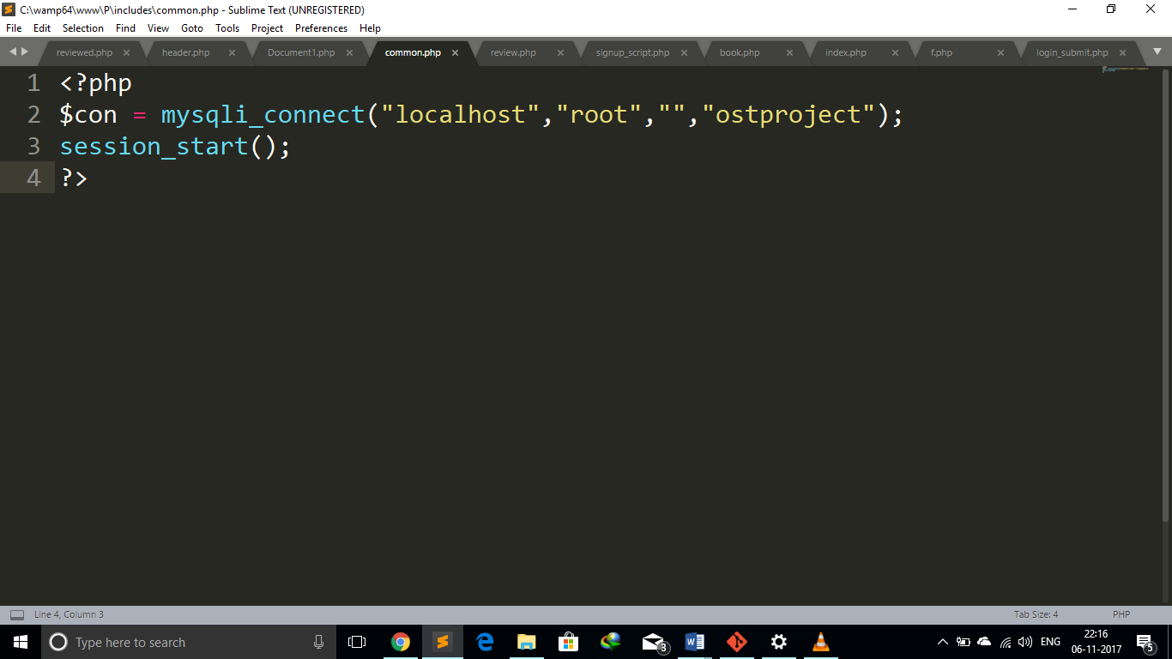

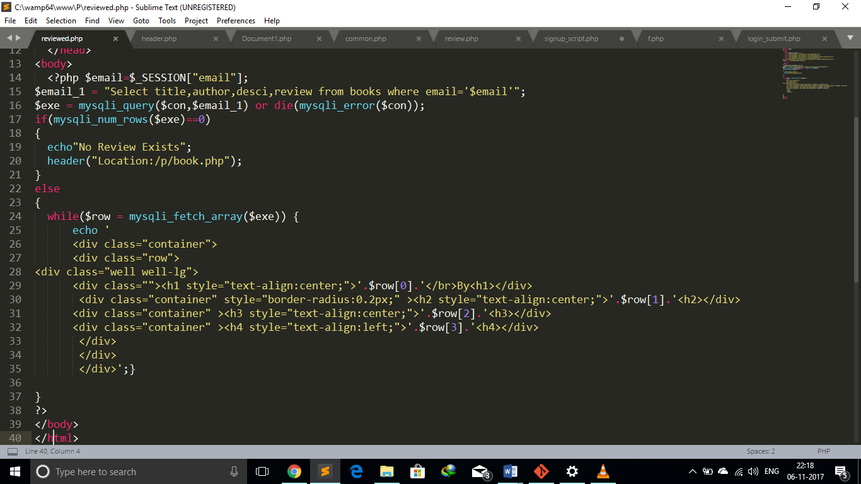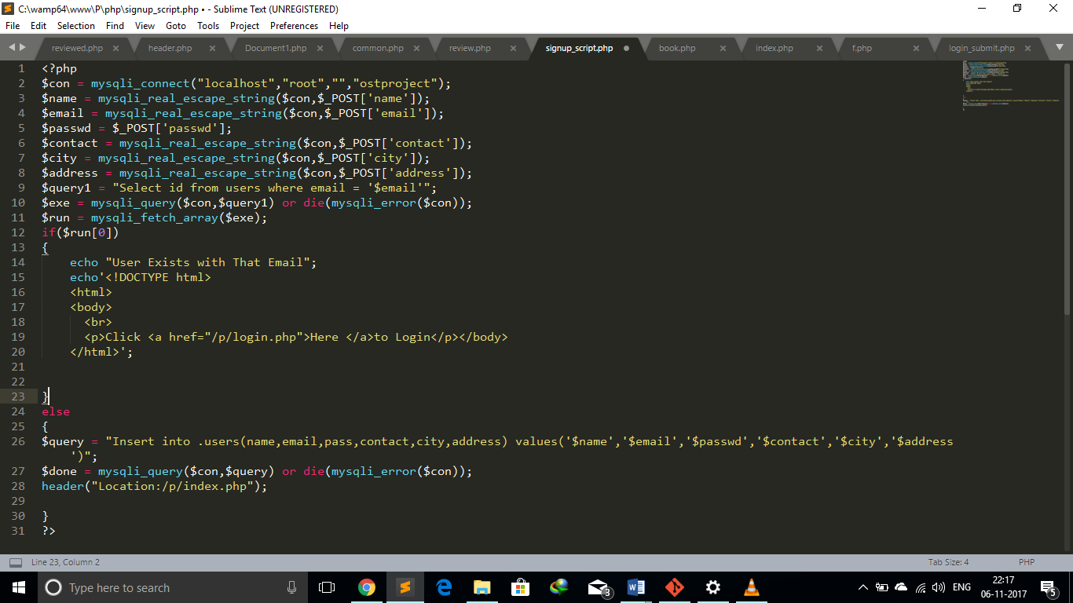

1. What are the different kinds of explicit validations applied in the project?

I have applied validation on form using HTML5,it helps in from validation and has predefined functions to check for certain types of inputs ,like maxlength and specific type email etc.

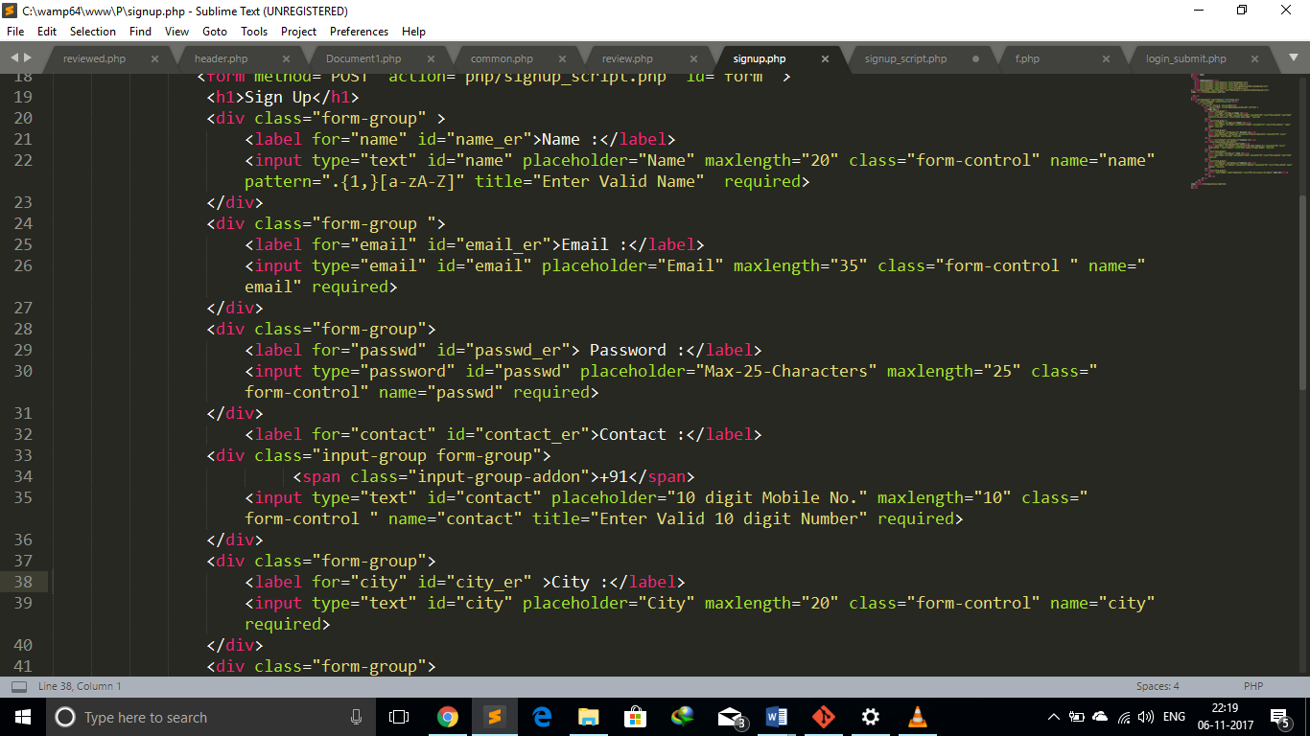

1. What kind of security technique is employed in the project?

I have defined a script which checks for session creation and deletion on certain pages where user need to logged on.

1. Does the content suffice the purpose of website in terms of functional requirements?

It gives user a number of options, since there are large number of functional requirements and I was only able to implement some of them but it will suffice for minimum functional requirements.

1. Have you optimized query for quick retrieval of data from the database?

I have used optimised query for retrieval of data from database.

Example, Instead of using select * form table_name; I used select col1,col2 from table_name limit by 3;

1. Have you employed any php function for the modularization of web pages?

Include.header

1. Have you used GitHub repository to maintain different revisions of the project?

Description: GitHub is used a platform for sharing and maintain versions of an application. I have used GitHub during the lifecycle development of my project.

GitHub link: https://github.com/Arjun8/OpenSourceProject