ONLINE EXAMINATION

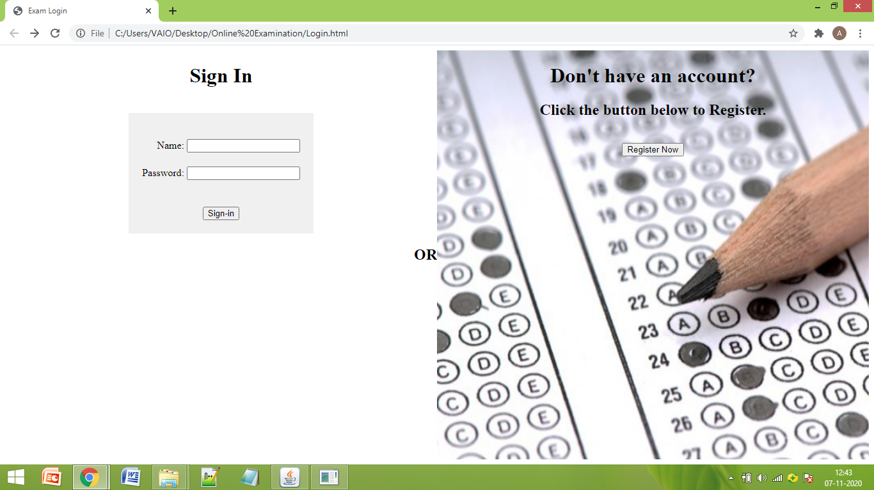

Login Page with Sign-In and new Registration options.

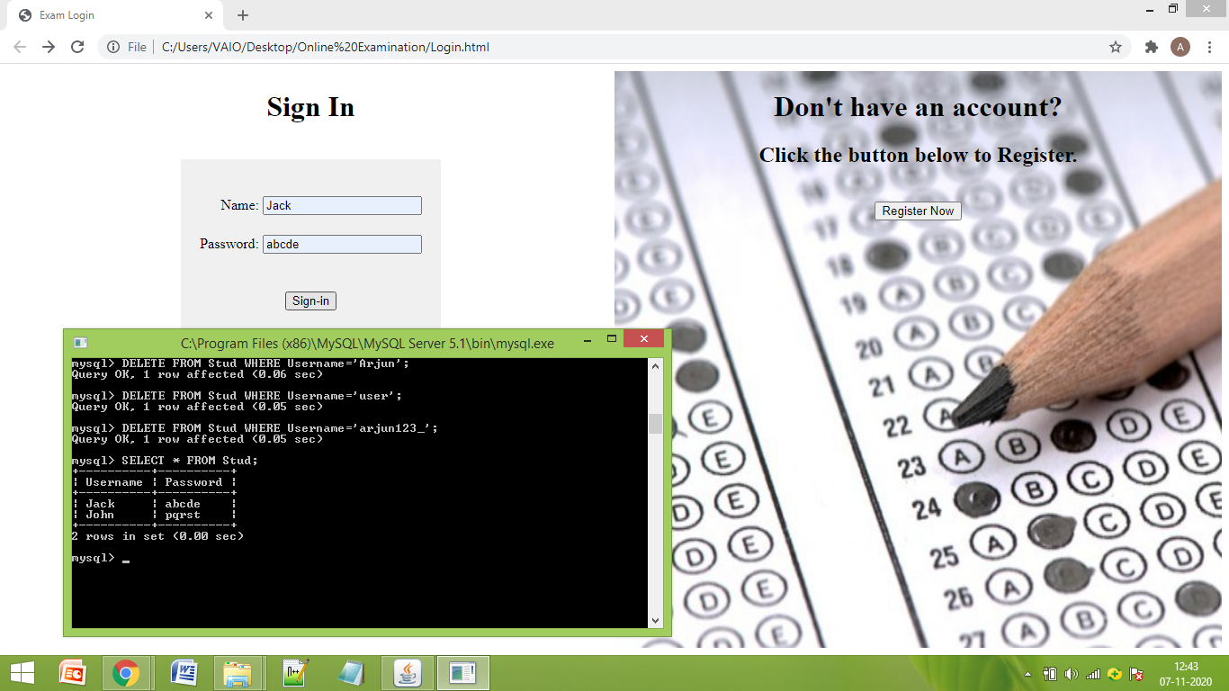

Current status of Database with Student Details is shown. In the sign-in section, an existing user’s details are being given.

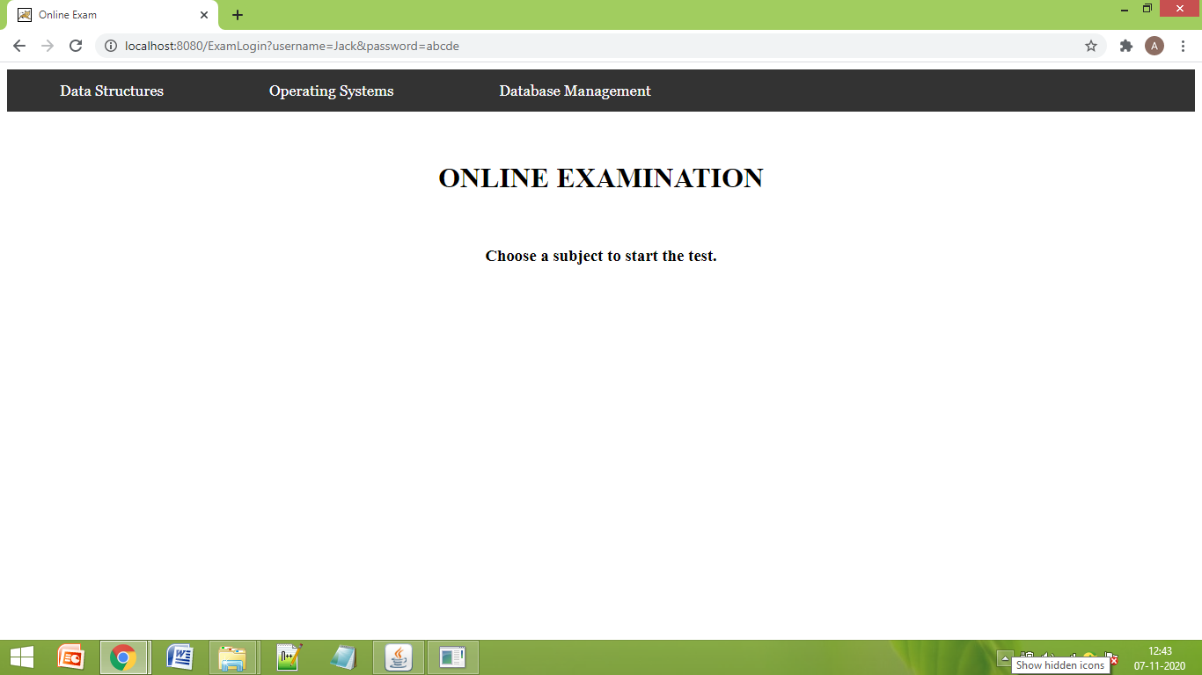

Since sign-in is successful, the main Exam Subjects page is displayed.

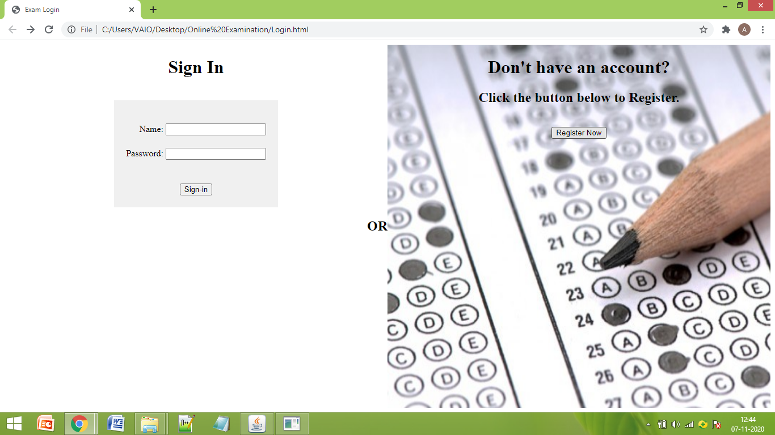

Here, the direct Register option is chosen from Login page.

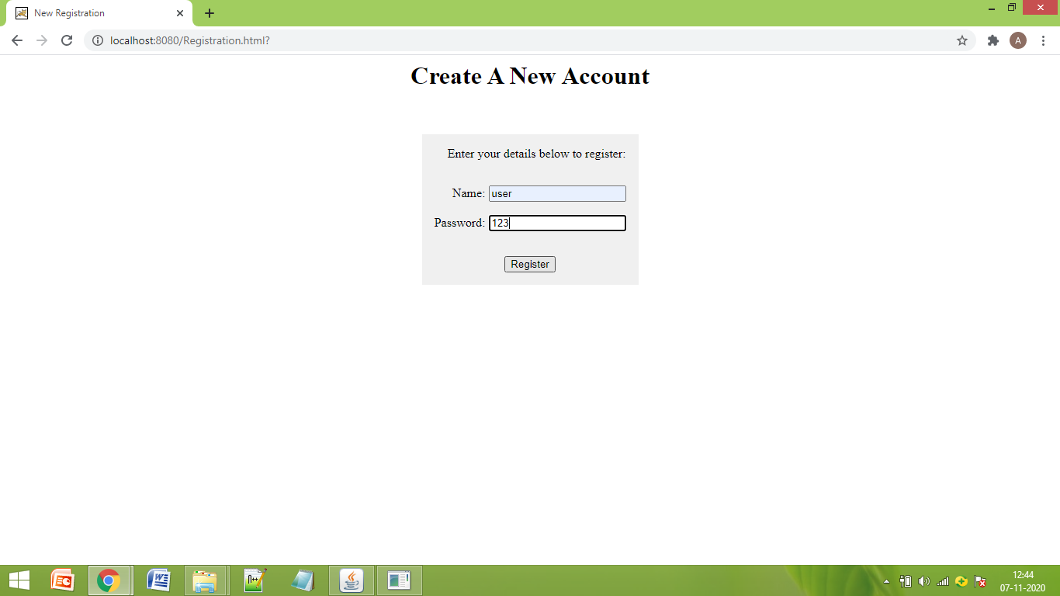

The chosen option takes us to the New Registration Page.

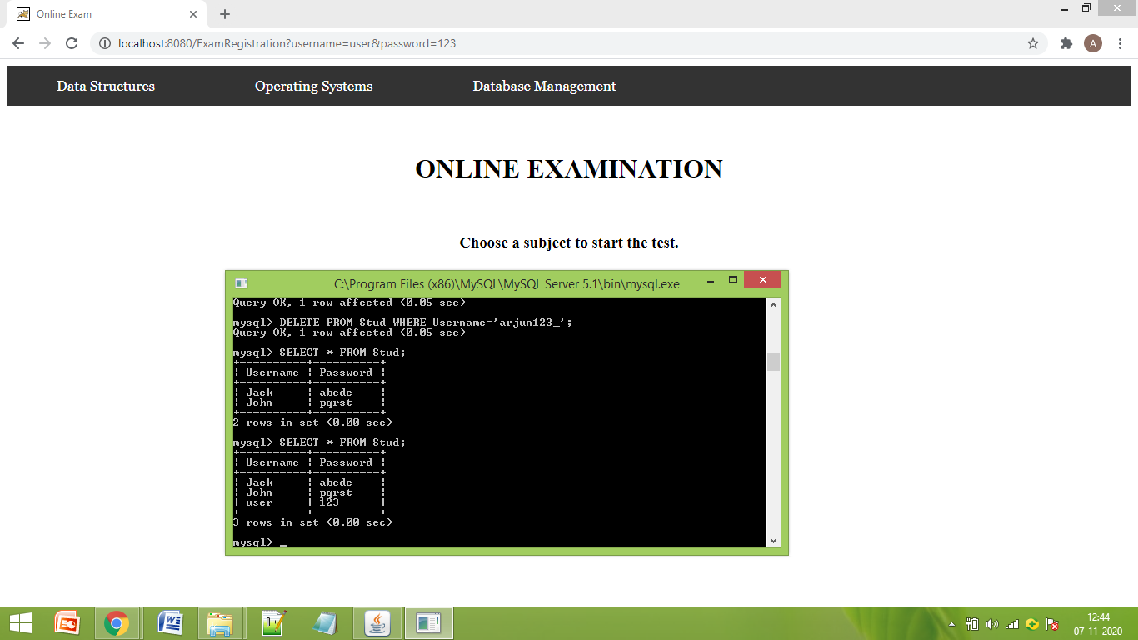

After the New Registration, the details are added to the database and we are taken to the main Exam Subjects page.

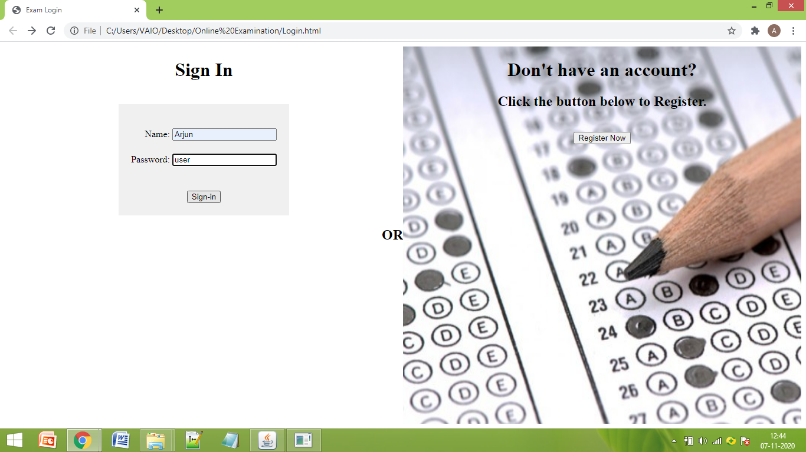

If we give wrong user details or details of a non-existing user,

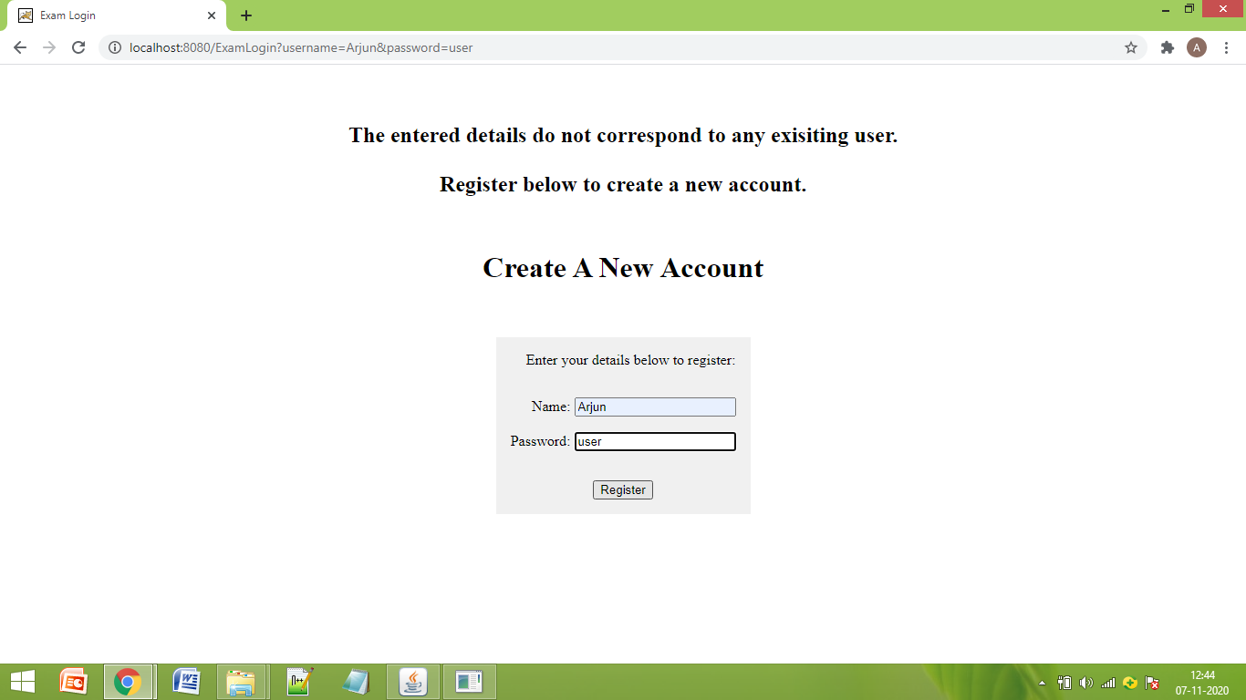

We will be taken to the New Registration page, and a message will be displayed on top.

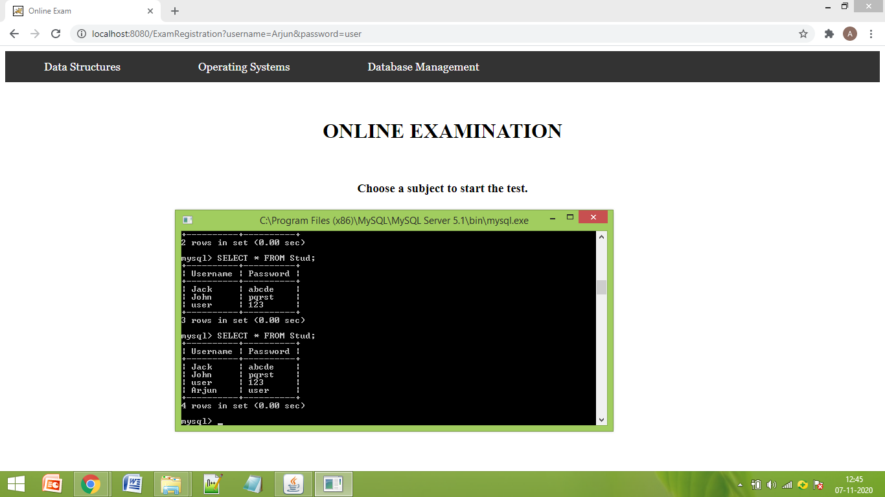

After registration, the details will be added to the database.

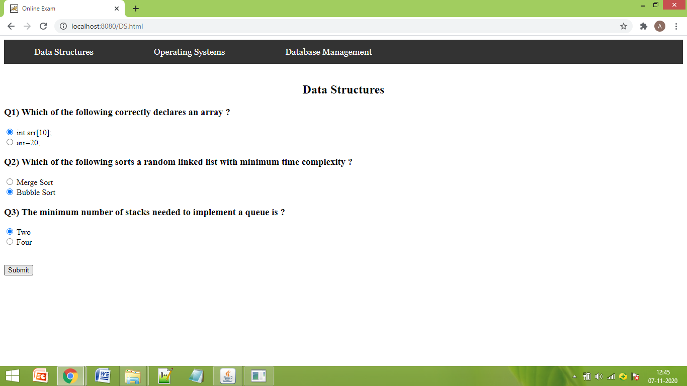

If we choose DS from the navigation bar, then the corresponding MCQs will be displayed.

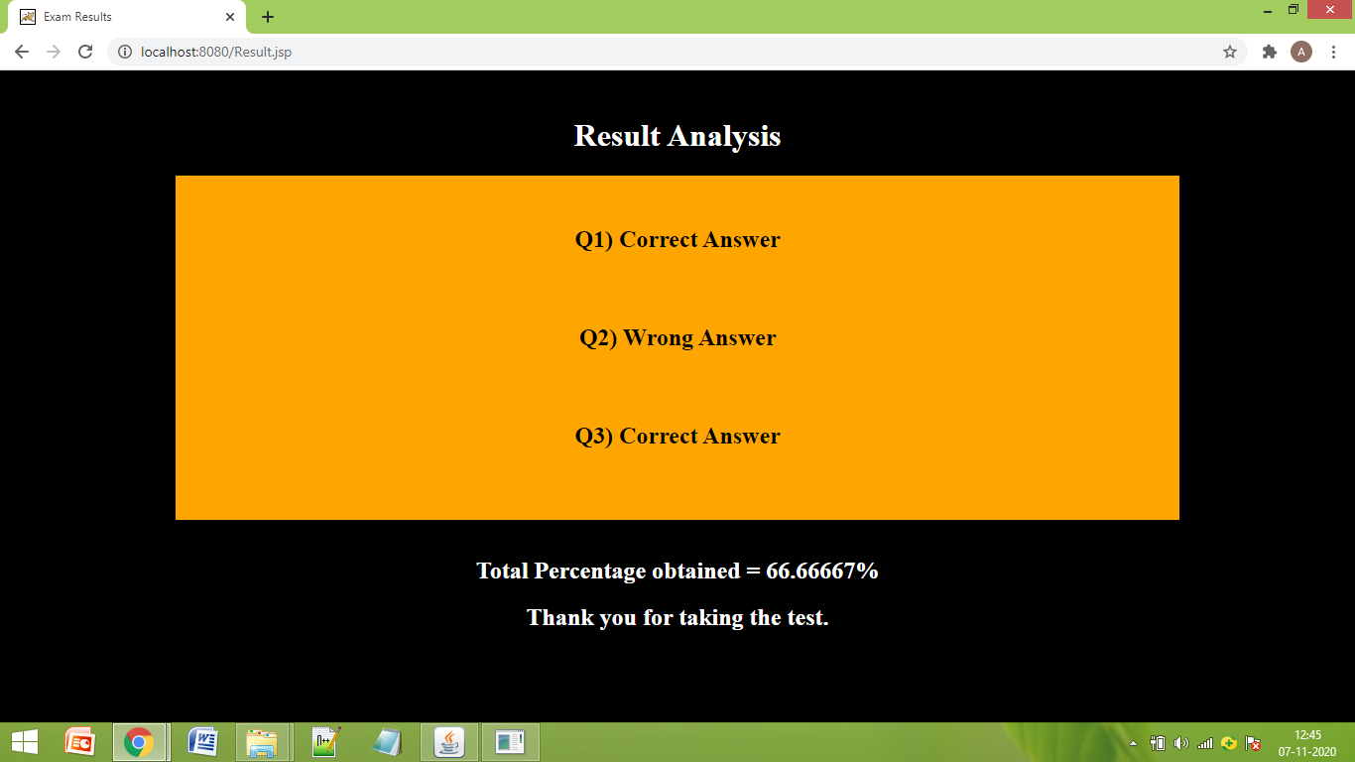

Results page for DS exam.

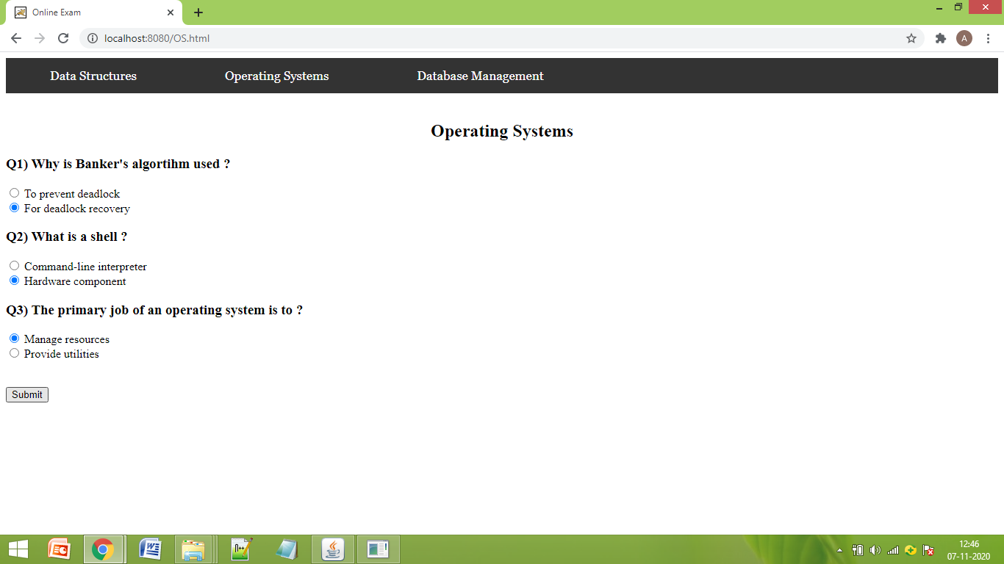

If we choose OS from the navigation bar, then the corresponding MCQs will be displayed.

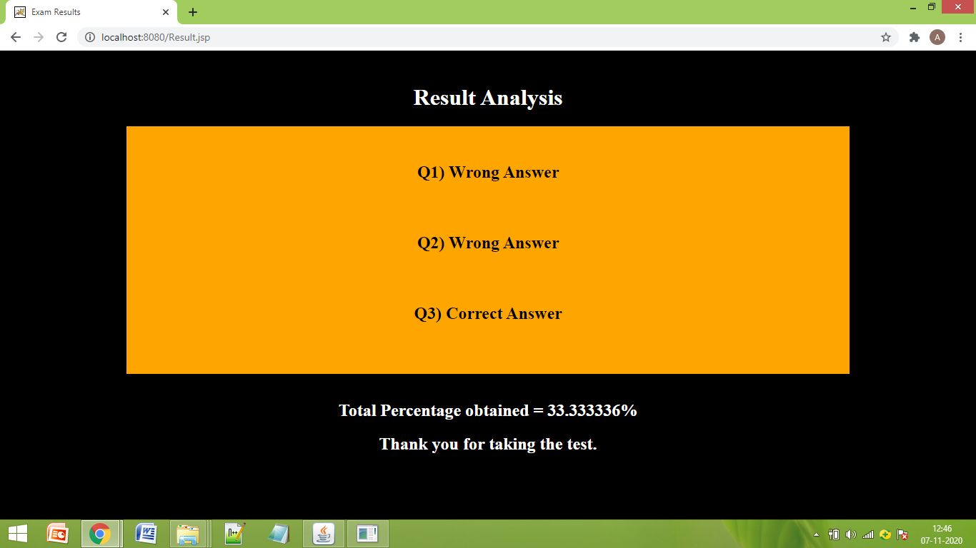

Results page : Case 2

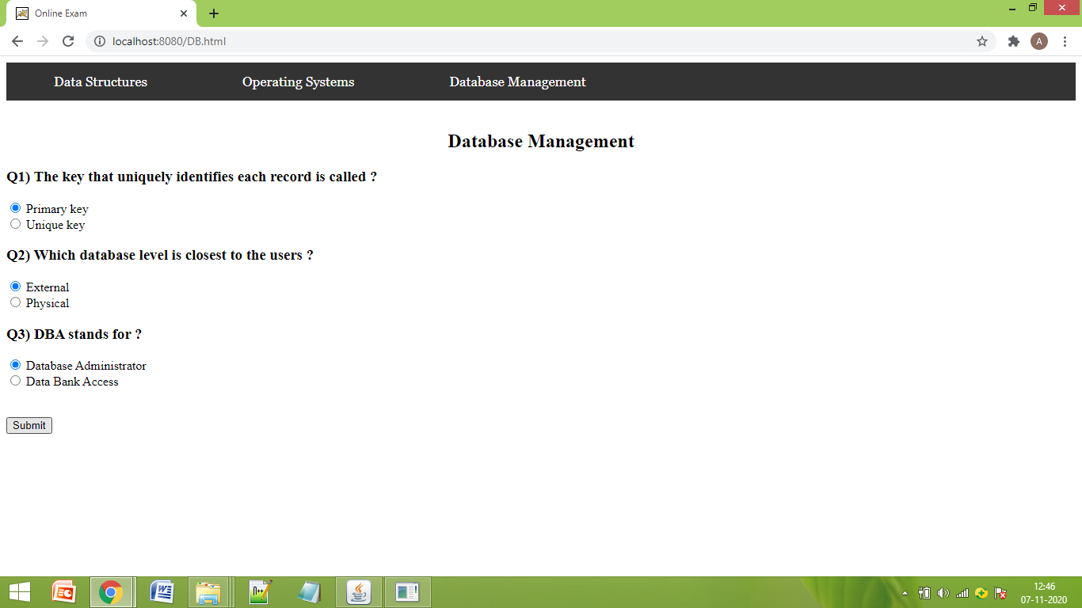

For DBMS (Case 3)

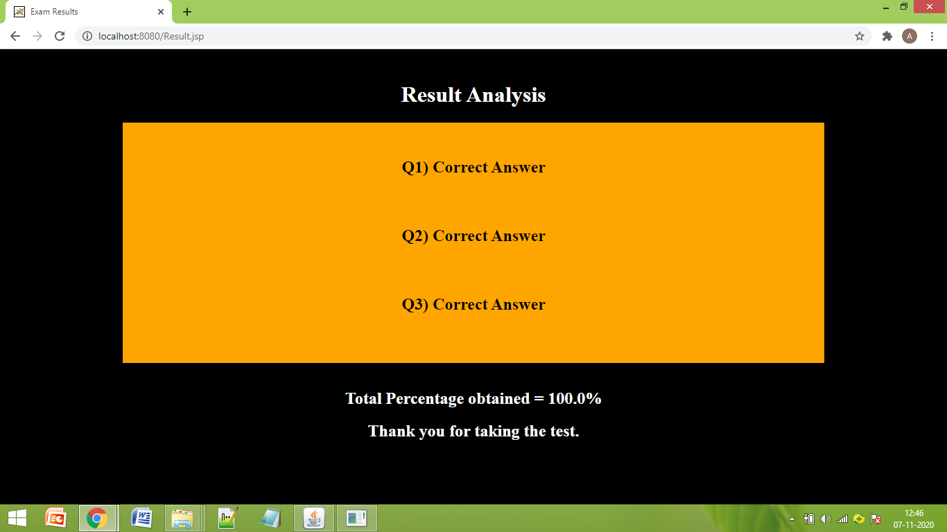

Results page for Case 3.