Programming Tools

1. I am intending to use a laptop running Windows 10 in order to complete the work required for this course.
2. 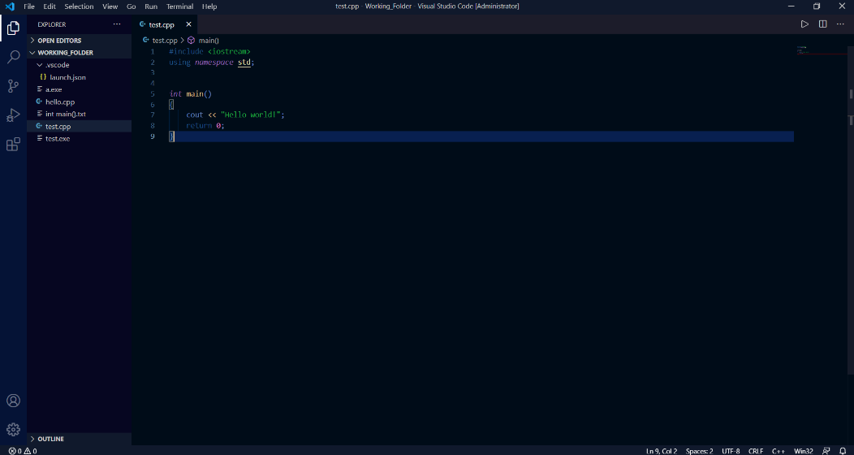For my editor, I have chosen to use Visual Code Studio for editing any code necessary. As a backup in case that does not work in some case, I will use either Windows Notepad or repl.it (online).
3. For my compiler, I am also intending to use Visual Studio Code in order to compile the code I write (using MinGW). As a backup in case that does not work, I will use Windows Command Prompt or repl.it (online).
4. 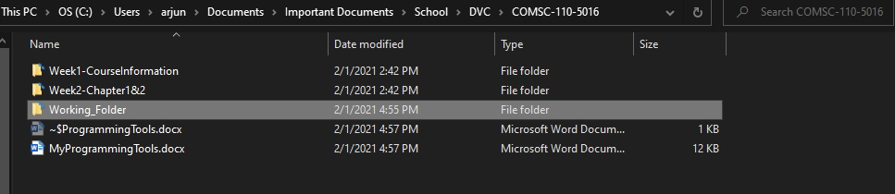For my working folder, I am using a folder located within my folder for the coursework of this class.
5. In order to configure the Windows file explorer to show file extensions, I enabled the “File name extensions” options in the view tab in File Explorer.

