1. **Results** 
   1. **Comparable model predictions are observed regardless of the model scenario and N adaptation strategy**

To test the usefulness of a lignin rate modifier, we fitted four different model scenarios to a set of publicly available data on 13C NMR compiled from the literature, using a more detailed stoichiometric litter description compared with traditional models. These four model scenarios included: i) no lignin protection and no oxidative enzyme cost (NPNE), ii) no lignin protection with invariant oxidative enzyme cost (NPWE), iii) lignin protection with invariant oxidative cost (PWOE), iv) lignin protection with variant oxidative cost (PWOV). Additionally, we modeled two microbial life history strategies to cope with stoichiometric imbalances: N retention and flexible CUE.

For the N retention strategy, we obtained comparable model calibration results of the five litter fractions (Figure 2), despite the high variability in the litter pools estimated using the molecular mixing model and NMR data (Figure S2). Many litter datasets showed an NSE > 0, indicating that the model performance is more accurate than merely using the mean of the observed values (Figure 3). Moreover, the same datasets had an RMSE close to zero, which is a good indicator of a robust model (Figure 3).

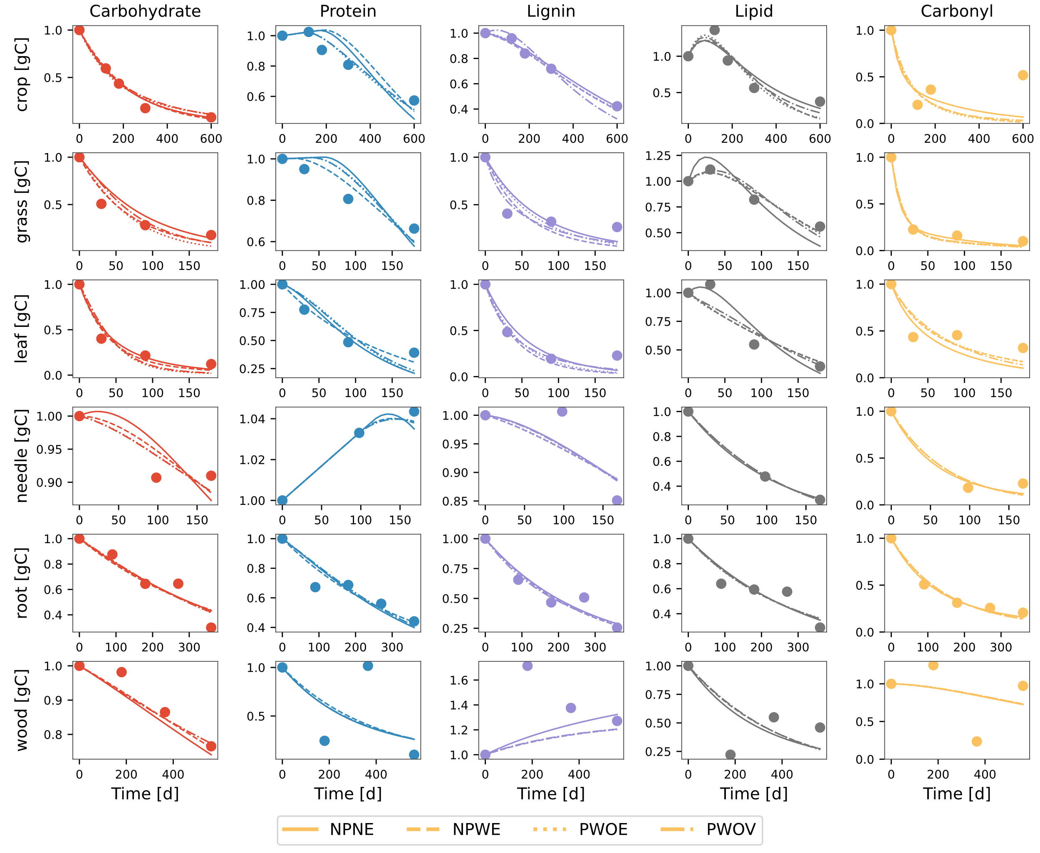

Figure 2 Comparison of modeled (different line styles) and observed (circles) changes in five litter pools (carbohydrate, protein, lignin, lipid, and carbonyl) for various litter types. The data points for the crop litter are from wheat straw buried at 15cm depth in sandy loam soil from Li et al. (2020); grass and leaf litter samples are from *A. mauritanicus* and *A. unedo*, respectively, from Bonanomi et al. (2013); needle litter is from *P. radiata* from Almendros et al. (2000); root litter samples are fine roots of *M. macclurei* from Wang et al. (2013); and wood litter of Mulga twigs from Mathers et al. (2007). Different line styles differentiate the four model variants. Model parameters and initial conditions used in the simulation were [0.01, 0.01, 0.008, 0.009, 0.01] d-1, and =1e-5 gN d-1; initial fraction of carbohydrate, protein, lignin, lipid, and carbonyl pools were 0.43,0.02,0.3,0.2,0.05, respectively; and the initial mass of litter was considered to be 1g on dry weight basis.

Model fits were heavily influenced by data availability or by the uncertainty in assigning certain NMR spectra to the litter fractions. For example, fractions like protein and carbonyl performed the worst regardless of the model scenario used, and this is highly notable when looking at the model performance metrics for each litter pool per model scenario (Figure 3). The model generally performed poorly for these pools, with a negative NSE, indicating that it performed worse than simply using the mean of the observations.

When comparing the two stoichiometry strategies, the model scenarios performed similarly (Figure S4), highlighting the fact that even such a detailed description of the litter fractions is insufficient to determine when a specific stoichiometry strategy is active.

Figure 3 Boxplot of Nash–Sutcliffe modeling efficiency coefficient (NSE) (A) and root mean square error (RMSE in gC) (B) for five litter fractions for four model scenarios. The boxplots show the interquartile range (IQR), with the median marked by a horizontal line. Whiskers extend to values within 1.5 times the IQR from the quartiles and outliers beyond the whiskers are indicated by individual markers. The percentage numbers in panel A show the % of litter dataset having NSE<0.

* 1. **Detailed description of litter fractions in models improves the constraining of kinetic model parameters**

One persistent issue common to all biogeochemical models is equifinality, or the inability to properly constrain model parameters, especially kinetic parameters. By adding more realism to the litter fractions compared to traditional models, we tested whether our proposed models could aid in constraining kinetic parameters. Overall, our model scenarios under the two stoichiometry strategies do not improve the uncertainty in the estimation of the decay rates of the litter fractions compared to more traditional models (Figure 3). The estimated parameters varied across many orders of magnitude, and these uncertainties in the model parameters will propagate to the model outputs as well. Following the parsimony principle, and given the similarity of parameter estimations across models, including simpler ones, our results suggest that models with fewer free parameters should be preferred.

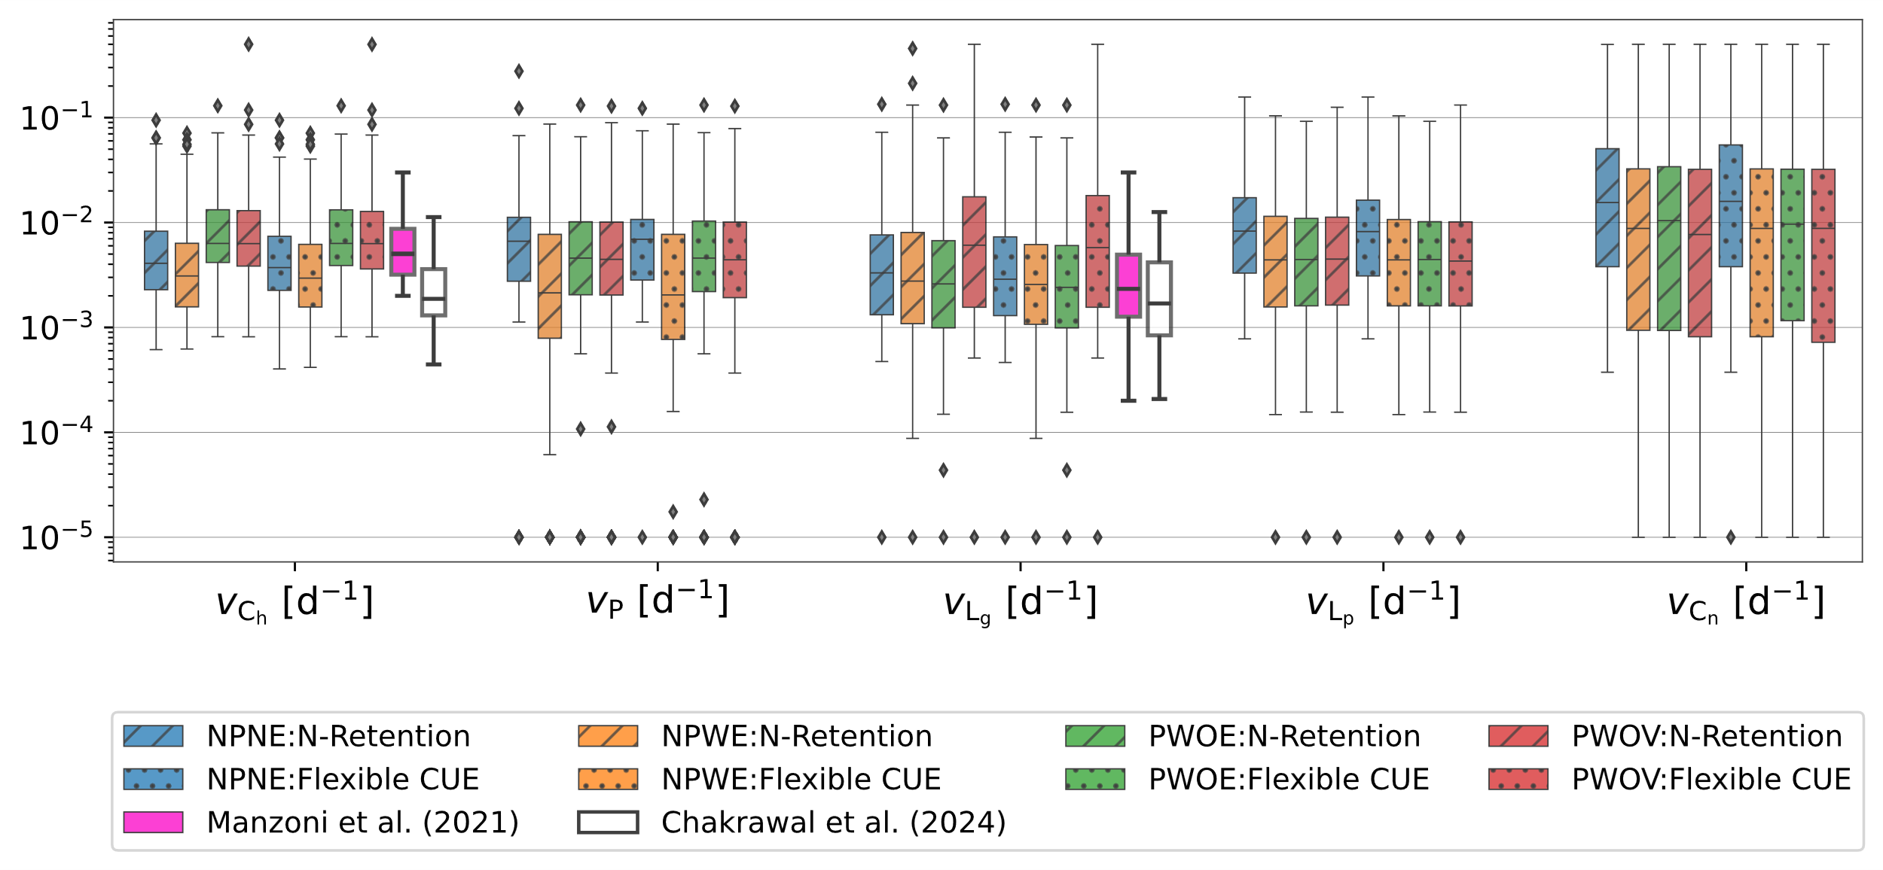

Figure 4. Distribution plot of estimated model parameters, i.e., the uptake rate constant for (A) carbohydrate, (B) protein, (C) lignin, (D) lipid, and (E) carbonyl for three model scenarios as different line styles. Note the log transformed values on the X-axis for each variable. Distribution plots illustrated by white and purple lines in panels A and C are the rates of carbohydrates, proteins, and oxidizable (representative of lignin) pools, respectively, taken from Manzoni et al. (2021), and nonaromatic (representative of carbohydrates and proteins) and aromatic (representing lignin and other aromatic compounds) pools from Chakrawal et al. (2024a).

* 1. **Model exploration: Mechanisms underlying litter decomposition under model scenarios and stoichiometry strategies**

We explored the dynamics of the different litter pools over time to unravel the mechanisms underpinning such dynamics under the four model scenarios and two stoichiometry strategies, namely, N retention (Figure 5) and flexible CUE (Figure S3). C pool dynamics did not differ under the proposed model scenarios, but the stoichiometry strategy did play a role in determining the mechanisms driving C pool dynamics, especially when accounting for lignin protection and the cost of oxidative enzymatic production. Under the N retention strategy, and without lignin protection and costs for oxidative enzyme production, microbes can take up C from each litter fraction without restriction, including lignin, at a maximum rate (Figure 5H, I, and J), independently of the lignin content in the system. Because uptake is at its highest, N retention in the form of biomass remains the longest compared to the other model scenarios (Figure 5G), and this is reflected by an increment in the protein pool (Figure 5B). These processes did not affect microbial CUE, as this remained constant under both stoichiometry strategies (Figure 5G and S3G).

On the other hand, when enzymatic costs are accounted for, we observed a strong reduction in CUE (Figure 5G), reducing microbial biomass formation and consequently N retention as necromass (Figure 5F), which is in turn observable as losses in the protein pool (Figure 5B). Comparable results were also observed under a flexible CUE strategy (Figure S3).

Model scenarios, including lignin protection and either static or dynamic enzymatic investment, yielded similar results in all litter fractions, with only slight differences in the protein dynamics, mainly due to reductions in CUE. In both models, the effect of lignin protection is also observable in a slower degradation of carbohydrates compared to the other model scenarios (Figure 5A). The main impact of having an invariant enzymatic cost of production was seen in a decrease in lignin decay due to a bigger delay in decomposition as lignin concentrations reduced.

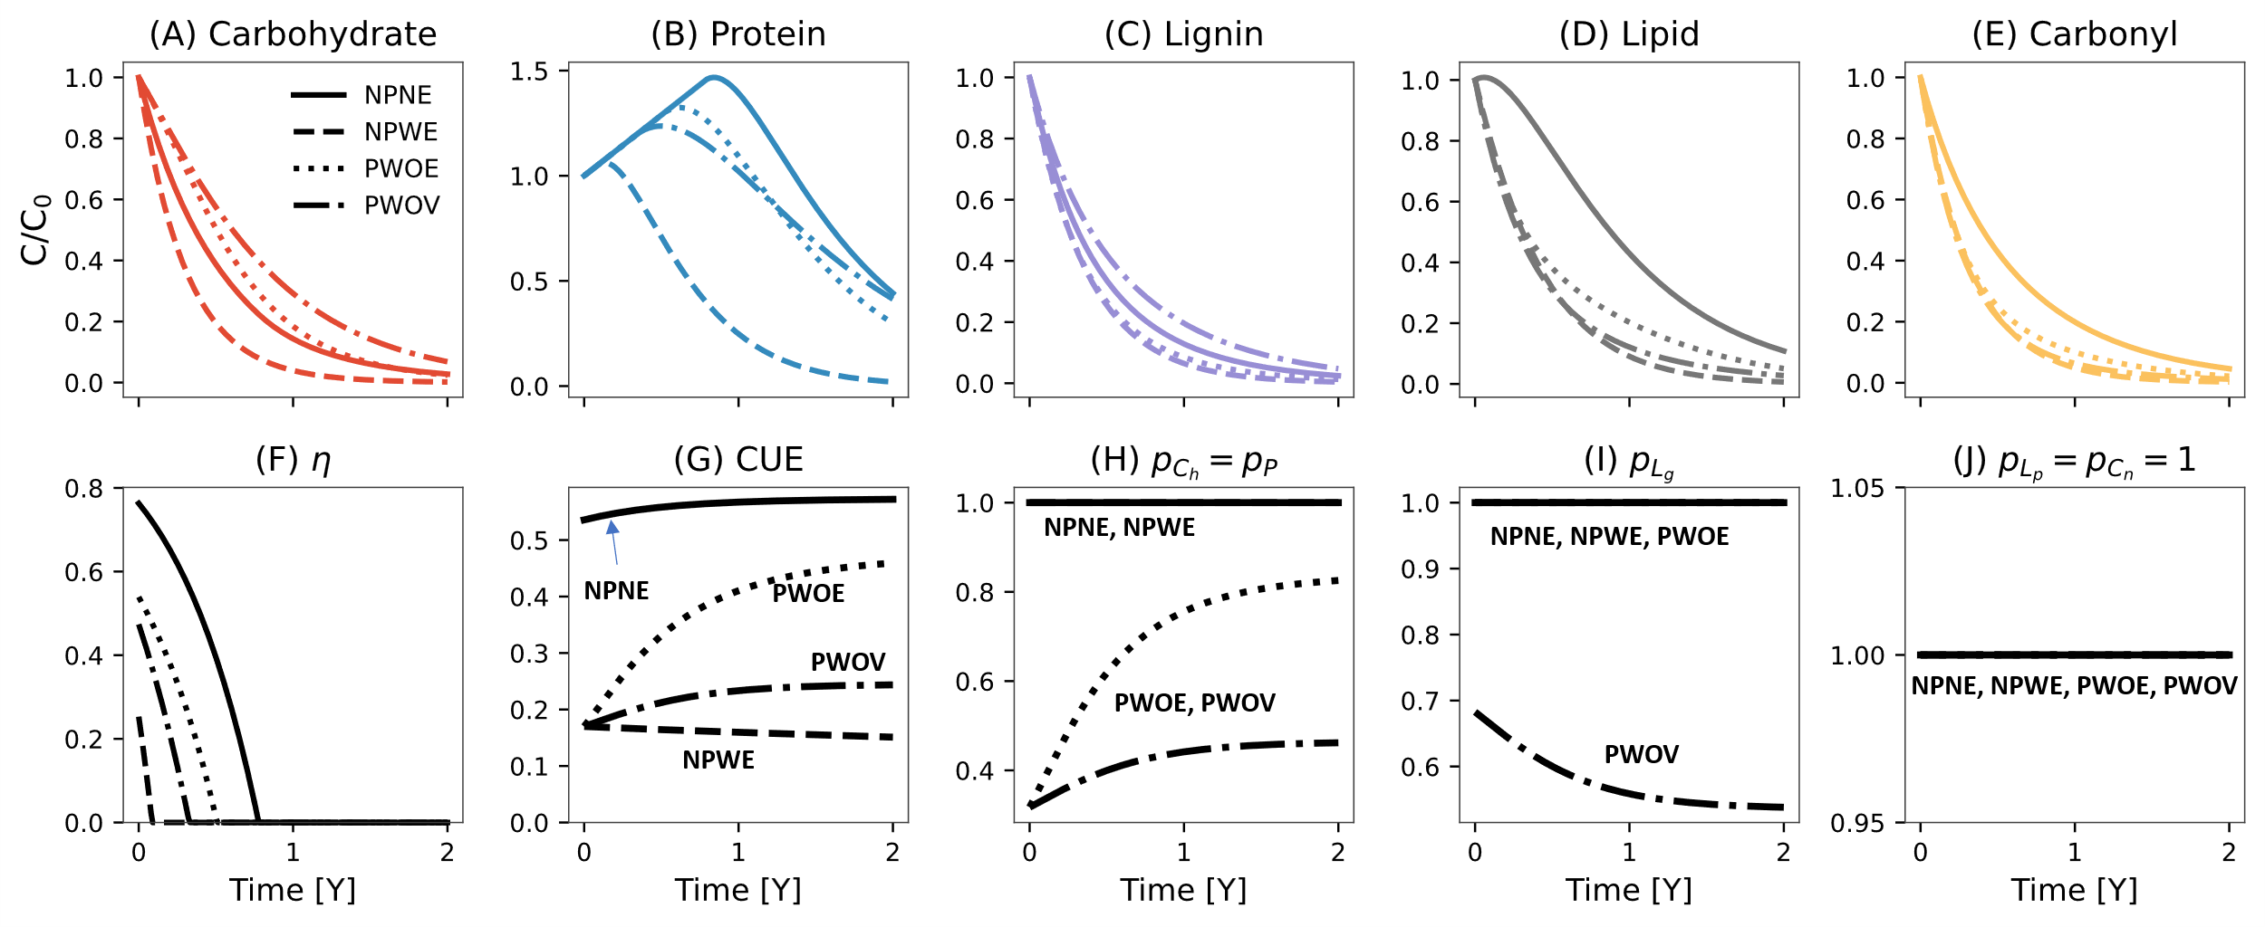

AC Notes for R and D.

* Model development paper with application in understanding the need of lignin rate modifier, if we have detailed molecular data instead of total C and N.
* Overall main text results and discussion will follow the central theme of model development and testing through using data to parametrize the model, and investigating how different hypothesis on microbial metabolism affected of lignin degradation in litter. We do this by four lignin model scenarios and two N limitation strat
* Main focus, in the describing model results using Figure 3 and 4, is done using N retention strat. CUE strat is used to so as alternate strat. We don’t care much about it. It is an additional thing we did to compare if model scenarios would performed substantially different. Since they did not, I prefer to keep the model performance results of CUE In figures 4 and 6.

There four nobs in the model.

1. Protection on and off: Protection of Ch and P decreases their uptake.
2. Oxidative enzyme on and off: Investment in oxidative enzymes decreases CUE, thus G, thus T-> less microbial turnover in substrate pool.
3. Oxidative enzyme time invariant vs variant. If variant (vO) then having more lignin increases its uptake
4. N limitation strategy N retention vs flexible CUE: N retention tends to keep more N in the by recycling it, flexible CUE increases waster of C through overflow respiration when there N limitation

Figure S2:

* useful figure to show how range of variations in NMR fractions across compounds. Gives a perspective there is mostly carbs, lipids and lignins in litter. (it does not add too much to story so I am open to push it to SI, if needed)

Figure 2: I would like this figure to be presented as model exploration figure to describe model capabilities. See figure S3 as well.

* We focus mainly on N Retention strategy and CUE regulation is used for model performance comparison
* model exploration figure. How does C [gC] in different pool changes with different scenarios under N retention strat.
* In NPNE, no protection and no incurred cost to oxidative enzyme, allowed microbes to uptake C containing compound at a maximum rate leading to prolonged period of N limitation (>0 for a year). This also implied longer period of N retention in necromass increasing protein pool size.
* In NPWE, no protection, but incurring cost to oxidative enzyme, reduced CUE to more than half of max CUE, which lead to low growth and necromass recycling, thus overall loss of protein pool. Interestingly, lower growth rate reflected lower N demand as the N limitation period was smallest in this case.
* In PWOE, protection of Ch and P relatively reduced their availability so there is lower decay of Ch.
* IN PWOV, time variant vO is lower than its max value in PWOE, which reduced lignin decay.

Figure 5. Simulated temporal variation in carbohydrate (A), protein (B), lignin (C) lipid (D), and carbonyl (E) pools, and N retention factor (F) in four model scenarios using the N-retention strategy. The bottom panels (G-J) show the variation with lignin fraction of C use efficiency (CUE) (G), rate modifier for carbohydrate () and protein () (H), lignin rate constant ( (I), and rate modifiers for lipid () and carbonyl pools () (J). In panels G–J, the red areas or lines extend the range of variation of rate modifiers with lignin fraction, and black lines are the simulated range of p vs. L in each model scenario. In panel G, the red area illustrates the plausible range of variation in CUE under different model scenarios—calculated based on a minimum and maximum degree of reduction of total litter, set at 3.8 and 4.5, respectively, to determine . Model legends are as follows, **NPNE**: **n**o **p**rotection of carbohydrate and protein, and **n**o oxidative **e**nzyme cost, **NPWE**: **n**o **p**rotection carbohydrate and protein but **w**ith oxidative **e**nzyme cost, **PWOE**: **p**rotection of carbohydrate and protein **w**ith **o**xidative **e**nzyme cost but time invariant lignin rate constant, **PWOV**: **p**rotection of carbohydrate and protein **w**ith **o**xidative enzyme cost but time **v**arying lignin rate constant. Model parameters and initial conditions used in simulation were [0.01, 0.01, 0.008, 0.009, 0.01] d-1, and =1e-5 gN d-1; initial fraction of carbohydrate, protein, lignin, lipid, and carbonyl pools were 0.43,0.02,0.3,0.2,0.05, respectively; and the initial mass of litter was considered to be 1g on dry weight basis.

Previous works have suggested that microbial CUE varies negatively proportional to the litter C:N ratio, and thus, CUE decreases as N becomes limiting in the system. This is mainly observed in a microbial community that uses flexible CUE as a strategy to cope with stoichiometric imbalances. Our four model scenarios, following a flexible CUE strategy, are also able to reproduce this relationship, CUE vs. C:N ration in litter (Figure 6B and D), when comparing both average CUE and initial CUE. However, under an N retention strategy, all models, with exception of the simplest model (neither lignin protection nor costs of oxidative enzymes), can reproduce the patterns described in a flexible CUE strategy. In the no-protection, no-enzyme-cost model scenario, CUE is higher due to reduced oxidative enzyme investment. As decomposition progresses, microbes may become less N-limited and CUE increases, reaching close to maximum CUE values under C-limited conditions. As a result, the average CUE is higher than the initial values (Figure 6A).

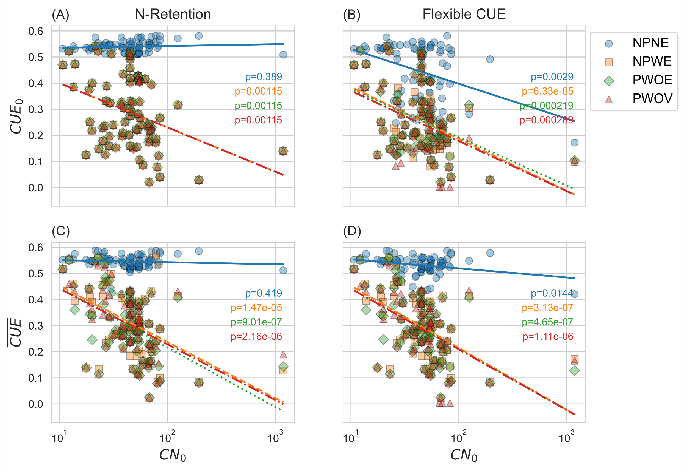

Figure 6 Variation in initial () and temporal average () carbon use efficiency under the N retention and flexible CUE adaptation strategies for four model scenarios.

1. **Discussion**

New technologies such as the Nuclear Magnetic Resonance (NMR) and Fourier Transform Ion Cyclotron Resonance mass spectroscopy (FTICR-MS) now allow us to accurately describe the composition of litter fractions and thus develop process-based models capable of incorporating more detailed process descriptors of the role of litter fractions on litter turnover rates. We built a model framework that incorporates and takes advantage of these data to understand the mechanisms of lignin protection in litter decomposition by incorporating a lignin rate modifier. We further analyzed how such a rate modifier would affect simulations of microbial-driven processes related to litter turnover and the consequences and practicality of scaling them up into soil models.

**Perks of using NMR data to constrain litter decomposition model parameters**

Traditional litter decomposition models attempt to accurately predict litter turnover rates using very coarse descriptors of litter, such as C/N ratios (1) or very general descriptors typically found in litter samples (2). Such models lack the resolution necessary to capture intra-molecular interactions (5) like lignin protection, which can create a bottleneck during litter decomposition (3,4). Our model framework bridges this gap as it can readily include NMR and FTICR-MS spectral data converted into five traditional litter pools using molecular mixing models (5). Furthermore, it allows us to explore the effects of chemodiversity by more accurately describing the litter fractions in each type of litter material. The use of highly resolved litter descriptions has not only been suggested from modeling but also empirical studies looking at the effects of distinct lignin chemistries on litter turnover rates (9).

However, high resolution in litter data does not fully resolve the persistent issue of equifinality in biogeochemical models (6). This becomes evident by the remaining uncertainty in kinetic parameter fits, which vary across many orders of magnitude and are even comparable to parameter fits using more traditional models. The many reasons why different models can fit empirical observations with comparable performance metrics can be summarized as either the data not providing sufficient information to constrain model parameters or because of compensation among parameter combinations (6). By adding high-resolution litter data, it is possible that equifinality issues in our results are mainly driven by compensatory effects of the kinetic parameters.

**Lignin modifier does not improve model calibration, but can improve process understanding**

Litter degradation is one of the main processes in C cycling in terrestrial ecosystems (7,8), and understanding the controls of litter degradation is crucial for accurate predictions. Lignin content in litter has been considered an important bottleneck of litter degradation (3,9). However, the role of lignin in degradation tends to be context-specific and related to whether the main driver of litter decomposition is either biotic or abiotic processes (4). Mechanistically, it has been suggested that lignin offers chemical rather than physical protection to more labile litter components such as cellulose and hemicellulose (9,10), and provides resistance to litter linkages upon decay (9). Lignin concentrations might control fungi without affecting bacterial activities (10), so that litter decomposition might progress without lignin controls.

Energetically speaking, lignin concentrations not necessarily limit litter decomposition as microorganisms can invest in oxidative enzymes to access more recalcitrant components. Only if there are not sufficient high-energy substrates in the system to fuel resource investment, microbial growth and activity may cease, affecting decomposition of multiple litter fractions, including lignin.

Many model formulations have been developed to account for lignin protection of more labile litter fractions. Since Herman, J. et al. (11) empirically validated the rate of lignin decay as a linear function of the lignocellulose index (lignin/[lignin + holocellulose]) proposed by Moorhead, D. L., & Sinsabaugh, R. L. (12), many models have adapted this empirical relationship to account for the shielding effect of lignin in litter decomposition (2,13,14,15,16). This rate modifier formulation and follow-up power law rate modifiers (17) have relied on coarse descriptors of litter fractions. We improved these model formulations in our modeling framework by successfully coupling high-resolution spectral data with a mechanistic, process-based model. This way, we can mechanistically validate the role of a lignin modifier in litter decomposition rates. To our knowledge, there is only one model that uses NMR data as input for C dynamic models (18,19). We expand upon this approach by including lignin protection processes and nutrient limitation as additional factors driving litter degradation (18).

Our model (model scenarios 3 and 4) describes a scenario in which higher lignin concentrations delay the degradation of more accessible carbon fractions (chemical protection), and the production of oxidative enzymes to access the lignin pool affect microbial turnover of litter via reduction of their CUE. However, the fact that all our model scenarios, including two alternatives to deal with microbial stoichiometric imbalances (N retention and flexible CUE), yield similar simulation results poses the question about the need to include a lignin rate modifier. We argue that even though the presence of a lignin rate modifier has a minor effect on model performance against empirical observations, the model scenario including the rate modifier and oxidative enzyme production provides hypothetical/putative mechanisms that can be tested and validated empirically.

Nevertheless, following the parsimony principle, we will prefer to choose simpler models if their performances are comparable. In this case, our proposed model scenarios 3 and 4 are conceptually similar to the “return-on-investment” function expressed as the total substrate uptake capacity per unit cost of enzyme investment. Under this heuristic approach (20), the key limitation of litter degradation is the usable energy that comes back to the microbes per unit of exoenzyme produced (21). If the return is positive, degradation will continue, regardless of the chemical composition of the substrate (21). This simpler approach has been previously used in the literature to model litter degradation (22,23,24). Probabilistic approaches, such as Maximum Entropy (25), could provide an additional alternative to our approach, as it can incorporate NMR data and be used to investigate the effect of soil chemodiversity in litter turnover.

**References**

(1) <https://www.sciencedirect.com/science/article/pii/S0038071712001046#sec3>

(2) <https://onlinelibrary.wiley.com/doi/epdf/10.1111/j.1461-0248.2012.01807.x>

(3) <https://esajournals.onlinelibrary.wiley.com/doi/10.1002/ecy.3113>

(4) <https://www.pnas.org/doi/10.1073/pnas.0909396107>

(5) <https://nph.onlinelibrary.wiley.com/doi/full/10.1111/nph.19572>

(6) <https://www.sciencedirect.com/science/article/pii/S1364815218311563>

(7) <https://www.sciencedirect.com/science/article/pii/S003807172100273X>

(8) <https://link.springer.com/article/10.1007/s40974-017-0064-9>

(9) <https://link.springer.com/article/10.1007/s10533-011-9599-6#Sec11>

(10) <https://esajournals.onlinelibrary.wiley.com/doi/10.1890/11-0843.1>

(11) <https://www.sciencedirect.com/science/article/pii/S0038071708002307#sec4>

(12) [https://doi.org/10.1890/0012-9615(2006)076[0151:ATMOLD]2.0.CO;2](https://doi.org/10.1890/0012-9615(2006)076%5b0151:ATMOLD%5d2.0.CO;2)

(13) <https://www.sciencedirect.com/science/article/pii/S0038071713002265?via%3Dihub>

(14) <https://www.sciencedirect.com/science/article/pii/S0038071716301080#bib35>

(15) <https://journals.plos.org/plosone/article?id=10.1371/journal.pone.0108769>

(16) <https://bg.copernicus.org/articles/16/1225/2019/>

(17) <https://doi.org/10.3389/ffgc.2021.686945>

(18) <https://link.springer.com/article/10.1007/s11104-024-07143-2#Sec14>

(19) <https://link.springer.com/article/10.1007/s11104-016-3039-2>

(20) <https://www.authorea.com/users/894155/articles/1270850-eco-evolutionary-optimality-in-soil-organic-matter-models?commit=87a6f84cbb83e081f3538d86b325545451a6529a>

(21) <https://www.sciencedirect.com/science/article/pii/S0038071703000154>

(22) <https://www.sciencedirect.com/science/article/pii/S0038071717305680#sec4>

(23) <https://gmd.copernicus.org/articles/15/8377/2022/>

(24) <https://nph.onlinelibrary.wiley.com/doi/10.1111/nph.19572>

(25) <https://link.springer.com/article/10.1007/s10533-021-00771-1#Abs1>

**Applications of a lignin modifier in soil models**

**SI**

Figure 2

Figure 5