Low-cost machine-learning risk stratification for medullary thyroid carcinoma in MEN2/RET carriers

Harnoor Kaur1, Arjun Vijay Prakash1, Shashwat Mishra1
1 City Montessori School, Lucknow, Uttar Pradesh, India

Student Authors
Harnoor Kaur, high school
Arjun Vijay Prakash, high school

KEYWORDS: MEN2; RET; calcitonin; machine learning; screening

OVERVIEW: This manuscript presents an open MEN2/RET-carrier dataset and a reproducible machine-learning benchmark for MTC risk stratification. The main genotype-blind model suggests that routine clinical and biomarker variables may support future high-sensitivity triage research, but prospective validation is required before clinical use.

SUMMARY
Multiple Endocrine Neoplasia type 2 (MEN2) is a rare inherited cancer syndrome in which RET genetic testing is central to care but may be difficult to access in resource-limited settings. We hypothesized that routine clinical and biomarker variables could support high-sensitivity risk stratification for medullary thyroid carcinoma (MTC) in published MEN2/RET-carrier records without using RET variant as a model input. We curated 149 RET carriers from 10 peer-reviewed sources, harmonized demographic, clinical, biomarker, and genotype variables, and evaluated logistic regression, random forest, XGBoost, LightGBM, and linear support vector machine models using an 80/20 stratified internal held-out split. The main genotype-blind XGBoost model removed RET variant and ATA risk features and retained 93.3% sensitivity with 73.3% accuracy. A sequencing-informed genotype-aware XGBoost comparator reached the same 93.3% sensitivity with higher specificity and 83.3% accuracy. A secondary synthetic-augmentation experiment reached 93.3% accuracy with LightGBM, but this result was interpreted only as a simulation because synthetic controls may not represent real clinical heterogeneity. These findings do not provide a deployable diagnostic tool. Instead, they provide an open rare-disease dataset and reproducible benchmark suggesting that routine clinical and biomarker features may help prioritize future prospective MEN2 triage studies while highlighting important limitations from small sample size, imputation, biomarker timing, and lack of external validation.

INTRODUCTION
Multiple Endocrine Neoplasia type 2 (MEN2) is a hereditary endocrine cancer syndrome caused by germline pathogenic variants in the RET proto-oncogene. MEN2 is clinically associated with medullary thyroid carcinoma (MTC), and may also involve pheochromocytoma and primary hyperparathyroidism depending on the MEN2 subtype and RET variant. Current clinical management is guided by genotype-phenotype correlations, serum calcitonin and carcinoembryonic antigen (CEA), family screening, and guideline-based timing of thyroidectomy or surveillance (1).
Computational modeling in MEN2 is limited by the rarity of the syndrome and by the limited availability of reusable patient-level datasets. Related machine-learning work in MTC has focused mainly on post-diagnosis tasks such as metastatic risk, recurrence, or prognosis, including a model for lateral lymph-node metastasis that used clinical baseline characteristics and TI-RADS features (22). Existing RET knowledge resources are valuable for variant interpretation and genotype-phenotype context, but they do not generally provide an openly packaged patient-level modeling table combining RET-carrier status, calcitonin, CEA, clinical features, source provenance, and MTC outcome labels for reproducible machine-learning evaluation. This gap matters because benchmarking is difficult when each study must first reconstruct scattered rare-disease evidence before evaluating a model.
The practical motivation for this research is rooted in healthcare equity. In India, MEN2-related RET genetic testing is advertised at about INR 20,000, or approximately 225 USD, which can put life-saving diagnosis out of reach for many families (19). By contrast, online Indian laboratory listings place serum calcitonin and CEA assays at roughly INR 700 each, although prices vary by city, laboratory, and collection model (20,21). A highly sensitive biomarker-driven triage model could therefore help identify which patients or families most urgently need referral for genetic sequencing. This research asks: can machine learning on routine blood biomarkers, including calcitonin and CEA, and clinical features stratify MTC risk without using expensive genetic sequencing as an input? The available literature is scientifically valuable for asking this question. It also creates methodological risks for machine learning: small sample size, overlapping familial patterns, inconsistent biomarker reporting, post-diagnostic measurements, missing CEA values, and possible circularity when genotype-derived risk categories are used to predict cancer status.
We hypothesized that routine clinical and biomarker variables would allow high-sensitivity MTC risk stratification in published MEN2/RET-carrier records without using RET variant as an input. To test this hypothesis, we separated two modeling tracks. The genotype-blind analysis removed RET variant and American Thyroid Association (ATA) risk features and was treated as the clinically motivated triage benchmark because it relied on non-genetic clinical and biomarker variables. The genotype-aware benchmark included RET variant and ATA-aligned risk features and was interpreted as a sequencing-informed comparator relevant only after genetic context was already known. A secondary synthetic-augmentation experiment was reported separately as a simulation, not as an expanded real-world cohort.
RESULTS
Cohort Summary
The literature-derived cohort contained 149 RET carriers from 10 studies, with 73 records with MTC and 76 without MTC. Baseline demographic and clinical characteristics stratified by MTC status are summarized in Table 1. Fourteen RET variants were represented: S891A, K666N, C634Y, C634R, R525W, C634G, C630R, C634W, L790F, V804M, Y791F, C618S, C620Y, and M918T.
Figure 1 shows the RET variant distribution, Figure 2 shows the age distribution, and Figure 3 shows the limited paired calcitonin-CEA data used for exploratory CEA imputation.
Model Comparison Across Algorithms
All five algorithms were trained and evaluated under the identical default full-feature configuration on both the 149-record literature-derived cohort and the synthetic-augmentation dataset, so that the primary model could be selected transparently rather than assumed. The model comparison table reports accuracy, sensitivity (recall), F1 score, and ROC-AUC for each model on the internal held-out split of both datasets. Metrics are produced by the standard held-out evaluation harness applied uniformly to every algorithm; the genotype-aware and genotype-blind feature ablations reported later use a separate ablation harness, so small differences in ROC-AUC between tables reflect the evaluation path rather than a different model.
On the real 149-record cohort, XGBoost achieved the strongest overall discrimination (83.3% accuracy, 93.3% sensitivity, F1 0.85, ROC-AUC 0.91), which is why it was carried forward as the primary model for the genotype-blind and genotype-aware analyses. On the synthetic-augmentation dataset, LightGBM was the best performer (93.3% accuracy, F1 0.86, ROC-AUC 0.98), consistent with its use in the synthetic-augmentation simulation. Logistic regression retained high sensitivity on both datasets but with lower accuracy and F1, and the linear support vector machine was the weakest overall. These patterns motivate reporting XGBoost as the real-data benchmark and treating the LightGBM synthetic result strictly as a simulation.
Primary Genotype-Blind Triage Benchmark
In the primary internal held-out split of the 149-record literature-derived cohort, the genotype-blind XGBoost model produced a confusion matrix of TN = 8, FP = 7, FN = 1, and TP = 14. This corresponds to 73.3% accuracy (22/30; 95% Wilson interval 55.6%-85.8%), 93.3% sensitivity (14/15; 95% Wilson interval 70.2%-98.8%), 53.3% specificity (8/15; 95% Wilson interval 30.1%-75.2%), and a ROC-AUC of 0.902. The model did not use RET variant or ATA risk features, making it the analysis most aligned with a low-cost triage scenario before genetic sequencing. Its high sensitivity is encouraging for screening-oriented risk stratification, but the low specificity, the single false negative, and the wide confidence intervals show that it is not ready for clinical deployment.
Sequencing-Informed Comparator
In the same held-out split, the genotype-aware XGBoost model produced a confusion matrix of TN = 11, FP = 4, FN = 1, and TP = 14. This corresponds to 83.3% accuracy (25/30; 95% Wilson interval 66.4%-92.7%), 93.3% sensitivity (14/15; 95% Wilson interval 70.2%-98.8%), 73.3% specificity (11/15; 95% Wilson interval 48.0%-89.1%), and a ROC-AUC of 0.929. Adding RET variant and ATA-aligned risk features improved specificity relative to the genotype-blind model at the same sensitivity in this split, but because the model uses genetic inputs it should be interpreted as a sequencing-informed benchmark rather than a low-cost triage solution.
Feature Sensitivity Analyses
Comparing the genotype-blind and genotype-aware XGBoost models suggests that non-genetic clinical and biomarker features may contain useful triage information, while genetic context still improves apparent performance in this small split. Therefore, the genotype-aware result should not be presented as a substitute for genetic testing. Instead, the genotype-blind result is best interpreted as an early benchmark for future triage systems that would flag high-risk patients for confirmatory genetic evaluation.
Removing CEA improved the XGBoost result in the original split to 90.0% accuracy while preserving high sensitivity (100.0%). This supports treating CEA imputation as exploratory rather than essential to the main result. Removing calcitonin, CEA, and nodule-derived features as a conservative biomarker-timing sensitivity analysis also preserved high sensitivity (100.0%) in this split, but this should not be interpreted as evidence that biomarkers are clinically unnecessary. It only shows that this small internal test split was not driven entirely by biomarker timing.
Leave-One-Study-Out Grouped Validation
Because the 149 records are drawn from only 10 source studies and several sources are single families or pedigrees, a row-wise stratified split can place related carriers in both the training and held-out sets, which may make internal performance look optimistic. As a sensitivity analysis we re-evaluated the original cohort with leave-one-study-out grouped cross-validation keyed on , so that every record from a given source study was held out together. Here is the closest available proxy for family or pedigree grouping, since clean family identifiers are not recoverable for all sources (studies 4-8 and 10 are single families). All preprocessing, including CEA imputation, feature scaling, and SMOTE, was fit on the training folds only, and metrics were pooled across the out-of-fold predictions.
Under this grouped scheme, the genotype-blind XGBoost model reached 87.7% sensitivity (64/73; 95% Wilson interval 78.2%-93.4%) with 57.9% specificity (44/76; 46.7%-68.4%), 72.5% accuracy (108/149; 64.8%-79.0%), and a ROC-AUC of 0.780. The genotype-aware model reached 82.2% sensitivity (60/73; 71.9%-89.3%), 48.7% specificity (37/76; 37.8%-59.7%), 65.1% accuracy (97/149; 57.2%-72.3%), and a ROC-AUC of 0.725. As expected, grouped validation lowered performance relative to the row-wise split, confirming that some of the apparent internal performance reflects within-study and familial similarity. Sensitivity nonetheless remained the strongest metric, consistent with the intended triage framing, while the reduced specificity and accuracy reinforce that the current cohort supports benchmarking rather than deployment.
Synthetic-Augmentation Simulation
In the synthetic-augmentation experiment, LightGBM achieved 93.3% accuracy (196/210) and 86.3% sensitivity (44/51) on the internal held-out split. These values were higher than the corresponding LightGBM result on the original 149-record cohort, but the augmented dataset contains synthetic records and synthetic controls. The result is therefore useful for studying how augmentation changes discrimination, not for estimating real-world clinical performance.
Interpretability
Exploratory SHAP analysis was generated for supported models. In the synthetic LightGBM analysis, genotype and biomarker-related features both contributed to predictions. Because the synthetic analysis may reflect assumptions used to generate controls, SHAP rankings from that experiment should not be treated as clinical feature rankings.
DISCUSSION
This study presents a dual contribution: an openly released patient-level MEN2/RET-carrier dataset and a reproducible machine-learning benchmark for MTC status. The central clinical question is reframed around triage toward low-cost access, but the contribution is not only the dataset and not only a single high-performing classifier. It is the combination of a reusable carrier-level data resource, genotype-aware versus genotype-blind benchmarking, ablation analyses, imputation sensitivity analyses, and a reproducible pipeline that makes each assumption inspectable. In that context, the genotype-blind XGBoost model provides preliminary evidence that non-genetic clinical and biomarker variables may support high-sensitivity triage in resource-constrained settings.
The 149-carrier sample should not be dismissed simply because it is small. MEN2 is rare, and most available studies are family reports, case series, or variant-specific cohorts. The limited availability of ready-to-use public datasets is part of the scientific problem: without a shared benchmark, each computational study must begin by reconstructing scattered evidence before any model can be compared. This dataset consolidates those scattered records into a balanced carrier-level benchmark with 73 MTC-positive and 76 MTC-negative records across 14 RET variants. That structure is sufficient for an internal sensitivity benchmark, especially because the manuscript reports raw counts and Wilson intervals. It is not sufficient for clinical deployment, which is why the conclusion is framed as preliminary evidence requiring prospective validation.
The most important methodological issue is the role of genotype. RET variant and ATA risk level are clinically meaningful variables, but they can also encode prior knowledge about disease risk. The genotype-aware model is therefore relevant only for confirmed or suspected RET-carrier datasets where genetic context is already known. Its high sensitivity (93.3% on the internal held-out split) is useful as a sequencing-informed comparator, but it cannot support the low-cost triage argument because a patient with a known RET variant has already undergone genetic testing. The genotype-blind model better matches the healthcare-equity motivation: it asks whether routine blood tests and clinical features can identify people who most need sequencing, referral, or specialist review.
High internal performance estimates in this study should be interpreted as benchmark results, not as inflated clinical claims. Several steps reduce direct data leakage: genotype-blind models remove RET variant and ATA-risk inputs, feature scaling is learned only from training data, SMOTE is applied only to training data, and the held-out test set contains real records rather than oversampled records. The remaining concerns are different: small-sample optimism, familial clustering, incomplete biomarker timing, and synthetic-control assumptions. These are why the manuscript emphasizes ablation analyses, no-CEA and biomarker-exclusion sensitivity analyses, and future prospective validation rather than deployment.
A future validated version of this workflow could help democratize rare-disease screening in resource-constrained settings. For example, a rural clinician could enter age, sex, calcitonin, CEA, thyroid nodule status, and family-history information into a simple decision-support application. A high-risk output would not diagnose MEN2 or MTC; instead, it would support referral to an endocrine oncology center, prioritization for RET sequencing, or counseling about the need for specialist evaluation. A low-risk output would still require clinical judgment, especially in families with known MEN2, but could help reduce unnecessary travel and testing when specialist access is limited.
The biology of low-cost biomarker triage also requires clinical nuance. Serum calcitonin is highly sensitive for MTC-related C-cell disease, but false-positive elevations can occur in settings such as chronic kidney disease, autoimmune thyroiditis, and smoking. Future triage models should therefore collect these confounders prospectively rather than treating calcitonin as a stand-alone diagnostic signal.
CEA imputation is another major limitation. Only 12 observed paired CEA values were available, and the observed calcitonin-CEA correlation was weak. MICE with predictive mean matching is a reasonable exploratory imputation method because PMM constrains imputed values toward observed donor values, but the no-CEA sensitivity analysis is more important for credibility than the imputed CEA result (12,23). Future versions should either collect more observed CEA values or treat CEA as optional/missing rather than central.
Biomarker timing also limits interpretation. Some calcitonin and CEA values were preoperative or surveillance measurements, while others were post-diagnostic or mixed with follow-up information. If a biomarker was measured after cancer diagnosis or surgery, it could leak outcome information into the model. Because timing could not be standardized across all records, the manuscript reports a conservative biomarker-exclusion sensitivity analysis and treats all biomarker-based findings as provisional.
The synthetic-augmentation experiment should be interpreted cautiously. Synthetic controls can make model training easier and improve apparent discrimination, but they may also encode assumptions about what non-MTC carriers look like. For this reason, the augmented LightGBM result is presented as a simulation of augmentation behavior, not as an expanded clinical cohort.
Several biological observations remain relevant for future work. RET K666N can show heterogeneous penetrance, and allele dosage may matter in some reports (3,9). RET S891A has been reported in Indian and Chinese pedigrees and may show variable clinical behavior across families (5-7). Codon 634 variants are associated with MEN2A phenotypes and have been reported with cutaneous lichen amyloidosis in some kindreds (8,10). These examples show why simple binary variant encoding is likely insufficient for future clinical modeling.
The main limitations are small sample size, retrospective literature-derived data, heterogeneous source reporting, possible familial clustering, incomplete biomarker timing, extensive CEA imputation, and lack of independent external validation. The held-out split is internal to the curated literature dataset and does not test generalization to a new institution, new country, or prospective clinical population. The public dataset was reconstructed from published reports; although no new identifiers were collected, rare-disease pedigrees can carry re-identification risk. Public-facing datasets should therefore use anonymized row identifiers and avoid unnecessary family labels or exact relationship details.
MEN2 Predictor is best framed as an open dataset and a reproducible first-step benchmark toward equitable rare-disease triage, not as a deployable diagnostic system. The dataset gives future researchers a citable, inspectable starting point for MEN2/RET-carrier modeling, while the model benchmark tests whether routine clinical and biomarker variables contain signal for high-sensitivity MTC risk stratification without using genetic sequencing as an input. The genotype-aware model establishes a sequencing-informed comparator, and the full workflow shows how performance changes when genotype features, CEA imputation, biomarker-dependent features, and synthetic augmentation are varied. These results support prospective, multi-center MEN2 registries in India and other resource-constrained settings to gather standardized, pre-diagnostic biomarker and clinical-confounder data before clinical or screening use.
MATERIALS AND METHODS
Study Design
This was a retrospective secondary analysis of published, de-identified MEN2/RET-carrier records. No new patients were recruited, and no new biological specimens were collected. The primary dataset was the literature-derived cohort of 149 confirmed RET carriers. The target variable was binary MTC status: MTC present vs. MTC absent in the extracted source record.
The sample size should be interpreted in the context of MEN2 rarity. The 149-carrier cohort is not large by common machine-learning standards, but it represents a deliberately curated rare-disease benchmark assembled from 10 peer-reviewed sources, 14 RET variants, and both MTC-positive and MTC-negative carrier records. The goal was therefore not to claim population-level generalizability from a small dataset. It was to create an auditable carrier-level dataset large enough to test sensitivity-oriented benchmarks, expose failure modes, and guide prospective data collection.
The public dataset release is reported alongside the model benchmark as a primary research output. Release files include anonymized row identifiers, row-level source DOI and title fields, a data dictionary, a source-study mapping table, citation metadata, and a separate marker for synthetic records in the secondary simulation file. This structure is intended to make the data reusable by rare-disease, endocrine oncology, and biomedical machine-learning researchers while preserving the distinction between real literature-derived records and augmentation artifacts.
Data Sources and Eligibility
Studies were eligible if they reported patient-level or reconstructable carrier-level information on RET-positive individuals, MTC status, age or demographic variables, and at least one clinical, genotype, or biomarker feature usable for harmonization. Sources were excluded if they lacked RET-carrier-level information, duplicated already extracted records, reported only aggregate non-reconstructable summaries, or focused on non-RET thyroid cancer without MEN2-carrier information.
Data Extraction and Harmonization
Each source was converted into structured JSON and then into a tabular dataset. Extracted variables included age, sex, RET variant, ATA-aligned risk level, calcitonin elevation and numeric value, CEA numeric value, CEA missingness flag, thyroid nodule indicators, family history of MTC, pheochromocytoma, hyperparathyroidism, MEN2 syndrome status, C-cell disease status, and MTC diagnosis. RET variants were normalized to protein-level short notation where possible.
The genotype-blind feature set included age, sex, calcitonin features, CEA features, thyroid nodule variables, family history of MTC, pheochromocytoma, hyperparathyroidism, age group, and simple non-genetic interaction terms. MEN2 syndrome status and C-cell disease status were treated as outcome-derived labels and were excluded from all model feature sets (genotype-blind and genotype-aware) to avoid leaking the MTC outcome through correlated diagnostic proxies. The genotype-aware comparator additionally included RET variant one-hot encodings, ATA-aligned risk level, and ATA-risk interaction terms. The no-CEA sensitivity analysis removed CEA numeric values. The biomarker-timing sensitivity analysis removed calcitonin, CEA, and nodule-derived features, leaving genotype and demographic features.
Missing Data and CEA Imputation
CEA was observed in only 12 of 149 records. To avoid preprocessing leakage, CEA was stored as an observed-or-missing value in the released dataset and was never imputed on the full cohort. Instead, multivariate imputation by chained equations (MICE) with predictive mean matching was fit on the training rows only within each split or fold and then applied to the held-out records, alongside no-CEA and biomarker-exclusion sensitivity analyses (12,23). CEA imputation was not treated as independently validated because the observed paired calcitonin-CEA subset was small and weakly correlated (r = 0.1158, n = 12). A binary CEA-missingness flag was retained to preserve missingness information.
Biomarker Timing and Leakage Handling
Biomarker timing varied across sources. Some studies reported preoperative calcitonin, some reported surveillance values from cascade testing, and some case reports mixed diagnostic, preoperative, postoperative, or follow-up measurements. Because patient-level timing was not uniformly recoverable across all extracted records, the primary manuscript reports biomarker timing as a limitation and includes a conservative biomarker-exclusion sensitivity analysis.
Models and Statistical Approach
Five model families were benchmarked: logistic regression, random forest, XGBoost, LightGBM, and linear support vector machine. Implementations used scikit-learn, XGBoost, and LightGBM (14-16). The dataset was split into 80% training and 20% internal held-out testing using stratification and fixed random seed 42. Feature scaling was fit on training data only and then applied to the held-out split. CEA imputation (MICE with predictive mean matching) was likewise fit on the training rows only within each split or fold and then applied to the held-out records; the imputer was never exposed to held-out data. SMOTE was applied only to training folds where class balancing was used (13). The order of operations within every split was fixed: split first, then fit CEA imputation, scaling, and SMOTE on training data alone. These controls reduce preprocessing leakage: the held-out records were not used to fit the scaler or the imputer, and synthetic oversampling was never applied to the held-out test set. CEA imputation was label-free, retained a missingness flag, and was evaluated with no-CEA sensitivity analyses. To probe residual optimism from familial and within-study similarity, we additionally reported a leave-one-study-out grouped cross-validation keyed on as a sensitivity analysis, reusing the same training-only preprocessing. Performance metrics included accuracy, precision, sensitivity, specificity, F1-score, ROC-AUC, and average precision. Raw confusion-matrix counts were reported with Wilson 95% confidence intervals for binomial proportions so that small held-out sample sizes were visible. The benchmark was reported with emphasis on transparent prediction-model methodology rather than immediate clinical deployment (24).
The primary endpoint was internal held-out sensitivity of the genotype-blind model on the literature-derived cohort, reflecting the intended role of a future screening or triage tool in which false negatives are especially undesirable. Secondary endpoints were accuracy, specificity, ROC-AUC, genotype-aware comparator performance, no-CEA performance, biomarker-exclusion performance, and performance in the synthetic-augmentation simulation. SHAP was used only as an exploratory interpretation method for supported models (17).
Synthetic-Augmentation Experiment
A secondary case-control simulation expanded the data to 1,047 records using variant-matched synthetic controls and synthetic MTC-like examples generated from source distributions, followed by SMOTE only within training data. These records are not real patients. Results from this experiment are therefore interpreted as a stress test of model behavior under augmentation, not as evidence of external clinical validity.
Data and code availability
The anonymized MEN2/RET-carrier benchmark dataset is available on Zenodo at https://doi.org/10.5281/zenodo.20594453. The release includes the 149-record literature-derived cohort, a secondary synthetic simulation artifact, a data dictionary, source-study mapping, license, and citation metadata. The analysis code, processing scripts, and figure-generation scripts are available in the GitHub repository at https://github.com/arjuncodess/men2-predictor. The dataset and hosted Hugging Face Space are provided for research, reproducibility, and educational demonstration only and must not be used for diagnosis, treatment, screening, triage, or any real-world clinical decision.
ACKNOWLEDGMENTS
We thank the authors of the contributing studies for publishing detailed clinical reports that enable secondary analyses in rare-disease research. We also thank Ms Unnati Saxena for mentoring support and for coordinating and facilitating the project work.
This research received no specific funding from any funding agency in the public, commercial, or not-for-profit sectors.
REFERENCES
1. Wells, Samuel A., et al. “Revised American Thyroid Association Guidelines for the Management of Medullary Thyroid Carcinoma.” Thyroid, vol. 25, no. 6, 2015, pp. 567-610. https://doi.org/10.1089/thy.2014.0335
2. Frank-Raue, K., et al. “Long-term Outcome in 46 Gene Carriers of Hereditary Medullary Thyroid Carcinoma after Prophylactic Thyroidectomy: Impact of Individual RET Genotype.” European Journal of Endocrinology, vol. 155, no. 2, 2006, pp. 229-236. https://doi.org/10.1530/eje.1.02216
3. Xu, Jian Yu, et al. “Medullary Thyroid Carcinoma Associated with Germline RET K666N Mutation.” Thyroid, vol. 26, no. 12, 2016, pp. 1744-1751. https://doi.org/10.1089/thy.2016.0374
4. Schulte, K. M., et al. “The Clinical Spectrum of Multiple Endocrine Neoplasia Type 2a Caused by the Rare Intracellular RET Mutation S891A.” Journal of Clinical Endocrinology & Metabolism, vol. 95, no. 9, 2010, pp. E92-E97. https://doi.org/10.1210/jc.2010-0375
5. Qi, Xiao-Ping, et al. “RET Mutation p.S891A in a Chinese Family with Familial Medullary Thyroid Carcinoma and Associated Cutaneous Amyloidosis Binding OSMR Variant p.G513D.” Oncotarget, vol. 6, no. 32, 2015, pp. 33993-34003. https://doi.org/10.18632/oncotarget.4992
6. Qi, X. P., et al. “The Rare Intracellular RET Mutation p.S891A in a Chinese Han Family with Familial Medullary Thyroid Carcinoma.” Journal of Biosciences, vol. 39, no. 3, 2014, pp. 505-512. https://doi.org/10.1007/s12038-014-9428-x
7. Vijayan, Roopa, et al. “A Rare RET Mutation in an Indian Pedigree with Familial Medullary Thyroid Carcinoma.” Indian Journal of Cancer, vol. 58, no. 1, 2021, p. 98. https://doi.org/10.4103/ijc.IJC_639_19
8. Florescu, Alexandru-Florin, et al. “Endocrine Perspective of Cutaneous Lichen Amyloidosis: RET-C634 Pathogenic Variant in Multiple Endocrine Neoplasia Type 2.” Clinics and Practice, vol. 14, no. 6, 2024, pp. 2284-2299. https://doi.org/10.3390/clinpract14060179
9. La Greca, A., et al. “MEN2 Phenotype in a Family with Germline Heterozygous Rare RET K666N Variant.” Endocrinology, Diabetes & Metabolism Case Reports, vol. 2024, no. 3, 2024. https://doi.org/10.1530/EDM-24-0009
10. Zhang, Hui-Fen, et al. “C634Y Mutation in RET-Induced Multiple Endocrine Neoplasia Type 2A: A Case Report.” World Journal of Clinical Cases, vol. 12, no. 15, 2024, pp. 2627-2635. https://doi.org/10.12998/wjcc.v12.i15.2627
11. Shankar, R. K., et al. “Medullary Thyroid Cancer in a 9-week-old Infant with Familial MEN 2B: Implications for Timing of Prophylactic Thyroidectomy.” International Journal of Pediatric Endocrinology, vol. 2012, 2012, p. 25. https://doi.org/10.1186/1687-9856-2012-25
12. van Buuren, Stef, and Karin Groothuis-Oudshoorn. “mice: Multivariate Imputation by Chained Equations in R.” Journal of Statistical Software, vol. 45, no. 3, 2011, pp. 1-67. https://doi.org/10.18637/jss.v045.i03
13. Chawla, N. V., et al. “SMOTE: Synthetic Minority Over-sampling Technique.” Journal of Artificial Intelligence Research, vol. 16, 2002, pp. 321-357. https://doi.org/10.1613/jair.953
14. Pedregosa, Fabian, et al. “Scikit-learn: Machine Learning in Python.” Journal of Machine Learning Research, vol. 12, 2011, pp. 2825-2830. https://jmlr.org/papers/v12/pedregosa11a.html
15. Chen, Tianqi, and Carlos Guestrin. “XGBoost: A Scalable Tree Boosting System.” Proceedings of the 22nd ACM SIGKDD International Conference on Knowledge Discovery and Data Mining, ACM, 2016, pp. 785-794. https://doi.org/10.1145/2939672.2939785
16. Ke, Guolin, et al. “LightGBM: A Highly Efficient Gradient Boosting Decision Tree.” Advances in Neural Information Processing Systems, vol. 30, 2017. https://doi.org/10.48550/arXiv.1712.01043
17. Lundberg, Scott M., and Su-In Lee. “A Unified Approach to Interpreting Model Predictions.” Advances in Neural Information Processing Systems, vol. 30, 2017. https://doi.org/10.48550/arXiv.1705.07874
18. Licata, Lorena, et al. “A Rare Case of Negative Serum Calcitonin in Metastatic Medullary Thyroid Carcinoma: Diagnosis, Treatment, and Follow-Up Strategy.” American Journal of Case Reports, vol. 23, 2022, e935207. https://doi.org/10.12659/AJCR.935207
19. DNA Labs India. “RET Gene RET, Selective Sequencing of Exons 5, 8, 10, 11 and 13-16 NGS Genetic DNA Test.” DNA Labs India. https://dnalabsindia.com/test/ret-gene-ret-selective-sequencing-of-exons-5-8-10-11-and-13-16-ngs-genetic-dna-test. Accessed 4 May 2026.
20. HealthCheckup.co.in. “Calcitonin Test from Thyrocare.” HealthCheckup.co.in. https://www.healthcheckup.co.in/package/calcitonin. Accessed 5 May 2026.
21. PharmEasy. “Carcinoembryonic Antigen (CEA) Test.” PharmEasy. https://pharmeasy.in/diagnostics/tests/cea-46. Accessed 5 May 2026.
22. Zhang, X., et al. “The Machine Learning-based Model for Lateral Lymph Node Metastasis of Thyroid Medullary Carcinoma Improved the Prediction Ability of Occult Metastasis.” Cancer Medicine, vol. 13, 2024, e7155. https://doi.org/10.1002/cam4.7155
23. Little, R. J. A. “Missing-data Adjustments in Large Surveys.” Journal of Business & Economic Statistics, vol. 6, no. 3, 1988, pp. 287-296. https://doi.org/10.1080/07350015.1988.10509663
24. Collins, Gary S., et al. “TRIPOD+AI Statement: Updated Guidance for Reporting Clinical Prediction Models That Use Regression or Machine Learning Methods.” BMJ, vol. 385, 2024, e078378. https://doi.org/10.1136/bmj-2023-078378
FIGURES AND FIGURE TITLES/CAPTIONS
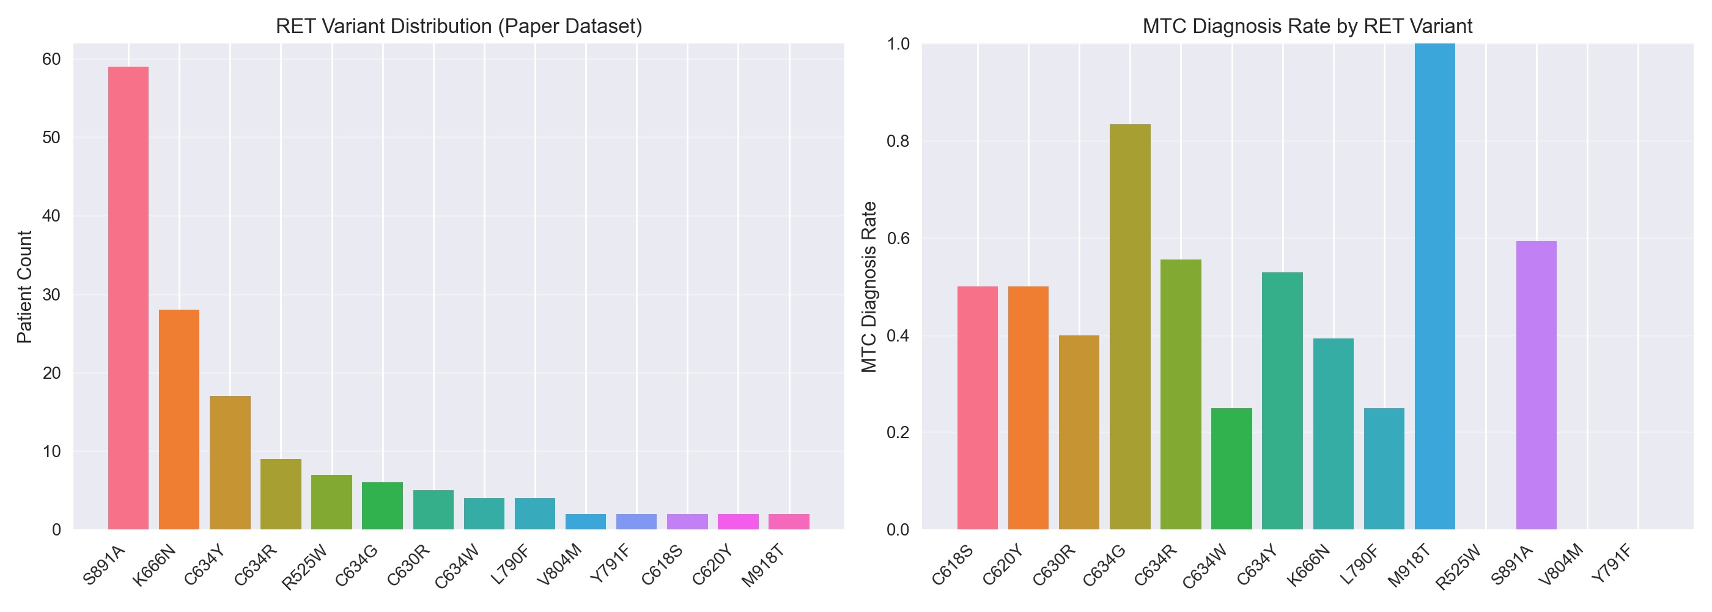
Figure 1. RET variant distribution and MTC diagnosis rate in the literature-derived MEN2/RET-carrier cohort. Left: the number of curated carrier records for each RET variant represented in the 149-record dataset. Right: the proportion of records with a medullary thyroid carcinoma (MTC) diagnosis for each RET variant.
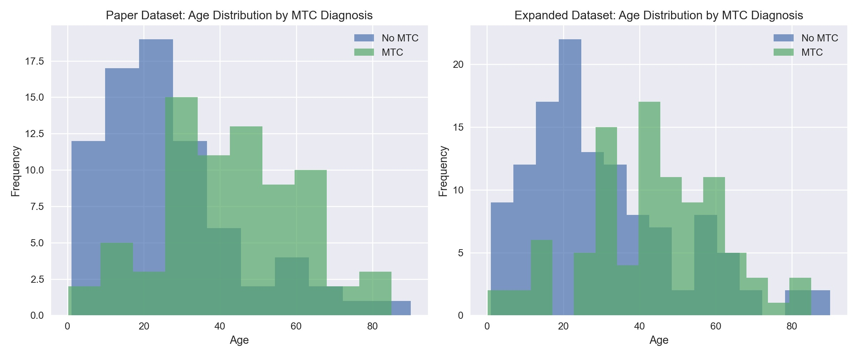
Figure 2. Age distribution of RET carriers in the literature-derived cohort. The histogram shows the age spread of the curated records used for internal model benchmarking.
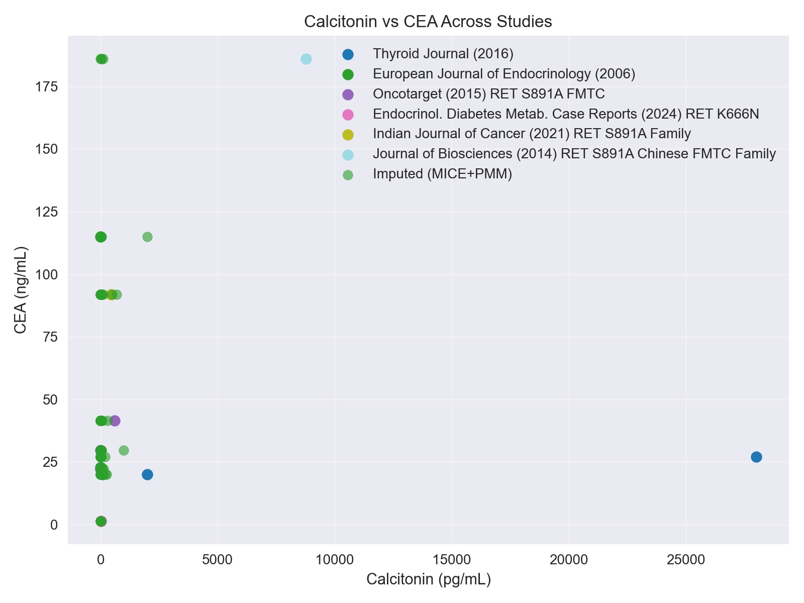
Figure 3. Observed calcitonin-CEA relationship in records with paired biomarker values. Only 12 paired observations were available, so CEA analyses were treated as exploratory.
TABLES WITH TITLES/CAPTIONS
Characteristic | Overall (n=149) | MTC present (n=73) | MTC absent (n=76)
Age, mean years | 34.27 | 43.30 | 25.59
Age, median years | 31.5 | 43.0 | 20.0
Age range, years | 0.17-90.0 | 0.17-85.0 | 1.0-90.0
Female sex, n (%) | 99 (66.4) | 46 (63.0) | 53 (69.7)
Male sex, n (%) | 50 (33.6) | 27 (37.0) | 23 (30.3)
Unique RET variants, n | 14 | 11 | 13
Calcitonin elevated, n (%) | 58 (38.9) | 47 (64.4) | 11 (14.5)
CEA missing (imputed within training folds), n (%) | 137 (91.9) | 65 (89.0) | 72 (94.7)
Thyroid nodules present, n (%) | 10 (6.7) | 8 (11.0) | 2 (2.6)
Family history of MTC, n (%) | 105 (70.5) | 53 (72.6) | 52 (68.4)
Pheochromocytoma, n (%) | 9 (6.0) | 9 (12.3) | 0 (0.0)
Hyperparathyroidism, n (%) | 5 (3.4) | 4 (5.5) | 1 (1.3)
Table 1. Baseline characteristics of the literature-derived cohort stratified by MTC status.
Study | Source | Main variant context | n | DOI
1 | Xu et al., 2016 (3) | RET K666N families | 24 | https://doi.org/10.1089/thy.2016.0374
2 | Frank-Raue et al., 2006 (2) | Multiple RET variants after thyroidectomy | 46 | https://doi.org/10.1530/eje.1.02216
3 | Qi et al., 2015 (5) | RET S891A/R525W familial MTC | 15 | https://doi.org/10.18632/oncotarget.4992
4 | Florescu et al., 2024 (8) | RET C634G kindred | 6 | https://doi.org/10.3390/clinpract14060179
5 | La Greca et al., 2024 (9) | RET K666N family | 4 | https://doi.org/10.1530/EDM-24-0009
6 | Vijayan et al., 2021 (7) | Indian RET S891A pedigree | 7 | https://doi.org/10.4103/ijc.IJC_639_19
7 | Zhang et al., 2024 (10) | RET C634Y family | 3 | https://doi.org/10.12998/wjcc.v12.i15.2627
8 | Shankar et al., 2012 (11) | Familial MEN2B infant | 2 | https://doi.org/10.1186/1687-9856-2012-25
9 | Schulte et al., 2010 (4) | RET S891A multicenter cohort | 36 | https://doi.org/10.1210/jc.2010-0375
10 | Qi et al., 2014 (6) | Chinese Han RET S891A family | 6 | https://doi.org/10.1007/s12038-014-9428-x
Table 2. Published sources used to construct the literature-derived cohort.
Variable group | Variables
Demographic | Age, sex, age group, age squared
Genotype-aware | RET variant one-hot encodings, ATA-aligned risk level, risk-age and risk-calcitonin interactions
Biomarker | Calcitonin elevated flag, numeric calcitonin, CEA numeric value, CEA missingness/imputation flag
Clinical presentation | Thyroid nodule indicators, family history of MTC, pheochromocytoma, hyperparathyroidism
Outcome | Binary MTC status extracted from source reports
Table 3. Key variable groups used in the benchmark.
Field | Observed or nonzero | Total | Note
Age | 149 | 149 | Missing ages were filled from source-level medians where required.
Sex | 149 | 149 | Unknown values were mode-filled for modeling.
RET variant | 149 | 149 | Required for genotype-aware inclusion.
Calcitonin numeric value | 77 | 149 | Zero includes unavailable, normal, or undetectable values after harmonization.
CEA observed | 12 | 149 | Observed CEA values; imputation was fit on training folds only.
CEA missing (imputed within training folds) | 137 | 149 | Missingness flag retained in the model dataset.
Table 4. Selected missingness and harmonization summary in the 149-record literature-derived cohort.
Model | Dataset | Accuracy | Sensitivity | F1 score | ROC-AUC
Logistic regression | Original (149) | 76.7% | 93.3% | 0.80 | 0.82
Random forest | Original (149) | 73.3% | 66.7% | 0.71 | 0.90
XGBoost | Original (149) | 83.3% | 93.3% | 0.85 | 0.91
LightGBM | Original (149) | 80.0% | 73.3% | 0.79 | 0.89
Linear SVM | Original (149) | 50.0% | 73.3% | 0.59 | 0.72
Logistic regression | Synthetic | 73.8% | 96.1% | 0.64 | 0.94
Random forest | Synthetic | 92.9% | 84.3% | 0.85 | 0.96
XGBoost | Synthetic | 88.1% | 90.2% | 0.79 | 0.97
LightGBM | Synthetic | 93.3% | 86.3% | 0.86 | 0.98
Linear SVM | Synthetic | 83.8% | 68.6% | 0.67 | 0.77
Table 5. Model comparison across the five algorithms under the default full-feature configuration, on the internal held-out split of both datasets. Sensitivity is the positive-class recall. Metrics are from the standard evaluation harness applied uniformly to every model.
Analysis | Model | Confusion matrix | Sensitivity | Specificity | ROC-AUC | Accuracy
Genotype-aware | XGBoost | TN=11, FP=4, FN=1, TP=14 | 93.3% (14/15; 70.2%-98.8%) | 73.3% (11/15; 48.0%-89.1%) | 0.929 | 83.3% (25/30; 66.4%-92.7%)
Genotype-blind | XGBoost | TN=8, FP=7, FN=1, TP=14 | 93.3% (14/15; 70.2%-98.8%) | 53.3% (8/15; 30.1%-75.2%) | 0.902 | 73.3% (22/30; 55.6%-85.8%)
No CEA | XGBoost | TN=12, FP=3, FN=0, TP=15 | 100.0% (15/15; 79.6%-100.0%) | 80.0% (12/15; 54.8%-93.0%) | 0.938 | 90.0% (27/30; 74.4%-96.5%)
No biomarkers | XGBoost | TN=12, FP=3, FN=0, TP=15 | 100.0% (15/15; 79.6%-100.0%) | 80.0% (12/15; 54.8%-93.0%) | 0.929 | 90.0% (27/30; 74.4%-96.5%)
Synthetic | LightGBM | TN=152, FP=7, FN=7, TP=44 | 86.3% (44/51; 74.3%-93.2%) | 95.6% (152/159; 91.2%-97.9%) | 0.981 | 93.3% (196/210; 89.1%-96.0%)
Table 6. Internal held-out performance with raw counts, Wilson 95% confidence intervals, specificity, and ROC-AUC. Sensitivity, specificity, and accuracy are shown as point% (count/total; Wilson interval); ROC-AUC is computed from model probability scores.
Analysis | Model | Confusion matrix | Sensitivity | Specificity | ROC-AUC | Accuracy
Genotype-blind | XGBoost | TN=44, FP=32, FN=9, TP=64 | 87.7% (64/73; 78.2%-93.4%) | 57.9% (44/76; 46.7%-68.4%) | 0.780 | 72.5% (108/149; 64.8%-79.0%)
Genotype-aware | XGBoost | TN=37, FP=39, FN=13, TP=60 | 82.2% (60/73; 71.9%-89.3%) | 48.7% (37/76; 37.8%-59.7%) | 0.725 | 65.1% (97/149; 57.2%-72.3%)
Table 7. Leave-one-study-out grouped validation on the 149-record cohort (pooled out-of-fold predictions), keyed on study_id. Preprocessing was fit on training folds only.

