Autonomous General-Purpose Model

A Project Report
Submitted by

Arkin Jain (E031)

Shrey Jyala (E035)

Arjun Deshmukh (E075)

Rohan Subramaniam (E080)

Under the Guidance of

Dr. Deepti Reddy

in partial fulfillment for the award of the
degree of

BACHELOR OF TECHNOLOGY

COMPUTER SCIENCE AND BUSINESS SYSTEMS

At

MUKESH PATEL SCHOOL OF TECHNOLOGY MANAGEMENT AND ENGINEERING

SEPTEMBER 2023
Specimen D

Table of contents

CHAPTER NO. TITLE PAGE NO.
- INTRODUCTION 1
- SCOPE 2
- PROBLEM STATEMENT 3
- OBJECTIVES 4
- PERSONA & SCENARIO 5
- USER REQUIREMENTS 9
- EMPATHY MAP 10
- DESIGNING 12
- TASK FLOW 17
- HEURISTIC EVALUATION 18
- COMPETITIVE ANALYSIS 26
- CONCLUSION AND FUTURE RESEARCH 27

Introduction

Large language models (LLMs) have been shown to be capable of impressive few-shot generalization to new tasks. However, they still tend to perform poorly on multi-step logical reasoning problems. Here we carry out a comprehensive evaluation of LLMs on 50 tasks that probe different aspects of logical reasoning. We show that language models tend to perform fairly well at single step inference or entailment tasks, but struggle to chain together multiple reasoning steps to solve more complex problems.

The rise of artificial intelligence (AI) is revolutionizing the way we work. AI-powered tools are now available to help us with a variety of tasks, from customer service to data analysis.
One area where AI is having a major impact is in document creation and editing. AI-powered document editors can help us to create more accurate and professional documents, faster than ever before.
Our Generalized AI model will pull models on demand for the required task prompted by the User.

Scope

The scope of our Autonomous project is extensive, covering the following aspects:
- Login and Registration: Users will need an account to access the website. They can either create an account or login directly with a pre-existing account. To register they will need to use their number or email on which an OTP will be sent for verification purposes.

- Managing customer database: Keep track of registered and logged in users. Every time a user creates an account or logs in, it is registered in the database.

- Subscription: After Users sign into their accounts, they will be required to buy a $7.99 Subscription. General access to our model, even during peak times, Faster response times,
Priority access to new features and improvements Auto GPM is available to customers in India and around the world.

- Payment Gateway: Users will be redirected to a Payment Gateway where using their preferred payment method can complete the transaction.

- Task and Track Log: This allows users to finally use our model, ask it questions, give their inputs and tracks their history.

- Logout: Users at the end of their session have a logout option to maintain maximum secrecy of their search history.

- Content & Data: Data Extraction and Processing: This would include tasks related to extracting and processing data from documents, such as summarizing the key points or identifying trends. Translation: This includes tasks related to translating documents from one language to another. Proofreading: This would include tasks related to proofreading documents for errors. Content Generation: This would include tasks related to generating different kinds of content, such as summaries, outlines, and pitches.

Problem Statement

The problem statement for our Autonomous General Purpose project is –

" The creation and editing of documents is a time-consuming and error-prone task. It requires a lot of attention to detail and accuracy. Even a small mistake can have a big impact on the overall quality of the document or data searched."

This statement highlights the core challenge that the project aims to address. In the vast landscape of making an AI model, users often face difficulties in navigating through numerous tasks and finding items that align with their specific needs of the user. Our project seeks to overcome this challenge by implementing intelligent algorithms and personalized recommendations that assist users in discovering suitable answers.

- Natural Language Understanding: The system should possess robust natural language processing capabilities to understand and interpret user-generated questions effectively, considering language nuances, context, and user intent.
- Document Analysis: The AI model should be equipped to read and analyse textual documents, extracting relevant information and insights from a variety of document formats to answer user questions accurately.
- User Interface and Interaction: It should provide a user-friendly interface, such as a chatbot or web application, allowing users to submit questions, receive responses, and interact with the system seamlessly.
- Continuous Learning and Adaptation: The system should continuously learn from user interactions, adapt to evolving data sources, and improve its performance over time, ensuring up-to-date and accurate responses.
- Security and Privacy: To protect user data and adhere to privacy regulations, robust security measures should be implemented, and mechanisms for securing sensitive information should be in place. These five points are crucial for the successful development of an AI QA system, ensuring both user satisfaction and data integrity.

Objectives

The objectives of our Autonomous General Model project are as follows:
- Task Coordination: Develop a system with a main Language Model (LLM) as a controller, collaborating with PDF, Excel, and Word agents to execute user prompts.

- Natural Language Understanding: Enhance LLM's language understanding for interpreting user instructions and generating task directives for specialized agents.

- Recursion and Coordination: Enable recursive querying between LLM and agents for complex document creation, structuring, and error handling.

- Security and Scalability: Implement robust security measures for data protection, privacy, and scalability to accommodate growing demand.

- User Interface and Feedback: Create a user-friendly interface for prompt input, task tracking, and user feedback, facilitating continuous system improvement.

- Testing and Reliability: Conduct comprehensive testing to ensure system reliability, accuracy, and robustness in agent functions and collaborative interactions.

By achieving these objectives, our project aims to create a comprehensive AI model that meets the needs and preferences of users, enhancing their experience and driving customer satisfaction. The project will adhere to the User-Centered Design (UCD) framework, ensuring that our Model is intuitive, user-friendly, and aligned with user expectations.

Real-world UseCase

Scenario 1:
Gabriel starts her day by researching potential international markets for her crafts. Using the AI-driven system, she enters prompts like, "Analyze consumer preferences for handmade crafts in Germany." The system employs natural language processing to gather and analyze market data, providing her with valuable insights and identifying trends in her target market.

Gabriel decides to list her crafts on a popular e-commerce platform in Germany. She inputs prompts such as, "Translate product descriptions and titles to German" into the system. The system engages the language translation agent, which swiftly translates her product listings into German, ensuring her offerings are accessible to German-speaking customers.

Recognizing the importance of localized marketing content, Gabriel inputs prompts like, "Create a marketing campaign tailored to French-speaking customers." The AI system guides her in crafting compelling marketing materials, ensuring her message resonates with her target audience.

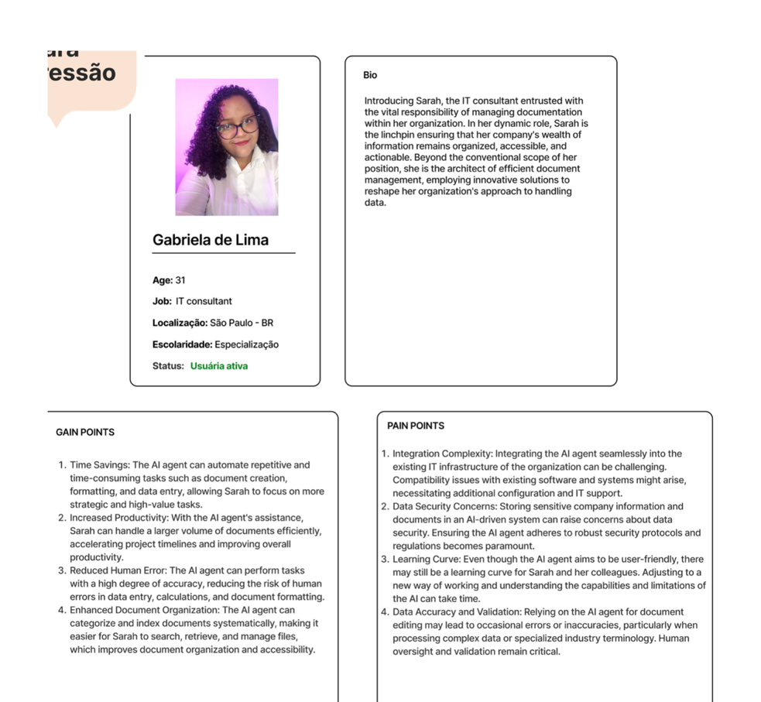
Scenario 2:
Research Assistance: Sarah needs to prepare for an upcoming marketing presentation. She uses AGPM to quickly gather statistics and industry insights related to her topic.
Content Ideas: She's stuck on brainstorming ideas for a new social media campaign. Sarah interacts with AGPM to get creative suggestions and refine her campaign concept.
Data Analysis: Sarah has received the latest performance data for a recent marketing campaign but needs to identify trends and areas for improvement. AGPM helps her analyse the data and generate recommendations.
.

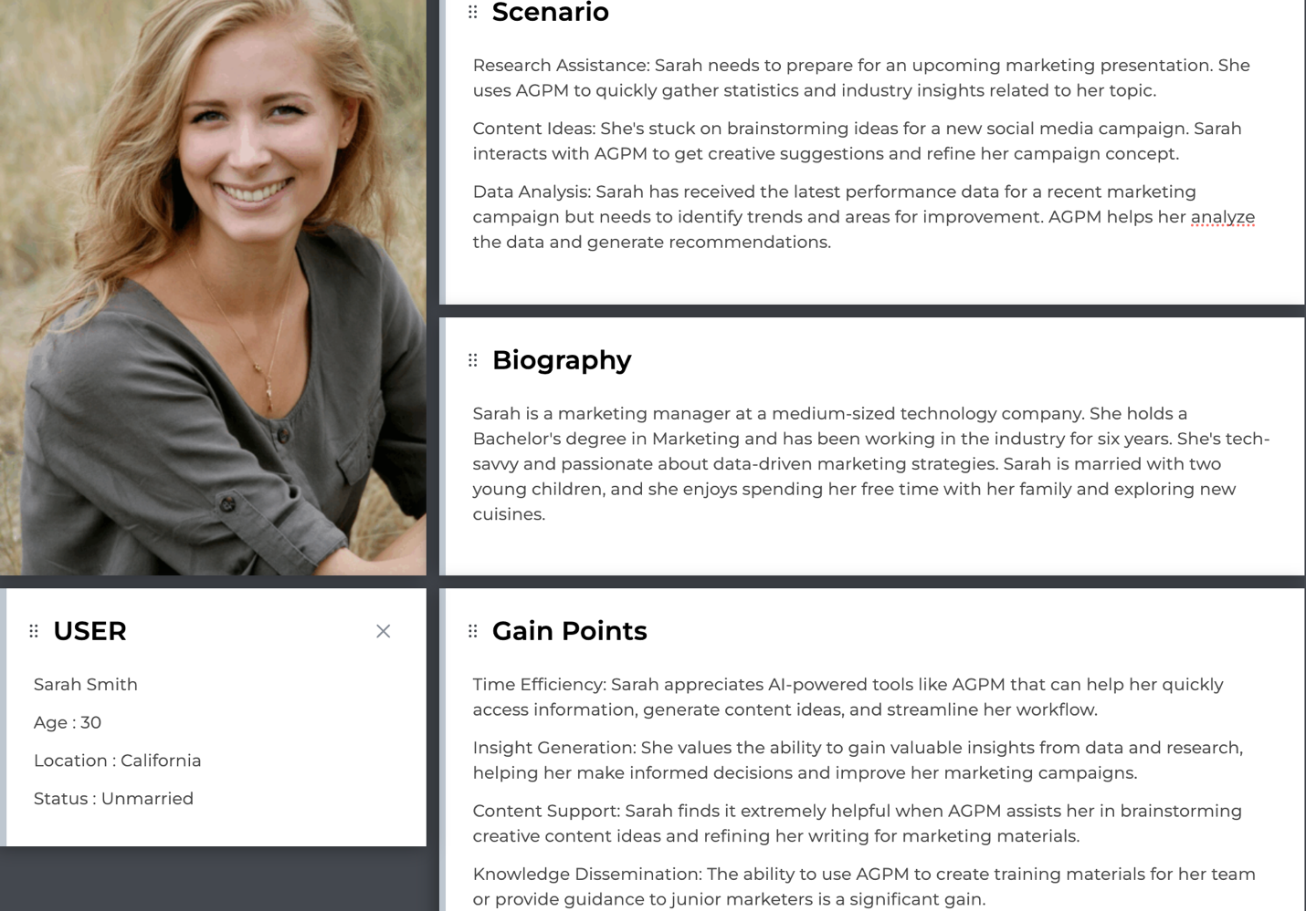

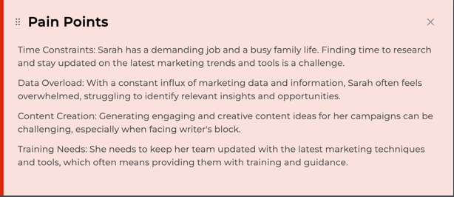

User Requirements

Methods of collecting information about user sentiment:
- User interviews: We conducted a one-on-one discussion and interview with our peers/colleagues, younger and elder siblings and our parents – 3 generations to understand user concerns with respect to varied demographics (Age)
- Along with user interviews (Semi-structured), we brainstormed with our teammates to identify the gaps between the existing and desired AI Chatbot websites. We brainstormed about the requirements of users and how to incorporate it into our own website.

Based on our research and information gained by interacting with varied group of potential users, we have decided on the following user requirements:
- User-Friendly UI Design:
The platform should feature a user-friendly and visually appealing user interface (UI) design, making it easy for users to navigate, browse products, and complete transactions without confusion.

2. Natural Language Understanding:
Users expect the system to possess advanced natural language processing capabilities. This means the system should not only understand the words in a question but also the context, intent, and nuances of the user's query. It should comprehend different languages and dialects and be capable of understanding colloquial language, jargon, and slang.

3. Accuracy:
Accuracy is paramount for users. They rely on the system to provide correct and reliable answers to their questions. This requirement entails that the system should strive for a high level of precision in its responses, minimizing errors, misinformation, or misinterpretation of questions.

4. Speed and Responsiveness:
Users expect timely responses. The system should be designed to minimize latency and provide answers quickly. This involves efficient processing of user queries, document analysis, and response generation to ensure users do not experience unnecessary delays.

5. Contextual Understanding:
Users want the system to maintain context during a conversation. This requirement means that the system should recognize and reference previous questions and answers in a conversation, ensuring that responses remain contextually relevant. This is crucial for natural and efficient interactions.

6. Security and Privacy:
Users are concerned about the security and privacy of their data and interactions. The system should employ robust security measures to protect user data and ensure compliance with data privacy regulations. Users expect their personal information to be safeguarded from unauthorized access or breaches.

7. Scalability:
The system should be able to handle a growing user base and increasing volumes of questions and documents. Scalability ensures that the system remains responsive and effective as more users engage with it. It should be capable of accommodating a diverse set of use cases without experiencing a significant drop in performance.
These user requirements are essential to meet user expectations and ensure the effectiveness and usability of the AI-powered Question-Answering system. Addressing these requirements contributes to a positive user experience and builds trust in the system's capabilities.

Quantitative Research
Survey
What is your age group?  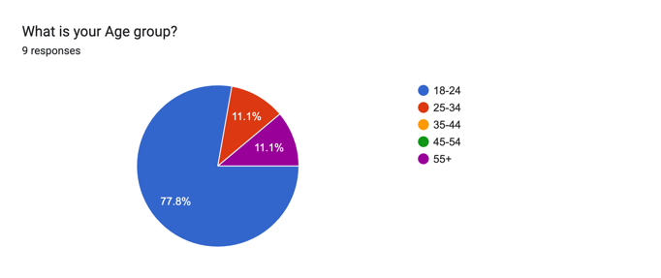 | What is your gender?  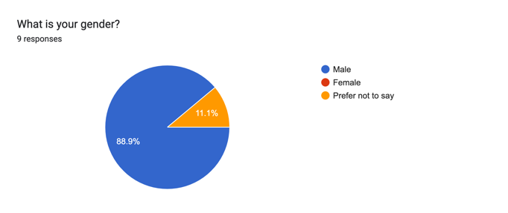
What is your occupation? 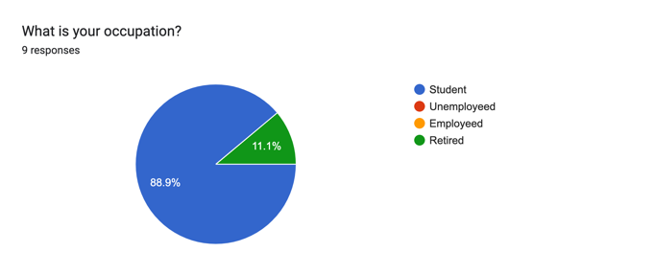 | Where in India are you located?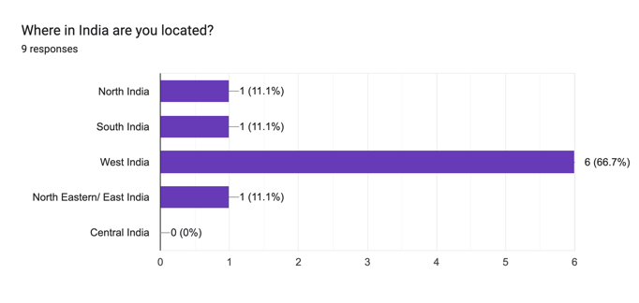
What’s you Highest Level of Education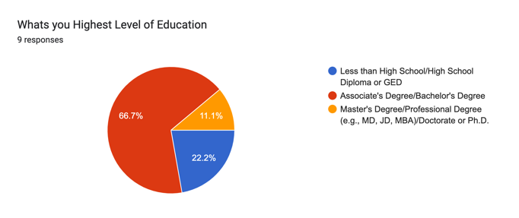 | How often do you use our website to search for Information?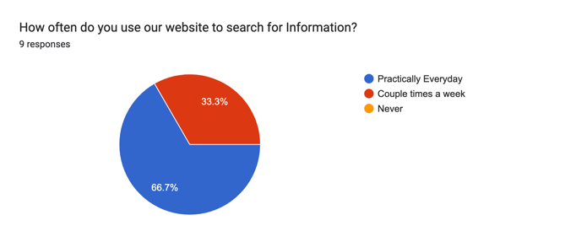
On a scale from 1 to 5, how satisfied are you with our product? - (1 - Very Dissatisfied, 5 - Very Satisfied)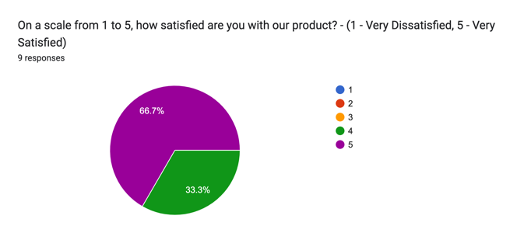 | What types of tasks or questions do you typically use our product for? (Select all that apply)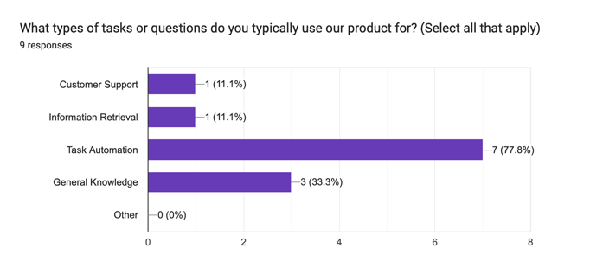
Have you ever customized or personalized our products responses to better suit your needs or preferences?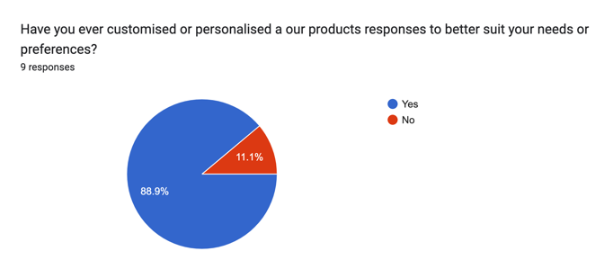 | 
Please rate your agreement with the statement: "I found this survey to be useful."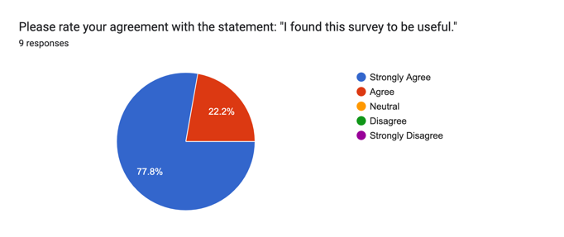 | Thank you for your response! Do you have any additional comments or suggestions about this survey?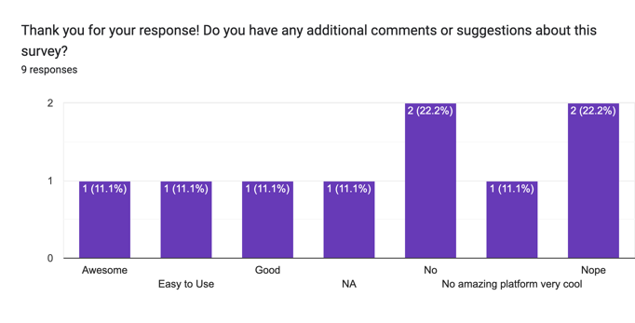

Empathy Map

- Empathy Map for Jay (Scenario 1)

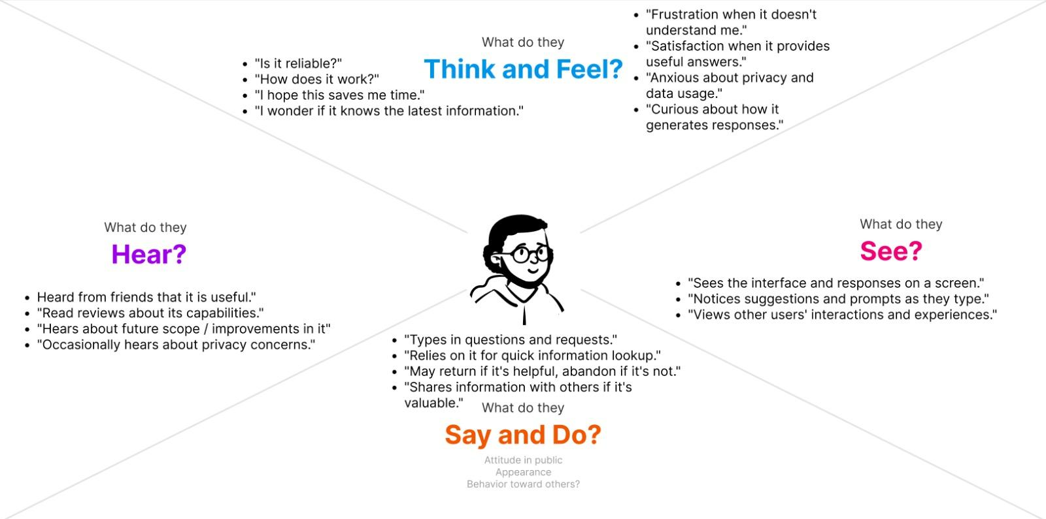

- Empathy Map for Param (Scenario 2)

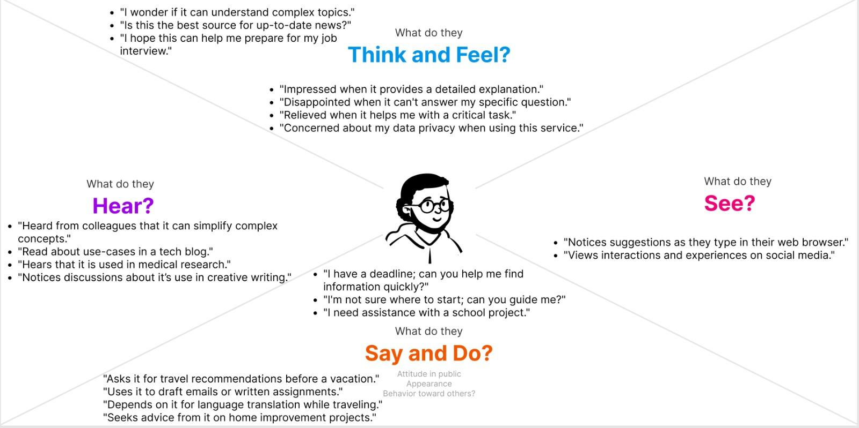

Designing
Low Fidelity Models:

LF Model of Home/Login Page.


LF Model of Subscription Page.

LF Model of Payment Page.


LF Model of Home Page.

High Fidelity Model:

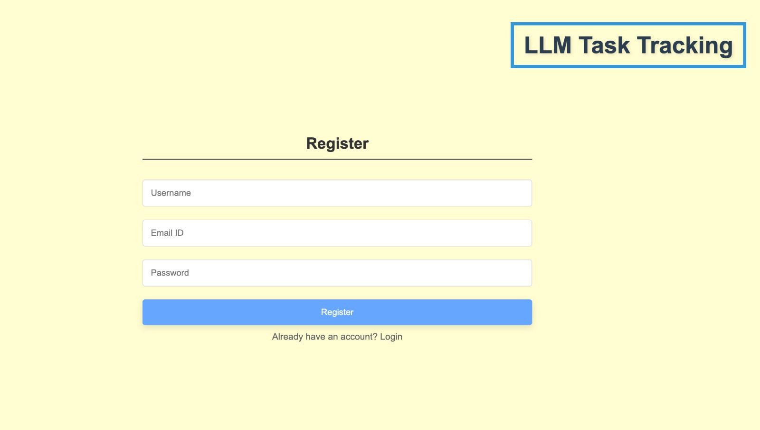

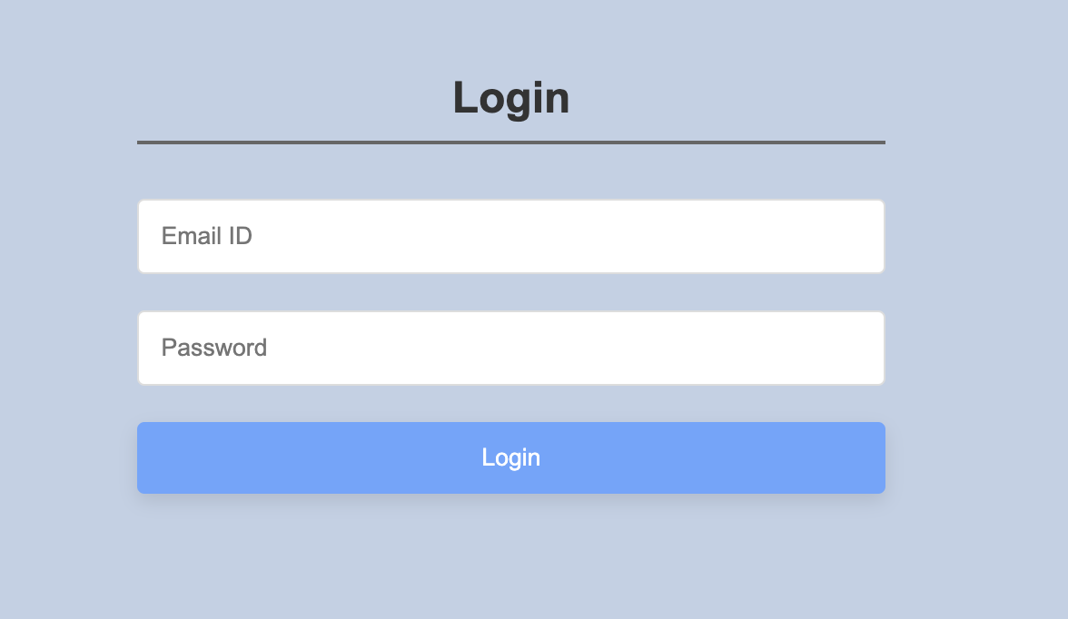
HF Model of Home/Login Page.

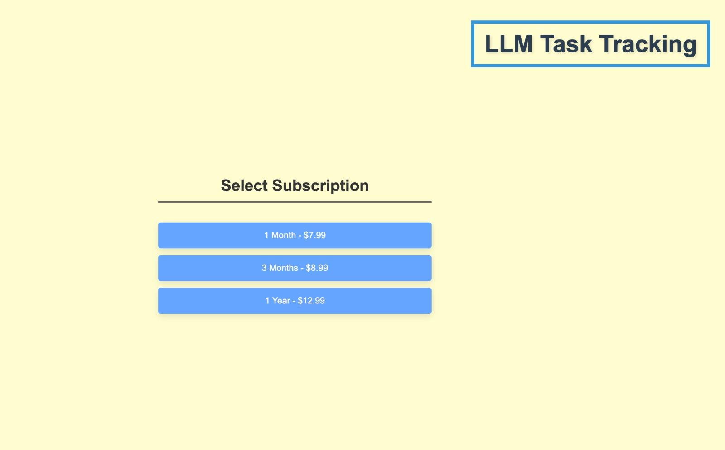
HF Model of Subscription Page.
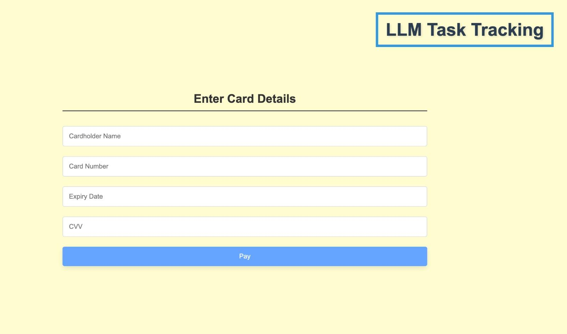
HF Model of Payment Page.

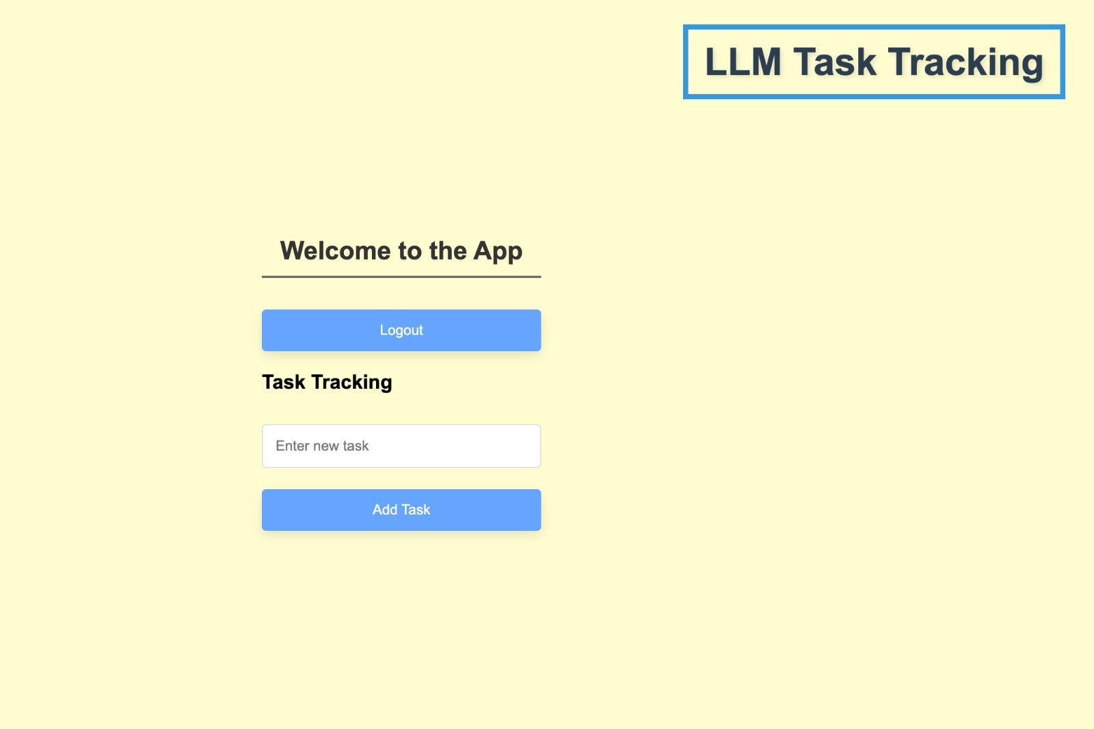
HF Model of Home Page.

Task Flow
Task Flow Diagram showing the flow of a user once they log on to our website, right from User Login to Checkout.

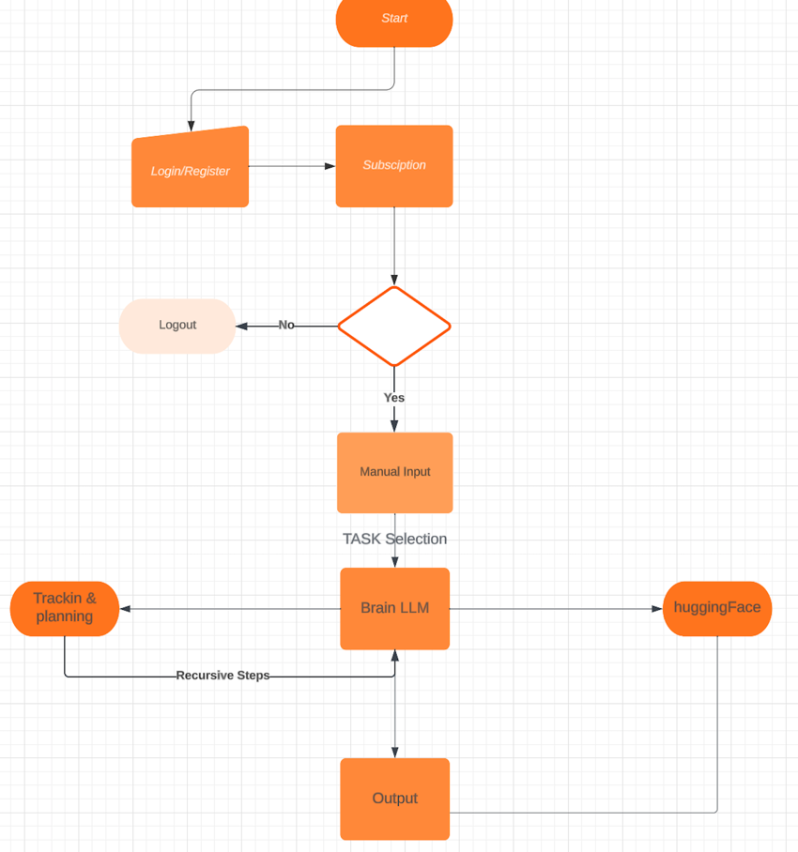

Heuristic Evaluation

Heuristic Principles | Followed?
Visibility of System Status | Yes
Match between the System and Real World | Yes
User Control and Freedom | Yes
Consistency and Standards | Yes
Error Prevention | -
Recognition rather than Recall | Yes
Flexibility and Efficiency of Use | Yes
Aesthetic and Minimalist Design | Yes
Help Users with Errors | -
Help and Documentation | -

- Visibility of System Status



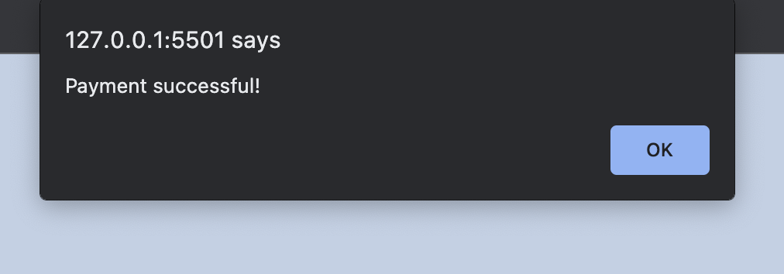
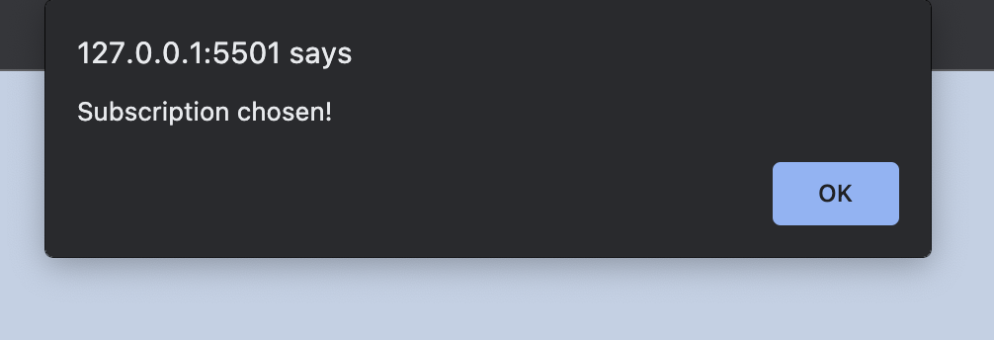
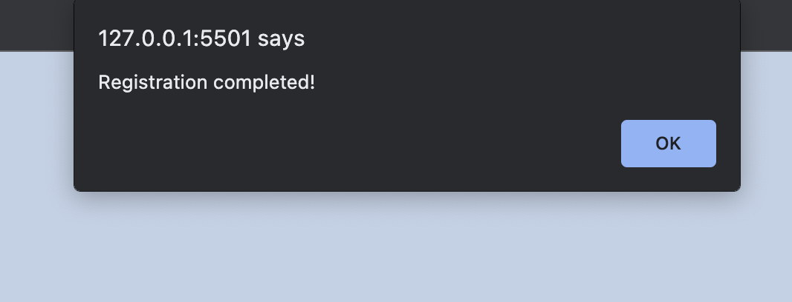

- Match between the System and the Real World
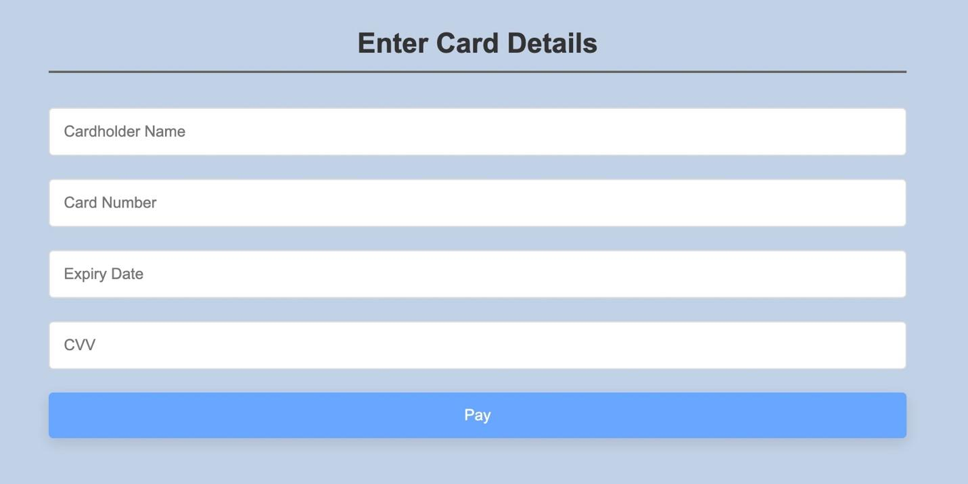
- User Control and Freedom




- Consistency and Standards
Website is following a similar pattern and color throughout.

- Error Prevention
-
- Recognition rather than Recall



- Flexibility and Efficiency of Use




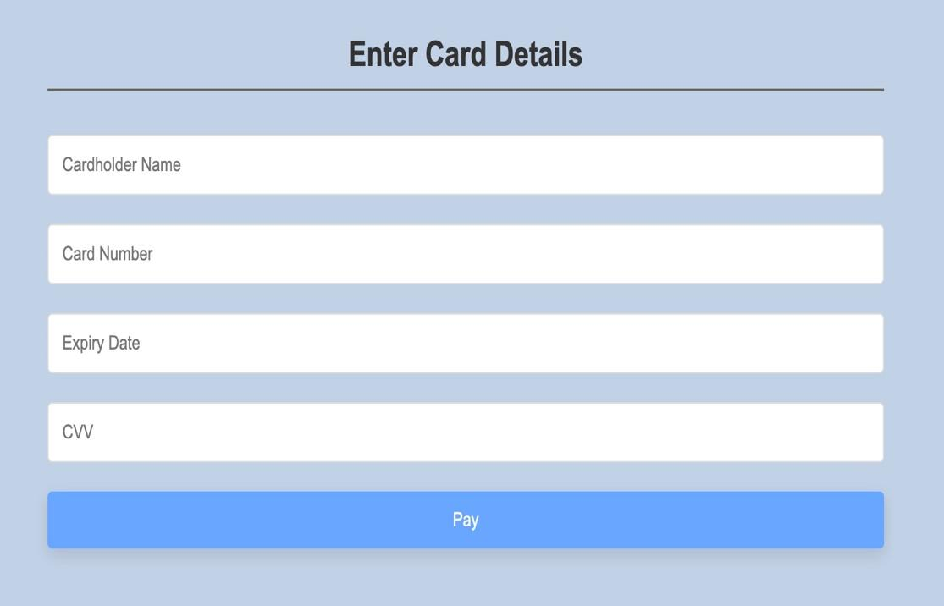


Users are redirected to the login page when they click on the logout button.

- Aesthetic and Minimalist Design

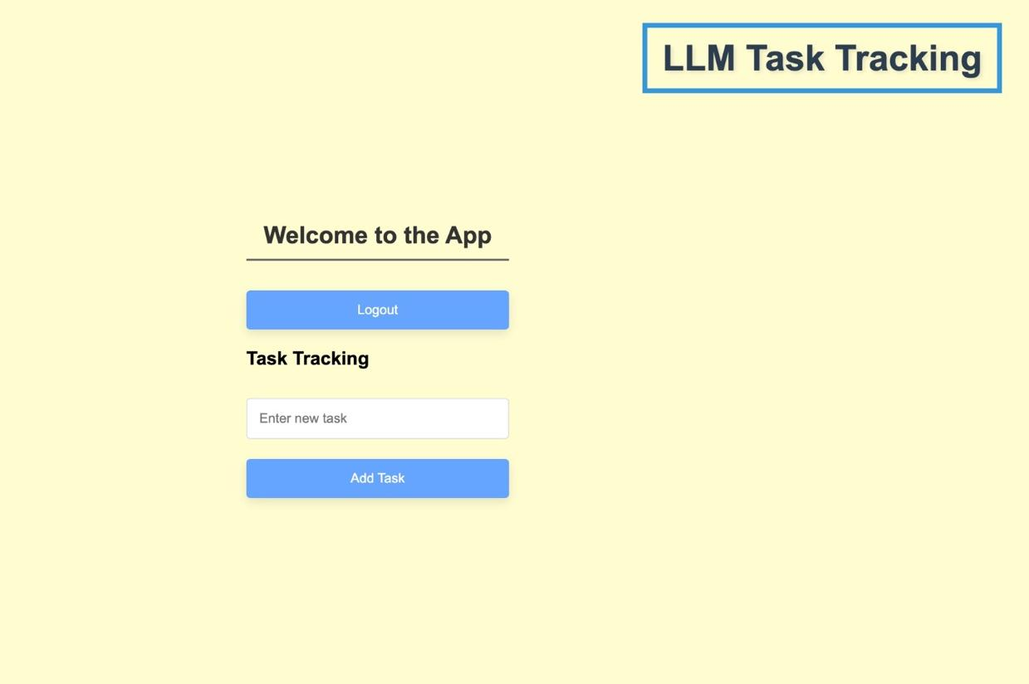

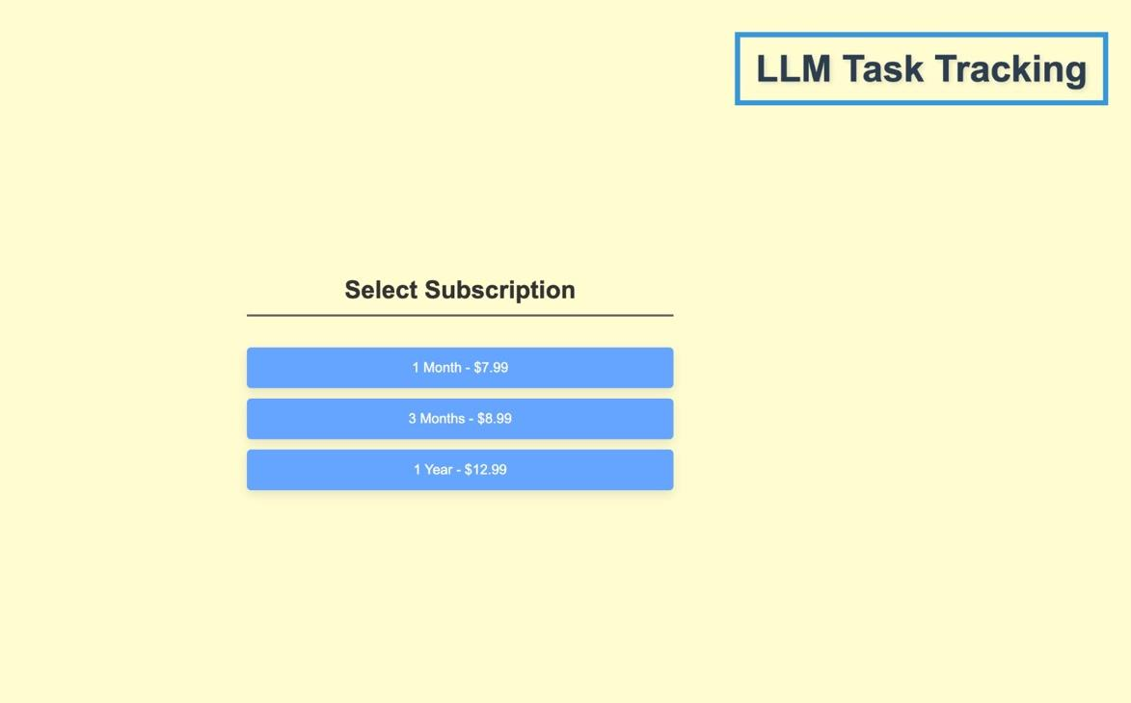

Competitor analysis

Parameters | Chat-GPT | Google Bert | Autonomous General Purpose Model
Model | Autoregressive | Discriminative | Cumulative
Objective | Generates human-like text | Recognizes sentiment | Serves On Demand Models
Architecture | Unidirectional: it processes text in one direction | Bidirectional: it processes text in both using a decoder directions using an encoder | Unidirectional: it processes text in one direction
Size | Size 175 billion parameters | 340 million parameters | Variable on Model Size
Training Data | Training data It is trained on language modelling by using  hundreds of billions of words | No Difference | No training
Pre-Training | Pre-training Unsupervised pre-training on a large data | Unsupervised pre-training on a large corpus of text | No Pretraining
Fine Turning | Does not require but can be fine-tuned  for specific tasks | Requires fine-tuning for specific tasks | Opinions Algorithm + Selection Inferencing for fast tracked finetuning.
Use Cases | Coding  ML code generation  Chatbots  virtual assistants  Creative storytelling  Language translation | Sentiment Analysis  Text classification  Question answering  Machine translation | Chatbots  NPC dialogue  Personal Assistant  Task Coordinator & Validator
Accuracy | Based on the SuperGLUE benchmark, 86.9% | Based on the GLUE benchmark, 80.5% | To be Tested

The above table shows how our Autonomous General Purpose Model fairs with competitors like ChatGPT and Google’s Bard.

Conclusion and Future Scope

Conclusion:
The development of an Autonomous General-Purpose Model is a complex and multifaceted task that requires a combination of natural language understanding, document analysis, and user-centric design. User requirements play a pivotal role in shaping the system's functionality and usability
Future Scope:
- Advanced Natural Language Processing: Future iterations can employ more advanced NLP models to improve the system's understanding of user queries, enabling it to handle a broader range of languages and complex language constructs.
- Enhanced Document Analysis: Future development can expand document analysis capabilities to process diverse document formats, including images, PDFs, and multimedia content.
- Improved Contextual Understanding: The system can evolve to maintain more sophisticated conversation history and context, enabling more coherent and context-aware responses.
- Enhanced Security and Privacy: Strengthening security measures and compliance with data privacy regulations will be crucial to ensure user trust and data protection.
- Machine Learning and Continuous Learning: Implementing machine learning techniques will enable the system to learn and adapt from user interactions, providing more accurate and personalized responses over time.
- Scalability and Performance: Future enhancements should focus on optimizing system performance, enabling it to handle large user bases and varying workloads efficiently.
- Multi-Modal Capabilities: Expanding the system's support for text, images, charts, and other forms of content within documents will make it more versatile and useful.
- Customization and User Feedback: Providing users with the ability to customize the system's behaviour and incorporating robust feedback mechanisms will enhance the user experience and assist in continuous improvement.

The future of an Autonomous General Purpose Model systems holds great potential in a wide range of domains, including education, healthcare, customer support, and research. It will depend on ongoing research, technological advancements, and user feedback to realize these possibilities and continuously enhance the user experience.

