FORM DESCRIPTION

AND

DATA VALIDATION

LOGIN

This form checks the username and password and directs the user to their respective home pages.

The input fields are type sensitive.

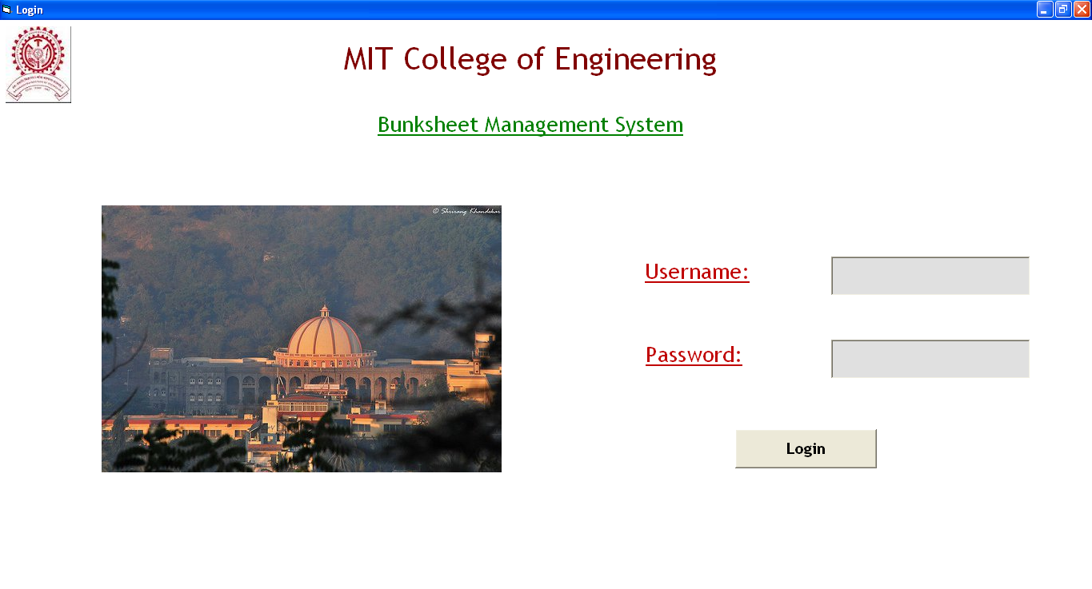

DATA VALIDATION:

* Checks whether the user has entered data in text boxes.

CENTRAL ADMINISTRATOR

This form is displayed when the central administrator logs in. It gives the central administrator various options and the next form is displayed according to his selection.

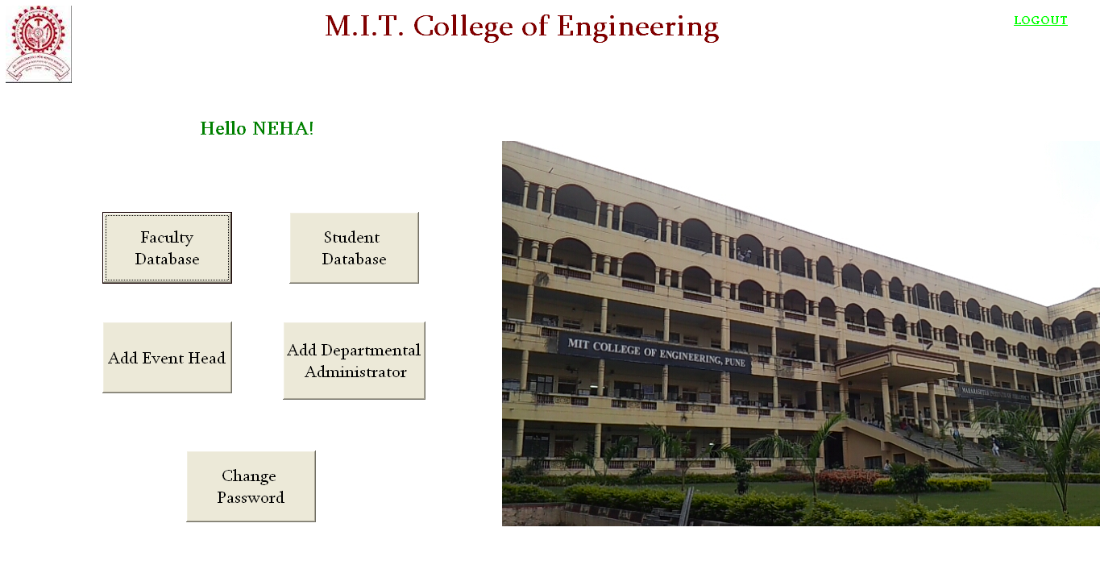

CLASS-DIVISION

It comes under the field of scope of central administrator. The user selects the department, class and division of the student whose information is to be entered and the starting characters of roll number are decided accordingly.

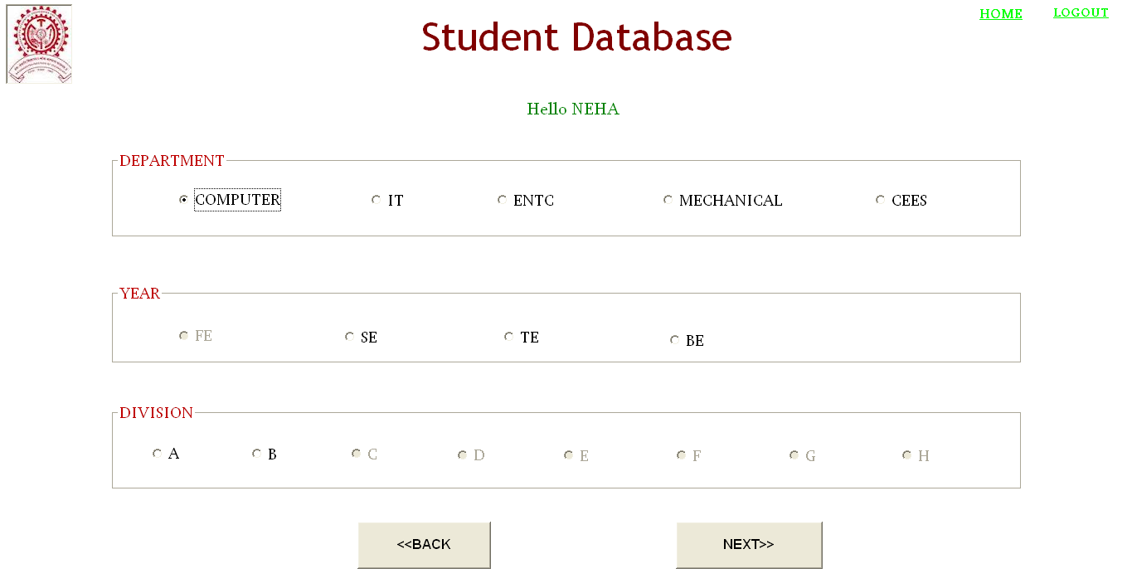

DATA VALIDATION:

* The option buttons for class and division are enabled/disabled according to the selection of department (with CEES as department, FE as class and all the 8 divisions are enabled while for the other departments, SE,TE,BE are enabled with A and B division only).

STUDENT DATABASE

This form comes under the field of work of central administrator. This form is used to input student information and store it in the database. It displays the entered information in data grid. It also provides the user with the facility of deleting or editing the student entry from data grid.

The roll no of the student is generated automatically in the ascending order of their last names. In case of late entry i.e. after the attendance or bunksheet of any student from the class has been added, the student is assigned with the last roll no.

The department and class of student are retrieved from the previous form and displayed.

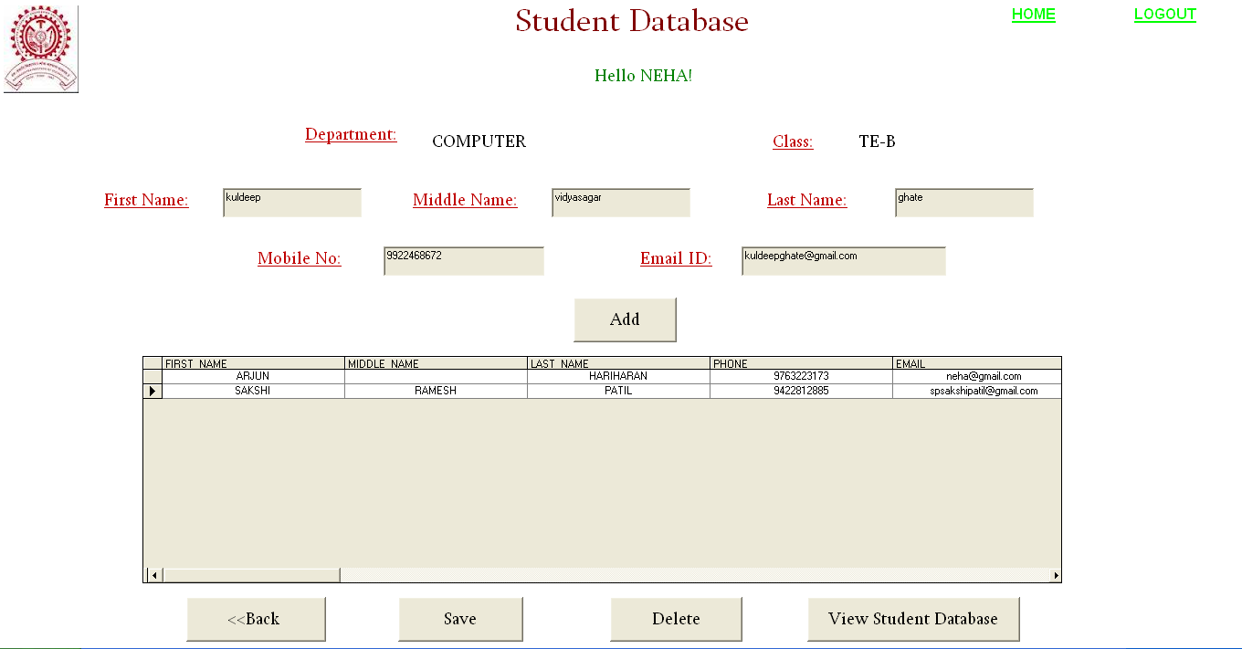

DATA VALIDATION:

* It is mandatory for the user to enter first name, last name, phone number, email id. Input fields are case insensitive.
* The validity of mobile number is ensured by checking the no of digits and for numeric type only.
* When a student entry is deleted all the related entries like bunksheet, attendance are deleted.

VIEW STUDENT INFORMATION

It displays the list of student from the class selected in the previous form with their details and roll no.

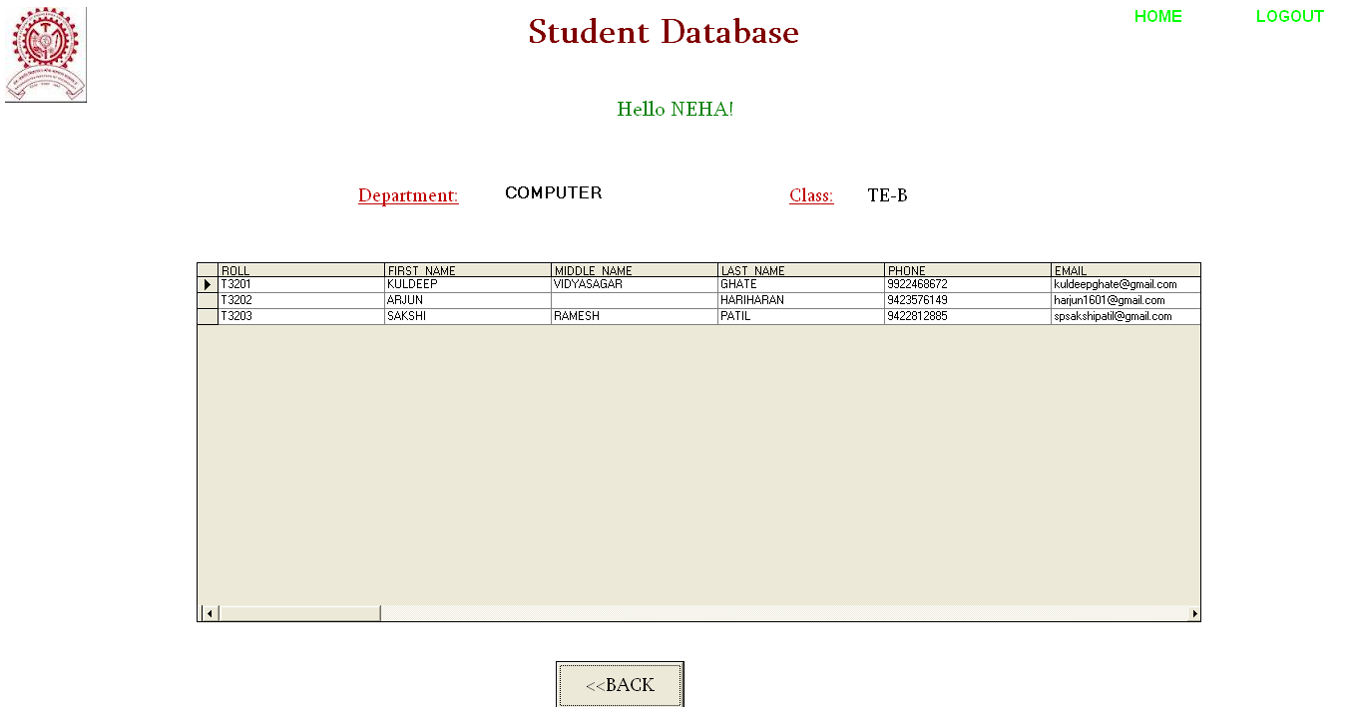

DATA VALIDATION:

* The user cannot edit the student information in this form.

FACULTY DEPARTMENT

The central administrator selects a department and following this form, the details of the faculty from that department is entered.

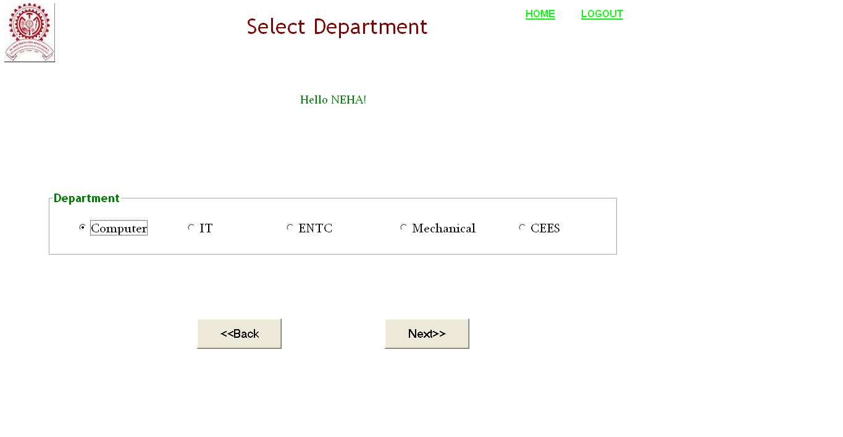FACULTY DATABASE

This form comes under the field of work of central administrator. The user can input faculty information. It displays the entered information in data grid. It also provides the user the facility of deleting or editing the student entry from data grid. The input fields are case insensitive. The department and class of student are retrieved from the previous form and displayed.

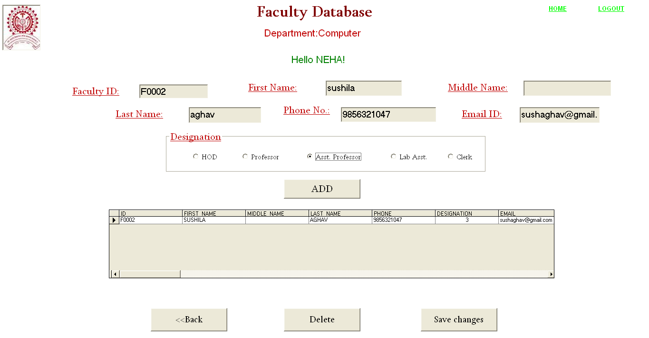

DATA VALIDATION:

* It is mandatory for the user to enter first name, last name, phone number, email id
* The mobile no is checked for 10 digits of numeric type only.
* With the deletion of a record, the account if deleted and in case of event head, a null value is substituted in the faculty in charge column of bunksheet table.

ASSIGNING FACULTY AS DEPARTMENT/EVENT ADMINISTRATOR

This form comes under the field of work of central administrator. It allows the user to assign existing faculty as department/event administrator. The user can search the faculty by either of department, first name or last name.

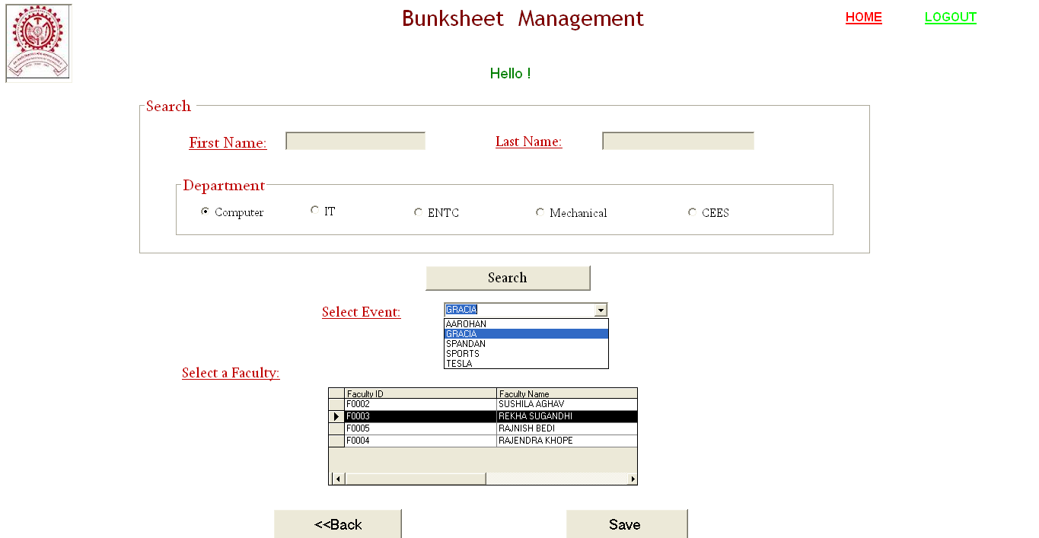

DATA VALIDATION:

* It does not allow an existing department administrator to be assigned as event administrator and vice versa.
* In case of department administrator, the search option works only with the department selected.

PASSWORD

This form allows the user to change their password. The system assigns ‘mitcoe’ as the default password when the account is created which can be changed later with this form.

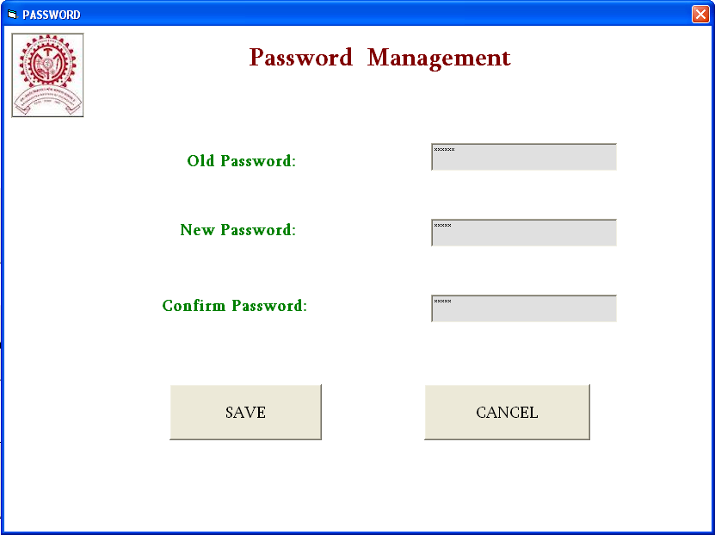

DATA VALIDATION:

* Firstly, all the fields are checked for text values. If empty, an error message is displayed.
* After checking the field for values, the old password is checked and if correct then the changes are saved. Else it is discarded.

Administrator login

This form comes under the field of work of department/event administrator. The user can select the account and accordingly, the next form comes into picture.

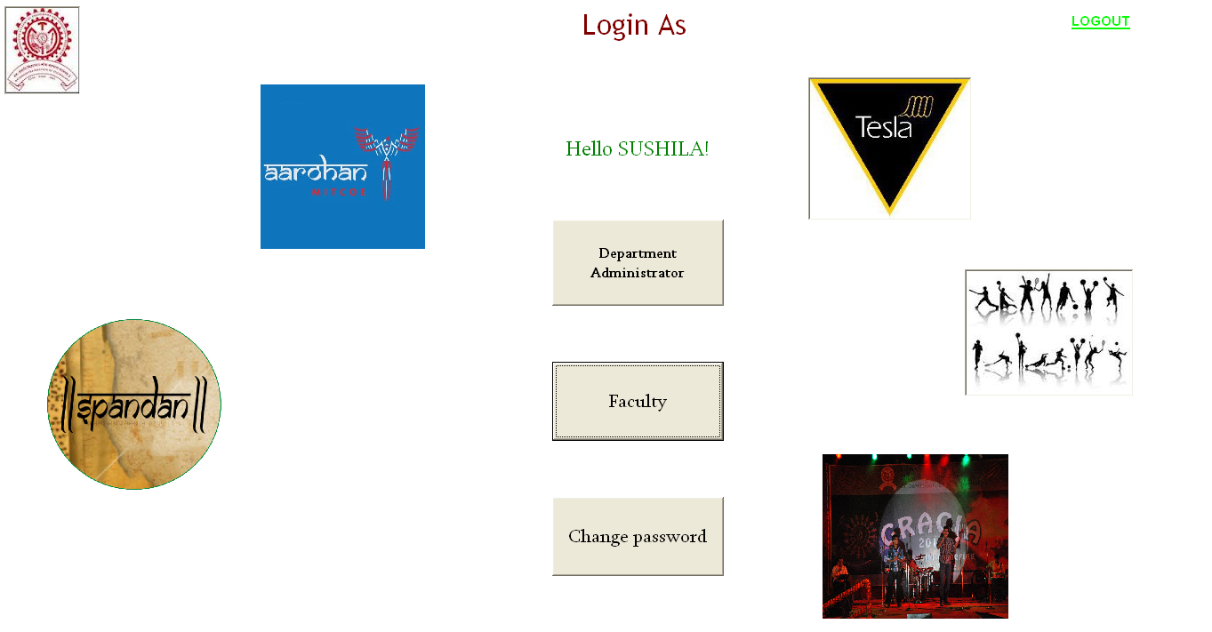

DEPARTMENT ADMINISTRATOR

This form allows the department administrator to update the student’s bunksheet in attendance table.

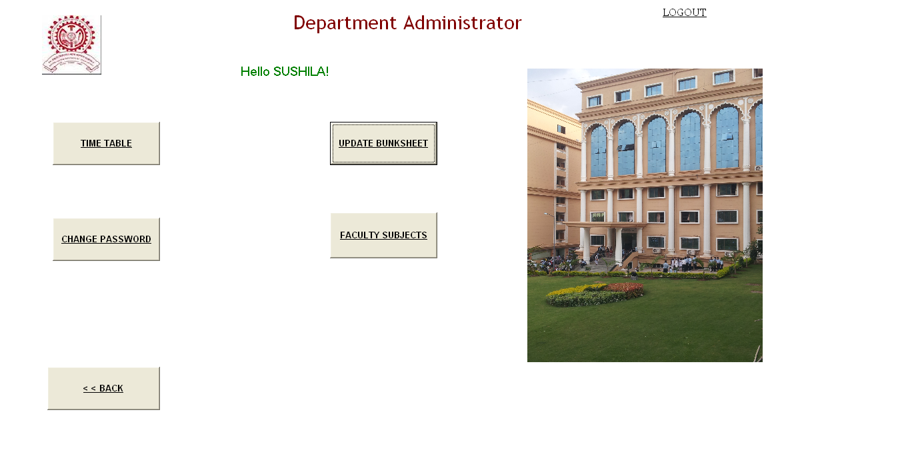

BUNKSHEET

This form comes under the field of work of event administrator. It allows the user to enter bunksheet. The data entered is displayed in data grid. It also allows user to delete a particular entry. The user just needs to enter the student’s roll number and then the student’s name, department and class are fetched by the system from student table and displayed. The input field is case insensitive.

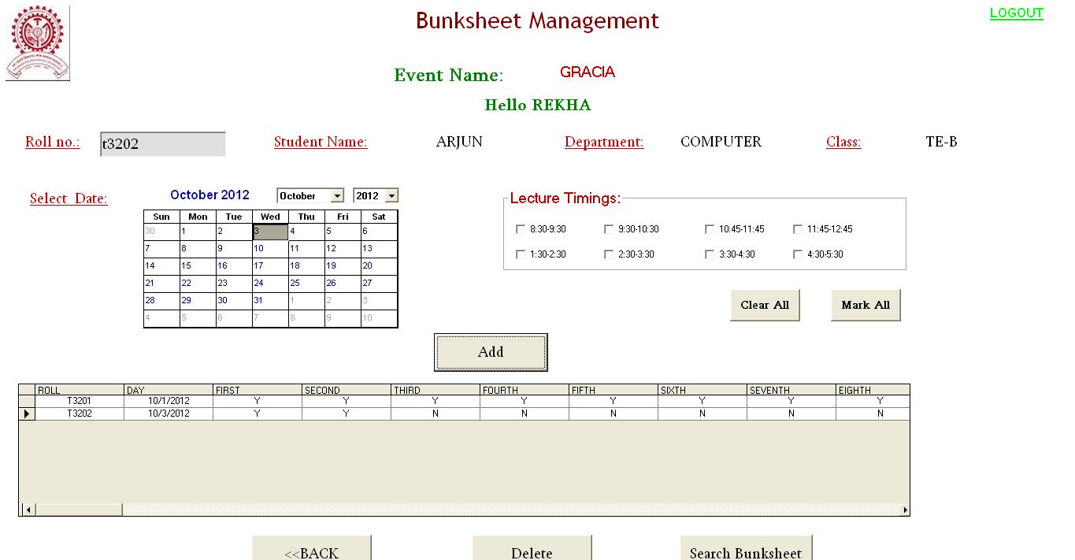

DATA VALIDATION:

* Checks for a valid roll no and displays the data accordingly
* If a bunksheet is found for the student on the selected date, a message is displayed and the user is asked for updation if required.SEARCH BUNKSHEET

It allows the event administrator to search for the bunksheet of students. There are various options provided to narrow the search. A record can be searched by first name, last name department, roll no or date. He can also view the entire bunksheet table. He has the facility to delete an entry.

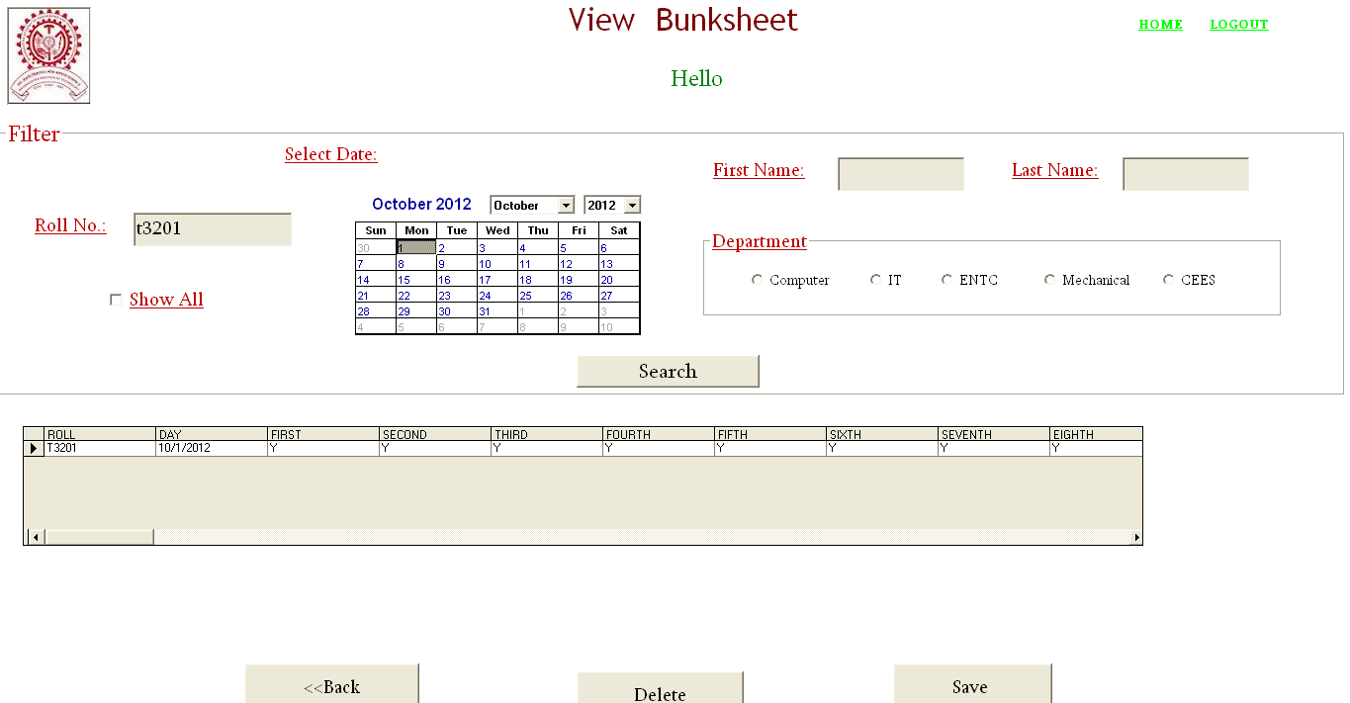

DATA VALIDATION:

* The input fields are case insensitive.
* The user cannot edit the data.

FACULTY HOME

This form is displayed when a faculty logs in. It allows the faculty to search a student’s bunksheet and attendance which is updated by the department/event administrator. Various filter options are provided to simplify the search.

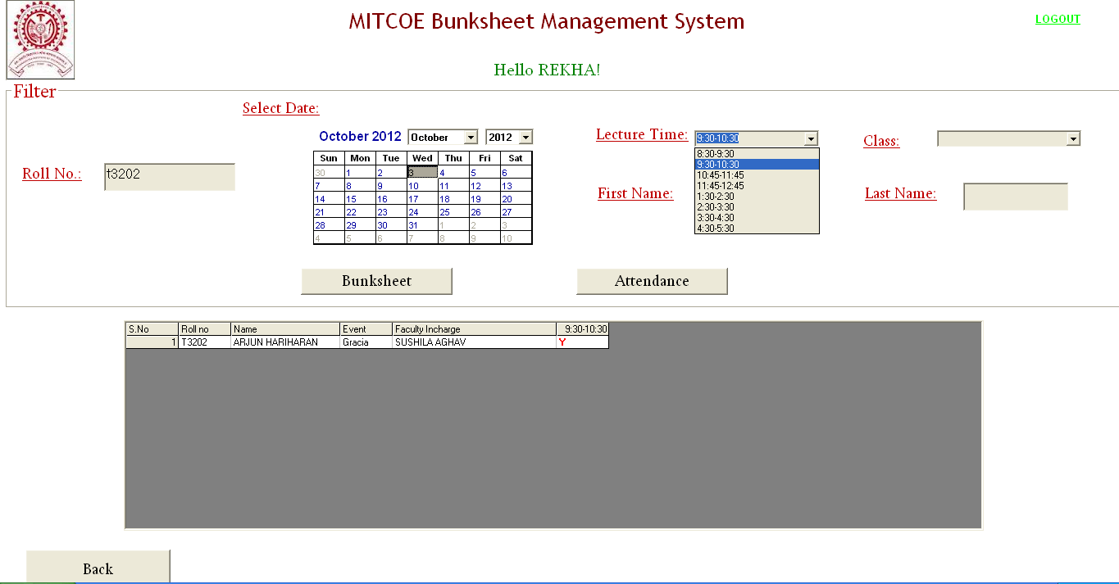

DATA VALIDATION:

* Input fields are case insensitive.
* Editing the record is not allowed.