MINOR PROJECT VALIDATION FORM

Supervisor Name Panel Head
Dr. M. Baskar
Dr. M. Baskar
Faculty Advisor Project Domain
Artificial Intelligence
Dr. P. Rama
Student(s) Details: Name Passport size photo(s)

- Arjun Jayakrishnan
- Tirtha Nath
Registration Number(s)
- RA2311003010326
- RA2311003010336
Email ID(s)&Mobile Number(s)
2: tn0557@srmist.edu.in
8247228028
1: aj1124@srmist.edu.in
9315694224

1 | Abstract | Traffic congestion is a major challenge which is globally prevalent. Most of the existing systems are built for the current traffic conditions and as cities continue to grow, they fail to keep up. Most of the solutions propose machine learning due to its better throughput but its high infrastructure costs and their black-box nature remain a problem. To counter this, we introduce RouteXpert, an Explainable Symbolic AI (Artificial Intelligence) Framework which addresses the limitations of the existing implementations and provides additional features. A rule-based logic is used here which also supports multi-intersection coordination. This framework has seven components- a traffic input layer which accepts and processes the inputs, traffic network model layer which represents the entire traffic network as a graph, a Knowledge Base for rule storage, an Inference Engine for symbolic reasoning, an Emergency Pre- emption Module for providing instant routes to emergency vehicles, a signal execution module which makes the decision whether signal should be RED or GREEN, and an explainability and performance analysis layer for generating human-readable decision logs. This  approach keeps transparency and semantic consistency intact. The framework proves that a reasoning-based, coordinated system

 |  | performs much better than traditional fixed-time or machine learning based solutions. This work builds a scalable and secure base for managing traffic in modern cities with uses in autonomous grid management, and emergency response provision.
2 | RESEARCH GAP  (not more than 3 points) | - Most existing traffic control systems focus only on individual intersections. They do not properly handle coordination between nearby junctions, which leads to inefficient traffic flow across the network.  - Many modern approaches use machine learning or reinforcement learning models, but these work like “black boxes.” It is difficult to understand why a particular signal decision was made, which reduces trust and makes debugging harder.  - Although some systems provide priority for emergency vehicles, they often depend on costly infrastructure or are not well integrated with normal traffic control. As a result, emergency handling is either inefficient or not practical for real-world use.
3 | Please furnish the details of 5 research articles in IEEE Reference format with Impact factor and year of publication from Which Research gap has been identified (F. Lastname, “Title of article,” *Journal Name*, vol., no., pp., year. And IF 3.1)) / 5 Patent Details for highlighting the innovation | - K. W. Lim, H. K. Lee, and J. Lee, “Knowledge-Based Expert System in Traffic Signal Control Systems,” in Proc. IEEE Int. Conf. Systems, Man and Cybernetics, 1991, pp. 1–6.  - V. Hirankitti and J. Krohkaew, “An Agent Approach for Intelligent Traffic-Light Control,” in Proc. First Asia Int. Conf. Modelling & Simulation (AMS), Phuket, Thailand, 2007, pp. 496– 501.  - R. Kumar and A. Banerjee, “AI for Sustainable Transportation: Challenges and Opportunities,” in Proc. IEEE Smart Cities Conf., 2022.  - V. Mandava, R. Srinivas, and K. P. Rao, “Knowledge-Based Agent for Intelligent Traffic Light Control,” in Proc. Int. Conf. Advances in Computing and Communications, 2011.  - B. Placzek, “A Self-Organizing System for Urban Traffic Control Based on Predictive Interval Microscopic Model,” in Proc. Int. Conf. Traffic and Transportation Engineering, 2014.
4 | Bridging the Research Gap/ Innovation Gap (not more than 3 points) | - To address the lack of coordination, the proposed system models the traffic network as a connected structure where multiple intersections can work together. This helps in improving overall traffic flow instead of treating each signal independently.  - To overcome the black-box issue in existing systems, this project uses rule-based logic and generates clear explanations for each signal decision. This makes the system easier to understand, verify, and trust.  - The system introduces a simple method to prioritize emergency vehicles by creating a green corridor using predefined rules. This

avoids the need for expensive hardware or complex systems while
still ensuring faster emergency response.
5 | OBJECTIVE  (not more than 5 points) | - Develop a system that uses simple IF–THEN rules to control traffic signals based on real-time conditions.  - Create a framework where nearby traffic signals can work together to improve overall traffic flow.  - Implement a mechanism that allows emergency vehicles to move faster by giving them signal priority.  - Make the system explainable by showing why a particular signal decision (RED/GREEN) was made.
6 | System Architecture | Seven-layer microservices architecture: (1) Traffic Input Layer; (2) Traffic Network model layer; (3) Knowledge Base; (4) Inference Engine; (5) Inference Engine; (6) Signal Execution; (7) Explainability  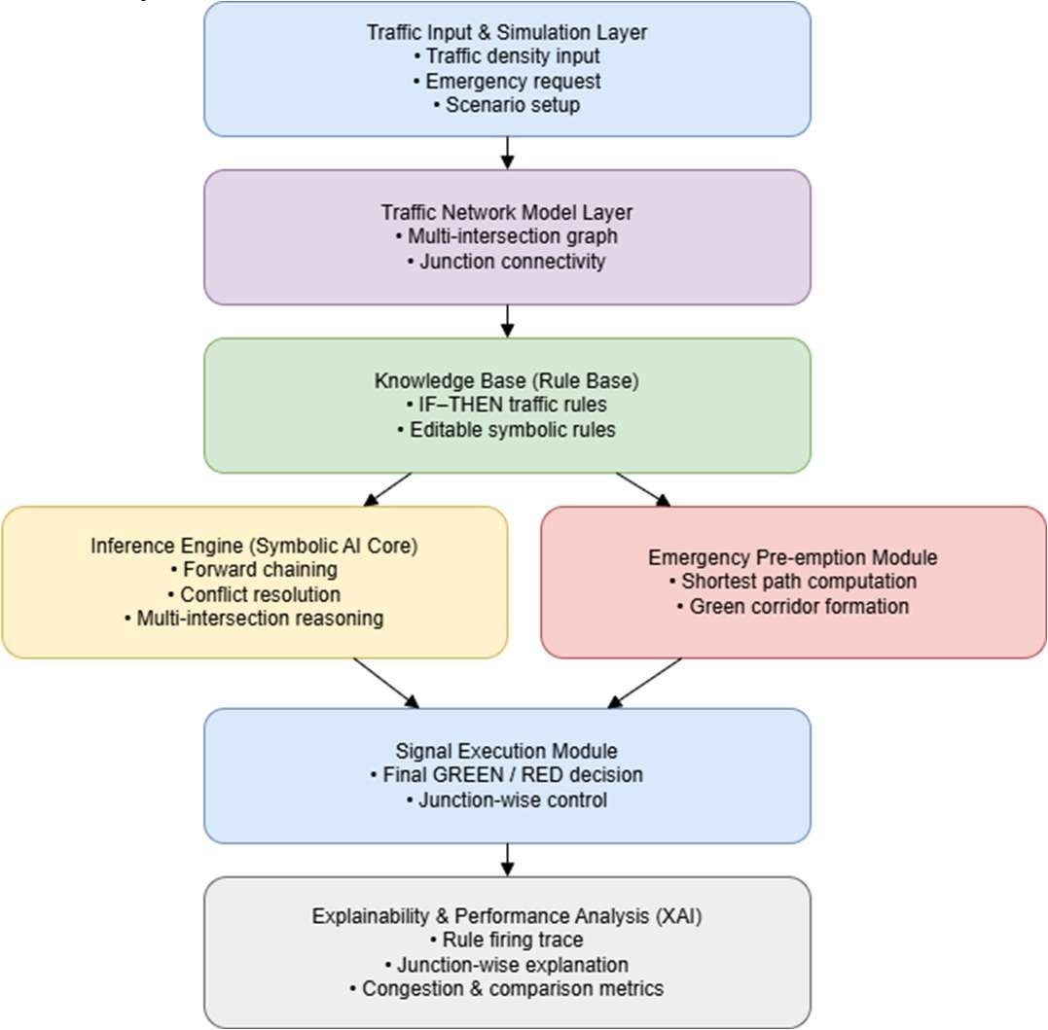
7 | METHODOLOGY  (not more than 10 points) | - Traffic density values and emergency details are taken as input for each intersection.  - The traffic system is represented as a network where intersections are nodes and roads connect them.  - A set of IF–THEN rules is defined to handle different traffic conditions.  - The system checks the current traffic situation and selects the applicable rules.  - Based on the selected rules, decisions are made for each signal (RED or GREEN).  - If an emergency vehicle is present, normal rules are overridden to create a green corridor.  The final signal states are applied, and a simple explanation for  each decision is generated.

8 | OUTCOMES OR DELIVERABLES  (not more than 5 points) | - A working rule-based traffic signal control system that adjusts signals based on traffic conditions.  - Implementation of multi-intersection coordination to improve overall traffic flow.  - A module for emergency vehicle priority, enabling faster movement through a green corridor.  - Generation of explainable outputs, showing why each signal decision was made.  - Performance results and analysis, including graphs for congestion reduction and system efficiency.
9 | NOVELTY  (not more than 3 points) | - Unlike many existing systems that handle signals individually, this project connects multiple intersections and applies rule-based logic across the network.  - The system not only controls signals but also provides clear explanations for each decision, which is not common in most traffic control solutions.  - The project introduces a green corridor mechanism using rules, avoiding the need for expensive infrastructure or complex technologies.
10 | Time line | Deliverables
 | February 21, 2026 (SPRIN  Review 1) | Created Knowledge Base for the Inference Engine.
 | March 22, 2026 (SPRINT  Review 2) | Integrated the knowledge bas into the system and tested  it out.
 | April 28 – 30,2026  (Project Demo and Report submission) | Full optimization with explainability layer.
11 | Collaboration details | - SRM Institute of Science and Technology: Academic  supervision.
12 | Target Technology Readiness Level of the project  (TRL Scale 1 to 9)  TRL 1 -Basic principles observed and reported. TRL 2 -Technology concept formulated.  TRL 3 -Experimental  proof of concept. | The proposed system has been designed, implemented, and tested in a controlled (simulated) environment. The core functionalities such as rule-based traffic control, multi-intersection coordination, and emergency handling have been validated through experiments and performance analysis. However, the system has not yet been deployed in a real-world environment.

TRL 4-Technology validated in lab.
TRL 5-Technology validated in a relevant environment.
TRL 6 -Technology demonstrated in a relevant environment. TRL 7-System prototype demonstration in operational environment.
TRL 8-System complete and qualified.
TRL 9- Actual system proven in operational
environment.
13 | Sustainable Development Goal (1-  17) (Most prominent one goal) | SDG 11 – Sustainable Cities and Communities This project supports SDG 11 by improving traffic  management in urban areas. The system helps reduce traffic congestion, waiting time, and improves the overall flow of vehicles at intersections. By optimizing signal control and giving priority to emergency vehicles, it contributes to safer and more efficient transportation  within cities.
14 | Industry Practice followed for system development (Agile- SCRUM)
Conference/Journal Publication/Patent Details :
Presented at ICNWC-2026 Conference held in SRM-KTR. IEEE Supported
Signature of Students: 1.

2.

Signature of the Supervisor

