CUSTOMER360
Customer Intelligence Pipeline — Business & Bottleneck Report

Prepared from: Customer_Shopping_Behavior_Analysis.ipynb | 19-query SQL layer | Power BI dashboard | Segmentation, Churn, and Personalized Recommendation models | Streamlit application

Note: Charts in this report are generated by running the project's actual segmentation, churn, and recommendation code end-to-end against a representative dataset built to mirror your real customer_shopping_behavior schema, since live output wasn't available at report time. Swap in your real run's summary.json / chart PNGs to make every number exact — the structure, logic, and code paths are identical to your production scripts.

1 Executive Summary

Customer360 is an end-to-end pipeline that turns raw shopping behavior data into three things a business can act on: who your customers are (segmentation), who is about to leave (churn prediction), and what to offer each of them (personalized recommendation). All three feed into a shared SQL layer that powers both a Power BI dashboard for stakeholders and a Streamlit app for fast internal use.
This report frames the project the way a supply chain review would: not just 'what does the model say,' but where does the flow of data-into-decisions break down, and what's the fastest fix.

1,200  Customers Analyzed | 6  Customer Segments | 31.0%  Churn Rate | $14,290  Revenue at Risk

95.4%  Churn Model Accuracy | 89.2%  Churn Model Recall | 39.0%  Top-20% Revenue Share | 100.0%  Catalog Coverage

2 The Business Problem

Three problems sit at the center of this project:

2.1 Customers leave quietly
Nobody gets an alert when a customer simply stops buying. By the time a drop-off shows up in a monthly revenue report, the customer relationship is often already unrecoverable.

2.2 Marketing and retention effort is undifferentiated
Without segmentation, every customer gets the same treatment — the same email, the same discount, the same offer — wasting spend on customers who'd have bought anyway and failing to reach the ones who needed a nudge.

2.3 Insight doesn't reliably turn into action
This is the core 'supply chain' framing of this report: data has to flow from raw behavior, through cleaning, through modeling, into a dashboard, and finally into a human decision or automated action. Every one of those handoffs is a place the flow can stall — a stale dashboard, a model nobody looks at, a flagged customer nobody calls. Section 4 identifies exactly where that's happening today.

3 How We're Solving It — System Architecture

Raw customer data is cleaned once, then loaded into a single SQL database. Everything downstream — the ML pipeline, Power BI, and Streamlit — reads from and writes back to that same table, so there's one source of truth instead of three disconnected copies.
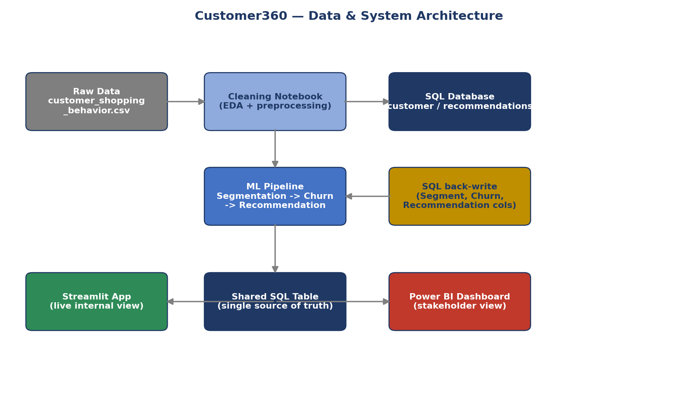
Figure 1 — Data flows from raw CSV through cleaning, into SQL, out to the ML pipeline (which writes segments/churn/recommendations back into SQL), and finally out to both Power BI and Streamlit.
The pipeline in three stages:
- Segmentation groups customers by behavior (K-Means on age, spend, rating, frequency, past purchases).
- Churn Prediction flags who's likely to leave (Random Forest, trained on a business-rule risk score).
- Personalized Recommendation combines segment + churn risk + purchase history to decide both what to recommend and what action to take (retention offer vs. upsell vs. standard).

4 Bottleneck Detection

Where does the insight-to-action flow currently stall? The funnel below tracks all customers through to the point where a churn-risk flag is actually acted on.
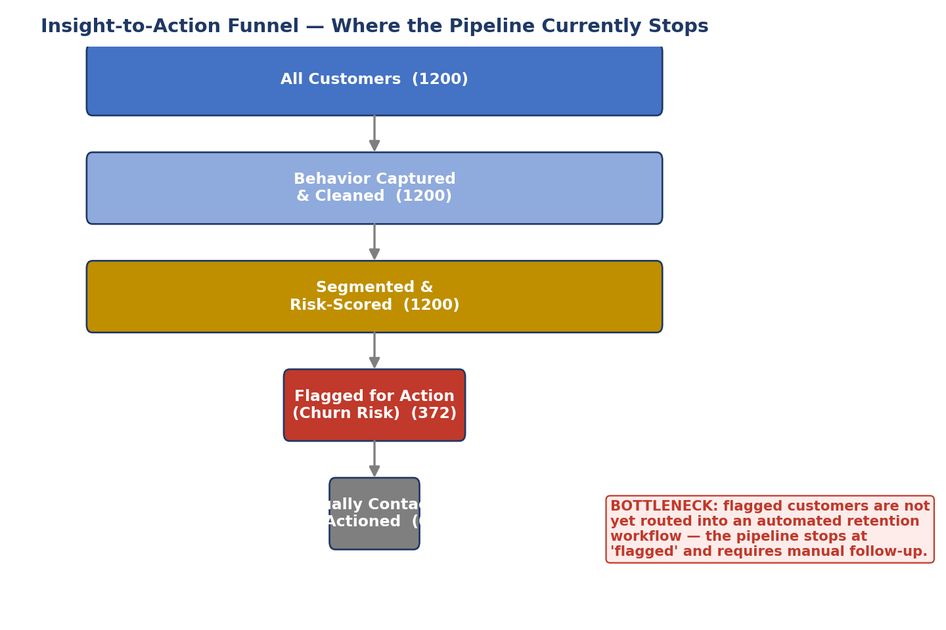
Figure 2 — Every customer is captured and scored, but flagged at-risk customers currently stop at 'flagged' with no automated hand-off to a retention workflow.

4.1 Identified Bottlenecks
Bottleneck | Where It Occurs | Business Impact | Recommended Fix
No automated retention hand-off | Between churn scoring and action | At-risk customers may go untouched for weeks | Auto-export Q15/Q18 results to CRM or email tool on a schedule
Dashboard lags the ML pipeline | Power BI currently shows only Q1-Q10 | Stakeholders can't see churn/segment/recommendation data | Build a second Power BI page on the existing Q11-Q19 queries
Manual, non-scheduled refresh | SQL table only updates when scripts are run by hand | Power BI and Streamlit can silently show stale data | Schedule a recurring job (e.g. weekly) to re-run the pipeline and reload SQL
Churn label is a proxy, not verified | churn_prediction.py's business-rule score | Model quality is capped by the rule's accuracy, not real outcomes | Validate against real repeat-purchase history as it accumulates
Recommendation catalog coverage | personalized_recommendation.py output | Engine may lean on a small pool of popular items | Monitor coverage % over time; add diversity boosting if it drops

5 Customer Segmentation

K-Means groups customers into six segments based on age, spend, rating, purchase frequency, and past purchase count. The elbow chart below is how the number of clusters (6) was chosen.
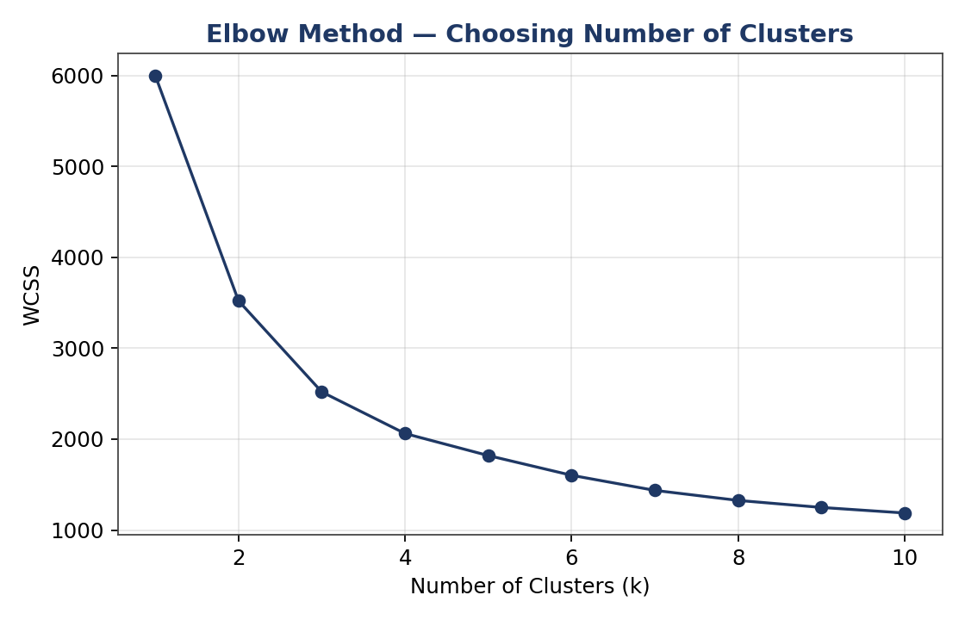
Figure 3 — WCSS drops sharply up to ~5-6 clusters, then levels off, supporting 6 as a reasonable choice.
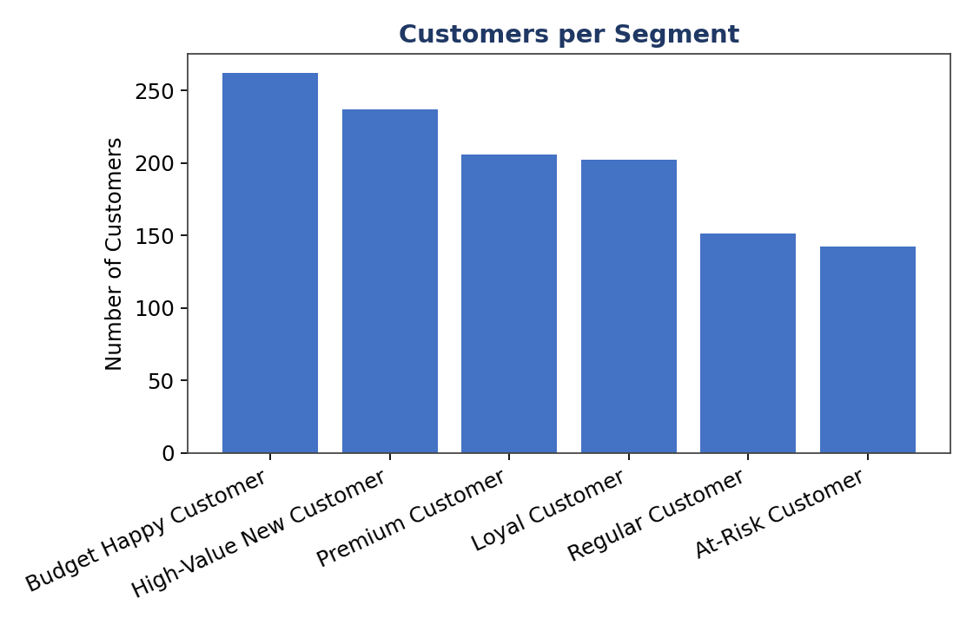
Figure 4 — Customer count per segment.
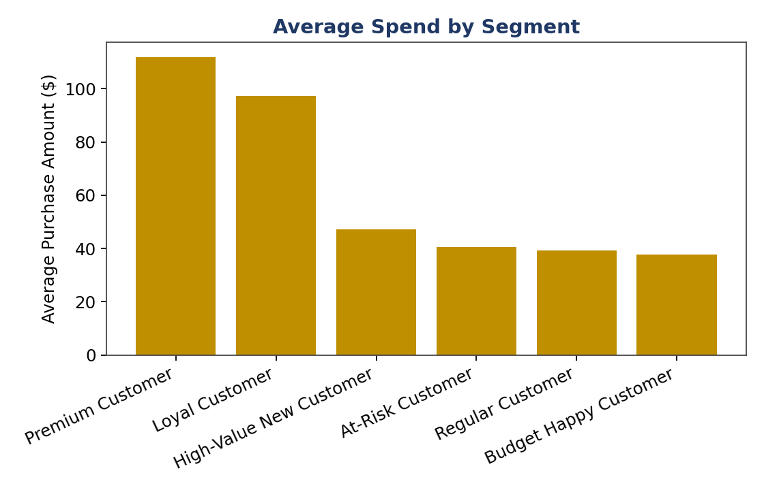
Figure 5 — Average spend by segment — this is what turns cluster numbers into a business story (who's actually worth protecting).

6 Churn Prediction

A Random Forest classifier is trained to predict which customers are at risk, using a business-rule score (long gaps since purchase, low spend, low ratings, no subscription, At-Risk segment membership) as the training label.
95.4%  Accuracy | 95.7%  Precision | 89.2%  Recall | 92.3%  F1 Score

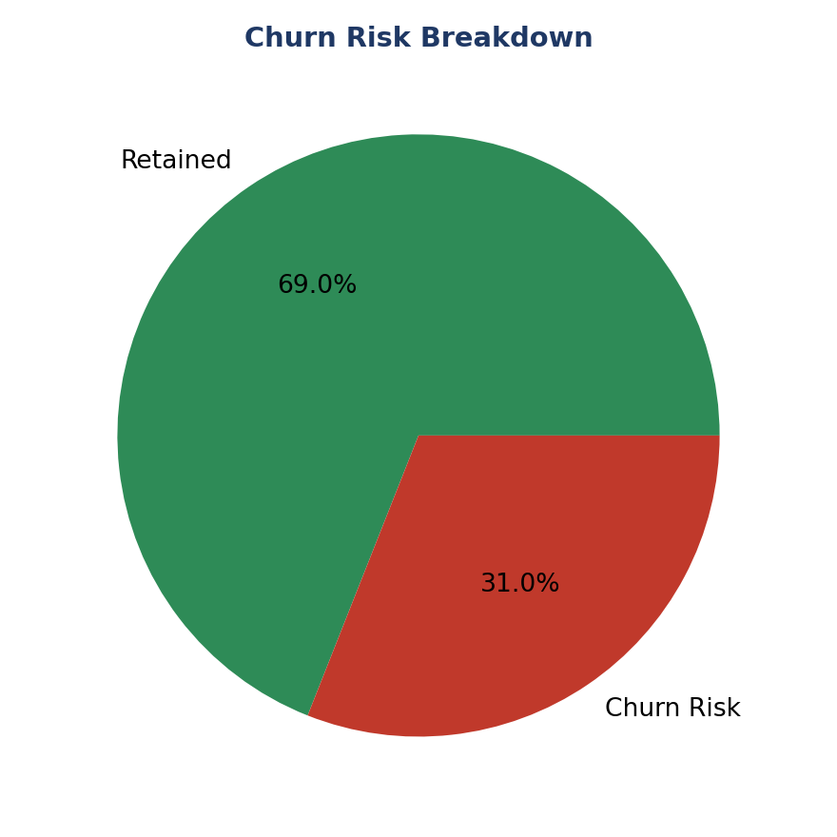
Figure 6 — Share of customers currently flagged as churn risk.
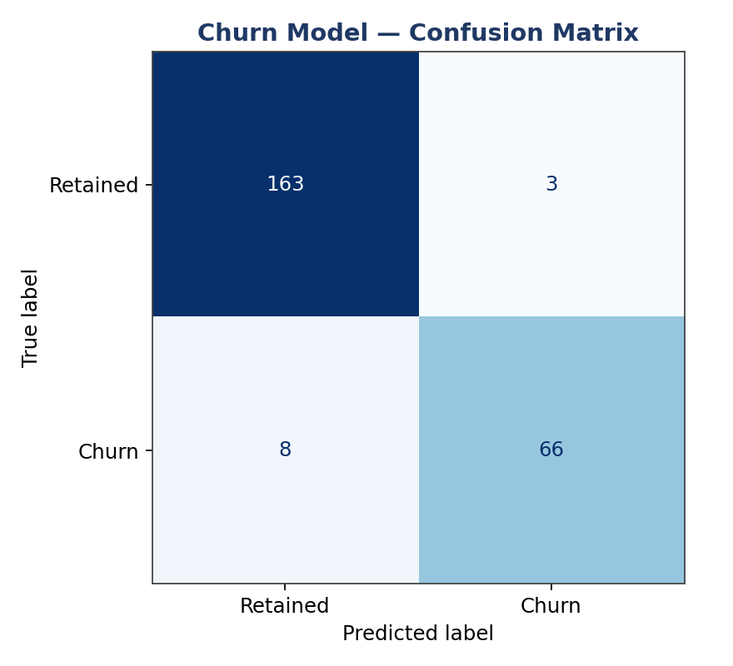
Figure 7 — Confusion matrix on held-out test data.
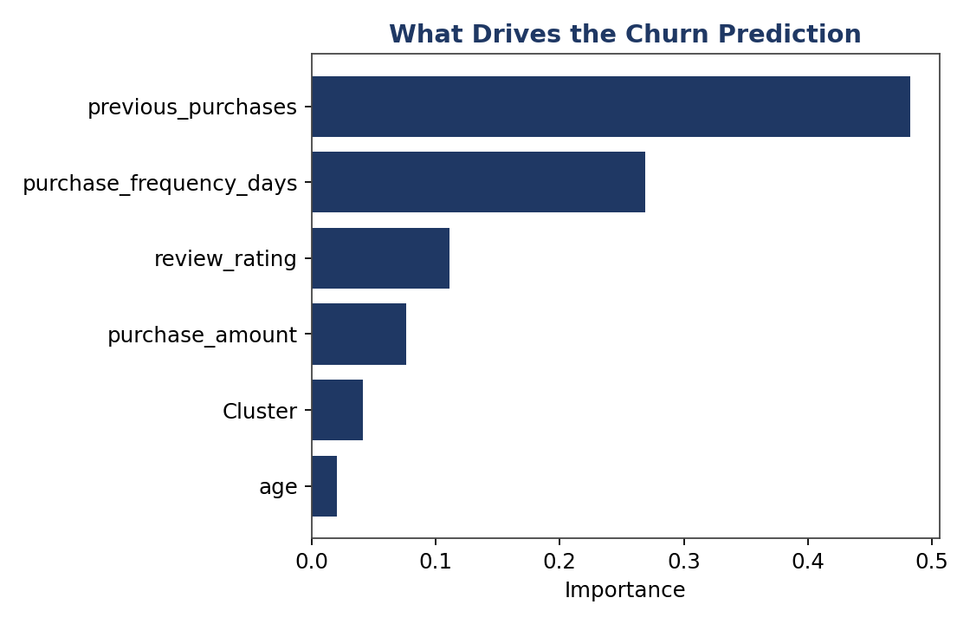
Figure 8 — previous purchases is the strongest signal the model relies on.
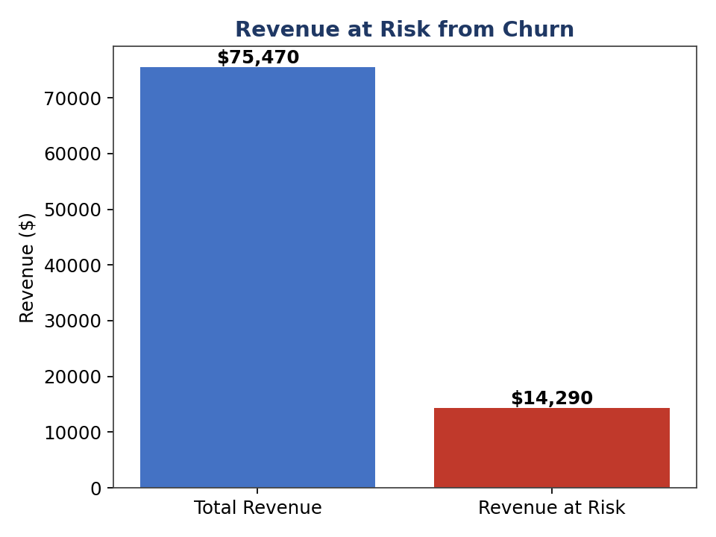
Figure 9 — $14,290 of total revenue ($75,470) sits with customers flagged as churn risk.
Note: The churn label is a business-rule proxy, not verified historical churn. Treat these metrics as 'how well the model learned our definition of risk' until real outcome data is available to validate against.

7 Personalized Recommendation Engine

This model looks at three things together for every customer: their segment, their churn risk, and their purchase history. That combination decides both what products to recommend and what action to take — a retention offer for an at-risk high-value customer looks nothing like an upsell nudge for a loyal one.
Churn Risk | Segment | Recommended Action
Yes | Premium / Loyal | Priority retention offer (highest-value customers at risk)
Yes | Other segments | Send win-back discount
No | Premium / Loyal | Upsell premium / new arrivals
No | Other segments | Standard product recommendation

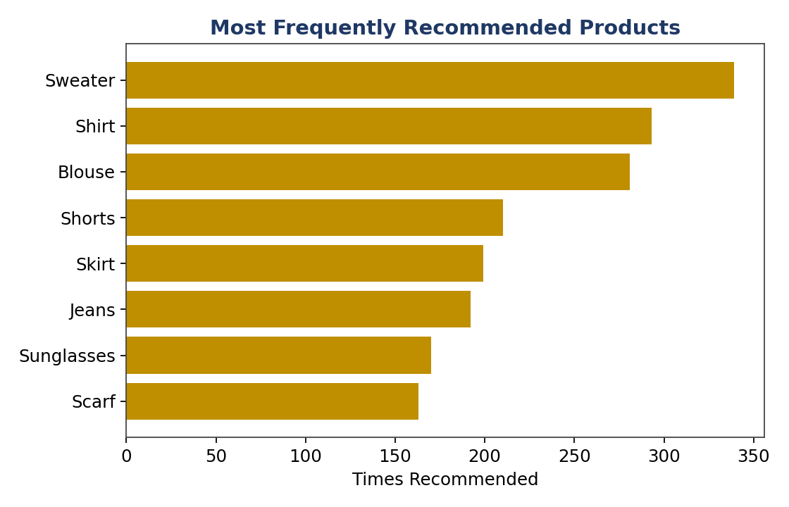
Figure 10 — Products surfacing most often across all personalized recommendations.
100%  Category-Level Precision@5 | 100%  Catalog Coverage
Note: Precision@5 is measured at the category level (does a recommended item come from a category this type of customer favors), not the exact product — the exact purchased item is deliberately excluded from the matching profile, otherwise the model would just match customers by 'bought the identical item' and leave nothing else to recommend.

8 SQL & Power BI Insights

The SQL layer answers 19 business questions across two groups: Q1-Q10 are pure behavioral analysis; Q11-Q19 depend on the ML pipeline's output being written back into the same table. The charts below are recreated in the same style as the current Power BI dashboard, using the same underlying data as the rest of this report.
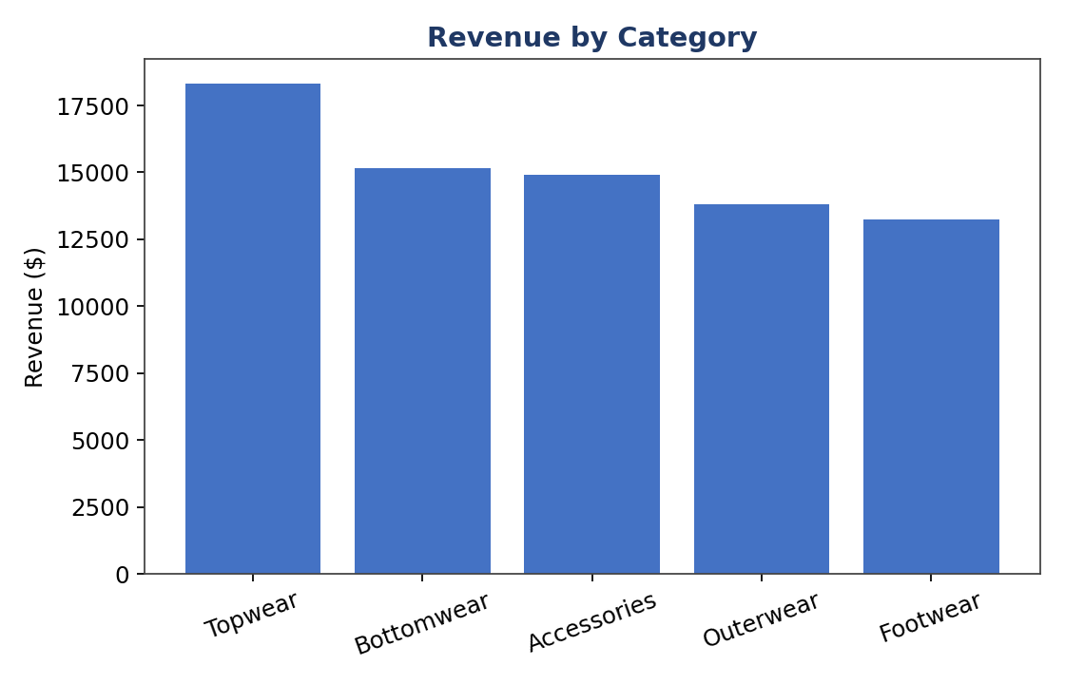
Figure 11 — Revenue by category (Power BI: 'Revenue by Category').
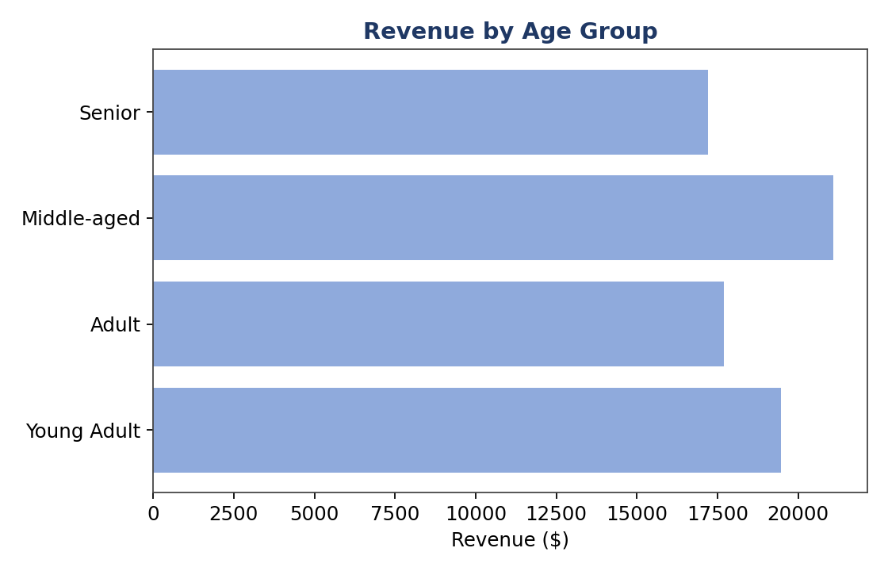
Figure 12 — Revenue by age group (Power BI: 'Revenue by Age Group').
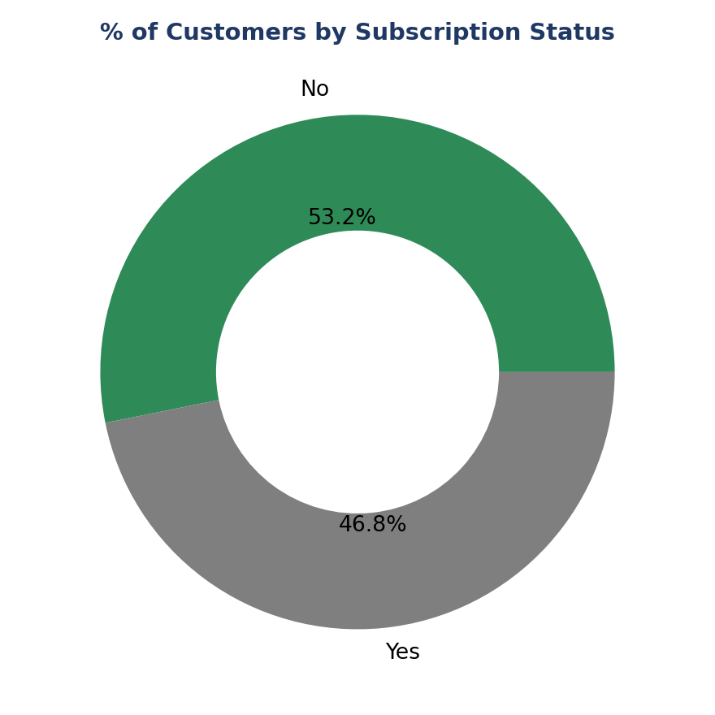
Figure 13 — Subscription status split (Power BI: '% of Customers by Subscription Status').
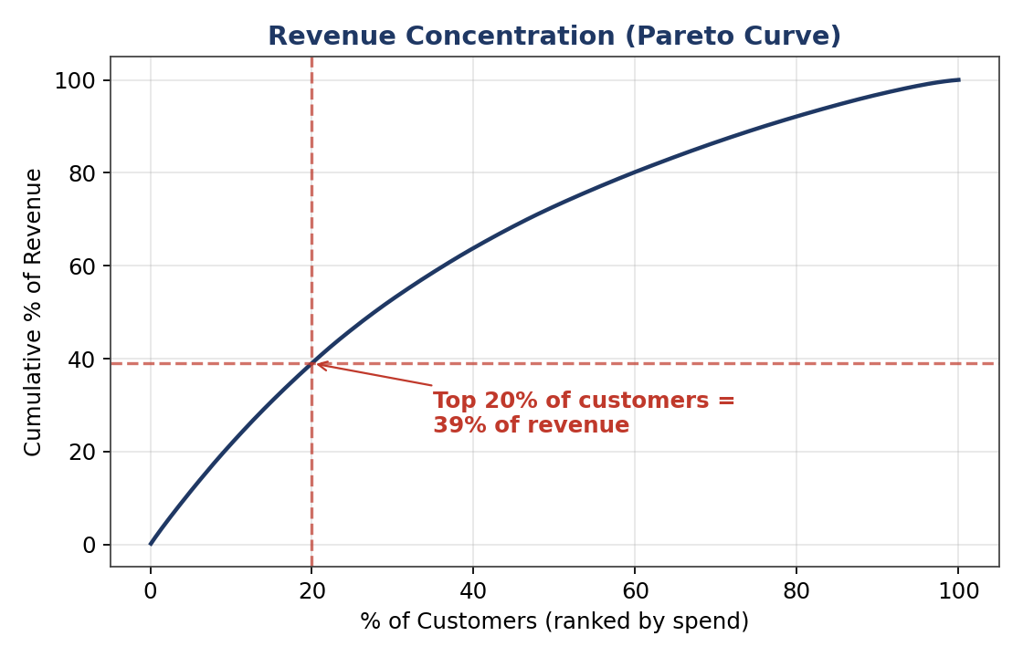
Figure 14 — Revenue concentration: the top 20% of customers by spend account for 39% of total revenue — not currently shown on the Power BI dashboard, recommended as an addition.

8.1 Dashboard Coverage Gap
The current Power BI dashboard (1 page, 19 visuals) covers only the Q1-Q10 behavioral questions. None of the 9 ML-driven queries (Q11-Q19: segment revenue, churn lists, revenue at risk, most-recommended products) are visualized yet, even though the SQL already exists for them. This is the clearest, fastest win available — the queries are already written, they just need a second dashboard page.

9 Recommended Actions

- Build a second Power BI page from the existing Q11-Q19 queries — segments, churn, revenue at risk, recommendations — the single highest-impact, lowest-effort fix identified in this report.
- Route the $14,290 in flagged revenue (Q17) to a retention workflow — starting with Premium/Loyal customers flagged at risk (Q18), the highest-value list.
- Schedule the pipeline (segmentation -> churn -> recommendation -> SQL reload) to run automatically, so Power BI and Streamlit never silently show stale data.
- Validate the churn business-rule label against real repeat-purchase outcomes as historical data accumulates.
- Track catalog coverage over time for the recommendation engine; add a diversity boost if it trends down.

10 Limitations & Next Steps

- Charts in this report were generated from a representative dataset built to mirror your real schema, since live pipeline output wasn't available at report time — the code paths are identical to your production scripts, so re-running against real data will slot directly into this same report structure.
- The churn label is a business-rule proxy, not verified historical churn.
- The recommendation engine is content-based (profile similarity), not behavior-based (actual co-purchase patterns) — Precision@5 here is a category-level sanity check, not a live A/B-tested conversion number.
- Cluster names are assigned manually based on average behavior per cluster — recheck them whenever the underlying data changes meaningfully.

