Retail Insights Assistant

GenAI + Scalable Data System

1. System Architecture & Data Flow
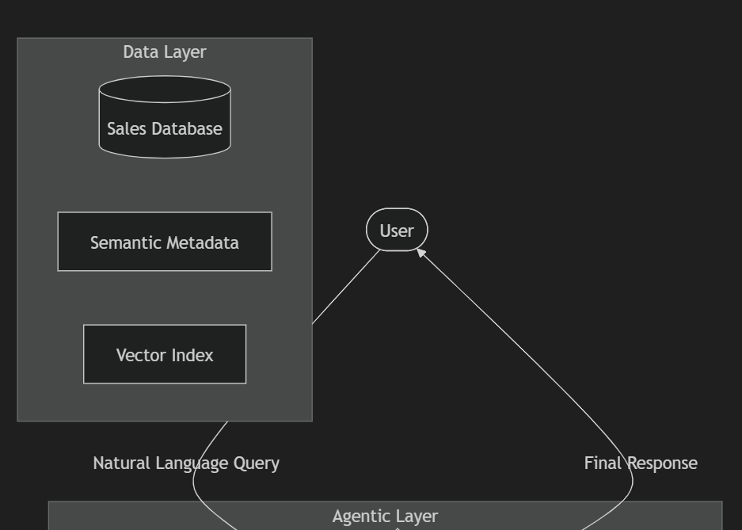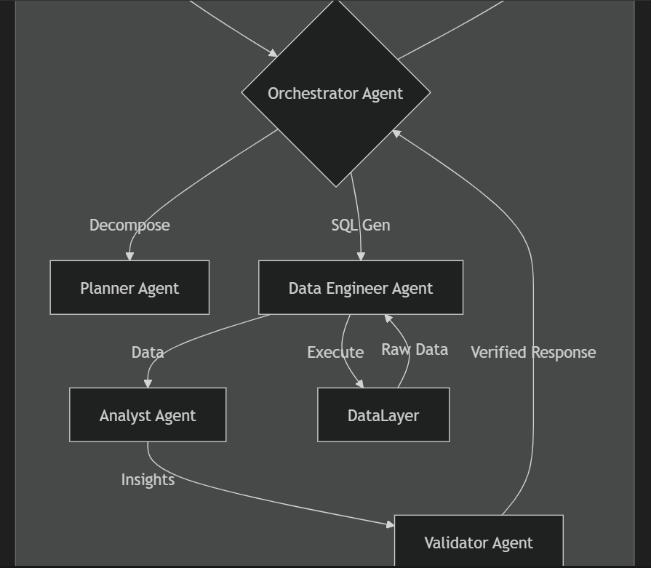
Figure 1: High-Level System Architecture and Agent Workflow
The system follows a modular Multi-Agent Architecture designed for extensibility and scalability.
- Workflow:
- Orchestrator: Manages workflow.
- Planner: Decomposes complex questions.
- Data Engineer: Generates safe DuckDB SQL.
- Analyst: Summarizes results into business insights.
- Validator: Prevents SQL injection and Hallucinations.

2. System Interface (Snapshot)
Below is a live snapshot of the Retail Insights Assistant interface:
[Image not found at c:\Users\arjun\OneDrive\Documents\Projects\MyProjects\Retail_Insights_Assistant_GenAI_Scalable_Data_System\results\retail_insights_assistant_view_1766633553898.png]

3. Scalability Strategy (100GB+)

A. Data Engineering & Storage
Current: Local DuckDB.
Proposed (100GB+): Snowflake/BigQuery + S3 Data Lake (Parquet).

B. Retrieval Efficiency
Partitioning: Date/Region based.
Vector Search: Pinecone/Qdrant for semantic search.

4. LLM Integration Strategy
Hub-and-Spoke Model:
Complex Logic: GPT-4o / Gemini 1.5 Pro.
Task Specific: GPT-3.5 / Llama 3.
RAG: Retrieve schema/values before prompting.

