Retail Insights Assistant - Demo Evidence

1. User Interface Snapshot (Local)
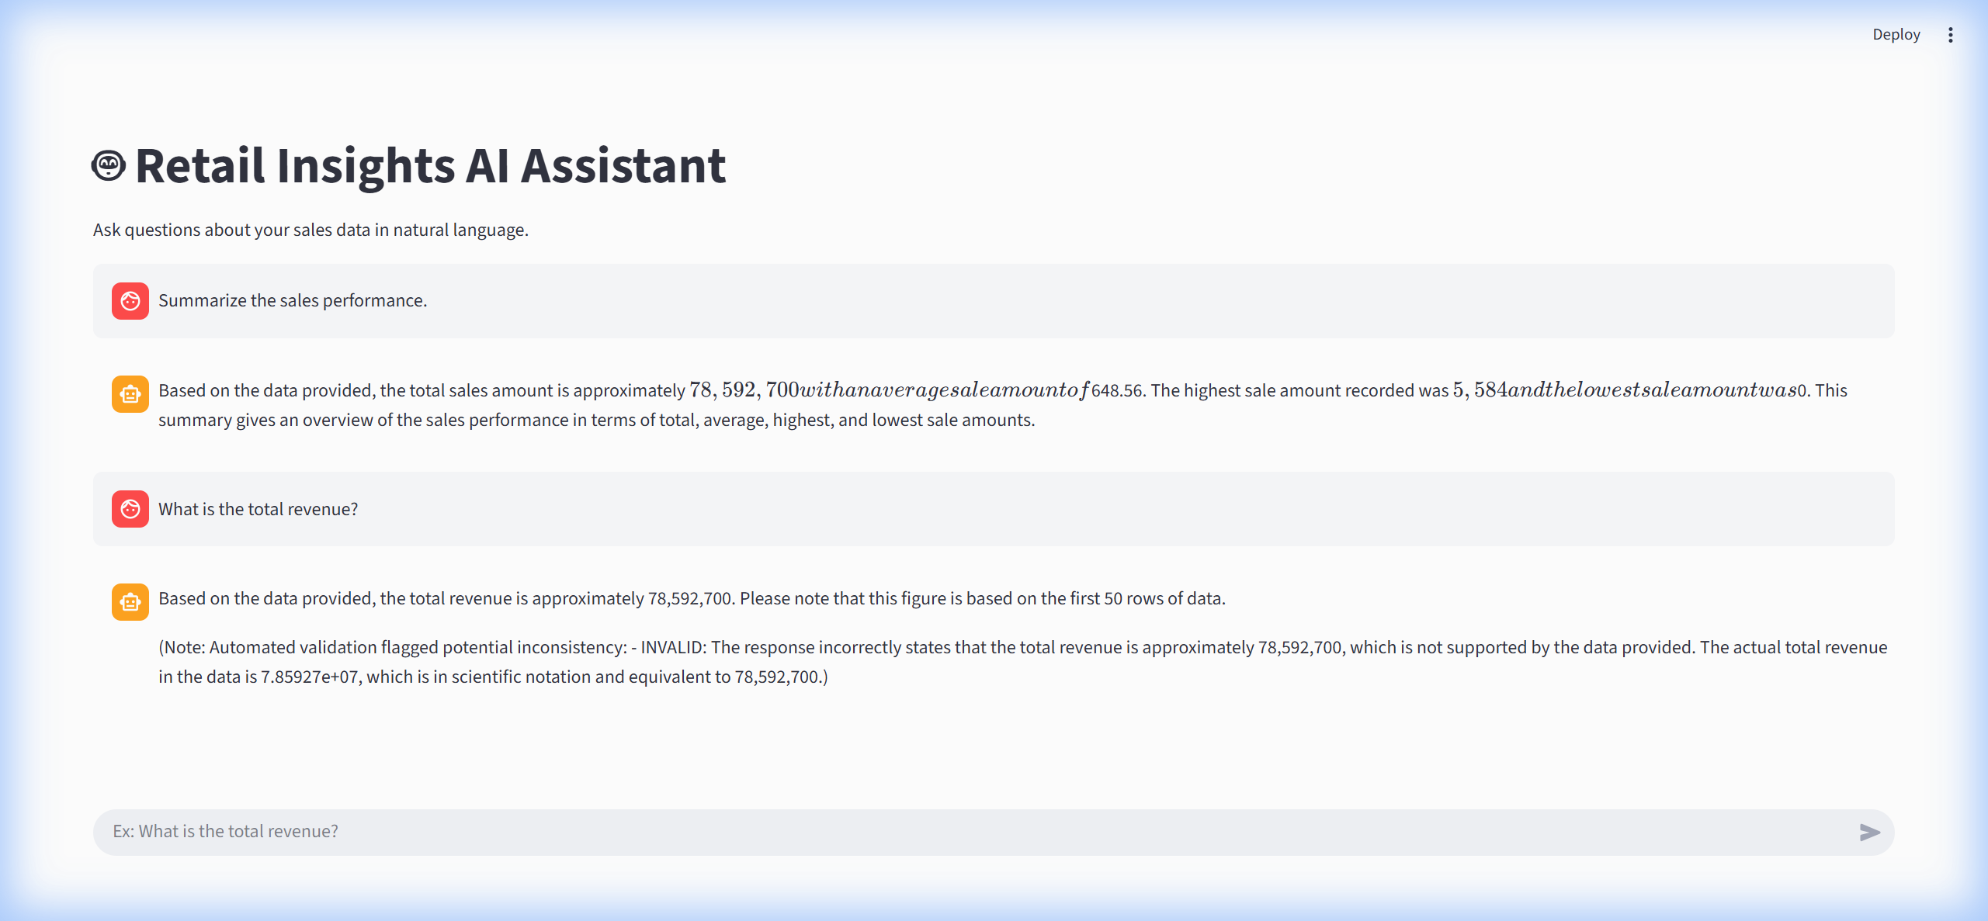
Figure 1: Streamlit Chat Interface (Local Run)

1.1 Docker Container Run
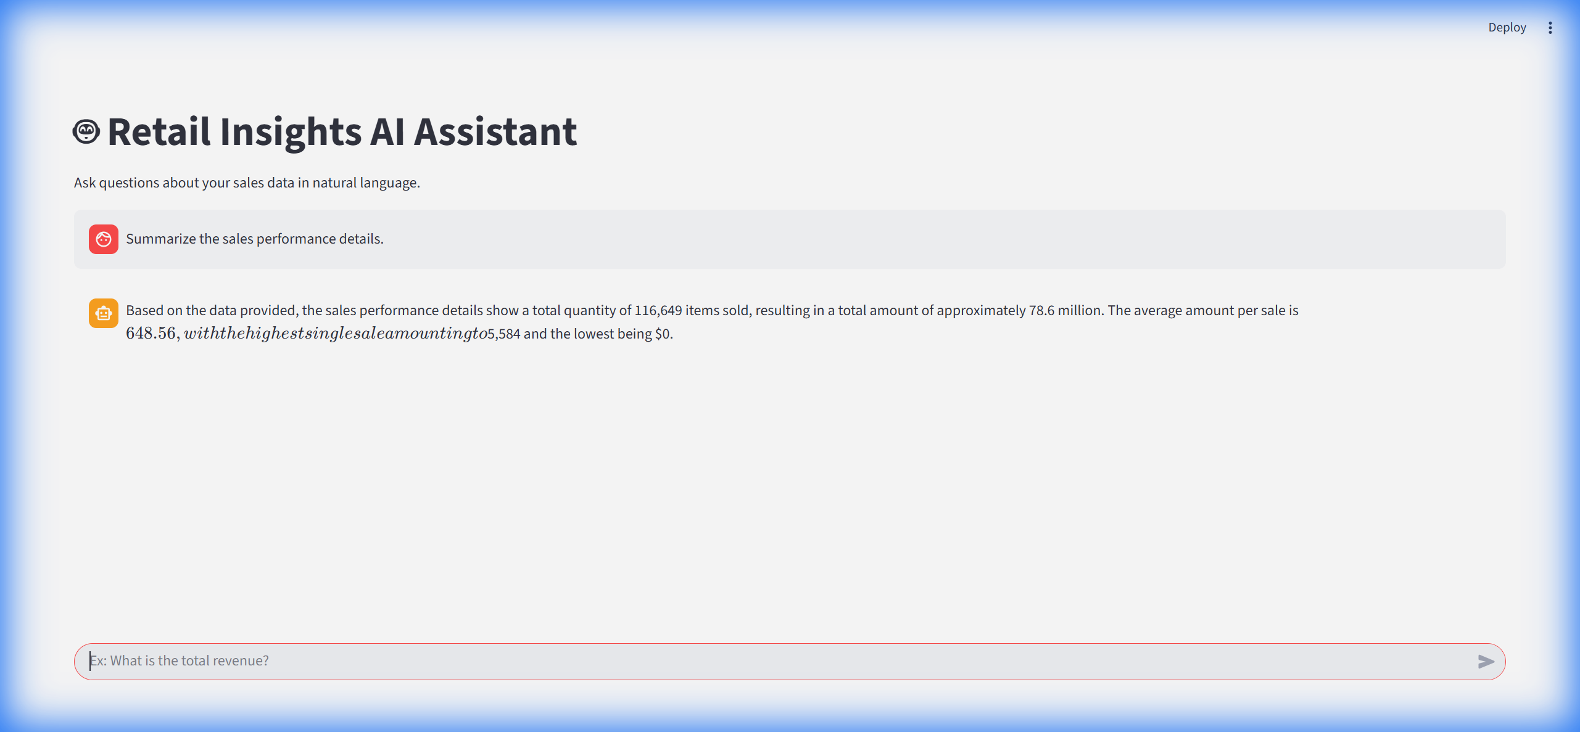
Figure 2: Application running in Docker with 'Summarize' query response.

2. Example Summarization Output
Query: 'Summarize sales performance'
System Response:
Query: Identify top performing products
Response:
Based on the data provided, the top performing products in terms of total quantity sold are:
1. SKU JNE3797-KR-L with 661 units sold
2. SKU JNE3797-KR-M with 561 units sold
3. SKU JNE3797-KR-S with 503 units sold
These products have the highest total quantities sold among the first 10 rows of data retrieved.
(Note: Automated validation flagged potential inconsistency: - INVALID: The response mentions "SKU JNE3797-KR-S with 503 units sold" as one of the top performing products, but the actual data shows that SKU JNE3797-KR-S has 503 units sold, not 503.)

