IS Methodology



Requirements Document

Project Methodology Used: Waterfall Lite
Project Platform Used: Blueprint
Project Name: Salesforce Marketing Cloud Email Campaign Tracking Details Ingestion into Lakehouse
Project ID: 1005310

Contents
1. Introduction 3
1.1 Business Context 3
1.2 In Scope 3
1.3 Out of Scope 3
1.4 Assumptions, Constraints & Dependencies 3
1.5 Intended Audience 3
2. Business Context 3
2.1 Current State Business Process Models 3
2.2 Current State Business Interaction Model 3
2.3 Limitations of Current State Business Processes and Systems 3
3. Requirements 4
3.1 <Feature 1> Requirements 4
1.1 Data Ingestion Requirements 7
3.2 Template-Do Not Use Requirements 13
1.2 Data Ingestion Requirements 16
4. Solution Context 16
4.1 Future State Business Processes 16
4.2 Solution Context Diagram 16
4.3 Solution Overview 16
5. Stakeholder Signoff 17
6. Appendix 18
6.1 Definitions and Acronyms 18
7. Revision History 18

- Introduction
  - Business Context
- As prospective members visit the AmeriHealth Caritas Next enrollment platform to research and shop for plans, there is currently no mechanism to chase the prospects and continue to engage them. ​​

- There is an opportunity to develop a marketing reengagement campaign that will identify prospects who visited the enrollment site (but did not enroll) and re-engage them via digital touchpoints (such as email, SMS). ​

- Such a campaign will be particularly helpful for 2023 redetermination and Open Enrollment to get maximum engagement, drive new member enrollment and retain existing members.

Capability | Category | Capability Description | Domain | SubDomain
Load the SFMC Email Campaign Data into Lakehouse | Email Tracking Data for Redetermination Campaigns for Members | Ingest the SFMC Email Campaign Data into Lakehouse for MDM and EMCIP Consumption | Member | Outreach
  - In Scope
• Transfer of Email Marketing Campaign Tracking files from SFMC SFG to the Lakehouse Landing zone.
• Below LOB’s is in Scope.
All Exchanges, Medicaid and Medicare Line of Business.
• This covers the field mappings, data types, constraints, and transformation rules required to ingest the of Email Marketing Campaign Tracking from SFMC into Lakehouse.
• Ensuring data accuracy and integrity through rigorous testing and validation procedures.
• Seamless integration with existing system and processes.
• Inclusion of requested Line of Business (LOBs) in the scope.
  - Out of Scope
- Any transformation or restricting of data beyond what is require for migration is not included.
- Enhancements to data quality or data cleansing beyond the accuracy required for migration are not included.
- Anything not covered in-scope list.
  - Assumptions, Constraints & Dependencies
ID # | Name | Description | ACD Type
1 | Data Accessibility | All necessary data needed for Enrolment/Disenrollment report as part of this FRD are accessible to the reporting team | Assumptions
2 | Data Format Compatibility | The data from the various sources can be transformed into a format compatible with DL 2.0 and the same landing location and same tables shall be used for loading the historical files as well. | Assumptions
3 | Consistent Data Sources | Data sources will remain consistent and accessible. | Assumptions
4 | QA testing scope | The QA will be testing the Data validation between the QA source tables and target tables and the ADF orchestration for this requirement completely. | Assumptions
5 | Data Dictionary and Data Quality Rules | There will not be any transformation of data involved, and the data quality rules are available in the mapping document. Please refer the appendix section. | Assumptions
6 | Data Governance | Data transformation rules must comply with existing data governance policies. | Constraints
7 | Data Source Availability | The availability and reliability of data sources are critical. Any changes or downtime in these sources can impact the automation process. | Dependencies
8 | Database Access | Timely access to required databases and servers. | Dependencies
  - Intended Audience
Name | Role | Title | Plan | Department
Phani Polapragada | Approver | Director |  | Information Technology
Baljot Kaur | Approver | Manager IS |  | Analytics and Data Delivery
Pallavi Jagtap | Reviewer | Director IS |  | Data Products
Sudha Arra | Reviewer | Manager IS |  | Data Products
Venkat Rajendran | Approver | Enterprise Architect |  | Data Products
Ananth Vijapurapu | Reviewer | Manager |  | Enterprise Information Management
Candi Boswell | Reviewer | Business Systems Analyst Lead |  | Data Quality
Kevin Merrit | Reviewer | Sr. Project Manager |  | PMO
- Business Context
  - Current State Business Process Models
Expanding the Exchange segment is a key strategic imperative for AmeriHealth Caritas as it protects and helps grow the core Medicaid business and allows AmeriHealth Caritas to create a diversified source of revenue over time​.

The Exchange (AmeriHealth Caritas Next) Market expansion plan over the next 3 years is focused on expanding the Exchange footprint to additional states with an anticipated growth in membership to approx.14,000 members. ​

A key component of the expansion strategy is enhancing marketing of the product for member acquisition and retention
.
  - Current State Business Interaction Model

NA
  - Limitations of Current State Business Processes and Systems

NA
- Requirements
  - Functional Requirements
    - Solution Requirements
Solution Requirement: 1
Name | Ingest the Email Campaign Tracking Details from SFMC
Description | NA
Functional Requirement | SFMC shall send the Email Campaign Tracking Details to the Lakehouse MFT landing location and these should be ingested into the Datalake for MDM/EMCIP consumption.  The inbound process should be able to process multiple files and update the data to data bricks.  Source File and Target table details are provided in mapping document.  Please refer the Appendix Section  Raw ADLS Location : mftlanding/inbound/member/outreach/salesforce_marketing_cloud  Load Strategy – Upsert  Upsert Key :  MEMBER_ID  MEMBER_SFX  LOB_ID  SUBSCRIBER_EMAIL  EMAIL_DTM  CAMPAIGN_NAME  INTERACTION_NAME  INTERACTION_TYPE  Frequency of data refresh – Daily 6 AM (Run hourly between 06 and 09 AM EST)  Staging Layer:  Schema Name: stg_mbr  Load Strategy – Truncate and Load  Table Name:  sfmc_member_outreach_email_tracking  Standard Layer:  Schema Name: mbr  Load Strategy – Upsert  Table Name:  sfmc_member_outreach_email_tracking  File Names: SFMC_CampaignInteractions_YYYYMMDDHHMMSS.csv  File Type: csv File  SLA: The file should be loaded within 6 hours after its arrival to SFG.
Impact Details
Solution Acceptance Criteria | All the required fields should be populated with the appropriate values from the inbound file.
Priority | High | Source/Reference
Traced/Related Requirements | N/A
IS Owner
Notes | DQ Rules are provided in the mapping document for identifying the bad records in the incoming files.  Note:  Approach for processing the bad record corrected file will be documented in the technical design document (TDD).

    - Business Rules
Business Rule ID: BR226638
Name | <Business Rule 1>
Description | ​
Source
Traced/Related Requirements

Business Rule ID: BR226637
Name | <Business Rule 2>
Description | ​
Source
Traced/Related Requirements

    - System Interface Requirements
System Interface Requirement ID: SIR226680
Name | New System Interface Requirement 1
Priority | Medium
Description | ​
Transaction Volume |  | Number of Users
Solution Acceptance Criteria

    - User Interface Requirements
    - Non-Functional Requirements
      - Security
Security Requirement ID: NFR226639
Name | <Security Requirement>
Description | ​

      - Disaster Recovery
Disaster Recovery Plan Requirement ID: NFR226646
Name | <Disaster Recovery Plan>
Description | ​

      - Data Migration
Data Migration Requirement ID: NFR226643
Name | <Data Migration>
Description | ​

      - Data Management
Data Management Requirement ID: NFR226645
Name | <Data Management>
Description | ​

      - Legal Regulatory
Legal Regulatory Requirement ID: NFR226644
Name | <Legal/Regulatory Requirement>
Description | ​

      - Performance
Performance Requirement ID: NFR226640
Name | <Performance Requirement>
Description | ​

      - Supportability
Supportability Requirement ID: 1
Name | Supportability
Description | - ADF Pipeline should not fail when there is an issue with any one of the outbound files.  - Email notification should be sent to the Support team (dlazuredatalakeprodsupport@amerihealthcaritas.com) whenever there is an issue while ingesting data from inbound files from the source mentioned in the scope section to Lakehouse  - In the event of failure.

      - Software Quality Attributes
Software Quality Attribute Requirement ID: NFR226641
Name | <Software Quality Attribute>
Description | ​

      - Other
Other Requirement ID: NFR226647
Name | <Other Requirement>
Description | ​

  - Data Ingestion Requirements
    - Descriptive Metadata
Descriptive Metadata
Name | Descriptive Metadata
Description | The FRD is developed to ingest the Email Campaign Tracking/Interaction Details from SFMC as part of the Member Communications Project into Lakehouse for MDM/EMCIP Team Consumption
Functional Requirement | This file contains the email campaing tracking details from the Salesforce Marketing Cloud Below are the Campaing Types  1) Redetermination  2) E-Welcome Kits  2) Member Payment Reminders  3) Birth Date Campaigns  These Campaign applicable Only for Members
Descriptive Metadata | Data Source | Vendor = SFMC (Salesforce Marketing Cloud)
Descriptive Metadata | Object Name
  Vendor | FileName
  SFMC | SFMC_CampaignInteractions_YYYYMMDDHHMMSS.csv
Descriptive Metadata | Description
Descriptive Metadata | Frequency | Please refer to the File Details tab of the mapping document attached in the appendix section.
Descriptive Metadata | LOBs | All
Descriptive Metadata | Tags/Keywords
Descriptive Metadata | Government Program | Y
Descriptive Metadata | Inbound Ingestion | Yes
Descriptive Metadata | SFG template (Y/N) | Yes
Descriptive Metadata | SR# for SFG Template | <TBD>
Descriptive Metadata | Data Catalog Entry | <TBD>
Impact Details
Solution Acceptance Criteria
Traced/Related Requirements
IS Owner

    - Structural Metadata
Structural Metadata: MDST231070
Name | Structural Metadata
Description | The SFMC Team shall provide the csv-based files that will be brought to the raw layer of ADLS and ingested into the datalake DL 2.0
Functional Requirement | This file contains the email campaign tracking details from the Salesforce Marketing Cloud Below are the Campaign Types  1) Redetermination  2) E-Welcome Kits  2) Member Payment Reminders  3) Birth Date Campaigns  These Campaign applicable Only for Members
Structural Metadata | Object/data Format | csv files
Structural Metadata | Target Schema | Stage: stg_mbr  Standard: mbr
Structural Metadata | Target Table Name
  Vendor | Target Table
  SFMC | sfmc_member_outreach_email_tracking
Structural Metadata | Domain and Subdomain | Domain = member  Subdomain = outreach
Structural Metadata | Load Strategy STG | Truncate and Load
Structural Metadata | Load Strategy STD | Upsert
Structural Metadata | Load Strategy Consumption (EDH, BSL)
Structural Metadata | Archive Schedule
Structural Metadata | Source Data Dictionary | File and field descriptions are mentioned in the mapping document.
Structural Metadata | ADLS Location | mftlanding/inbound/member/outreach/salesforce_marketing_cloud
Structural Metadata | Inbound File Folder Path
Impact Details
Solution Acceptance Criteria
Traced/Related Requirements
IS Owner

    - Administrative Metadata
Administrative Metadata: MDA231068
Name | Administrative Metadata
Description
Functional Requirement
Administrative Metadata | Business Owner | MDM Team & EMCIP Team
Administrative Metadata | Technical Owner | Ananth Vijapurapu
Administrative Metadata | Business Steward (SMEs) | Phani Polapragada
Administrative Metadata | Technical Steward (SMEs) | Ananth Vijapurapu/ Alan Gibbs
Administrative Metadata | Contact Information (Internal) | agibbs1@amerihealthcaritas.com/ACFC_sfdccoesupport@amerihealthcaritas.com
Administrative Metadata | Contact Information (External)
Administrative Metadata | Data Custodian | MDM/EMCIP Team
Administrative Metadata | Access Rights/Permissions | Read Permissions
Administrative Metadata | Access Exclusions | NA
Administrative Metadata | Record Retention Schedule | Up to 10 Years
Impact Details
Solution Acceptance Criteria
Traced/Related Requirements
IS Owner

    - Technical Metadata
Technical Metadata: MDT231141
Name | Technical Metadata
Description
Functional Requirement
Technical Metadata | Business Rules | Data Quality Rules Provided in the Mapping document.
Technical Metadata | Filter Criteria
Technical Metadata | Data Definitions | File and field descriptions are mentioned in the mapping document.
Technical Metadata | Critical Data Elements
Technical Metadata | PII Fields | Included in the Mapping Document
Technical Metadata | Transformation Logic | NA
Technical Metadata | Business Key | NA
Technical Metadata | Primary Key | Included in the Mapping Document
Technical Metadata | Foreign Key(s) | NA
Technical Metadata | Unique Key(s) | Included in the Mapping Document
Technical Metadata | Service Level Agreement | The file should be loaded within 3 years after the delivery
 | Link to STTM | https://amerihealthcaritas.sharepoint.com/:x:/r/sites/EnterpriseDataOffice/ProjectDocumentsRepository/STTM_MMCC_Email_Campaign_Tracking_Ingestion_Lakehouse_1005310.xlsx?d=wb98ab64182c2477d985759317c5b5d3e&csf=1&web=1&e=lNZBPh
Impact Details
Solution Acceptance Criteria
Traced/Related Requirements
IS Owner

    - Data Quality
Data Quality: MDDQ231071
Name | Data Quality
Description
Functional Requirement
 | Uniqueness/Duplicate Record check/reject (HARD - In pipeline) | NA
 | Incomplete Record Rejection Process (HARD - In pipeline) | Yes – all the mandatory columns are listed in the STTM.
 | Record Recycle Process (HARD - In pipeline) | Recycle Process on the Patient Medicaid that is included in the mapping document.
 | Accuracy (Only for BSL and EDH)
 | Validity (Only for BSL and EDH)
 | Consistency (Only for BSL and EDH)
 | Completeness (Only for BSL and EDH)
 | Alert Notification distribution list/names (Only for BSL and EDH)
Impact Details
Solution Acceptance Criteria
Traced/Related Requirements
IS Owner

    - Vendor Metadata
Vendor Metadata: MDV231142
Name | Vendor Metadata
Description
Functional Requirement
Vendor Metadata | Vendor Name | Salesforce Marketing Cloud
Vendor Metadata | Vendor Abbreviation | SFMC
Vendor Metadata | Vendor Relationship Manager | Vendor Name | Vendor Contact | Vendor Phone
Vendor Metadata | Vendor Relationship Manager | SFMC | agibbs1@amerihealthcaritas.com/ACFC_sfdccoesupport@amerihealthcaritas.com (Internal)
Vendor Metadata | Service Grouping
Vendor Metadata | Data Type | Member - outreach
Vendor Metadata | Vendor Type Agreement
Vendor Metadata | Delegated Entity
Impact Details
Solution Acceptance Criteria
Traced/Related Requirements
IS Owner

  - Template-Do Not Use Requirements
    - Solution Requirements
Solution Requirement: SRQ226433
Name | New Solution Requirement 1
Description | ‹Add Business Requirement Here›
Functional Requirement
Impact Details
Solution Acceptance Criteria
Priority | Medium | Source/Reference
Traced/Related Requirements
IS Owner
Notes

    - Business Rules
Business Rule ID: BR226409
Name | <Business Rule 1>
Description | ​
Source
Traced/Related Requirements

Business Rule ID: BR226408
Name | <Business Rule 2>
Description | ​
Source
Traced/Related Requirements

    - System Interface Requirements
System Interface Requirement ID: SIR226434
Name | New System Interface Requirement 1
Priority | Medium
Description | ​
Transaction Volume |  | Number of Users
Solution Acceptance Criteria

    - User Interface Requirements
    - Non-Functional Requirements
      - Security
Security Requirement ID: NFR226414
Name | <Security Requirement>
Description | ​

      - Disaster Recovery
Disaster Recovery Plan Requirement ID: NFR226421
Name | <Disaster Recovery Plan>
Description | ​

      - Data Migration
Data Migration Requirement ID: NFR226418
Name | <Data Migration>
Description | ​

      - Data Management
Data Management Requirement ID: NFR226420
Name | <Data Management>
Description | ​

      - Legal Regulatory
Legal Regulatory Requirement ID: NFR226419
Name | <Legal/Regulatory Requirement>
Description | ​

      - Performance
Performance Requirement ID: NFR226415
Name | <Performance Requirement>
Description | ​

      - Supportability
Supportability Requirement ID: NFR226417
Name | <Supportability>
Description | ​

      - Software Quality Attributes
Software Quality Attribute Requirement ID: NFR226416
Name | <Software Quality Attribute>
Description | ​

      - Other
Other Requirement ID: NFR226422
Name | <Other Requirement>
Description | ​

  - Data Ingestion Requirements
    - Descriptive Metadata
    - Structural Metadata
    - Administrative Metadata
    - Technical Metadata
    - Data Quality
    - Vendor Metadata

- Solution Context
  - Future State Business Processes
  - Solution Context Diagram
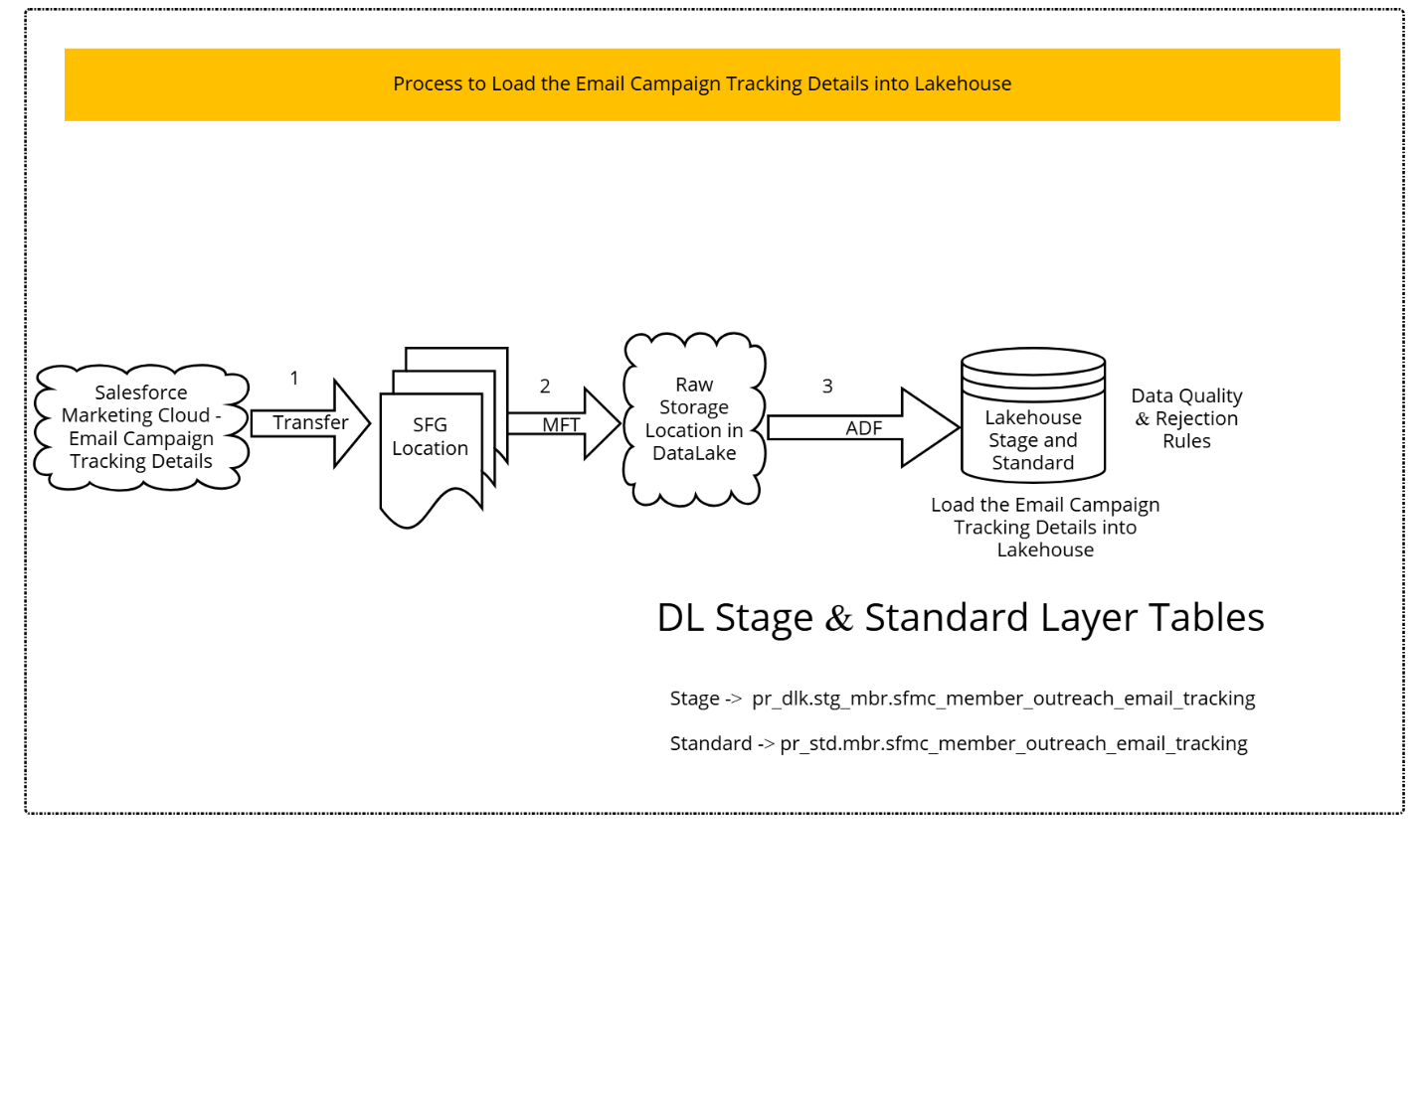

- Stakeholder Signoff
Approver Name | Date | Signature/Proof
Phani Polapragada
Ananth Vijapurapu
- Appendix
  - Definitions and Acronyms
Acronym | Definition
EDO | Enterprise Data Office
LOB | Line of Business
ADF | Azure Data Factory
SFG | Sterling File Gateway
SFMC | Salesforce Marketing Cloud
ACFC | AmeriHealth Caritas  Family of Companies
MCO | Managed Care Organization
  - Reference Documents
Document Name | Description | Network Path | Attachment
STTM_MMCC_Email_Campaign_Tracking_Ingestion_Lakehouse_1005310.xlsx | SFMC – Email CampaignTracking /Interactions ingestions into Lakehouse | https://amerihealthcaritas.sharepoint.com/:x:/r/sites/EnterpriseDataOffice/ProjectDocumentsRepository/STTM_MMCC_Email_Campaign_Tracking_Ingestion_Lakehouse_1005310.xlsx?d=wb98ab64182c2477d985759317c5b5d3e&csf=1&web=1&e=lNZBPh

- Revision History

Date | Version | Author(s) | Description of Version/Changes
06/10/2026 | Initial Draft | Hemanth Julapalli V | Initial Version

