IS Methodology



Requirements Document

Project Methodology Used: Waterfall lite
Project Platform Used: None
Project Name: Payment Integrity - TPL Inbound files ingestion to DL
Project ID: 1005034 – Payment Integrity Redesign

Contents
1 Introduction 3
1.1 Business Context 3
1.2 In Scope 3
1.3 Out of Scope 3
1.4 Assumptions, Constraints & Dependencies 3
1.5 Intended Audience 4
2 Business Context 5
2.1 Current State Business Process Models 5
2.2 Current State Business Interaction Model 5
2.3 Limitations of Current State Business Processes and Systems 5
3 Requirements 6
3.1 TPL CAQH Files to Data Lake Requirements 6
3.2 Data Ingestion Requirements 9
4 Solution Context 18
4.1 Future State Business Processes 18
4.2 Solution Context Diagram 18
4.3 Solution Overview 18
5 Stakeholder Signoff 19
6 Appendix 20
6.1 Definitions and Acronyms 20
7 Revision History 20

- Introduction
  - Business Context
Efficient solution to enable end-to-end traceability of the member data across multiple source systems. Currently, processed data is available in the on Prem systems (Facets) business users lack visibility into the original source files and data lineage resulting on high manual efforts to retrieve historical data from archived folders.

To address this gap, approach is to ingest all the raw source files (From state, Third party vendors) into centralized data lake similar to existing EDI dashboard framework.

  - In Scope
- CAQH TPL Inbound Files ingestion into DL
CAQH (Council for Affordable Quality Healthcare) Vendor
The CAQH Coordination of Benefits (COB) solution, which handles Third Party Liability (TPL) for Medicaid and commercial payers, primarily focuses on real-time verification and identification of coverage overlaps nationwide
- Expose the data to On Prem TPL Application.
  - Out of Scope
- Following Files Ingestion
  - Acknowledge Files
  - State/ CAQH / Syrtis Error Files
  - TPL Outbound Files
  - Retro TPL Files
  - HMS/ DHP Recovery Claims
- TPL Dashboard build, Web Based front-end application
- Vendors other than listed in the ‘In Scope’
  - Assumptions, Constraints & Dependencies

ID # | Name | Description | ACD Type
1 | Connectivity | SFG connectivity between vendors and ACFC are already established. | Assumptions
2 2 | Data Format Compatibility | The data from the various sources can be transformed into a format compatible with DL 2.0 | Assumptions
3 3 | Consistent Data Sources | Data sources will remain consistent and accessible. | Assumptions
4 4 | QA testing scope | Source systems have limited lower environments with masked data. QA team will need to work with developers/ Architects to perform QA testing in masked environment. | Constraint
5 5 | UAT signoff | The team is expected to provide UAT signoff on the test results shared by QA team on QA data for the requirement to be finalized as per the change management process. | Dependency
6 6 | Data Source Availability | The availability and reliability of data sources are critical. Any changes or downtime in these sources can impact the automation process. | Dependencies
7 7 | Data Quality Rules | Any data quality rules outside business/ consumer requirements to be documented separately by Data quality team. | Assumptions
8 8 | Masking | Files should be masked prior to performing Dev & QA testing. Files masking request can be submitted to ‘DL-ACFC: IS QACoE Delphix Admin’. ETA for masking is 2 weeks. | Dependencies
9 9 | Access | Access requests to DL 2.0 will be provided by data owner based on ticketing process. | Assumptions

  - Intended Audience

Name | Role | Title | Department
Jagtap, Pallavi | Reviewer | Director | Data Products
Tumuluri, Chaitanya | Approver | Mgr Information Services | ECA
Mahesh Nallamala | Approver | Sr Architect | Data Products
Vinod Shinde | Approver | Mgr, Enterprise Solution Architect | Data Products
Iyer, Vidya | Approver | Director | Data Governance and Quality
Horton, Angela | Reviewer | Mgr, Enterprise Solution Architect | Data Governance

- Business Context
  - Current State Business Process Models
Current Process Flow (As-Is)

Member TPL (Third Party Liability) Data is received from multiple sources (State systems, Third party Vendors like CAQH, Syrtis). Files arrive in different formats and frequencies. Source files are archived in shared drive/archival location (O Drive). Currently there is no structured indexing or searchable repository, Business users request for member origin details to identify the source system, data changes. IS team searches files manually from the archived share drives which takes long time to retrieve.

  - Current State Business Interaction Model

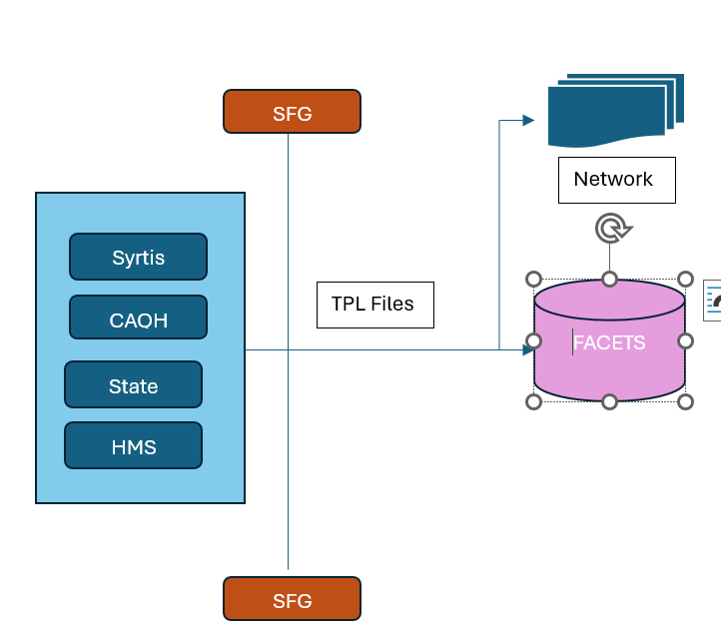

  - Limitations of Current State Business Processes and Systems
- Time consuming file retrieval process
- No complete member view to easily trace the source file origin.
- Manual processes cannot handle increasing data volumes.

- Requirements
  - TPL CAQH Files to Data Lake Requirements

    - Solution Requirements
Solution Requirement: SRQ226433
Name | TPL vendor CAQH Files ingestion
Description | CAQH performs real-time verification and identification of coverage overlaps nationwide and shares the data to ACFC via SFG
Functional Requirement | CAQH vendor sends the TPL information for ACFC members on Weekly basis. These files should be loaded into Data Lake. The File layout for CAQH files across the LOBs is unified. Detailed requirements for CAQH files are under Data Ingestion Requirements.
Impact Details
Solution Acceptance Criteria | All the CAQH files should be loaded into Data Lake as is.  History files upto 3 years should be loaded into Data Lake.  History files start Date & file location:  The data should be accessible when queried from Web Based TPL Application.
Priority | Medium | Medium | Medium
Traced/Related Requirements
IS Owner | EDO - DL
Notes | PA Weekly file Volume: ~10k in a file.

    - Business Rules

Business Rule ID: BR226408
Name | Users should be able to view Raw Data via on-Prem TPL Web application
Description | All the TPL Inbound Files should be searched for the given input member ID
Source | Data Lake
Traced/Related Requirements

    - System Interface Requirements
System Interface Requirement ID: SIR226434
Name | Connectivity with on Prem TPL Database
Priority | Medium
Description | ​TPL team developed Application will connect to DL and query the tables based on user inputs. Following are the Input parameters that user will provide and based on which query will be framed and executed in the DL The data set will be displayed back to the user in the UI screen (Read Only).  - Member ID  - File Type  - LOB  - Date Range
Transaction Volume |  | No of Users
Solution Acceptance Criteria | Connection between Data Lake and On Prem Application should be established and Application should be able to extract data from Data Lake based on user inputs.

    - User Interface Requirements

None
    - Non-Functional Requirements
      - Security
Security Requirement ID: NFR226414
Name | <Security Requirement>
Description | ​

      - Disaster Recovery
Disaster Recovery Plan Requirement ID: NFR226421
Name | <Disaster Recovery Plan>
Description | ​

      - Data Migration
Data Migration Requirement ID: NFR226418
Name | <Data Migration>
Description | ​

      - Data Management
Data Management Requirement ID: NFR226420
Name | <Data Management>
Description | ​

      - Legal Regulatory
Legal Regulatory Requirement ID: NFR226419
Name | <Legal/Regulatory Requirement>
Description | ​

      - Performance
Performance Requirement ID: NFR226415
Name | Data retrieval from DL to On Prem Application
Description | Data lake is primarily for data storage. Proper solution should be implemented to minimize latency.

      - Supportability
Supportability Requirement ID: NFR226417
Name | ODBC Connection
Description | ​Connection between Data Lake and TPL On Prem SQL Server should be established.  On Prem SQL Server:

      - Software Quality Attributes
Software Quality Attribute Requirement ID: NFR226416
Name | <Software Quality Attribute>
Description | ​

      - Other
Other Requirement ID: NFR226422
Name | <Other Requirement>
Description | ​

  - Data Ingestion Requirements
      - Source Metadata
Descriptive Metadata
Name | CAQH Files Metadata
Description | CAQH sends Member Third party liability coverage details for ACFC Lines of business in different frequencies.
Functional Requirement | - SFG process should pick the file based on the file naming convention and place in the ADLS location.  - Build ETL Process to pick multiple LOB files from ADLS location. Process should validate the source file naming convention and be able to support text files. Duplicate file name check shall be turned off as vendor may re-send the corrected file with same file name.  - Files are pipe delimited and contain incremental changes.  - Process shall fail when file layout is not as per source dictionary.  - Files are received for different Lines of business and following LOB field should be mapped to ‘Payer Area’ field.  LOB_ID  - File should be loaded before business hours 8 AM. Files received during business hours should be loaded after 5 PM.  - Process should be able to handle historical files.
Descriptive Metadata | Data Source | CAQH
Descriptive Metadata | Object Name | File Names:  YYYYMMDD_1022_1340_COBReport_*_P_I_1_T.txt  YYYYMMDD_1022_1341_COBReport_*_P_I_1_T.txt  YYYYMMDD_1022_1342_COBReport_*_P_I_1_T.txt  YYYYMMDD_1022_1343_COBReport_*_P_I_1_T.txt  YYYYMMDD_1022_1364_COBReport_*_P_I_1_T.txt  YYYYMMDD_1022_1356_COBReport_*_P_I_1_T.txt  YYYYMMDD_1022_1357_COBReport_*_P_I_1_T.txt  YYYYMMDD_1022_1345_COBReport_*_P_I_1_T.txt  YYYYMMDD_1022_1346_COBReport_*_P_I_1_T.txt  YYYYMMDD_1022_1347_COBReport_*_P_I_1_T.txt  YYYYMMDD_1022_1355_COBReport_*_P_I_1_T.txt  YYYYMMDD_1022_1353_COBReport_*_P_I_1_T.txt  YYYYMMDD_1022_1352_COBReport_*_P_I_1_T.txt  YYYYMMDD_1022_1354_COBReport_*_P_I_1_T.txt  YYYYMMDD_1022_1358_COBReport_*_P_I_1_T.txt  YYYYMMDD_1022_1359_COBReport_*_P_I_1_T.txt  YYYYMMDD_1022_1362_COBReport_*_P_I_1_T.txt  YYYYMMDD_1022_1363_COBReport_*_P_I_1_T.txt
Descriptive Metadata | Description | File contains member coverage details.
Descriptive Metadata | Frequency | Weekly Monday 8 PM
Descriptive Metadata | LOBs
  Region | LOB
  REG#1 | 0100
  REG#1 | 0500
  REG#1 | 0530
  REG#1 | 0540
  REG#1 | 0550
  REG#1 | 2400
  REG#1 | 7100
  REG#1 | 7200
  REG#2 | 0900
  REG#2 | 5400
  REG#5 | 1200
  REG#5 | 2600
  REG#6 | 6400
  REG#6 | 7700
Descriptive Metadata | Tags/Keywords | TPL
Descriptive Metadata | Government Program | Medicaid
Descriptive Metadata | Inbound Ingestion | Y
Descriptive Metadata | SFG template (Y/N) | Y
Descriptive Metadata | SR# for SFG Template | TBD
Descriptive Metadata | Data Catalog Entry | Prod: Z-USE-PR-DLK-DK-01.PR_DLK  Non Prod: Z-USE-D1-DLK-DK-01.D1_DLK,  Z-USE-Q1-DLK-DK-01.Q1_DLK
Impact Details | Compare the history files layout with current layout.
Solution Acceptance Criteria | - ETL process should pick the files from ADLS based on file naming convention.  - File should be mapped for header, detail and trailer records.  - Process should validate the source metadata as per Source Dictionary provided in the Mapping document.
Traced/Related Requirements
IS Owner | Data Lake

    - Structural Metadata
Structural Metadata: MDST231070
Name | CAQH Structural Metadata
Description | Organization of the metadata
Functional Requirement | CAQH files are text files and contain Weekly changes.  The File contains:  Header record  Detail records with field names  Trailer record
Structural Metadata | Object/data Format | Pipe Delimited (|) Text format (.txt)
Structural Metadata | Target Schema | Workspace: Z-USE-PR-DLK-DK-01  Catalog: pr_dlk  Schema: stg_mbr
Structural Metadata | Target Table Name | EXT_TPL_CAQH_HDR  EXT_TPL_CAQH_DTL  EXT_TPL_CAQH_TRL  EXT_TPL_CAQH_DTL_RECYCLE
Structural Metadata | Domain and Subdomain | Domain: Member  Sub Domain: Third Party Liability
Structural Metadata | Load Strategy STG | Truncate and Load
Structural Metadata | Load Strategy STD | Append
Structural Metadata | Load Strategy Consumption (EDH, BSL) | Not Applicable
Structural Metadata | Archive Schedule | Files: 7 Years  Data: Corporate retention schedule
Structural Metadata | Source Data Dictionary | Refer CAQH STTM
Structural Metadata | ADLS Location | mftlanding/inbound/member/tpl/caqh
Structural Metadata | Inbound File Folder Path | Incremental Files: Not Applicable as file is received via SFG.  History files: One time movement from O drive to ADLS location based on start date to be provided by Source team.
Impact Details | Header and trailer records ingestion is required
Solution Acceptance Criteria | - Tables should be available in the target schemas. Metadata of the tables is provided in the STTM.  - Header, Detail, Trailer data should be mapped to respective HDR, DTL and TRL tables.  - Data Type of the fields in Stage and standard should be STRING except for audit date fields.  - Tables should follow data load strategy as given above.  - Member ID validation should be performed against Facets for existence.
Traced/Related Requirements
IS Owner | EDO - DL

    - Administrative Metadata
Administrative Metadata: MDA231068
Name | Administrative Metadata
Description | Management and controls
Functional Requirement | Data should be maintained in the Data Lake with proper governance and controls.
Administrative Metadata | Business Owner | David Malec, Dir Third Party LS • Ops TPL & Subrogation
Administrative Metadata | Technical Owner | EDO – DL:  Gokaraju, Nataraj <ngokaraju@amerihealthcaritas.com>;  Shinde, Vinod <vshinde@amerihealthcaritas.com>  Nallamala, Mahesh mnallamala@amerihealthcaritas.com  Bari, Nikshit <nbari@amerihealthcaritas.com>;
Administrative Metadata | Business Steward (SMEs) | TPL:  Majid, Wajiha wmajid@amerihealthcaritas.com  EDO – DL:  Jagtap, Pallavi <pjagtap1@amerihealthcaritas.com>
Administrative Metadata | Technical Steward (SMEs) | TPL:  Tumuluri, Chaitanya <ctumuluri@amerihealthcaritas.com>; Ramineni, Sridhar <sramineni@amerihealthcaritas.com>; Penimatsa, Raju <rpenimatsa@amerihealthcaritas.com>
Administrative Metadata | Contact Information (Internal) | 1.DL-ACFC: TPL File Distribution DLACFCTPLFILEDISTRIBUTION@amerihealthcaritas.com  2.DL-ACFC: TPL Production Support Team DLACFCTPLProductionSupportTeam@amerihealthcaritas.com
Administrative Metadata | Contact Information (External) | All the queries are sent via Business owner
Administrative Metadata | Data Custodian | Gokaraju, Nataraj <ngokaraju@amerihealthcaritas.com>;
Administrative Metadata | Access Rights/Permissions | DL-ACFC: EDO Cloud Data Platform Team
Administrative Metadata | Access Exclusions | None
Administrative Metadata | Record Retention Schedule | 7 Years
Impact Details
Solution Acceptance Criteria | Every file must carry metadata indicating business/ technical owner for traceability.
Traced/Related Requirements
IS Owner | ECA and EDO

    - Technical Metadata
Technical Metadata: MDT231141
Name | Technical Metadata
Description | Details of how the data is processed and mapped
Functional Requirement | File should get processed into data lake and below is high level flow  - Tidal will trigger the ETL Process based on the frequency configured.  - Process will pick the files from SFG transferred ADLS location  - File will be read based on delimiter and the source attributes will be mapped to Target fields.  - Audit fields – Source File Name, Load date, Update date will be populated for each record in the target table.  - Map LOB_ID = ‘Payer Area’. File_Type = CAQH.  - Member ID validation will be performed against facets_member table for existence. Invalid records will be moved to Recycle table.  - No Transformation: Process should load the files AS-IS after Member ID validation and should not perform any data transformation while loading into Data Lake.  - Post successful file load, file will be moved to Archive location.  - Success and Failure Notification will be sent to the Source Prod Support team. DL is Provided in the Admin Metadata. Standard email template to be used.
Technical Metadata | Business Rules | LOB ID and File Name should be captured in the target table. Data should be loaded AS IS into STG and STD.
Technical Metadata | Filter Criteria | None
Technical Metadata | Data Definitions | Refer CAQH STTM
Technical Metadata | Critical Data Elements | Medicaid Id
Technical Metadata | PII Fields | Refer CAQH STTM
Technical Metadata | Transformation Logic | None
Technical Metadata | Business Key | None
Technical Metadata | Primary Key | None
Technical Metadata | Foreign Key(s) | None
Technical Metadata | Unique Key(s) | None
Technical Metadata | Service Level Agreement | 24 Hours
 | Link to STTM | STTM_STG_STD_PaymentIntegrity_TPL_CAQH_To_DL_Mapping_Document_1005034__.xlsx
Impact Details
Solution Acceptance Criteria | File data should be loaded into respective target fields in Data Lake based on the source to target mapping sheet.  - Process should get triggered based on the file frequency with buffer time for file arrival.  - Process should perform Member ID check against facets and load only valid records into details table. Invalid records shall be moved to Recycle table  - Process should populate source File name, Load timestamp, LOB ID, File type fields in the Target tables.  - Send email notification email post Job completion.
Traced/Related Requirements
IS Owner | EDO - DL

    - Data Quality
Data Quality: MDDQ231071
Name | Data Quality
Description | How accurately, completely, and reliably raw, multi-format data is stored and managed
Functional Requirement | Perform Member Id validation for existence against the Facets_Member table in the Stage layer.  If Member doesn’t exist, then move the record to RECYCLE table.
 | Uniqueness/Duplicate Record check/reject (HARD - In pipeline) | None
 | Incomplete Record Rejection Process (HARD - In pipeline) | None
 | Record Recycle Process (HARD - In pipeline) | Yes. 15 Days.
 | Accuracy (Only for BSL and EDH) | None
 | Validity (Only for BSL and EDH) | None
 | Consistency (Only for BSL and EDH) | None
 | Completeness (Only for BSL and EDH) | None
 | Alert Notification distribution list/names (Only for BSL and EDH) | None
Impact Details | None
Solution Acceptance Criteria | Load member records into target table after Member ID validation. Invalid member records should be recycled up to 15 days.
Traced/Related Requirements | None
IS Owner | EDO - DL

    - Vendor Metadata
Vendor Metadata: MDV231142
Name | Vendor Metadata
Description | External Vendor/3rd party details
Functional Requirement | Maintain the vendor details for each file for traceability.
Vendor Metadata | Vendor Name | Council for Affordable Quality Healthcare
Vendor Metadata | Vendor Abbreviation | CAQH
Vendor Metadata | Vendor Relationship Manager | DL-ACFC: TPL File Distribution
Vendor Metadata | Service Grouping | CAQH (Council for Affordable Quality Healthcare) is a non-profit organization that streamlines administrative processes between healthcare providers and insurance companies. It primarily provides a centralized database—the CAQH Provider Data Portal—where medical professionals can submit their credentials once to be shared with multiple authorized health plans, drastically reducing paperwork
Vendor Metadata | Data Type | Member Third Party Liability details provides health plans with COB data to help identify overlapping coverage and process claims correctly before payment.
Vendor Metadata | Vendor Type Agreement
Vendor Metadata | Delegated Entity
Impact Details
Solution Acceptance Criteria | Vendor details should be maintained in the DL for each file ingestion.
Traced/Related Requirements
IS Owner | EDO - DL

- Solution Context
  - Future State Business Processes
The Future State solution will utilize data lake to store data and files. Business users will be able to query the data from On prem application to Data lake to view TPL member raw data.

  - Solution Context Diagram

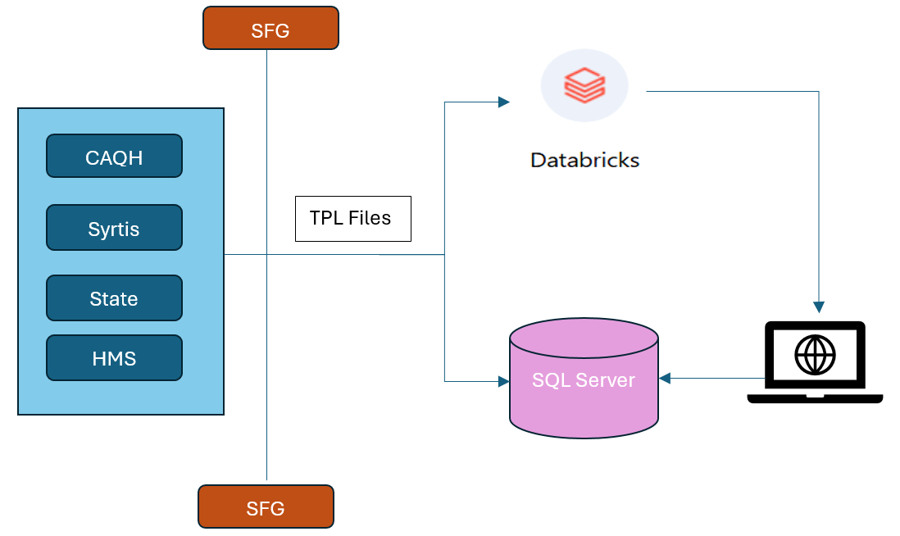
  - Solution Overview
TPL Vendor and state files coming via SFG are landed in the Azure Data Lake Storage (ADLS). There are around 100 files with 15 layouts that will land into ADLS Location based on file frequency.
Databricks ETL process will pick the files from ADLS location and process as per metadata entries and load into Target schema tables.

TPL Web Application will be built by ECA team to access this data. Business users will query member data using this UI interface. Based on the input, data will be retrieved from Data Lake and displayed to Users. This will reduce time consuming process of checking the files manually.

- Stakeholder Signoff
Approver Name | Date | Signature/Proof

- Appendix
  - Definitions and Acronyms
Acronym | Description
CAQH | Council for Affordable Quality Healthcare
HMS | Health Management Systems, Inc., a company specializing in Third-Party Liability (TPL) and Coordination of Benefits (COB) services for government and commercial healthcare plans. HMS works with states and health plans to identify other, often private, insurance coverage that should pay before Medicaid or other primary payers.
Syrtis | Syrtis Solutions, known for its ProTPL platform and Coverage Verify service, specializes in prospective Third-Party Liability (TPL) cost avoidance for pharmacy and medical claims.
TPL | Third Party Liability
ETL | Extract Transform Load
SFG | Sterling File Gateway

- Revision History

Date | Version | Author(s) | Description of Version/Changes
6/5/2026 | 1.0 | Suchitra | Created for TPL Inbound file ingestion

