PrepPath
Software Design Document
Version | 1.0 — Hackathon MVP
Context | Internal hackathon — interview tracking within the organisation
Frontend | React (Vite)
Backend | Python FastAPI
LLM Provider | Groq API — open source models
Database | SQLite (dev) / PostgreSQL (demo)

This document describes PrepPath: an internal tool for tracking and preparing candidates for interviews within the organisation. It covers architecture, user roles, AI agents, channel progression, and the question difficulty system.

1. Purpose
PrepPath is an internal interview preparation and tracking tool. It assigns candidates to structured learning paths, mentors them through an AI chat interface, and tracks their readiness for client or internal interviews. Managers (Executives) can see all candidates and their readiness status in one place.

It is not a job board or recruitment tool. It tracks preparation quality, not hiring decisions.

1.1 Users
Role | What they do
Executive | Views the dashboard. Sees all candidates, their current level, readiness score, and interview-ready status. Read-only.
Feeder | Creates and publishes interview preparation paths. Assigns paths to candidates.
Candidate | Takes tests, chats with the Mentor AI, runs mock interviews, tracks their own progress.

2. Architecture
Five layers. Each has one responsibility. The React frontend talks only to the FastAPI backend. LLM calls happen only in the AI agents layer.

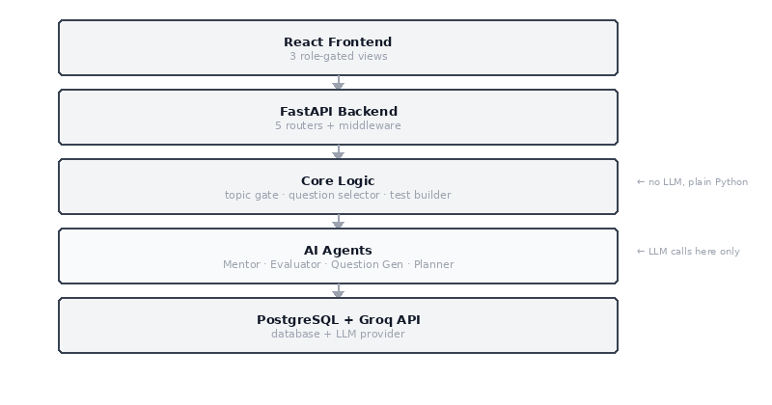
Figure 1 — System layers

Layer | Role
React Frontend | Single-page app. Three views gated by role. Communicates with the backend over HTTP and WebSocket for streaming.
FastAPI Backend | Five routers. Orchestrates all logic. Calls agents and core modules. Reads and writes to the database.
Core Logic | Plain Python. No LLM. Topic gate, question selector, preliminary test builder. Fast enough to run on every chat turn.
AI Agents | Four modules backed by Groq-hosted open source models. Called synchronously (no task queue).
Data | PostgreSQL. In-process dict for session cache. Groq API for LLM.

3. Frontend — React (Vite + TypeScript)
One React app, three views. Role is read from the JWT on login and routes are protected accordingly.

Route | Role | Purpose
/dashboard | Executive | Table of all candidates: name, channel, readiness score, interview-ready badge. Click a candidate to see their history.
/pipeline | Feeder | Create and edit interview paths. Add sections, concepts, evaluation patterns, seed questions. Publish button triggers question generation.
/chat | Candidate | Mentor chat window with streaming. Shows current concept and a topic coverage progress bar.
/test | Candidate | Preliminary test on first visit. Used for all advancement assessments. Shows results and feedback after submit.
/mock | Candidate | Interview simulation. Mentor acts as interviewer. Debrief shown at the end.
/progress | Candidate | Read-only view: current channel, covered concepts, gaps, strengths, readiness score.

4. Backend — FastAPI routers

Key endpoints
Endpoint | What it does
PUT /candidates/{id}/pipeline | Assign a path. Triggers preliminary test build and Plan Gen Agent.
POST /pipelines/{id}/publish | Publish a path. Triggers Question Gen Agent to expand seeds into question bank.
POST /sessions/{id}/chat | Main chat turn. Calls Mentor Agent, parses signal tag, updates topic gate, fires Evaluator if gate triggers.
GET /sessions/{id}/gate-status | Returns topic coverage % — polled by the progress bar in /chat.
POST /assessments/{id}/submit | Submit test answers. Calls Evaluator Agent. Writes channel + level + gaps back to candidate.
GET /candidates/{id}/progress | Full progress data for /progress view and Executive dashboard.

All routes require a JWT. Role guards are enforced per endpoint — a Candidate cannot call pipeline endpoints; a Feeder cannot call session endpoints.

5. AI agents
Four agents. All are Python modules called directly (no queue). Each makes one synchronous HTTP call to the Groq API.

Model choices: llama-3.3-70b-versatile for reasoning-heavy agents (Mentor, Question Gen, Plan Gen). llama-3.1-8b-instant for the Evaluator — it only needs to parse structured answers and return JSON, so a smaller faster model is appropriate.

Agent | Model | Triggered by | What it does
Mentor Agent | llama-3.3-70b-versatile (streaming) | Every chat turn | Reads channel, gaps, strengths, candidate plan, section context. Picks a teaching technique. Appends a hidden <signal> tag with concept_tag and answer quality. Does NOT plan — only executes.
Evaluator Agent | llama-3.1-8b-instant (non-streaming) | On test submit, topic gate fire, mock end | Marks answers against the rubric. Returns JSON: { level, channel, gaps[], strengths[], scores }. The ONLY place channel is assigned.
Question Gen Agent | llama-3.3-70b-versatile (non-streaming) | On path publish | Expands each seed question into 9 variants (3 bands × 3 types). Generates rubrics in the same run. Tags every question with concept_tag, difficulty_band, seniority.
Plan Gen Agent | llama-3.3-70b-versatile (non-streaming) | Once per candidate-path assignment | Reads preliminary test results. Creates a personalised plan: section order, concept emphasis, pattern emphasis, difficulty starting points per concept.

5.1 Groq API configuration
# .env
GROQ_API_KEY=gsk_...
GROQ_BASE_URL=https://api.groq.com/openai/v1

# agents/base.py — shared client
from groq import Groq
client = Groq(api_key=os.environ["GROQ_API_KEY"])

Groq exposes an OpenAI-compatible API. Streaming is supported on all models. Switching models requires only changing the model string in the agent file.

6. Candidate journey
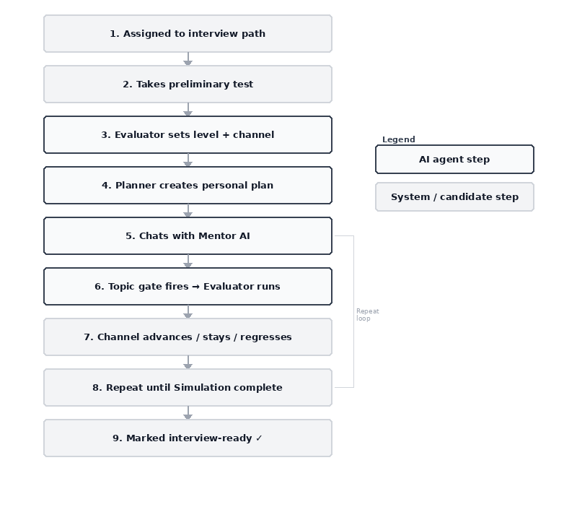
Figure 2 — Candidate journey from assignment to interview-ready

7. Channel progression
Candidates move through three progression channels. Channel assignment is done exclusively by the Evaluator Agent after every assessment.

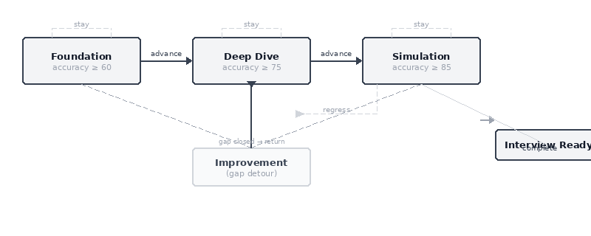
Figure 3 — Channel progression and transitions

Channel | Advancement threshold | Behaviour
Foundation | accuracy ≥ 60, fluency ≥ 50 | Mentor teaches before testing. Scaffolding and analogies. No time pressure. Goal: concept coverage at basic correctness.
Deep Dive | accuracy ≥ 75, depth ≥ 65, fluency ≥ 65 | Mentor challenges with Socratic probing and constraint injection. Goal: trade-off reasoning and edge-case awareness.
Simulation | accuracy ≥ 85, depth ≥ 80, fluency ≥ 75 | Mentor acts as interviewer. No hints. Time pressure. Debrief only at the end. Sets interview_ready = True on completion.
Improvement | Triggered from any channel | Detour — not a progression step. Targets specific gap concepts. Candidate returns to previous channel when gaps close. Tracked via pre_improvement_channel column.

Regression is supported. Deep Dive can drop back to Foundation if accuracy falls below 55. Simulation can drop back to Deep Dive on significant regression.

8. Topic gate and chat turn sequence
The topic gate is the mechanism that decides when to trigger an assessment. It is plain Python — no LLM. It fires when two conditions are both true:
- session.answer_count >= 3 (safety floor — prevents firing on one lucky answer)
- set(covered_concepts) contains all of set(required_concepts)

For the Improvement channel, required_concepts is set to only the gap concepts. When those are covered, the candidate returns to their previous channel.

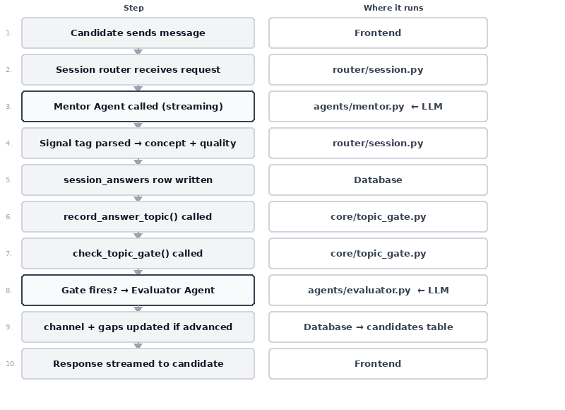
Figure 4 — What happens on each chat turn

9. Question difficulty

Three bands
Band | Definition
foundational | Recall and basic comprehension. Single concept, unambiguous answer, under 60 seconds.
deepdive | Application and analysis. Multi-step reasoning, at least one trade-off named.
interview_ready | Synthesis and evaluation. Ambiguous framing, time pressure implied, interviewer style.

Band selection at runtime
select_band() in core/question_selector.py decides which band to pull for each turn — no LLM:
- Simulation → always interview_ready
- Improvement → always foundational
- First attempt at a concept → one step below channel ceiling
- Wrong or partial → back to foundational
- Correct on second attempt → ceiling band for this channel

Repetition prevention
- Layer 1 — session exclusion: never repeat a question in the same sitting (in-memory set, zero DB cost).
- Layer 2 — history exclusion: skip questions the candidate already answered correctly (one DB read).
- Fallback: if pool empty, drop history filter. If still empty, Mentor asks freeform.

10. Database
Table | Key columns
users | id, email, name, role, hashed_pw
candidates | id, user_id, path_id, plan_id, channel, level, gaps[], strengths[], pre_improvement_channel, interview_ready, readiness_score
learning_paths | id, name, target_role, seniority, tech_stack[], description, status
sections | id, path_id, name, description, order_index, core_concepts[]
eval_patterns | id, section_id, name, description, sample_patterns[]
questions | id, section_id, pattern_id, concept_tag, difficulty_band, seniority, pattern_type, text, is_preliminary, status
rubrics | id, section_id, pattern_id, seniority, correct_criteria, partial_criteria, disqualifiers
sessions | id, candidate_id, section_id, covered_concepts[], required_concepts[], answer_count, status
session_answers | id, session_id, question_id, candidate_text, quality, concept_tag
assessments | id, candidate_id, trigger, level_assigned, channel_assigned, gaps[], scores{}, feedback_text
candidate_plans | id, candidate_id, section_order[], concept_weights{}, pattern_weights{}, difficulty_start{}
candidate_question_history | id, candidate_id, question_id, last_quality, times_seen

In-process Python dicts (FastAPI app memory): session_id → last 6 chat turns · session_id → set of question IDs used this session. These reset on server restart — acceptable for a hackathon.

11. Build order
When | What to build
Day 1 AM | DB schema, JWT auth, user and candidate CRUD, role guard middleware.
Day 1 PM | Pipeline router, Feeder view (create path, sections, patterns, seeds, publish), Question Gen Agent — verify questions appear in DB.
Day 2 AM | Preliminary test builder, Assessment router, Evaluator Agent, candidate test UI — verify channel and gaps written after submit.
Day 2 PM | Plan Gen Agent, Session router (the orchestrator), Mentor Agent with streaming, topic gate, chat UI with coverage bar.
Day 3 AM | Question selector, question history table, mock interview mode, channel advancement and regression end-to-end.
Day 3 PM | Executive dashboard with interview_ready flag, candidate progress view, demo data, end-to-end test run.

If time runs short: prioritise Mentor Agent (demo centrepiece), then Executive dashboard (business value), then mock interview mode (nice to have).

12. Stack and environment
Component | Technology
Frontend | React 18 + Vite + TypeScript + Tailwind CSS
Backend | Python 3.11 + FastAPI + SQLAlchemy + Uvicorn
LLM | Groq SDK — llama-3.3-70b-versatile + llama-3.1-8b-instant
Database | SQLite (local) / PostgreSQL (demo)
Auth | JWT (python-jose) + bcrypt

# Required .env variables
GROQ_API_KEY=gsk_...
DATABASE_URL=sqlite:///./preppath.db
JWT_SECRET=your-secret
VITE_API_URL=http://localhost:8000

— end of document —

