A SUMMER INTERNSHIP REPORT
ON
MAGICPIN AI AGENT – CONTEXT-AWARE
CONVERSATIONAL AI BACKEND

2-Month Summer Internship Report
submitted towards the partial fulfillment of the degree
Bachelor of Technology
By
Arjun Reddy
[Enrollment Number]
Submitted to

Department of Computing and Informatics,
School of Engineering & Sciences,
Sir Padampat Singhania University,
Udaipur, 313601, Rajasthan, India

Chapter -
DECLARATION

I, Arjun Reddy, student of B.Tech. (CSE), hereby declare that the 2-Month Summer Internship project report titled “Magicpin AI Agent – Context-Aware Conversational AI Backend”, submitted to the Department of Computing and Informatics, School of Engineering & Sciences, Sir Padampat Singhania University, Udaipur, Rajasthan, towards the partial fulfillment of the requirement for the award of the degree of Bachelor of Technology, is my original work. The work described in this report has not previously formed the basis for the award of any degree, diploma, or similar academic recognition.
Name and signature of Student: ______________________________
Place: ____________________
Date: _____________________

Chapter -
CERTIFICATE

This is to certify that the 2-Month Summer Internship project entitled “Magicpin AI Agent – Context-Aware Conversational AI Backend” being submitted by Arjun Reddy towards the partial fulfillment of the requirement for the award of the degree of Bachelor of Technology has been carried out under the guidance and supervision of the concerned project/internship guide. The matter embodied in this report has not been submitted, in part or in full, to any other university or institute for the award of any degree, diploma, or certificate.
External Guide: [Name / Designation / Organization / Address / Website]
Internal Guide: [Name / Designation / Affiliation]
Signature of External Guide: ____________________
Signature of Internal Guide: ____________________

Chapter -
ACKNOWLEDGEMENT

I would like to express my sincere gratitude to my project and internship guides for providing me with the opportunity to work on the Magicpin AI Agent project. Their guidance, feedback, and encouragement helped me understand the practical aspects of backend development, REST API design, LLM integration, context management, persistent storage, testing, and cloud deployment.
I also express my gratitude to the Department of Computing and Informatics, School of Engineering & Sciences, Sir Padampat Singhania University, for providing the academic environment and resources required to complete this work. Finally, I thank everyone who supported me during the development and documentation of the project.
Arjun Reddy
[Enrollment Number]

Chapter -
ABSTRACT

The Magicpin AI Agent is a context-aware conversational AI backend designed to demonstrate how a large language model can be integrated into a real-world web application through structured APIs, conversation memory, merchant-specific context, and persistent storage. A basic stateless chatbot may treat every user message independently, which can lead to repetitive interactions and generic responses. The proposed system addresses this limitation by maintaining merchant context and conversation history and combining them with the current user query before invoking an LLM.
The backend is implemented using Python and FastAPI. The system follows a modular service-oriented structure containing API routes, context management, conversation memory, prompt construction, LLM integration, response processing, and storage components. PostgreSQL is used for persistence, while Pydantic models provide request validation. The system exposes REST endpoints for saving merchant context, creating conversations, processing chat messages, retrieving conversation history, and performing health checks.
The project was deployed as a web service on Render and can be integrated with an existing website or application through REST APIs. The design also provides a foundation for future extensions such as retrieval-augmented generation, vector databases, tool/function calling, personalization, authentication, monitoring, and scalable cloud infrastructure. The work demonstrates the practical integration of an LLM into a modular backend rather than treating the LLM as an isolated chatbot.

Chapter -
CONTENTS

Right-click and update field to generate the table of contents.

Chapter -
LIST OF FIGURES

List of Figures
Figure No. | Description | Page No.
Figure 4.1 | High-Level System Architecture | [Update]
Figure 4.2 | End-to-End Request Workflow | [Update]
Figure 6.1 | Deployment and Service Integration | [Update]

Chapter -
LIST OF TABLES

List of Tables
Table No. | Description | Page No.
Table 1.1 | Project Objectives | [Update]
Table 3.1 | Tools and Technologies | [Update]
Table 5.1 | Major Software Modules | [Update]
Table 6.1 | Representative Functional Outcomes | [Update]
Table 7.1 | Testing Strategy and Test Areas | [Update]

Chapter -
LIST OF ABBREVIATIONS

List of Abbreviations
Abbreviation | Description
AI | Artificial Intelligence
API | Application Programming Interface
LLM | Large Language Model
REST | Representational State Transfer
HTTP | Hypertext Transfer Protocol
JSON | JavaScript Object Notation
DB | Database
SQL | Structured Query Language
RAG | Retrieval-Augmented Generation
UI | User Interface

Chapter - 1
INTRODUCTION

1.1 Background
Conversational AI systems are increasingly being integrated into websites and business applications to provide natural-language interaction. In a practical marketplace or merchant-oriented application, an AI assistant should not only generate fluent text but should also understand the application context in which the conversation occurs. Merchant information, session information, and previous user messages can significantly affect the relevance of an answer.
The Magicpin AI Agent project focuses on this integration problem. It provides a backend service that can be placed behind a website or application chat interface. The client sends a message to the FastAPI service, and the backend retrieves relevant context and conversation memory, constructs a contextual prompt, communicates with an LLM, processes the generated response, persists conversation information, and returns the result to the client.

1.2 Problem Statement
A basic LLM integration is often stateless: the application sends the current user message to a model and returns the generated answer. Such a design can fail to preserve merchant-specific information or conversational continuity. It also makes it difficult to maintain persistent history, validate requests, separate application logic from model calls, and integrate the AI component into an existing software architecture.

1.3 Objectives and Scope of Work
The primary objective is to implement a modular, context-aware AI backend that can be consumed through REST APIs.
- Store and retrieve merchant-specific context.
- Create and maintain conversation sessions.
- Use conversation history when generating subsequent responses.
- Build structured prompts using context, memory, and the current user message.
- Integrate an LLM through a dedicated service layer.
- Persist relevant application data using PostgreSQL.
- Expose documented REST endpoints through FastAPI and OpenAPI/Swagger.
- Provide a deployable backend service suitable for integration with a website.
The scope includes backend API design, context and memory management, LLM integration, persistence, error handling, testing support, and deployment. The current scope does not claim direct access to Magicpin's production merchant, user, order, payment, or recommendation systems.
Table 1.1: Project Objectives
Objective | Description
Context management | Maintain merchant-specific information used during conversations.
Conversation memory | Maintain session-based conversational continuity.
LLM integration | Generate responses using a dedicated LLM service.
API integration | Expose functionality through REST endpoints.
Persistence | Store application and conversation data in PostgreSQL.
Deployment | Make the backend accessible as a cloud service.

Chapter - 2
LITERATURE REVIEW

2.1 Conversational AI and LLM Applications
Modern conversational applications commonly use LLMs to interpret natural-language input and generate responses. However, an LLM call by itself does not provide an application with reliable access to current business data or the application's own conversation history. Practical systems therefore place application logic around the model to supply the required context and control how responses are generated.
The project follows this general principle by separating the LLM service from context, memory, prompt construction, and API layers. This separation makes the system easier to test, replace, and extend.

2.2 Context and Conversation Memory
Conversation memory provides the model with relevant previous interactions. Context management provides application-specific information, such as merchant identity, category, and location. Combining these sources can reduce repetition and improve continuity. In the implemented design, memory is associated with a conversation session, while merchant context is associated with the merchant.

2.3 REST APIs for AI Integration
REST APIs provide a practical boundary between an AI backend and a website or mobile application. A frontend can send structured JSON requests and receive structured responses without knowing the internal implementation of the LLM service. FastAPI is suitable for this role because it supports type-based request validation and automatic OpenAPI documentation.

2.4 Persistent Storage
Persistent databases are required when conversation and context data must survive application restarts and be shared across service instances. PostgreSQL provides relational persistence and can be extended with indexes, constraints, and additional data models as the application grows.

2.5 Identified Gap and Project Motivation
The project combines these concepts into one modular backend: a website-facing API layer, merchant context, conversation memory, prompt construction, LLM access, response processing, and PostgreSQL persistence. This provides a practical demonstration of how an LLM feature can be incorporated into a conventional web-service architecture.

Chapter - 3
ORGANIZATION / TOOLS & TECHNOLOGY OVERVIEW

3.1 Project / Internship Context
The work documented in this report focuses on the development of the Magicpin AI Agent as an AI-enabled backend project. The application is designed around a merchant-oriented marketplace use case and is structured so that an existing website can consume the AI functionality through REST APIs. Specific internship organization, external guide, and administrative details should be completed according to the official internship records.

3.2 Tools and Technologies
Table 3.1: Tools and Technologies
Technology | Purpose
Python | Primary backend programming language.
FastAPI | REST API framework and request handling.
Pydantic | Request/response data validation.
LLM API / OpenAI Python SDK | Communication with the language model service.
PostgreSQL | Persistent relational storage.
Uvicorn | ASGI server used to run the FastAPI application.
Render | Cloud deployment platform used for the deployed web service.
Git / GitHub | Source-code version control and repository hosting.
Swagger / OpenAPI | API documentation and interactive testing.

3.3 Development Environment
Development was carried out using a Python virtual environment on a Mac development machine. The application was run locally with Uvicorn during development and later deployed as a web service on Render. Environment variables are used for configuration and credentials so that secrets are not hard-coded into application source code.

Chapter - 4
METHODOLOGY / SYSTEM DESIGN

4.1 Design Approach
The system follows a modular backend architecture. The API layer is responsible for receiving and validating requests. Service modules handle context, memory, prompt construction, LLM communication, and response processing. Storage components provide persistence. This separation of concerns allows individual modules to be tested and modified without changing the entire application.
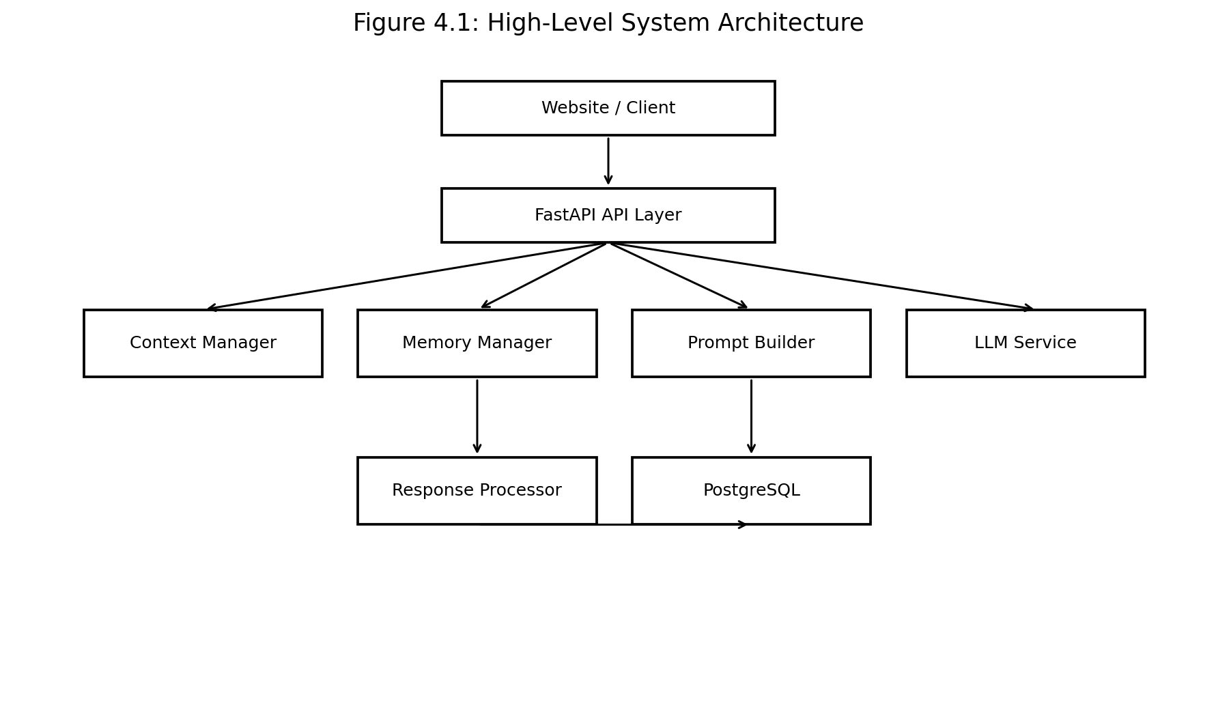
Figure 4.1: High-Level System Architecture

4.2 End-to-End Workflow
When a user sends a chat message, the request is received by the FastAPI endpoint. The application identifies the merchant and conversation session, retrieves the available context and memory, constructs a prompt, sends it to the LLM service, processes the generated response, stores the conversation information, and returns the response to the client.
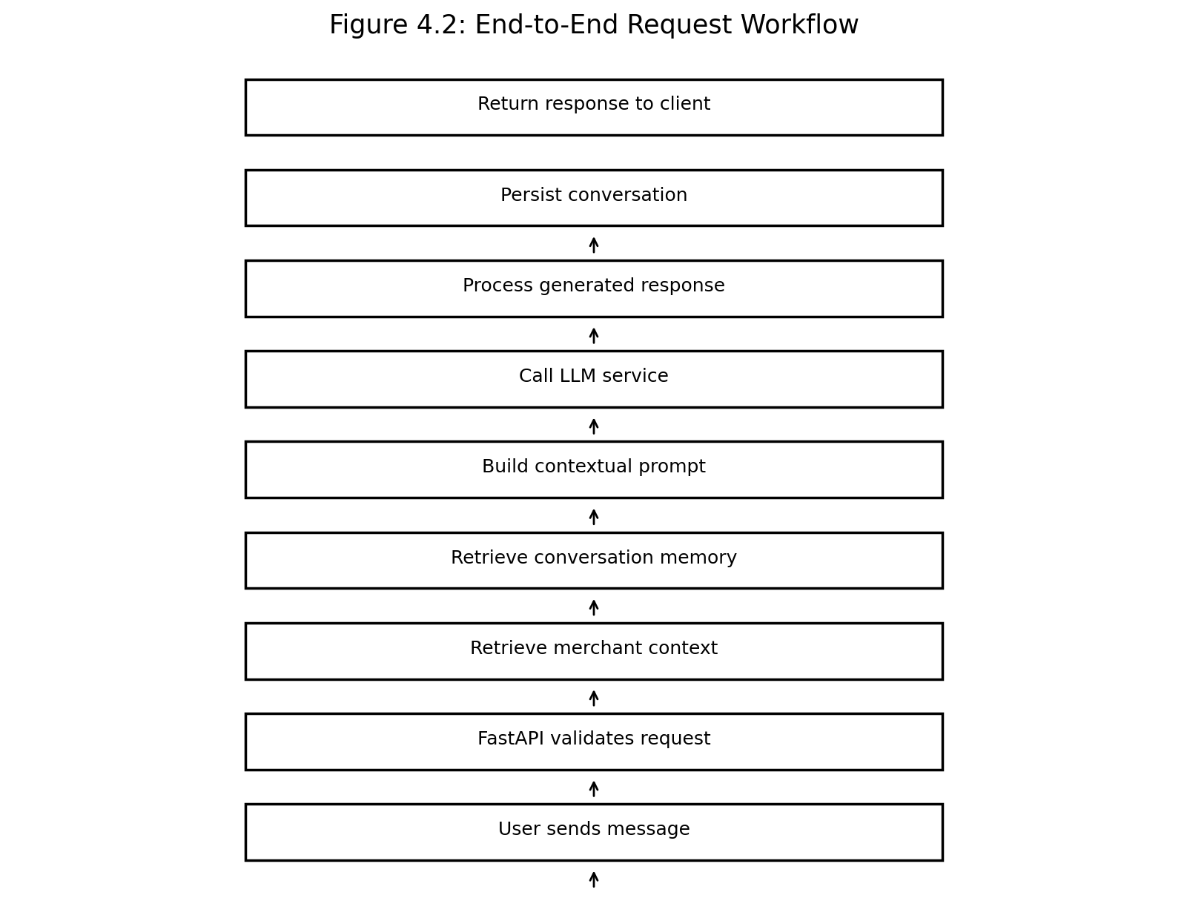
Figure 4.2: End-to-End Request Workflow

4.3 API Design
Table 4.1: Core REST API Endpoints
Endpoint | Purpose
POST /v1/context | Save merchant-specific context.
POST /v1/conversations | Create a conversation session.
POST /v1/chat | Process a user message and generate an AI response.
GET /v1/conversations/{session_id} | Retrieve conversation information/history.
GET /v1/healthz | Check service health.

4.4 Context and Memory Model
Merchant context and conversation memory represent two different sources of information. Merchant context describes relatively stable business information. Conversation memory describes the sequence of interactions within a session. The Prompt Builder combines the relevant portions of both with the current user message before the LLM request is made.

4.5 Website Integration Model
A website can integrate the service by adding a chat interface that sends HTTP requests to the deployed FastAPI backend. The frontend does not need to know how the LLM or database works. It only needs the API contract, including the merchant identifier, conversation session identifier, and user message. The backend remains responsible for context retrieval, memory, prompt construction, LLM communication, and response processing.

Chapter - 5
IMPLEMENTATION

5.1 Project Structure
The implementation is organized into API, service, model, storage, configuration, and utility components. The structure supports separation of concerns and makes it possible to evolve individual parts of the application independently.
Table 5.1: Major Software Modules
Module / Component | Responsibility
api/routes.py | Defines REST API endpoints and coordinates service calls.
api/schemas.py | Defines Pydantic request/response schemas.
services/context_manager.py | Handles merchant context operations.
services/memory_manager.py | Handles conversation memory operations.
services/prompt_builder.py | Constructs prompts from context, memory, and user input.
services/llm_service.py | Encapsulates LLM API communication.
services/response_processor.py | Processes the generated response before returning it.
storage/context_store.py | Provides context storage operations.
storage/conversation_store.py | Provides conversation storage operations.
models/context.py | Represents context data structures.
config.py | Handles application configuration.
utils/logger.py | Provides logging utilities.
main.py | Creates/configures the FastAPI application.

5.2 Merchant Context Implementation
The context endpoint accepts a merchant identifier and a context object. The context can contain fields such as merchant name, category, and city. The Context Manager separates API concerns from storage concerns, allowing the underlying store to be changed without changing the route contract.

5.3 Conversation Implementation
A conversation is created for a merchant and assigned a session identifier. Subsequent chat requests use the session identifier to associate user and assistant messages with the same conversation. This session-based approach enables continuity across multiple requests.

5.4 Prompt Construction
The Prompt Builder prepares the model input using the available merchant context, relevant conversation history, and current user message. The purpose is to give the LLM the application information required to generate a response that is consistent with the conversation.

5.5 LLM Service
The LLM Service encapsulates communication with the selected LLM provider. Keeping this logic in a separate service prevents API routes from becoming tightly coupled to a particular provider and makes it easier to introduce alternative providers in the future.

5.6 Response Processing and Error Handling
The response processor provides a dedicated location for handling model output before it is returned to the client. The application also uses exception handling and logging so that unexpected backend errors can be recorded while the API returns an appropriate HTTP error response instead of exposing internal implementation details.

5.7 Configuration and Security
Sensitive credentials and deployment-specific settings should be provided through environment variables. API keys should not be committed to the Git repository. The deployed service should also use HTTPS, appropriate authentication, rate limiting, and access controls before being exposed to a broad production audience.

Chapter - 6
RESULTS AND DISCUSSION

6.1 Functional Outcome
The implemented backend provides the core workflow required for a context-aware conversational service: merchant context can be stored, conversation sessions can be created, chat requests can be processed, and conversation information can be retrieved. The API is exposed through FastAPI and documented using its OpenAPI/Swagger interface.
Table 6.1: Representative Functional Outcomes
Area | Outcome
Merchant context | API workflow implemented for saving and retrieving context.
Conversation sessions | Session-based conversation workflow implemented.
Chat | LLM-backed chat endpoint implemented.
Memory | Conversation information is associated with a session.
Persistence | PostgreSQL is used as the persistent storage layer.
API documentation | Swagger/OpenAPI interface available through FastAPI.
Cloud deployment | Application deployed as a Render web service.

6.2 Deployment
The application has been deployed as a Render web service. The deployed base address provided for the project is https://magicpin-ai-agent.onrender.com/. The FastAPI Swagger interface is available under the /docs path when the service is running. This deployment model allows a website or other client to communicate with the AI backend over HTTP.
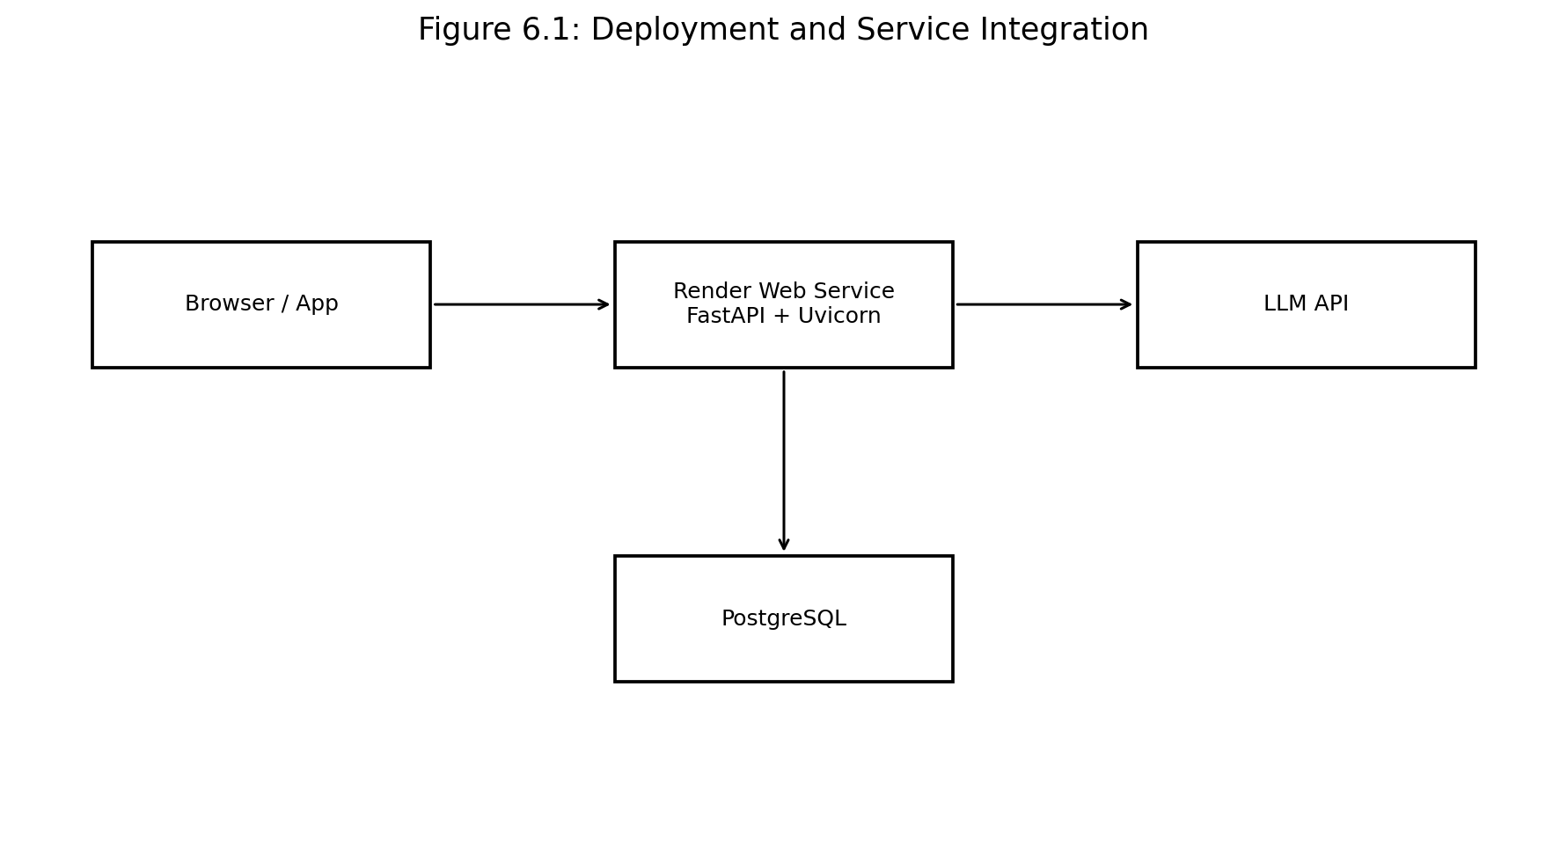
Figure 6.1: Deployment and Service Integration

6.3 Practical Real-World Integration
The project is practical as an AI backend component rather than as a complete marketplace platform. A real website could place a chat widget in its user interface and send requests to the deployed API. The AI service could then be extended with real merchant databases, user profiles, location services, offers, search services, and other application tools. Such integrations would allow the agent to answer questions using live business data rather than only stored demonstration context.

6.4 Discussion
The main engineering value of the project is the separation of the LLM from application-specific context and memory. This makes the design more maintainable than embedding all logic in a single prompt or route. At the same time, production deployment would require additional security, observability, scalability, cost controls, evaluation, and integration with trusted live data sources.

Chapter - 7
TESTING

7.1 Testing Strategy
Testing focuses on API availability, request validation, context operations, conversation creation, chat processing, memory retrieval, error handling, and deployment accessibility. The Swagger/OpenAPI interface provides an interactive method for manually validating the deployed endpoints. Automated tests can additionally be executed with pytest against either the local or deployed service.
Table 7.1: Testing Strategy and Test Areas
Test Area | Validation
Health check | Verify that the service is reachable and the health endpoint responds.
Context creation | Verify that valid merchant context can be submitted.
Conversation creation | Verify that a valid merchant can receive a conversation session.
Chat request | Verify that a valid session and message can be processed.
Conversation continuity | Send multiple messages using the same session and verify continuity.
Conversation retrieval | Verify that session information/history can be retrieved.
Invalid input | Verify that malformed or incomplete requests receive validation errors.
LLM failure handling | Verify that unexpected LLM/API failures are handled without exposing sensitive internals.
Deployment | Verify the Render service and Swagger documentation are reachable.

7.2 Recommended End-to-End Test Sequence
- Call GET /v1/healthz and confirm the service is available.
- Call POST /v1/context with a sample merchant context.
- Call POST /v1/conversations and record the returned session_id.
- Call POST /v1/chat with the merchant_id, session_id, and a first message.
- Send a second message using the same session_id to evaluate conversational continuity.
- Call GET /v1/conversations/{session_id} to inspect the stored conversation.
- Repeat the workflow with invalid inputs to verify error handling.

7.3 Note on the 29-Test Suite
The project discussion included a requirement to execute a 29-test suite. This report does not claim that all 29 tests passed because the final 29-test execution output was not supplied as evidence for this report. Before final submission, the exact pytest output should be captured and the results inserted here. A suitable final statement is: “29/29 tests passed” only after the complete suite has actually been executed successfully against the intended environment.

Chapter - 8
CONCLUSION AND FUTURE SCOPE OF WORK

8.1 Conclusion
The Magicpin AI Agent project demonstrates the practical design and implementation of a context-aware conversational AI backend. The system combines a FastAPI REST interface, merchant context, conversation memory, prompt construction, LLM integration, response processing, and PostgreSQL persistence. The modular architecture separates application logic from model communication and provides a clear integration point for websites and other clients.
The project also demonstrates the difference between a simple LLM call and an application-level AI service. A production-oriented AI feature needs context management, memory, validation, persistence, error handling, deployment, and clear API boundaries in addition to the model itself.

8.2 Future Scope of Work
- Retrieval-Augmented Generation (RAG) for grounding responses in large merchant and business knowledge bases.
- Vector database integration for semantic retrieval of relevant context.
- Tool/function calling for live search, location, offers, availability, and merchant services.
- User personalization using preferences and interaction history.
- Authentication, authorization, rate limiting, and stronger API security.
- Streaming responses for improved conversational user experience.
- Caching and asynchronous processing to improve performance and reduce LLM costs.
- Monitoring, tracing, analytics, and automated evaluation of LLM response quality.
- Multi-provider LLM support and fallback mechanisms.
- Horizontal scaling and production-grade cloud infrastructure.

Chapter -
REFERENCES

[1] S. Yao et al., “ReAct: Synergizing Reasoning and Acting in Language Models,” arXiv preprint arXiv:2210.03629, 2022.
[2] P. Lewis et al., “Retrieval-Augmented Generation for Knowledge-Intensive NLP Tasks,” in Advances in Neural Information Processing Systems, vol. 33, 2020.
[3] S. OpenAI, “OpenAI API Documentation,” OpenAI. [Online]. Available: https://platform.openai.com/docs
[4] S. Ramírez, “FastAPI Documentation,” FastAPI. [Online]. Available: https://fastapi.tiangolo.com/
[5] PostgreSQL Global Development Group, “PostgreSQL Documentation.” [Online]. Available: https://www.postgresql.org/docs/
[6] Render, “Render Documentation.” [Online]. Available: https://render.com/docs
[7] M. Fowler, “Microservices,” Martin Fowler. [Online]. Available: https://martinfowler.com/articles/microservices.html

Chapter -
ANNEXURE

Annexure - I: Monthly Attendance Report
Attach the official monthly attendance report from the biometric system, mentor, or internship coordinator here.
[SPACE RESERVED FOR ATTENDANCE REPORT]

Annexure - II: Feedback Form from Supervisor
Attach the completed feedback form from the supervisor with the required signature and organization stamp here.
[SPACE RESERVED FOR SUPERVISOR FEEDBACK FORM]

Annexure - III: Deployment / API Evidence
Recommended evidence to attach: screenshot of the Render service, Swagger /docs page, health-check response, and selected API request/response screenshots.
Deployed service: https://magicpin-ai-agent.onrender.com/

