

**UNIVERSITY OF PETROLEUM & ENERGY STUDIES**

**Dehradun**

[**Application Containerization Lab**](https://learn.upes.ac.in/webapps/blackboard/execute/launcher?type=Course&id=_49490_1&url=)

**Experiment- 10**

**Name: Aakarshit Agarwal**

**Course: B. TECH CSE DevOps (2018-22)**

**Roll no.: R171218001**

**Sapid: 500067782**

**Experiment-10**

**Aim:-** Working with Metadata,Log File using Docker

1. Adding single label

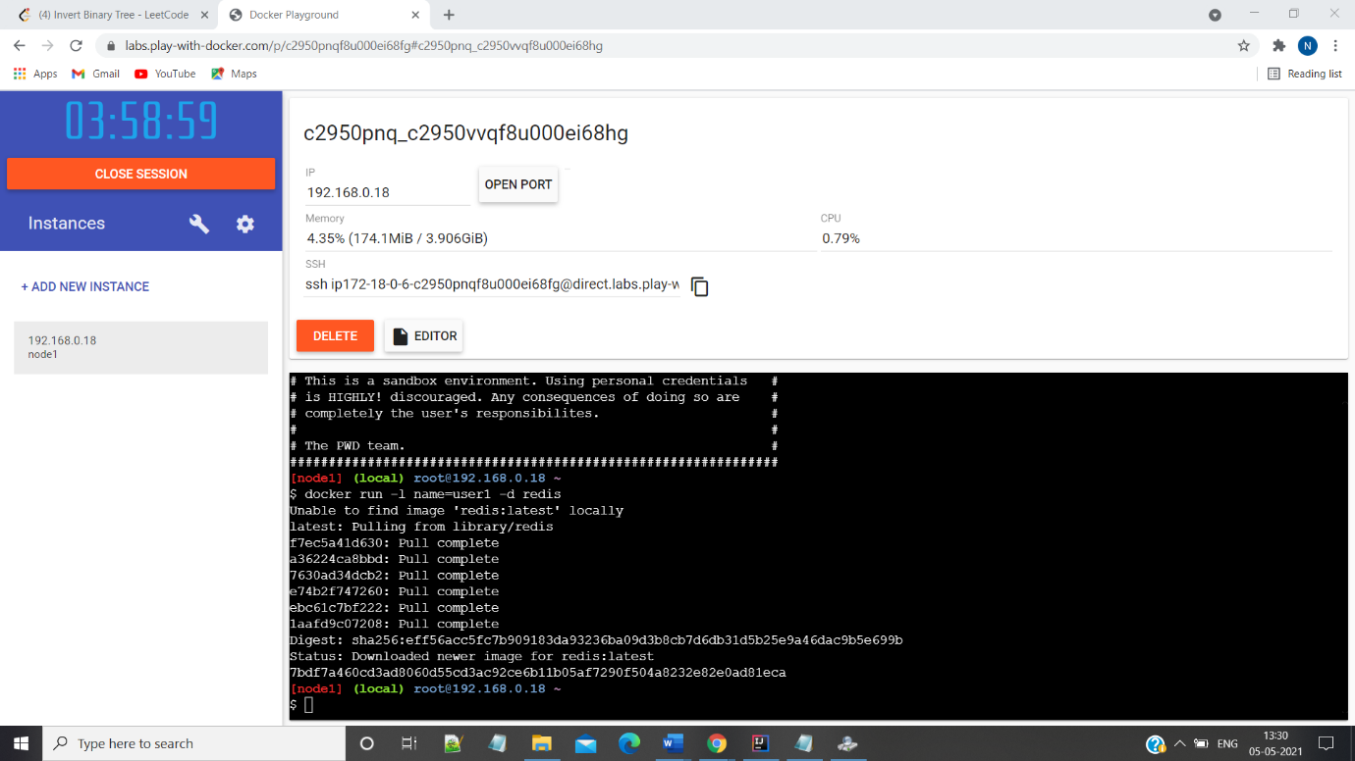

2>Inspecting

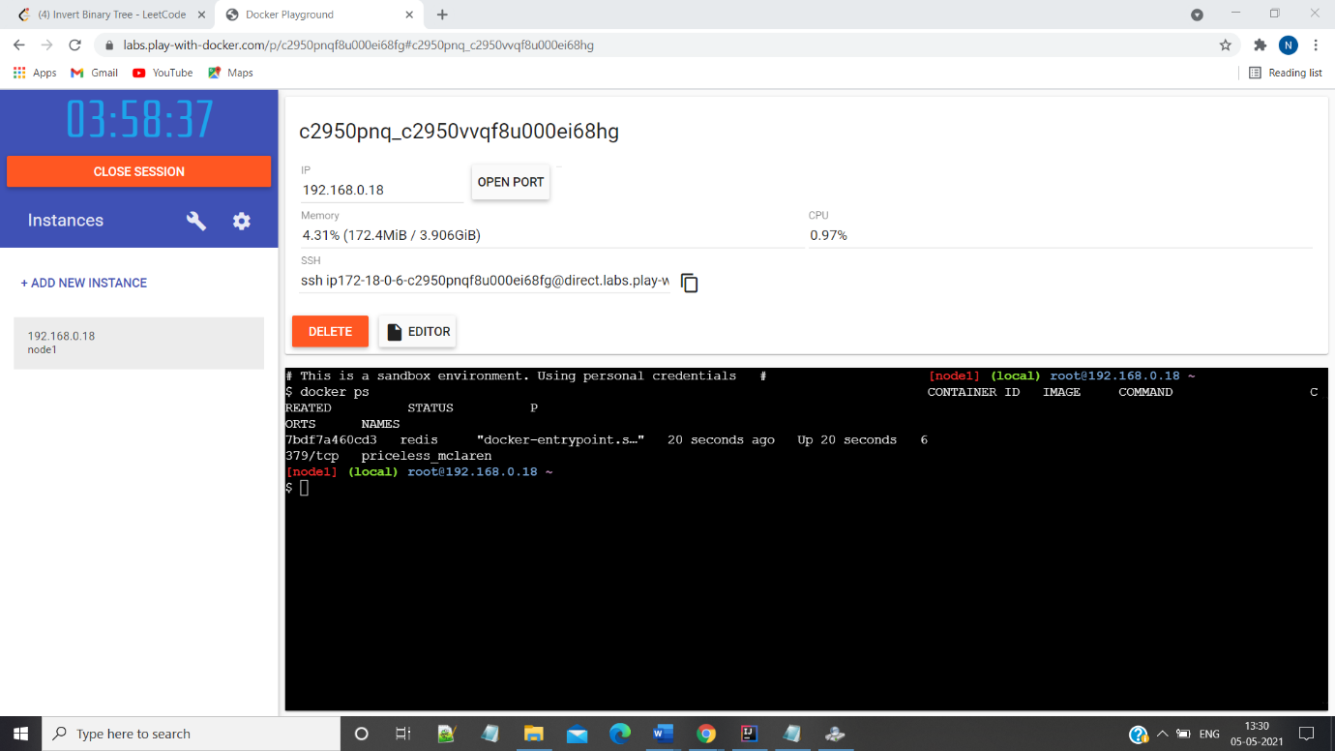

3>Adding multiple labels

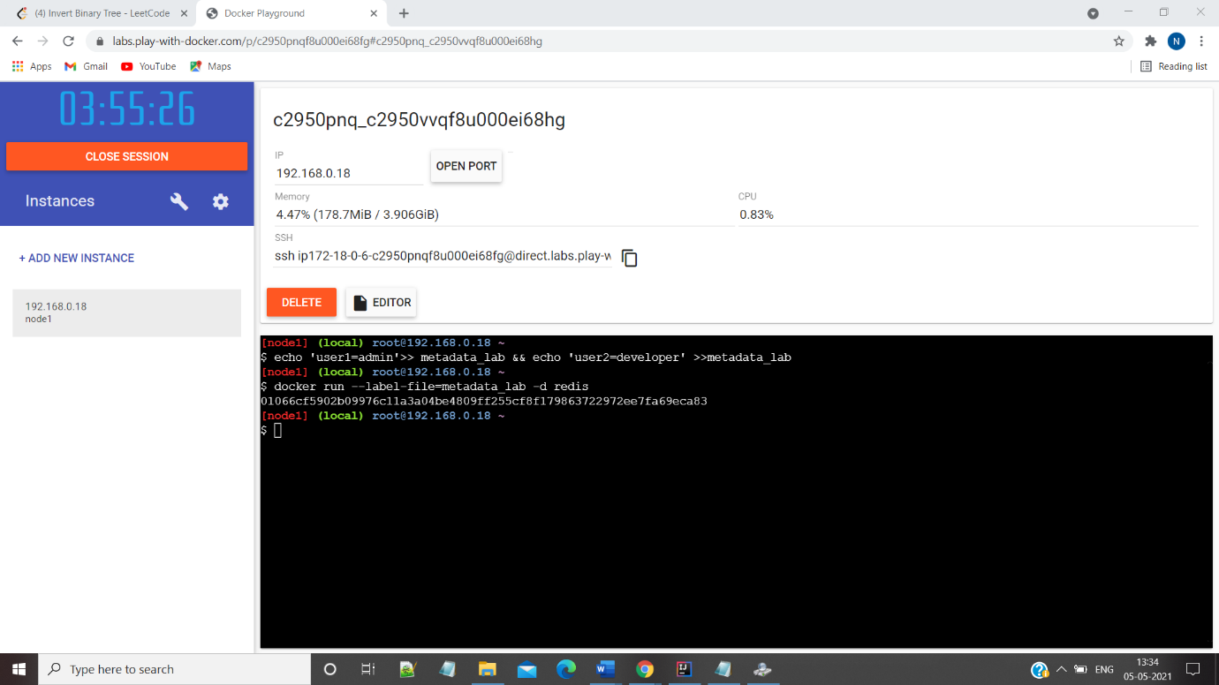

4>Filtering

