

**UNIVERSITY OF PETROLEUM & ENERGY STUDIES**

**Dehradun**

[**Application Containerization Lab**](https://learn.upes.ac.in/webapps/blackboard/execute/launcher?type=Course&id=_49490_1&url=)

**Experiment-1**

**Name: Aakarshit Agarwal**

**Course: B. TECH CSE DevOps (2018-22)**

**Roll no.: R171218001**

**Sapid: 500067782**

**EXPERIMENT 1**

**Playing with Vagrant**

**Prerequisite**

1. **Download Ubuntu version less than 6**
2. **Boot Startup machine should be enabled**

**Steps**

1. **Install** [**Vagrant**](https://www.vagrantup.com/downloads.html)**.**
2. **Do the normal setup and restart your pc**
3. **Open command prompt and check version by typing vagrant --version**



1. **Now go to location where you want to store your vagrant file and type**

**vagrant init**

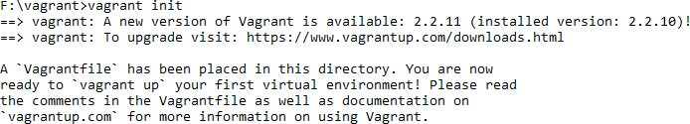

1. **Go to that folder Vagrantfile will be created.**

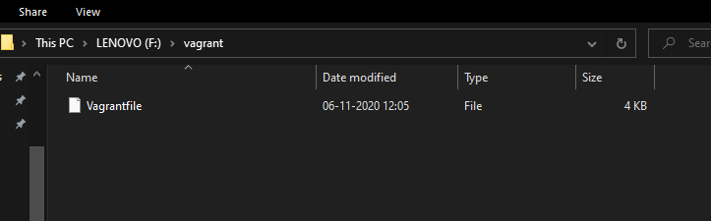

1. **Now open that file and change config.vm.box = "base" to config.vm.box = "ubuntu/xenial64"**



1. **Now in command prompt type vagrant up**

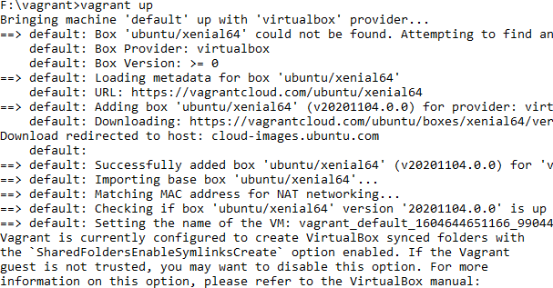

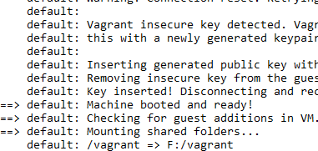

1. **Now type vagrant ssh**

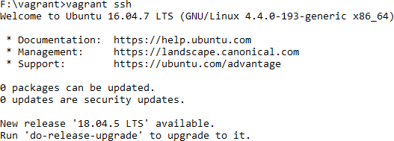

**This will change your terminal to ubuntu xenial64.**