

**UNIVERSITY OF PETROLEUM & ENERGY STUDIES**

**Dehradun**

[**Application Containerization Lab**](https://learn.upes.ac.in/webapps/blackboard/execute/launcher?type=Course&id=_49490_1&url=)

**Experiment-2**

**Name: Aakarshit Agarwal**

**Course: B. TECH CSE DevOps (2018-22)**

**Roll no.: R171218001**

**Sapid: 500067782**

**EXPERIMENT 2**

**Starting VM**

**$ vagrant up**

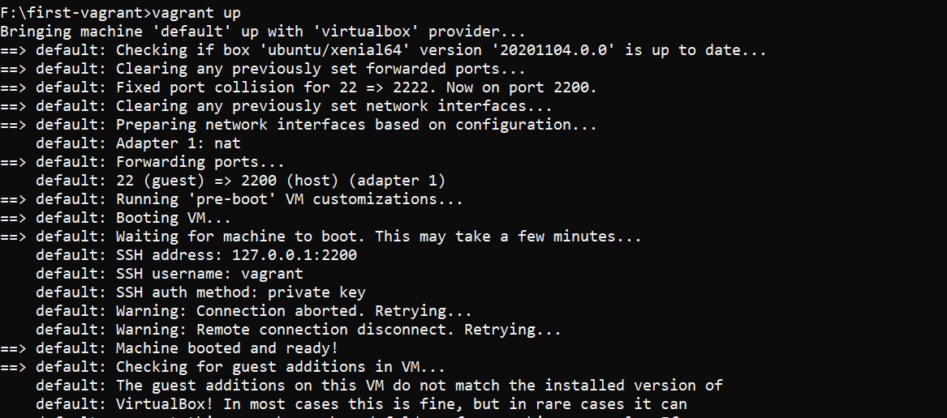

**Listing all the volumes in docker and inspecting a volume**

**$ docker volume ls**

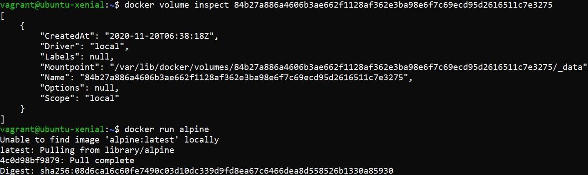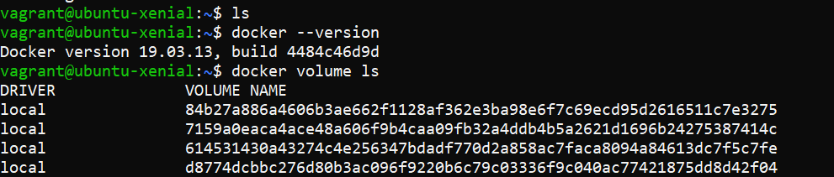

**Running an Alpine Image**

**$ docker run alpine**

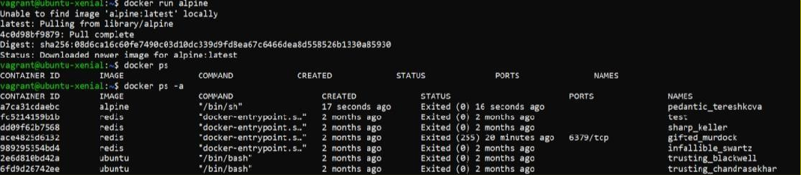

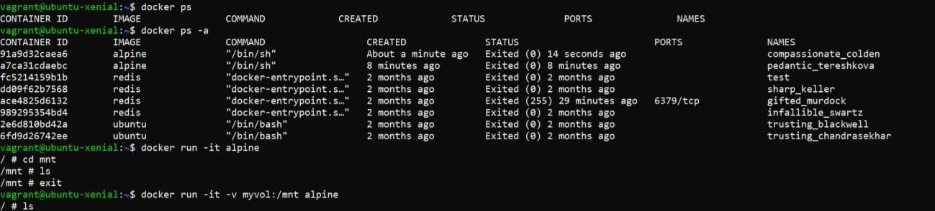

**Creating some files in that alpine cont.**

**$ docker run –it –v myvol:/mnt alpine**

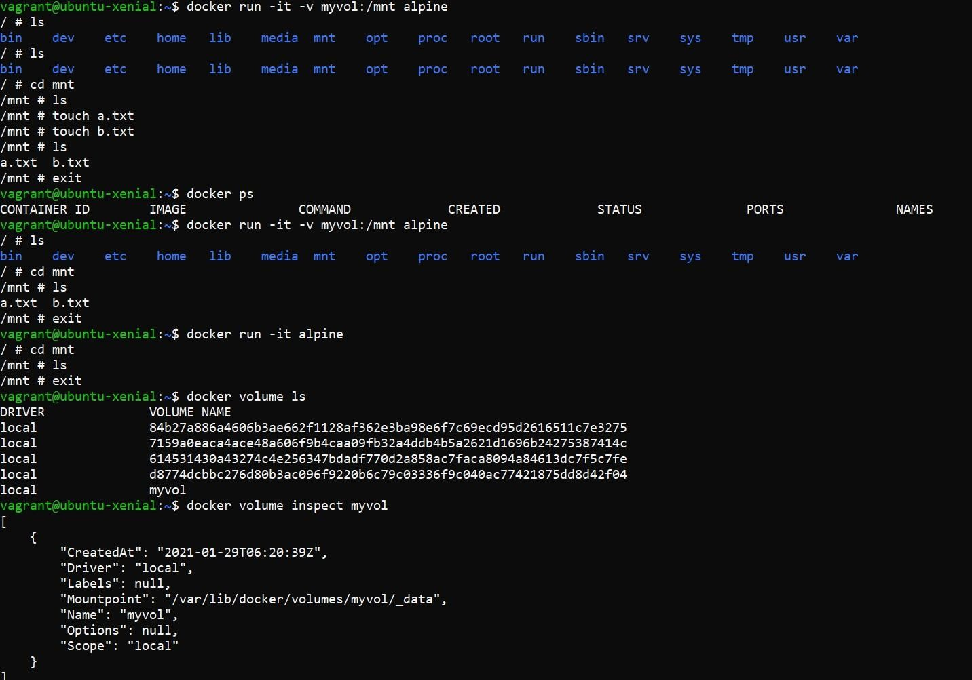

**Creating Container with Volume**

**$ docker run –it –v myvol:/mnt –name c1 alpine**

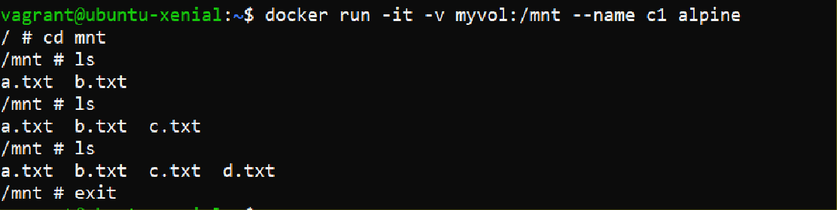

**In another instance of terminal, starting a VM and running docker in that**

**$ docker run –it –v myvol:/mnt –name c2 alpine**

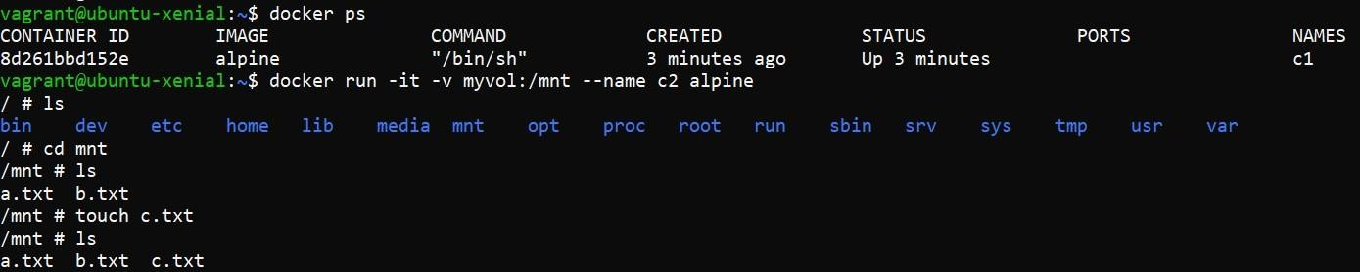

**All the files show synced up**

**$ docker run -it –v myvol:/var ubuntu**