

**UNIVERSITY OF PETROLEUM & ENERGY STUDIES**

**Dehradun**

[**Application Containerization Lab**](https://learn.upes.ac.in/webapps/blackboard/execute/launcher?type=Course&id=_49490_1&url=)

**Experiment-3**

**Name: Aakarshit Agarwal**

**Course: B. TECH CSE DevOps (2018-22)**

**Roll no.: R171218001**

**Sapid: 500067782**

**EXPERIMENT - 3**

**Check if any container is running**

**Run command – $ docker ps**

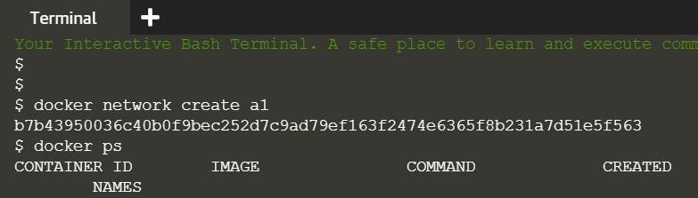

**Creating a container**

**Run command – $ docker run –d –name=b1 –net=a1 redis**

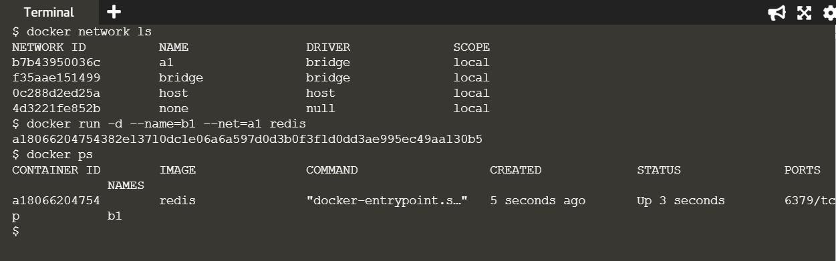

**To check IP address**

**Run command - $ docker inspect a180**

**(Note : a180 is unique initials of container ID you want ip**

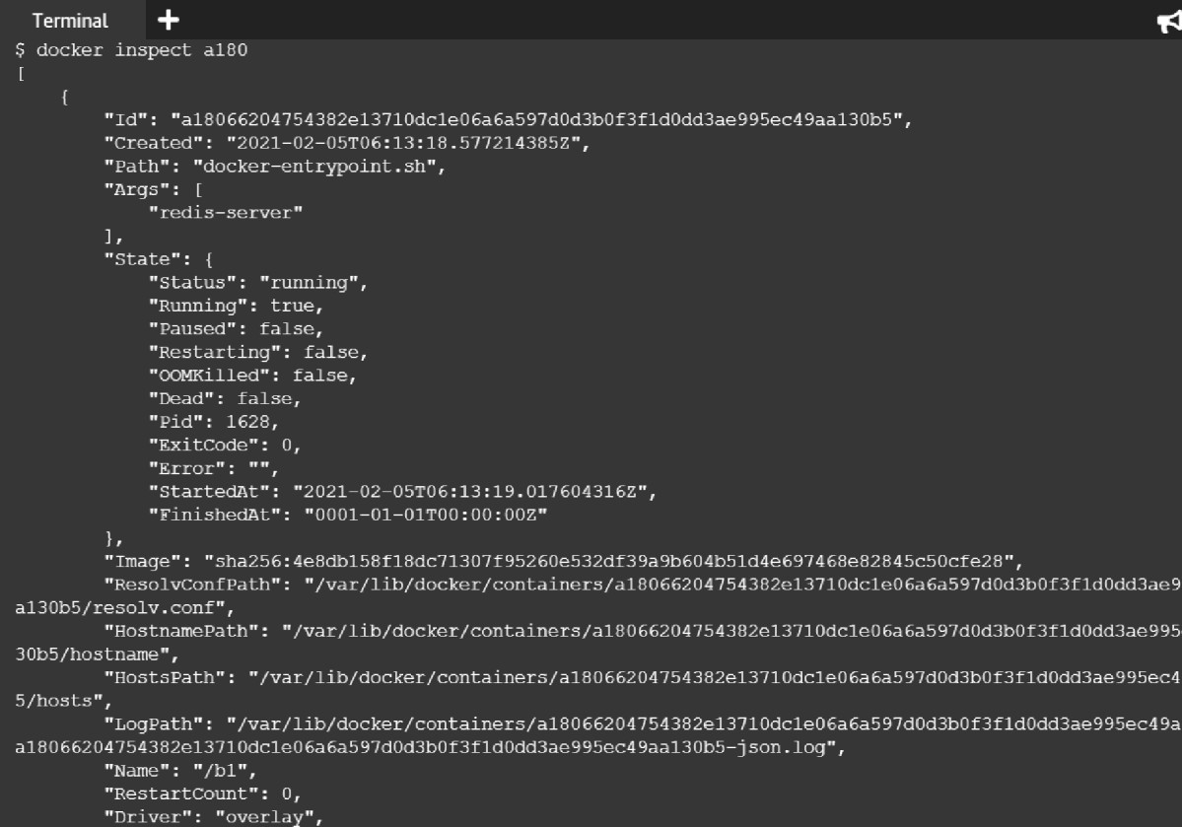



"NetworkID": "b7b4?95I5?6c40b0f9bec252d7c9ad79ef

"EndpointID": "0bda2 d 9a° 9b4?ae54b d2552f9ee9??

"Gat "ay" , y2 ,-

"IPAddress": " 72. 9.u.?", "IPPrefir. fifi"4 VG; "IPvGGateway": "", "GLobalIPvGAddress": "", "GLobalIPv6Prefixlen": v, "MacAddress": "v2:42:ac: ?::':v2",

"DriverOpts"

: null

"NetworkID": "b7b4?95003GC40b0f9bec252d7c9ad79ef G?f2474e

"EndpointID": "e94Gac tJdf4a522G?525d CG549?ceaG?aGdGt t?

"Gat "ay" yy ,-, "IPA.H.Press": " 72. ?•.1.?",

"IPPrefir.men": G, "IPvGGateway": "", "GlotalIPv6Address": "", "GLotalIPv6Prefirlen": I, "MacAddress": "02:42:ac: ?:00:0?", "DriverOpts": null

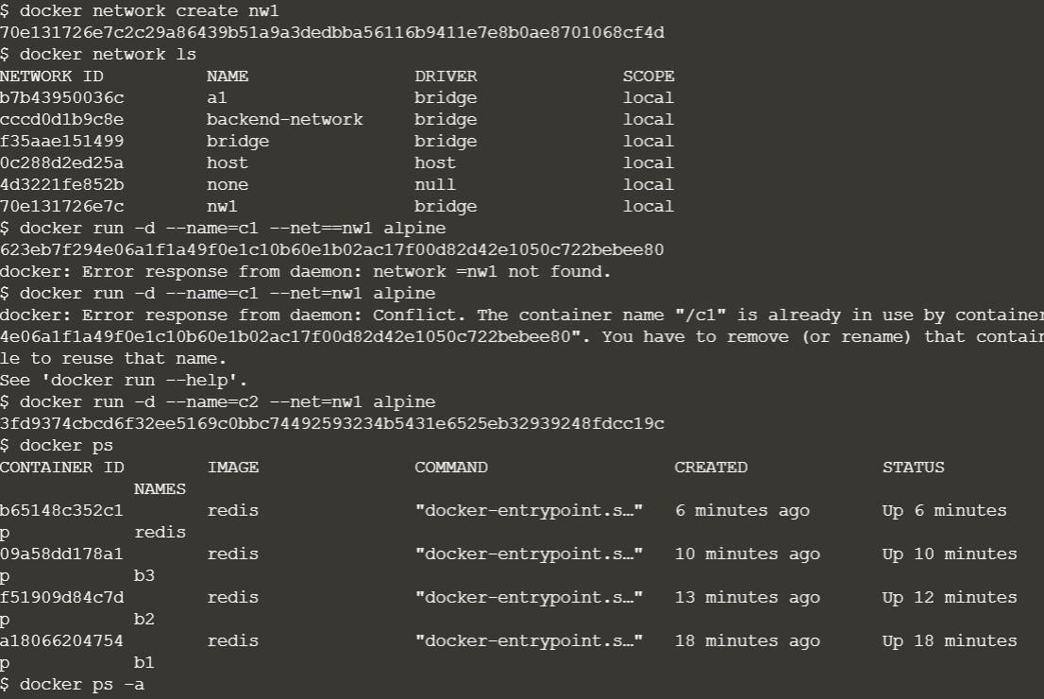

**Ping network**

**$ docker run –name=c3 –net=backend-network alpine ping redis**

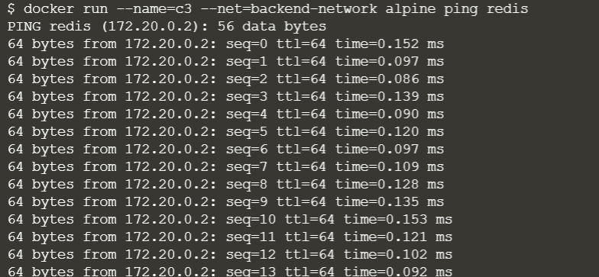

**Create a network**

**$ docker network create backend-network**

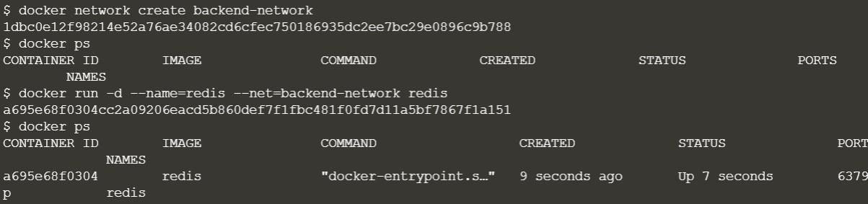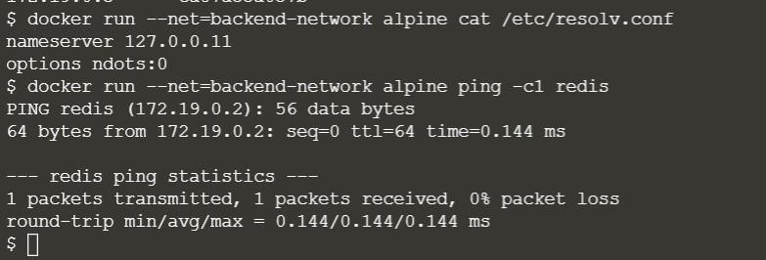

**Create a network**

**$ docker network create frontend-network**

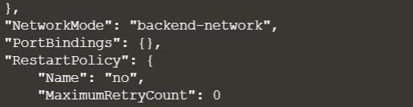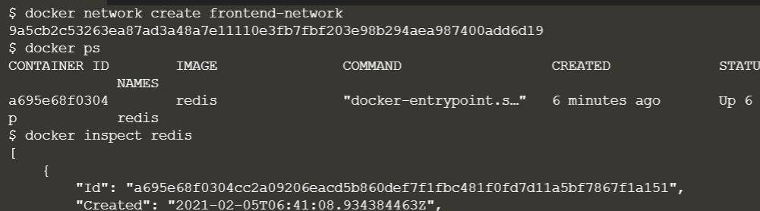

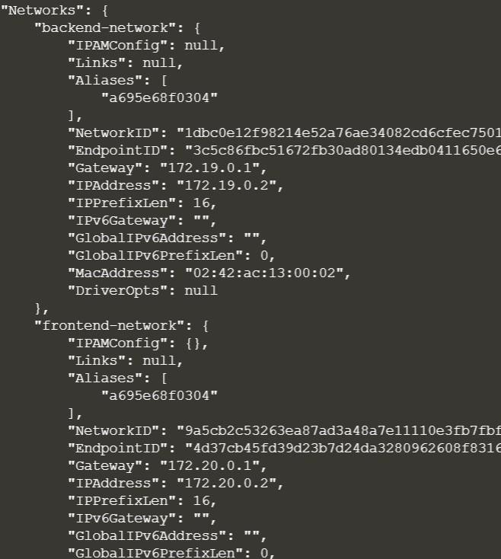

**$ docker run –d –p 3000:3000 –net=frontend-network katacoda/redis-node- docker-example**

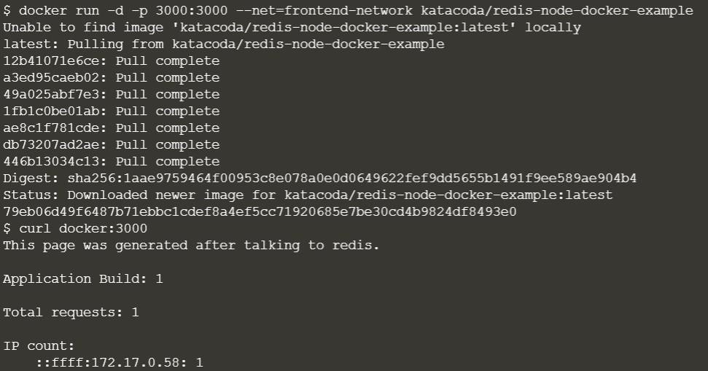

**To create a network**

**$ docker network create frontend-network**

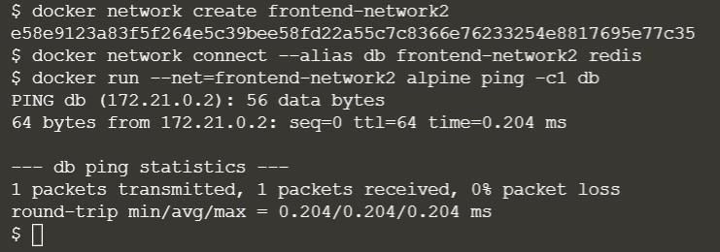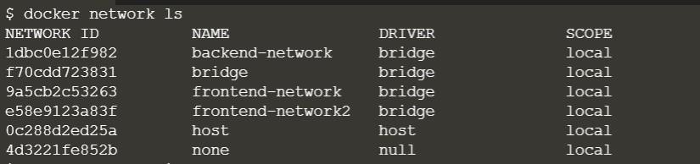

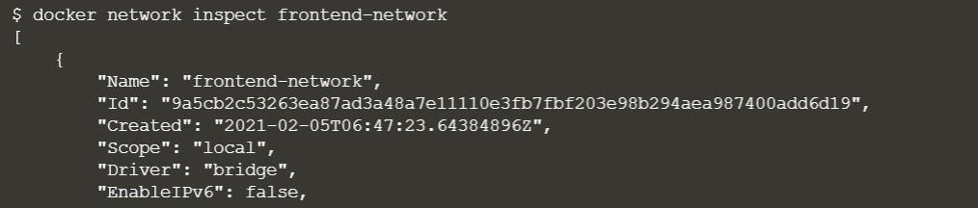

**To disconnect from server**

**$ docker network disconnect frontend-network redis (frontend- network is name of network)**

