

**UNIVERSITY OF PETROLEUM & ENERGY STUDIES**

**Dehradun**

[**Application Containerization Lab**](https://learn.upes.ac.in/webapps/blackboard/execute/launcher?type=Course&id=_49490_1&url=)

**Experiment-5**

**Name: Aakarshit Agarwal**

**Course: B. TECH CSE DevOps (2018-22)**

**Roll no.: R171218001**

**Sapid: 500067782**

**EXPERIMENT-5**

**Docker compose usage**

1. Create two files named

-evs.env

-docker-compose.yml

1. In evs.env MYSQL_ROOT_PASSWORD=redhat08 MYSQL_DATABASE=nginxdb MYSQL_USER=root
2. In docker-compose.yml version: '3'

services:

databases:

image: mysql ports:

- "3307:3306"

env_file:

* evs.env web:

image: nginx ports:

- "80:80"

depends_on:

* databases

1. Now run command “$ docker-compose up -d” to install all images and create containers of it in detached mode.

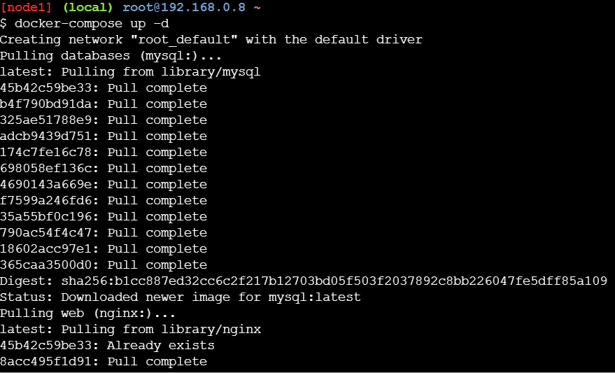

1. Run “$ docker ps” to check running containers



1. Now got to port 80:80 to check if ngnix is up or not

