

**UNIVERSITY OF PETROLEUM & ENERGY STUDIES**

**Dehradun**

[**Application Containerization Lab**](https://learn.upes.ac.in/webapps/blackboard/execute/launcher?type=Course&id=_49490_1&url=)

**Experiment-6**

**Name: Aakarshit Agarwal**

**Course: B. TECH CSE DevOps (2018-22)**

**Roll no.: R171218001**

**Sapid: 500067782**

**Experiment-6**

**Aim - Linking Containers Using docker link Command**

**Step1:** Run a container in detached mode with name "db" from image "training/postgres"

$ docker run -it -d --name db training/postgres

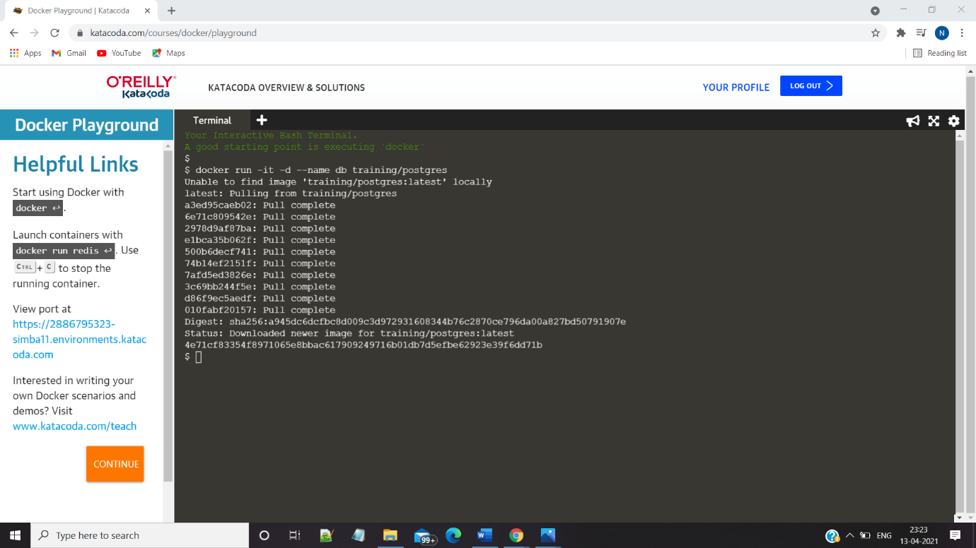

**Step-2:** Run another container in detached mode with name "web" from image "training/webapp", link container "db" with alias "mydb" to this container and finally pass an inline command "python app.py" while running container.

$ docker run -it -d -–name web -–link db:mydb training/webapp

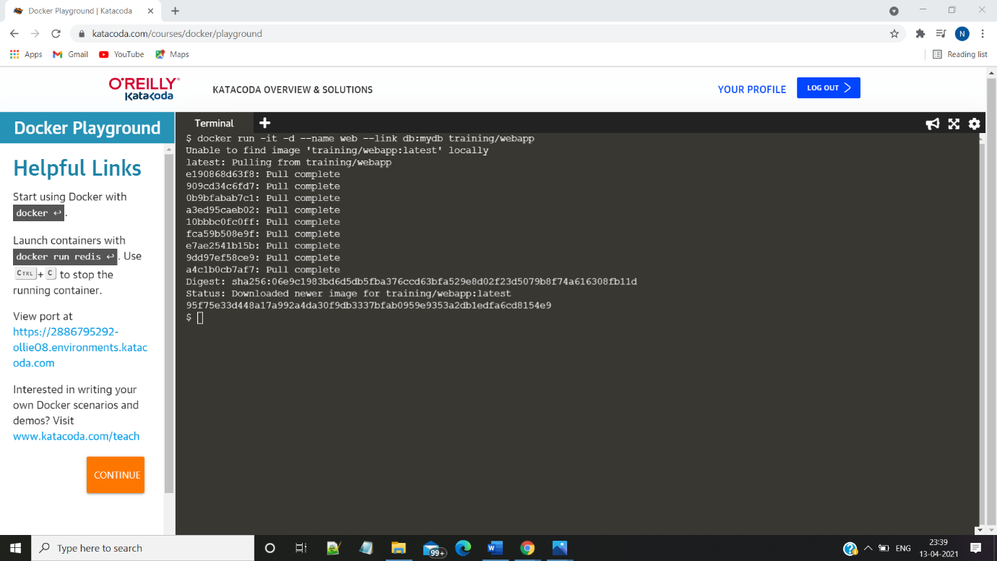

**Step-3:** Take a bash terminal in "web" container and Test container linking by doing a ping to "mydb"

$ docker exec -it web bash

And then run  
# ping mydb

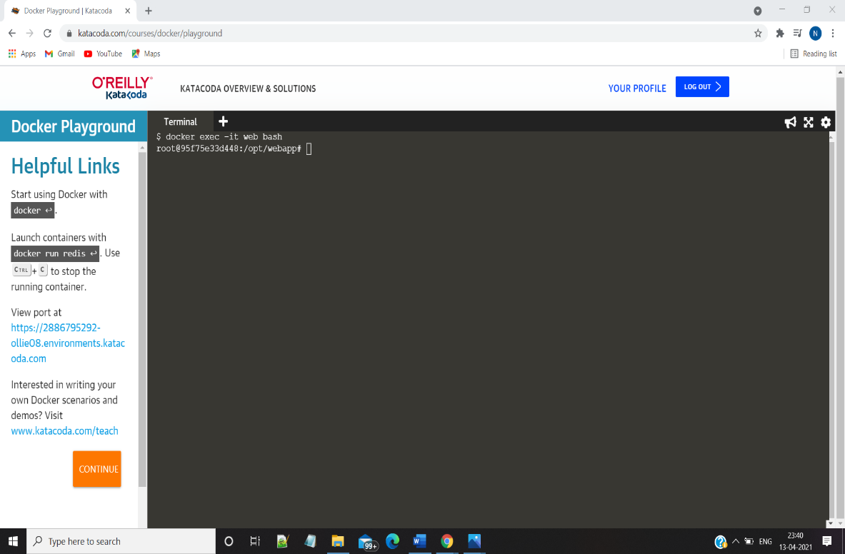

**Step 4:Run**

**$** ping mydb

