

**UNIVERSITY OF PETROLEUM & ENERGY STUDIES**

**Dehradun**

[**Application Containerization Lab**](https://learn.upes.ac.in/webapps/blackboard/execute/launcher?type=Course&id=_49490_1&url=)

**Experiment-8**

**Name: Aakarshit Agarwal**

**Course: B. TECH CSE DevOps (2018-22)**

**Roll no.: R171218001**

**Sapid: 500067782**

**Experiment-8**

**Aim: Deploying a Service using Kubernetes**

**Step 1:** Run the minikube start command to initialize a

Cluster this will make a cluster with a single node

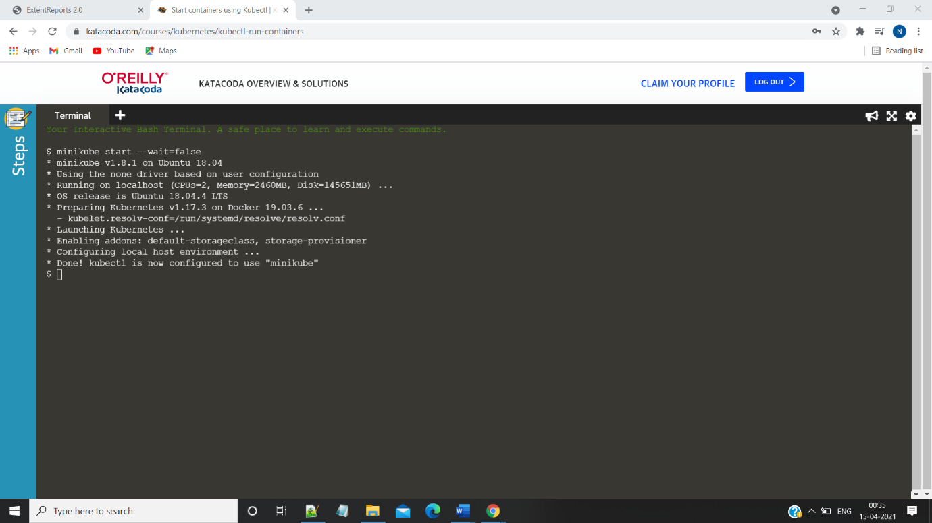

**Step2:** run the kubectl get nodes

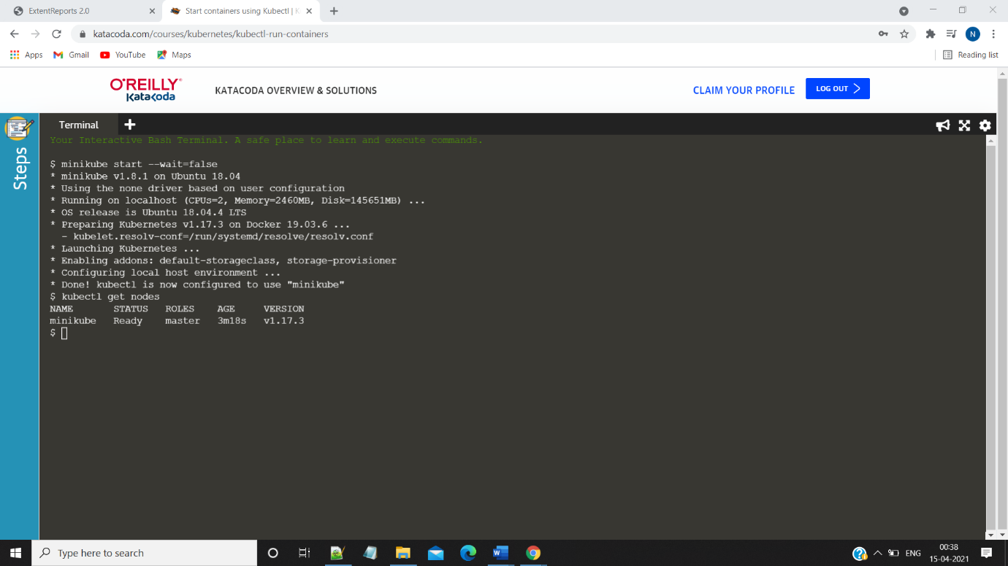

**Step 3:** Run the kubectl run command to deploy a service

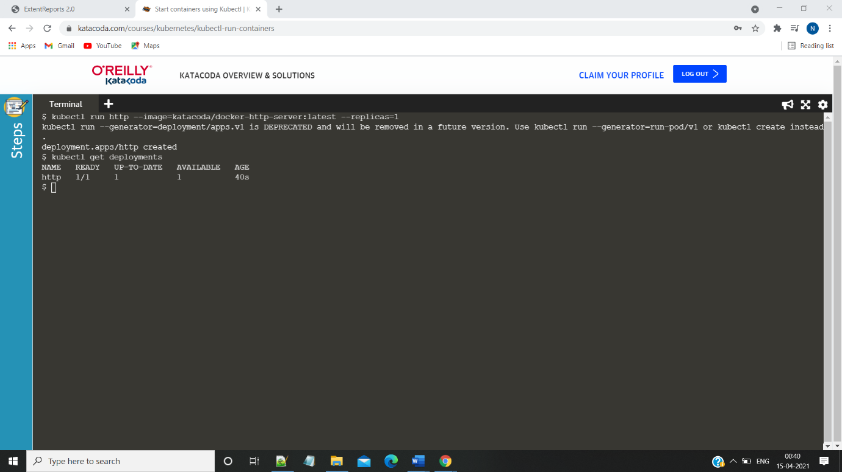

**Step4:**run the kubectl describe deployment command

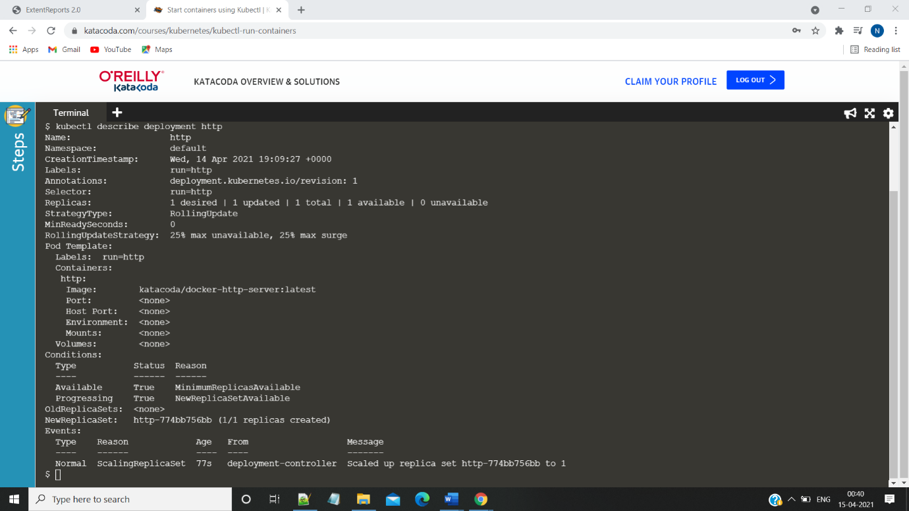

**Step5:** run the expose deployment command to expose the port and run the curl command subsequently

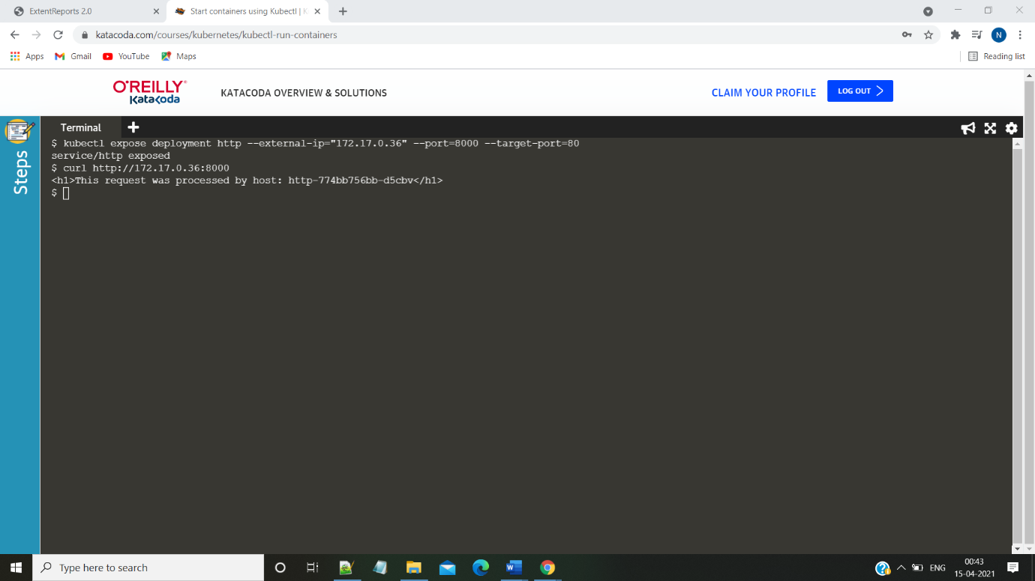

**Step 6:** Run the kubectl get svc command

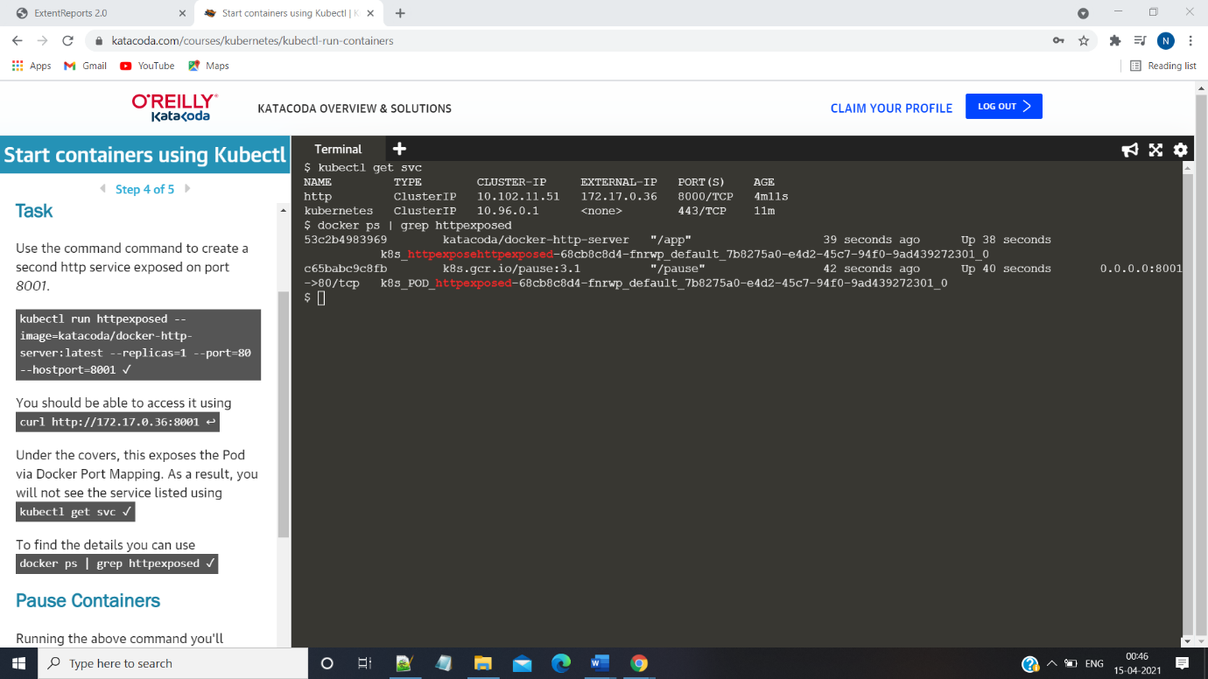

**Step 7:** run the kubectl scale –replicas command to scale the replicas of the deployment

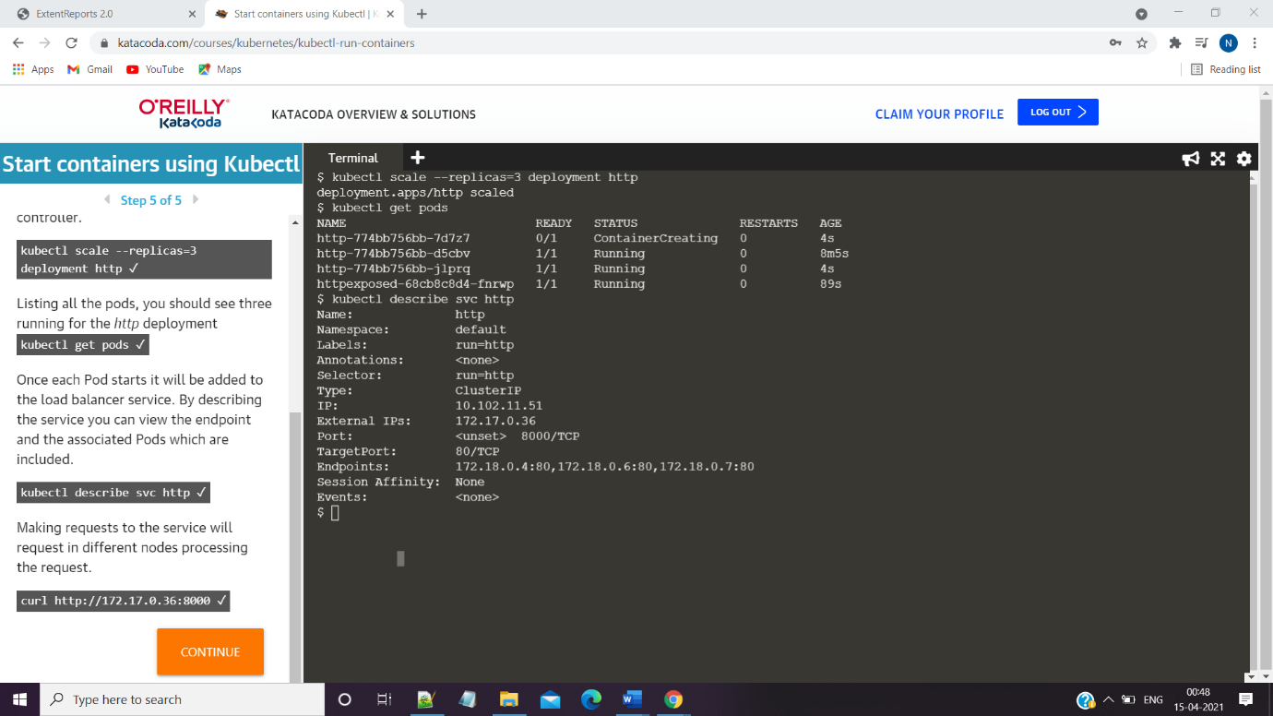

**Part-II**

**Aim: Kubernetes UI**

**Step1:** Run the minikube start version

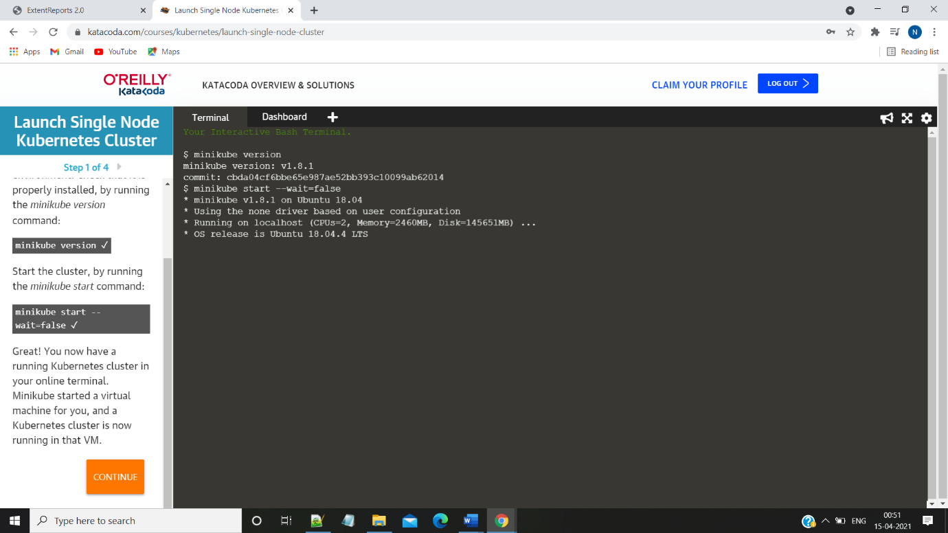

**Step2:** Run the minikube addons enable dashboard command &

Kubectl get pods command

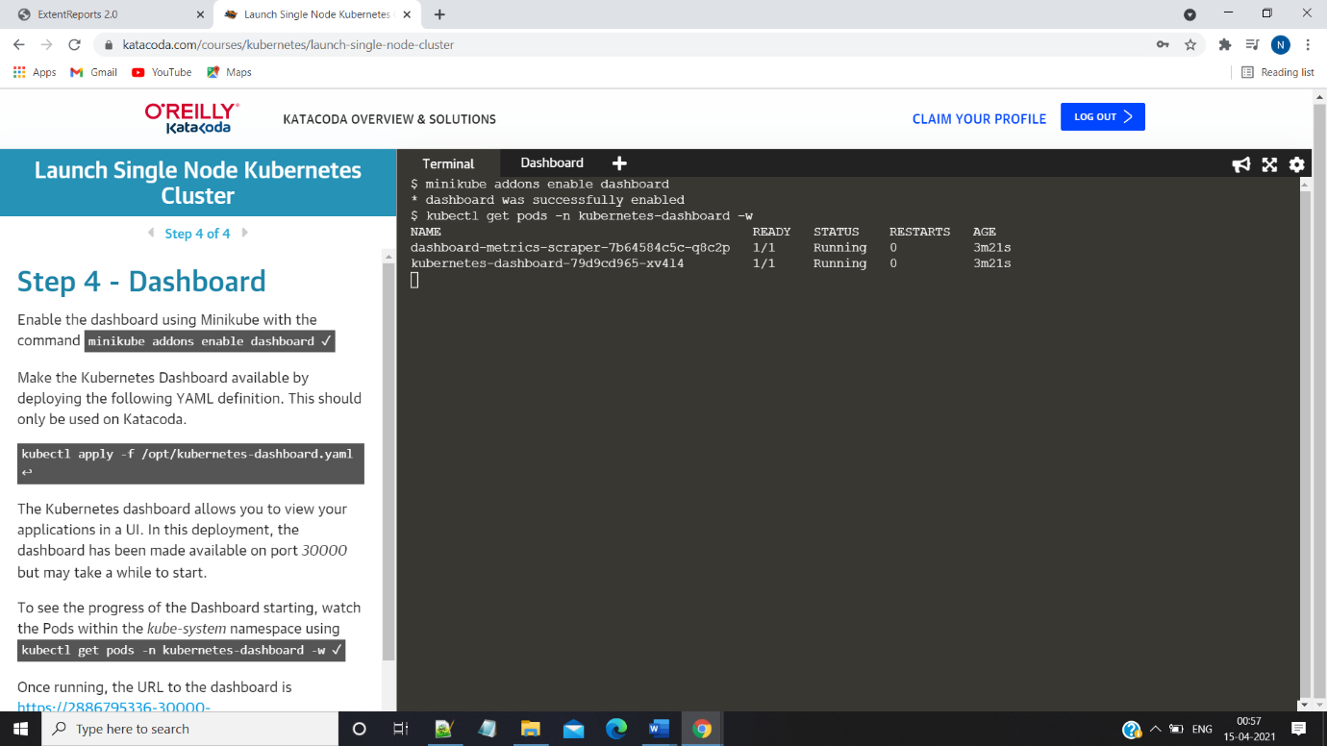

**Step3:See the deployments inside the UI**

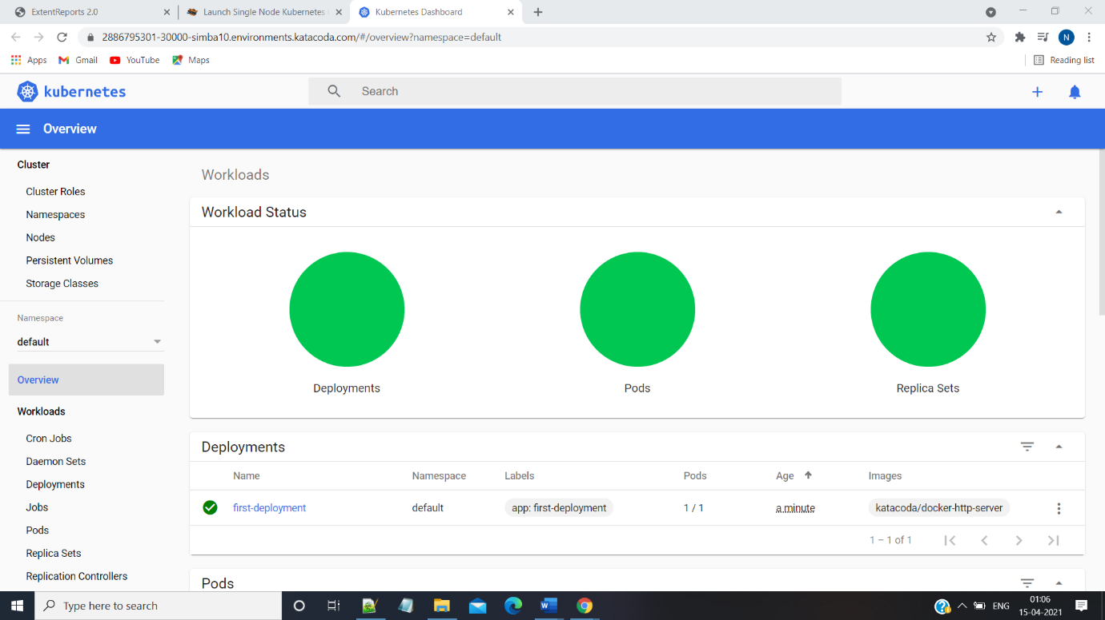

**Step4:Deploy another service and Check for changes inside the ui**

